Ty Madsen

EcEn 220

12/6/13

Lab 11: Controlling the LC3 Datapath

**Datapath Verilog Module**

module Datapath(

input clk,

input reset,

input [1:0] aluControl,

input enaALU,

input [2:0] SR1,

input [2:0] SR2,

input [2:0] DR,

input regWE,

input [1:0] selPC,

input enaMARM,

input selMAR,

input selEAB1,

input [1:0] selEAB2,

input enaPC,

input ldPC,

input ldIR,

input ldMAR,

input ldMDR,

input selMDR,

input memWE,

input flagWE,

input enaMDR,

output N,

output Z,

output P,

output [15:0] IR

);

wire [15:0] Buss, aluOut, pc, MARMuxOut, eabOut, Ra, Rb, mdrOut;

PC pcModule(ldPC,clk,reset, selPC, Buss, eabOut, pc);

ts_driver PCdriver(pc, Buss, enaPC);

EAB EABModule(IR[10:0], Ra, pc, selEAB1, selEAB2, eabOut);

IR IRmodule(ldIR, clk, reset, Buss, IR);

MARMux marmodule(IR[7:0],selMAR,eabOut,MARMuxOut);

ts_driver enaMARMdriver (MARMuxOut, Buss, enaMARM);

ALU alumodule(Ra, Rb, IR[5:0], aluControl, aluOut);

ts_driver aluDriver(aluOut, Buss, enaALU);

RegFile REG(DR,SR1,SR2,regWE,clk,reset,Buss,Ra,Rb);

NZP nzp(Buss,reset,clk,flagWE,N,Z,P);

Memory mem(mdrOut, Buss, clk, reset, ldMAR, ldMDR, selMDR, memWE);

ts_driver memdriver(mdrOut, Buss, enaMDR);

endmodule

MASTER TCL FILE

source wave.tcl

isim force add clk 0 -time 0 -value 1 -time 5ns -repeat 10ns

isim force add reset 1 -time 0 -value 0 -time 12ns

run 12ns

source fetch.tcl

source and1.tcl

source fetch.tcl

source add1.tcl

source fetch.tcl

source not1.tcl

source fetch.tcl

source branch1.tcl

source fetch.tcl

source jsr1.tcl

source fetch.tcl

source load1.tcl

source fetch.tcl

source load2.tcl

source fetch.tcl

source add2.tcl

source fetch.tcl

source store.tcl

source fetch.tcl

source jump1.tcl

source fetch.tcl

source branch2.tcl

source fetch.tcl

WAVE TCL FILE

#add signals to view the IR and IR control

wave add ldIR

wave add IR -radix hex

#add signals to view the EAB control

wave add selEAB1

wave add selEAB2

wave add eabOut -radix hex

#add signals to view the MARMux control

wave add selMAR

wave add enaMARM

wave add MARMuxOut -radix hex

#add signals to view Register File control

wave add DR

wave add SR1

wave add SR2

wave add regWE

#add signals to view the Registers in the Register File

wave add /REG/R0 -radix hex

wave add /REG/R1 -radix hex

wave add /REG/R2 -radix hex

wave add /REG/R3 -radix hex

wave add /REG/R4 -radix hex

wave add /REG/R5 -radix hex

wave add /REG/R6 -radix hex

wave add /REG/R7 -radix hex

wave add Ra -radix hex

wave add Rb -radix hex

#add signals to view the ALU control

wave add aluControl

wave add enaALU

wave add aluOut -radix hex

#view the condition flags

wave add N

wave add Z

wave add P

wave add flagWE

#add signals to view the Memory Registers and the Memory control

wave add ldMAR

wave add /mem/MARReg -radix hex

wave add ldMDR

wave add enaMDR

wave add selMDR

wave add mdrOut -radix hex

wave add /mem/memOut -radix hex

wave add memWE

INACTIVE TCL FILE

isim force add enaALU 0

isim force add enaMARM 0

isim force add enaPC 0

isim force add enaMDR 0

isim force add ldIR 0

isim force add ldPC 0

isim force add ldMAR 0

isim force add ldMDR 0

isim force add regWE 0

isim force add memWE 0

isim force add flagWE 0

FETCH TCL FILE

source inactive.tcl

isim force add enaPC 1

isim force add ldMAR 1

run 10ns

source inactive.tcl

isim force add selPC 00

isim force add ldPC 1

isim force add ldMDR 1

isim force add selMDR 1

run 10ns

source inactive.tcl

isim force add ldIR 1

isim force add enaMDR 1

run 10ns

source inactive.tcl

AND1 TCL FILE

isim force add aluControl 10

isim force add SR1 000

isim force add DR 000

isim force add enaALU 1

isim force add regWE 1

run 10ns

ADD1 TCL FILE

isim force add aluControl 01

isim force add SR1 000

isim force add DR 001

isim force add enaALU 1

isim force add regWE 1

run 10ns

NOT1 TCL FILE

isim force add aluControl 11

isim force add SR1 010

isim force add DR 011

isim force add enaALU 1

isim force add regWE 1

run 10ns

BRANCH1 TCL FILE

isim force add selPC 01

isim force add selEAB1 0

isim force add selEAB2 10

isim force add ldPC 1

run 10ns

JSR TCL FILE

isim force add DR 111

isim force add regWE 1

isim force add enaPC 1

run 10ns

source inactive.tcl

isim force add selPC 01

isim force add selEAB1 0

isim force add selEAB2 11

isim force add ldPC 1

run 10ns

LOAD1 TCL FILE

isim force add selEAB1 0

isim force add selEAB2 10

isim force add enaMARM 1

isim force add ldMAR 1

isim force add selMAR 0

run 10ns

source inactive.tcl

isim force add ldMDR 1

isim force add selMDR 1

run 10ns

source inactive.tcl

isim force add DR 010

isim force add regWE 1

isim force add enaMDR 1

run 10ns

LEAD2 TCL FILE

isim force add selEAB1 0

isim force add selEAB2 10

isim force add enaMARM 1

isim force add ldMAR 1

isim force add selMAR 0

run 10ns

source inactive.tcl

isim force add ldMDR 1

isim force add selMDR 1

run 10ns

source inactive.tcl

isim force add DR 001

isim force add regWE 1

isim force add enaMDR 1

run 10ns

ADD2 TCL FILE

isim force add aluControl 01

isim force add SR1 010

isim force add SR2 001

isim force add DR 110

isim force add enaALU 1

isim force add regWE 1

run 10ns

STORE TCL FILE

isim force add selEAB1 0

isim force add selEAB2 10

isim force add enaMARM 1

isim force add ldMAR 1

isim force add selMAR 0

run 10ns

source inactive.tcl

isim force add aluControl 00

isim force add SR1 110

isim force add enaALU 1

isim force add ldMDR 1

isim force add selMDR 0

run 10ns

source inactive.tcl

isim force add memWE 1

run 10ns

JUMP1 TCL FILE

isim force add SR1 111

isim force add selPC 01

isim force add selEAB1 1

isim force add selEAB2 00

isim force add ldPC 1

run 10ns

BRANCH2 TCL FILE

isim force add selPC 01

isim force add selEAB1 0

isim force add selEAB2 10

isim force add ldPC 1

run 10ns

**1st three instructions**

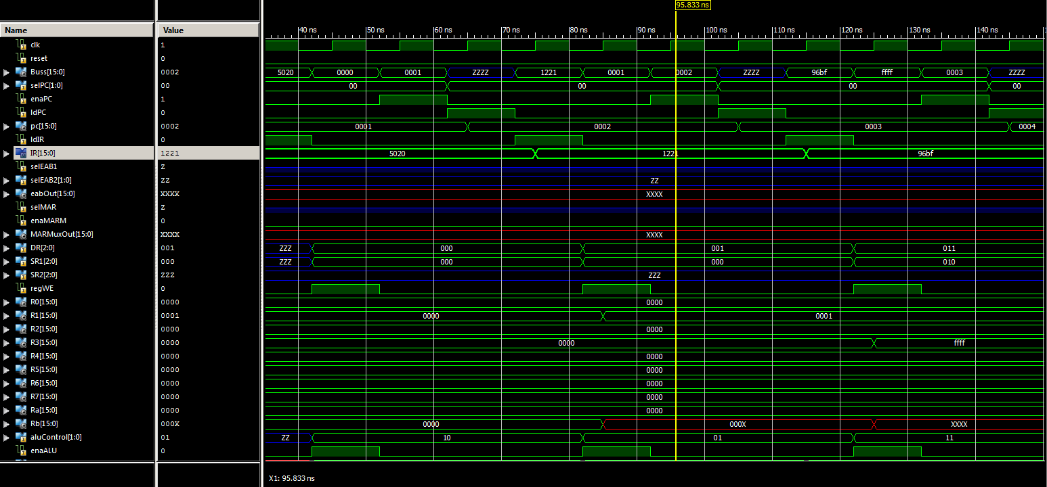

**2nd three instructions**

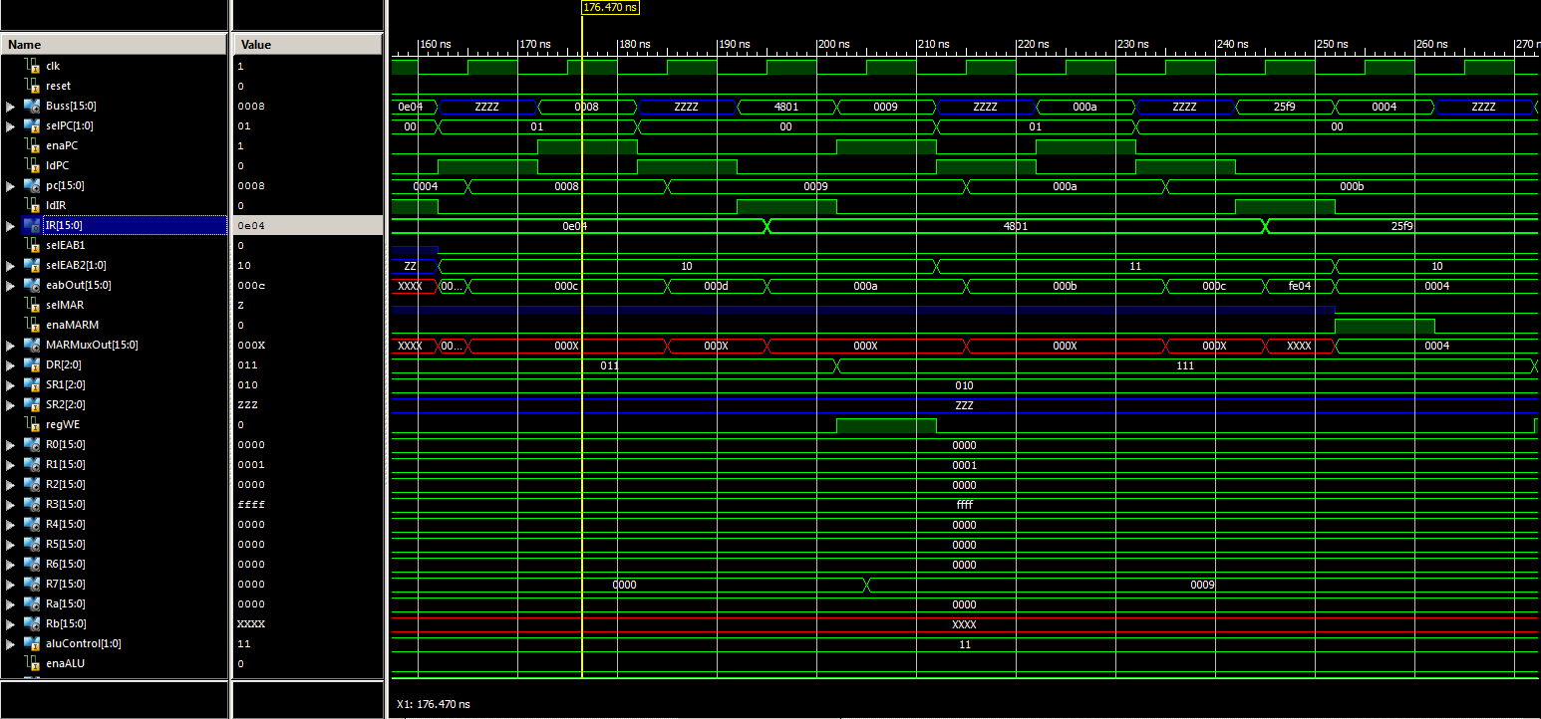

**3rd three instructions**

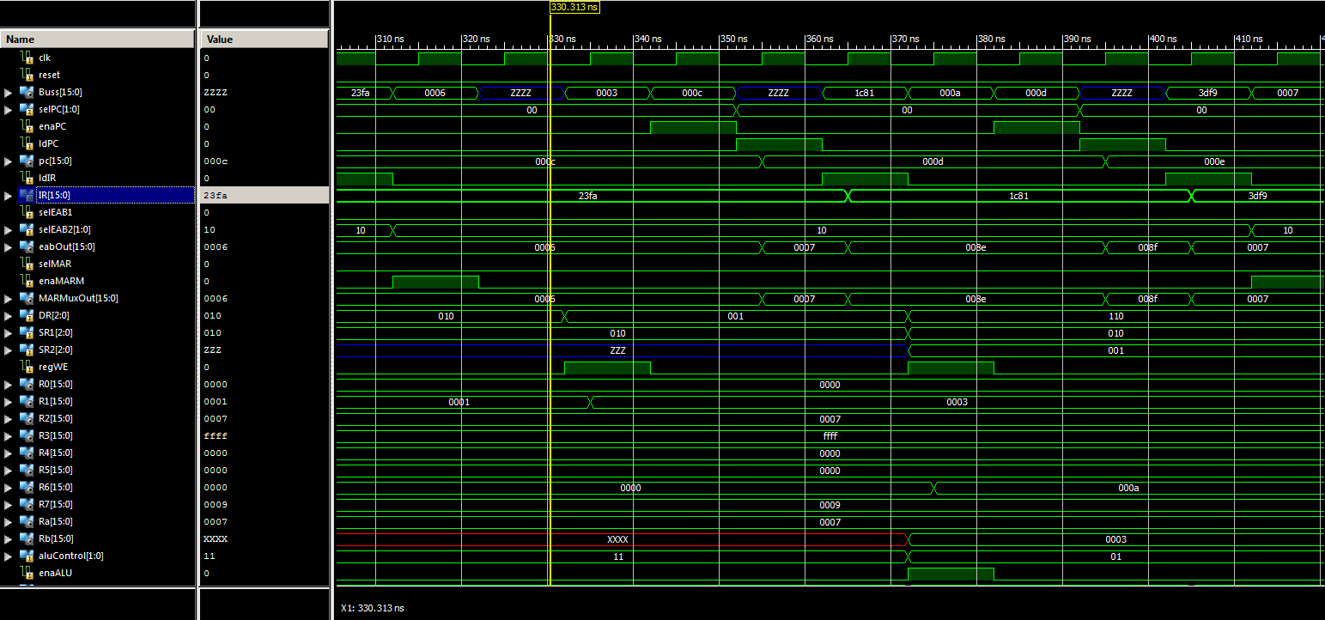**Last instructions**

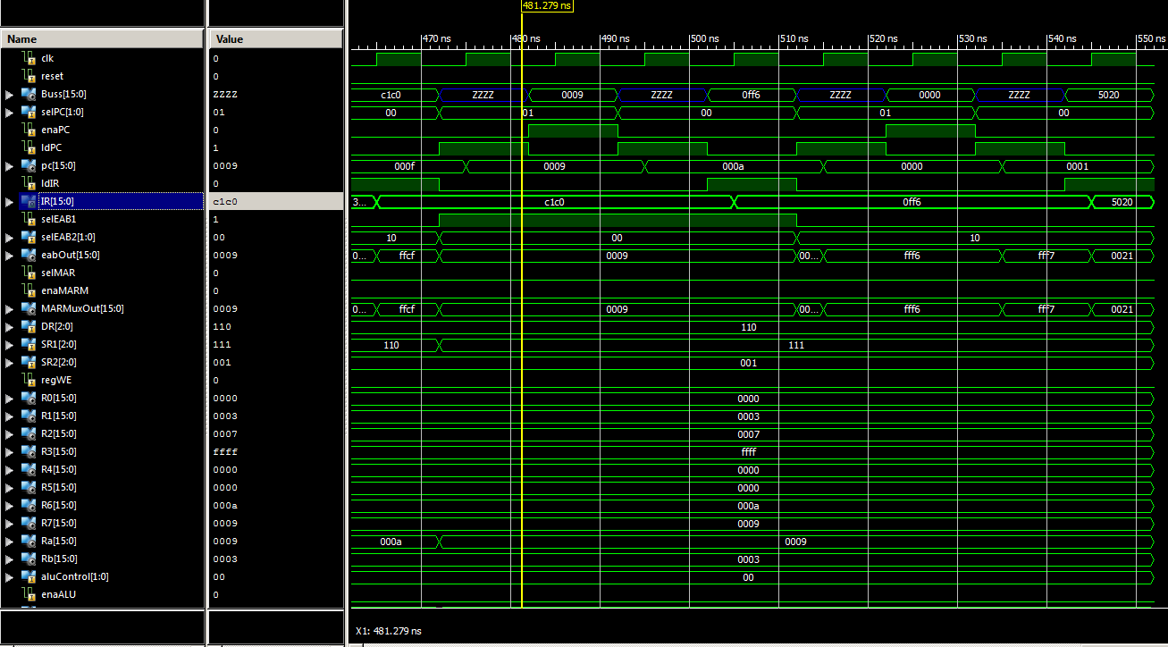

**Anomalies**

Our only anomalies were that ISE crashed once or twice and we also got confused by the select symbols on the table in the Homework online of the Datapath signals, specifically selMDR and selMAR because they were mixed in with the enable and load signals.