|  |  |  |  |  |  |  |  |  |  |  |  |
| --- | --- | --- | --- | --- | --- | --- | --- | --- | --- | --- | --- |
| **N3** | **N2** | **N1** | **N0** |  | **a** | **b** | **c** | **d** | **e** | **f** | **g** |
| 0 | 0 | 0 | 0 |  | 0 | 0 | 0 | 0 | 0 | 0 | 1 |
| 0 | 0 | 0 | 1 |  | 1 | 0 | 0 | 1 | 1 | 1 | 1 |
| 0 | 0 | 1 | 0 |  | 0 | 0 | 1 | 0 | 0 | 1 | 0 |
| 0 | 0 | 1 | 1 |  | 0 | 0 | 0 | 0 | 1 | 1 | 0 |
| 0 | 1 | 0 | 0 |  | 1 | 0 | 0 | 1 | 1 | 0 | 0 |
| 0 | 1 | 0 | 1 |  | 0 | 1 | 0 | 0 | 1 | 0 | 0 |
| 0 | 1 | 1 | 0 |  | 0 | 1 | 0 | 0 | 0 | 0 | 0 |
| 0 | 1 | 1 | 1 |  | 0 | 0 | 0 | 1 | 1 | 1 | 1 |
| 1 | 0 | 0 | 0 |  | 0 | 0 | 0 | 0 | 0 | 0 | 0 |
| 1 | 0 | 0 | 1 |  | 0 | 0 | 0 | 0 | 1 | 0 | 0 |
| 1 | 0 | 1 | 0 |  | 0 | 0 | 0 | 1 | 0 | 0 | 0 |
| 1 | 0 | 1 | 1 |  | 1 | 1 | 0 | 0 | 0 | 0 | 0 |
| 1 | 1 | 0 | 0 |  | 0 | 1 | 1 | 0 | 0 | 0 | 1 |
| 1 | 1 | 0 | 1 |  | 1 | 0 | 0 | 0 | 0 | 1 | 0 |
| 1 | 1 | 1 | 0 |  | 0 | 1 | 1 | 0 | 0 | 0 | 0 |
| 1 | 1 | 1 | 1 |  | 0 | 1 | 1 | 1 | 0 | 0 | 0 |

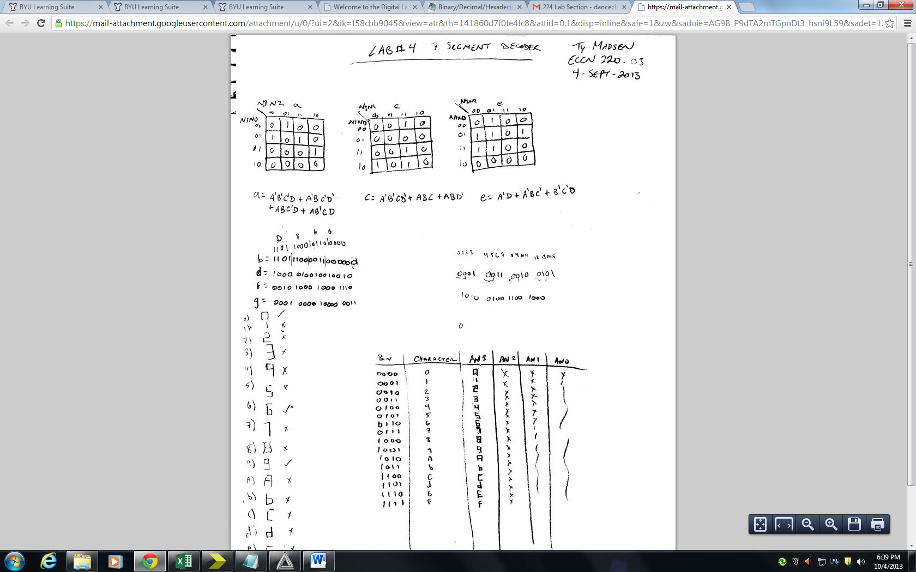

Combinational a, c, e

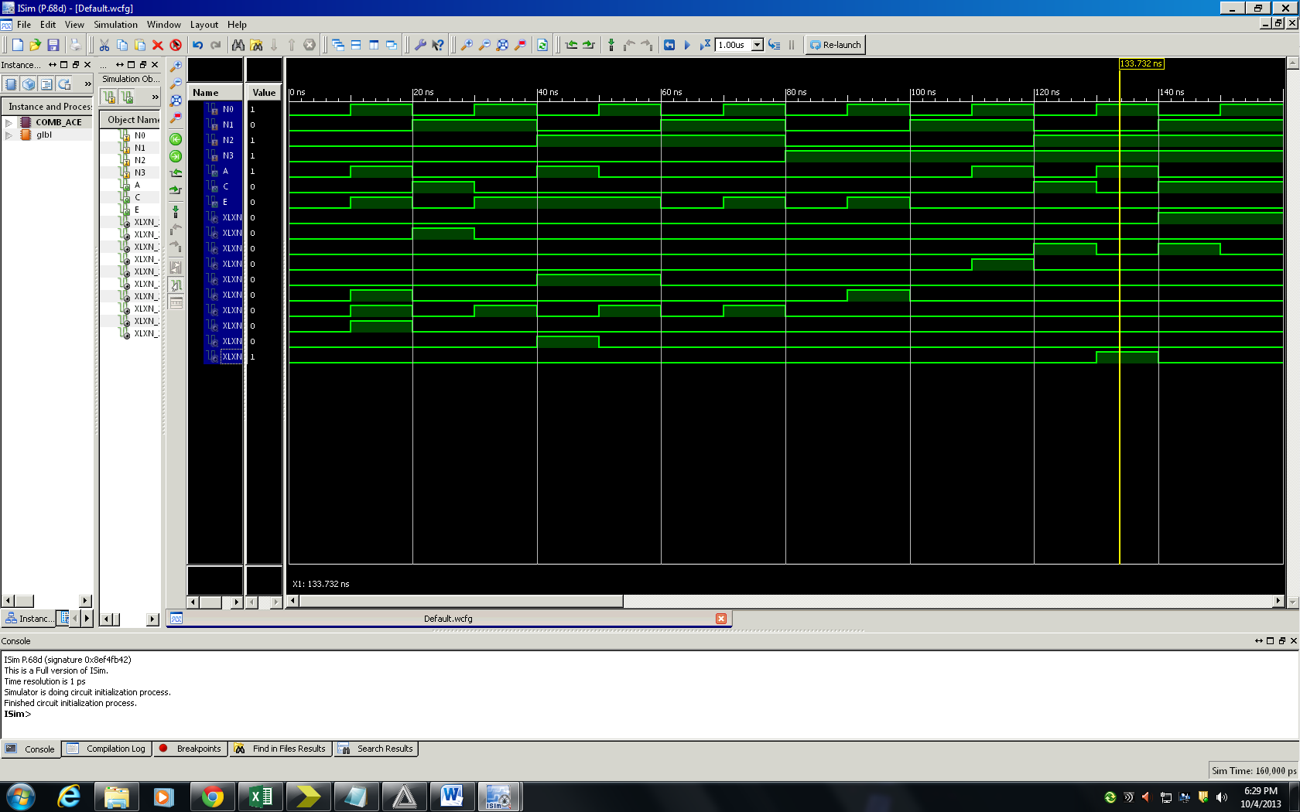

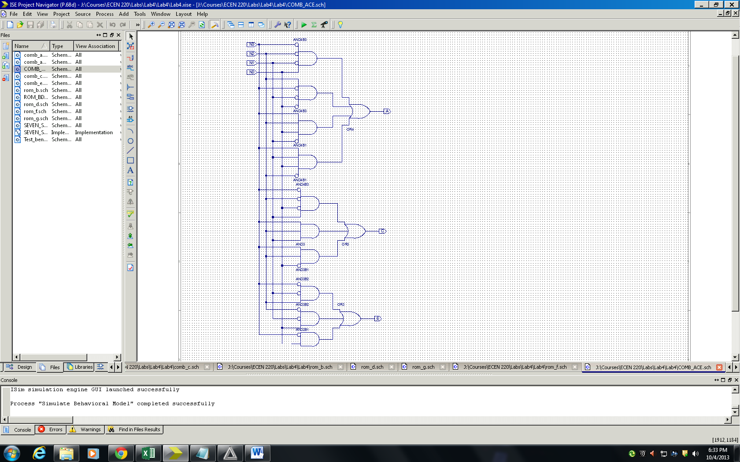

Rom b, d, f, g

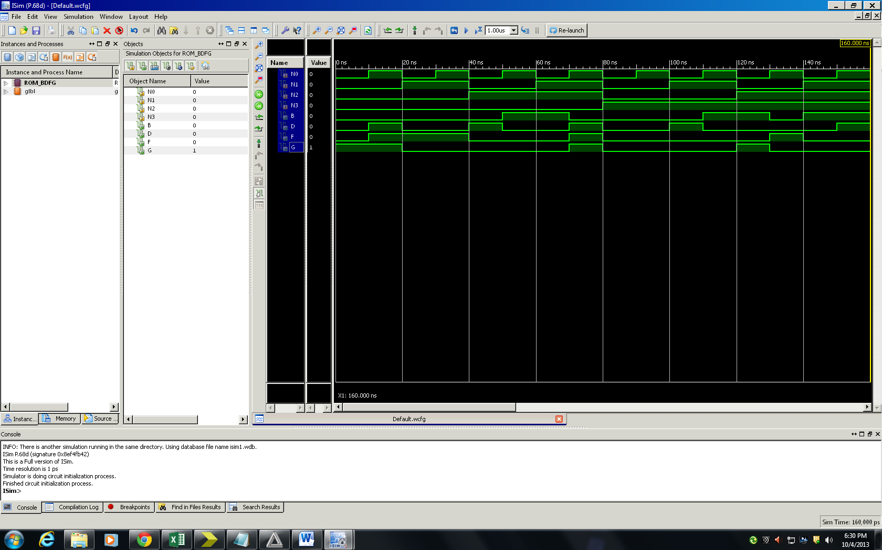

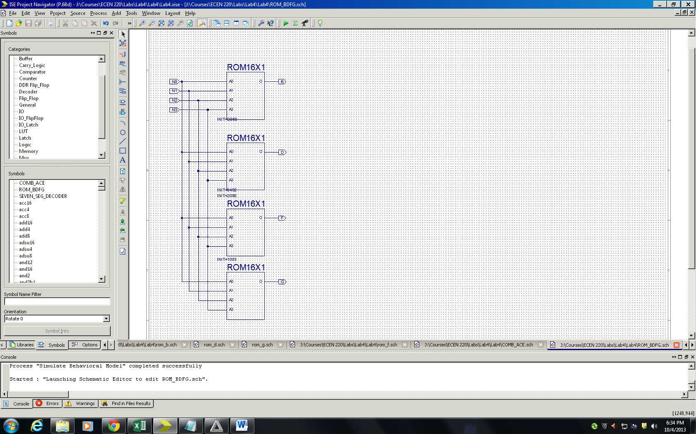

Seven Segment Decoder

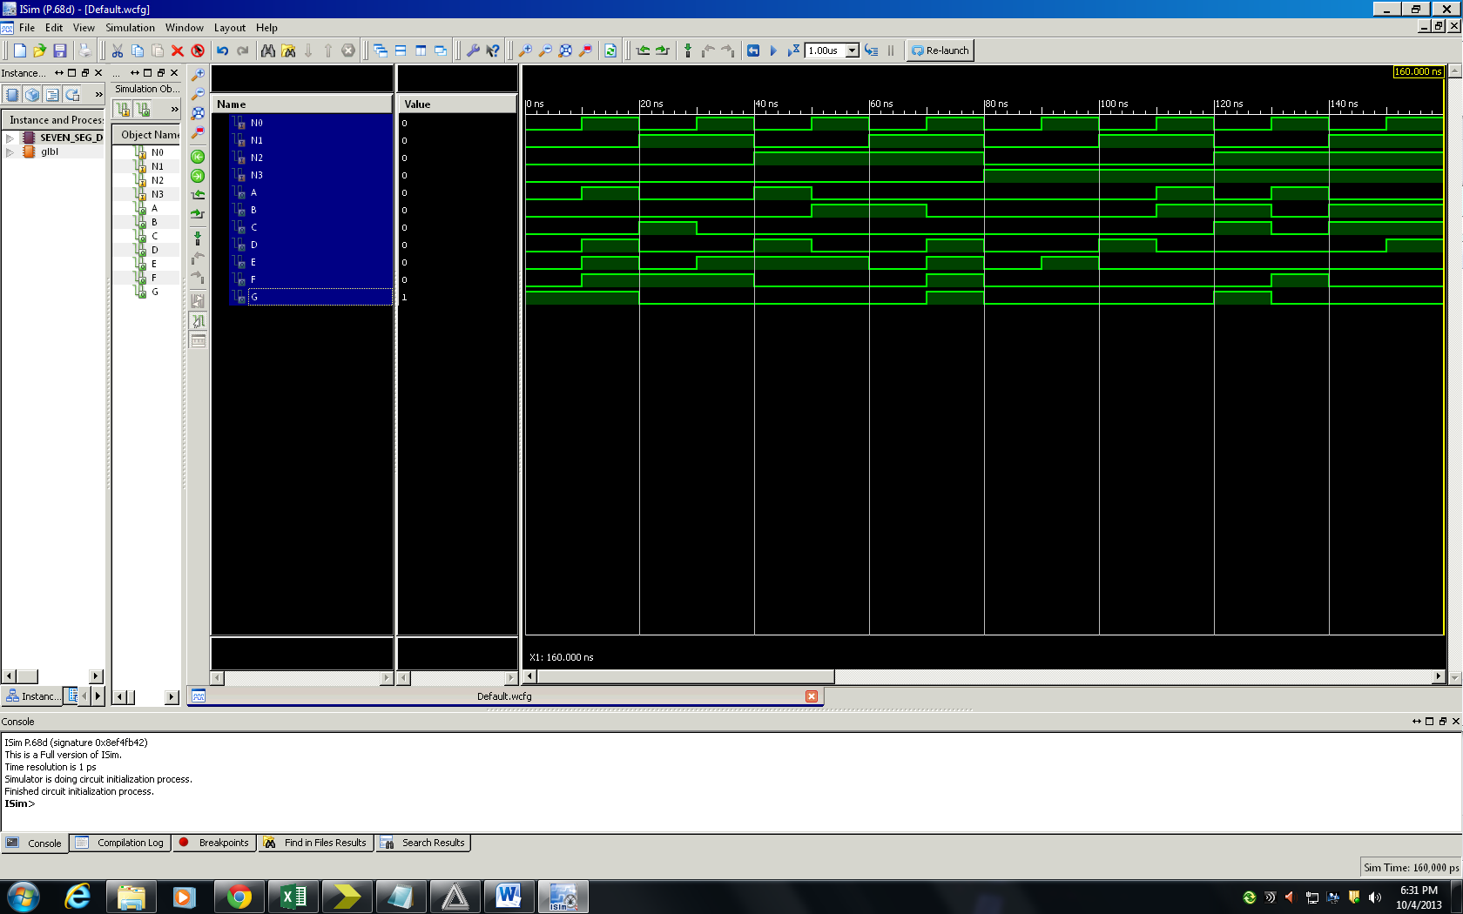

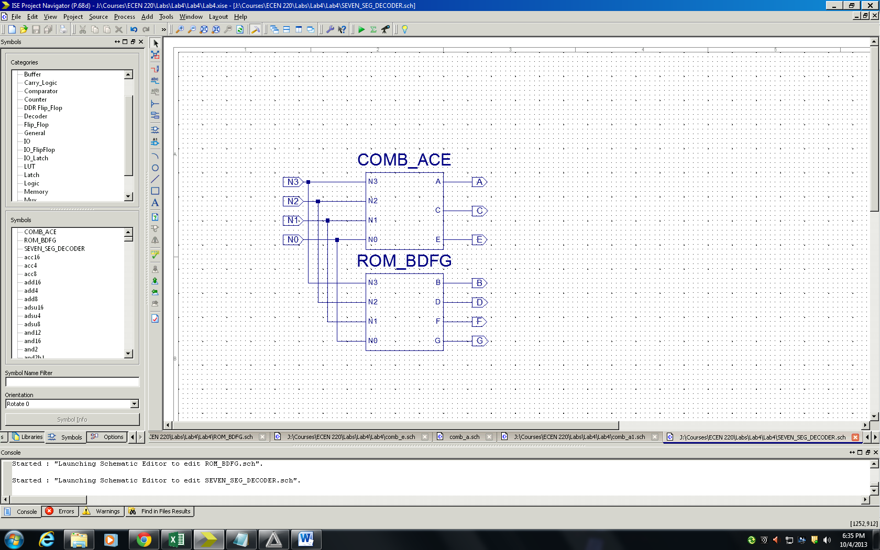

Test Bench

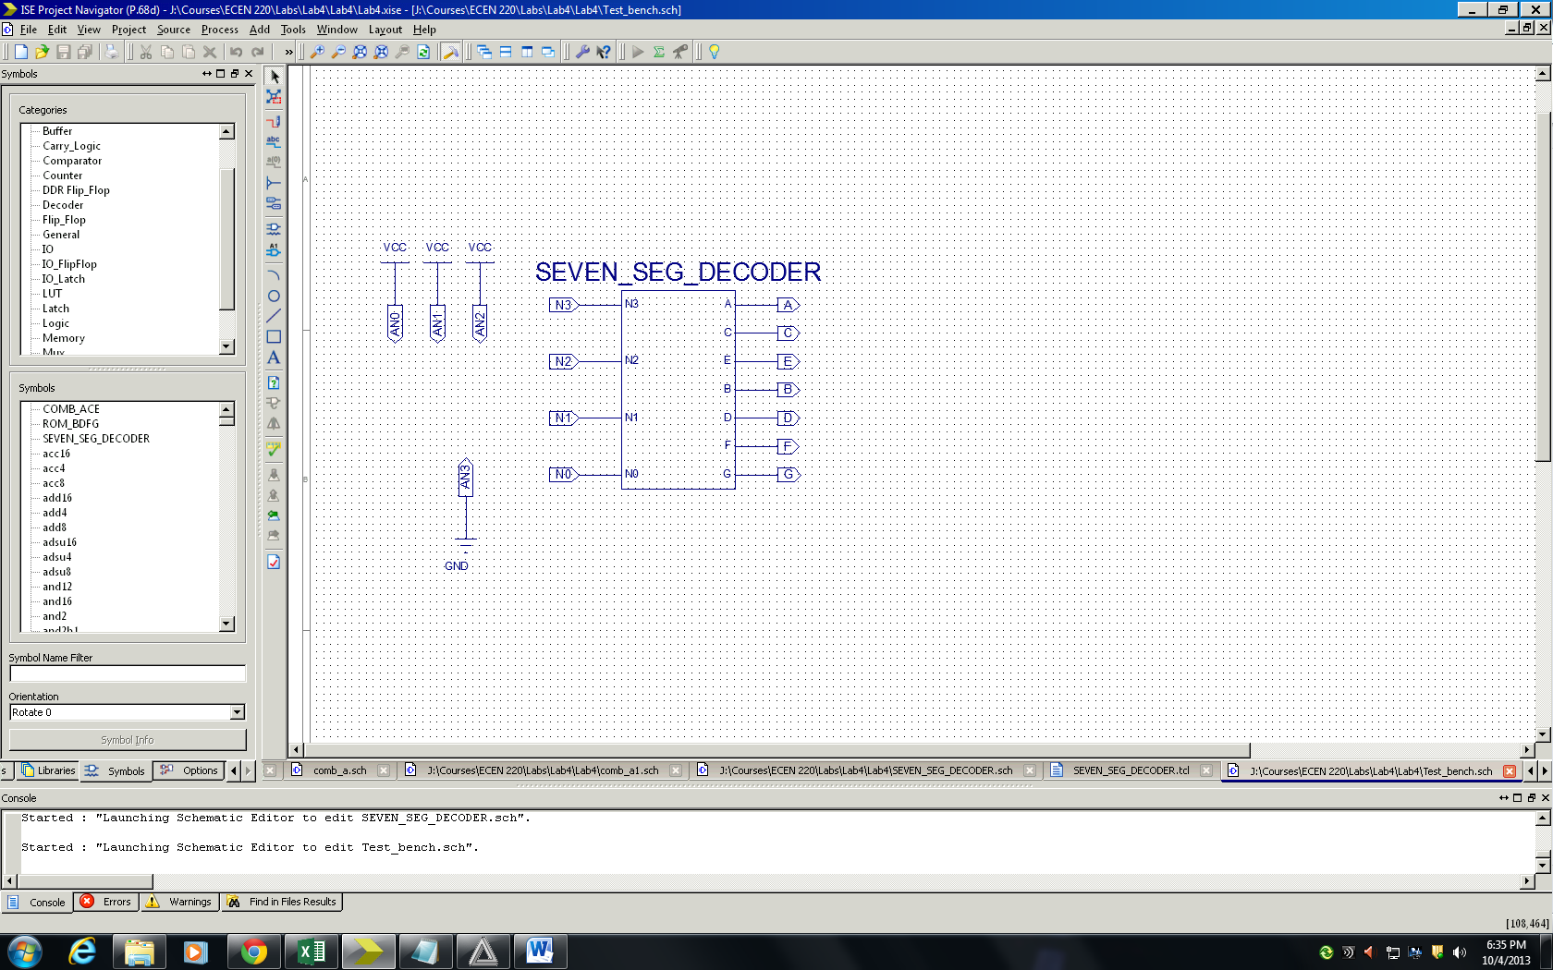

UCF

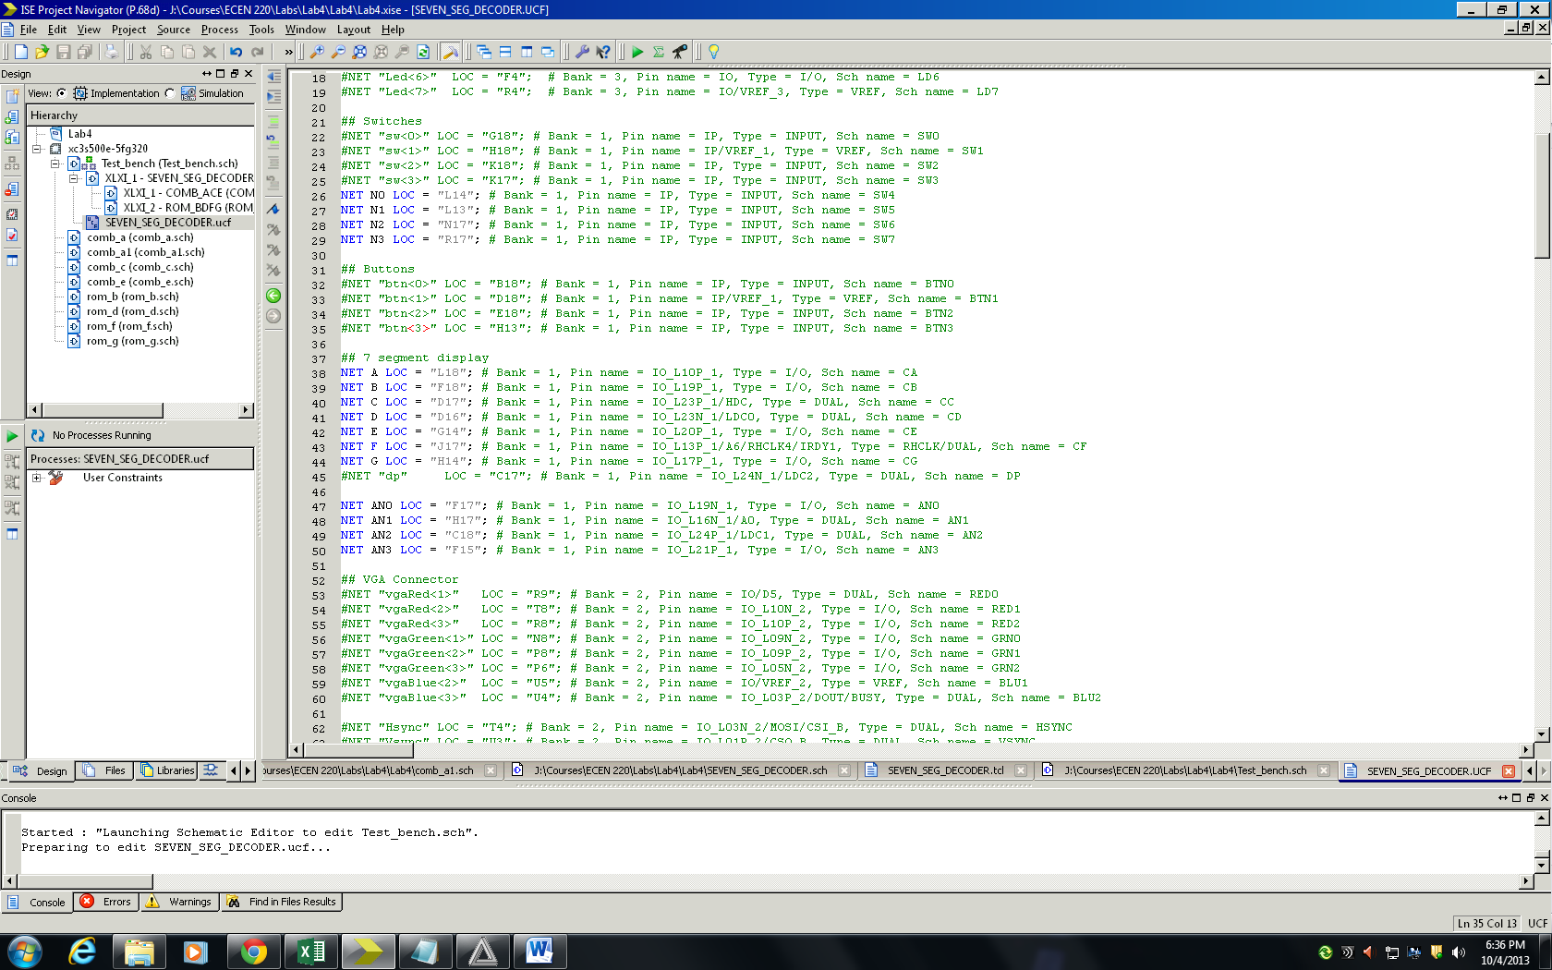

TCL file

