Ty Madsen

ECEN 220

9 October 2013

Lab #5 - Arithmetic Logic Unit

MUX 4:1:

VERILOG:

module MUX41(

input A,

input Sum,

input AandB,

input Anot,

input [1:0] control,

output Result

);

wire out;

assign Result= control == 2'b00 ? A :

control == 2'b01 ? Sum :

control == 2'b10 ? AandB :

Anot;

Endmodule

TCL:

wave add / -radix hex

isim force add A 0 -time 0 -value 1 -time 10ns -repeat 20ns

isim force add Sum 0 -time 0 -value 1 -time 20ns -repeat 40ns

isim force add AandB 0 -time 0 -value 1 -time 40ns -repeat 80ns

isim force add Anot 0 -time 0 -value 1 -time 80ns -repeat 160ns

isim force add control 00 -time 0 -value 01 -time 160ns -value 10 -time 320ns -value 11 -time 480ns

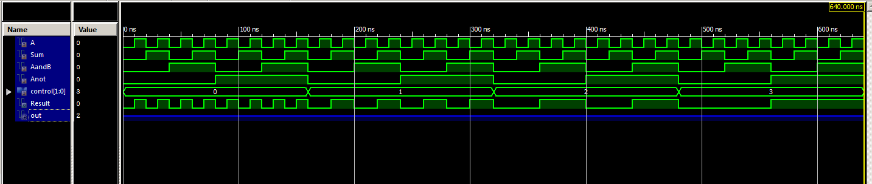

Full Adder:

VERILOG:

module FullAdder(

input A,

input B,

input Cin,

output Sum,

output Cout

);

wire An,Bn,Cn,ABnCn,AnBnC,ABC,AnBCn,CB,AB,AC;

not(An,A);

not(Bn,B);

not(Cn,Cin);

and(ABnCn,A,Bn,Cn);

and(AnBnC,An,Bn,Cin);

and(ABC,A,B,Cin);

and(AnBCn,An,B,Cn);

or(Sum,ABnCn,AnBnC,ABC,AnBCn);

and(AB,A,B);

and(AC,A,Cin);

and(CB,Cin,B);

or(Cout,AB,AC,CB);

endmodule

TCL:

wave add / -radix hex

isim force add A 0 -time 0 -value 1 -time 10ns -repeat 20ns

isim force add B 0 -time 0 -value 1 -time 20ns -repeat 40ns

isim force add Cin 0 -time 0 -value 1 -time 40ns -repeat 80ns

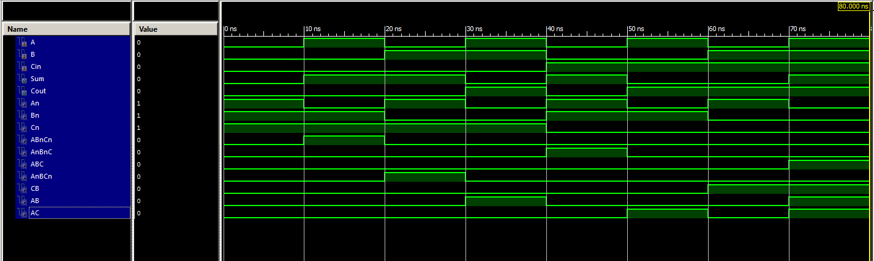

1 Bit ALU:

VERILOG:

module OneBitALU(

input A,

input B,

input Cin,

input [1:0] control,

output Result,

output Cout

);

wire FASum, FACout,AandB,Anot;

and(AandB,A,B);

not(Anot,A);

FullAdder FullAdd(A,B,Cin,FASum,FACout);

assign Cout = control == 2'b01 ? FACout : 0;

MUX41 Multiplexor(A,FASum,AandB,Anot,control,Result);

Endmodule

TCL:

wave add / -radix hex

isim force add A 0 -time 0 -value 1 -time 10ns -repeat 20ns

isim force add B 0 -time 0 -value 1 -time 20ns -repeat 40ns

isim force add Cin 0 -time 0 -value 1 -time 40ns -repeat 80ns

isim force add control 00 -time 0 -value 01 -time 80ns -value 10 -time 160ns -value 11 -time 240ns -repeat 320ns

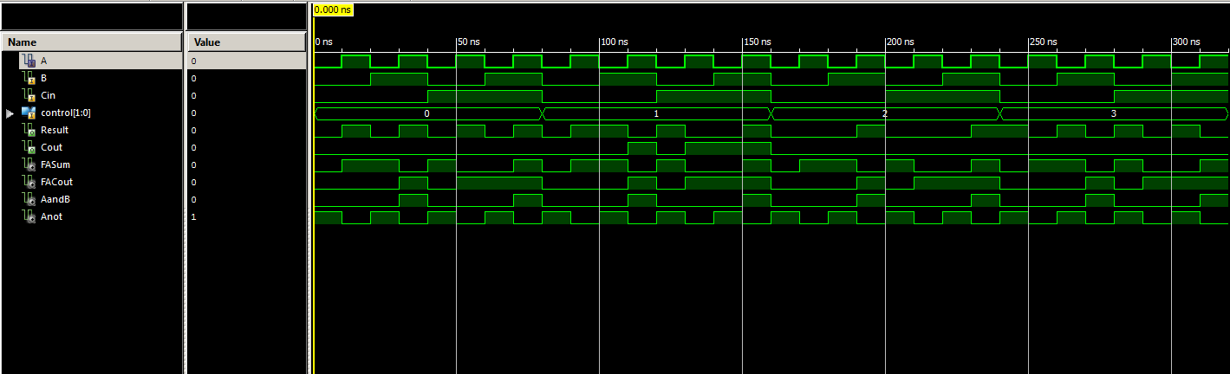

4 Bit ALU:

VERILOG:

module FourBitALU(

input [3:0] A,

input [3:0] B,

input Cin,

input [1:0] control,

output [3:0] Result,

output Cout

);

wire Cout1,Cout2,Cout3,R1,R2,R3,R4;

OneBitALU A0(A[0],B[0],1'b0,control,R1,Cout1);

OneBitALU A1(A[1],B[1],Cout1,control,R2,Cout2);

OneBitALU A2(A[2],B[2],Cout2,control,R3,Cout3);

OneBitALU A3(A[3],B[3],Cout3,control,R4,Cout);

assign Result[0] = R1;

assign Result[1] = R2;

assign Result[2] = R3;

assign Result[3] = R4;

endmodule

TCL:

wave add / -radix hex

isim force add Cin 0

isim force add control 00 -time 0 -value 01 -time 10ns -value 10 -time 20ns -value 11 -time 30ns -repeat 40ns

isim force add A 0000 -time 0 -value 1111 -time 40ns -repeat 80ns

isim force add B 0000 -time 0 -value 1111 -time 80ns -repeat 160ns

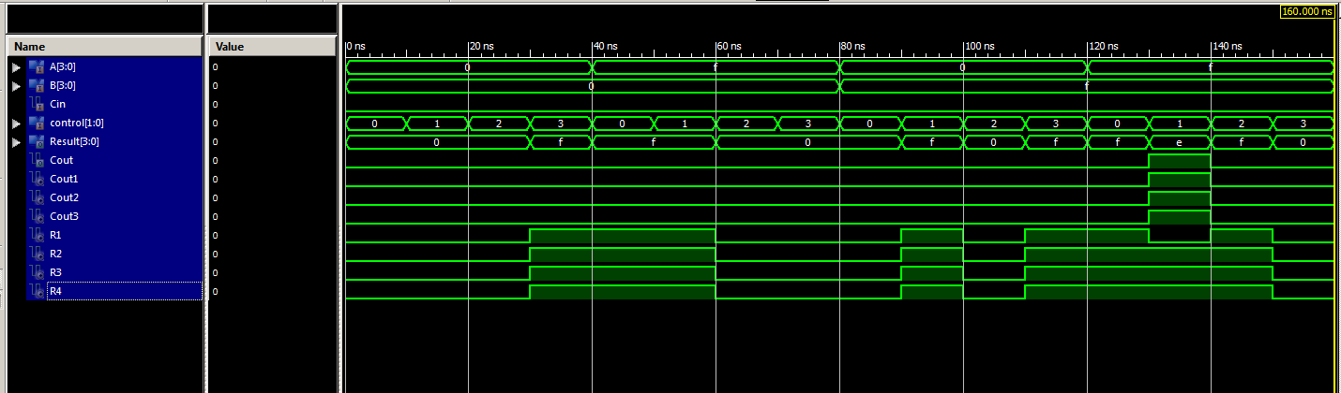

UCF:

## Leds

NET Result<0> LOC = "J14"; # Bank = 1, Pin name = IO_L14N_1/A3/RHCLK7, Type = RHCLK/DUAL, Sch name = JD10/LD0

NET Result<1> LOC = "J15"; # Bank = 1, Pin name = IO_L14P_1/A4/RHCLK6, Type = RHCLK/DUAL, Sch name = JD9/LD1

NET Result<2> LOC = "K15"; # Bank = 1, Pin name = IO_L12P_1/A8/RHCLK2, Type = RHCLK/DUAL, Sch name = JD8/LD2

NET Result<3> LOC = "K14"; # Bank = 1, Pin name = IO_L12N_1/A7/RHCLK3/TRDY1, Type = RHCLK/DUAL, Sch name = JD7/LD3

#NET "Led<4>" LOC = "E17"; # Bank = 1, Pin name = IO, Type = I/O, Sch name = LD4

#NET "Led<5>" LOC = "P15"; # Bank = 1, Pin name = IO, Type = I/O, Sch name = LD5

#NET "Led<6>" LOC = "F4"; # Bank = 3, Pin name = IO, Type = I/O, Sch name = LD6

NET Cout LOC = "R4"; # Bank = 3, Pin name = IO/VREF_3, Type = VREF, Sch name = LD7

## Switches

NET B<0> LOC = "G18"; # Bank = 1, Pin name = IP, Type = INPUT, Sch name = SW0

NET B<1> LOC = "H18"; # Bank = 1, Pin name = IP/VREF_1, Type = VREF, Sch name = SW1

NET B<2> LOC = "K18"; # Bank = 1, Pin name = IP, Type = INPUT, Sch name = SW2

NET B<3> LOC = "K17"; # Bank = 1, Pin name = IP, Type = INPUT, Sch name = SW3

NET A<0> LOC = "L14"; # Bank = 1, Pin name = IP, Type = INPUT, Sch name = SW4

NET A<1> LOC = "L13"; # Bank = 1, Pin name = IP, Type = INPUT, Sch name = SW5

NET A<2> LOC = "N17"; # Bank = 1, Pin name = IP, Type = INPUT, Sch name = SW6

NET A<3> LOC = "R17"; # Bank = 1, Pin name = IP, Type = INPUT, Sch name = SW7

## Buttons

#NET "btn<0>" LOC = "B18"; # Bank = 1, Pin name = IP, Type = INPUT, Sch name = BTN0

#NET "btn<1>" LOC = "D18"; # Bank = 1, Pin name = IP/VREF_1, Type = VREF, Sch name = BTN1

NET control<0> LOC = "E18"; # Bank = 1, Pin name = IP, Type = INPUT, Sch name = BTN2

NET control<1> LOC = "H13"; # Bank = 1, Pin name = IP, Type = INPUT, Sch name = BTN3

ANOMALIES:

None found