Ty Madsen

Ecen 220

October 17, 2013

Lab 6 – Oscilloscope/ Logic Analyzer

Toggle Circuit Verilog:

module Toggle(

output Qout,

output Clk_out,

input GCLK,

input CLR

);

wire Q_not;

not(Q_not,Qout);

buf(Clk_out, GCLK);

FlipFlop FF(Qout,GCLK,CLR,Q_not);

endmodule

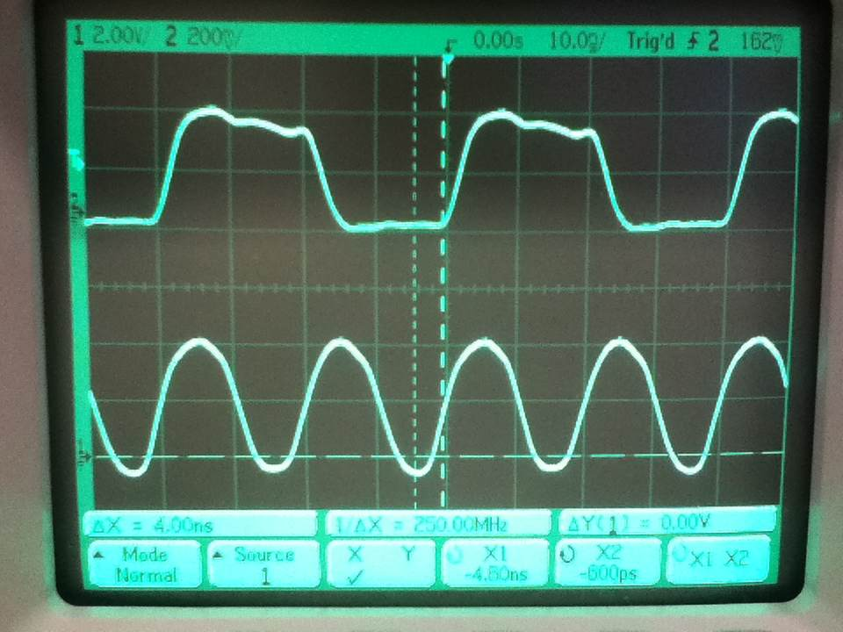Toggle screen:

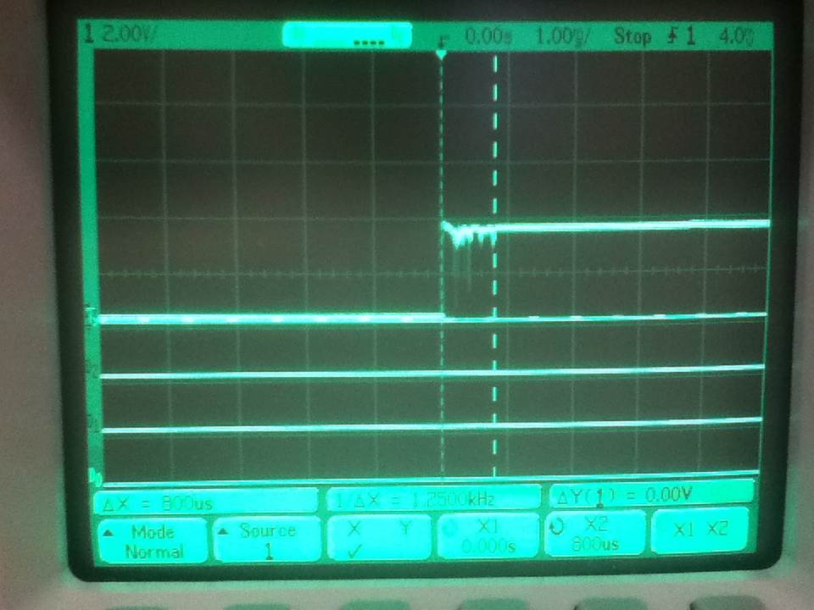Bounce Screen:

4Bit screen:

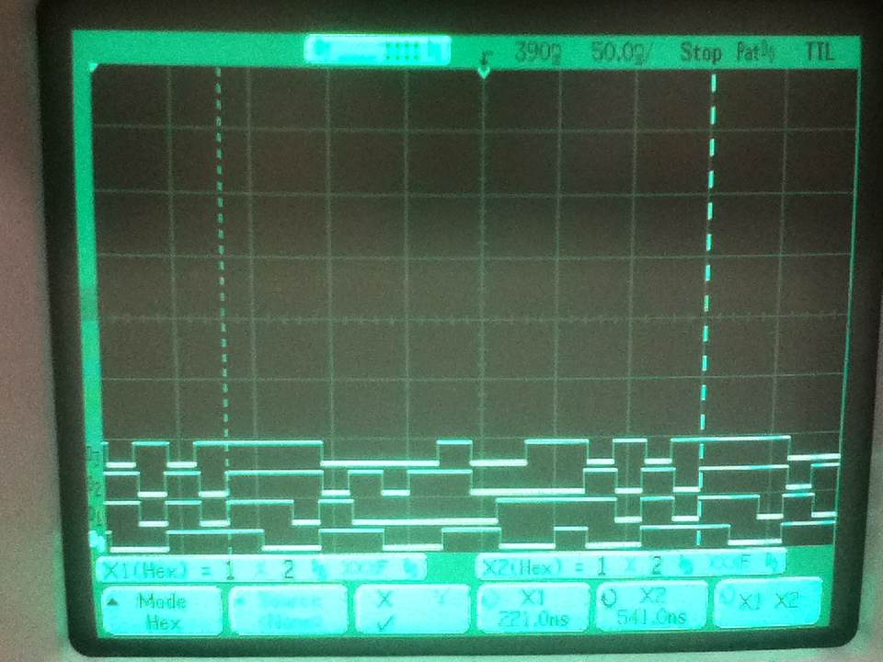

16Bit start:

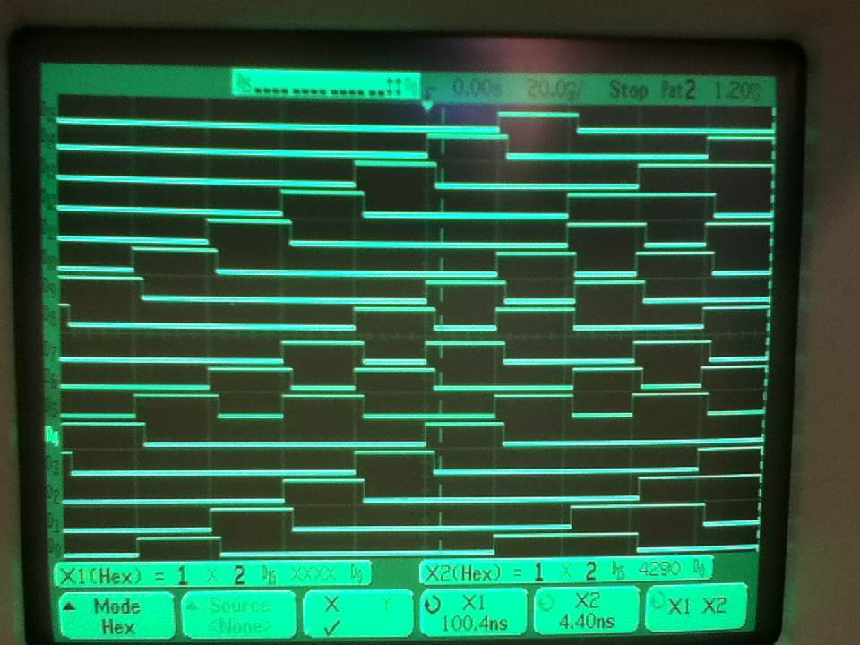

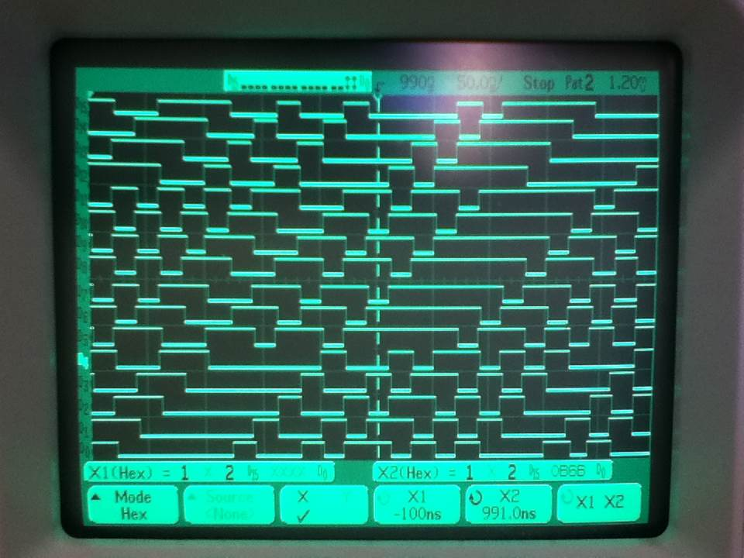16Bit 990 nS:

16Bit 16.38 micro seconds:

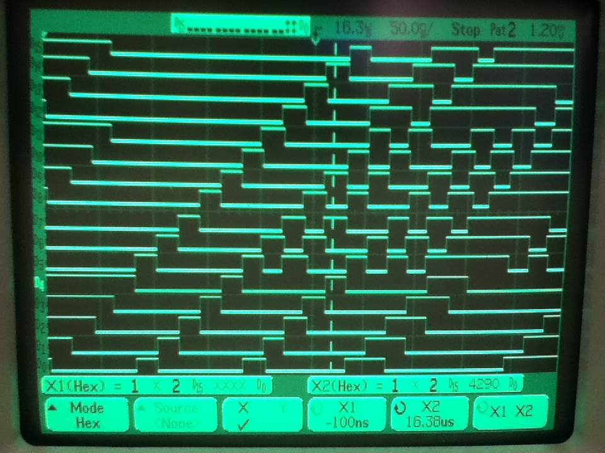



5821

1A43

34A6

694C