Ty Madsen

ECEN 360

Lab #1

1/14/2015

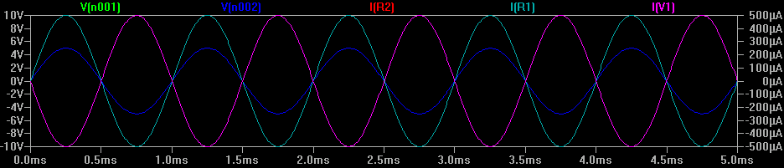

The traces V[n001], I[R1] and I[R2] overlap (although I[R1] and I [R2] are Current measurements and V[n001] is a voltage measurement. It makes sense that the current going through R1 and R2 is the same because they are in series, and the current through that wire is the same. The voltage fluctuates at the positive side of the voltage source from +10 V to -10 V since it is sinusoidal. Half of the voltage drops across R1 and then the other half across R2, causing V[n002] to be half of V[n001]. I[V1] is equal and opposite to I[R1] and I[R2] because at the voltage source the current has to cancel by KCL.

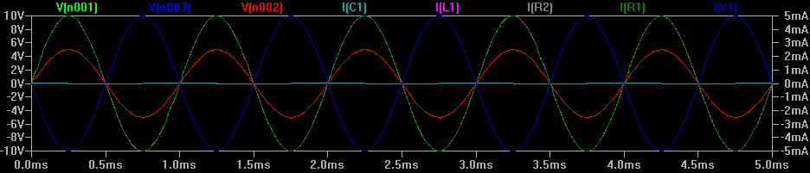

V[n001] Fluctuates from +10V to -10V since it is the sinusoidal voltage source.

V[n002] Fluctuates from +5V to -5V since the frequency of the signal is low enough that the capacitor has a large impedance, not allowing current to flow through it. V[n002] and V[n003] are the same since there is no voltage drop across the inductor.

I[C1] is very small because of the low frequency of the signal. Thus I[L1], I[R1], and I[R2] are all about the same since all the current flows through them and not through the capacitor.

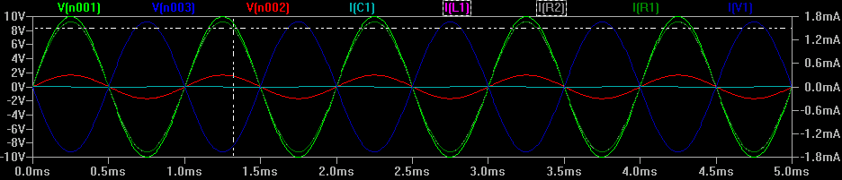

I change R2 to 5k Ohms and L1 to 10uH.

I[R1], I[R2] and I[L1] dropped a little because the total current is less since the overall impedance is higher. The Voltage drop across R2 is higher because it has a higher resistance. Not much else changed.