Ty Madsen

ECEN 360 Sec 2

01/21/15

**Lab 2 LTSpice T-Line**

**Initial calculations**

Characteristic impedance = 50.26 Ohms

|  |  |  |  |  |  |  |
| --- | --- | --- | --- | --- | --- | --- |
| Frequency | 500 KHz | 1 MHz | 2 MHz | 5 MHz | 10 MHz | 20 MHz |
| Phase constant | .015 | .03 | .06 | .15 | .3 | .6 |

Phase velocity = 2.094 x 10^8

Overall capacitance = 0.95 nF

1. **Comments**

The simulated difference is 1m between each segment. The inductor values are chosen to represent the specs given in the RG-58 Coaxial cable. The source and load resistors are both 50 Ohms to represent a standard load and source impedance.

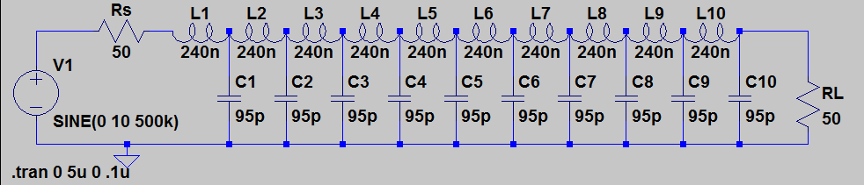

2. **Observations**

**500kHz**: The delay of the voltage wave form from the source to the load is very small, so the voltage is seen almost immediately.

**5MHz**: The delay between source and load is about ¼ of a cycle.

**10 MHz**: The delay between source and load is about ½ of a cycle.

**20 MHz**: The delay between source and load is about a full cycle.

3. **Phase velocity**:

**500 KHz**: Hard to determine, about 4.4405 ns delay 2.27 x 10^8 m/s

The frequency is so low that the time delay between each segment is a much smaller part of each period, thus making the measurement of the delay more difficult.

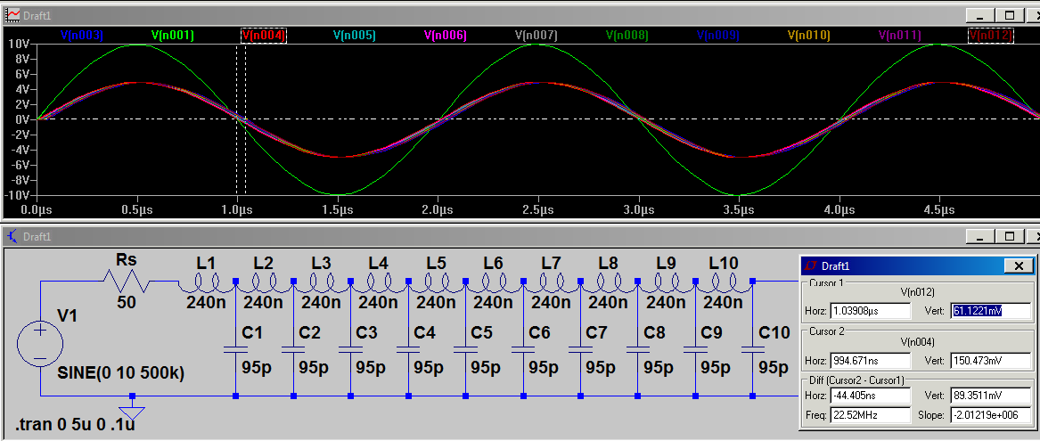

**5 MHz**: 4.93772 ns delay = 2.025 x 10^8 m/s

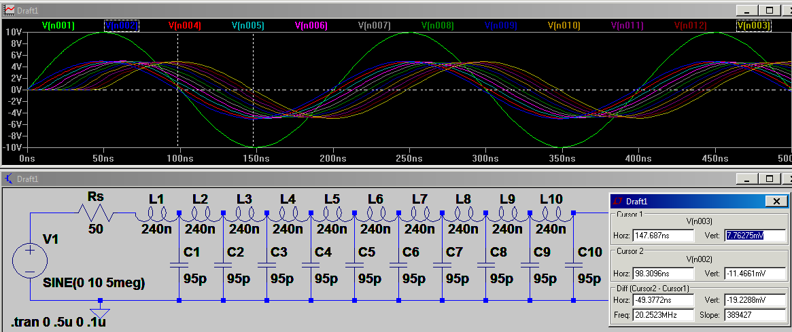

**10 MHz**: 4.91103 ns delay = 2.036 x 10^8 m/s

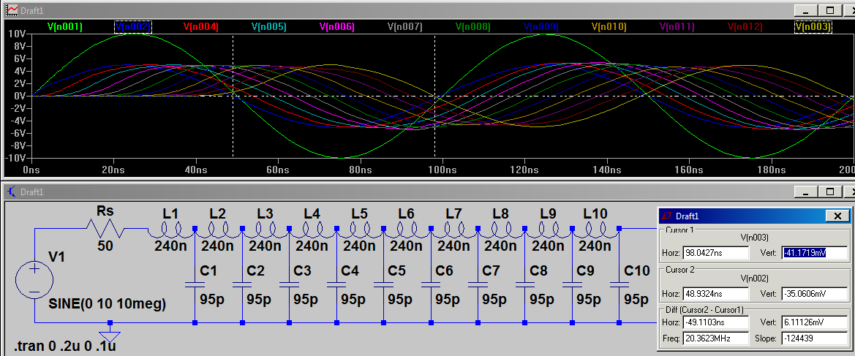

**20 MHz**: 4.98221 ns delay = 2.007 x 10^8 m/s

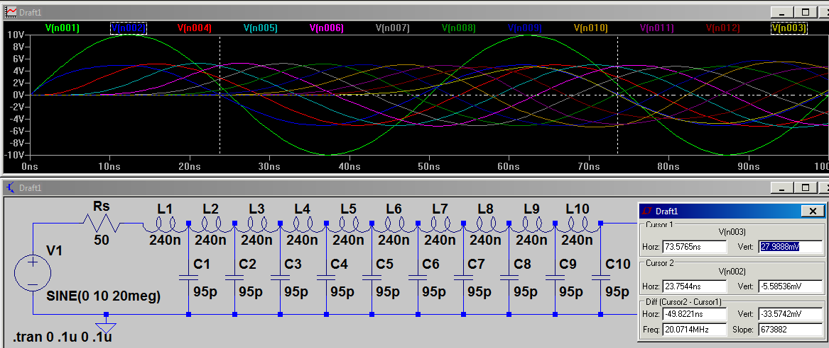

**Conclusion**

I have learned how the frequency of an input signal changes the time delay across a transmission line as well as how it affects the delay of the signal from the source to the load. I also learned how we can use lumped elements in LTSpice to simulate a transmission line with given specifications. The elements that made up the circuit were chosen with values to mimic the respective distributed capacitances and inductances of a t-line.

**Exploration and Creativity**

I changed the load resistor to 100 Ohms (or 2x the source resistance). Because this changes the reflected or reverse propagating wave to be set such that the amplitude of the reverse propagating wave is added to the forward propagating wave makes the voltage on the t-line about 6.57V (13.11 Vpp), which is close to 6.66 = (5+5/3). This is to be expected because the reflection coefficient is now approximately 1/3 = (100-50.26)/(100+50.26) instead of -.0026 = (50-50.26)/(50+50.26).