**Ty Madsen**

**ECEN 360**

**Simulation of Digital Matching Schemes**

**Lab 8 (Winter 2015)**

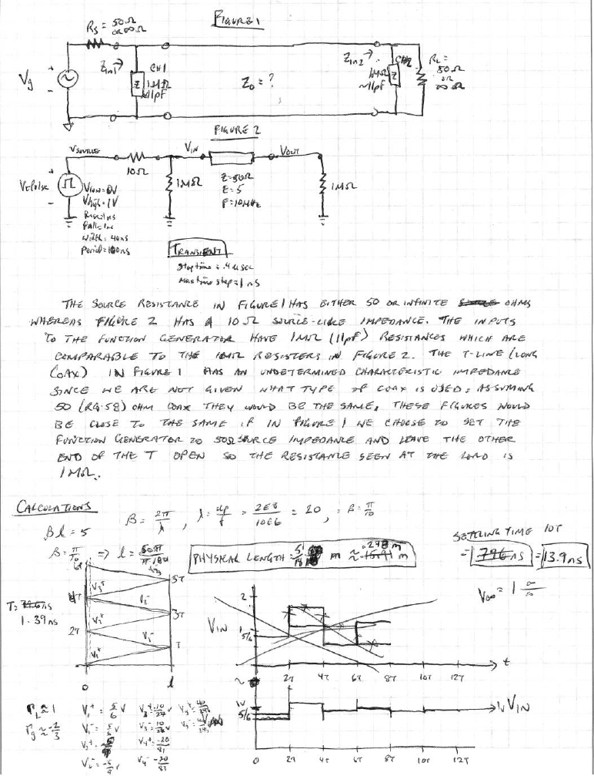

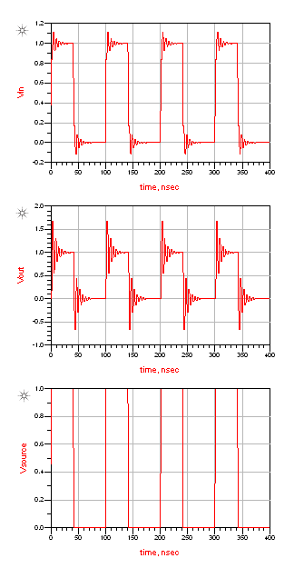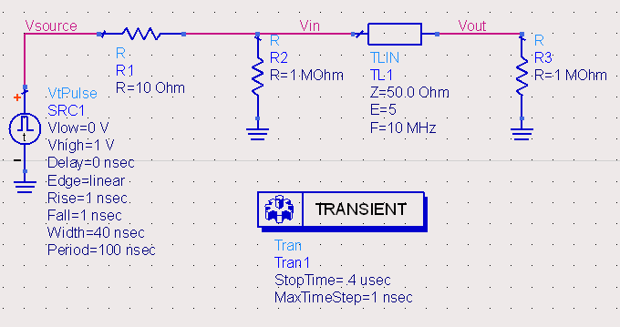**ADS Simulations:**

Figure 4

Figure 3

These results show the bouncing like the bounce diagram with each voltage change from the generator. After seeing the other simulations, it is clear that if we want to see the stepping voltage (or bouncing) as seen in this figure, we must have matched lines, otherwise we get wonky results. The Vout has taller bounces because the load reflection coefficient is 1, causing the voltage value to double, so the amplitude of these bounces are twice that of the Vin signal. The source is just going from 0V to 1V as we set it to do.

Pulse Frequency:

1/Period = 1/100 ns = 10 MHz

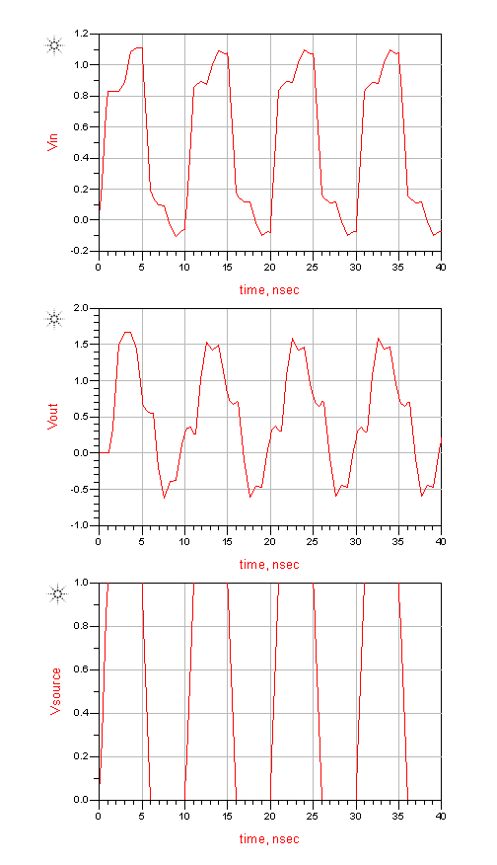Pulse frequency = 100 MHz

Figure 5

Pulse width = 4 ns

Stop time = .04 us

The high (100 MHz) frequency causes the electrical length to increase proportionally with respect to what it was before changing the frequency. This makes the stepping happen later and slower. Since the pulse with is only 4 ns and the period of the circuit is 13.9 ns, so it will not have time to settle before the generator goes to 0.

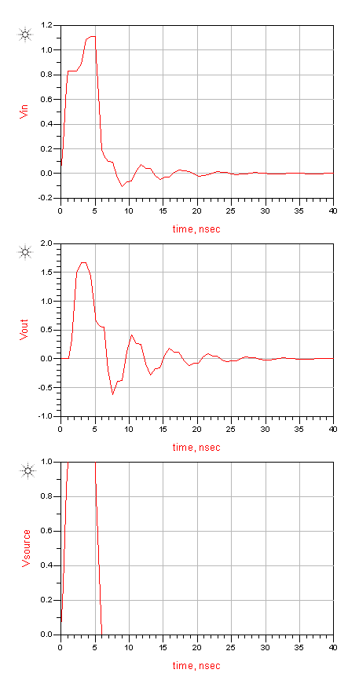Pulse period = 40 ns

Figure 6

Pulse width = 4 ns

Stop time = .04 us

The signal settles at about 15 to 20 ns, after dropping to 0 at 4 ns. So the settling time is between 11 and 16 ns. Taking the mean of values the settling time shown is around 13.5ns.

Settling time ≈ 13.5ns

*Simulations for increased line length:*

As electrical length is increased the steps in the transient response took longer since the wavelength decreases, causing it to not have time to settle. Compare Figure 4 to Figure 55 degrees and Figure 8. At 75 degrees (Figure 9) the reflected voltage from the load does not reach the generator until after the input voltage drops to 0V. At this point instead of the first change being negative after dropping to 0V it is positive in response to the reflected 1V on the load.

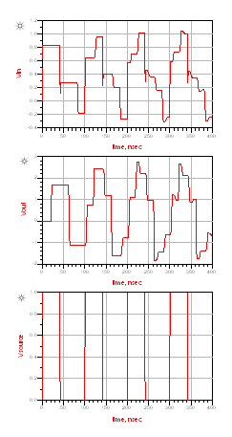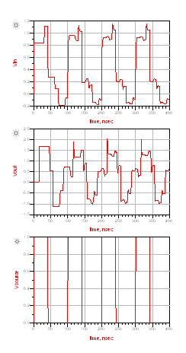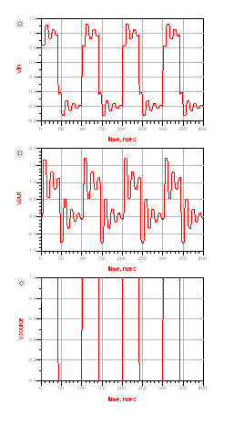

Figure 9 (75 degrees)

Figure 8 (55 degrees)

Figure 7 (15 degrees)

*Matched driver:*

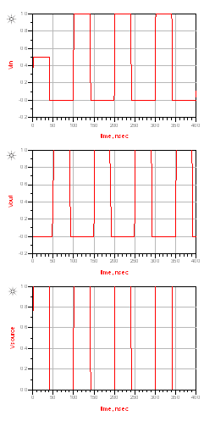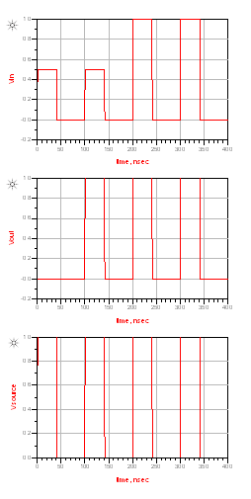These all have matched source impedances so they all look similar for 90, 180 and 360 since those are π/2, π, and 2π respectively, the addition reflected by the load are just delayed by 1/2, 1, and 2 period respectively. For the E=135 plot, it is different because it is a multiple of π/4 (line of quarter wavelength), so the amplitude adds at ¾ of a period after the source pulse.

Figure 12 (E=180)

Figure 13 (E=360)

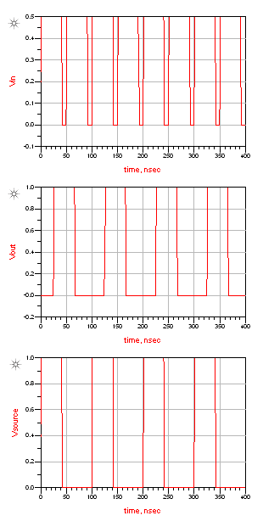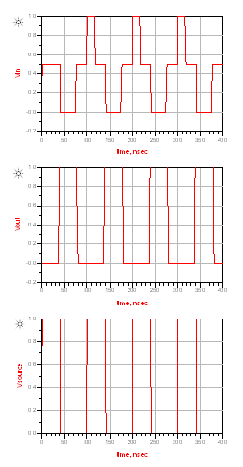

Figure 10 (E=90)

**Figure 11 (E=135)**

*Matched load:*

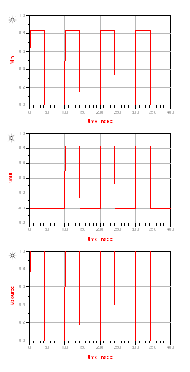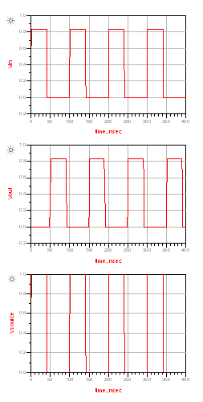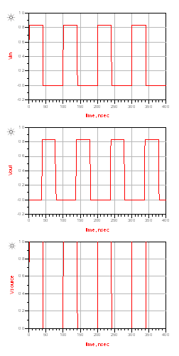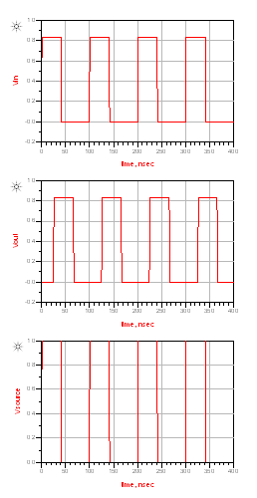All of the waveforms look similar because the load reflection coefficient is 0, so nothing is reflected. The only things that is seen is the propagation delay from the source to the generator.

Figure 14 (E=90)

Figure 15 (E=135)

Figure 17 (E=360)

Figure 16 (E=180)