10.

1. 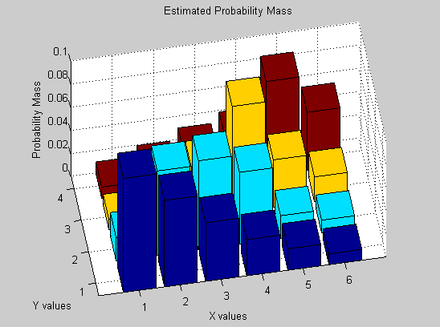Estimated joint PMF of burger/fry data

|  |  |  |  |  |
| --- | --- | --- | --- | --- |
|  | 1 | 2 | 3 | 4 |
| 1 | 0.0984 | 0.0201 | 0.0087 | 0.0095 |
| 2 | 0.0746 | 0.0729 | 0.0185 | 0.0189 |
| 3 | 0.0506 | 0.0769 | 0.0449 | 0.0293 |
| 4 | 0.0312 | 0.0621 | 0.0919 | 0.0383 |
| 5 | 0.0185 | 0.0199 | 0.041 | 0.0815 |
| 6 | 0.0094 | 0.0113 | 0.0215 | 0.0501 |

1. Probability that a normal customer will buy three burgers and two servings of fries: **0.0769 = 7.69%**

|  |  |  |  |  |  |
| --- | --- | --- | --- | --- | --- |
| 1 | 2 | 3 | 4 | 5 | 6 |
| 0.1367 | 0.1849 | 0.2017 | 0.2235 | 0.1609 | 0.0923 |

c) Marginal PMF for the number of burgers a normal customer will buy:

|  |  |  |  |
| --- | --- | --- | --- |
| 1 | 2 | 3 | 4 |
| 0.2827 | 0.2632 | 0.2265 | 0.2276 |

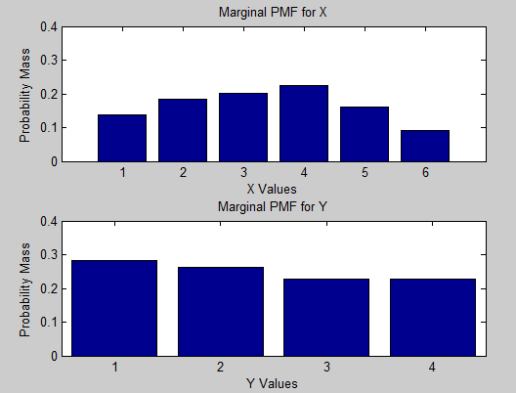d) Marginal PMF for the number of servings of fries a customer will buy:

e) Expected number of burgers that a normal customer will buy: **3.3639 Burgers**

f) Expected number of servings of fries that a normal customer will buy: **2.3990 Fries**

g) If burgers cost $2.00 and fries cost $1.00, what is the expected amount of money that you will obtain from each normal customer:

2*E[X] + 1*E[Y] = 2*3.3639+2.3990 = **$9.13**

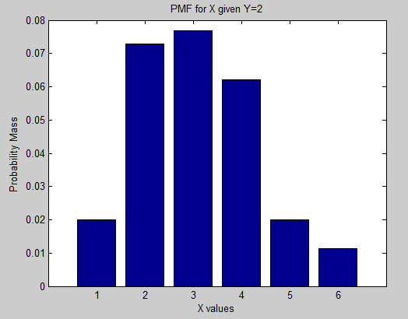h) PMF of the number of burgers given 2 fries purchased:

|  |  |
| --- | --- |
| Burgers | 2 Fries |
| 1 | 0.0201 |
| 2 | 0.0729 |
| 3 | 0.0769 |
| 4 | 0.0621 |
| 5 | 0.0199 |
| 6 | 0.0113 |