Problem 4) PDF:

clear;

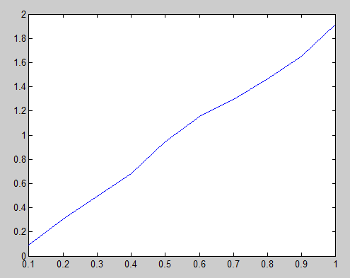N=10000;

hits = 0;

r = 1;

X = zeros(N,1);

pdf = zeros(10,1);

x_range = linspace(.1,1,10);

while hits < N

x = rand()*2 - 1;

y = rand()*2 - 1;

dist = sqrt(x^2 + y^2);

if(dist > r) %ignore

else %add

hits = hits+1;

|  |  |
| --- | --- |
| PDF | ~2x |
| Mean | .6682 |
| Var | .0555 |

X(hits,1) = dist;

idx = ceil(dist*10);

pdf(idx) = pdf(idx)+1;

end;

end;

PDF = pdf./1000;% = 2x/r^2 = (2x)

plot(x_range,PDF);

mean = sum(X)/N;% = 2r/3 = (2/3)

moment_2 = sum(X.^2/N);%E[X^2] = r^2/2 = (1/2)

var = moment_2 - mean^2;% = r^2/18 = (1/18)

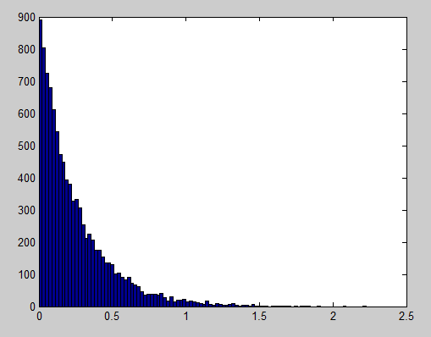Problem 6)

clear;

N = 10000;

lambda = 4;%arbitrary

X = zeros(1,N);

for k=1:N

u = rand();

X(k) = -log(1-u)/lambda;

end;

hist(X, 100);