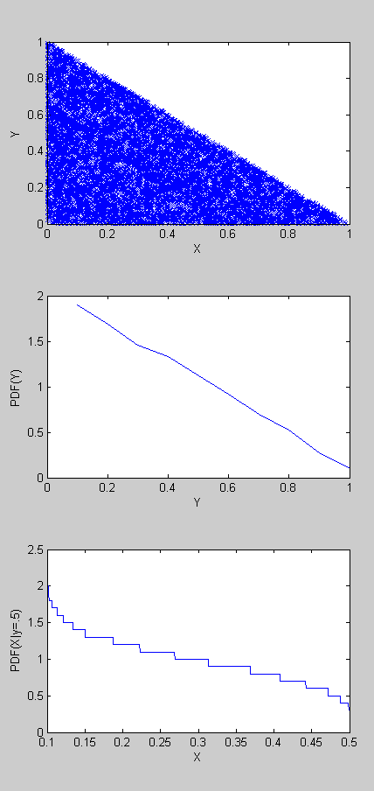Problem 8)

E[X] = .3331

Problem 9)

E[X] = .328

E[Y] = .664

