Ty Madsen
ECEN 324
25 March 2014
HW 10

Problem 324-8:

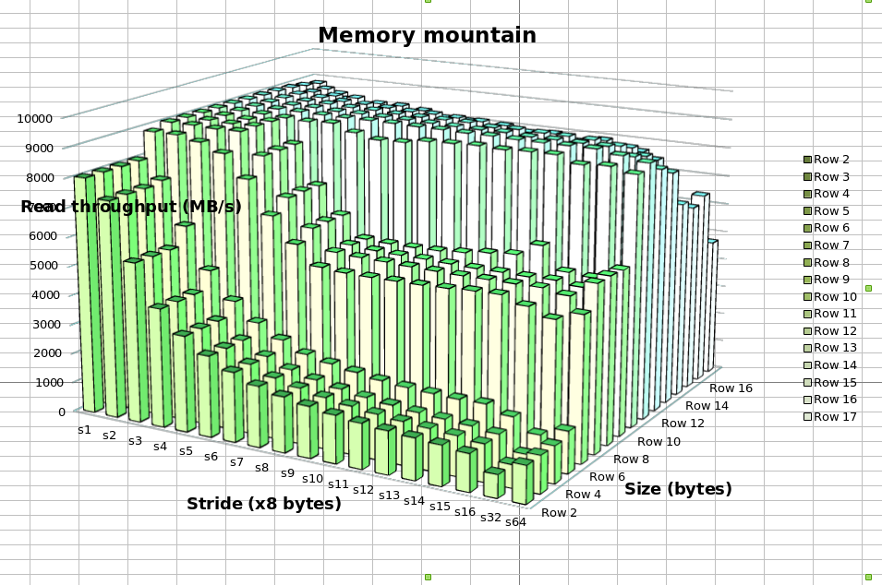
The results show that with higher optimization the throughput increases on average. The higher optimization levels showed less of a difference in throughput. With no op flags, the system runs at about the speed of the RAM, which is pretty sad compared to what it could run at with the L1 and L2 caches. With -O1 through -O4 Op flags the chart is similar to the original. The main difference I noticed is with a high data size, the throughput drops significantly especially with higher step. The map is similar to the one shown in the book, but the steps in the mountain are more defined, and rigid. The throughput values are in the book are 2000 less than my values on average. The cpu us running properly as reflected by the memory mountain.

Problem 7.8:

A) ERROR
B) UNKNOWN
C) ERROR

Problem 7.12:

Line # in Fig. 7.10 | Address | Value
5 | 0 | 80483c8
15 | 3 | 804945c
16 | 9 | 8049458
18 | 10 | 8049458
23 | 1f | 8049548

Problem 324-9:

The y variable is being overwritten by P2() because x is a double, and declared before y in intdblconf1 (making it strong):
x: 7, y: 3
&x: 0x600980, &y: 0x600984
x: 226774273, y: 1087727205

Both x variables are strong so it throws an error:

intdblconf2.o:(.data+0x0): multiple definition of `x'
intdblconf1.o:(.bss+0x0): first defined here
/usr/bin/ld: Warning: size of symbol `x' changed from 4 in intdblconf1.o to 8 in intdblconf2.o
collect2: ld returned 1 exit status
make: *** [intdblconf] Error 1

The int x is weak, while the double x is strong, so P2() is not overwriting y:

x: 7, y: 3
&x: 0x600970, &y: 0x600988
x: 226774273, y: 3

Both x values are weak. So the linker is choosing the double x since y is not being overwritten by P2():

x: 7, y: 3
&x: 0x600988, &y: 0x600980
x: 226774273, y: 3

