Ty Madsen
ECEN 324
HW #11
04-08-2014

8.18:
A, C, E
324-10:
The measurements are quite consistent, and only vary by 1 ms on average. They all run the parent process and then the child. The relative overhead of the fork function is pretty low, it takes much less than accessing the main memory.
324-11:
#include <stdio.h>
#include <stdlib.h>
#include <signal.h>
#include "csapp.h"
void handler1(int sig){
printf("Not so simple -- I can't be stopped with a ctr-c!\n");
}
void handler2(int sig){
printf("Nope -- I refuse to be put in the background!\n");
}
int main(){
signal(SIGINT, handler1);
signal(SIGTSTP, handler2);
pid_t pid = getpgrp();
printf("PID: %d\n", (int)pid);
printf("Just try to stop me!\n");
while (1)
sleep(1);
}
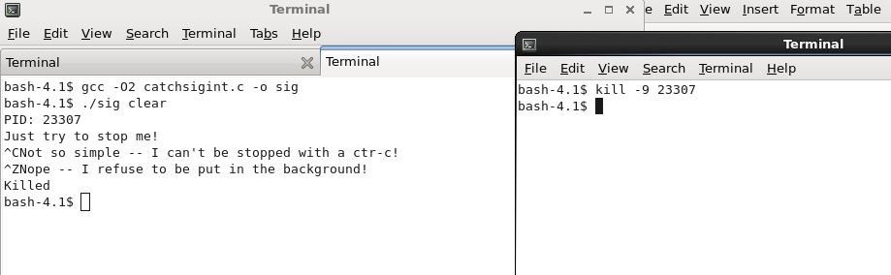
I learned the right SIG code for the ctl-z input (20 – SIGTSTP) and how the kill process works. I printed the PID at the beginning of the process, and then used a separate terminal window to terminate the process when ctl-c and ctl-z didn't work.

