**Iteration 1**

**CIS – 320**

**Team: Savants**

**Alex Rodriguez, Ty Mcphail, Adam Axelrod, Arturo Garcia, Brody Hayden**

**System Request**

**Summary**

Guide Book currently has a publicly available website that promotes fishing guide services, and more importantly facilitates the booking process on their behalf. Guide Book is extending this platform to offer a more lavish experience to clients willing to pay a premium for exceptional convenience, extraordinary experiences, and the most prestigious guides. Guide Book Pro should allow permitted clients to access the webpage and use built-in functions to naturally find the best adventure money has to offer. At the end of their experience there should be a way to directly accept payment for selected bookings or inquire about the trip. The experience will be personal and the opportunity to choose listed adventures will be exclusive.

**Project Sponso**r:

Dr. Zara Hatami

Office: 378 College of Business

Telephone: 502-852-4679

Email: zahra.hatami@louisville.edu

**Business need:**

Guide Book needs a system to offer their most sought-after fishing experiences in a more exclusive manner, offering their best guides and experiences behind a subscription. The current platform that exists does not cater to the niche audience that prefers paying a premium to expedite highly coveted adventures. Guide Book Pro will package the most alluring offerings available while also facilitating an efficient booking process for those who value time above all else.

**Business requirements:**

* Selected clients should be able to receive invitations from Guide Book Pro for onboarding and registration.
* The system should have built-in widgets or pop ups prompting clients to fill out surveys to gauge interest.
* Clients should be able to naturally find their dream fishing experience using built in search functions and/or fluid page design.
* Guide Book Pro must be able to filter traffic to only allow permitted visitors to view exclusive trip details.
* Payments or inquiry form submission should be accepted at the end of the experience on the site.
* First time visitors should have personalized “Welcome” greetings post sign in.
* Personalized “Thank You” message should be delivered after check-out.
* The system should capture enough information so that other CRM tools can contact clients via email or messaging for updates and reminders as the details of the trips are finalized.

**Business Value:**

* Guide Book Pro will allow avid fishers, with an expensive taste, a way to gain direct access to premium dates, guides/captains, and locations in a timelier manner than before.
* The target audience will be willing to spend more money leading to higher payout per trip booked. This also creates opportunities in the future to offer bundled experiences which could include lodging or other amenities.
* The handpicked client invitation process allows Guide Book to control the annual booking levels and leverage an already existing social network. This initially limits the risk of cancellation and unbooked trips.
* The subscription-based model will provide a direct way to establish cash flows and mitigate sunk costs, which is more cost effective than before.

**Special Issues or Constraints**:

* International trips would invoke additional travel considerations due to the potential restrictions related to COVID 19 or other general travel advisories published by the Department of State.
* Payment acceptance should be carefully constructed to keep the site out of scope from PCI regulation, or else there will be extensive development requirements to ensure cardholder data is protected in accordance with the law.
* Building the new site into the current Guide Book stack may disrupt the personal and exclusive experience that Guide Book Pro is attempting to construct. This could potentially undermine the justification of additional subscription fees on top of bookings, and cannibalize Guide Book Pro.
* Building Guide Book Pro separate from the current stack invokes additional infrastructure and overhead costs and generates more risk.
* Current staffing will either absorb additional workload to now accommodate new cliental, or additional training and staffing may be necessary.
* Guide onboarding and marketing is not a focal point for Guide Book’s business strategy, so these processes will be omitted.

**Narrative**

**Problem :**

Guide Book is an organization that publicly markets fishing guide services, ranging from fly fishing in a small stream to full-blown saltwater charters. The business has ventured into a niche market because high earning individuals are demanding more flexible availability from guides, even if it means spending more for the same experience. Guide Book co-founders have leveraged interpersonal connections and industry experience to build clientele and recruit the most prestigious guides. Now the business and its stakeholders need an extension of their platform, that offers an exclusive membership giving selected individuals a tailored, premium experience with access to the best trips that Guide Book’s network has to offer.

**Technical Feasibility:**

Using the current platform as the landing page reduces the technical risk compared to implementing a new standalone system. A previously existing team of developers has already launched the original rendition of the Guide Book service and is nearing completion of the platform’s newest overhaul. An addition to the current stack will be more fluid as it builds upon an already familiar system utilizing the same domain hosting, web hosting, content management, and selection of APIs. Additions that are required for Guide Book Pro include content restriction, message popups, survey forms, interactive maps, and payment acceptance or inquiry forms which can all be implemented easily via plugins using a mature CMS like WordPress.

**Economic feasibility:**

*Development costs***:**

The primary source of initial costs for Guide Book Pro are reserving guide’s most valuable time slots, and initial development efforts. A well-equipped development team could build the system in as little as 6 weeks but could take 5 months or more for smaller teams. That means using the current monthly development costs, this system could cost between $30,000 and $100,000 to develop assuming development overhead is about $20,000 per month. New technical features would cost little in comparison, as most features are available as plugins. Plugins for the new system range from $50 – $200 on average but can be higher when considering an all-inclusive solution like WPForms which costs $40 - $240 annually.

*Annual costs***:**

Annual costs include API and infrastructure costs, which could increase by $500. assuming Guide Book Pro will cost as much to maintain as the original. For trip reservations an assumption is made that Guide Book Pro requires trips to be booked a in blocks of 5 days, each day is $1,000, Guide Book Inc. Pays guides 20% the original price, and 5 trips for each guide are allotted which means the annual cost per guide is about $5,000. It is projected that the number of guides will start at twenty, so the initial trip inventory cost for year one will be $100,000 and increase as needed. It’s unclear just how often trips will go unbooked, but this is a critical item to consider when analyzing annual cost benefit analysis. If unbooked trips are 10% of the total listings, that would mean that the annual operating cost of reserving these trips would be $10,000 annually but it scales as inventory increases. Lastly there are payment processing costs and based on research Stripe costs: 2.9% + 30 cents per transaction, 10$ for a custom domain per month, and 0.4% + 2.00$ per transaction for invoicing if included. One intangible cost worth noting is the customer service resource requirement for our targeted audience who expect a high level of service. The current staff for this task will not be expanded initially, but this responsibility may be burdensome and require dedicated staffing in the future.

*Annual benefits***:**

The primary source of cash flow will be the subscription fee that clients pay monthly, which is estimated to be about $2,000. Assuming the client list starts at 20 and doubles yearly for the first 5 years, that means subscription cash flow will be $40,000, $80,000, $160,000, $320,000, and $640,000 respectively. Additionally, it is possible once this subscription model is established that there will be enough interest to provide additional tiers. Also, since these individuals are already willing to spend more money in exchange for flexibility and time savings, it is entirely possible to include additional amenities in the future such as lodging or access to fishing tournaments which would increase revenue generated per trip. Though it may not be possible currently, it is possible with enough demand to require guides to pay an additional fee to post their services on this platform.

**Organizational feasibility:**

With pre-existing interest from members of the target audience, the customer base for Guide Book Pro is already well on its way and shows there is opportunity in this niche area of the market. Guide Book Pro will enable its stakeholders to cater to these high earners in a way that the original platform falls short. Making its debut as an invite-only service, Guide Book Pro relies heavily on exclusivity to drive initial demand, but overall customer satisfaction and unique product offering will retain and grow the clientele list. Guide Book Pro will help facilitate this by providing a seamless and flexible way to find, and recommend, trips as well as a hassle-free way to pay for or inquire about booking dream adventures.

***As-Is Model***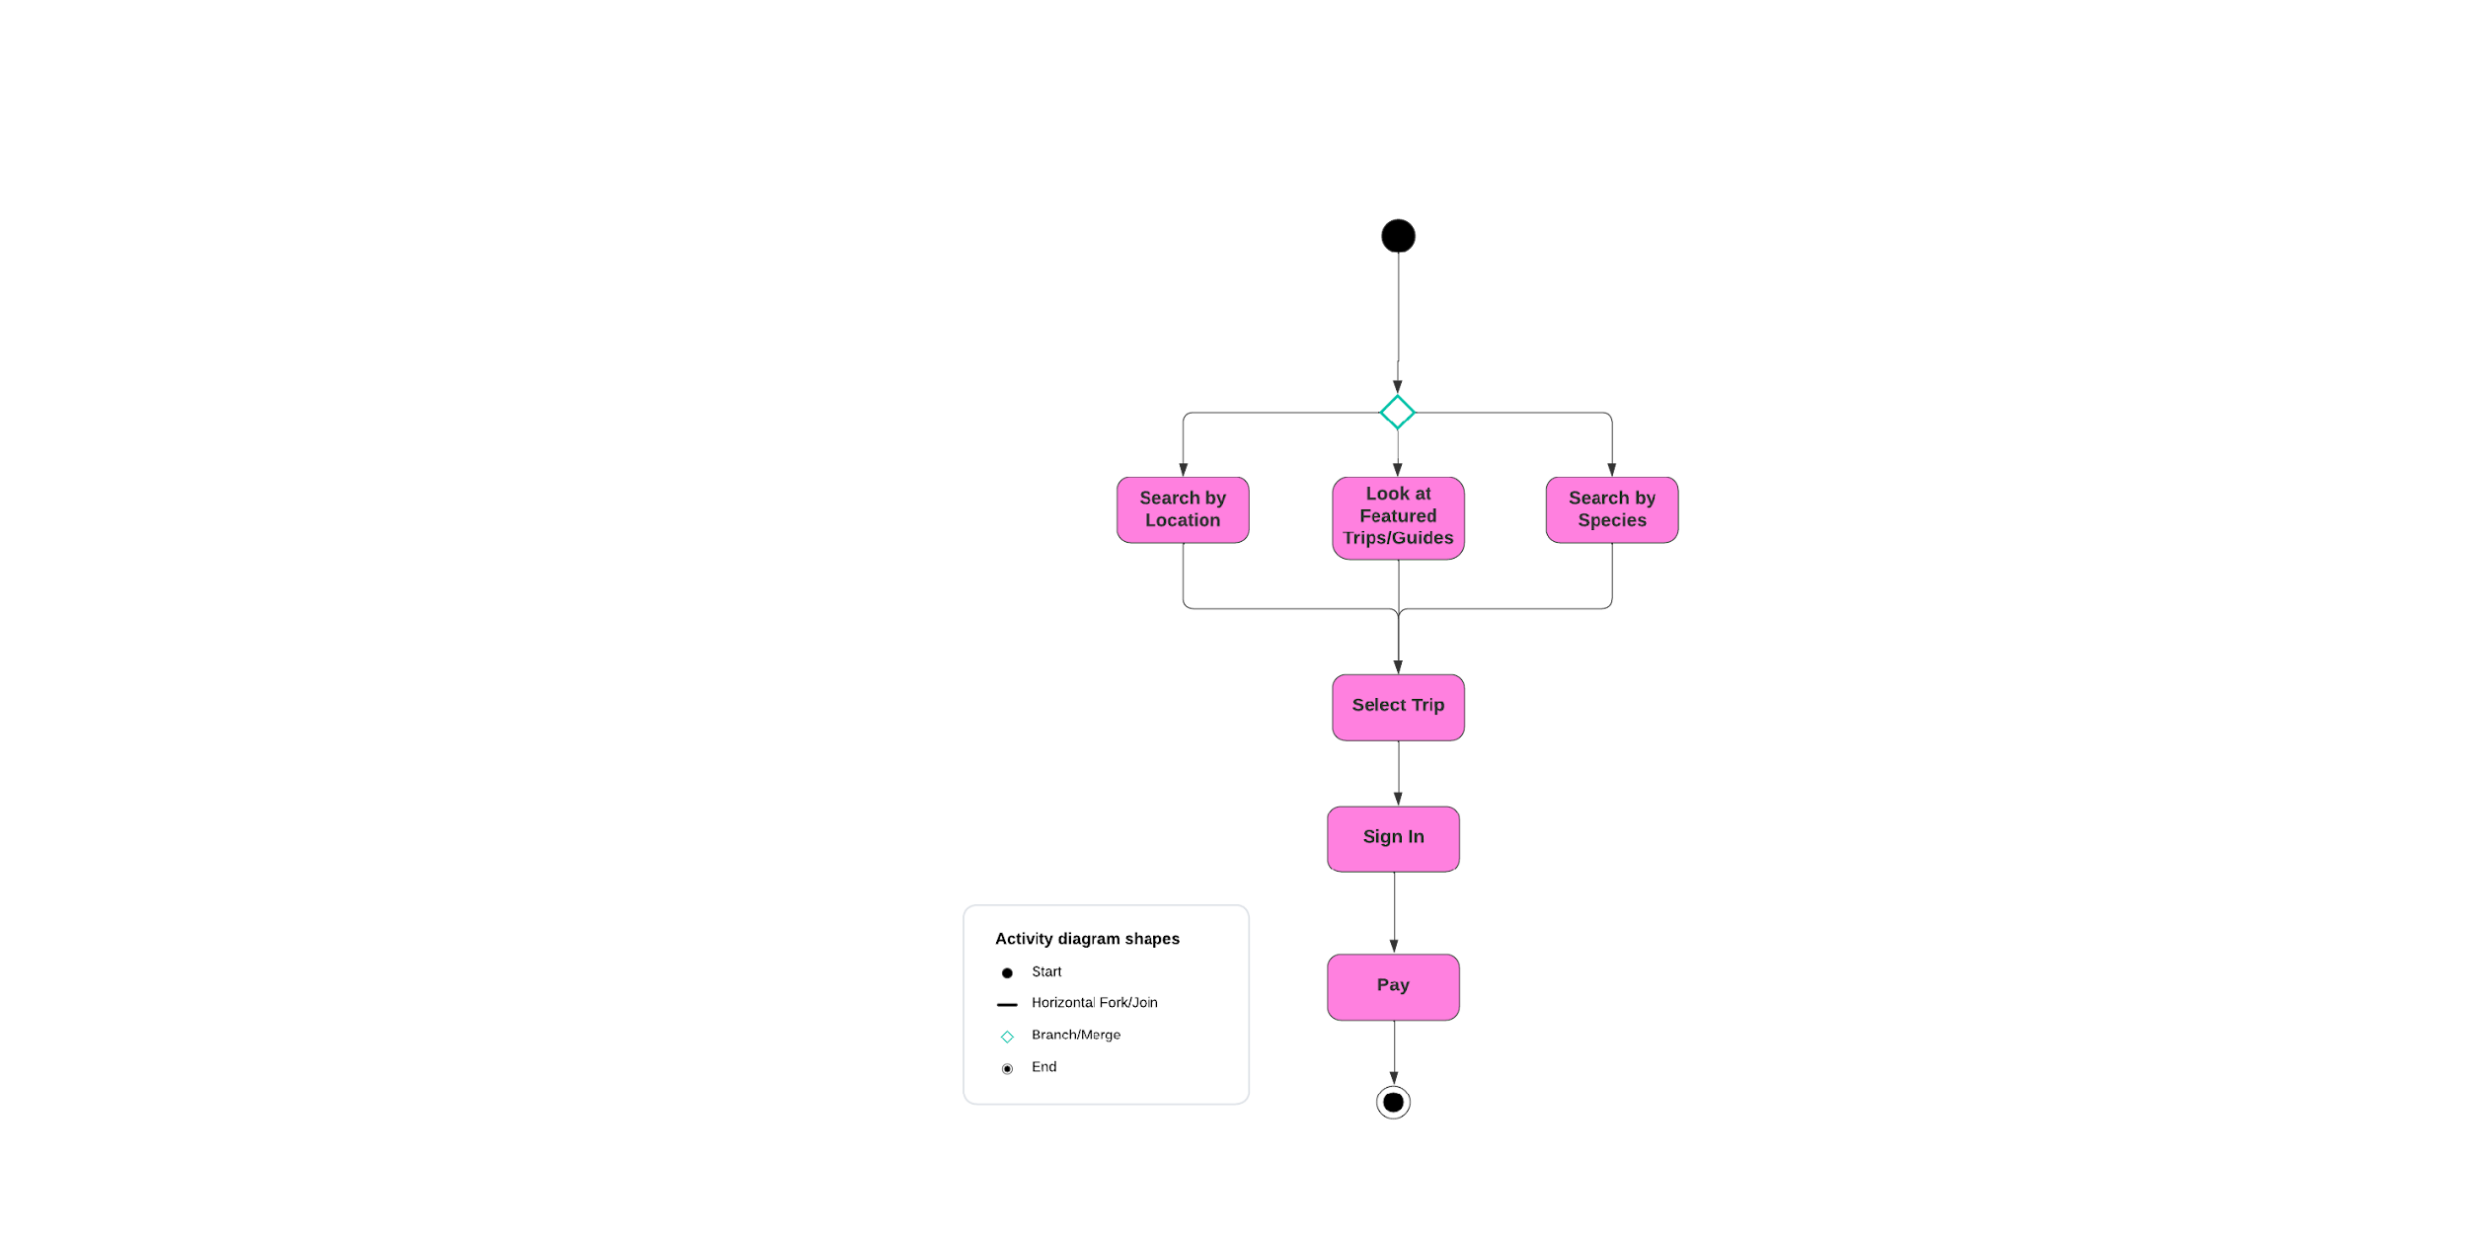

***To-Be Model***

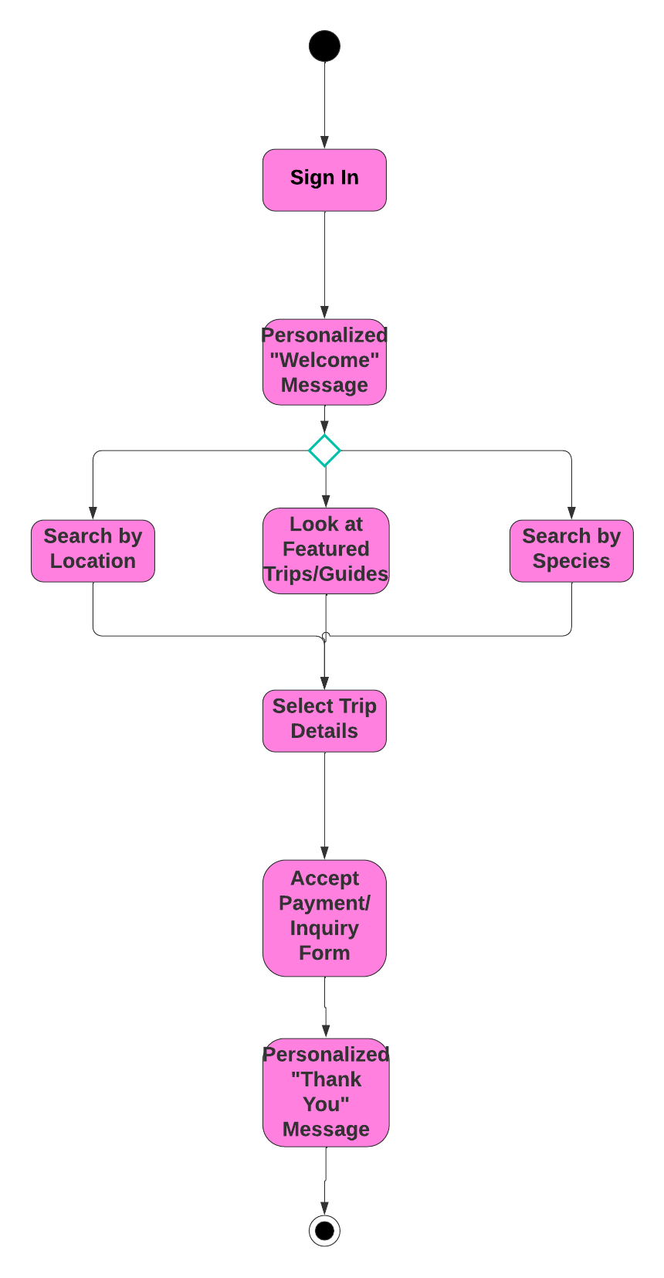

**Description**:

After the Client is invited to the website a survey will be sent by email asking what type of species/techniques the clients would like and where they would like to fish. The point of the survey is for Guide Book to reserve the trips that are most in demand. The trips in the new system would not be available in the old. These are the premium experiences stated in the narrative and system request. Signing in to the website is first because of the invitation only requirement to keep exclusiveness. Then the search feature from the as-is model as well as the payment method/inquiry will be in the to-be model. There is also the personal touch with the special messages after booking a trip.

**Guide Book Pro**

**Vision - Savants**

**Revision History**

| **Date** | **Version** | **Description** | **Author** |
| --- | --- | --- | --- |
| 02/17/24 | 1.0 | Iteration 1 | Alex, Arturo, Adam, Brody, Ty |
|  |  |  |  |
|  |  |  |  |
|  |  |  |  |

1.1 References 12

2. Positioning 12

2.1 Problem Statement 12

2.2 Product Position Statement 13

3. Stakeholder and User Descriptions 14

3.1 Stakeholder Summary 14

3.2 User Summary 15

3.3 User Environment 15

3.4 Summary of Key Stakeholder or User Needs 16

3.5 Alternatives and Competition 16

4. Product Overview 17

4.1 Product Perspective 17

4.2 Assumptions and Dependencies 17

5. Product Features 17 - 18

6. Other Product Requirements 19 - 20

# 1. Introduction

The purpose of this document is to collect, analyze, and define high-level needs and features of Guide Book Pro. It focuses on the capabilities needed by the stakeholders and the target users, and **why** these needs exist. The details of how the Guide Book Pro fulfills these needs are detailed in the use-case and supplementary specifications.

# 2. Positioning

## 2.1 Problem Statement

| The problem of | * Not having an exclusive booking process for individuals willing to pay a premium for highly sought after adventures that are readily available to them |
| --- | --- |
| affects | * Ben Roberson (Co-Founder) * Stuart Jordan (Co-Founder) * Other staff * Guides |
| the impact of which is | * Missed opportunity to leverage specialty market to grow horizontally and maximize revenue |
| a successful solution would be | * Increase revenue for the company * Increase customer satisfaction |

## 2.2 Product Position Statement

| For | * Wealthy individuals with a passion in fishing |
| --- | --- |
| Who | * Must wait months or years to purchase their dream fishing adventure |
| The Guide Book Pro | * Is an exclusive fishing trip booking platform |
| That | * Provides access to extraordinary experiences that would otherwise be scheduled years in advance |
| Unlike | * Yellow Dog Flyfishing * Fly Water Travel * Fishing Booker * Bait Your Hook |
| Our product | * Reserves guides in advance, so the most exciting trips are available at any given time |

# 3. Stakeholder and User Descriptions

Guide Book, despite being a successful business thus far, is looking to expand their services to a slightly more niche side of the market. They would like an additional platform that, while retaining its brand identity, distinguishes itself from the standard service and other competitors. With this project, Guide Book is provided this framework.

3.1 Stakeholder Summary

| Name | Description | Responsibilities |
| --- | --- | --- |
| Ben Roberson  Stuart Jordan | Co-Founders of Guide Book | -Manage the Guide Book’s resources and direct business strategy  -Establish relationships and leverage industry knowledge |
| Developers | Employees coding and creating the new system | Create a stable framework for new system and ensure that the system is user friendly |
| Customer Service Director | Ambassador aiming to promote and support user experience. | Manages customer inquiries  and overall customer satisfaction. |

3.2 User Summary

| Name | Description | Responsibilities | Stakeholder |
| --- | --- | --- | --- |
| Guides | Professionals listing services on the platform | -List available trips  -Manage calendar of bookings | Ben Roberson |
| Clients | Affluent individuals looking to book a premium experience on short notice. | Book experiences through the system, create an account, pay subscription fee | Customer Service Director |

3.3 User Environment

The current system allows users to see guides and their available trips, with short notice booking being virtually impossible for the best guided trips. This project aims to bring exclusivity to the guided fishing world. Our new system will enable subscribed users to access sought after trips with short notice. For our users operating businesses on the site, this will be advantageous knowing they have paying clients ready to book their excursions. There will not be any large changes to the current user environment interface. Subscribed users will log into a similar system that only they have access to. Our platform will integrate with a payment management system to handle in-site bookings. This all aims to make the user experience simple and efficient.

3.4 Summary of Key Stakeholder or User Needs

Issues with the current system include a lack of scalability. Because the system was created on a low code/small-scale platform, it is not able to support the growth of Guide Book. Our stakeholders want a platform that can support the growth of the company. Guide Book Pro aims to provide users with an exclusive booking experience, that the current system does not have the access control to support.

| Need | Priority | Concerns | Current Solution | Proposed Solutions | |
| --- | --- | --- | --- | --- | --- |
| Access Control | High | Security | None | | Content management via CMS |
| Scalability | High | System cannot handle current load | Low-code website | | Additional webpages within Guide Book Co, utilizing CMS solutions and development team |
|  |  |  |  |  |  |

3.5 Alternatives and Competition

Alternatives include keeping the same system, and dealing with the gradual performance degradation as more users join the platform. This would be more cost-effective in the short term, but in the long term it will decrease customer satisfaction. There are other excursion booking sites out there but none of them are taking advantage of this micro market that Guide Book is aiming for.

4. Product Overview

4.1 Product Perspective

This product, Guide Book Pro, will be a niche product that the guided fishing industry has never seen before. Guide Book Pro will allow premium users to access the best guided fishing trips with short notice. This new system will bring guides to a single platform to allow easier booking for customers and give guides more exposure to clients. Guide Book Pro will help guides stay organized by managing bookings and accepting payments, so they can focus on doing what they do best.

4.2 Assumptions and Dependencies

This project is contingent on having a substantial enough budget to allow for implementation of the required features of this project. There is an assumption that experienced developers are present to build this system. This project is also dependent on having an established network of guides to offer services, and that enough clients are willing to pay the subscription fee to gain access to the platform.

5. Product Features

Exclusive Booking Process: Guide Book Pro is designed as an exclusive platform for individuals willing to pay a premium for access to highly sought-after fishing adventures. This feature ensures that premium clients can book their dream fishing experiences without the long wait times typically associated with such exclusive trips.

Advanced Search and Booking Functionality: The platform offers advanced search functionalities, allowing users to easily find and book the fishing trips that best suit their preferences. This includes filtering options for location, type of fishing, guide availability, and more.

Personalized User Experience: Upon signing in, first-time visitors receive personalized welcome messages, enhancing the customer service experience. A tailored "Thank You" message is also sent after booking, adding a personal touch to the transaction.

Integration with CRM Tools: Guide Book Pro is designed to capture sufficient information during the booking process to integrate with other CRM tools. This allows for efficient follow-up communication, including updates and reminders about the trip details.

Secure and Exclusive Access: The platform includes security measures to restrict access to the site, ensuring that only permitted clients can view and book the exclusive trips offered. This feature maintains the exclusivity of the Guide Book Pro experience.

Payment and Inquiry Handling: The system is equipped to handle payments and inquiries at the end of the booking process, offering a seamless end-to-end user experience. This includes considerations for international booking complexities and compliance with PCI regulations to ensure secure payment transactions.

Scalable and Secure System Design: Guide Book Pro is built on a full CMS developed by professionals to handle a growing client base, ensuring high-level security for an exclusive booking experience. This addresses the key needs for scalability and security highlighted by stakeholders.

Competitive Differentiation: Unlike its competitors, Guide Book Pro reserves guides in advance, ensuring that the most exciting trips are available at any given time. This feature sets the platform apart by providing access to extraordinary experiences without the typical advance scheduling required.

These features collectively aim to offer a premium, exclusive, and seamless booking experience for high-end fishing trips, addressing the specific needs of affluent fishing enthusiasts. The platform's design emphasizes user experience, and exclusivity, which positions Guide Book Pro as a unique offering in the market.

6. Other Product Requirements

Special Issues or Constraints Highlighted:

International Travel Considerations: There may be additional considerations for international trips, including COVID-19 restrictions or advisories by the Department of State. This implies a need for flexible, adaptable platform capabilities to handle varying international travel guidelines.

Payment Processing Compliance: The payment acceptance mechanism must be designed to avoid falling under PCI regulation scope, suggesting a high standard for security and data protection without extensive development requirements.

System Integration Concerns: Integrating the new site with the current Guide Book stack might disrupt the exclusive experience intended for Guide Book Pro. This suggests requirements for seamless integration that does not compromise user experience or security.

Infrastructure and Overhead Costs: Building Guide Book Pro separately could increase infrastructure and overhead costs, indicating a need for careful planning in system architecture and resource allocation.

Staffing and Training: The existing staff may need to absorb additional workload or require new training, pointing towards requirements for efficient staff management and training programs.

Inferred Product Requirements:

Standards: Adherence to travel advisory standards and PCI compliance for payment processing.

Hardware/Platform: Flexible infrastructure capable of integrating with existing systems or standing alone without compromising functionality.

Performance Requirements: The system must handle secure transactions efficiently, manage international booking complexities, and operate under varying loads without degradation in performance.

Environmental Requirements: While not explicitly mentioned, the platform would need to be resilient and adaptable to changes in travel advisories and regulations.

Quality Ranges: Robustness, security (especially for payments), and scalability to accommodate growth without requiring extensive redevelopment.

Documentation Requirements: Given the complexities involved, comprehensive documentation for users, including manuals, online help, and installation guides, would be crucial for ensuring ease of use and maintaining security standards.

Design Constraints and Dependencies: The platform's design must consider the existing Guide Book ecosystem, international regulatory compliance, and the need for a highly secure payment processing system.

These insights, derived from the constraints and issues discussed, help outline the broader product requirements necessary for the successful deployment and operation of Guide Book Pro, focusing on security, scalability, user experience, and compliance with international and financial data protection standards.

**Agile Stories**

ID: 111

Title: New Client

As a(n): New Client

Workflow (I want to…): Gain access to GuideBook Pro with ease and simplicity

**When I can** receive an invitation to the platform through email **this happens**, I am able to gain access to premium content behind security, with an efficient sign up process

ID: 112

Title: Client

As a(n): Customer looking to pay for a trip

Workflow (I want to…): Enter payment info in a secure and efficient process

**When I can** Enter payment info in a secure and efficient process **this** **happens**, I am able to pay safely and quickly, and have confidence in my personal information security

ID: 113

Title: Customer Service Director

As a(n): Customer Service

Workflow (I want to…): Create personal messages that clients will see when visiting the site and completing choosing to book a trip

**When I** can make personal messages pop up for our customers, **this happens**, we are showing our customers that we value their business and make an intentional effort to keep them moving forward.

ID: 114

Title: CEO (Stuart Jordan)

As a(n): CEO wanting to track interest and to predict trip inventory

Workflow (I want to…): Have access to survey form submissions

**When I** can see surveys from clients, **this happens**, I am able to effectively gauge interest in the trips we offer and make intelligent decisions for moving forward to book accordingly with guides.

***Team Charter***

Our team’s goal is to help GuideBook design a new exclusive website to book premium fishing trips. GuideBook’s current website does allow users to book trips, and GuideBook Pro will share many elements from the platform. However, the exclusive and premium nature of GuideBook Pro also brings many differences in what type of experience the users require. Our goal is to design an interface that works well for the target audience, while retaining the character and brand identity of GuideBook that these users have grown to enjoy. There are some functions seen in their competitor’s systems that are included in GuideBook Pro like: interactive maps, detailed search utility with content filtering, recommendations based on selections, and the ability to accept payments or inquire about the trip. Additionally, there are minimum requirements that are needed like access controls which will manage who can access GuideBook Pro’s content, and message boxes that greet subscribers and thank subscribers for scheduling a trip.

We aim to achieve our objective this semester through collaborative teamwork. Our project leader, Alex Rodriguez, oversees the team’s work and keeps us aligned with our plan. Secondly, Savant’s project coordinator, Arturo Garcia, supports by coordinating project activities. To foster a culture of collaboration we equally distribute tasks by dividing them into manageable portions, but also ensure not to segment too much so that each team member understands the project in its entirety. Each team member selects or is assigned tasks that align with their skills and provides updates or asks questions throughout the process. Our goal is to nurture an atmosphere of openness, where team members feel comfortable communicating any delays, issues, or concerns, enabling us to support one another. We also aim to foster a sense of accountability, with each team member holding one another accountable for their tasks and quality of work.

The main means of communication outside of class time is through a GroupMe group-chat which allows each member to share opinions, ask questions, and give updates on current progress on tasks. This is an efficient way to reach each other outside of class, and does not rely on emails and fosters more convenient communication. To collaborate on our work and store documents like notes and project deliverables we use Microsoft Teams. Additionally, Teams serve as a virtual meeting space throughout the semester. We frequently use Teams as a space to meet virtually and discus any issues we are having with certain tasks, and to make sure we all are on the same page.

If we need to contact our project sponsor, we can visit her office hours, schedule a meeting after class, or email her and expect a response within 24 hours. We rely on email to communicate with GuideBook founders, Ben Roberson and Stuart Jordan, when clarification is needed. To respect each member’s schedule, we prioritize our class time for meetings. During the meetings, we discuss the schedule and current work list thoroughly to ensure we are on track to accomplish our goal. When we have differing opinions, we have a constructive discussion and resolve the matter rationally. We conclude the meetings with a clear plan for the current task and what each person is expected to contribute. If situations arise where we are unable to meet at these times, we communicate in and cover material that may have been missed. We also will use Teams to meet if someone misses class, to fill in project members on what they missed.

In iteration one, the team established phases which broke up the timeline into two short-term objectives about a week in length. This allowed each team member to avoid procrastination and hastily make decisions that would likely lower the quality of our work. Also, we decided as a team to complete the written portion days before the deadline to leave enough time to develop the presentation piece. In retrospect, this was a good idea because the written portion took longer than anticipated so this technique will be used moving forward. As a group we worked through the project instead of fragmenting the project and potentially allowing someone to misinterpret the goals of our project.

In iteration two, we broke the project up into small, manageable objectives to keep the project moving forward at a steady pace. Each team member created a portion of the use cases, and corresponding system requirements. This task was spread amongst the team in order to ensure everybody had a deep understanding of the