Engineering Guide: Understanding Wired Telephone DTMF Transmission and Reception
The problem you describe is very common when designing a telephone dialing circuit from individual integrated circuits.
You have already achieved an important result: your DTMF decoder works, and your HT9200 transmitter produces an audible tone. However, generating a tone that sounds like a telephone keypad is not the same as generating a valid DTMF signal that a telephone exchange can recognize.
The issue could be in the generated frequencies, the relative amplitudes of the two tones, your transistor amplifier, the impedance of the telephone line, or the timing and operating conditions of the dialing circuit.
One important component-name issue: I could verify the HT9200 transmitter and the MT8870 DTMF receiver, but I could not verify a DTMF decoder with the exact part number MT5088. The detailed receiver circuit below therefore uses the documented MT8870 family. If your actual IC is MT5088, its manufacturer and pinout must be confirmed before using that circuit.
1. How a wired telephone actually works
A traditional analog wired telephone uses two wires, called Tip and Ring, to carry electrical power, signaling, and speech.
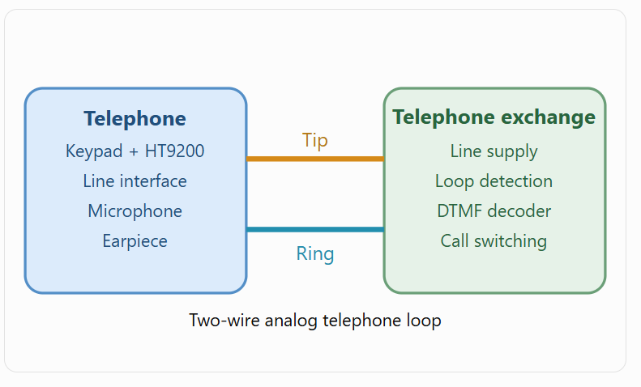
The operation has five main stages:
- On-hook: The handset is resting. The telephone presents a high DC impedance, and the telephone exchange typically supplies approximately 48 V DC.
- Off-hook: You lift the handset. The telephone closes its DC loop through an appropriate circuit, and current flows. The exchange detects that the telephone is active.
- Dial tone: The exchange sends an audible dial tone, telling you that dialing can begin.
- DTMF dialing: Pressing a keypad button generates two specific audio frequencies simultaneously. These travel through the telephone line.
- Call connection: The exchange identifies the sequence of digits and routes the call. Speech then travels as an audio signal over the same pair of wires.
An important distinction is that the telephone exchange generally does not decode the raw digital commands sent to the HT9200. It receives only the resulting analog audio tones.
2. The operating principle of DTMF
DTMF means Dual-Tone Multi-Frequency.
Every keypad digit corresponds to the simultaneous generation of one low-frequency tone and one high-frequency tone.
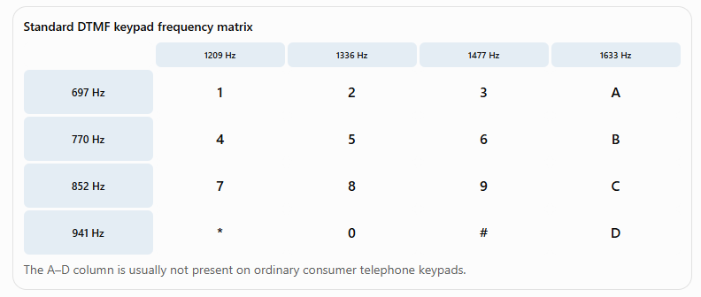
For example, when you press 5, the transmitter generates:
- Low frequency: 770 Hz
- High frequency: 1336 Hz
The resulting electrical signal is
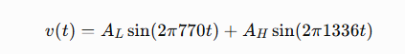

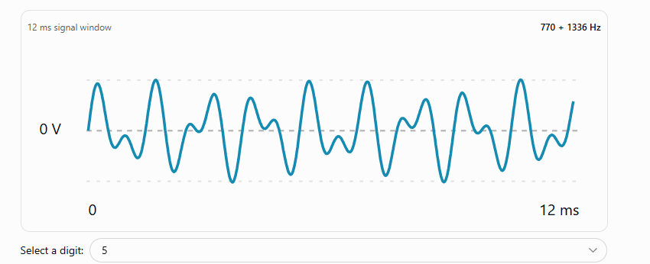
Idealized, AC-centered waveform. Real HT9200 output can include a DC bias and other characteristics that must be measured.
Notice that the waveform is not a single sine wave. It has an irregular-looking, repeating shape because two sine waves are added together.
A telephone decoder must identify both frequencies correctly. Listening to the signal is insufficient because your ear may perceive an incorrect or distorted signal as an ordinary telephone keypad sound.
3. Why your HT9200 transmitter may not work properly
From your description, my first suspicion is the transistor amplifier and how its output is connected to the telephone circuit.
The HT9200 is specifically designed to generate DTMF signals. With the correct supply voltage, crystal, control sequence, and load, it should produce recognizable frequencies. The transistor can make the signal worse even when it increases the overall amplitude.
Here are the most important failure mechanisms, in priority order.
3.1 Transistor amplifier distortion
Suppose your HT9200 produces a valid dual-tone signal. You connect its output to the base of a transistor and amplify the signal.
If the transistor is not biased at an appropriate operating point, it may enter cutoff or saturation during parts of the waveform.
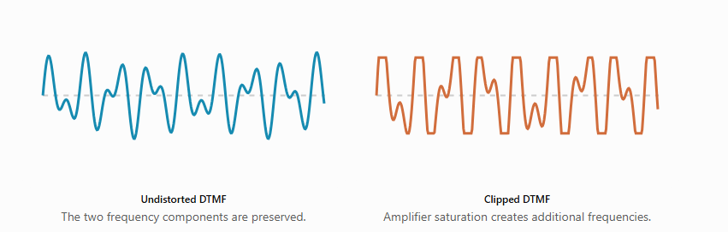
An incorrectly biased amplifier can cause:
- Harmonic distortion
- Intermodulation distortion
- Unequal amplification of the low and high tones
- Excessive signal amplitude
- Loss of one frequency component relative to the other
Even if the generated tone sounds familiar to you, the decoder may reject it.
Recommended correction: Disconnect the transistor temporarily. Test the HT9200 through an AC-coupled, high-impedance receiver input. If that works reliably, the transistor stage or the line interface is responsible.
3.2 Incorrect relationship between the two tone amplitudes
The two DTMF frequencies must have suitable relative power levels.
The difference is called twist:
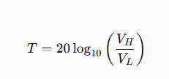
where \(V_H\) is the RMS amplitude of the high-frequency component and \(V_L\) is the RMS amplitude of the low-frequency component.
For example, suppose:
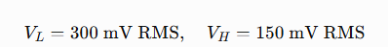
Then:
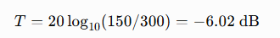
A receiver has limits on acceptable twist. If the transistor amplifier or coupling network attenuates one component too much, decoding may fail.
For a first laboratory test, aim for approximately equal amplitudes, or 0 dB twist, at the receiver input.
3.3 Incorrect signal amplitude
An analog telephone line is not simply a high-impedance audio input. It presents an AC load determined by the line, telephone exchange, and interface circuitry.
Therefore, the voltage measured with no load can differ substantially from the voltage delivered to the actual line.
An amplifier may generate a large voltage when disconnected but collapse in amplitude when connected to the telephone circuit.
Conversely, an excessively strong signal can overdrive a receiver.
You need to measure the voltage under the intended load, not just at the HT9200 output when disconnected.
3.4 Incorrect crystal oscillator
The HT9200 requires a 3.579545 MHz timing reference.
If you use the wrong crystal, or the oscillator does not operate reliably, the generated frequencies may be wrong.
For instance, a 4 MHz crystal would shift the nominal frequency of a 770 Hz tone to approximately:
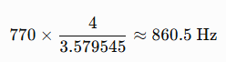
That is clearly not acceptable for a standard 770 Hz DTMF component.
The correct crystal is therefore essential, even when the output is audible.
3.5 DTMF tone duration and dialing pauses
The telephone system must have enough time to recognize each digit.
If you transmit a tone for only a few milliseconds, a decoder may reject it.
For initial testing, use these conservative values:
Parameter | Initial design setting
Tone duration | 100–150 ms
Pause between digits | 100 ms
Crystal | 3.579545 MHz
Initial twist target | 0 dB
HT9200 supply | Regulated 5 V
Initial connection | Isolated low-voltage test circuit
These durations are engineering test settings, not a claim that every telephone exchange requires exactly these values.
3.6 Telephone line interface problems
This is particularly important if you are trying to dial through an actual analog telephone network.
A DTMF generator does not automatically replace a complete telephone.
The HT9200 generates only audio signaling. It does not create the off-hook current, perform line supervision, provide a properly matched telephone interface, or protect the electronics from ringing and line transients.
Your circuit must correctly establish an off-hook condition before transmitting digits.
It also needs a suitable audio injection path into the two-wire telephone line.
Do not connect the HT9200, a bare transistor output, a microcontroller ground, or an ordinary oscilloscope ground directly to a public telephone line. Use an approved, isolated telephone-line interface, or carry out the initial experiments on a separate low-voltage laboratory circuit.
4. HT9200 transmitter IC: pin configuration
There are two principal versions:
- HT9200A: 8-pin package, serial control.
- HT9200B: 14-pin package, serial or parallel control.
The following pin assignments and operating details are taken from the Holtek HT9200A/B datasheet.

Farnell+1
HT9200A pin assignment
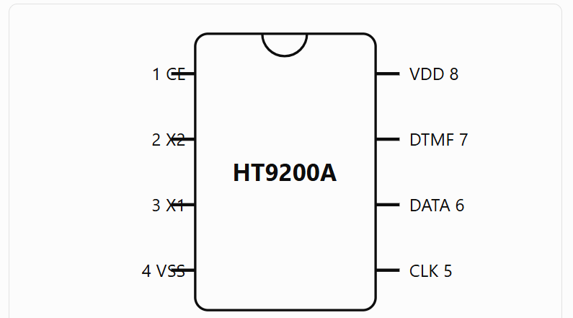
Pin | Label | Purpose
1 | CE | Chip enable, active low
2 | X2 | Crystal oscillator terminal
3 | X1 | Crystal oscillator terminal
4 | VSS | Ground
5 | CLK | Serial data clock
6 | DATA | Serial data input
7 | DTMF | Analog DTMF output
8 | VDD | Positive supply
HT9200B pin assignment
Pin | Label | Purpose
1 | CE | Active-low enable
2 | X2 | Crystal oscillator
3 | X1 | Crystal oscillator
4 | VSS | Ground
5 | NC | No connection
6 | D0 | Parallel data, bit 0
7 | D1 | Parallel data, bit 1
8 | D2 | Parallel data, bit 2
9 | D3 | Parallel data, bit 3
10 | S/P | Serial/parallel mode selection
11 | CLK | Serial clock
12 | DATA | Serial input
13 | DTMF | Analog output
14 | VDD | Positive supply
For the HT9200B, S/P = LOW selects serial operation and S/P = HIGH selects parallel operation.
5. Building a working HT9200A transmitter circuit
I recommend constructing the transmitter in two separate stages:
- HT9200 DTMF generation.
- A linear audio-buffer circuit to connect to the receiver.
Do not introduce the telephone line until these stages pass laboratory testing.
5.1 Minimum HT9200A circuit
HT9200A laboratory transmitter connections
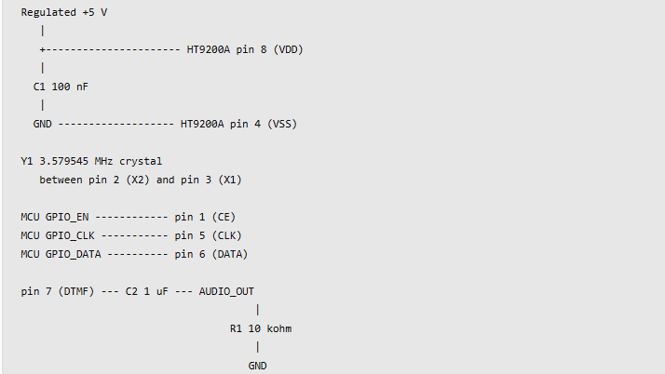
This is a low-voltage bench-test arrangement, not a telephone-line interface. The 10 kΩ output load and coupling capacitor are initial test values.
The component values are:
Reference | Component | Specification | Purpose
U1 | HT9200A | Holtek DTMF generator, DIP-8/SOP-8 | Generates tone pairs
Y1 | Quartz crystal | 3.579545 MHz | Establishes frequency reference
C1 | Ceramic capacitor | 100 nF, X7R, 10 V or higher | Local supply decoupling
C2 | Film or ceramic capacitor | 1 µF, suitable voltage rating | Removes DC component from the output
R1 | Resistor | 10 kΩ, 1%, 0.125 W or higher | Provides a defined laboratory audio load
R2 | Resistor, optional | 10 kΩ | Pulls CE high while MCU initializes
U2 | Microcontroller | 5 V-compatible GPIO or level-shifted control | Sends serial control information
Holtek's documentation describes internal oscillator bias and load capacitance. Do not automatically install two external crystal capacitors based only on a generic microcontroller oscillator example; use the crystal and the applicable HT9200 datasheet recommendations.
The 100 nF capacitor should be placed physically close to the supply pins. Also verify that MCU logic-high levels meet the HT9200 input specifications.
5.2 HT9200 serial communication principle
The HT9200A does not use normal UART communication.
It uses a synchronous serial interface consisting of:
- DATA
- CLK
- CE
Each command contains five bits, from D0 through D4.
The least-significant bit is transmitted first, and the IC latches data on the falling edge of CLK.
For the digit 5, the datasheet assigns binary:
00101 (D4 through D0)
The transmitted order is therefore:
1 → 0 → 1 → 0 → 0
The IC interprets the command and generates the two frequencies:
770 Hz and 1336 Hz.
5.3 Transmitting digits
In serial mode, CE enables the device, the microcontroller sends five clocked data bits, and the corresponding tone appears at DTMF.
To make an identifiable telephone digit, the firmware must then hold the tone for an appropriate interval and create a pause before the next digit.
A useful 5-bit code table is:
Key | Serial code (D4…D0) | Decimal
1 | 00001 | 1
2 | 00010 | 2
3 | 00011 | 3
4 | 00100 | 4
5 | 00101 | 5
6 | 00110 | 6
7 | 00111 | 7
8 | 01000 | 8
9 | 01001 | 9
0 | 01010 | 10
* | 01011 | 11
# | 01100 | 12
Off | 11111 | 31
The 11111 code is useful because it stops tone generation without needing to treat every pause as a power-down/startup cycle.
5.4 Example microcontroller control program
This example uses an Arduino Uno and the HT9200A in serial mode.

const int CE_PIN = 8;
const int CLK_PIN = 9;
const int DATA_PIN = 10;

uint8_t digitCode(char digit) {
if (digit >= '1' && digit <= '9')
return digit - '0';

if (digit == '0') return 10;
if (digit == '*') return 11;
if (digit == '#') return 12;

return 31; // DTMF OFF
}

void sendCode(uint8_t code) {
// CE remains low while transmitting.
for (int i = 0; i < 5; i++) {
digitalWrite(CLK_PIN, HIGH);
digitalWrite(DATA_PIN,
(code >> i) & 1);
delayMicroseconds(10);

// Falling edge latches the bit.
digitalWrite(CLK_PIN, LOW);
delayMicroseconds(10);
}

digitalWrite(CLK_PIN, HIGH);
}

void sendDigit(char digit) {
sendCode(digitCode(digit));
delay(120); // Tone duration

sendCode(31); // Explicit DTMF OFF
delay(100); // Interdigit pause
}

void setup() {
digitalWrite(CE_PIN, HIGH);
digitalWrite(CLK_PIN, HIGH);
digitalWrite(DATA_PIN, LOW);

pinMode(CE_PIN, OUTPUT);
pinMode(CLK_PIN, OUTPUT);
pinMode(DATA_PIN, OUTPUT);

delay(20);
digitalWrite(CE_PIN, LOW);

// Allow oscillator to stabilize.
delay(20);
sendCode(31);
}

void loop() {
sendDigit('1');
sendDigit('5');
sendDigit('9');

delay(2000);
}
This is a simple continuously enabled laboratory example. The 20-microsecond bit-cell timing is deliberately conservative. Check the final oscillator-startup and serial timing requirements against your exact chip revision before production use.
The output should repeatedly generate the DTMF sequence 1, 5, 9.
For the first test, measure the signal directly after the coupling capacitor, with no transistor connected.
6. Designing a suitable analog transmitter amplifier
Once the HT9200 works directly, the next step is to design the analog amplification and coupling stage.
Your transistor circuit is especially important here.
6.1 Why a simple transistor can create problems
Consider a common-emitter amplifier.
Its approximate small-signal voltage gain is:
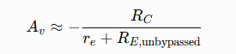
where:
- \(R_C\) is the collector resistor.
- \(R_E\) is the unbypassed emitter resistor.
- \(r_e\) is the transistor's internal small-signal emitter resistance.
The transistor needs a suitable DC bias so that the signal can move both upward and downward without clipping.
A common error is to connect the DTMF output directly to a transistor base with only a resistor, expecting that transistor to operate as a linear amplifier.
Depending on the circuit, it may instead act as a switch, emitter follower, or badly biased nonlinear stage.
6.2 Recommended solution: use an operational amplifier
For laboratory testing, an operational amplifier is generally easier to control than a single-transistor stage.
A suitable example is the MCP6002, which can operate from a single 5 V supply.
The following is a specific starting circuit for an isolated low-voltage audio experiment.
Non-inverting AC-coupled buffer/amplifier
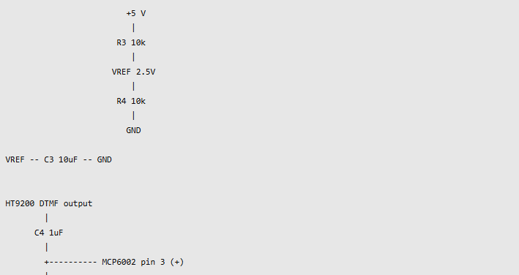
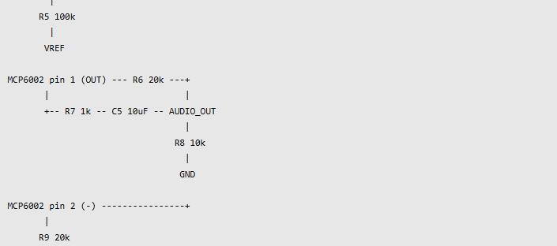
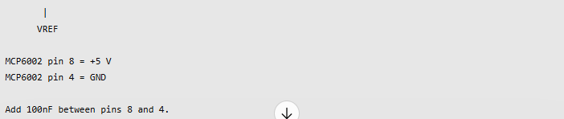
Add 100nF between pins 8 and 4.
This circuit has a mid-supply reference at approximately 2.5 V. Both input and output audio are centered around that reference inside the op-amp circuit.
Its nominal voltage gain is:
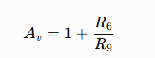
With both feedback resistors equal to 20 kΩ:
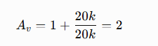
The resulting signal is AC-coupled through C5 and then applied to a high-impedance laboratory audio load.
You can reduce the gain to unity by connecting the inverting input directly to the op-amp output and removing the two gain-setting resistors, which is a good first test if the HT9200 output is already strong enough.
Important limitations: This circuit assumes the input and amplified output stay within the op-amp's linear voltage range. The 10 µF output capacitor should be a nonpolarized type, or a correctly oriented polarized capacitor after verifying the DC voltages. The circuit is not intended to drive 600 Ω directly or connect to Tip/Ring.
6.3 What about the 600 Ω telephone impedance?
Traditional telephone audio equipment often uses a nominal 600 Ω reference impedance, although real subscriber lines and exchanges can have different or frequency-dependent impedances.
For a 600 Ω resistive laboratory load:
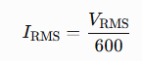
For example, a total audio signal of 0.5 V RMS requires:
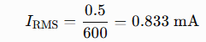
The current may appear small, but the amplifier still needs sufficient output swing and appropriate stability with the actual load.
The MCP6002 circuit above is a high-impedance signal-conditioning example, not a validated 600 Ω line driver.
For a real telephone interface, I recommend this architecture:
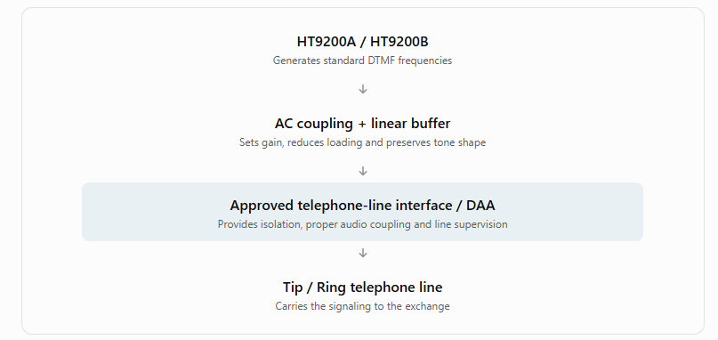
The line interface must support the intended exchange's operating requirements. It is not sufficient merely to connect the amplifier through a capacitor or transformer and assume that the resulting device is safe or compatible.
7. Decoder design: MT8870 receiver
For the receiver, I'll use the verified MT8870/M-8870 device until the exact MT5088 identification is resolved.
The MT8870 integrates the important processing stages needed for DTMF reception, including band separation, frequency identification, and digit validation.

people.ece.cornell.edu+1
7.1 Internal operating principle
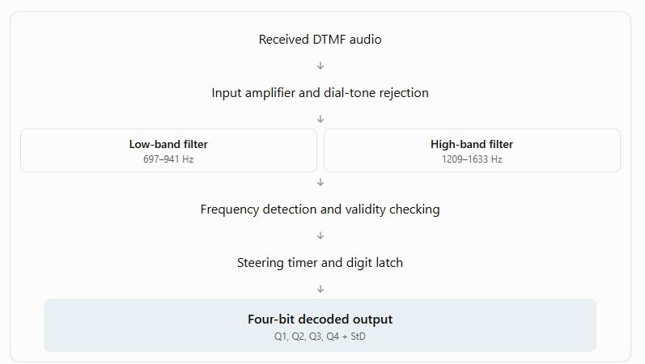
The decoder performs several operations.
Stage 1 — Input conditioning. The incoming audio is delivered to the integrated amplifier. The signal must have a suitable amplitude without excessive clipping.
Stage 2 — Band separation. Internal filters separate the low- and high-frequency groups.
Stage 3 — Frequency recognition. The IC checks whether each group contains an acceptable DTMF frequency.
Stage 4 — Timing validation. The steering circuit ensures the tone persists for an appropriate interval.
Stage 5 — Output conversion. Once a valid digit has been recognized, the corresponding four-bit value is latched and a data-valid signal is asserted.
This explains why a tone can be audible but not decoded: the receiver performs more sophisticated checks than simply detecting the presence of sound.
7.2 MT8870 pin assignments
Pin | Symbol | Description
1 | IN+ | Non-inverting amplifier input
2 | IN− | Inverting amplifier input
3 | GS | Amplifier output / gain-setting connection
4 | VREF | Internal reference output
5 | INH | Inhibit control, on supported variants
6 | PWDN | Power-down control, on supported variants
7 | OSC1 | Crystal terminal
8 | OSC2 | Crystal terminal
9 | VSS | Ground
10 | TOE/OE | Output-enable input
11 | Q1 | Decoded data bit 0
12 | Q2 | Decoded data bit 1
13 | Q3 | Decoded data bit 2
14 | Q4 | Decoded data bit 3
15 | StD | Delayed steering / valid-digit indication
16 | ESt | Early steering
17 | St/GT | Steering input / guard-time output
18 | VDD | Positive 5 V supply
7.3 Practical MT8870 decoder circuit
The following is a laboratory connection based on the published M-8870 single-ended input configuration.
Receiver circuit and input conditioning
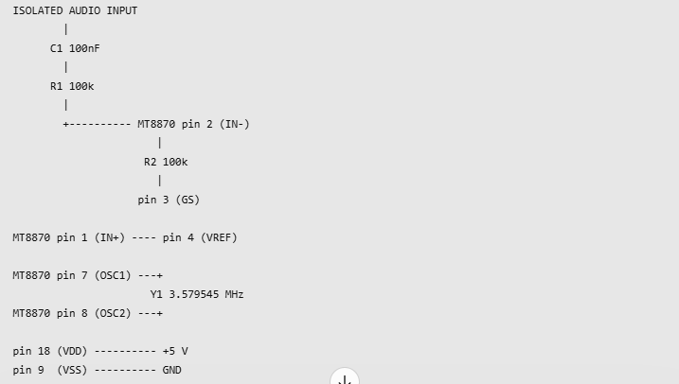
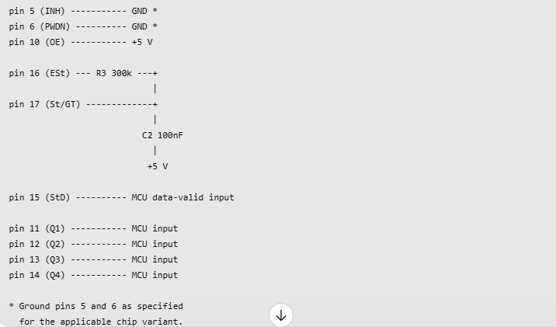
The input amplitude must be verified. This is a laboratory, low-voltage receiver arrangement, not a protected direct telephone-line connection.
The unusual steering capacitor connection—to +5 V rather than GND—is intentional and follows the reference circuit.
The 300 kΩ resistor and 100 nF capacitor are used to establish the digit-recognition guard interval. The decoder's total acquisition time includes internal processing delay.
Add a separate 100 nF supply decoupling capacitor directly between pins 18 and 9.
The receiver can then connect to a microcontroller to collect digits.
7.4 How the digital receiver output works
For example, pressing 5 produces a binary output:
Q4 Q3 Q2 Q1 = 0101
The following table gives the typical decoder output:
Key | Q4 Q3 Q2 Q1
1 | 0001
2 | 0010
3 | 0011
4 | 0100
5 | 0101
6 | 0110
7 | 0111
8 | 1000
9 | 1001
0 | 1010
* | 1011
# | 1100
For a microcontroller-based receiver, use StD to determine when to read the four data bits rather than repeatedly reading those bits without checking whether a new digit has arrived.
A critical debugging detail is the difference between ESt and StD:
- If ESt never goes high, the incoming frequency pair may not be valid, or the input level may be unsuitable.
- If ESt goes high but StD does not, check the steering circuit and tone duration.
- If StD goes high but you obtain the wrong digit, check data-bit wiring and the output mapping.
These observations can quickly identify which receiver processing stage is failing.
8. How to find the exact fault in your existing transmitter
The most useful thing you can do now is measure the signal at several points.
An oscilloscope is helpful, but an FFT spectrum analyzer is especially valuable, because it can show whether both DTMF frequencies are present at the correct amplitudes.
Measurements for the digit 5
When your transmitter generates digit 5, measure the following.
Measurement | What you should observe
HT9200 VDD | Stable supply within datasheet limits
HT9200 oscillator | 3.579545 MHz nominal
DTMF output | Composite of two tones
Low-frequency component | Approximately 770 Hz
High-frequency component | Approximately 1336 Hz
Tone duration | Approximately 120 ms in the example firmware
Amplifier output | No clipping or excessive distortion
Receiver ESt | Goes high while a valid pair is recognized
Receiver StD | Goes high after valid tone duration
One interesting detail from the Holtek datasheet is that its documented generated frequencies are not mathematically identical to the ideal DTMF frequencies. For example, it gives approximately 766 Hz and 1332 Hz for the two tones used by digit 5. These deviations are intentional characteristics of its internal frequency-generation implementation.
Farnell
A practical step-by-step diagnosis
Transmitter troubleshooting checklist
0 of 10 completed
Reset
Verify the HT9200 part number and pin connections
Check the supply voltage and 3.579545 MHz crystal
Disconnect the transistor amplifier
Generate digit 5 directly from the HT9200
Measure both frequencies with FFT
Check the amplitudes of the two frequency components
Test the direct HT9200 signal using the working decoder
Reconnect the amplifier and measure again
Compare amplifier input and output distortion
Test through the isolated telephone-line interface
9. How to interpret the test results
Test result | Most likely problem | Next action
HT9200 output is incorrect before amplification | Crystal, power supply, serial code, control timing | Test the generator alone
HT9200 output is valid, transistor output distorted | Improper transistor bias, saturation, insufficient headroom | Redesign or replace the amplifier
Both frequencies are correct but levels differ substantially | Frequency-dependent gain or loading | Measure and correct twist
Decoder accepts the direct signal but rejects amplified signal | Amplifier or coupling stage | Reduce gain and examine clipping
Decoder accepts the signal locally, but telephone exchange does not | Off-hook signaling, line loading, injection level, timing, or interface | Inspect the isolated line-interface design
Single digits work but multiple digits fail | Interdigit pause, timing, or control sequence | Check tone-on and tone-off intervals
My strongest recommendation is to carry out one very simple experiment:
Connect the HT9200A output through a coupling capacitor directly to your working decoder's suitable audio input, without using the transistor amplifier or telephone line.
If that arrangement decodes every digit correctly, you have strong evidence that the HT9200's frequency-generation function is operating correctly.
Then reconnect your transistor stage and compare the measurements.
If the decoder rejects the direct HT9200 output as well, investigate the oscillator, data protocol, output loading, and amplitude before making any amplifier changes.
10. Equipment for developing and verifying your design
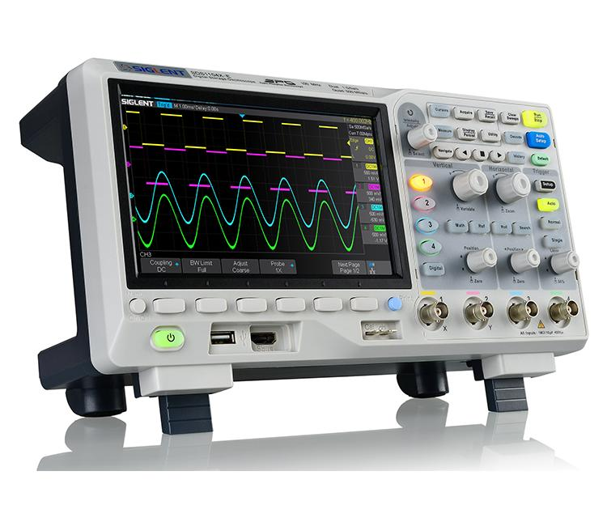
Digital oscilloscope
Use it to view the DTMF waveform, detect clipping, verify control timing, and compare amplifier input and output.
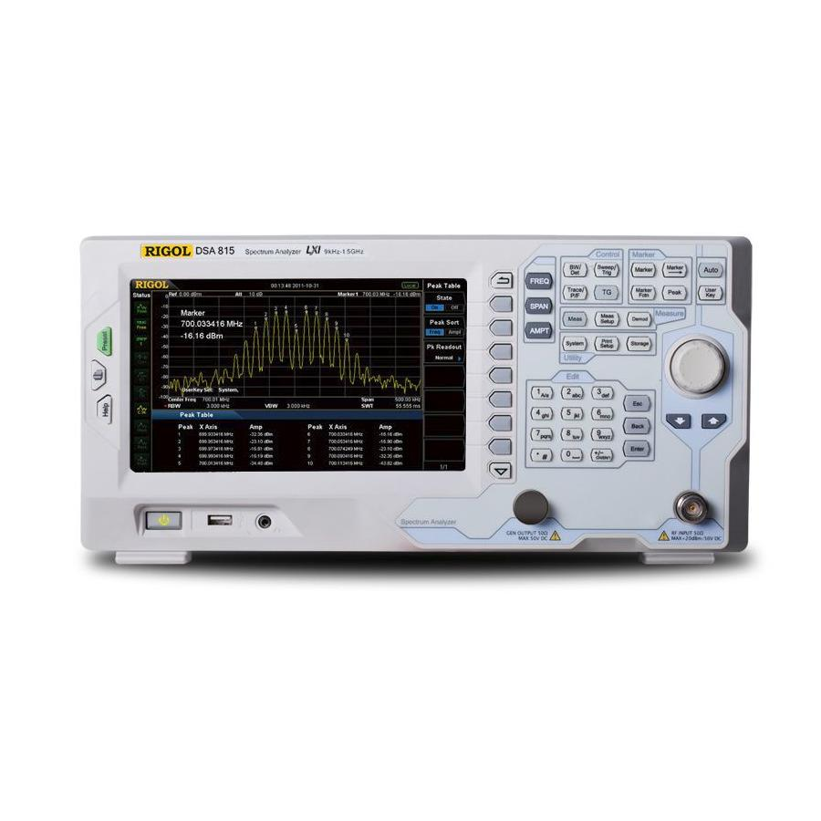
Spectrum analyzer or oscilloscope FFT
Use it to measure the two frequency peaks, relative amplitude (twist), and unwanted harmonics. An oscilloscope with FFT capability may be sufficient for this project.
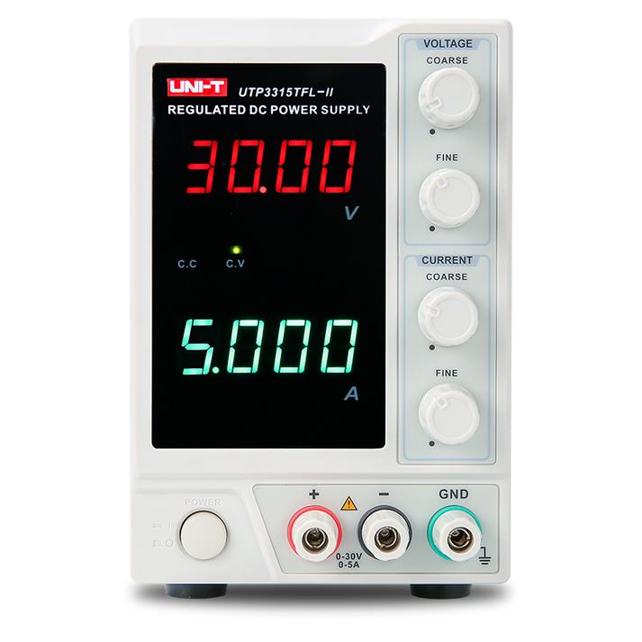
Regulated laboratory power supply
Supply a stable 5 V rail and monitor the current drawn by the circuitry.
You will also benefit from a multimeter, breadboard or prototype PCB, logic analyzer, and a known-good DTMF decoder board.
For telephone-line experiments, use a dedicated isolated line simulator or an approved telephone interface. A standard earth-referenced oscilloscope should not be connected directly across a live public telephone line.
11. Datasheets and technical references
The following are particularly useful for the engineering work.
- Holtek HT9200A/B DTMF Generator Datasheet — pin connections, serial/parallel operation, timing, oscillator, and output characteristics.
- M-8870 DTMF Receiver Datasheet — receiver signal processing, input circuitry, guard-time design, pin functions, and decoding specifications.
The remaining key uncertainty is the actual decoder part number. The verified documentation is for MT8870/M-8870, not MT5088, and their pinouts should not be assumed interchangeable.
12. Three details I need from your existing hardware
To diagnose why your particular transmitter is failing, please tell me:
- Which transmitter IC do you use — HT9200A (8 pins) or HT9200B (14 pins)?
- How is the transistor connected? Please share your schematic or a clear photograph showing the transistor type, resistors, capacitors, and connection to the line.
- What does “doesn't work well” mean? Does your decoder reject digits, recognize incorrect digits, work intermittently, or does the actual telephone exchange fail to dial the number?
Also, please confirm whether the decoder marking is MT5088 or MT8870.
With those details, we can move from a general explanation to component-level fault analysis, including transistor DC bias calculations, AC voltage gain, DTMF frequency measurements, and a corrected transmitter schematic suitable for your particular telephone arrangement.

