GAUNTLET
INQUISITION FACTION GUIDE
v0.6
FACTION IDENTITY
Turn the opponent's commitments into evidence, then decide whether to suppress the present threat or remove it permanently.

At a glance
Category | Inquisition
Victory | Breakthrough or Purification
Resource | Conviction, maximum 4
Leaders | Grand Inquisitor / Witch Hunter
Faction pool | 12 cards; curve 1 / 3 / 4 / 2 / 2
Cost-5 cards | Heresy and Hellfire
Core doctrine | Condemnation, Blasphemy, Purge, Purification
Contents
1. Inquisition overview 2 | 2. Conviction and doctrine 2
3. Inquisition leaders 3-4 | 4. Playing Inquisition 5
5. Rules reference 5 | 6. Canonical card pool 6-7
7. Pool summary 7 | Appendix A. Quick reference 8
Use with the Gauntlet v0.6 core rules. General movement, battle, retreat, capture, deck construction, Assets, and ordinary breakthrough victory remain in the core rulebook.
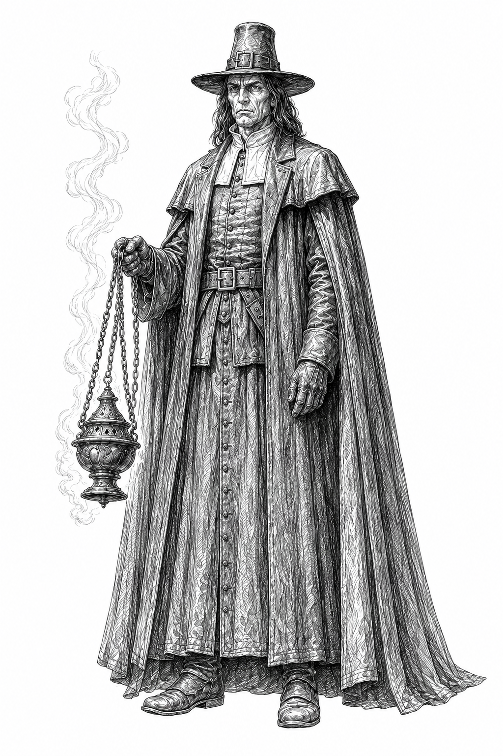  GRAND INQUISITOR |   WITCH HUNTER

1. Inquisition overview
The Inquisition turns the opponent's played cards, discarded resources, exposed hand, and battlefield losses into evidence. It can win normally by breaking through the opponent's Heartland or by permanently condemning enough of the opponent's deck that a normal start-of-turn draw becomes impossible.
Components and setup  - Choose Grand Inquisitor or Witch Hunter during deck construction.  - Place the selected Leader Card over the shared Conviction Tracker, fully covering it at 0.  - Keep the Inquisition Doctrine and Purge Reference visible.  - Use any Inquisition cards included through normal deck construction.  - Slide the Leader upward to the 1-4 registration line as Conviction changes; no token is used. | Faction profile  Element Rule  Victory Breakthrough or Purification  Conviction Maximum 4  Normal gain First qualifying after-battle Graveyard event each turn  Blasphemy Extra Conviction from opposing Arcane-trait cards  Purge Spend Conviction instead of playing an Action card  Pool 12 cards; average cost 3.08
2. Conviction and doctrine
Conviction  Maximum 4. The first time each turn one or more opposing cards enter the Graveyard after a battle involving you, gain 1. Several cards entering together still produce only 1 normal gain. | Condemnation  In battles involving you, opposing played battle-drawn cards go to their Graveyard after battle instead of discard. Hand commitments already do; unplayed battle-drawn cards are discarded normally. | Blasphemy  Whenever the opponent plays a card with the Arcane trait, gain 1 Conviction outside the normal once-per-turn limit, up to 4. The Arcane trait is separate from faction allegiance; not every Arcane card belongs to Mystics.
Purge
Instead of playing an Action card during the Action step, spend Conviction to choose one eligible Purge:
Cost | Effect
1 | Choose one: send the top card of the opponent's discard pile to their Graveyard; or send up to two cards there with combined deckbuilding value 2 or less to their Graveyard.
2 | Send one opposing Asset to its owner's Graveyard.
3 | The opponent sends one card from hand to their Graveyard.
4 | Look at the opponent's hand. Send one card to their Graveyard.
PURIFICATION
At the start of the opponent's turn, after their normal draw attempt, if they draw no cards because both deck and discard are empty, you win. Failed battle draws and card-effect draws do not trigger Purification.

3. Inquisition leaders
  GRAND INQUISITOR  We judge. We purge. | Institutional Judgment - Post-Victory Punishment - Efficient Purges  The Grand Inquisitor is the tribunal made flesh. He turns battlefield victory into immediate judgment, using defeat to condemn an Asset, a card in hand, or part of the opponent's future deck before they can recover.  Choose the Grand Inquisitor when you want to combine conventional battle victories with destructive post-battle sequences and carefully ration Conviction for discounted Purges.
FINAL JUDGMENT
Once per turn, after you win a battle, you may immediately Purge without using the Action opportunity. Reduce that Purge's Conviction cost by 1, minimum 1.

Priorities
- Preserve at least 1 Conviction before a likely victory so Final Judgment remains available.
- Spend only as much Conviction as needed on Tyranny or Hellfire to secure the battle.
- Compound a victory with Excommunication, Act of Faith, Burning at the Stake, or a discounted Purge.
- Decide whether Divine Mercy's immediate Conviction is worth restoring a condemned card to discard.
LEADER LENS
Final Judgment compresses battle victory and Purge into one sequence. Its discount is powerful because it still requires a prepared target, enough Conviction, and a victory first.

3. Inquisition leaders - continued
  WITCH HUNTER  You ran. I followed. | Defense - Retaliation - Pursuit - Exposure  The Witch Hunter tracks corruption into the places it hides and punishes attackers who fail to finish what they began. He turns a successful defense into an abrupt end to the opponent's turn, then advances before they can reorganize.  Choose the Witch Hunter when you want to defend efficiently, deepen the cost of failed attacks, and reserve Conviction for immediate counterattack rather than spending everything on Purges.
RELENTLESS PURSUIT
Once per turn, after an opponent loses a battle they initiated against you, you may spend 2 Conviction. If you do, end their turn, then move one space toward their Heartland. If this starts a battle, resolve it immediately; you are the attacker, and neither player may play an Action before it.

Priorities
- Preserve 2 Conviction when a defensive victory could create a decisive counterattack.
- Use Penance or Divine Mercy to reach the pursuit threshold.
- Use No Martyrs to prevent a defeated attacker from profiting from loss or retreat.
- Treat Purification pressure as a constraint on the opponent while advancing conventionally.
LEADER LENS
Relentless Pursuit changes initiative. The attacker loses the rest of the turn, and the Witch Hunter advances immediately - but only after a defensive victory and only if 2 Conviction was preserved.

4. Playing Inquisition
CENTRAL DECISION
Spend Conviction to control the present danger, or preserve it for a harsher judgment later.

Strengths  - Condemnation turns opposing battle commitments into permanent loss.  - Pressure reaches discard, hand, deck, Assets, and recovery plans.  - Coercive information converts exposure into forced choices.  - Dual victory pressure threatens breakthrough and Purification.  - The shared pool changes meaning under two distinct leaders.  Limits  - Limited unconditional battle power and raw card advantage.  - Conviction generation depends partly on opponent commitments.  - No routine movement or capture acceleration.  - Purification is slow and vulnerable to large decks and recovery.  - Many effects need populated discard piles or exposed targets.  Playing against Inquisition  - Commit from hand only when the effect justifies permanent loss.  - Watch the top discard card and duplicate titles.  - Force choices among Purge, Tyranny, Hellfire, and leader abilities.  - Use deck size or recovery without sacrificing too much quality.  - Respect Final Judgment and the Witch Hunter's 2-Conviction threshold. | 5. Rules reference  After-battle Conviction  One or several opposing cards entering the Graveyard from the same battle produce only one normal Conviction gain for that turn.  Battle-drawn card  A card played from battle draw. Against Inquisition it goes to Graveyard after battle; unplayed battle-drawn cards still go to discard.  Hand commitment  A Battle card committed from hand already goes to Graveyard after battle; Condemnation does not change that destination.  Discard-pile order  The top card is the most recently placed card unless a rule changes the order. Choosing another card does not reorder the pile.  Combined value  Add printed deckbuilding values. The total cannot exceed the stated limit. A zero-card choice is legal only when the effect says up to.  Negate  A negated card remains played and follows its normal destination, but its text has no effect unless another rule changes that destination.  No Martyrs  Prevents the losing opponent from benefiting from effects they control triggered by that loss or retreat. It does not prevent ordinary retreat or harmful effects.  Heresy  Heresy may resolve one copied Battle effect that itself resolves one additional Battle effect; that additional effect cannot resolve another.  Purification timing  Check only after the opponent's normal start-of-turn draw attempt. Other failed draws do not count.
Strategic threads
Thread | Cards
Evidence and coercion | Accusation; Confession; Penance; Burning at the Stake
Permanent condemnation | Excommunication; Guilt by Association; Act of Faith; Hellfire
Present suppression | Tyranny; Confession; No Martyrs
Conviction conversion | Penance; Divine Mercy; Tyranny; Heresy; Hellfire
Conventional punishment | No Martyrs; Burning at the Stake; Hellfire
DECK-SIZE COUNTERPLAY
Large low-cost decks are legitimate resistance to Purification. Excommunication and the 1-Conviction Purge scale against cheap cards, while Hellfire attacks raw quantity. If the opponent sacrifices too much card quality, pursue normal breakthrough instead.

6. Canonical Inquisition card pool
Accusation  Cost 1 | Basic  ACTION: Choose a card in the opponent's discard pile. They put it on top of their deck or send it to their Graveyard.  BATTLE: After the battle, choose a card in the opponent's discard pile. They put it on top of their deck or send it to their Graveyard. | Confession  Cost 2 | Advanced  ACTION: Look at the opponent's hand and choose a Battle card. Until end of turn, if they commit from hand in a battle involving you, they must commit that card if able.  BATTLE: After both players select their Battle cards, before reveal, reveal Confession and the opponent's hand commitment, if any. You may return your hand commitment to hand and replace it with another Battle card from hand, played face up.  One informed replacement, not an additional commitment or play.
Penance  Cost 2 | Basic  ACTION: The opponent chooses one: send a card from hand to their Graveyard; or you gain 1 Conviction.  BATTLE: After Battle cards are revealed, the opponent chooses one: send a card from hand to their Graveyard; or add +1 to your battle total. | Divine Mercy  Cost 2 | Basic  ACTION: Move a card from the opponent's Graveyard to their discard pile. Gain 2 Conviction.  BATTLE: Move a card from the opponent's Graveyard to their discard pile. Add +2 to your battle total.  Reverses one permanent loss for immediate power.
No Martyrs  Cost 3 | Advanced  ACTION: Bank No Martyrs as an Asset. After Battle cards are revealed in a battle involving you, you may discard it. If you do and the opponent loses, they cannot benefit from effects they control triggered by that loss or retreat, and retreat one additional space.  BATTLE: If the opponent loses, they cannot benefit from effects they control triggered by that loss or retreat, and retreat one additional space. | Excommunication  Cost 3 | Advanced  ACTION: Choose one or more cards in the opponent's discard pile with combined deckbuilding value up to 5. Send them to their Graveyard.  BATTLE: After the battle, choose one or more cards in the opponent's discard pile with combined deckbuilding value up to 3. Send them to their Graveyard.
Guilt by Association  Cost 3 | Basic  ACTION: Choose a card in the opponent's discard pile. Send every card there with that title to their Graveyard.  BATTLE: After the battle, choose a card the opponent played. Send every card in their discard pile with that title to their Graveyard. | Act of Faith  Cost 3 | Basic  ACTION: Reveal up to three cards from the top of the opponent's deck. Send one to their Graveyard and discard the rest.  BATTLE: After the battle, reveal up to two cards from the top of the opponent's deck. Send one to their Graveyard and discard the rest.  If only one card is revealed, send it to the Graveyard.

6. Canonical Inquisition card pool - continued
Tyranny  Cost 4 | Advanced  ACTION: Bank Tyranny as an Asset. Once per turn, after Battle cards are revealed in a battle involving you, you may spend 1 Conviction to negate one opposing played Battle card.  BATTLE: Negate one opposing played Battle card.  Negation does not return the card to its source. | Burning at the Stake  Cost 4 | Advanced  ACTION: The opponent reveals their hand. Send the card with the highest deckbuilding value to their Graveyard; choose among ties. If it has the Arcane trait, gain 1 Conviction.  BATTLE: If the opponent loses, they reveal their hand. Send the card with the highest deckbuilding value to their Graveyard; choose among ties. If it has the Arcane trait, gain 1 Conviction.  If the opponent has no cards in hand, the effect does nothing.
Heresy  Cost 5 | Advanced | Arcane  BATTLE: You may spend 4 Conviction to resolve the Battle effect of a card in the opponent's Graveyard as though you played it. That effect may resolve one additional Battle effect; the additional effect cannot resolve another.  The chosen card remains in the opponent's Graveyard. | Hellfire  Cost 5 | Advanced  ACTION: Spend any amount of Conviction. Send that many cards from the top of the opponent's deck to their Graveyard.  BATTLE: After Battle cards are revealed, spend any amount of Conviction. For each Conviction spent, choose one: add +1 to your battle total; or, if you win, after the battle send the top card of the opponent's deck to their Graveyard. You may choose either option more than once.  Each Conviction provides only one chosen benefit.
7. Card-pool summary and deckbuilding reference
Cost | Cards
1 | Accusation
2 | Confession; Penance; Divine Mercy
3 | No Martyrs; Excommunication; Guilt by Association; Act of Faith
4 | Tyranny; Burning at the Stake
5 | Heresy; Hellfire
Total: 12 unique cards; total unique-card value 37; average cost 3.08.
Selecting cards
- Grand Inquisitor: preserve Conviction for Final Judgment and compound battle wins with permanent loss.
- Witch Hunter: preserve 2 Conviction for pursuit while using No Martyrs and conventional Battle pressure.
- Purification: Accusation, Excommunication, Guilt by Association, Act of Faith, and Hellfire attack different deck structures.
- Coercive control: Confession, Penance, Tyranny, and Burning at the Stake pressure commitments and premium cards.
- Mixed plans: use Purification as a threat while retaining enough strength to win normally.
Traits, copies, and complexity
Heresy has the Arcane trait. No Inquisition card is Unique by default. Basic and Advanced labels are player aids, not additional game rules.

Appendix A. Inquisition quick reference
Conviction and doctrine  - Maximum Conviction: 4.  - Normal gain: first qualifying after-battle Graveyard event each turn.  - Condemnation: opposing played battle-drawn cards go to Graveyard.  - Blasphemy: opposing Arcane-trait cards grant extra Conviction.  - Purification: opponent fails normal start-of-turn draw with deck and discard empty.  Purge  Cost Purge  1 Top discard; or up to two discard cards with combined value 2 or less.  2 One opposing Asset.  3 Opponent chooses one hand card.  4 Look at hand; choose one card. | Leader abilities  Grand Inquisitor - Final Judgment: once per turn after winning, Purge immediately at -1 Conviction cost, minimum 1.  Witch Hunter - Relentless Pursuit: after an opponent loses a battle they initiated, spend 2 Conviction to end their turn and move toward their Heartland.  Five reminders  - Normal Conviction gain is once per turn.  - Blasphemy is outside that limit but still stops at 4.  - Purge replaces playing an Action card unless Final Judgment applies.  - Condemnation affects played, not unplayed, battle-drawn cards.  - Purification checks only the normal start-of-turn draw.

