GAUNTLET
MILITARY FACTION GUIDE
v0.6

Command, leaders, Orders, faction components, strategy, and canonical card pool
July 15, 2026
CANONICAL FACTION INSERT
Use this guide with the Gauntlet v0.6 core rules. It contains the complete player-facing Military faction rules and the canonical twelve-card Military pool. General movement, battle, capture, deck construction, Assets, Overlays, and victory rules remain in the core rulebook.

Contents
SECTION | CONTENTS
1. Military overview | Faction identity, victory, components, and setup
2. Command and Orders | How Command is earned, tracked, and spent
3. Military leaders | General and Commandant
4. Playing Military | Strategy, strengths, limits, and counterplay
5. Military-specific rules reference | Timing and terms used by the card pool
6. Canonical card pool | All twelve cards with exact text
Appendix A. Quick reference | Command, Orders, and card list by cost
Using this guide: Choose one Military leader, place the shared Command Tracker beneath that Leader Card, and use this guide as the canonical reference for all Military-specific rules and faction cards.

1. Military overview
The Military wins Gauntlet by doing what armies do best: taking the field, forcing decisive battles, occupying enemy ground, surviving the counterattack, and converting victory into further pressure or durable control. It has no alternate victory condition. The Military wins by running the Gauntlet.
FACTION IDENTITY
Turn battlefield success into strategic advantage while deciding how far to press before success becomes overextension.

At a glance
ELEMENT | MILITARY RULE
Victory | Run the Gauntlet.
Resource | Command, maximum 2.
Resource gain | The first time each turn you win a battle, gain 1 Command, up to the maximum.
Leaders | General - attack, forward pressure, tempo. Commandant - defense, counterattack, holding captured ground.
Faction pool | 12 unique Military cards; curve 1 / 4 / 3 / 3 / 1 at costs 1-5.
Statement card | Shock and Awe, cost 5, Unique - maximum one copy per deck.

Faction components
- Chosen Leader Card: General or Commandant. The card contains the shared Command rule and that leader's three Orders.
- Military Command Tracker: Place it directly beneath the chosen Leader Card. The Leader Card slides upward to show the current Command value.
- Military faction cards: The twelve-card pool listed in Section 6. These are playable cards and use normal deckbuilding costs and copy rules unless a card says otherwise.

Setup
- Choose General or Commandant during deck construction.
- Place the selected Leader Card near your play area.
- Place the Military Command Tracker directly beneath it, fully covered, to show 0 Command.
- Keep this guide available for the complete faction reference and card pool.
NO EXTRA COMMAND TOKEN
The Leader Card is the Command indicator. At 0 Command, it fully covers the tracker. Slide it upward to the 1 or 2 registration line as Command changes.

2. Command and Orders

Command
Military may have up to 2 Command. The first time each turn the Military player wins a battle, gain 1 Command, up to the maximum. Spend Command to use Orders printed on the chosen Leader Card.
EACH TURN
The trigger is not limited to your own turn. A defensive victory during the opponent's turn can generate Command, and only the first Military victory during that turn generates it.

Tracking Command
VALUE | DISPLAY
0 Command | Leader Card and Command Tracker are fully aligned. The tracker is covered.
1 Command | Slide the Leader Card upward until its bottom edge reaches the 1 Command line.
2 Command | Slide it farther upward until its bottom edge reaches the 2 Full Command line.

Using Orders
- Use an Order only at the timing printed in that Order.
- Spend the listed Command when the Order is used unless a card reduces or replaces that cost.
- If you do not have enough Command, you cannot use the Order.
- Command above the maximum is lost. A victory while already at 2 Command still counts as the first Military victory of that turn.
- An Order modifies the battle, movement, retreat, or capture specified by its text. It does not change unrelated core rules.

Why the cap is 2
The cap forces meaningful choices. The two 1-Command Orders can be combined only with preparation, and the 2-Command signature Order requires restraint or successful Command management. A larger cap would allow complete three-Order sequences too routinely and reduce the value of cards such as Field Command.
COMMAND DISCIPLINE
Military is strongest when Command is spent deliberately. Hoarding can waste future gains; spending too early can leave Rout or Fortify unavailable at the decisive moment.

3. Military leaders
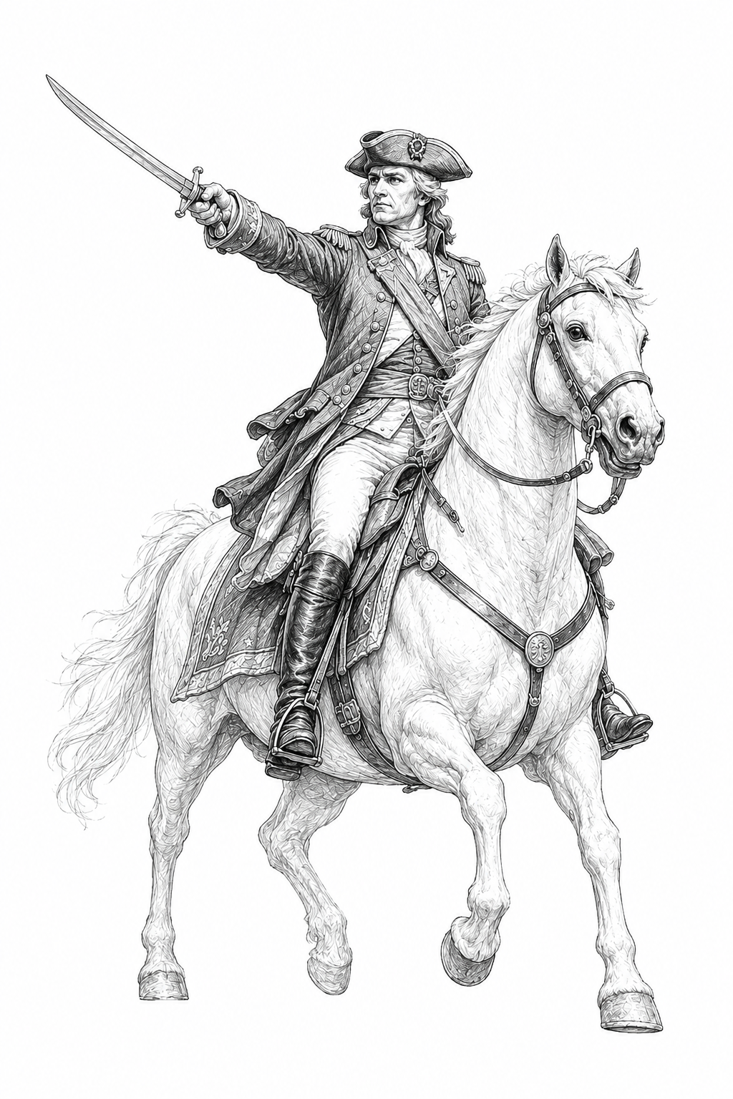 | GENERAL  Forward. Again.  Attack - Forward Pressure - Tempo  The General rides where the line is breaking and turns hesitation into motion. He leads from the decisive point, using Command to advance, rally an attack, and press a defeated enemy before they can recover.  Choose the General when you want to initiate engagements, threaten repeated movement, and convert one successful attack into a larger operation.

General Orders
ORDER | COST | EFFECT
Onward | 1 Command | Move one additional space this turn. This movement may initiate a battle.
Rally | 1 Command | Before dice are rolled in a battle you initiated, add +1 to your battle total.
Rout | 2 Command | After you win a battle you initiated, move one space toward the opponent's Heartland. This movement may initiate another battle.

General priorities
- Create the engagement: Onward helps reach the battle you want, but spending it may leave less Command for Rally or Rout.
- Choose certainty or momentum: Rally improves the current attack. Saving 2 Command threatens Rout after victory.
- Respect the second battle: A follow-up battle is a new battle. Cards and one-battle effects from the first engagement have already resolved and moved to their destinations.
- Know when to stop: The General is rewarded for pressing, but the faction's strongest turns often end with exposed position and depleted cards.
GENERAL SIGNATURE
Rout is the General's defining conversion: a battle win becomes another advance, and possibly another battle. It is powerful because it risks the position and resources earned by the first victory.

3. Military leaders - continued
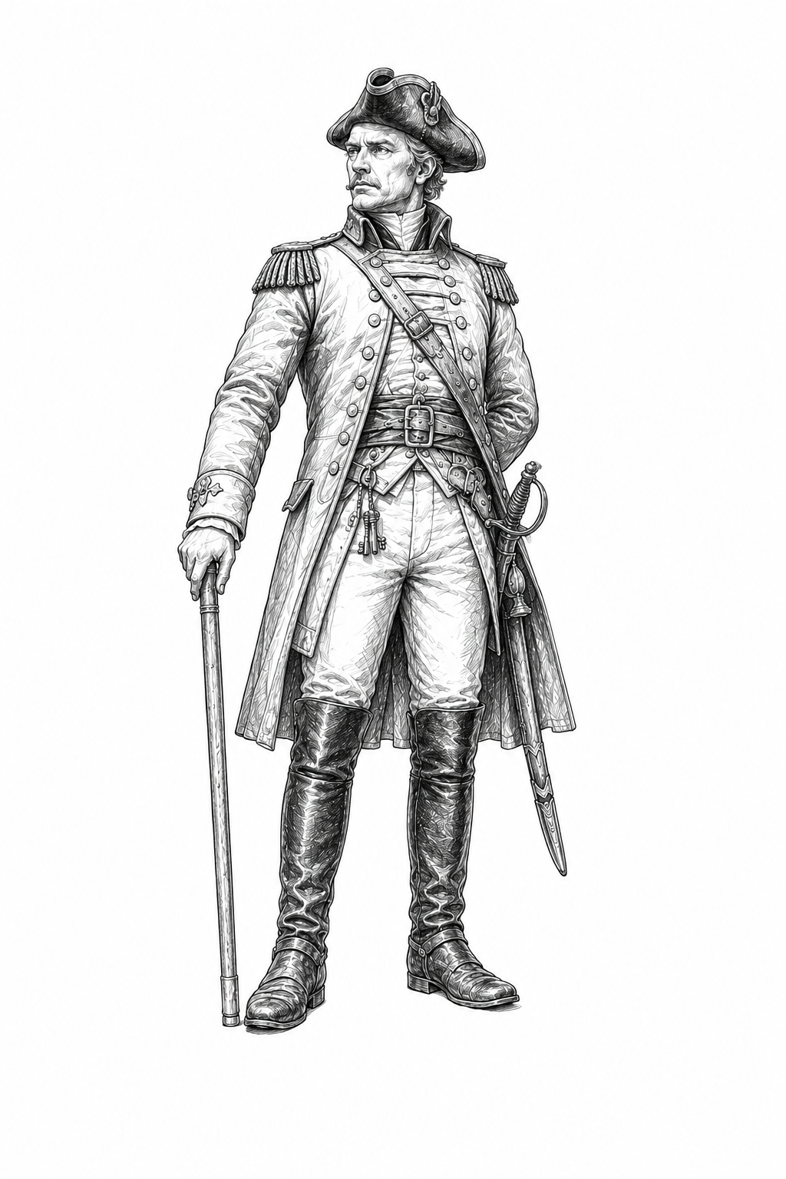 | COMMANDANT  We hold. They break.  Defense - Counterattack - Control  The Commandant is the iron center of the line. He turns ground into position, position into discipline, and a successful defense into deeper retreat pressure, counterattack, or immediate capture.  Choose the Commandant when you want to defend controlled ground, survive the opponent's counterattack, and make an occupation become lasting control.

Commandant Orders
ORDER | COST | EFFECT
Entrench | 1 Command | Before dice are rolled in a battle you did not initiate, add +1 to your battle total.
Repel | 1 Command | After you win a battle you did not initiate, the defeated opponent retreats one additional space, if able.
Fortify | 2 Command | After you win a battle while occupying an enemy Territory, capture that Territory immediately.

Commandant priorities
- Make the counterattack costly: Entrench improves the defense; Repel changes where the defeated attacker ends the turn.
- Secure occupied ground: Fortify turns a victory while occupying enemy Territory into immediate capture, removing the normal delay.
- Use defensive victories offensively: Countercharge and other cards can turn a battle you did not initiate into a new attack.
- Avoid passive play: The Commandant holds ground in order to create durable progress. The leader remains dependent on movement, occupation, battle, and capture.
COMMANDANT SIGNATURE
Fortify rewards the hardest kind of Military victory: winning while already exposed on enemy-controlled ground. It converts that success into control before another counterattack can reopen the position.

4. Playing Military

The central decision
MOMENTUM OR CONSOLIDATION?
After a victory, decide whether the most valuable outcome is another movement, another battle, immediate capture, Command readiness, retreat pressure, card preservation, or simply stopping before you become overextended.

What Military does well
- Victory conversion: Military turns wins into movement, retreat pressure, capture, Command, preserved cards, and prepared operations.
- Commitment coordination: Brothers in Arms, Reserve Force, Hold the Line, and Shock and Awe coordinate hand commitments with battle draw.
- Initiative control: Give Chase and Rout extend an attack; Countercharge turns a defensive victory into a new attack.
- Visible preparation: Assets and Encampment let Military prepare a position or operation that the opponent can see and plan around.
- Leader flexibility: The same card pool changes meaning under the General and Commandant rather than splitting into two separate subfactions.

What Military does not do
- No alternate victory condition. Military must run the Gauntlet.
- No broad hand surveillance, generic cancellation, negotiation, economic denial, or unconditional draw engine.
- No automatic battle superiority. Most advantages require timing, position, Command, preparation, or a prior victory.
- Capture shortcuts are narrow and expensive. Ordinary occupation and counterattack rules still matter.
- Overextension remains dangerous. Follow-up battles can leave the Military player with fewer cards, spent Assets, and poor defensive position.

Building a Military deck
The twelve-card pool is a strategic vocabulary, not a set of required packages. Select cards that support the decisions you want to make, then combine them with Neutral cards and Territories that complement those decisions without erasing Military's weaknesses.
STRATEGIC THREAD | MILITARY CARDS
Command discipline | Unbroken Ranks, Encampment, Field Command
Combined commitment | Brothers in Arms, Reserve Force, Hold the Line, Shock and Awe
Pursuit and initiative | Give Chase, Countercharge
Force preservation | Battlefield Promotion, Rearguard
Victory conversion | War Crimes, Shock and Awe

Playing against Military
- Deny easy first victories when possible; Command is most reliable when Military can choose favorable engagements.
- Watch banked Assets. Military preparation is powerful but visible and competes for Asset-bank capacity.
- Punish the second battle. A Military player who continues an operation may be depleted and out of position.
- Force hard choices between immediate battle strength and saving Command for post-victory Orders.
- Remember that War Crimes and Shock and Awe surrender other victory benefits when their special outcomes are chosen.

5. Military-specific rules reference

Terms used by the card pool
TERM | MEANING IN MILITARY TEXT
Battle-drawn card | A card played from battle draw. It normally goes to discard after the battle unless an effect changes its destination.
Committed from hand | A Battle card deliberately committed from hand. It normally goes to the Graveyard after the battle.
Initiated a battle | Your movement or effect began that battle. The player who initiated it is the attacker.
Did not initiate | You are fighting a battle begun by the opponent, including a defense against an attack or occupation counterattack.
Occupying enemy Territory | Your token is on an opponent-controlled Territory after winning there but before capture.
Defending a Territory you control | Your token was already on a Territory you control when the battle began.
Enemy-controlled Territory | A Territory currently controlled by the opponent, whether or not you occupy it.

Assets and the Asset Bank
- Many Military Action effects bank the card as an Asset. It remains visible and uses one Asset-bank space.
- The Asset-bank limit equals the number of Territories you control. Occupied enemy Territories do not increase the limit until captured.
- If a Military Asset instructs you to put it in the Graveyard, that destination overrides normal voluntary Asset removal.
- Prepared Assets advertise a future threat, allowing the opponent to adapt or attack the underlying position.

Encampment as an Overlay
- Encampment is placed over a revealed Territory and does not use an Asset-bank space.
- Only the top exposed Overlay is active. It supersedes the printed effect immediately beneath it.
- Leaving the Territory does not remove Encampment. Temporary enemy occupation does not remove it.
- When an opponent gains control of that Territory, Encampment goes to its owner's Graveyard.
- Heartlands are not Territories and cannot receive Encampment.

Additional Battle cards after reveal
When a Military effect lets you play a Battle card after all Battle cards are revealed, play it face up. You may play it only if its Battle effect can still resolve at that timing. The card retains its source and follows the destination specified by the effect or the normal destination for that source.

Conflicting victory benefits
Several Military effects change what happens after victory. Follow the specific card text. War Crimes and Shock and Awe explicitly prohibit additional movement, capture, or Orders from that victory after their special outcome is chosen. When multiple effects would replace the same movement, capture, retreat, or card destination, apply the core rules for replacement effects and resolve only legal combinations.
CORE RULES STILL APPLY
This section collects only the rules most often referenced by Military cards. Use the v0.6 core rulebook for the full battle sequence, retreat, occupation, capture, Asset Bank, Overlay, and replacement-effect procedures.

6. Canonical Military card pool
The following entries are the canonical v0.6 Military names, costs, complexity, uniqueness, and exact player-facing text. A battle-drawn card is a card played from battle draw.
Unbroken Ranks Cost 1 | Basic
ACTION: Bank this as an Asset. After you win a battle in which you used no Orders, you may discard it to gain 1 Command.
BATTLE: When you win this battle, if you used no Orders in it, gain 1 Command.
PLAY NOTE: Rewards winning without Orders; its Command gain occurs before a post-victory Order from that battle.

Battlefield Promotion Cost 2 | Basic
ACTION: Play after you win a battle. Return one battle-drawn card you played in that battle from your discard pile to your hand.
BATTLE: If you win, return one other battle-drawn card you played to your hand instead of discarding it during cleanup.
PLAY NOTE: Turns an uncertain battle-drawn card into a reliable future hand card.

Encampment Cost 2 | Advanced - Territory Overlay
ACTION: Place this as an Overlay on a revealed Territory you occupy and control.
OVERLAY: At the end of your turn, if you occupy and control this Territory, gain 1 Command. When an opponent gains control of it, put this in its owner's Graveyard.
BATTLE: If you win while defending a revealed Territory you control, place this on it as an Overlay during cleanup.
PLAY NOTE: While exposed, Encampment supersedes the printed effect immediately beneath it.

Rearguard Cost 2 | Advanced
ACTION: Bank this as an Asset. After you lose a battle and retreat, when your opponent would enter your space that turn using an Order or card effect, you may discard this to prevent that movement. No Command is spent; any card used returns to its owner's hand.
BATTLE: If you lose and retreat, bank this during cleanup.
PLAY NOTE: Prevents one immediate pursuit effect without reversing the original battle loss.

Brothers in Arms Cost 2 | Advanced
ACTION: Bank this as an Asset. Before committing a Battle card from hand, you may discard this to delay that commitment until after your initial battle draw. Then play one Battle card from hand and one from that draw face up together, or play neither. Both Battle effects must still be able to resolve.
BATTLE: If this is in your initial battle draw and you committed no card from hand, you may choose it as your battle-drawn play and play one Battle card from hand face up with it.
PLAY NOTE: Pairs exactly one hand commitment with one battle-drawn play; it does not create a third play.

Field Command Cost 3 | Advanced
ACTION: Bank this as an Asset. After using a 1-Command Order, you may discard this to use your leader's other 1-Command Order once this turn, at its next legal timing, for 0 Command.
BATTLE: After using a 1-Command Order during this battle, you may use your leader's other 1-Command Order once this turn, at its next legal timing, for 0 Command. If you do, put this in your Graveyard after that Order resolves.
PLAY NOTE: General combines Onward and Rally; Commandant combines Entrench and Repel.

Reserve Force Cost 3 | Advanced
ACTION: Bank this as an Asset with another Battle card from your hand face down beneath it. After all Battle cards are revealed in a battle involving you, you may discard this to play the stored card face up as an additional Battle card, if its Battle effect can still resolve. Put the stored card in your Graveyard during cleanup, or immediately if this leaves play before deployment.
BATTLE: After all Battle cards are revealed, you may replace this with a Battle card from your hand whose Battle effect can still resolve. If you do, put this in your Graveyard and play that card face up. Otherwise, discard this during cleanup.
PLAY NOTE: The Action form is visible preparation; the Battle form is a provisional commitment.

Give Chase Cost 3 | Advanced
ACTION: Play after you win a battle you initiated. Move one space toward the opponent's Heartland. This may initiate a battle.
BATTLE: If you win and initiated this battle, after the opponent retreats, move one space toward their Heartland. This may initiate a battle.
PURSUIT: In a battle initiated this way, you cannot commit from hand or use Orders. Draw one fewer card in its initial battle draw for each prior battle this turn after the first, to a minimum of zero. After the movement, put this in your Graveyard.
PLAY NOTE: The battle-draw reduction counts every additional battle already fought that turn, regardless of cause.

Hold the Line Cost 4 | Advanced
ACTION: Bank this as an Asset. When a battle begins in which you defend a Territory you control, before Battle cards are committed, you may put this in your Graveyard to use the effect below.
BATTLE: If you are defending a Territory you control, use the effect below, then put this in your Graveyard during cleanup.
EFFECT: After all Battle cards are revealed, draw two additional battle cards and immediately play up to one face up as an additional Battle card, if its Battle effect can still resolve. If you lose, after you retreat, the opponent captures that Territory immediately.
PLAY NOTE: Does not apply in a Heartland because Heartlands are not Territories.

Countercharge Cost 4 | Advanced
ACTION: Bank this as an Asset. After you win a battle you did not initiate, you may put this in your Graveyard to use the effect below.
BATTLE: If you win this battle and did not initiate it, use the effect below, then put this in your Graveyard.
EFFECT: After the opponent retreats, move one space toward their Heartland. This may initiate a battle.
PLAY NOTE: The follow-up battle is unrestricted and can occur during the opponent's turn.

War Crimes Cost 4 | Advanced
ACTION: Bank this as an Asset. After you win a battle, you may put this in your Graveyard to use the effect below.
BATTLE: If you win, you may use the effect below. If you do, put this in your Graveyard during cleanup.
EFFECT: Put every battle-drawn card your opponent played in that battle in their Graveyard instead of their discard pile, and make them retreat one additional space. You cannot move, capture a Territory, or use an Order as a result of that victory.
PLAY NOTE: Trades all normal exploitation from that victory for permanent enemy card loss and retreat pressure.

Shock and Awe Cost 5 | Advanced | UNIQUE
ACTION: Bank this as an Asset. When you initiate a battle on an enemy-controlled Territory, before Battle-card commitments, you may put this in your Graveyard to use the effect below.
BATTLE: If attacking on an enemy-controlled Territory, use the effect below, then put this in your Graveyard during cleanup.
EFFECT: After all Battle cards are revealed, you may play one Battle card from hand face up as an additional Battle card if its Battle effect can still resolve. During cleanup, if you lose, retreat one additional space after your normal retreat. If you win, choose Breakthrough or Consolidate.
BREAKTHROUGH: Choose only if the opponent can retreat one additional space. They do so after their normal retreat; then move one space toward their Heartland. This cannot initiate a battle.
CONSOLIDATE: Capture the contested Territory immediately, then set your Command to 2.
LIMIT: After either option, you cannot move again, capture another Territory, or use an Order from that victory.
PLAY NOTE: Military's statement card: commit heavily, accept a deeper retreat on failure, and choose positional breakthrough or immediate consolidation on success.

7. Card-pool summary and deckbuilding reference

Pool profile
COST | CARDS
Cost 1 | Unbroken Ranks
Cost 2 | Battlefield Promotion; Encampment; Rearguard; Brothers in Arms
Cost 3 | Field Command; Reserve Force; Give Chase
Cost 4 | Hold the Line; Countercharge; War Crimes
Cost 5 | Shock and Awe
Total | 12 unique cards; total unique-card value 35; average cost 2.92

Selecting cards
- For a proactive General deck: consider Give Chase, Brothers in Arms, Reserve Force, Battlefield Promotion, and Shock and Awe, then add enough defensive or recovery tools to survive the position you create.
- For a consolidating Commandant deck: consider Encampment, Hold the Line, Rearguard, Countercharge, and War Crimes, while retaining enough movement to avoid becoming passive.
- For Command-heavy play: Unbroken Ranks, Encampment, and Field Command increase the value of careful Order sequencing, but none replaces the need to win battles.
- For prepared operations: banked Assets are visible and compete for limited space. Avoid filling the Asset Bank with plans that cannot all resolve in time.
- For mixed plans: the faction is designed for overlapping synergies. Do not assume every card in a strategic thread must appear together.

Uniqueness and copies
Shock and Awe is Unique: maximum one copy per deck. The other Military cards use the normal v0.6 copy rules. Costs count toward the deckbuilding-value limit established in the core rules.

Complexity
Basic cards are suitable for straightforward or introductory deck construction. Advanced cards introduce more timing, preparation, source, destination, or follow-up-battle interactions. Complexity is a player aid, not an additional in-game rule.
RELEASE AUTHORITY
This guide and the v0.6 canonical data should match exactly. If a historical draft, approval note, development conversation, or earlier card sheet differs, use the text in this guide until a later official v0.6 revision replaces it.

Appendix A. Military quick reference

Command
COMMAND
Maximum 2. The first time each turn you win a battle, gain 1 Command. Spend Command to use Orders. Track 0, 1, or 2 by sliding the Leader Card over the Command Tracker.

General Orders
ORDER | COST | EFFECT
Onward | 1 | Move one additional space this turn; may initiate a battle.
Rally | 1 | Before dice in a battle you initiated, +1 to your battle total.
Rout | 2 | After winning a battle you initiated, move one space toward the enemy Heartland; may initiate another battle.

Commandant Orders
ORDER | COST | EFFECT
Entrench | 1 | Before dice in a battle you did not initiate, +1 to your battle total.
Repel | 1 | After winning a battle you did not initiate, the defeated opponent retreats one additional space, if able.
Fortify | 2 | After winning while occupying enemy Territory, capture it immediately.

Card list by cost
COST | MILITARY CARDS
1 | Unbroken Ranks
2 | Battlefield Promotion; Encampment; Rearguard; Brothers in Arms
3 | Field Command; Reserve Force; Give Chase
4 | Hold the Line; Countercharge; War Crimes
5 | Shock and Awe - Unique

Five reminders
- Only the first Military victory during each turn generates normal Command.
- A battle-drawn card is a card played from battle draw; it normally goes to discard.
- A hand commitment normally goes to the Graveyard.
- Heartlands are not Territories. Territory-only Military effects do not apply there.
- After War Crimes or a Shock and Awe victory option, obey that card's limit on additional movement, capture, and Orders from the same victory.

END OF MILITARY FACTION GUIDE

