**SENG8030**

**Testing Tools________________________________________________________**

**Assignment #1 – Defect Logging – due September 18th @ 11:00AM – in eConestoga.**

**75 Marks – worth 7.5%**

*This is an individual assignment. Do your own work and do not share your work with others. Sharing work is an Academic Offense and is subject to a penalty. Be aware that all source code and other documentation is automatically checked by eConestoga upon submission.*

For this assignment, we are going to practice logging defects for a Windows based application that adds two numbers. Your job as a Lead QA Analyst is to (a) test this application and (b) find as many defects as possible. Once you have found each defect, proceed to log them using the MantisBT bug tracking tool.

You will find the application to test in eConestoga as well – simply download and unzip this file on to your Windows laptop and double click on the .exe file. Test this application from your knowledge of how Windows applications should behave and also see how user friendly it is (or not).

As you’re testing this application, you may encounter some defects 😊 Your job now, is to log each defect with this application using MantisBT as mentioned above. You will then submit one Word document that contains all of your found defects as screenshots. Having said this, there are a lot more than five defects. Your job is to find as many defects as possible with this application and log them.

**XAMPP Installation**

Before you can install MantisBT, you’ll need to install XAMPP first. Download the latest version of XAMPP from here: <https://www.apachefriends.org/download.html>

Start the XAMPP Console after the installation:

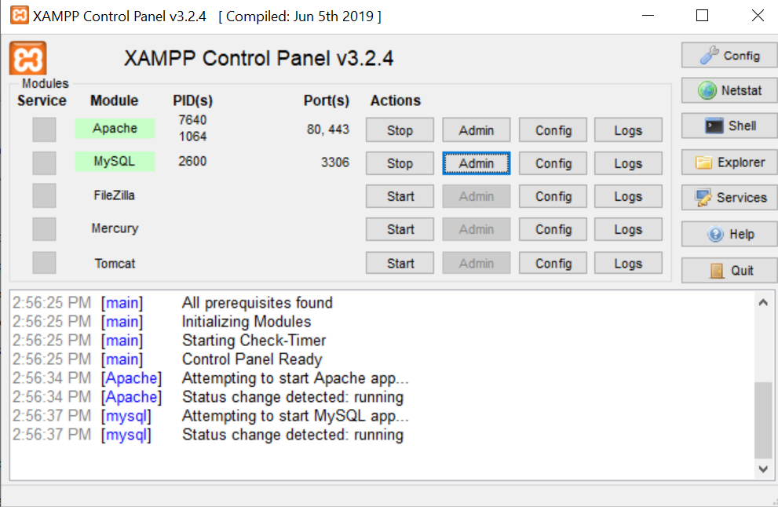

(the XAMPP console is available in the directory where you installed XAMPP with the filename: xampp-control.exe)

Click on the “Start” buttons for both Apache and MySQL

**Mantis BT Installation**

Download and install MantisBT from the following link: <https://www.mantisbt.org/download.php>

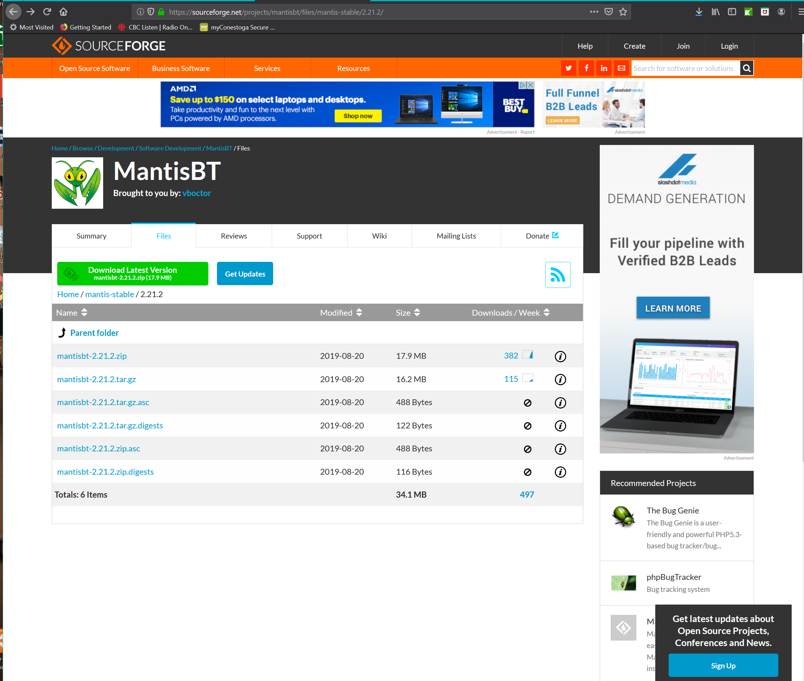

Proceed with the download and then extract the files to someplace on your computer’s hard-drive.

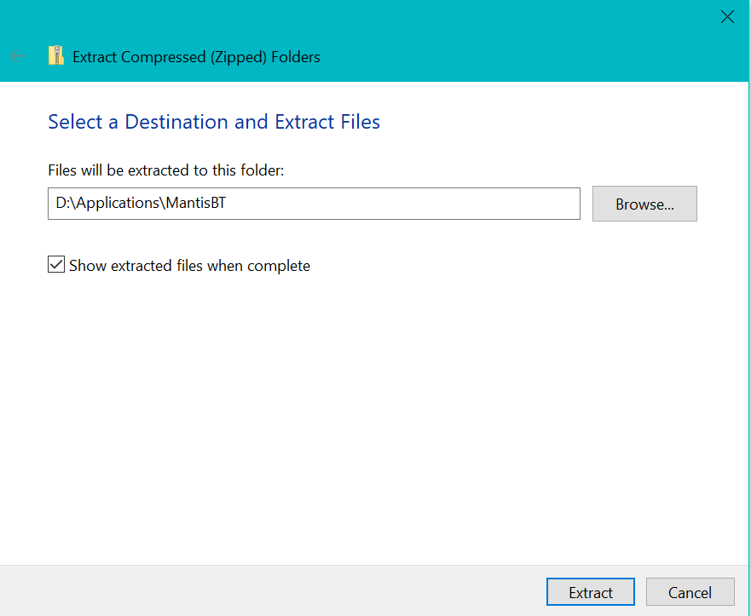

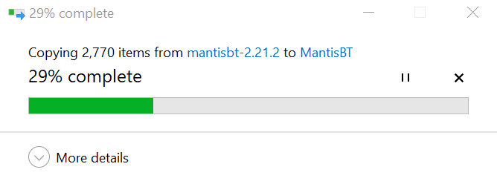

Next, copy the contents of the folder where the files were extracted into the c:\xampp\htdocs\mantisbt folder – **note:** that this folder must be called mantisbt and should look something like this:

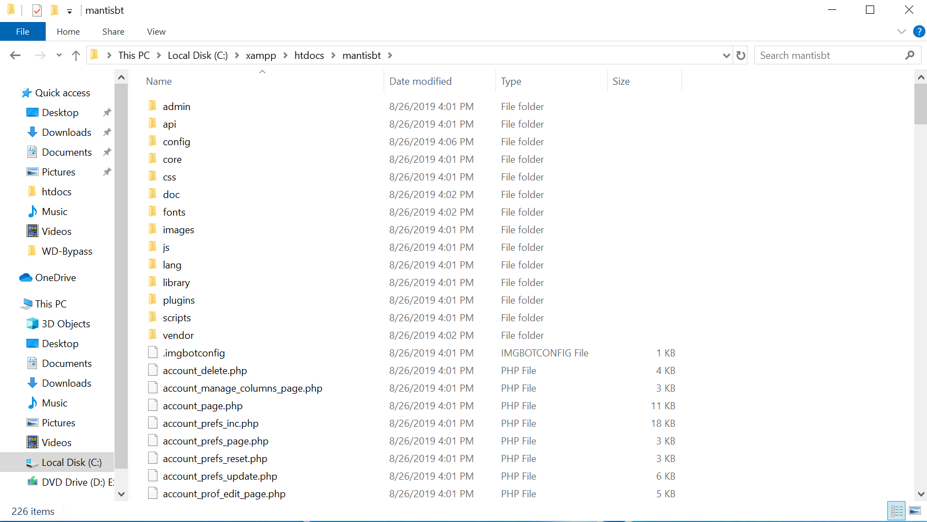

Access the following link: <http://localhost/mantisbt/admin/install.php> and click on the Install / Upgrade Database button

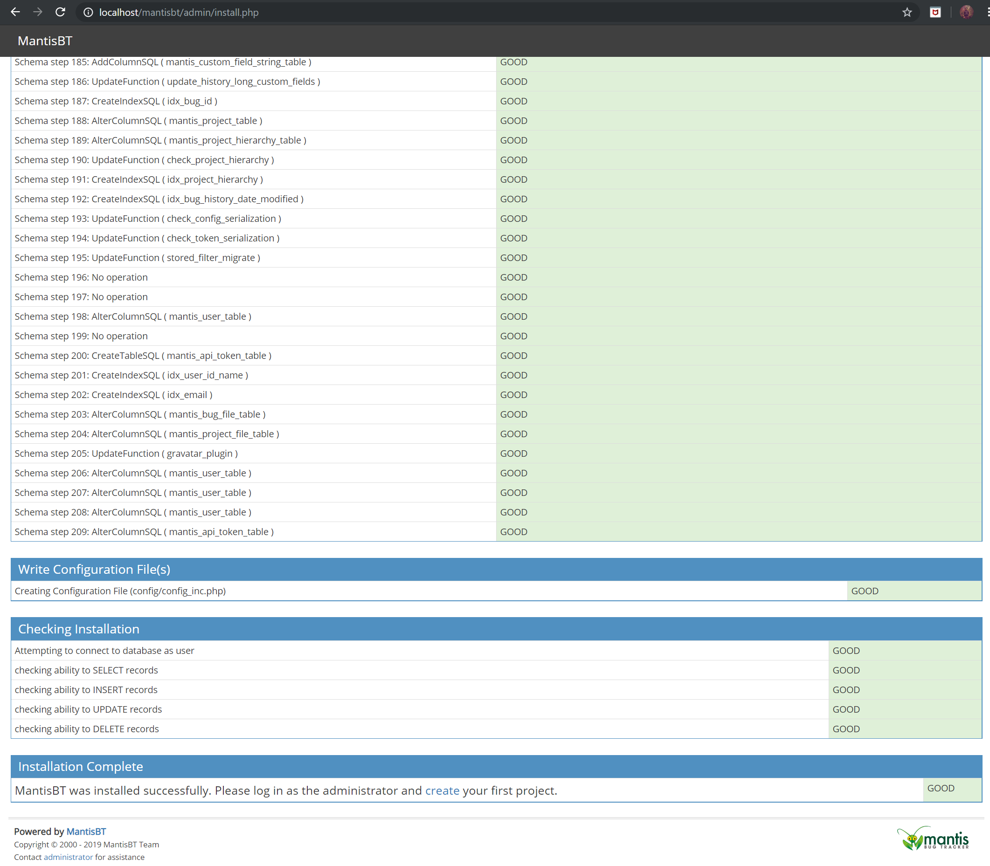

Login using the following credentials:

**Username:** administrator

**Password:** root

Click on the My View in the top left to see the current status of all defects (there should be none):

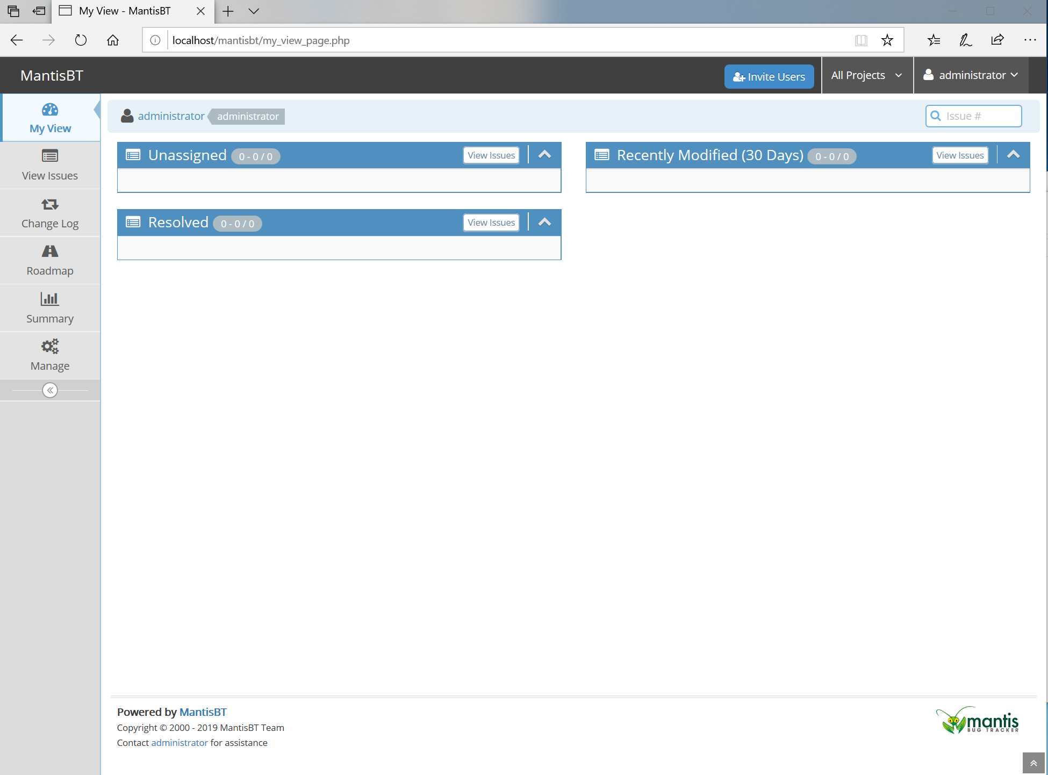

Go to Manage and then Manage Projects:

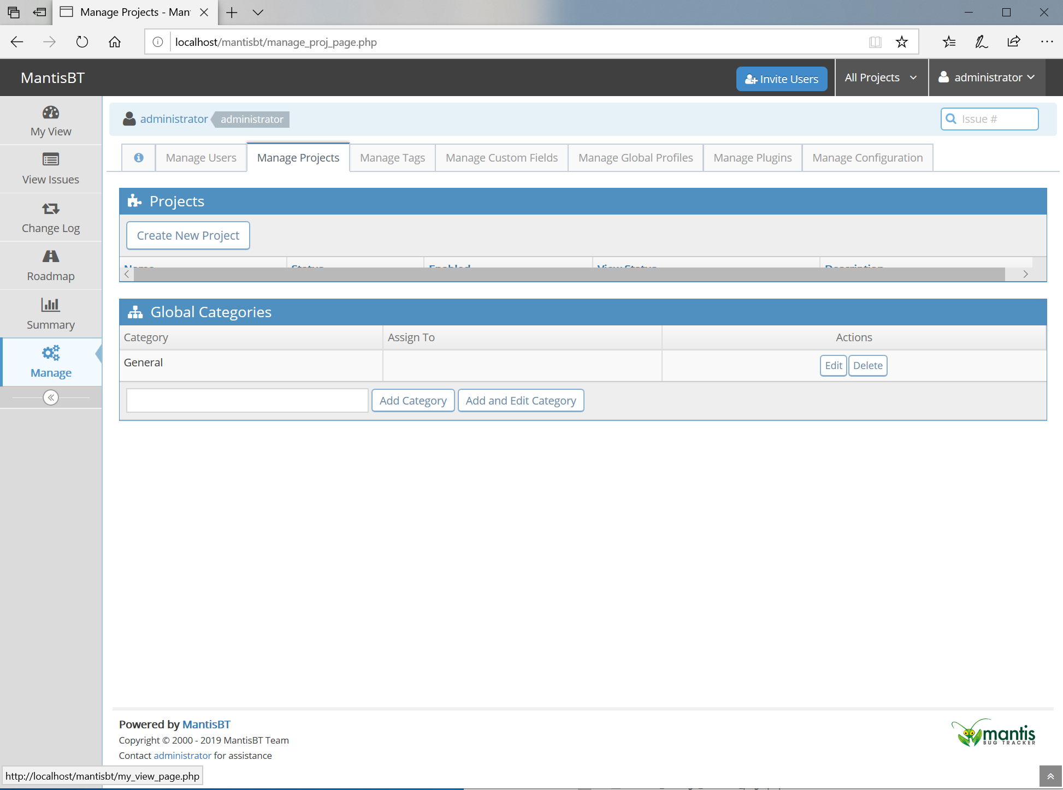

Click on: “Create New Project” and call it “SENG8030 Assignment #1_{your name}” – where {your name} is your first name only – do not include the {}’s 😊

Next, go to “Report Issue” and fill in the appropriate fields as well as (as applicable) upload any screenshots (in the Upload Files section of the Defect Report) or other important details of the defect, and then click on “Submit Issue”

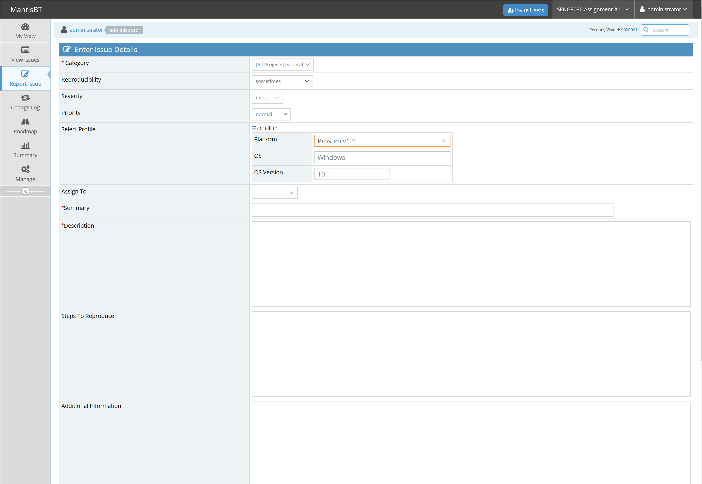

Continue with the above process for logging all of the defects that you were able to find. Be sure to log them with the correct “Severity” and “Reproducibility” values.

In terms of Severity, there should be at least one defect logged for each of the following five Severity levels (in order of decreasing Severity):

* Crash
* Major
* Minor
* Text
* Feature

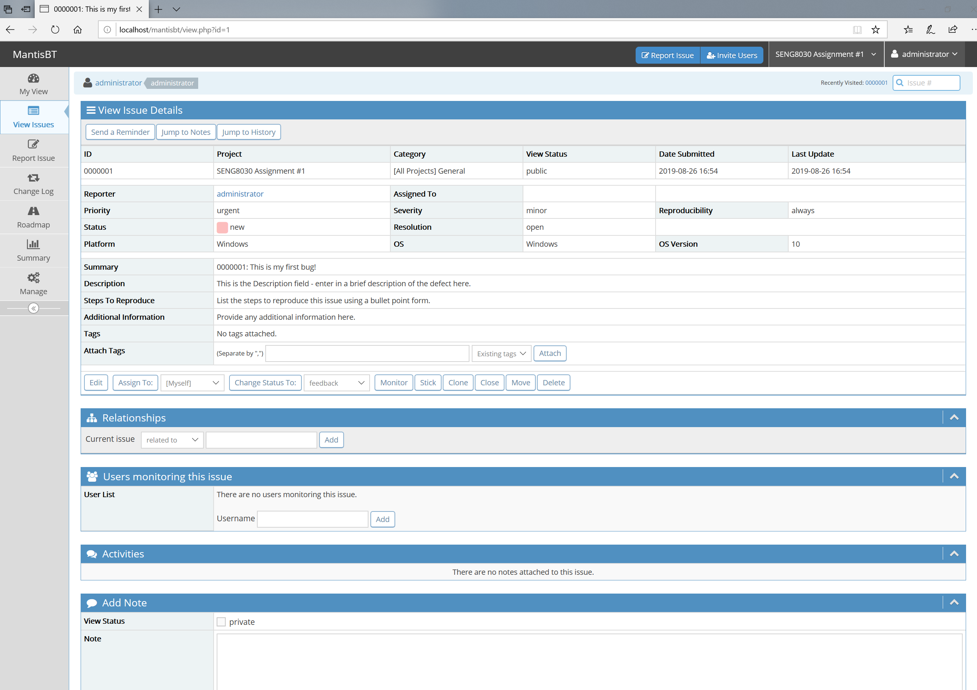

Once you’ve finished logging all of the defects for the application, go to the “Summary” section and take two screenshots – one for the “Synthesis” and one for “By Severity” as shown in the below examples:

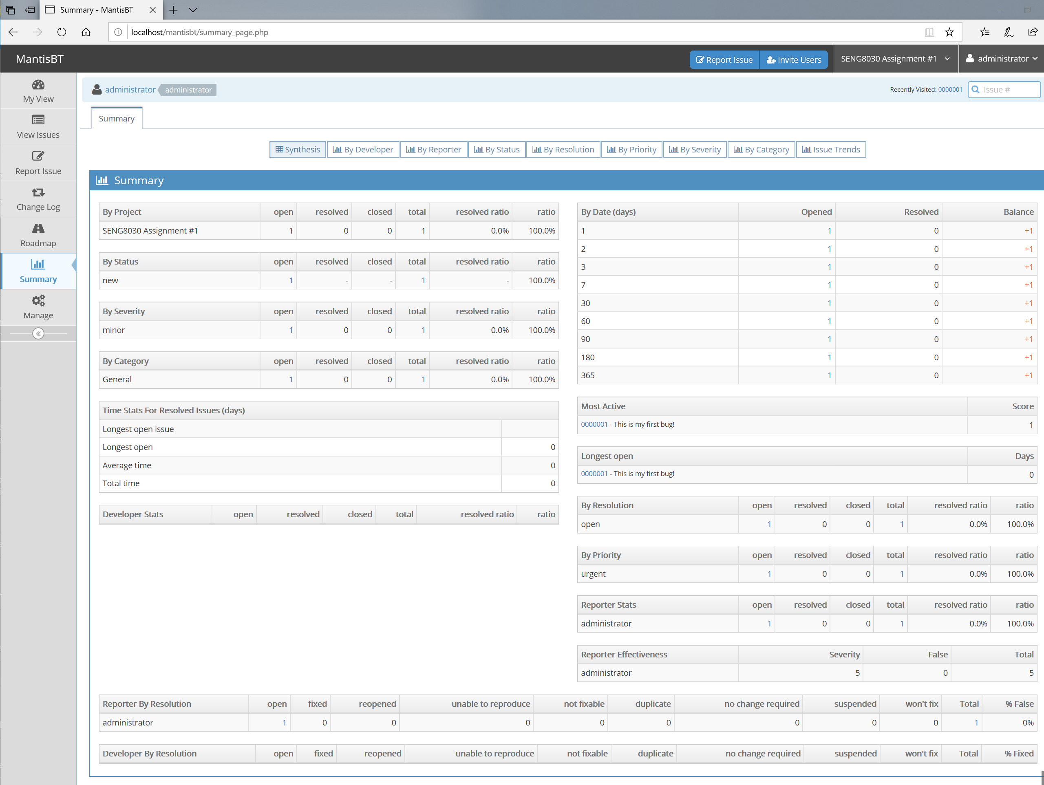

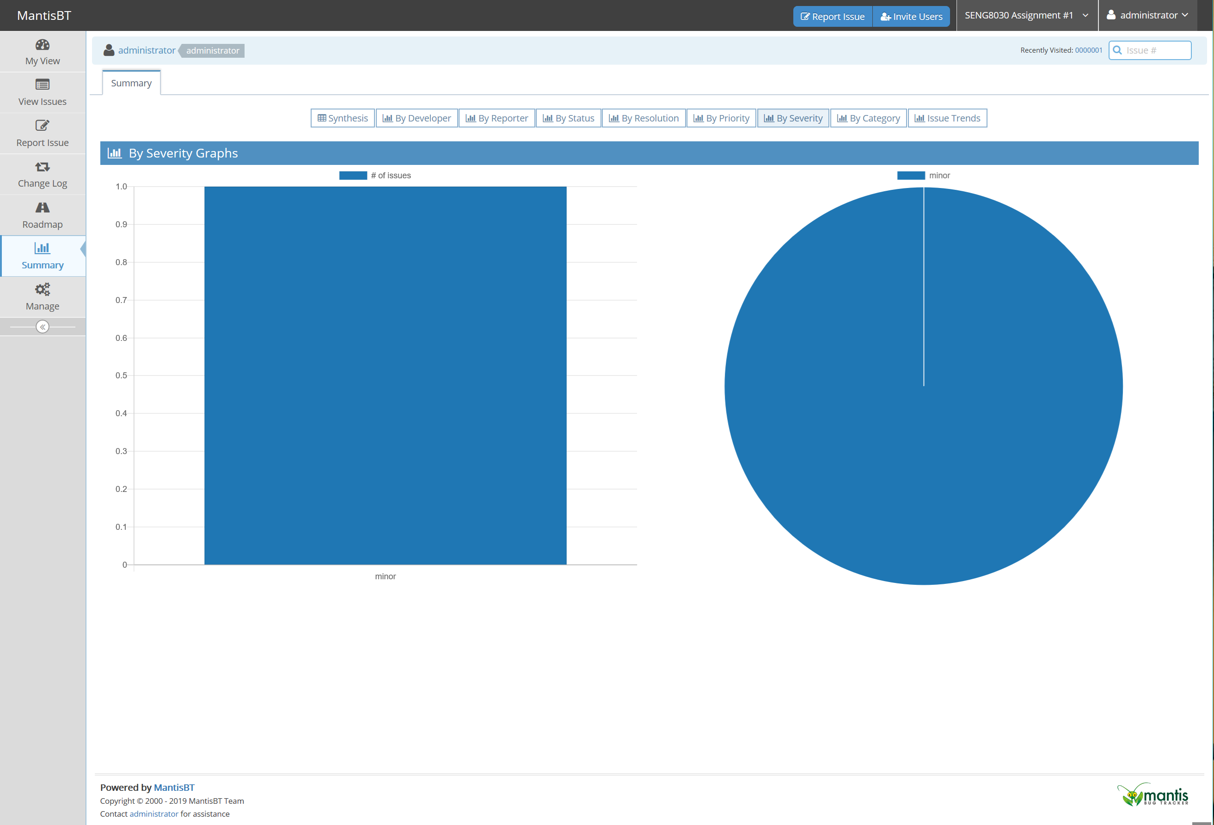

What can you conclude about the defects that were found and more importantly, the Quality of this application? Provide your answer to this question in the same MS Word document as your screenshots.

**Submissions**

The format for submitting the assignment is as follows:

1. eConestoga submissions:

A single MS Word document with:

* + 1. Assignment Title Page with your name, student ID, “Assignment #1” in the title and date;
    2. A listing of all of the defects as screenshots from MantisBT found with the ProSum application **[60 Marks]**
    3. Screenshots of the Synthesis and By Severity reports **[10 Marks]**
    4. Answer to the question about the overall Quality of the application **[5 Marks]**
    5. Please submit to the **“Assignment #1”** assignment folder in eConestoga.

**Late penalties will apply for any late submissions.**

**Do not zip your file – submit it as a single MS Word document otherwise, a -10% penalty will be applied.**