**Assignment #3**

**Tymur Koltunov**

**StudentID 8672727**

**03/11/2019**

**Rubrics**

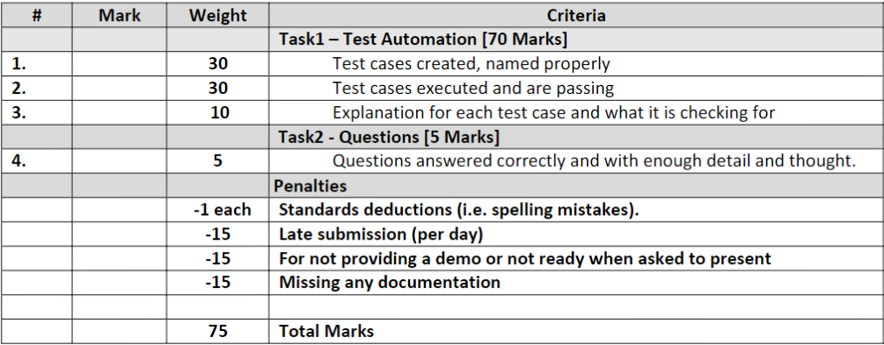

**Task 1**

#1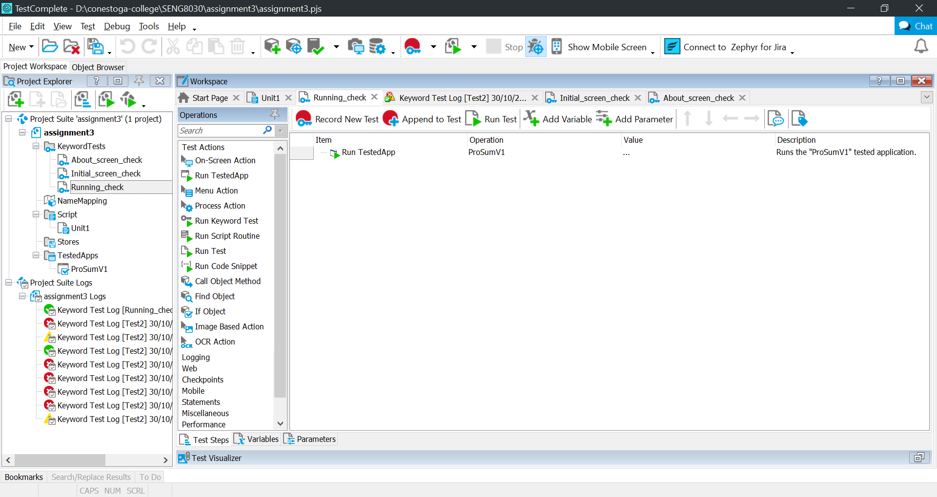

Test checking if the application starts without errors.

#2

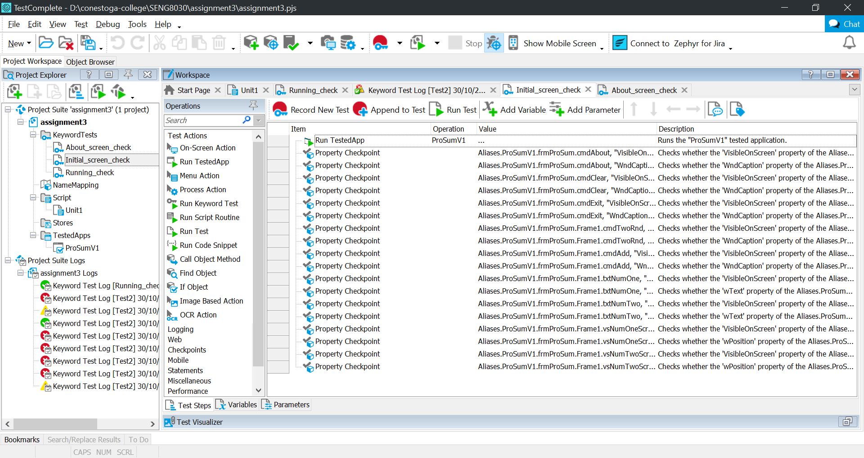

Test checking presence and spelling of elements on initial screen. “About”, “Clear”, “Exit”, “Add ‘Em Up”, “Pick Two Random Numbers” buttons, number fields and number one, number two scrolls.

#3

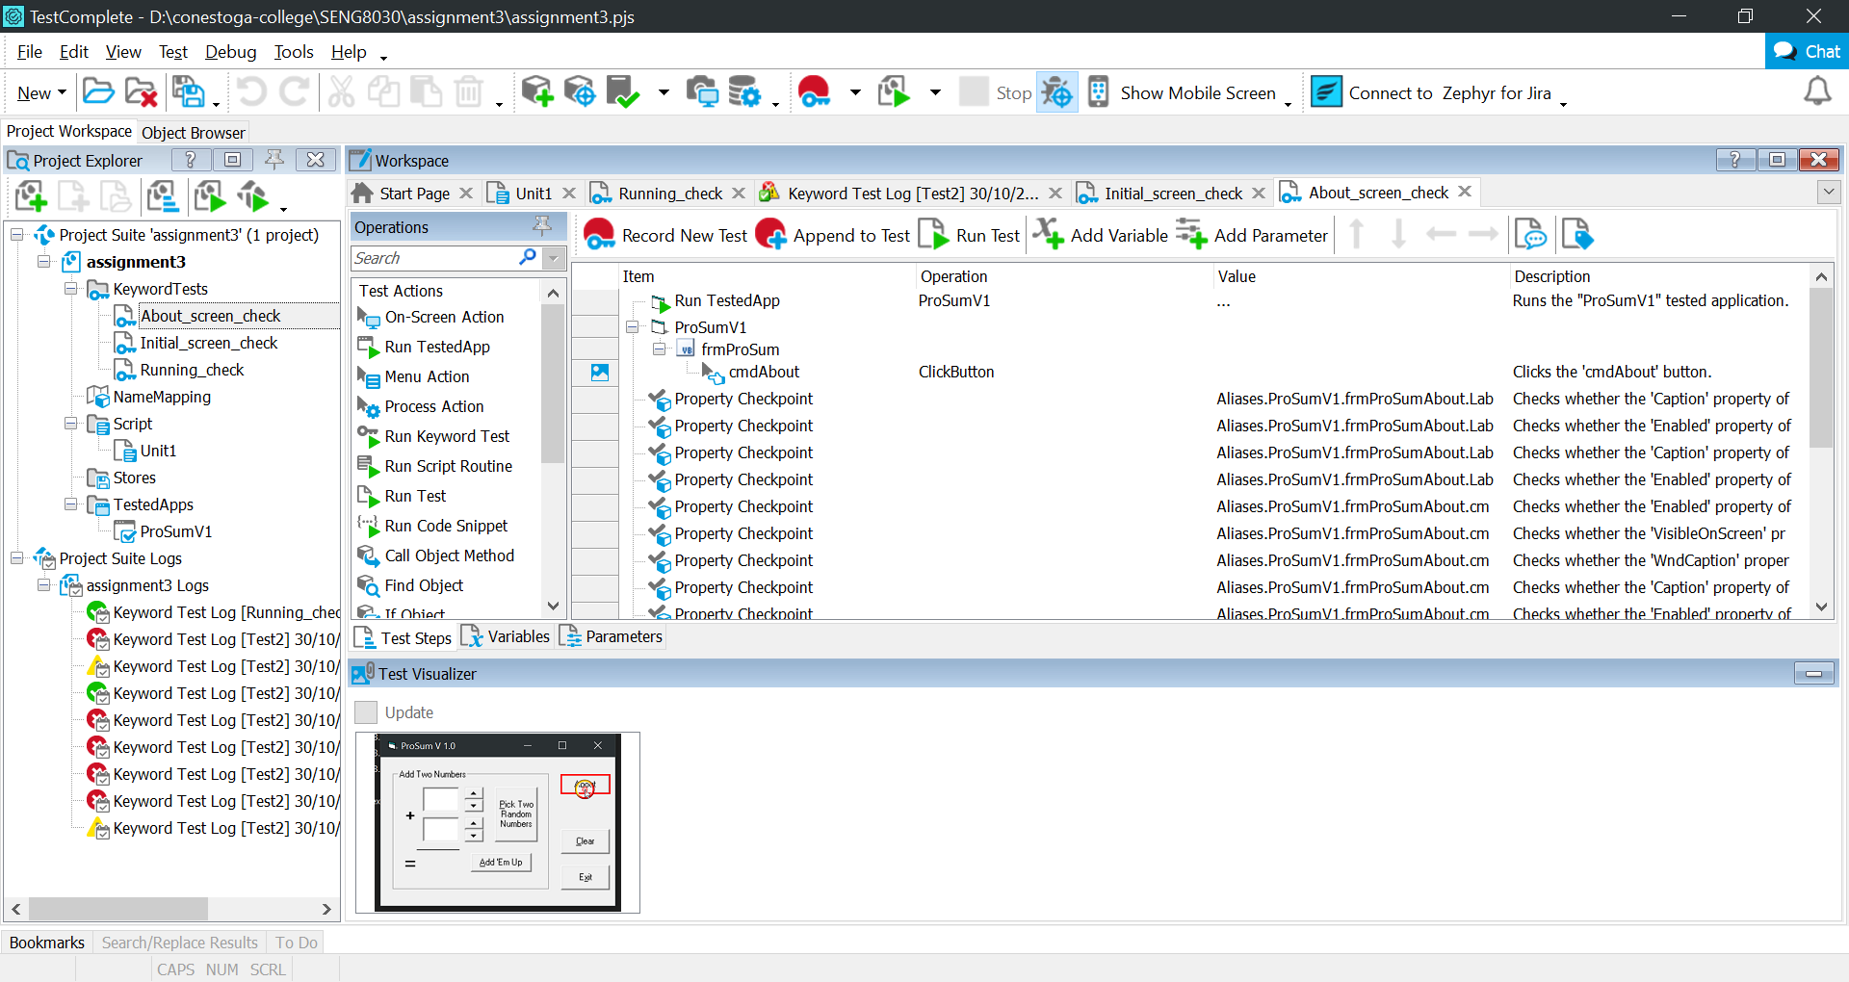

Test checking presence and spelling of elements on “About” screen. “OK”, “Fine”, “Cancel”, “Exit” buttons, and text on the screen.

#4

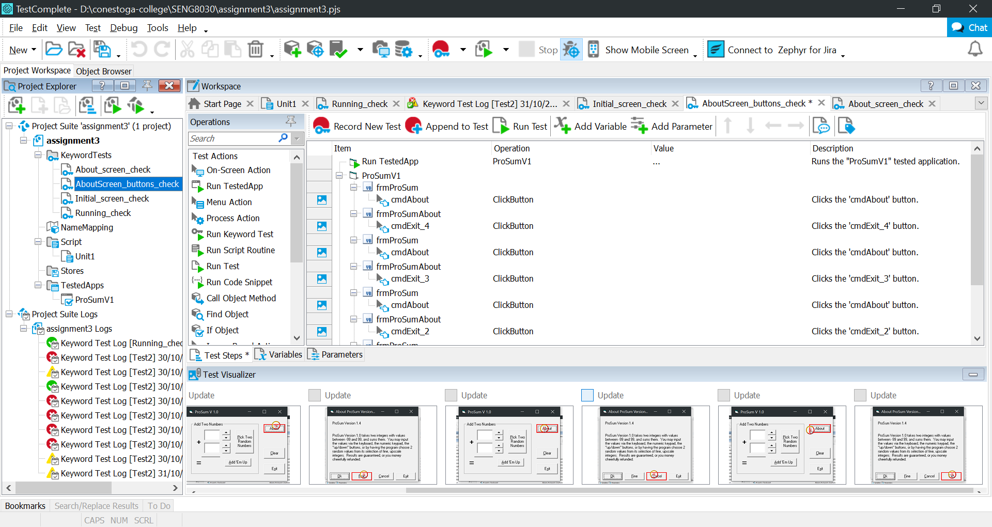

Test checking that buttons in “About” window are working as required and that they do not alter initial screen in any way.

#5

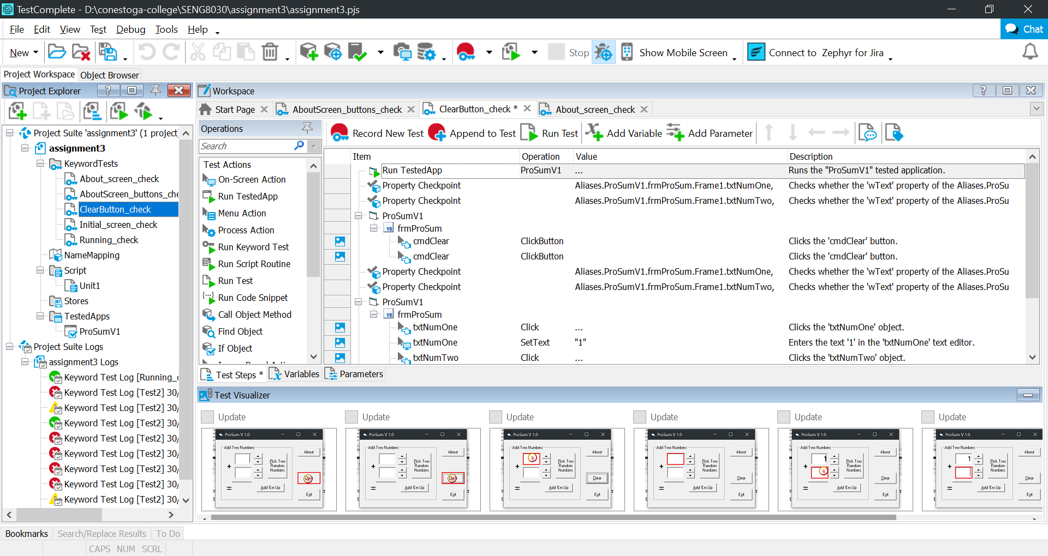

Test is verifying “Clear” button behavior.

#6

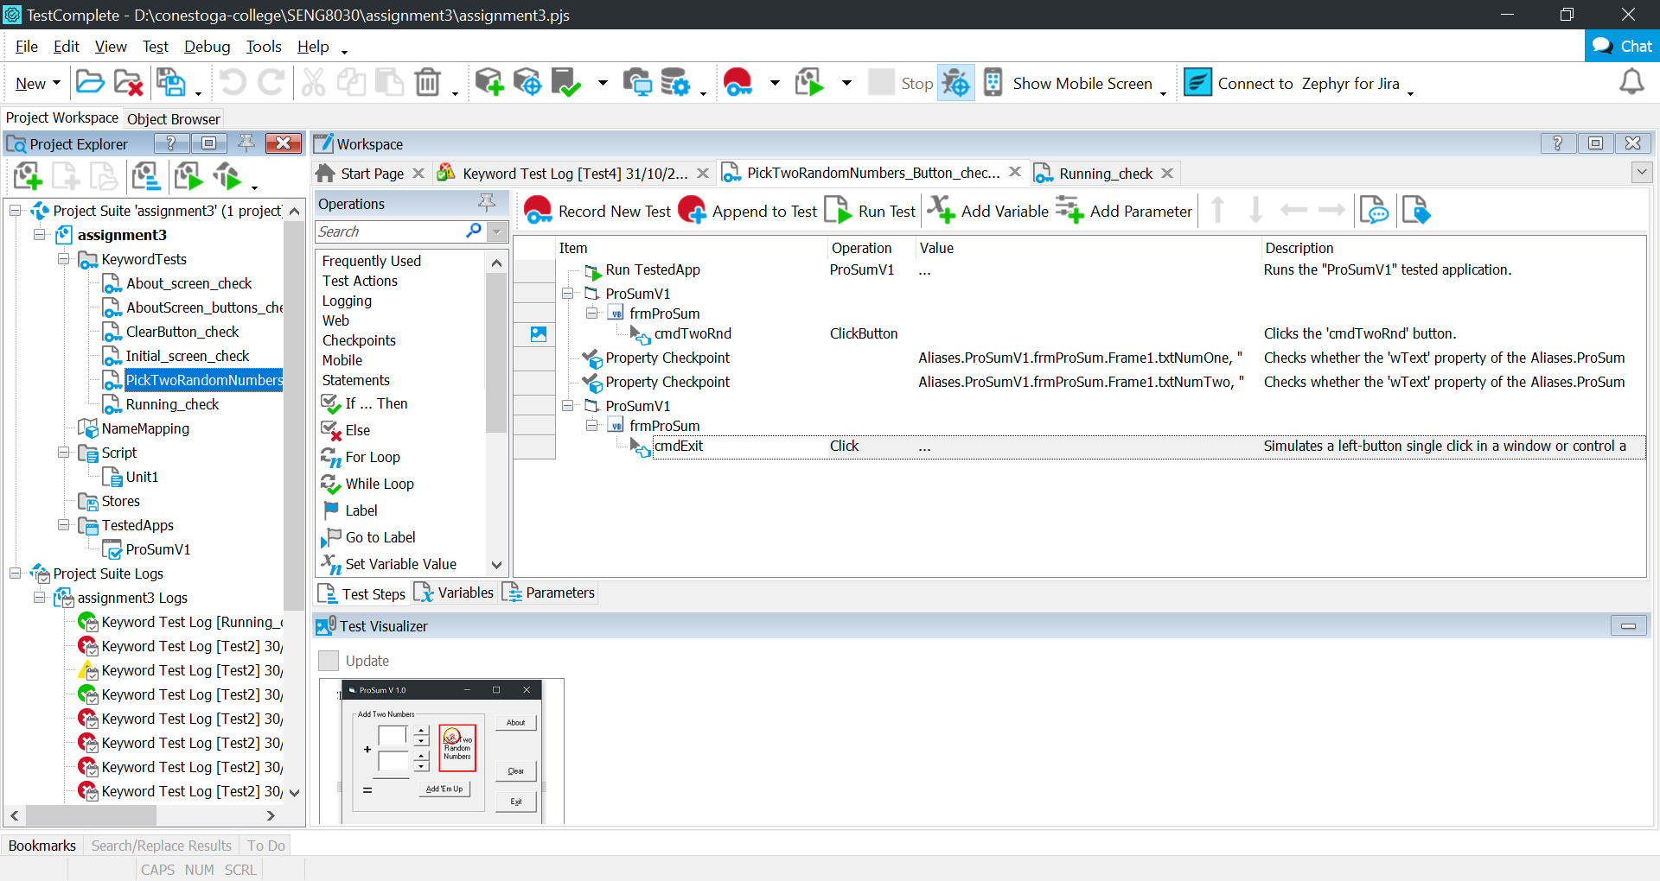

Test checking “Pick Two Random Numbers” button. It verifies that after pressing this button number fields are not empty.

#7

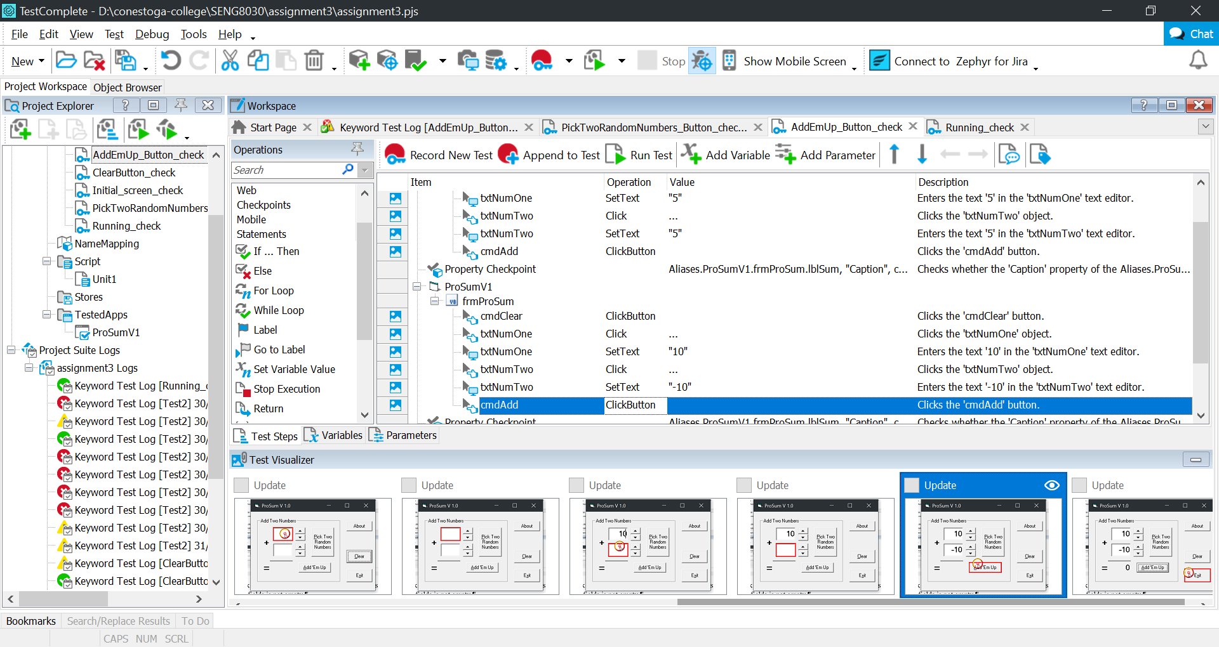

Test verifying behavior of “Add ‘Em Up” button when 2 valid integers entered.

#8

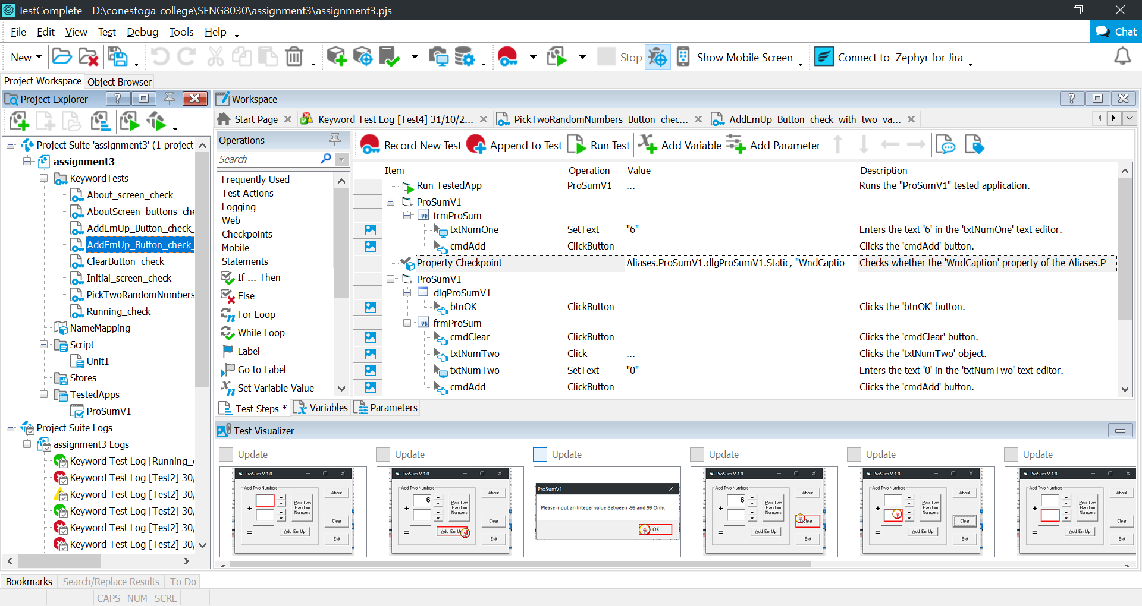

Test is verifying error appearance if one of the fields is empty upon pressing “Add ‘Em Up” button.

#9

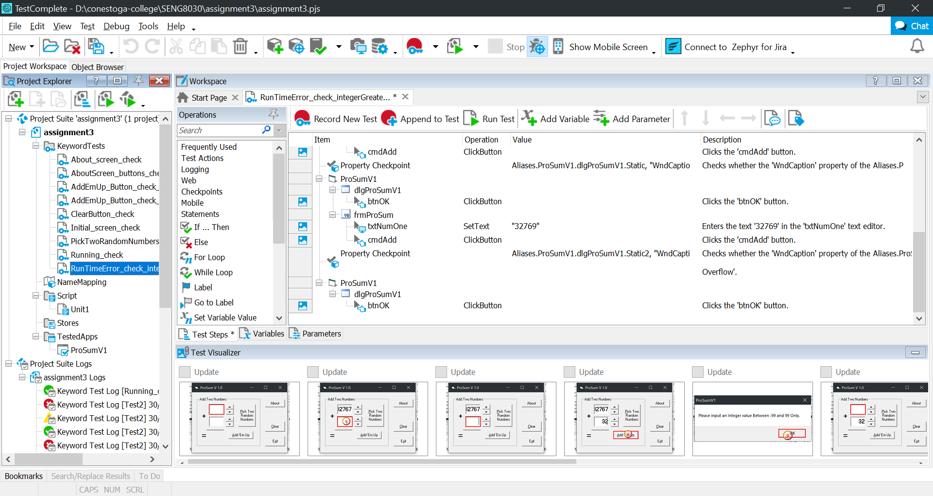

Test is verifying that runtime error appears on integers greater than 32768.

#10

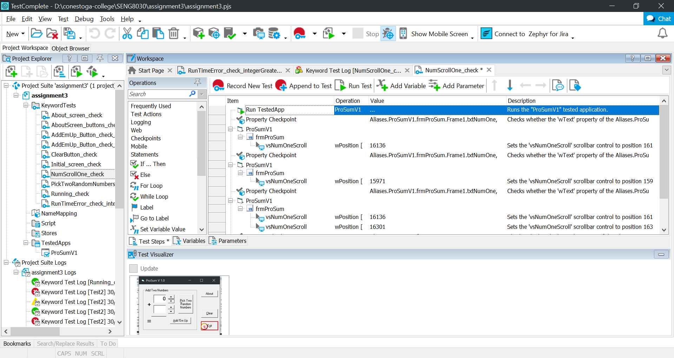

Test is checking behavior of NumScrollOne. Number should be increased by 1 and decreased by 1 upon pressing corresponding buttons.

#11

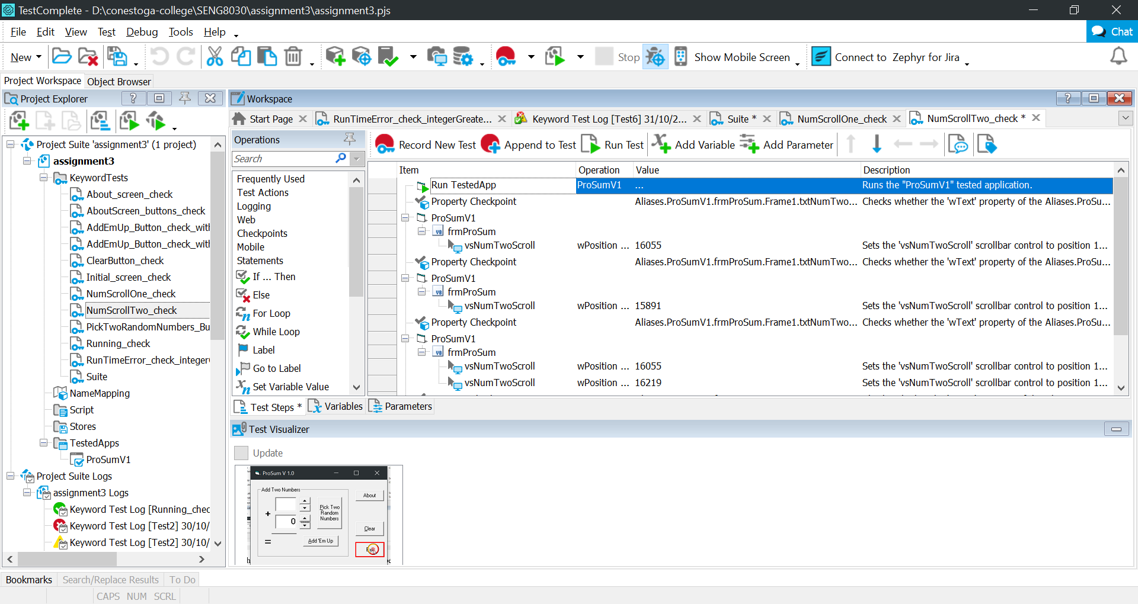

Test is checking behavior of NumScrollTwo. Number should be increased by 1 and decreased by 1 upon pressing corresponding buttons.

#12

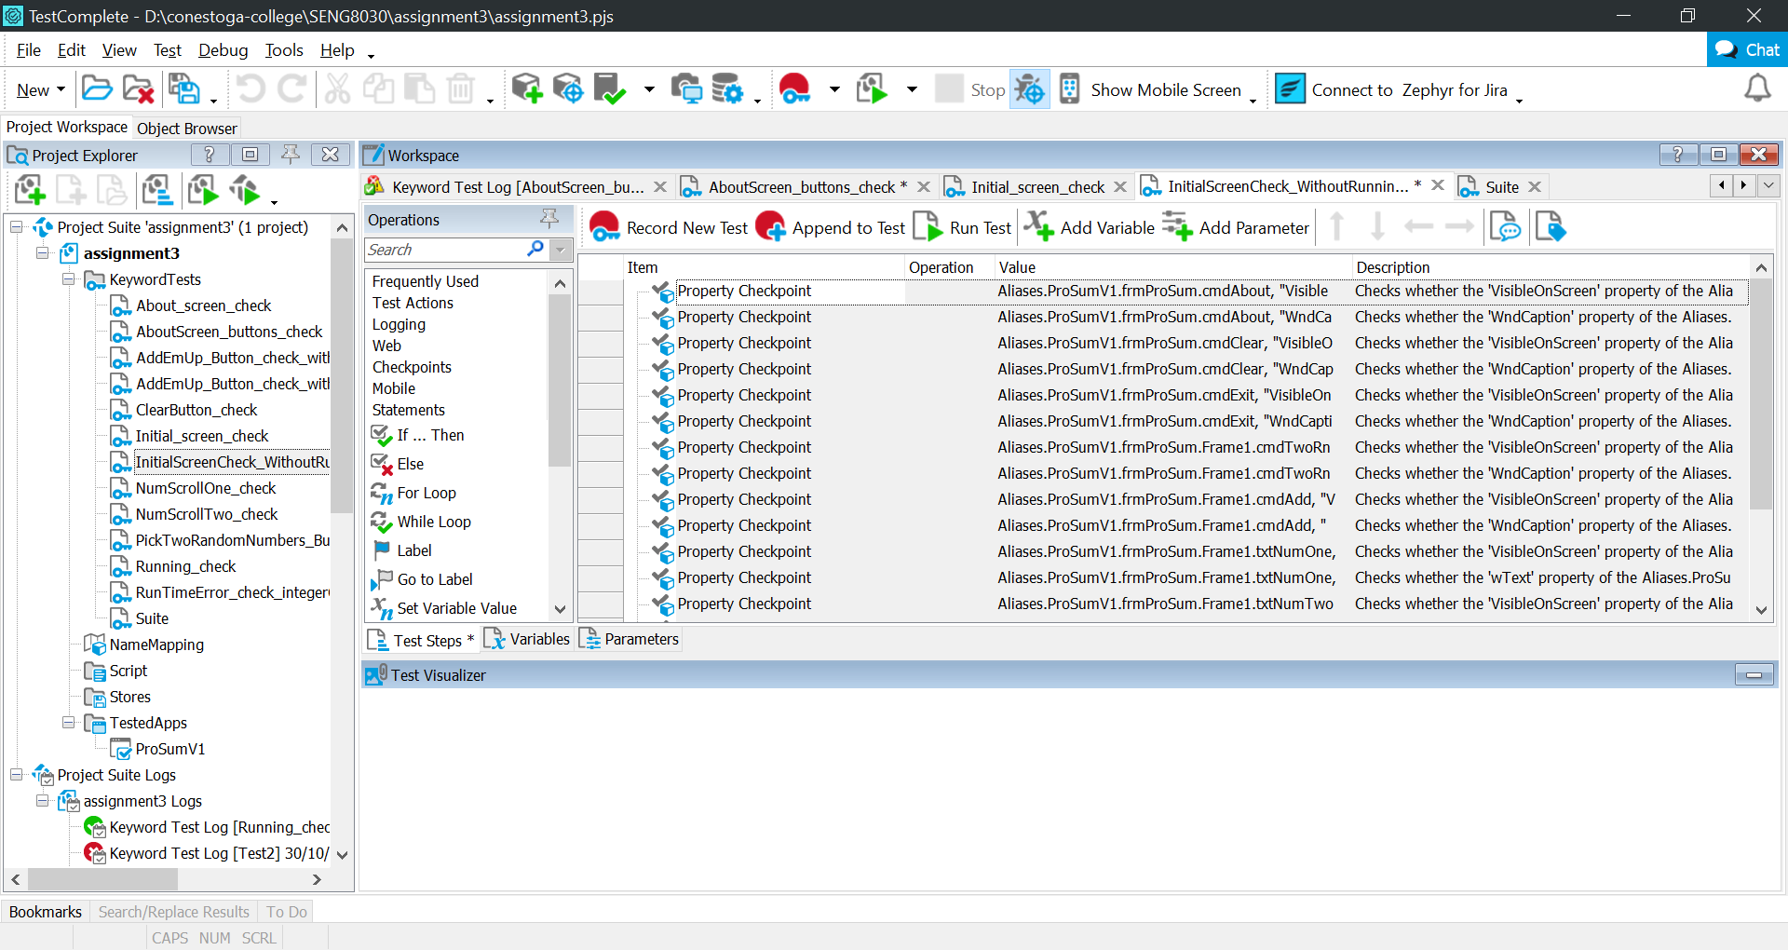

Test to check initial screen of the app without opening and closing it. Created to be used in other cases.

#13

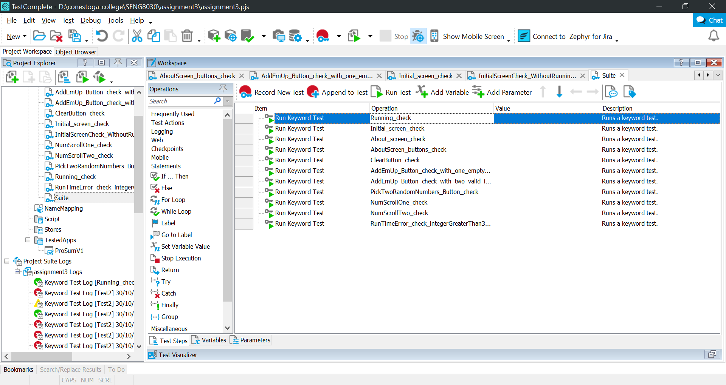

This case combines every other cases into one sequence.

Test results

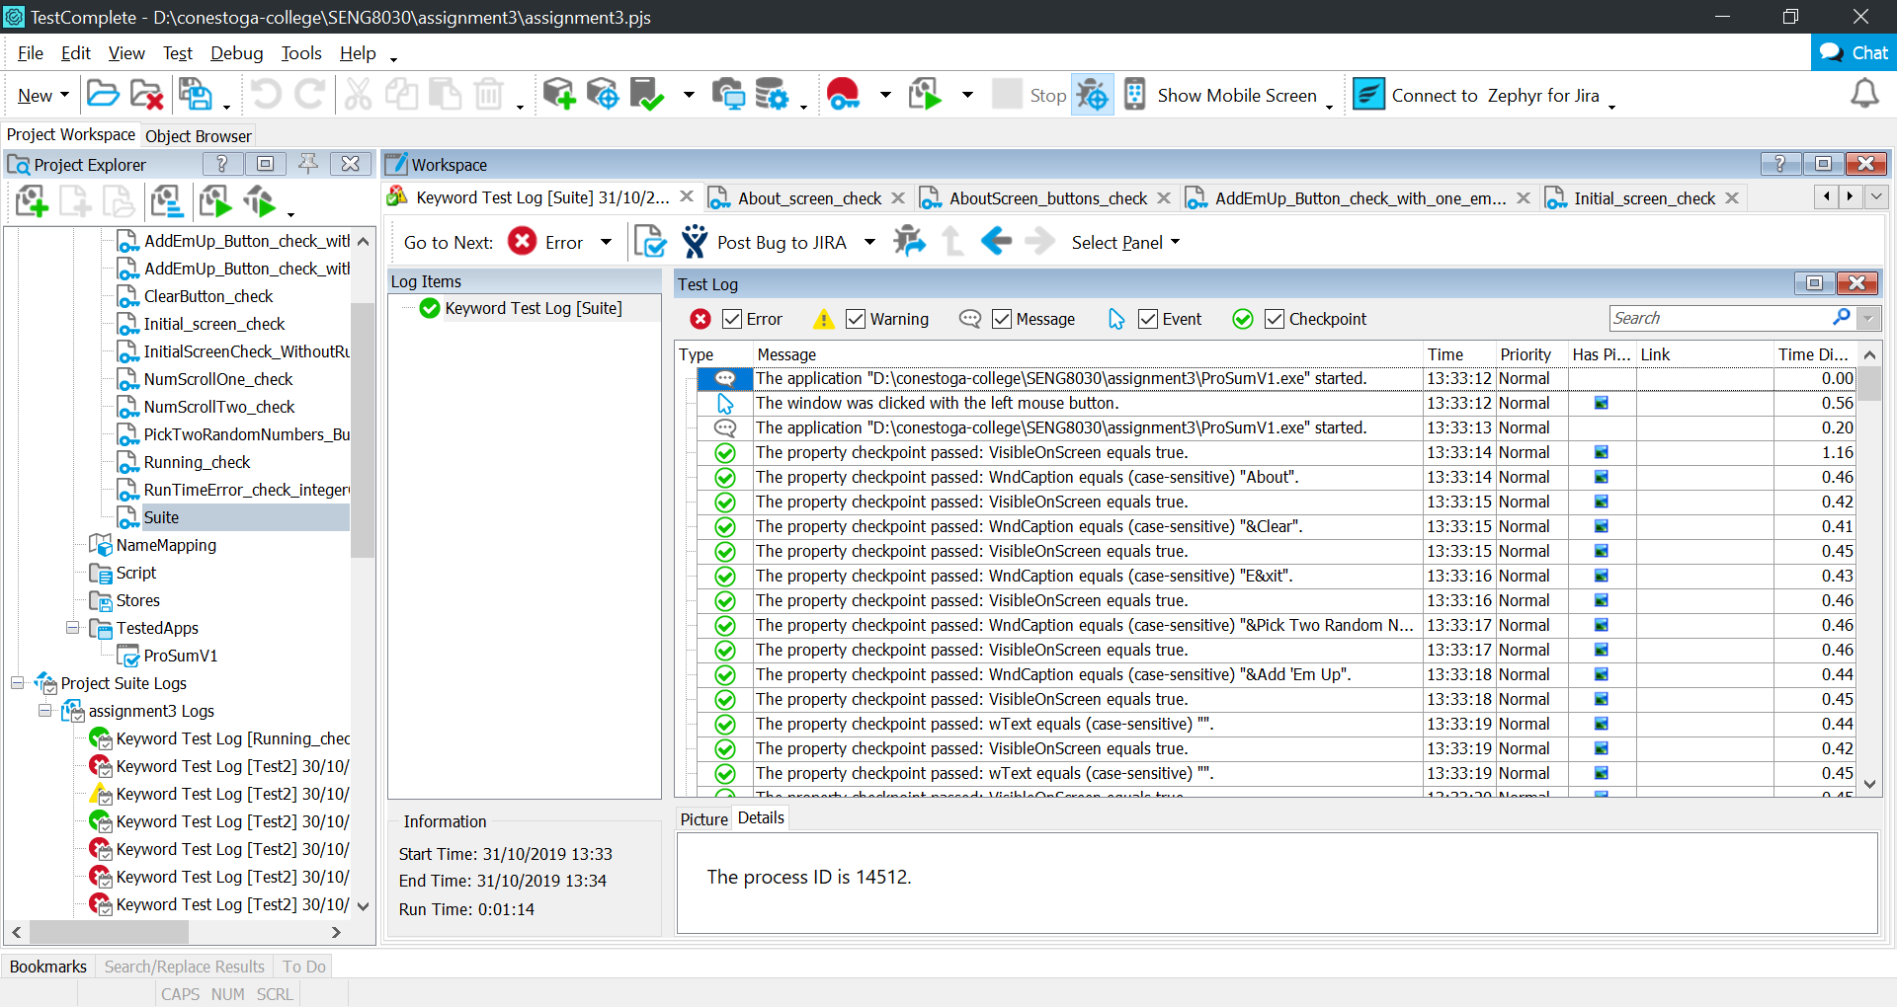

**Task 2**

Benefits from Record / Playback testing are speed of execution of tests, they are repeatable and we can be sure that inputs are always the same. One of the main drawback is that automation requires time to get familiar with the automation tool, even for the simple Record / Playback testing it can be challenging to master. Also simple Record / Playback testing mostly focuses on surface of the program.

I found this tool quite handy comparing to manual approach. For example it is a lot easier to check spelling of the blocks of text, and spelling on any buttons as well. It would require lot more time using manual approach, especially if you need to check it on every software update. Very good at verifying button presses, and working of buttons in general.

But it is quite complex application and requires time to master it to use variables and other means of storing data within a test.