Druid Hills High School

Name: Tynan Purdy

Session: May 2019

How curves are implemented in modern art and design

Extended Essay: Mathematics

# Abstract

This is where the super awesome abstract goes. It is a summary of the entire 3000+ word essay into a single paragraph which sounds insane, but we will see how it goes.

Table of Contents

Abstract 1

Introduction 3

Bézier Curves 5

Where did Bézier Curves come from? 5

What are Bézier Curves? 5

Real World Uses 5

Fonts 5

Vectors 5

Conclusion 5

Bibliography 6

# Introduction

The Information Age has introduced some drastic changes to the way humans communicate and exchange information. Over the past several hundred years, the dissemination of information has benefited from inventions such as Gutenberg’s printing press and the digital computer have revolutionized the way we encode and decode information. Advances in communication lie at the heart of the development of civilization. Before the printing press made books and published works accessible to the world, books were available only to monks and scholars, who made up a very small part of the population. Books and papers were handwritten by scribes, a tedious process subject to human error. With most information behind closed doors, education, even literacy, was an uncommon skill.

Information technology (IT) has real effects. European cities that made use of the printing press in the 16th century grew 60% faster than comparable cities that did not. (Dittmar) Books, libraries, newspapers, all became publicly acquirable resources. When information is more accessible, more ideas can be shared and innovated on. Medical and hygienic practices and advancements can be mass produced for everyone to implement lifesaving habits. Informed populations carry more democratic power to have their own opinions based on personal research as opposed to listening to some omnipotent higher authority. Abundance of information and sharing of information leads directly to a wide myriad of benevolent consequences lending to a healthier society.

IT can take many forms, some rather unexpected, and each with their own tradeoffs. Scrolls, paper books, ink pens are all forms of IT. Scrolls were the most efficient method of storing information for centuries. Paper books, an improvement on the scroll, are able to hold many more pages per unit of volume than scrolls but can be difficult to manufacture without the right tools. The pen has gone through many innovations. The original feather and ink were a functional way to write, despite requiring frequent dips in the ink. The feather’s ability to hold ink was less than desirable, only able to write for a word or two between ink dips. Fountain pens held ink for far longer, allowing the user to be much more efficient with their writing. Innovations in IT allow for more storage and bandwidth for transferring information, as well as making content creation accessible to the public. Handwritten letters are an invaluable source for historians.

Modern information technology has grown to an enormously complicated and diverse field due to recent globally revolutionizing inventions: the digital computer and the internet. In the 21st century, IT encompasses computer networking, servers, online communication mediums like Twitter and Gmail, photos, videos, I/O ports, smartphones, and even file formats. Some areas of IT are so new and unique that world governments are still figuring out how to regulate it. Net Neutrality protections give internet users the right to communicate with whoever they chose on the internet without interference from Internet Service Providers. Net Neutrality hasn’t been particularly successful in recent years, but there are good regulations that are already in effect. In April of 2018, the European Union passed the General Data Protection Regulation (GDPR), which strictly defines what internet companies can do with user data and gives users specific rights to their data. Because the internet is so global, unlike communication mediums of the past, regulations like GDPR are treated as if they are worldwide rules, even though they are only enforced in Europe. Companies would rather have one universal policy for their users than have to deal with different policies for users in different countries. IT is a deep and difficult topic, with many branches of influence. However, there is a particular IT innovation that is used across the entire internet, and almost every form of communication today, the Bézier curve.

Bézier curves, a mathematical process for drawing curves, has found its way into the lifeblood of modern communication, digital graphics and text. Every screen in the world is almost constantly using Bézier curves to draw whatever it is displaying. Most technology users don’t know what Bézier curves are, despite looking at them every day for hours on end. The lines of text on this very page were drawn using Bézier curves. The art on billboards were rendered with Bézier curves as they were printed. The ability to render text characters virtually instantly has contributed to the content boom of the internet. The following pages will describe what Bézier curves are, where they came from, and exactly how they are used to deliver words and shapes to the digital world.

# Bézier Curves

## Where did Bézier Curves come from?

While the mathematics behind Bézier curves has existed for decades before computers were invented, it was the French automotive engineer, Pierre Bézier (1910-1999), who popularized the method for digital curve and surface drawing. Bezier was a mathematician and head of design at Renault, a Paris based automaker. (Farin, Hoschek and Kim) Before the origin of these special curves is revealed, it must be understood why curves are important and so difficult to procure digitally.

Curves have been used in mechanical design for hundreds of years, and for good reason. They give a smooth, attractive form that is not only more inviting to the touch, but also lends itself toward aerodynamics. Curves are perfect for effortlessly passing through fluids such as air and water.

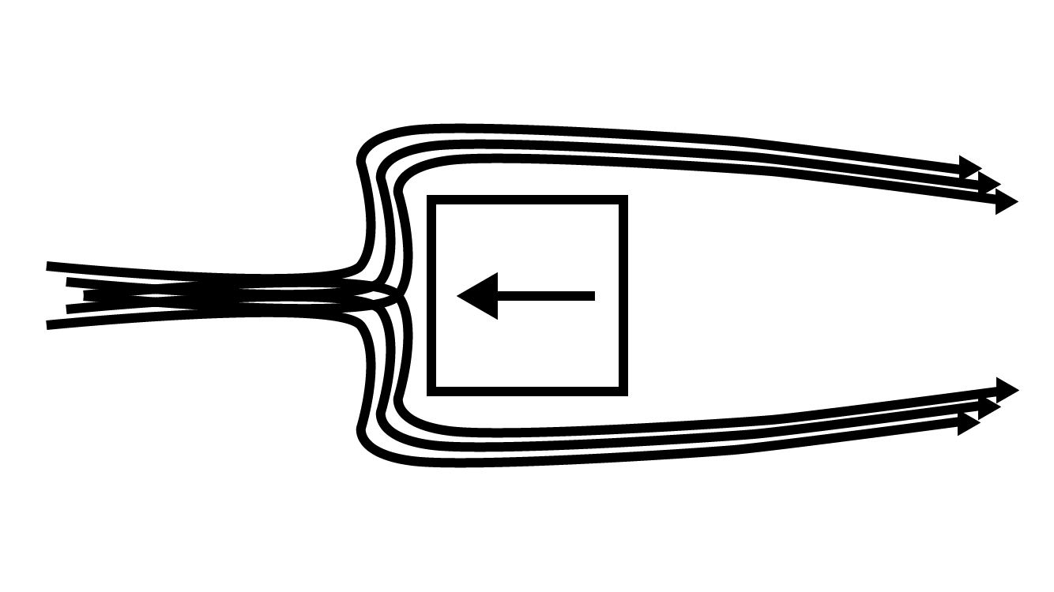

Figure Fluid passing a cornered object. Fluid must be redirected harshly to get around the square object, creating excess friction and heat.

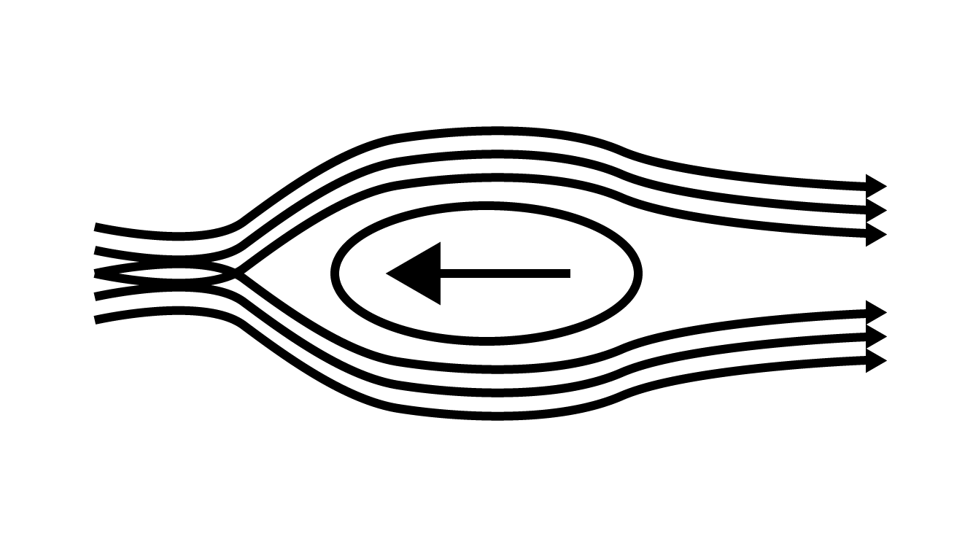

Figure Fluid passing over a curved object. The fluid is redirected less to pass around the object, resulting in less friction and heat than the square object.

Unsurprisingly, aerodynamics in air and water accounts for the primary uses of curved surfaces both in ancient Rome and today: boats, planes, and cars. Consider the cars seen on the road today. Even an astute observer would have a hard time finding a perfectly flat surface or hard corner anywhere on the vehicle. Geometric patterns are so popular in the 2010s, yet they haven’t made their way to cars, simply because curves are so energy efficient compared to straight lines and corners that there is no compelling reason to abandon them.

Curves are also much safer than square edges and corners. Even objects that appear to have square corners often have a small filet to smooth them out and avoid potential accidental cuts or scratches. Curves’ safety properties arise from the same traits as its aerodynamic properties. An angled edge is more able to split open a solid that a curved edge, the reason knives must be sharp to function properly. The concern of safety against hard edges is addressed extensively in the manufacturing space. A wide variety of tools exist purely to reduce sharp edges to a smooth and save curve. Most subtractive machining tools leave a straight edge after a linear cut, as well as small bits of debris still attached to the edge called burrs. Belt sanders, files, deburring tools, countersink bits, and sanding blocks are all different tools used to round or smooth edges after a cut and remove burrs. 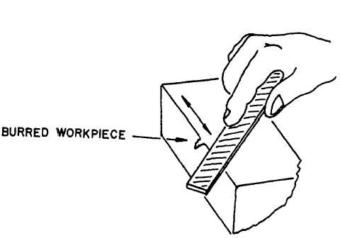

Figure Safety diagram illustrating how to remove burrs with a hand file

When considering a user of an object or product, curves are an easy way to make the user feel at ease and comfortable with the product, as well as keep them safe.

Curved edges and surfaces clearly have their benefits. As shown above, there are ways to add curves to a cornered object, but it would be better to include curves in the original design. With manually operated tools, creating a curve is not particularly difficult. The human brain can describe and instruct the hands to use tools to make any shape or surface imaginable that the tool is capable of creating. Handcrafted wood objects can be curved with a chisel and some sanding. In the car manufacturing industry, most auto bodies are modeled at full scale in clay during the design phase. Handcrafting is fine for many purposes, but when the end goal of a design is to mass produce it, at some point the shape of the object must be described by a computer. Manually operated tools are time consuming and labor intensive to make thousands of identical parts for mass production, which is not feasible for large scale manufacturing. Computer numerical control (CNC) tools have solved the mass production issue by allowing tools to be programmed to execute precise cuts perfectly. CNC tools require far less attention from a human operator and produce consistent machining, perfect for mass production. The catch is, since the machine is computer controlled, the computer must be able to describe the cuts it is supposed to make, which means they must be described mathematically. Pierre Bezier was one of the first engineers to address the need for digital rendering of physical parts, and so began development of the Bezier curve for Renault. Bezier was not the first, nor the only engineer to work on a mathematical curve algorithm for computers, but his was the widely adopted method. The famous de Casteljau’s algorithm was developed for Citroën, a competing auto company in Paris. His algorithm was kept secret for years after its development in the ‘60s. (Farin, Hoschek and Kim)

## What are Bézier Curves?

The Bezier curve uses a parametric equation for a point to follow a line between two points.

# Real World Uses

## Fonts

A new font every day. TrueType, OpenType, and PostScript

## Vectors

Down with rasters, long live vectors! Adobe Illustrator and CorelDRAW, SVG

## Computer-Aided-Design

Do u even cad bro

# Conclusion

Bézier curves b fye

# Bibliography

Casselman, Bill. "From Bézier to Bernstein." *American Mathematical Society* (n.d.).

Dittmar, Jeremiah E. "Information Technology and Economic Change: The Impact of The Printing Press." *The Quarterly Journal of Economics* (2011): 1133-1172.

Farin, G., J. Hoschek and M.-S. Kim. *Handbook of Computer Aided Geometric Design*. Elsevier Science, 2002.