Goal 1: Add lead from chrome extension

Goal 2: Recognize number, click on it, add lead window appears

Goal 3: Gmail integration, recognize email address and pipe to QD(look at collabspot for examples)

Basic chrome extension creation

1. Create a folder for the extension
   1. Folder will contain at minimum
      1. Manifest.json
      2. Icon.png(19x19 PNG file)
      3. Popup HTML file
      4. Popup JS file
2. Step 2 Create manifest file named “manifest.json”
   1. Manifest for our usage, declares the following:
   2. -Manifest version
   3. -name
   4. -Description(mouse over popup)
   5. -version number
   6. -icon for extension
   7. -popup html
   8. -permissions
3. Step 3
   1. Create front-end popup.html file
   2. And JS file containing logic
   3. HTML and JS must be in different files
   4. <https://developer.chrome.com/extensions/contentSecurityPolicy> contains reasons why apparently

Visualization

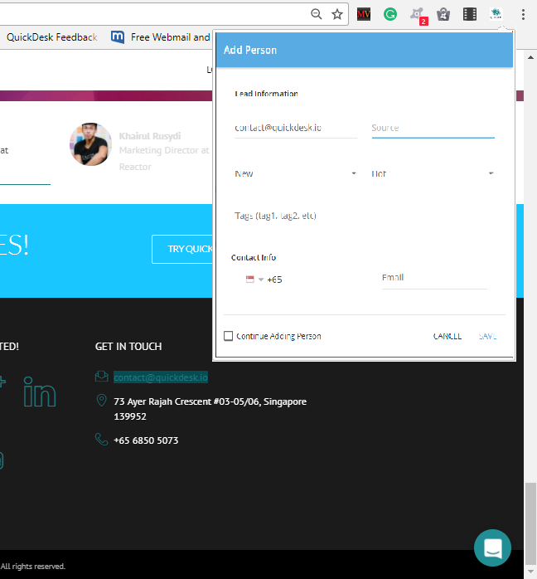v