
Name: Tinotenda Mupati Student Number: 22202963
CMPE412 System Programming
Project: Distributed Inventory Management
Description: Implementing a client-server system for managing product inventory data.
Distributed Inventory Management with Personalized Verification
The client-server system manages product inventory data. The server hosts multiple inventory files (one per category). Clients connect from a different PC to view product lists or request statistical overviews.

Port Number Derivation:
The port number was derived from the student number 22202963 where the last 4 digit (2963) was divided modulo with 1000 giving us 963. 5000 was added with 963 to give us a port number 5963.

How the inventory files were seeded:
The files were seeded using Java’s class (Random) with the student number (22202963). Meaning that the file content was randomly generated using the 22202963 as the seed value making the generated content unique. The 4 files generated contain 30 products each and one special record (P9999, Student_22202963_Demo, 0.01)

How verification hash computed:
The verification hash was computed by multiplying the digit sum of the student ID with the active port and divided modulo with 1000. The digit sum of the student ID was calculated by adding 2, 2, 2, 0, 2, 9, 6 and 3 to give us 26.
(26 * 5963 = 155038) ---- (155038 % 1000 = 038), the server computes this and sends it back when the client clicks Verify button.

Screenshots:
Server GUI after Start Button clicked
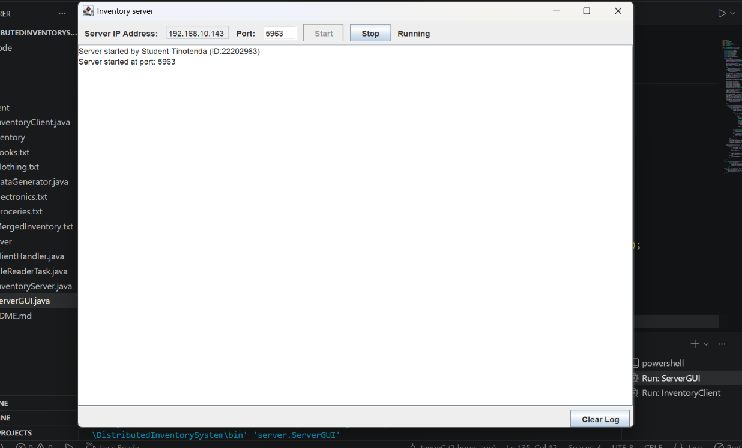

Client GUI and the Server GUI after running/debugging the Client Inventory
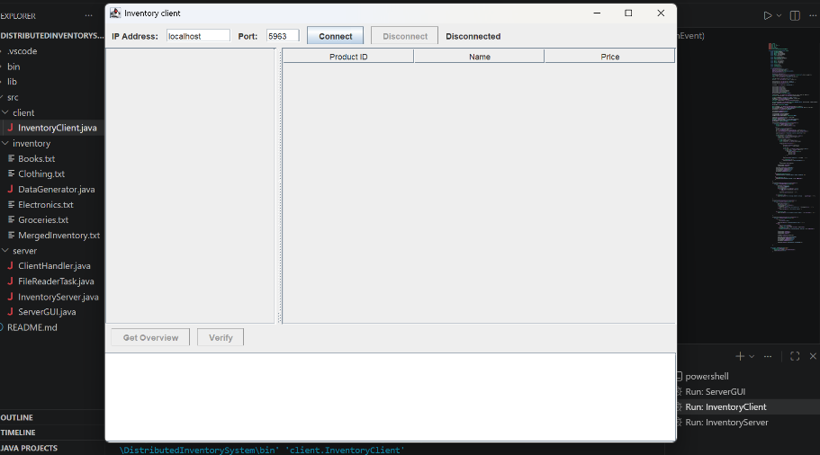 | 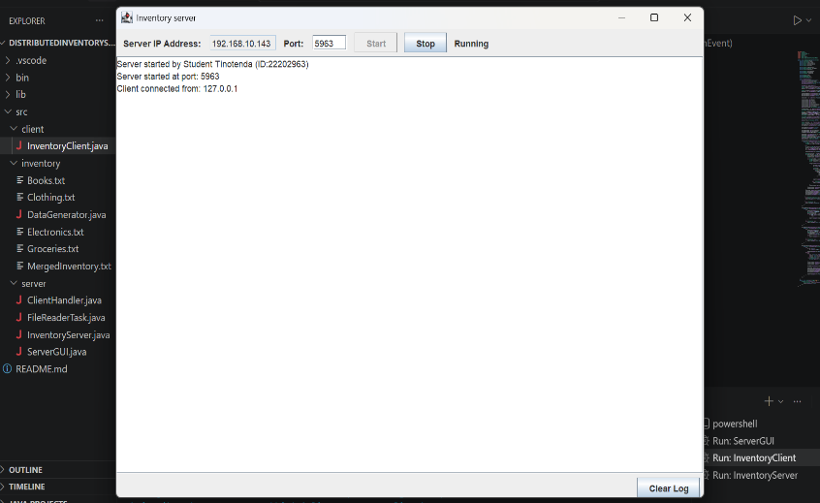

Client GUI after Connection to the server and showing the inventory files contents
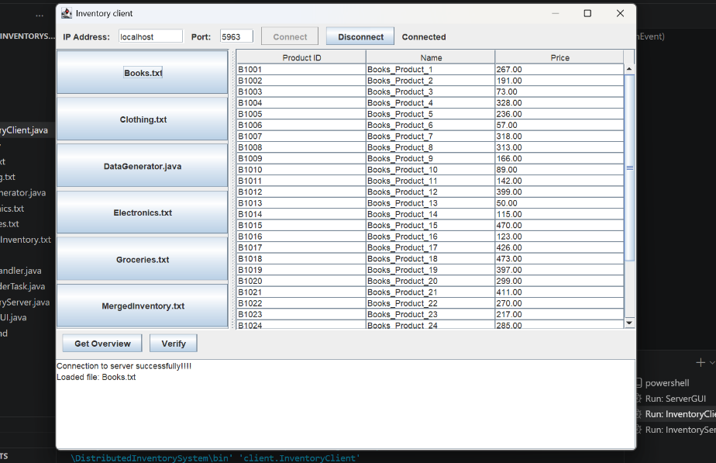 | 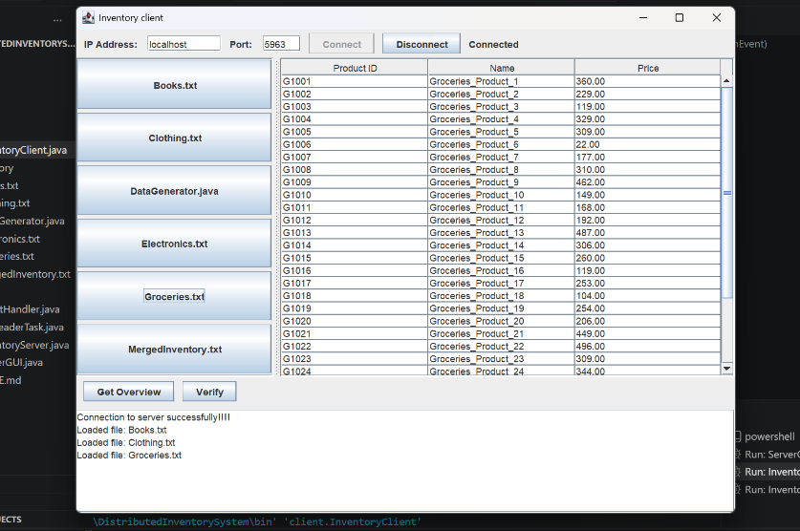

Results from shown after clicking Get Review and Verify button respectively

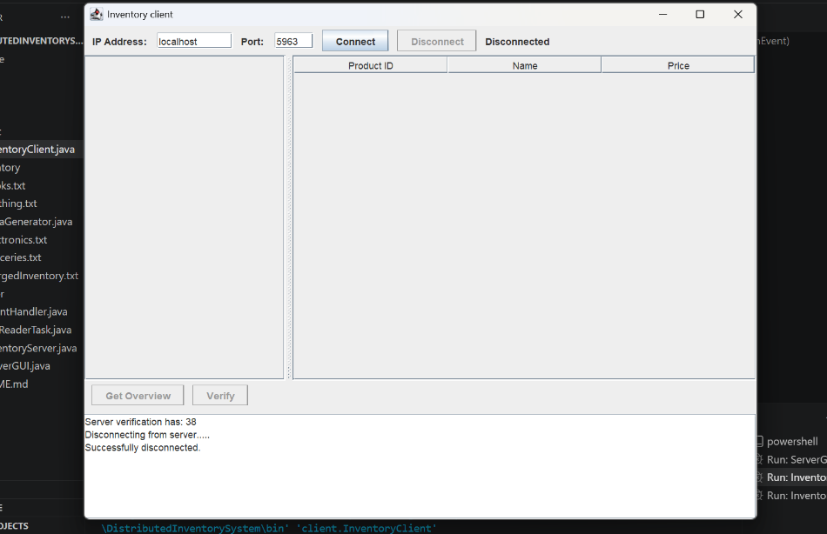 | 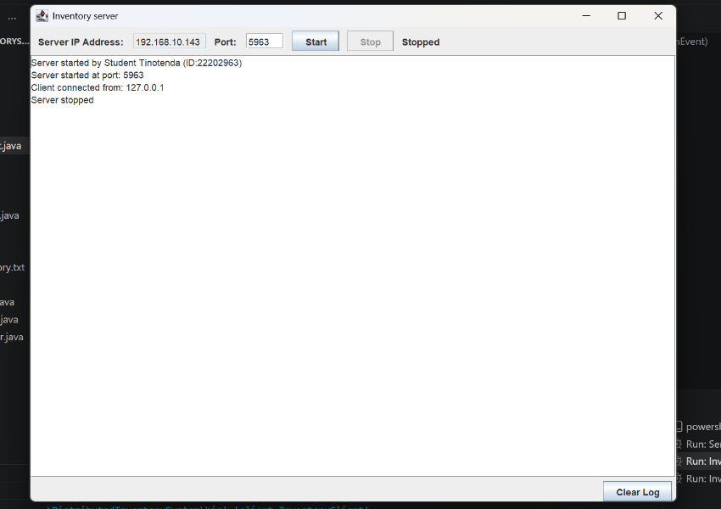
Results from Disconnecting client from server and stopping the server

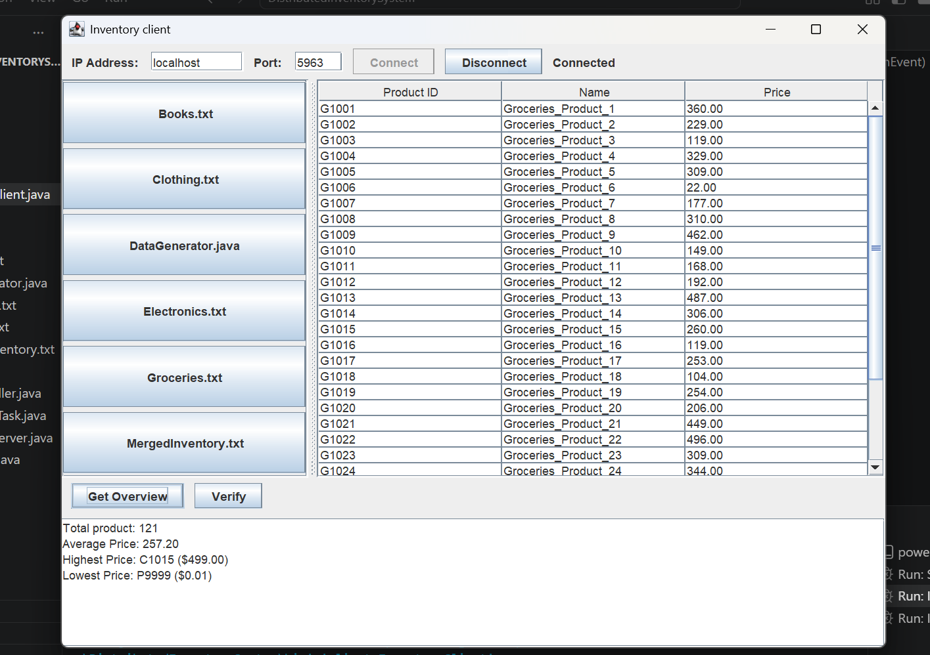 | 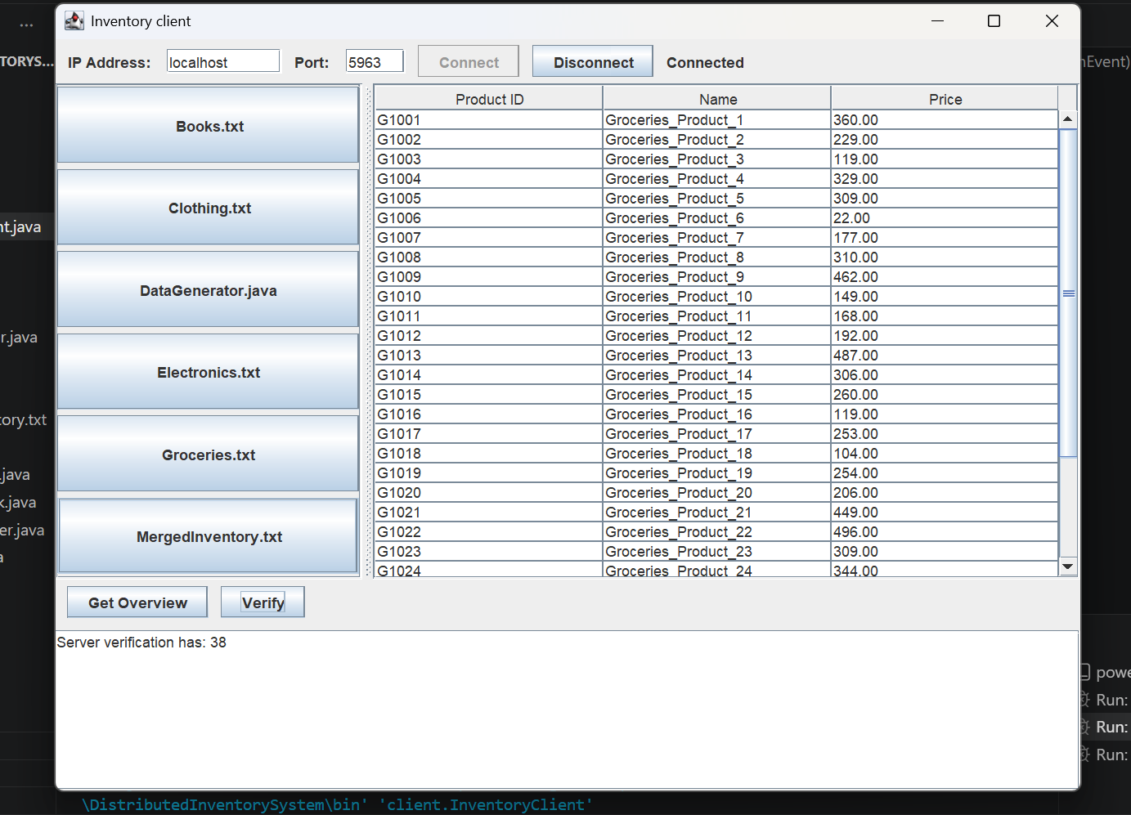

Conclusion:
This project is an inventory system that allows many clients to connect to the server at the same time and work with product data without crashing the program or damaging the files. The server handles client connections and file reading using ClientHandler.java and FileReaderTask.java, while the client side uses InventoryClient.java to let users view products and analytics. The system uses ServerSocket for communication between the server and clients, thread pools to run tasks at the same time, and ConcurrentHashMap to safely manage shared data between threads. The port number is student ID based and is then used with ID student sum to produce the verification code, and the student Id was used in seeding the inventory content.

