Electrical Double layer lies at the heart of soft matter and colloidal physics. They play a decisive role in dictating transport and thermodynamics in processes occurring from macroscale systems like batteries to small scale behavior in biophysical systems. The structure of EDL is very well described by mean field Poisson-Boltzmann (PB) at the so-called weak coupling limit where the system is characterized by low valency, low concentration, and low surface charge values. But the absence of electrostatic correlations, image charge and excluded volume effects does not allow PB to model the rich and complex behavior shown by EDLs at moderate and strong coupling, especially for multivalent ions. We have recently developed a field theory based statistical mechanical model to self consistently include all the missing effects in PB into the EDL and have been successful in explaining experiments related to many fundamental phenomena like charge inversion and like charge attraction. Our group is currently working on using this theory to understand the effect of these complex electrostatic forces on surface tension, biological membranes, microgels, and nanoscale electrokinetics.

**Ion correlation induced electrostatic wetting transition**

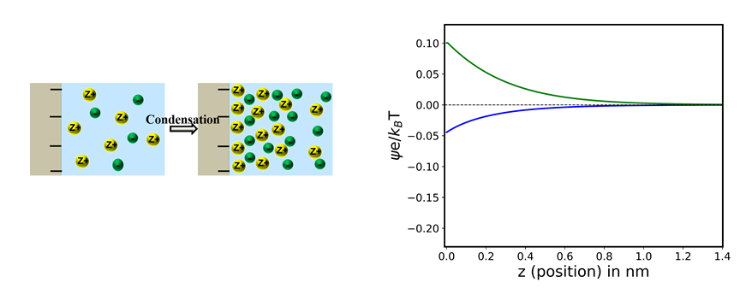

**Flip in potential profile**