Helical Pile Foundation Design
Lighting Pole Foundation — Calculation Package

Project | —
Location / pole ID | —
Engineer | —
Date | 2026-08-06
Trial shaft | 273 mm OD × 9.3 mm wall, 2 helices, tip depth 4.50 m
OVERALL: ALL IMPLEMENTED CHECKS PASS
This package is generated directly from the helical_pile_design calculation engine. Every result should be independently checked by a qualified engineer before use in a stamped submittal.

Design Check Summary
Check | Result | Status
Step 3 — Embedment | L = 4.50 m | PASS
Step 4 — Compression FS | 59.0 (req 2.0) | PASS
Step 4 — Tension FS (frost uplift) | 4.4 (req 2.0) | PASS
Step 5 — Service deflection/rotation | y_gl=2.00 mm, θ_gl=-0.102° | PASS
Step 5 — Pushover λ_ult | 9.0 (req ≥ 2.0) | PASS
Step 6 — H1 interaction | 0.133 (H1-1b) | PASS
Step 8 — Bolt combined stress | 149 / 291 MPa | PASS
Step 8 — Weld | 348.8 / 1247.1 kN/m | PASS
Step 8 — Torsion slip | Tz=0.00 kN·m | PASS

Step 10 load tests triggered: D1143/D3689, D3689, D3966

Step 1 — Loads
V_u (kN) | 2.75
M_u (kN·m) | 20.42
P_u (kN) | 2.19
e = M/V (m) | 7.41
V_s (kN) | 1.21
M_s (kN·m) | 8.98

Step 3 — Preliminary sizing / embedment
Trial shaft 273 mm OD, pile tip depth 4.50 m.
Embedment OK (frost req 2.55 m, deep-mode req 2.25 m)
L = 4.50 m = 16.5 * D_shaft -- verify against Broms/p-y required length in Step 5; typical short-rigid-pile range is L >= 10*D_shaft.

Step 4 — Axial capacity
Check | FS actual (req) | Status
Compression | 59.0 (2.0) | PASS
Tension (frost uplift) | 4.4 (2.0) | PASS
Compression governed by individual bearing (individual bearing Qu=129.1 kN, cylindrical shear Qu=196.4 kN). Frost uplift demand T_frost=20.6 kN, tension resistance Tu=90.5 kN.

Step 5 — Lateral / moment (governing check)
Broms Hu (kN) | 32.4 (FS=11.8)
Pushover λ_ult | 9.0 (PASS, req ≥ 2.0)
Service y_gl (mm) | 2.00 (limit 12 mm)
Service θ_gl (deg) | -0.102 (limit 0.50°)
Strength case: M_max = 23.9 kN·m at z = 1.30 m.
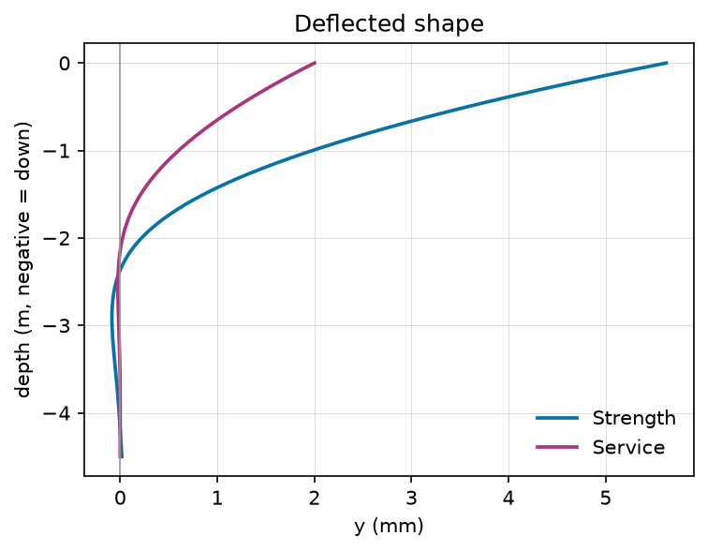 | 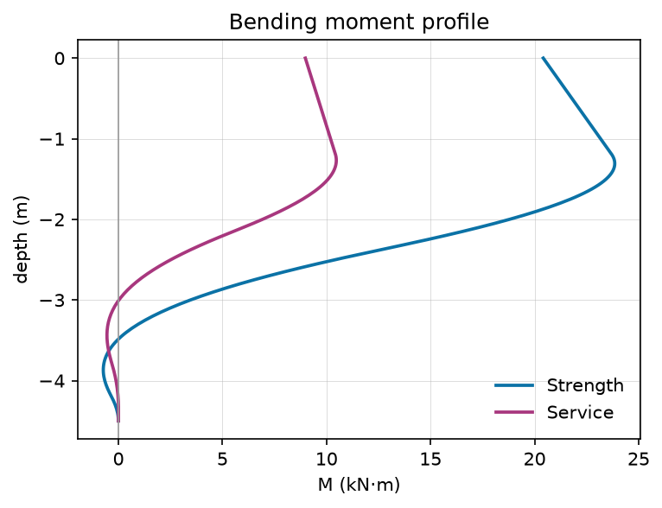
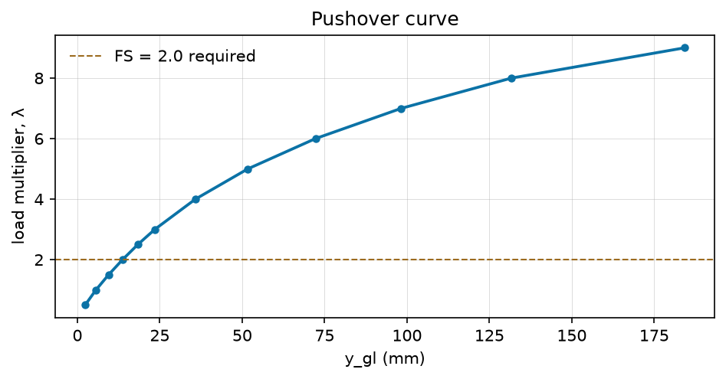

Step 6 — Structural (AISC 360, corroded section)
t_corroded (mm) | 8.30
Section compact? | Yes
H1 interaction ratio | 0.133 (H1-1b)
PASS

Step 7 — Corrosion
Zinc life (yr) | 25
Sacrificial thickness (mm) | 1.00
Corroded wall (mm) | 8.30
moderately corrosive design case -- explicit sacrificial-thickness calculation required (screen passes, but life exceeds AC358 baseline and/or life-safety-adjacent application)

Step 8 — Pole-to-pile connection
Check | Demand / Capacity | Status
Bolt combined stress (tension + bending) | 149 / 291 MPa | PASS
Weld | 348.8 / 1247.1 kN/m | PASS
Torsion slip | Tz=0.00 kN·m (3×Tz=0.00) | PASS
4 bolts on 175 mm radius, 25 mm nominal diameter; bolt tension 58.3 kN (tension stress 149 MPa; no standoff bending addend); 8 mm fillet weld; assumed pile torsional slip capacity 30.0 kN·m [ASSUMED — validate].

Step 9 — Installation torque
Required ultimate axial (kN) | 41.2
Kt (1/m) | 7.0
T_min (kN·m) | 5.88
Kt established by AC358 report? | No — assumed

Step 10 — QA/QC triggers
- D1143/D3689: Kt not established by AC358 report for this exact shaft/helix product
- D3689: Frost-uplift design relies on assumed tau_ad or sleeve performance
- D3966: p-y parameters assumed without lab/CPT data

