INF2005 Cyber Security Fundamentals · ACW1
Test Evidence
Steganographic Image and Audio Integrity Verification with Digital Signature-Based Authentication
Item | Detail
Team | P6-4
Generated | 2026-09-28 16:16 by tools/generate_evidence.py
Code version | branch m6-advanced, commit f883eb2
Environment | Python 3.12.0 on Windows 11; PySide6 6.9.3, numpy 2.5.3, Pillow 12.3.0, cryptography 50.0.1, matplotlib 3.11.2
Signing keys | Team demo key pair in keys/ (Ed25519). Verify with keys/public_key.pem
Stego key used | "p6-4-demo-key" (coursework demo passphrase, not a real secret)
Automated tests | 83 passed in 20.33s

Result at a glance: 4 positive and 7 negative cases across image and audio, all with the expected outcome. The Attack Lab caught 11/11 attacks on the image and 11/11 on the audio. The optional challenges (video, robust embedding, steganalysis) add 6 more cases. 83 passed automated tests.

1. Summary of cases
Every case below was run through the real command-line tool and the real GUI. The logs are in tests/evidence/logs/, the screenshots in tests/evidence/screenshots/ and the files in tests/evidence/files/.
ID | Case | Cover | Expected | Actual | Result
P1 | Image, short message (learning outcome), 2 LSBs | image | Authentic | Authentic | PASS
P2 | Audio, long message (project overview), 2 LSBs | audio | Authentic | Authentic | PASS
P3 | Image, custom payload encrypted with AES-GCM, 3 LSBs | image | Authentic | Authentic | PASS
P4 | Audio, custom encrypted payload, 8 LSBs | audio | Authentic | Authentic | PASS
N1 | Capacity check: payload larger than cover | image | Blocked | Blocked | PASS
N2 | Image edited after protection (block blacked out) | image | Tampered | Tampered | PASS
N3 | Audio edited after protection (0.5 s made 35% louder) | audio | Tampered | Tampered | PASS
N4 | Forged payload signed with an attacker's key | image | Signature Invalid | Signature Invalid | PASS
N5 | Wrong stego key (start location can't be found) | audio | Wrong Start Location | Wrong Start Location | PASS
N6 | Replay: the same genuine file presented again | image | Replay Detected | Replay Detected | PASS
N7 | Limitation: stego image re-saved as JPEG (quality 95) | image | Not authentic | Not authentic | PASS
V1 | Video (FFV1 .mkv), short message, 2 LSBs | video | Authentic | Authentic | PASS
V2 | Video: a different frame edited after protection | video | Tampered | Tampered | PASS
R1 | Image, robust mode (x5 repetition), 2 LSBs | image | Authentic | Authentic | PASS
R2 | Robust file vs normal file under noise and a scratch | image | Payload recovered | Payload recovered | PASS
S1 | Steganalysis reads a version 1 payload without the key | image | Hidden Text Found | Hidden Text Found | PASS
S2 | Steganalysis finds nothing in a version 2 (masked) file | image | Nothing Found | Nothing Found | PASS

Coverage of the spec's required cases
Requirement (spec section 5 / 6) | Where it is shown
At least 2 positive and 3 negative cases | 4 positive (P1-P4), 7 negative (N1-N7), plus 18 Attack Lab runs
One positive and one negative per cover type | Image: P1, P3 / N1, N2, N4, N6, N7. Audio: P2, P4 / N3, N5
Cover object vs payload capacity check | N1 (blocked at 1 LSB, fits at 8 LSBs)
Payload sizes: short, long, custom | P1 short (a learning outcome), P2 long (project overview), P3/P4 custom encrypted
Selectable LSBs 1 to 8 | Section 4 table (k = 1..8 on both covers), P3 at k = 3, P4 at k = 8
Stego object sent from party A to party B | Section 8: manual email transfer with SHA-256 check (to be completed by the team)
Start location: derivation and protection | N5 (wrong stego key), Attack Lab rows 1-3 (wrong key, off-by-one start, crop)
Hash verification | N2, N3 (media edited), Attack Lab rows 6 and 7
Digital signature verification | N4 (forged signer), Attack Lab row 5 (one payload bit changed)
Verdicts | Authentic, Tampered, Signature Invalid, Payload Missing, Wrong Start Location, plus our Replay Detected
Innovation | Section 6: attack simulation module (Attack Lab). Section 7: video covers, robust embedding and steganalysis (with the fix it led to). Keyed start location with a masked header
Optional challenge: video cover object | V1, V2 and the Attack Lab on video (section 7.1)
Optional challenge: robust embedding | R1, R2 (section 7.3)
Optional challenge: steganalysis | S1, S2 (section 7.2)
Limitations | N7 and Attack Lab row 11: lossy compression destroys the payload. S1: version 1 payloads can be read without the key

2. Test setup

Inputs
- Image cover: tests/evidence/files/image_cover.png, a 400 × 469 RGB photo (Grace Hopper portrait, U.S. Navy, public domain, shipped with matplotlib's sample data). 562,800 carrier bytes.
- Small image for the capacity check: image_tiny.png, a 24 × 24 crop of the same photo (1,728 carrier bytes).
- Audio cover: audio_cover.wav, the first 4 s of M2's generated stereo track (16-bit, 44.1 kHz, 352,800 carrier bytes).
- Video cover: video_cover.mkv, a 24-frame 320 × 240 pan across the same photo, saved as lossless FFV1 (4,608,000 carrier bytes).
- Format: all new stego files use format version 2 (payload body masked with a key-derived stream). Version 1 files from earlier builds still verify.
- Messages: short = learning outcome 1, long = the Project Overview paragraph, custom = a confidential message sent with AES-GCM encryption on.

How the evidence was produced
- tools/generate_evidence.py drives the real CLI (python -m stego.cli) and the real GUI window. The GUI runs offscreen, and only the Save dialog and pop-up boxes are answered automatically; every other click goes through the same code a user would trigger.
- It runs inside a throwaway replay history, so the real keys/seen_nonces.json is never touched. The history is cleared before each independent verification, so one case can't turn into a replay of another. Replay itself is shown on purpose in N6.
- To reproduce everything from a fresh clone:
$ pip install -r requirements.txt
$ python tools/generate_evidence.py
$ python -m pytest

3. Positive cases

P1: Image, short message (learning outcome), 2 LSBs
Requirement: Positive image case, short payload
Result: Authentic (expected Authentic)
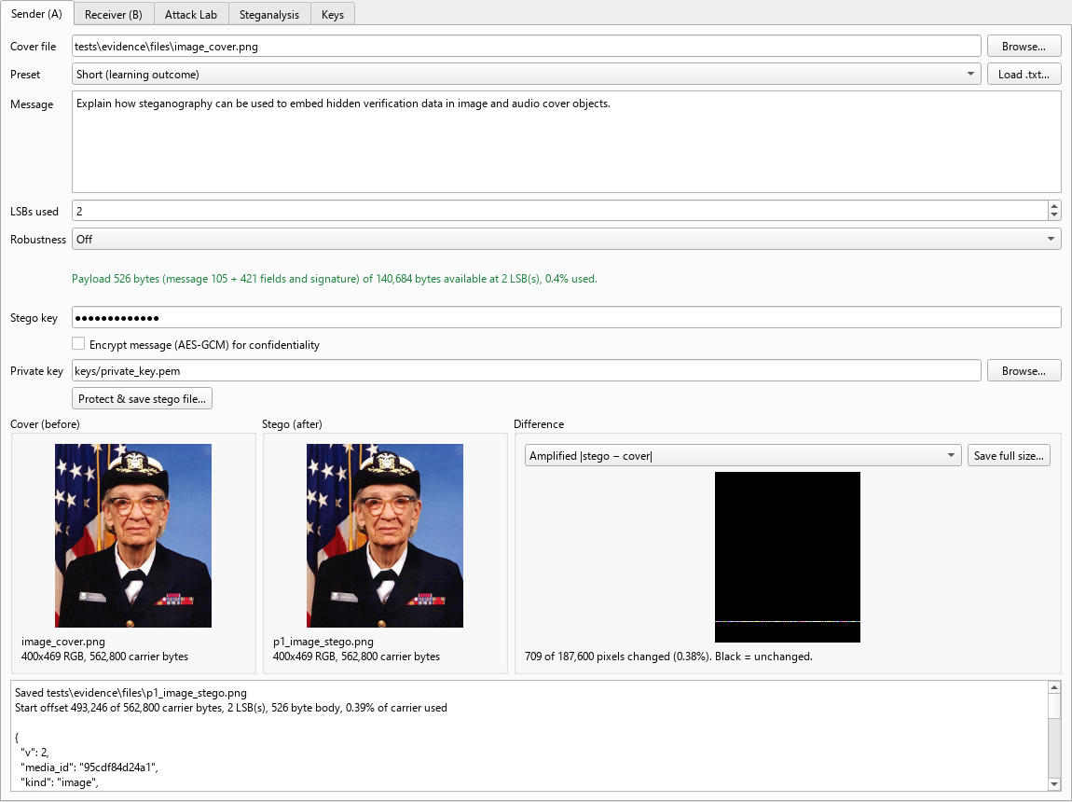
P1 Sender tab: cover, stego and difference view after protecting
Saved tests\evidence\files\p1_image_stego.png
Start offset 493,246 of 562,800 carrier bytes, 2 LSB(s), 526 byte body, 0.39% of carrier used
"team": "P6-4",
"enc": false,
$ python -m stego.cli verify tests/evidence/files/p1_image_stego.png --key p6-4-demo-key --pub keys/public_key.pem
Verdict: Authentic
Signature valid and media hash matches.
Message: Explain how steganography can be used to embed hidden verification data in image and audio cover objects.
"start": 493246,
"k": 2,
"body_len": 526,
"expected_hash": "f97f1265bd0d420afdae41ee320c9d00754ea6258bfc6cee64111b3b9de87b7a",
"current_hash": "f97f1265bd0d420afdae41ee320c9d00754ea6258bfc6cee64111b3b9de87b7a"
"enc": false,
"team": "P6-4",
(exit code 0)

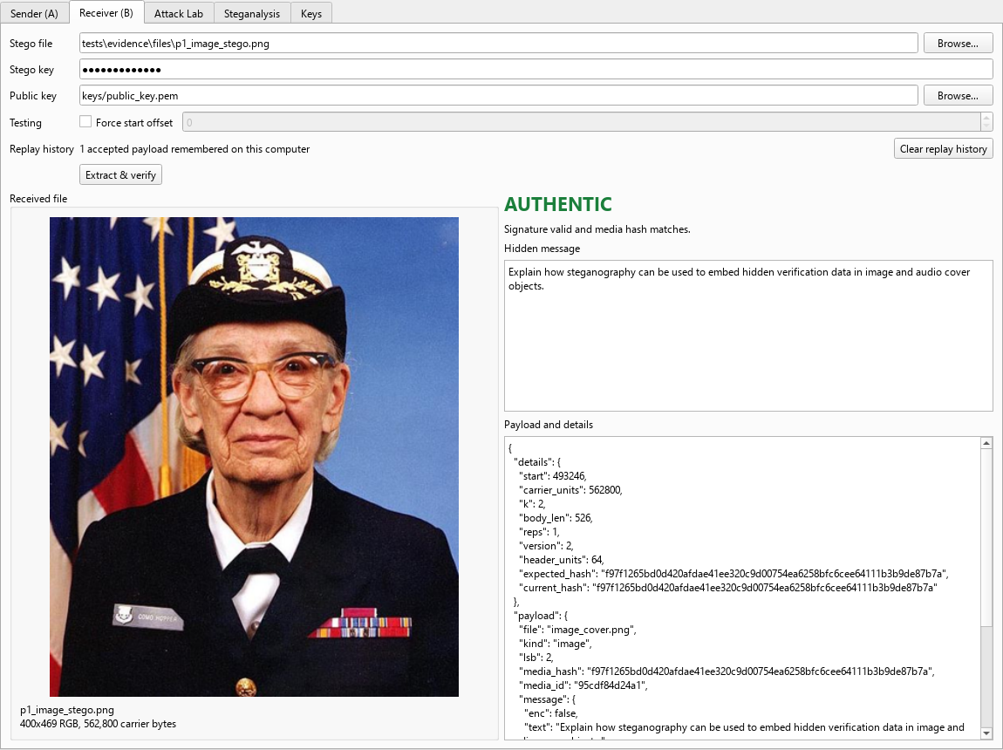
P1 Receiver tab: extracted message and verdict

P2: Audio, long message (project overview), 2 LSBs
Requirement: Positive audio case, long payload
Result: Authentic (expected Authentic)
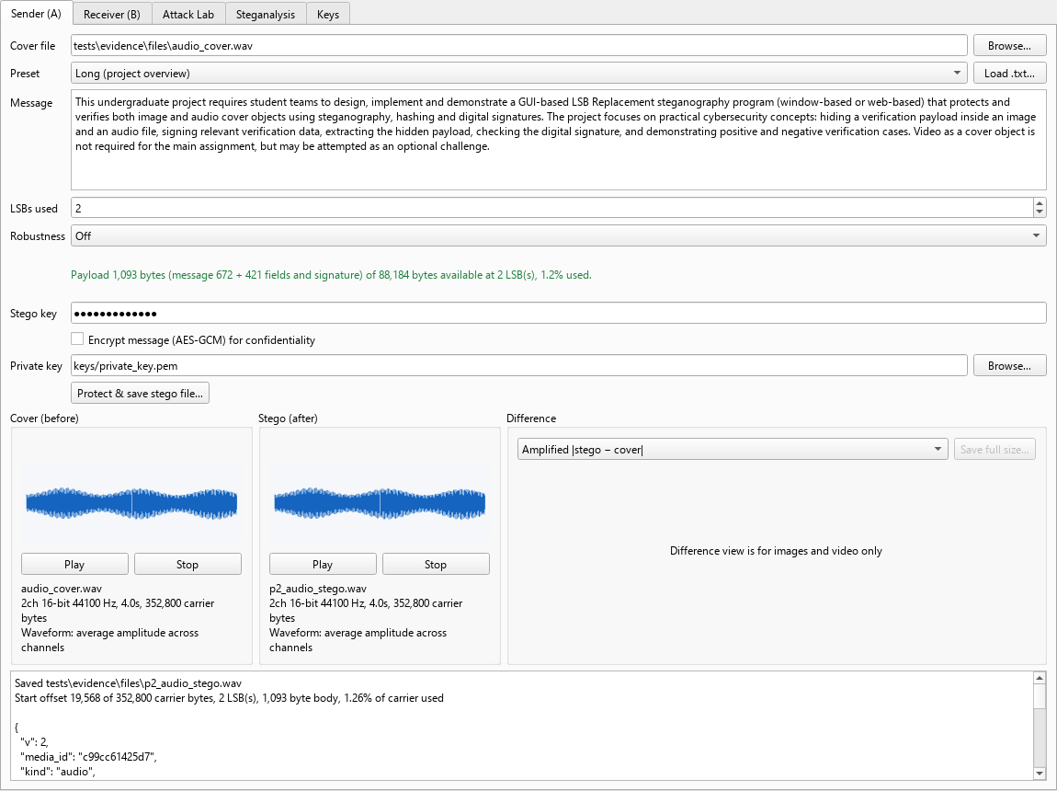
P2 Sender tab: cover, stego and difference view after protecting
Saved tests\evidence\files\p2_audio_stego.wav
Start offset 19,568 of 352,800 carrier bytes, 2 LSB(s), 1,093 byte body, 1.26% of carrier used
"team": "P6-4",
"enc": false,
$ python -m stego.cli verify tests/evidence/files/p2_audio_stego.wav --key p6-4-demo-key --pub keys/public_key.pem
Verdict: Authentic
Signature valid and media hash matches.
Message: This undergraduate project requires student teams to design, implement and demonstrate a GUI-based LSB Rep…
"start": 19568,
"k": 2,
"body_len": 1093,
"expected_hash": "ddfceed7e99045bd25ff5a0a1e15e7d62e4ab571079343beda2d0d87991b5578",
"current_hash": "ddfceed7e99045bd25ff5a0a1e15e7d62e4ab571079343beda2d0d87991b5578"
"enc": false,
"team": "P6-4",
(exit code 0)

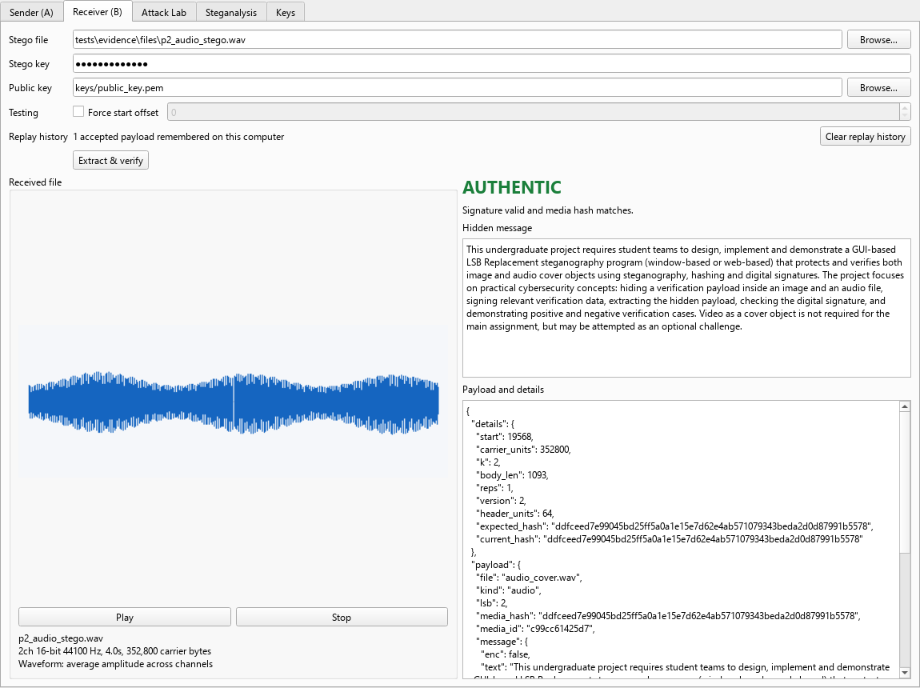
P2 Receiver tab: extracted message and verdict

P3: Image, custom payload encrypted with AES-GCM, 3 LSBs
Requirement: Custom payload: confidentiality + integrity
Result: Authentic (expected Authentic)
The payload stores only the AES-GCM ciphertext ("enc": true, "ct": …), so the message can't be read from the file without the stego key. The Receiver decrypts it after the signature and hash checks pass.
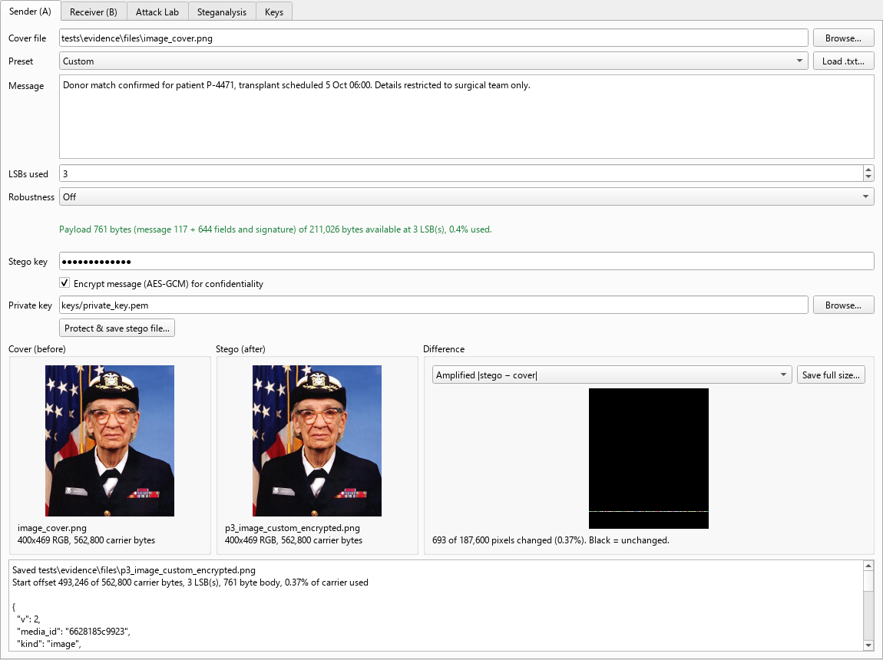
P3 Sender tab: cover, stego and difference view after protecting
Saved tests\evidence\files\p3_image_custom_encrypted.png
Start offset 493,246 of 562,800 carrier bytes, 3 LSB(s), 761 byte body, 0.37% of carrier used
"team": "P6-4",
"enc": true,
"ct": "00e08b6b66381148511b09fe…"
$ python -m stego.cli verify tests/evidence/files/p3_image_custom_encrypted.png --key p6-4-demo-key --pub keys/publ…
Verdict: Authentic
Signature valid and media hash matches.
Message: Donor match confirmed for patient P-4471, transplant scheduled 5 Oct 06:00. Details restricted to surgical…
"start": 493246,
"k": 3,
"body_len": 761,
"expected_hash": "6c7a2bcbd4973c170458199f3fde41ef981a613a93787e341eb4bb3cbcac8c5a",
"current_hash": "6c7a2bcbd4973c170458199f3fde41ef981a613a93787e341eb4bb3cbcac8c5a"
"ct": "00e08b6b66381148511b09fe…",
"enc": true,
"team": "P6-4",
(exit code 0)

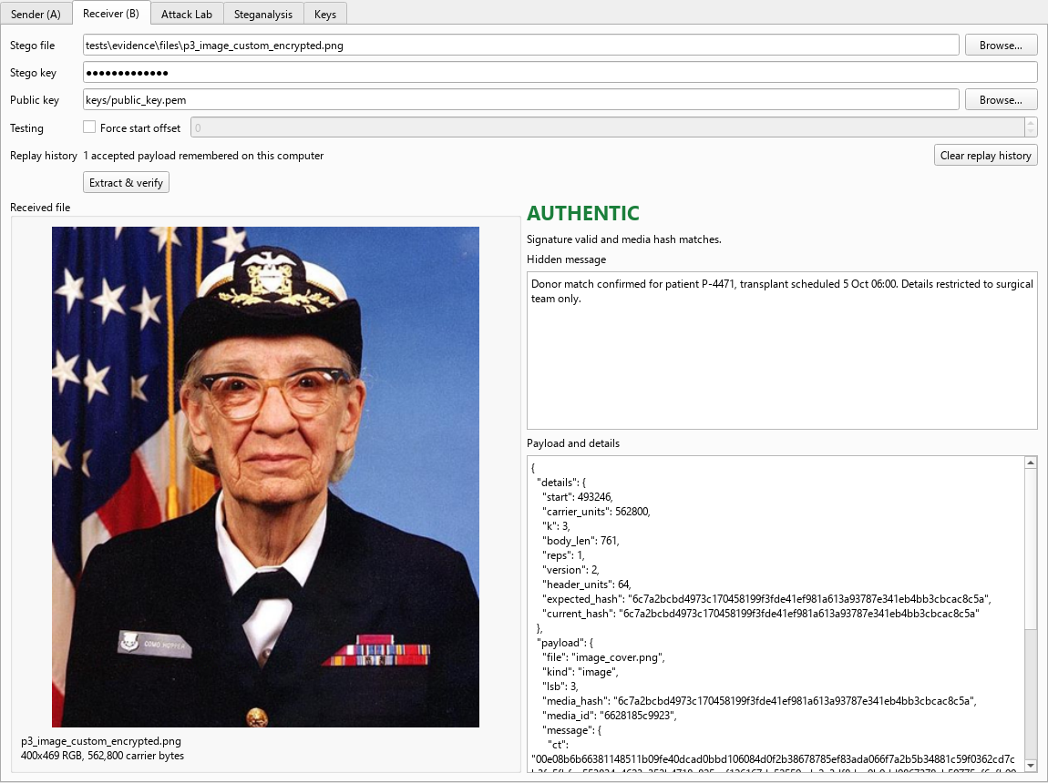
P3 Receiver tab: extracted message and verdict

P4: Audio, custom encrypted payload, 8 LSBs
Requirement: Positive audio case at the LSB extreme
Result: Authentic (expected Authentic)
The payload stores only the AES-GCM ciphertext ("enc": true, "ct": …), so the message can't be read from the file without the stego key. The Receiver decrypts it after the signature and hash checks pass.
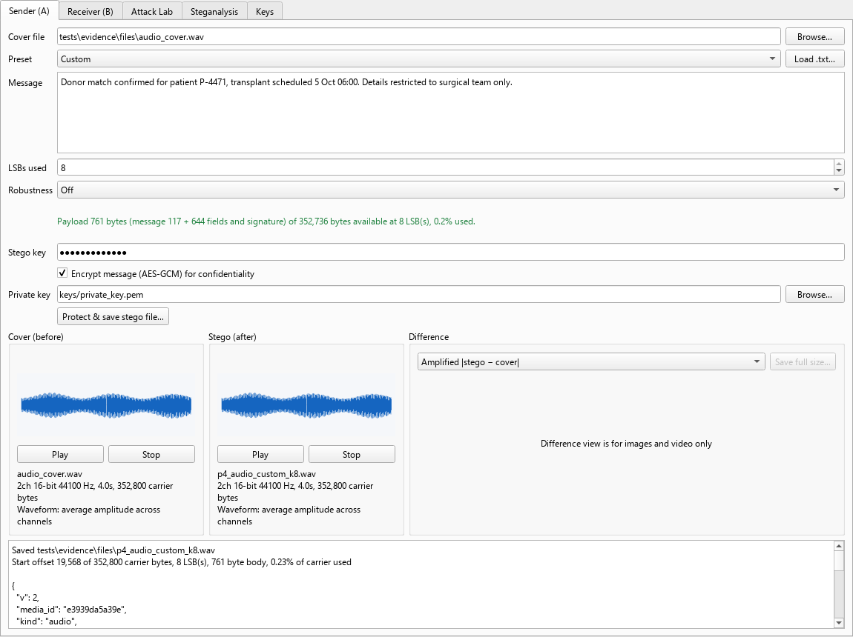
P4 Sender tab: cover, stego and difference view after protecting
Saved tests\evidence\files\p4_audio_custom_k8.wav
Start offset 19,568 of 352,800 carrier bytes, 8 LSB(s), 761 byte body, 0.23% of carrier used
"team": "P6-4",
"enc": true,
"ct": "58dd791da27cad89dc2df4a9…"
$ python -m stego.cli verify tests/evidence/files/p4_audio_custom_k8.wav --key p6-4-demo-key --pub keys/public_key.pem
Verdict: Authentic
Signature valid and media hash matches.
Message: Donor match confirmed for patient P-4471, transplant scheduled 5 Oct 06:00. Details restricted to surgical…
"start": 19568,
"k": 8,
"body_len": 761,
"expected_hash": "747eb00fa1290013cf668dc7923550c421923eeabf7e0be424d831cab721ed60",
"current_hash": "747eb00fa1290013cf668dc7923550c421923eeabf7e0be424d831cab721ed60"
"ct": "58dd791da27cad89dc2df4a9…",
"enc": true,
"team": "P6-4",
(exit code 0)

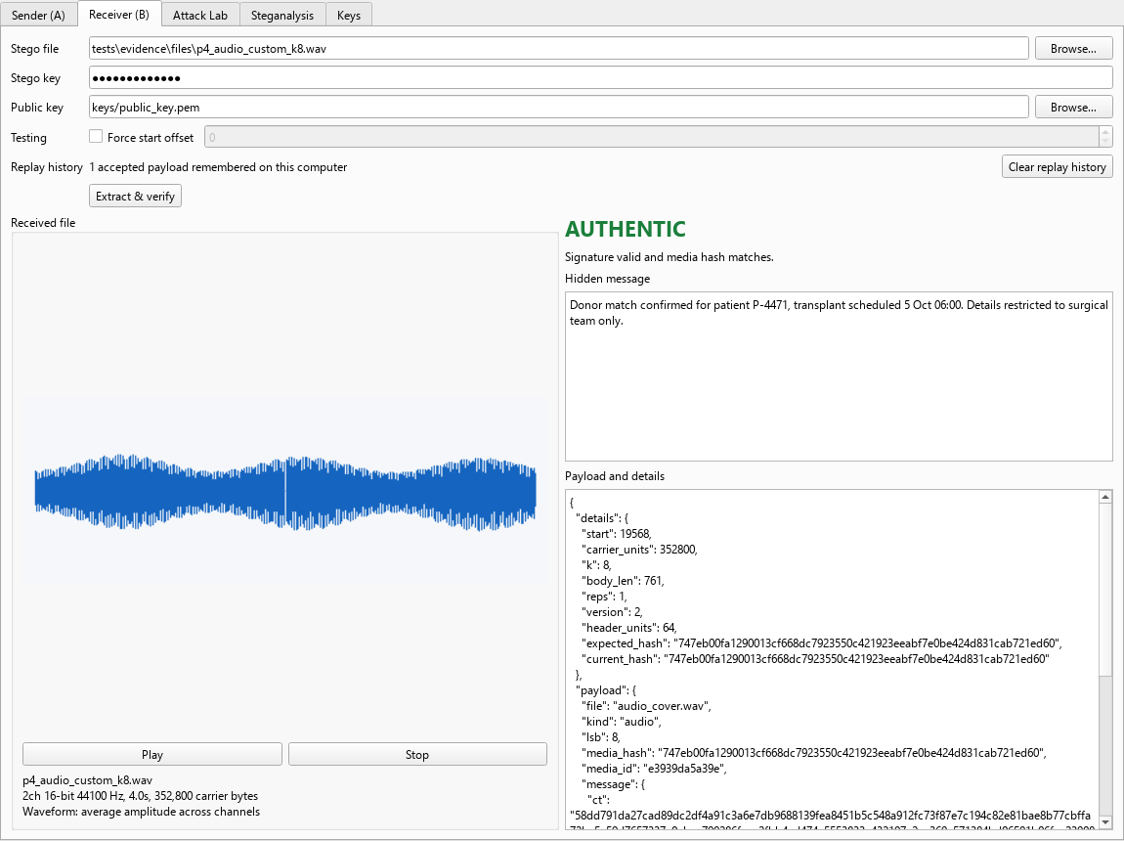
P4 Receiver tab: extracted message and verdict

4. LSB selection (k = 1 to 8)
The long message was embedded at every LSB setting on both covers and verified each time. Higher k fits more data and changes fewer carrier bytes for the same message, but each change is larger, so the quality number drops. Quality is measured over the whole file.

Image (image_cover.png)
k | Capacity (bytes) | Payload (bytes) | Carrier used | Bytes changed | PSNR | Verdict
1 | 70,342 | 1,093 | 1.565% | 4,422 | 69.2 dB | Authentic
2 | 140,684 | 1,093 | 0.788% | 3,316 | 65.2 dB | Authentic
3 | 211,026 | 1,093 | 0.529% | 2,578 | 60.9 dB | Authentic
4 | 281,368 | 1,093 | 0.4% | 2,066 | 55.4 dB | Authentic
5 | 351,710 | 1,093 | 0.322% | 1,716 | 52.2 dB | Authentic
6 | 422,052 | 1,093 | 0.27% | 1,477 | 46.0 dB | Authentic
7 | 492,394 | 1,093 | 0.233% | 1,273 | 39.2 dB | Authentic
8 | 562,736 | 1,093 | 0.206% | 1,123 | 32.8 dB | Authentic

Audio (audio_cover.wav)
k | Capacity (bytes) | Payload (bytes) | Carrier used | Bytes changed | SNR | Verdict
1 | 44,092 | 1,093 | 2.497% | 4,480 | 96.0 dB | Authentic
2 | 88,184 | 1,093 | 1.257% | 3,277 | 92.0 dB | Authentic
3 | 132,276 | 1,093 | 0.844% | 2,582 | 87.8 dB | Authentic
4 | 176,368 | 1,093 | 0.638% | 2,072 | 82.9 dB | Authentic
5 | 220,460 | 1,093 | 0.514% | 1,723 | 77.7 dB | Authentic
6 | 264,552 | 1,093 | 0.431% | 1,463 | 72.3 dB | Authentic
7 | 308,644 | 1,093 | 0.372% | 1,267 | 67.1 dB | Authentic
8 | 352,736 | 1,093 | 0.328% | 1,117 | 61.5 dB | Authentic

Amplified difference |stego − cover| for the image (black = unchanged). The payload sits in one band starting at the key-derived offset, not at the top-left corner:
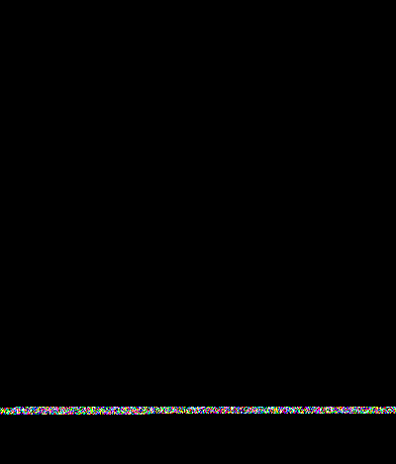  k = 1 |   k = 8

5. Negative cases

N1: Capacity check: payload larger than cover
Requirement: Capacity check / LSB selection
Result: Blocked (expected Blocked)
At 1 LSB the long message doesn't fit, at 8 LSBs it does.
# N1 Capacity check: long message into a 24x24 image at 1 LSB
$ python -m stego.cli capacity tests/evidence/files/image_tiny.png -k 1 --msg-file tests/evidence/files/long_messag…
24x24 RGB, 1,728 carrier bytes
Payload 1,092 bytes, capacity 208 bytes at 1 LSB(s)
Does NOT fit
(exit code 1)
$ python -m stego.cli protect tests/evidence/files/image_tiny.png tests/evidence/files/n1_should_not_exist.png -k 1…
Capacity check failed: Payload needs 1,092 bytes but this cover only holds 208 bytes at 1 LSB(s). Use more LSBs, a …
(exit code 1)
$ python -m stego.cli capacity tests/evidence/files/image_tiny.png -k 8 --msg-file tests/evidence/files/long_messag…
24x24 RGB, 1,728 carrier bytes
Payload 1,092 bytes, capacity 1,664 bytes at 8 LSB(s)
Fits
(exit code 0)
Capacity check failed: Payload needs 1,092 bytes but this cover only holds 208 bytes at 1 LSB(s). Use more LSBs, a …
CAPACITY CHECK FAILED
Payload needs 1,092 bytes but this cover only holds 208 bytes at 1 LSB(s). Use more LSBs, a bigger cover, or a shor…

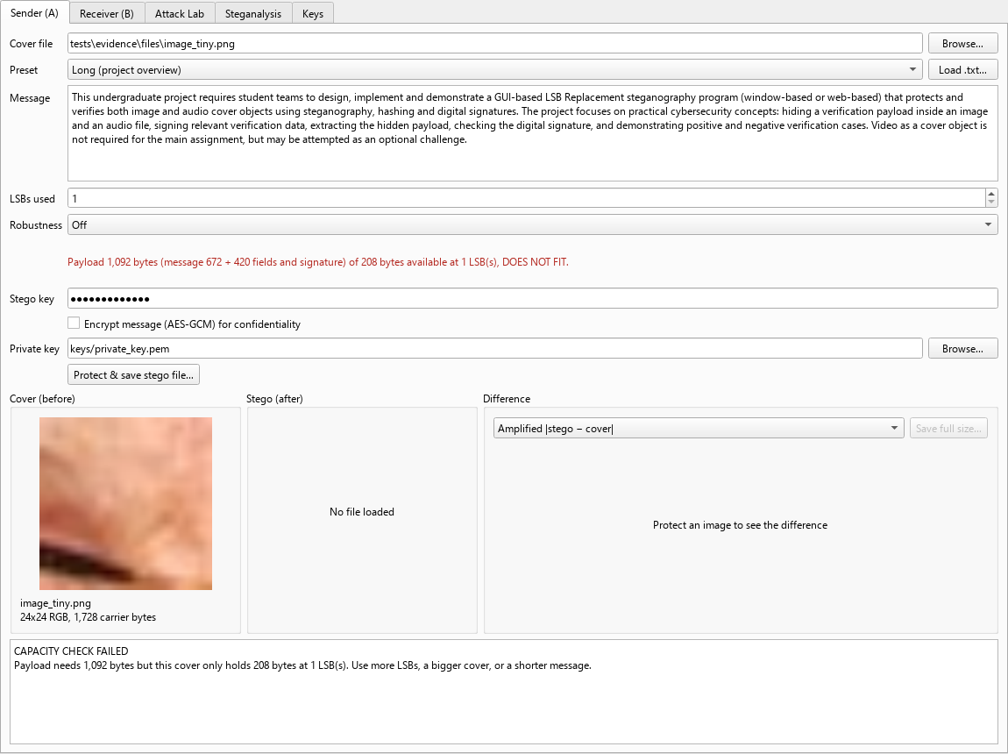
N1 sender capacity fail

N2: Image edited after protection (block blacked out)
Requirement: Negative image case
Result: Tampered (expected Tampered)
The payload rows were left alone, so the signature is valid and the media hash catches it.
$ python -m stego.cli verify tests/evidence/files/n2_image_tampered.png --key p6-4-demo-key --pub keys/public_key.pem
Verdict: Tampered
Signature is valid, but the media hash doesn't match. The file was modified after it was protected.
Message: Explain how steganography can be used to embed hidden verification data in image and audio cover objects.
"start": 493246,
"k": 2,
"body_len": 526,
"expected_hash": "f97f1265bd0d420afdae41ee320c9d00754ea6258bfc6cee64111b3b9de87b7a",
"current_hash": "6446491b6a20152b950486de618eec8c2a6a0b181955328701dd244edcc0193a"
"enc": false,
"team": "P6-4",
(exit code 1)

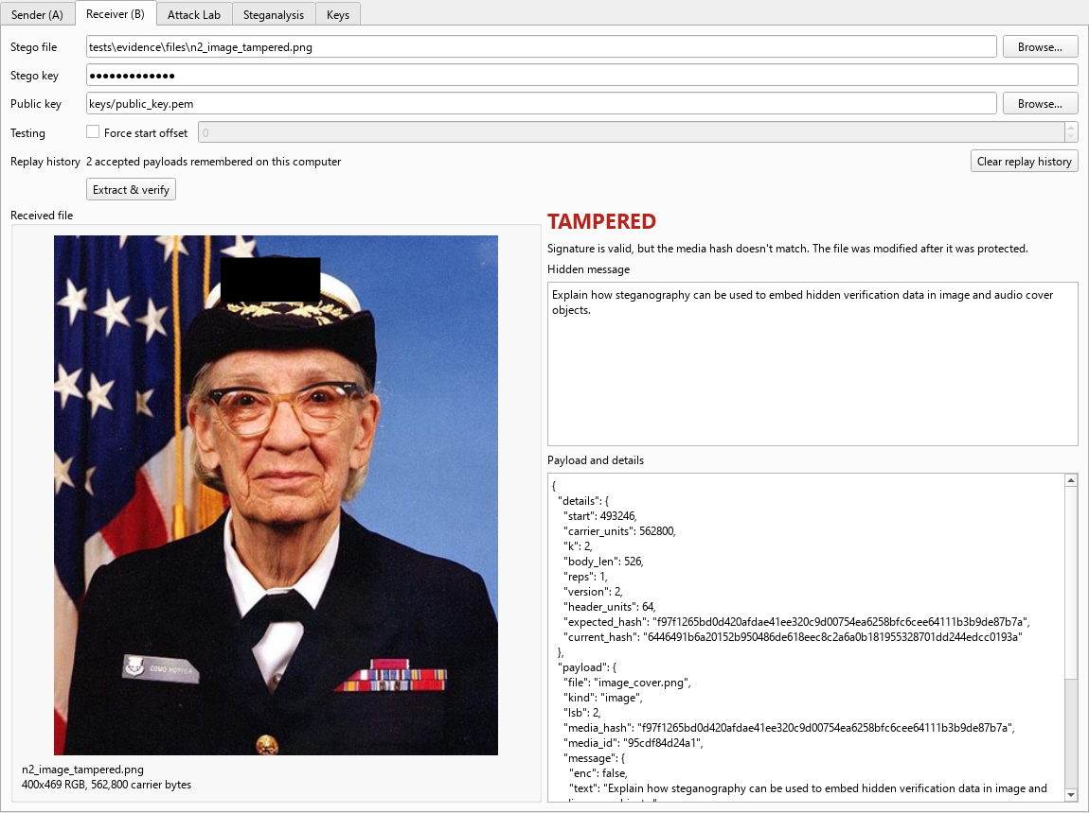
N2 receiver tampered

N3: Audio edited after protection (0.5 s made 35% louder)
Requirement: Negative audio case
Result: Tampered (expected Tampered)
$ python -m stego.cli verify tests/evidence/files/n3_audio_tampered.wav --key p6-4-demo-key --pub keys/public_key.pem
Verdict: Tampered
Signature is valid, but the media hash doesn't match. The file was modified after it was protected.
Message: This undergraduate project requires student teams to design, implement and demonstrate a GUI-based LSB Rep…
"start": 19568,
"k": 2,
"body_len": 1093,
"expected_hash": "ddfceed7e99045bd25ff5a0a1e15e7d62e4ab571079343beda2d0d87991b5578",
"current_hash": "555bdce7ebb407bcf3fa3773436e242c1ed74ee98b8f5dbfc48d88ba7424fb8e"
"enc": false,
"team": "P6-4",
(exit code 1)

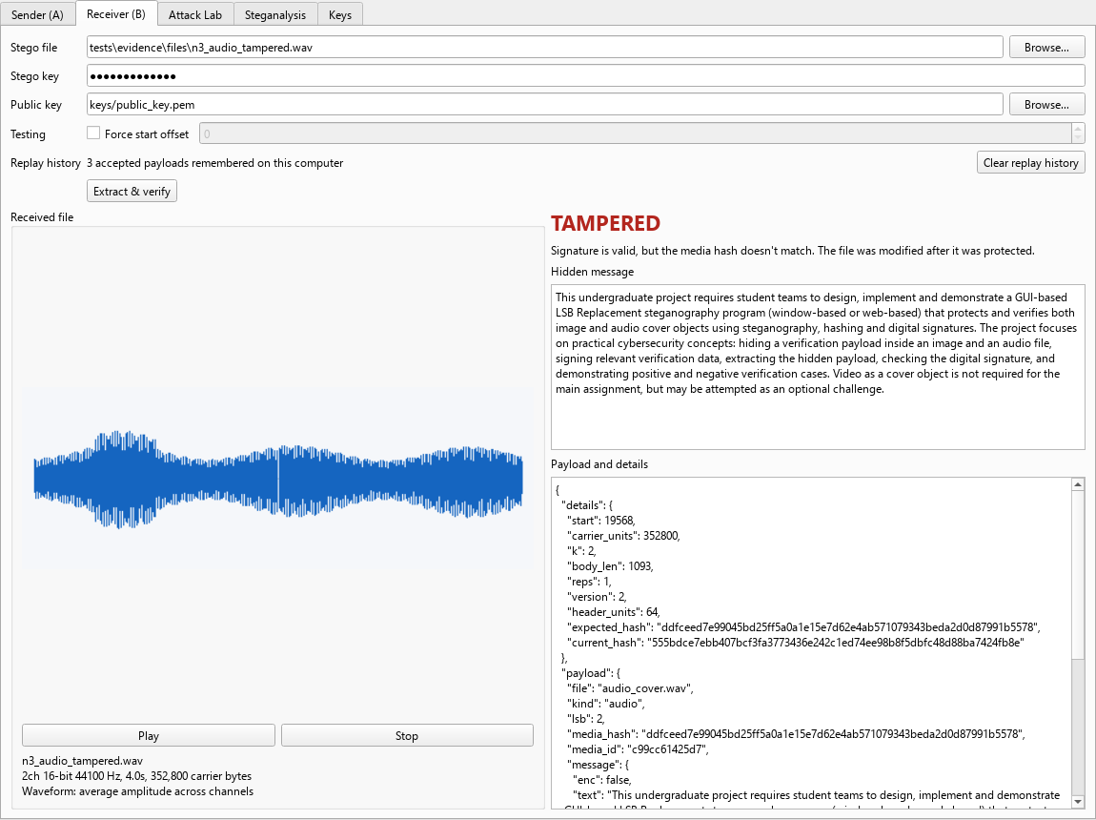
N3 receiver tampered

N4: Forged payload signed with an attacker's key
Requirement: Signature verification
Result: Signature Invalid (expected Signature Invalid)
Attacker key pair generated only for this test, in files/attacker_keys/.
$ python -m stego.cli protect tests/evidence/files/image_cover.png tests/evidence/files/n4_image_forged.png -k 2 --…
"start": 493246,
"k": 2,
"body_len": 447,
"team": "P6-4",
"enc": false,
(exit code 0)
$ python -m stego.cli verify tests/evidence/files/n4_image_forged.png --key p6-4-demo-key --pub keys/public_key.pem
Verdict: Signature Invalid
Signature check failed. The embedded payload was altered, or it was signed by a different key than the public key p…
"start": 493246,
"k": 2,
"body_len": 447,
(exit code 1)

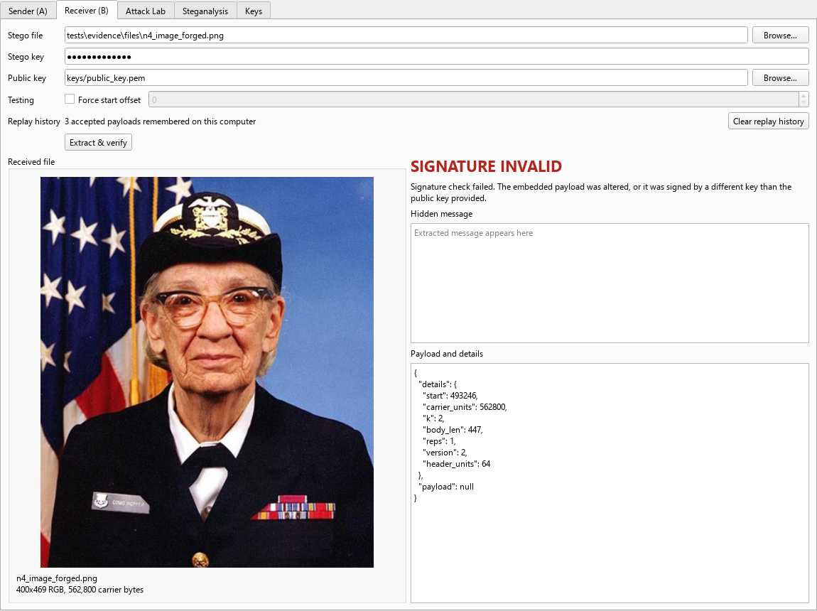
N4 receiver signature invalid

N5: Wrong stego key (start location can't be found)
Requirement: Start-location security
Result: Wrong Start Location (expected Wrong Start Location)
$ python -m stego.cli verify tests/evidence/files/p2_audio_stego.wav --key wrong-guess --pub keys/public_key.pem
Verdict: Wrong Start Location
No valid header at offset 206616. Either the stego key is wrong (so the derived start location is wrong) or this fi…
"start": 206616,
(exit code 1)

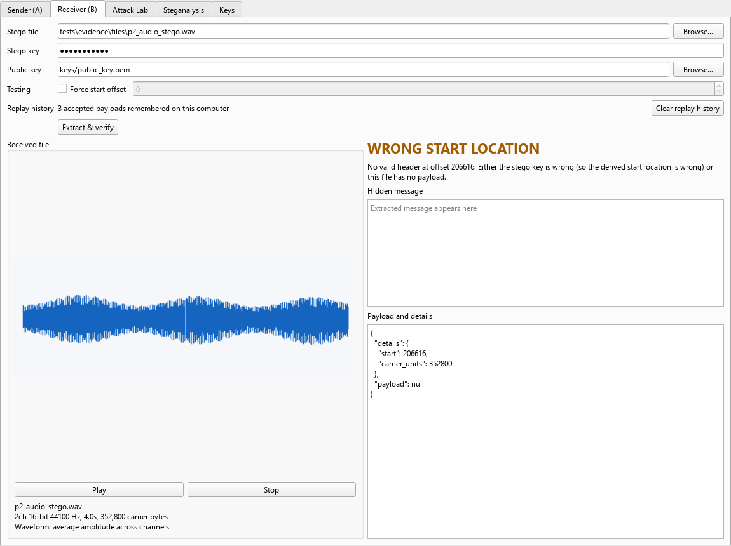
N5 receiver wrong key

N6: Replay: the same genuine file presented again
Requirement: Replay detection (team addition)
Result: Replay Detected (expected Replay Detected)
$ python -m stego.cli verify tests/evidence/files/p1_image_stego.png --key p6-4-demo-key --pub keys/public_key.pem
Verdict: Authentic
Signature valid and media hash matches.
Message: Explain how steganography can be used to embed hidden verification data in image and audio cover objects.
"start": 493246,
"k": 2,
"body_len": 526,
"expected_hash": "f97f1265bd0d420afdae41ee320c9d00754ea6258bfc6cee64111b3b9de87b7a",
"current_hash": "f97f1265bd0d420afdae41ee320c9d00754ea6258bfc6cee64111b3b9de87b7a"
"enc": false,
"team": "P6-4",
(exit code 0)
$ python -m stego.cli verify tests/evidence/files/p1_image_stego.png --key p6-4-demo-key --pub keys/public_key.pem
Verdict: Replay Detected
Signature and hash are valid, but this exact payload has been verified before. This file may be a replay of an earl…
Message: Explain how steganography can be used to embed hidden verification data in image and audio cover objects.
"start": 493246,
"k": 2,
"body_len": 526,
"expected_hash": "f97f1265bd0d420afdae41ee320c9d00754ea6258bfc6cee64111b3b9de87b7a",
"current_hash": "f97f1265bd0d420afdae41ee320c9d00754ea6258bfc6cee64111b3b9de87b7a"
"enc": false,
"team": "P6-4",
(exit code 1)
$ python -m stego.cli clear-replay
Forgot 1 accepted payload(s). Verifying them again will say Authentic.
(exit code 0)
$ python -m stego.cli verify tests/evidence/files/p1_image_stego.png --key p6-4-demo-key --pub keys/public_key.pem
Verdict: Authentic
Signature valid and media hash matches.
Message: Explain how steganography can be used to embed hidden verification data in image and audio cover objects.
"start": 493246,
"k": 2,
"body_len": 526,
"expected_hash": "f97f1265bd0d420afdae41ee320c9d00754ea6258bfc6cee64111b3b9de87b7a",
"current_hash": "f97f1265bd0d420afdae41ee320c9d00754ea6258bfc6cee64111b3b9de87b7a"
"enc": false,
"team": "P6-4",
(exit code 0)

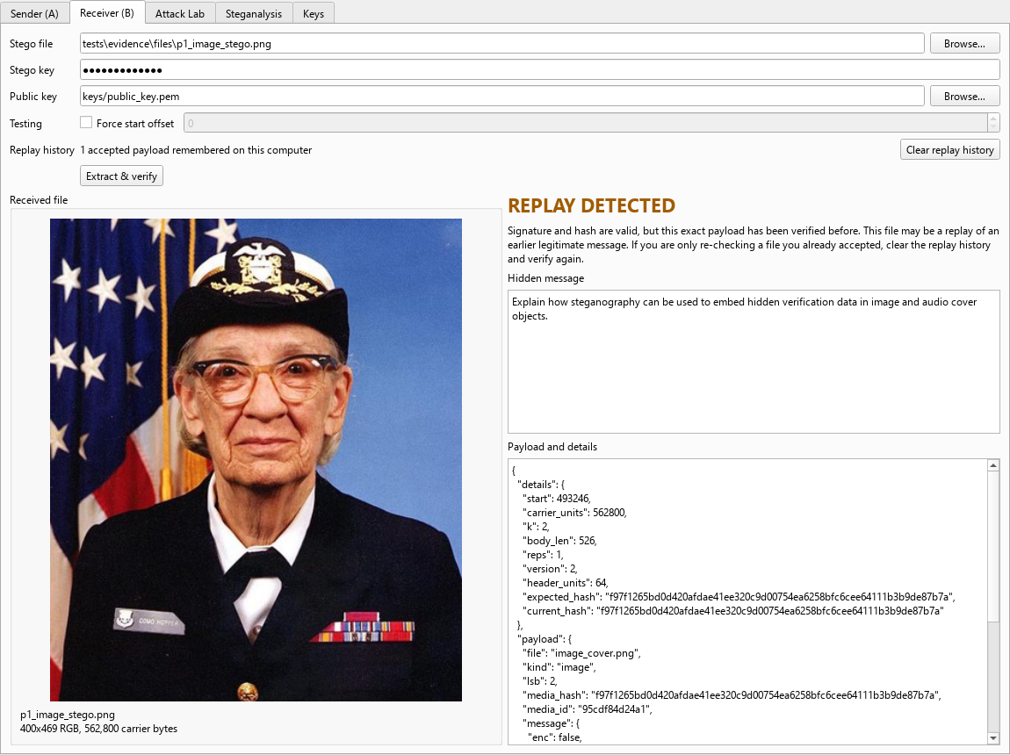
N6 receiver replay

N7: Limitation: stego image re-saved as JPEG (quality 95)
Requirement: Limitations
Result: Not authentic (expected Not authentic)
verify() said Wrong Start Location: the payload doesn't survive lossy compression.
$ python -m stego.cli verify tests/evidence/files/n7_after_jpeg.png --key p6-4-demo-key --pub keys/public_key.pem
Verdict: Wrong Start Location
No valid header at offset 493246. Either the stego key is wrong (so the derived start location is wrong) or this fi…
"start": 493246,
(exit code 1)

6. Innovation: attack simulation (Attack Lab)
The attacks follow the order verify() runs its checks: attacks 1-3 go after finding the header, 4 the length check, 5 the signature, 6-7 the media hash and 8 the replay log. Attacks 9-11 are damage in transit rather than tricks. Each attack runs on its own fresh copy of the genuine file, so they are independent.
core/attacks.py takes a genuine stego file and runs eleven attacks on copies of it, each changing exactly one thing, then checks verify() gives the expected verdict. It starts by verifying the untouched file, so a row only counts if the file was authentic to begin with. It runs in a throwaway replay history, so it never affects the real one.

Image (P1 stego file): 11 of 11 caught
# | Attack | Check it targets | What the attacker did | Expected | Got | Result
1 | Wrong stego key | 1. find the header | Tried to extract with a guessed passphrase | Wrong Start Location | Wrong Start Location | PASS
2 | Off-by-one start | 1. find the header | Read the payload one byte after the real start | Wrong Start Location | Wrong Start Location | PASS
3 | Crop / trim | 1. find the header | Removed a pixel row, the last video frame, or 100 audio frames | Wrong Start Location | Wrong Start Location | PASS
4 | Break length field | 2. body fits | Flipped the top bit of the header's length field | Payload Missing | Payload Missing | PASS
5 | Flip one payload bit | 3. signature | Changed a single bit inside the hidden payload | Signature Invalid | Signature Invalid | PASS
6 | Edit outside payload | 4. media hash | Flipped the top bit of 500 bytes that hold no payload | Tampered | Tampered | PASS
7 | Substitute payload | 4. media hash | Pasted the genuine payload into a different file | Tampered | Tampered | PASS
8 | Replay | 5. replay log | Presented the same authentic file a second time | Replay Detected | Replay Detected | PASS
9 | Mild LSB noise | damage (robustness) | Flipped the lowest bit of 1% of all carrier bytes | Wrong Start Location / Signature Invalid / Payload Missing | Payload Missing | PASS
10 | Scratch over payload | damage (robustness) | Overwrote 200 bytes in the middle of the hidden payload | Wrong Start Location / Signature Invalid / Payload Missing | Signature Invalid | PASS
11 | Lossy re-encode | damage (limitation) | JPEG for images, H.264 for video, full LSB noise for audio | Wrong Start Location / Signature Invalid / Payload Missing | Wrong Start Location | PASS

Audio (P2 stego file): 11 of 11 caught
# | Attack | Check it targets | What the attacker did | Expected | Got | Result
1 | Wrong stego key | 1. find the header | Tried to extract with a guessed passphrase | Wrong Start Location | Wrong Start Location | PASS
2 | Off-by-one start | 1. find the header | Read the payload one byte after the real start | Wrong Start Location | Wrong Start Location | PASS
3 | Crop / trim | 1. find the header | Removed a pixel row, the last video frame, or 100 audio frames | Wrong Start Location | Wrong Start Location | PASS
4 | Break length field | 2. body fits | Flipped the top bit of the header's length field | Payload Missing | Payload Missing | PASS
5 | Flip one payload bit | 3. signature | Changed a single bit inside the hidden payload | Signature Invalid | Signature Invalid | PASS
6 | Edit outside payload | 4. media hash | Flipped the top bit of 500 bytes that hold no payload | Tampered | Tampered | PASS
7 | Substitute payload | 4. media hash | Pasted the genuine payload into a different file | Tampered | Tampered | PASS
8 | Replay | 5. replay log | Presented the same authentic file a second time | Replay Detected | Replay Detected | PASS
9 | Mild LSB noise | damage (robustness) | Flipped the lowest bit of 1% of all carrier bytes | Wrong Start Location / Signature Invalid / Payload Missing | Wrong Start Location | PASS
10 | Scratch over payload | damage (robustness) | Overwrote 200 bytes in the middle of the hidden payload | Wrong Start Location / Signature Invalid / Payload Missing | Signature Invalid | PASS
11 | Lossy re-encode | damage (limitation) | JPEG for images, H.264 for video, full LSB noise for audio | Wrong Start Location / Signature Invalid / Payload Missing | Wrong Start Location | PASS

What each row proves
- Edit outside payload, Substitute payload → Tampered: the signature covers the media hash, so the payload is bound to this exact file. A genuine payload pasted into a fake file still verifies its signature but fails the hash.
- Flip one payload bit → Signature Invalid: a single changed bit in the signed payload breaks Ed25519.
- Break length field → Payload Missing: a damaged header is reported cleanly instead of crashing.
- Wrong stego key, Off-by-one start, Crop / trim → Wrong Start Location: the start offset and header mask come from the stego key and the carrier length. Without the key, or one byte off, or after cropping, the header can't be found, and a scan for the magic bytes doesn't work because the header is XOR-masked.
- Mild LSB noise, Scratch over payload → lost, or Tampered in robust mode: a normal payload is destroyed. A robust file (section 7.3) votes the damage away, keeps its signed payload and still reports the change as Tampered.
- Lossy re-encode → not Authentic: our limitation. JPEG (even at quality 95), H.264 for video, or LSB noise destroys the payload. The tool fails safe, but the data is lost. Robust embedding would need error correction.
- Replay → Replay Detected: each payload carries a random nonce, and the receiver remembers accepted nonces.
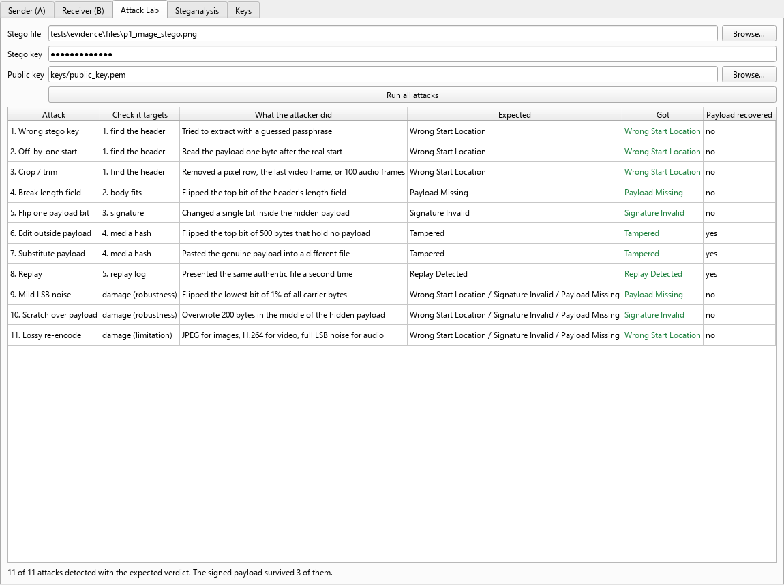
Attack Lab tab on the image stego file
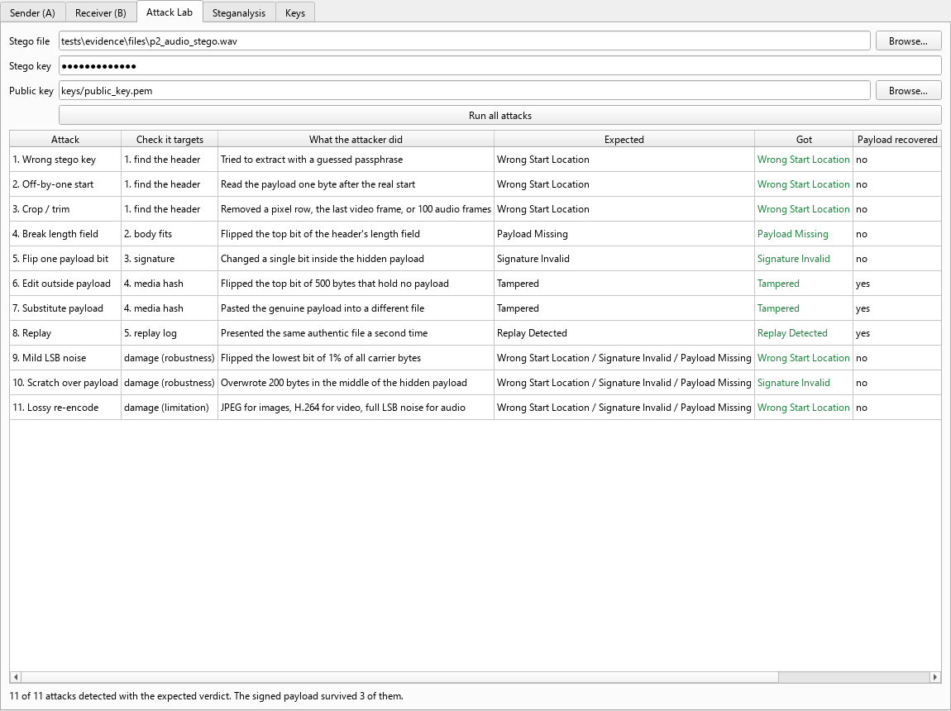
Attack Lab tab on the audio stego file

7. Optional challenges
These are the spec's optional challenges beyond the attack simulation module. They are on the m6-advanced branch and all run through the same GUI, CLI and tests.

7.1 Video as a cover object
- Video is decoded to RGB frames and the frames are joined end to end, so the carrier is simply every pixel of every frame. The same key-derived start then picks which frame the payload lands in: frame 24 of 24 here, and a different frame for a different key.
- Stego video is saved as FFV1 in an .mkv file, a lossless codec, so the LSBs survive exactly. MP4/MOV are accepted as covers (decoded to frames) but never written, because H.264 is lossy (Attack Lab row 11 shows it destroying the payload).
- The media hash covers every frame, so editing any frame, not just the payload frame, is caught (V2).
- Limitation: the original audio track is not kept, and every frame is held in memory, so long HD clips are refused.

V1: Video (FFV1 .mkv), short message, 2 LSBs
Requirement: Optional challenge: video cover object
Result: Authentic (expected Authentic)
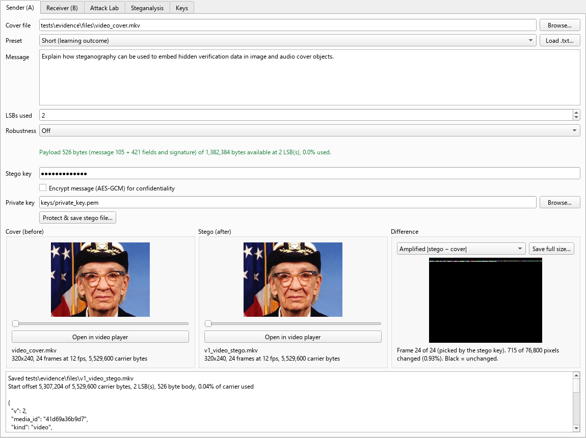
V1 Sender tab: video cover and stego (frame slider), difference view on the key-picked frame
Saved tests\evidence\files\v1_video_stego.mkv
Start offset 5,307,204 of 5,529,600 carrier bytes, 2 LSB(s), 526 byte body, 0.04% of carrier used
"team": "P6-4",
"enc": false,
$ python -m stego.cli verify tests/evidence/files/v1_video_stego.mkv --key p6-4-demo-key --pub keys/public_key.pem
Verdict: Authentic
Signature valid and media hash matches.
Message: Explain how steganography can be used to embed hidden verification data in image and audio cover objects.
"start": 5307204,
"k": 2,
"body_len": 526,
"expected_hash": "bdb0563ff63b39c063eca90001e17e7176a35179cf7ea1ee71a73744b2de68d2",
"current_hash": "bdb0563ff63b39c063eca90001e17e7176a35179cf7ea1ee71a73744b2de68d2"
"enc": false,
"team": "P6-4",
(exit code 0)

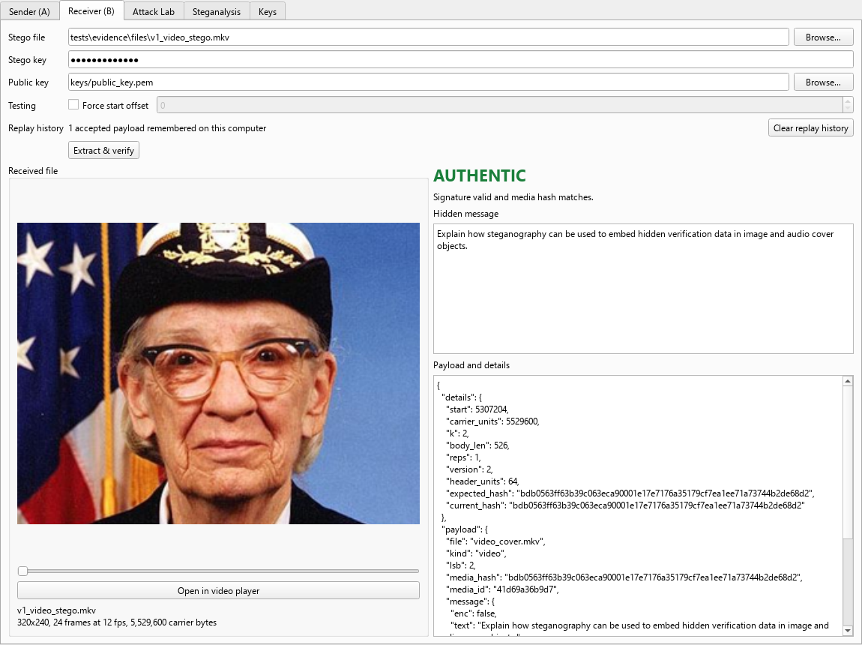
V1 Receiver tab: video verified as Authentic

V2: Video: a different frame edited after protection
Requirement: Optional challenge: video cover object
Result: Tampered (expected Tampered)
The payload sits in frame 24 of 24 and frame 1 was edited. It is still caught, because the media hash covers every frame.
$ python -m stego.cli verify tests/evidence/files/v2_video_tampered.mkv --key p6-4-demo-key --pub keys/public_key.pem
Verdict: Tampered
Signature is valid, but the media hash doesn't match. The file was modified after it was protected.
Message: Explain how steganography can be used to embed hidden verification data in image and audio cover objects.
"start": 5307204,
"k": 2,
"body_len": 526,
"expected_hash": "bdb0563ff63b39c063eca90001e17e7176a35179cf7ea1ee71a73744b2de68d2",
"current_hash": "216be977bc61fab21f107e81db4ab762f8cab04e94982dfa6e9a5b61a88e6be3"
"enc": false,
"team": "P6-4",
(exit code 1)

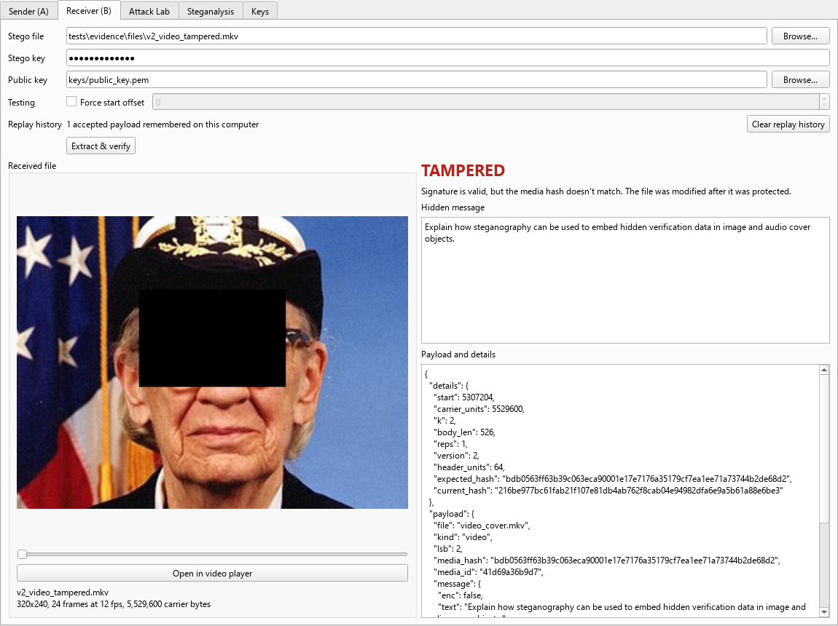
V2 Receiver tab: edited video caught as Tampered

Attack Lab on the video (V1): 11 of 11 caught
# | Attack | What the attacker did | Expected | Got | Payload kept | Result
1 | Wrong stego key | Tried to extract with a guessed passphrase | Wrong Start Location | Wrong Start Location | no | PASS
2 | Off-by-one start | Read the payload one byte after the real start | Wrong Start Location | Wrong Start Location | no | PASS
3 | Crop / trim | Removed a pixel row, the last video frame, or 100 audio frames | Wrong Start Location | Wrong Start Location | no | PASS
4 | Break length field | Flipped the top bit of the header's length field | Payload Missing | Payload Missing | no | PASS
5 | Flip one payload bit | Changed a single bit inside the hidden payload | Signature Invalid | Signature Invalid | no | PASS
6 | Edit outside payload | Flipped the top bit of 500 bytes that hold no payload | Tampered | Tampered | yes | PASS
7 | Substitute payload | Pasted the genuine payload into a different file | Tampered | Tampered | yes | PASS
8 | Replay | Presented the same authentic file a second time | Replay Detected | Replay Detected | yes | PASS
9 | Mild LSB noise | Flipped the lowest bit of 1% of all carrier bytes | Wrong Start Location / Signature Invalid / Payload Missing | Signature Invalid | no | PASS
10 | Scratch over payload | Overwrote 200 bytes in the middle of the hidden payload | Wrong Start Location / Signature Invalid / Payload Missing | Signature Invalid | no | PASS
11 | Lossy re-encode | JPEG for images, H.264 for video, full LSB noise for audio | Wrong Start Location / Signature Invalid / Payload Missing | Wrong Start Location | no | PASS
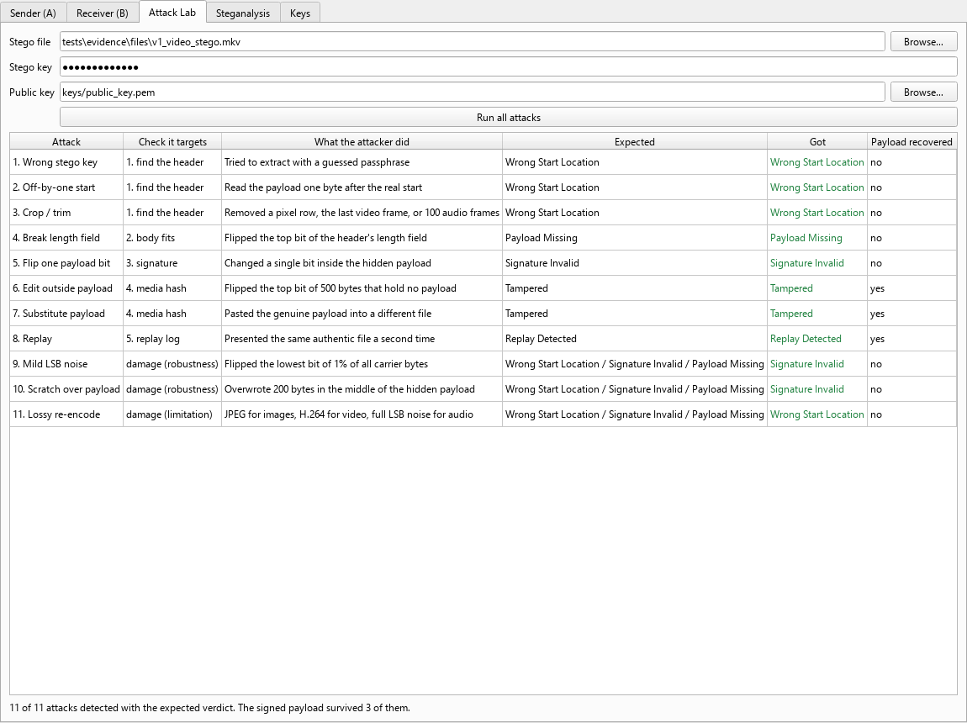
Attack Lab tab on the video stego file

7.2 Steganalysis, and the fix it led to
The Steganalysis tab (core/steganalysis.py) plays the analyst: it gets only the file, with no stego key and no public key, and asks whether anything is hidden.
- Chi-square attack (Westfeld & Pfitzmann, 2000): the textbook test for LSB replacement. It measures whether each pair of values (2i, 2i+1) is suspiciously balanced. On our covers it is inconclusive: the clean photo already scores about the same as the stego files (table below), because real photos and audio have noisy low bits.
- Structure scan: for every LSB count k = 1..8 and every bit alignment it decodes the low bits into bytes and looks for windows that read like JSON (mostly printable, mostly lowercase, several quote marks). Random noise never does this. It found every version 1 payload, reported the right k and location, and read the whole payload out, message included, without the key. That includes M2's demo audio sample.
- The fix (format version 2): the payload body is now XOR-masked with a keystream derived from the stego key (SHAKE-256), just like the header already was. The low bits then look like noise, and the same scan finds nothing (S2). Version 1 files still verify, so nothing already made breaks.
File | Found | k | Carrier bytes | Chi-square | What the scan read (start)
Version 1 file (body not masked) | yes | 2 | 493,282–495,054 | 62% | F.8.p.w{"file":"image_cover.png","kind":"image","lsb":2,"med…
M2's audio sample (made with version 1) | yes | 2 | 595,907–599,991 | 99% | !..$.{"file":"cover_stereo_music.wav","kind":"audio","lsb":2…
P1, made with version 2 (body masked) | no | - | - | 62%
R1, robust version 2 file | no | - | - | 63%
Clean cover, nothing hidden | no | - | - | 62%
Chi-square column: share of 1 KB chunks the test calls "embedded". It is the same for the clean cover and the stego files, which is why we don't rely on it.

S1: Steganalysis reads a version 1 payload without the key
Requirement: Optional challenge: steganalysis
Result: Hidden Text Found (expected Hidden Text Found)
The structure scan finds the JSON, the LSB count and the location, and reads the message out.
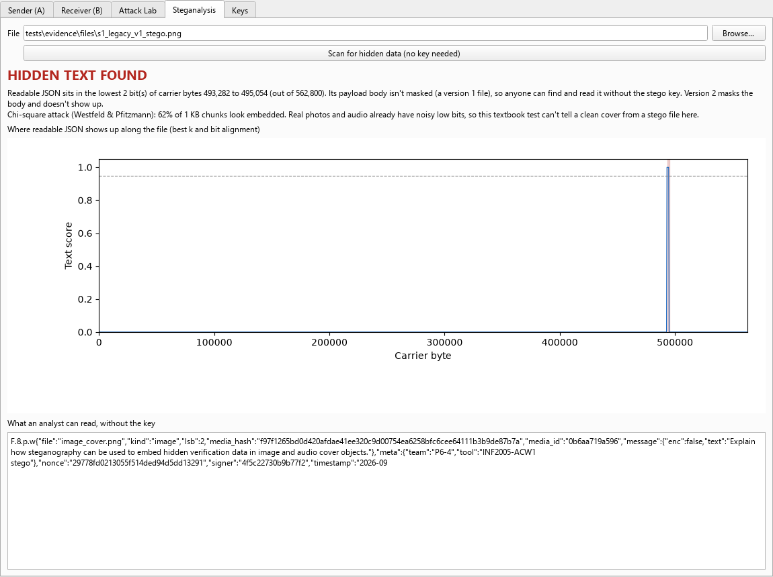
S1 Steganalysis tab on a version 1 file: payload found and read without the key

S2: Steganalysis finds nothing in a version 2 (masked) file
Requirement: Our fix for S1
Result: Nothing Found (expected Nothing Found)
Masking the body with a key-derived stream removes the structure the scan relies on.
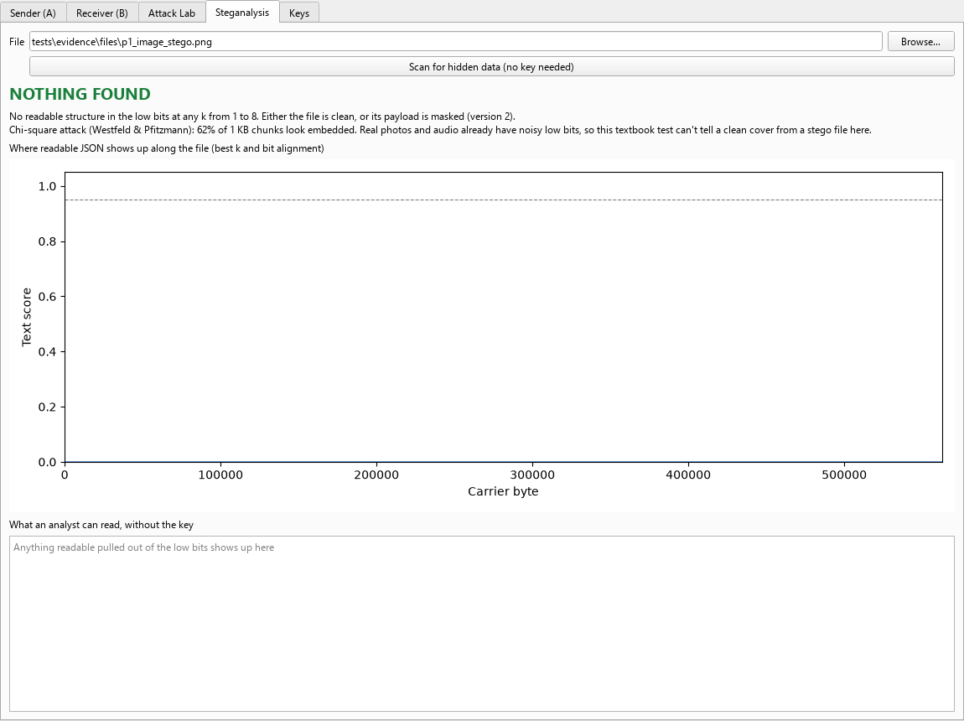
S2 the same scan on a version 2 file: nothing to find

7.3 Robust embedding
- Robust mode stores every bit several times (x3, x5 or x7) and reads it back by majority vote (core/robust.py). The copies are laid out one whole copy after another, so the copies of any one bit are far apart, and a burst of damage in one place only hits one copy of each bit.
- The header is kept 7 times and carries the repetition count in its spare bits, so the receiver knows how to read the body. Normal files are unaffected.
- The verdict stays strict: if the file changed, it still says Tampered. What robust mode adds is that the signed payload, and so the proof of who signed it and the message, survives.
- Limitation: capacity drops by the repetition factor, and it only helps against bit-level damage. JPEG and H.264 change too many bits for any vote to fix, which would need embedding in a transform domain instead.
Attack | Normal file (P1) | Payload kept | Robust x5 file (R1) | Payload kept
Flip one payload bit | Signature Invalid | no | Authentic | yes
Mild LSB noise | Payload Missing | no | Tampered | yes
Scratch over payload | Signature Invalid | no | Tampered | yes
Lossy re-encode | Wrong Start Location | no | Wrong Start Location | no

R2: Robust file vs normal file under noise and a scratch
Requirement: Optional challenge: robust embedding
Result: Payload recovered (expected Payload recovered)
Only the robust file keeps its signed payload after: Flip one payload bit, Mild LSB noise, Scratch over payload.

R1: Image, robust mode (x5 repetition), 2 LSBs
Requirement: Optional challenge: robust embedding
Result: Authentic (expected Authentic)
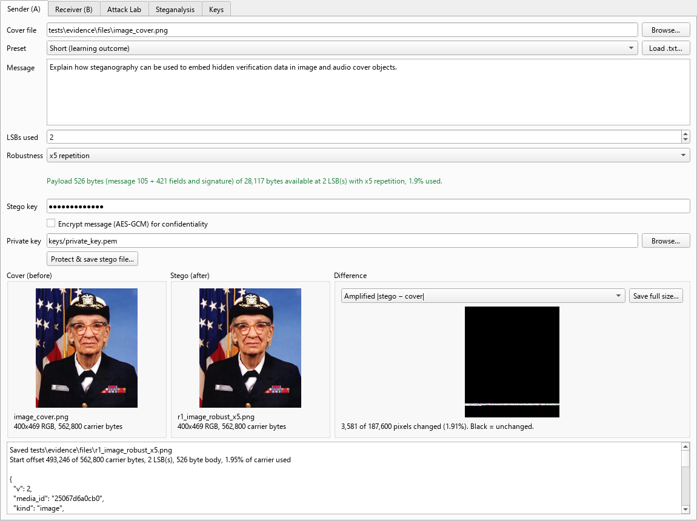
R1 Sender tab with Robustness set to x5
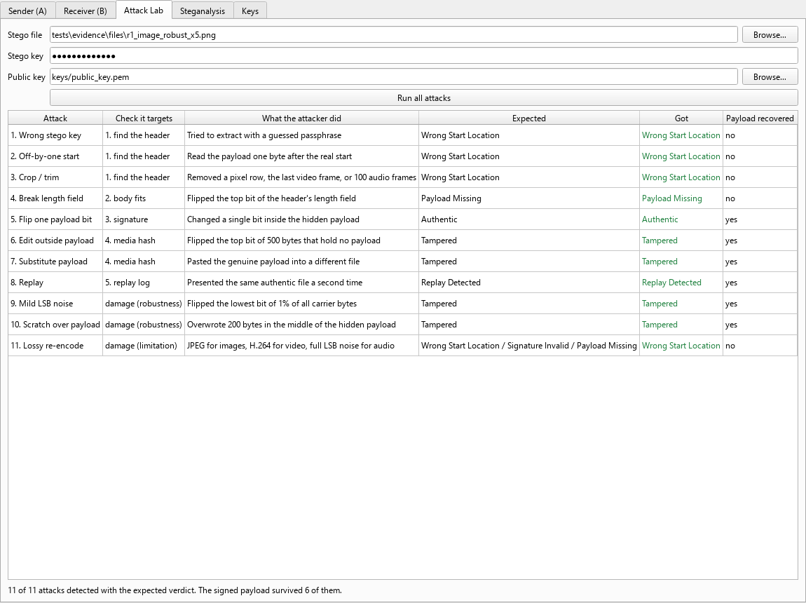
Attack Lab on the robust file: the payload is kept after noise, a scratch and a flipped bit

8. Party A to party B transfer (to be completed by the team)
This step has to be done by people, so it is left for the demo laptops. It is done by hand with a normal email client; the project contains no email code.
- A attaches the stego file to an email as an attachment (not pasted inline, which can re-compress images) and sends it to B.
- B downloads it to a folder and computes its SHA-256 (Windows: certutil -hashfile <file> SHA256). It must match the value below, which shows the file arrived byte for byte.
- B opens the Receiver tab, loads the downloaded file, enters the stego key and A's public key, and verifies. Expected: Authentic, with the hidden message shown.
- Paste the screenshots below: A's sent email, B's download folder, B's hash output and B's Receiver verdict.
File | SHA-256
p1_image_stego.png (as sent) | 5ebcd4f24cec2d62650b74021bcceb884cf4fa90dccfc6ed16c3d39491251df1
p1_image_stego.png (as received)
p2_audio_stego.wav (as sent) | 5128fbe1721762442b6428c7ddb7fd46adb805cb179ccf51a63f1eb09deb697b
p2_audio_stego.wav (as received)

Screenshots from the transfer (paste here)

9. Automated test suite
python -m pytest -v: 83 passed in 20.33s. The full output is in tests/evidence/logs/pytest.txt.
test_advanced.py::test_vote_fixes_a_minority_of_bad_copies PASSED
test_advanced.py::test_header_carries_reps_and_old_headers_still_parse PASSED
test_advanced.py::test_robust_roundtrip[3] PASSED
test_advanced.py::test_robust_roundtrip[5] PASSED
test_advanced.py::test_robust_capacity_is_divided_by_reps PASSED
test_advanced.py::test_robust_file_survives_what_breaks_a_normal_one[png] PASSED
test_advanced.py::test_robust_file_survives_what_breaks_a_normal_one[wav] PASSED
test_advanced.py::test_old_v1_files_still_verify PASSED
test_advanced.py::test_scan_reads_a_v1_payload_without_the_key[1] PASSED
test_advanced.py::test_scan_reads_a_v1_payload_without_the_key[2] PASSED
test_advanced.py::test_scan_reads_a_v1_payload_without_the_key[8] PASSED
test_advanced.py::test_scan_finds_nothing_in_v2_or_a_clean_cover[1] PASSED
test_advanced.py::test_scan_finds_nothing_in_v2_or_a_clean_cover[2] PASSED
test_advanced.py::test_scan_finds_nothing_in_v2_or_a_clean_cover[8] PASSED
test_advanced.py::test_video_roundtrip_is_lossless PASSED
test_advanced.py::test_video_authentic_after_save[1] PASSED
test_advanced.py::test_video_authentic_after_save[8] PASSED
test_advanced.py::test_video_attacks_all_caught PASSED
test_advanced.py::test_video_lossy_output_refused PASSED
test_attacks.py::test_every_attack_is_caught[png-1] PASSED
test_attacks.py::test_every_attack_is_caught[png-2] PASSED
test_attacks.py::test_every_attack_is_caught[png-8] PASSED
test_attacks.py::test_every_attack_is_caught[wav-1] PASSED
test_attacks.py::test_every_attack_is_caught[wav-2] PASSED
test_attacks.py::test_every_attack_is_caught[wav-8] PASSED
test_attacks.py::test_real_replay_store_untouched PASSED
test_attacks.py::test_needs_an_authentic_file PASSED
test_core.py::test_lsb_roundtrip_wraps_around PASSED
test_core.py::test_image_authentic_all_k[1] PASSED
test_core.py::test_image_authentic_all_k[2] PASSED
test_core.py::test_image_authentic_all_k[3] PASSED
test_core.py::test_image_authentic_all_k[4] PASSED
test_core.py::test_image_authentic_all_k[5] PASSED
test_core.py::test_image_authentic_all_k[6] PASSED
test_core.py::test_image_authentic_all_k[7] PASSED
test_core.py::test_image_authentic_all_k[8] PASSED
test_core.py::test_audio_authentic[1] PASSED
test_core.py::test_audio_authentic[4] PASSED
test_core.py::test_audio_authentic[8] PASSED
test_core.py::test_audio_high_byte_untouched PASSED
test_core.py::test_audio_formats_roundtrip_and_preserve_non_carrier_bytes[pcm_wav0] PASSED
test_core.py::test_audio_formats_roundtrip_and_preserve_non_carrier_bytes[pcm_wav1] PASSED
test_core.py::test_audio_formats_roundtrip_and_preserve_non_carrier_bytes[pcm_wav2] PASSED
test_core.py::test_audio_formats_roundtrip_and_preserve_non_carrier_bytes[pcm_wav3] PASSED
test_core.py::test_audio_formats_roundtrip_and_preserve_non_carrier_bytes[pcm_wav4] PASSED
test_core.py::test_audio_formats_roundtrip_and_preserve_non_carrier_bytes[pcm_wav5] PASSED
test_core.py::test_audio_waveform_is_normalised_for_pcm_widths[1] PASSED
test_core.py::test_audio_waveform_is_normalised_for_pcm_widths[2] PASSED
test_core.py::test_audio_waveform_is_normalised_for_pcm_widths[3] PASSED
test_core.py::test_stereo_ten_second_capacity_at_two_lsbs PASSED
test_core.py::test_encrypted_message PASSED
test_core.py::test_wrong_key_gives_wrong_start PASSED
test_core.py::test_wrong_start_offset PASSED
test_core.py::test_wrong_public_key PASSED
test_core.py::test_tampered_outside_payload PASSED
test_core.py::test_tampered_audio_upper_bits_in_region PASSED
test_core.py::test_payload_bits_corrupted PASSED
test_core.py::test_capacity_check PASSED
test_core.py::test_jpeg_output_refused PASSED
test_core.py::test_replay_nonce_unseen_by_default PASSED
test_core.py::test_replay_nonce_seen_after_record PASSED
test_core.py::test_replay_different_nonce_not_flagged PASSED
test_core.py::test_replay_clear_forgets_everything PASSED
test_core.py::test_replay_clear_on_fresh_checkout PASSED
test_core.py::test_second_verify_is_replay_until_cleared PASSED
test_gui.py::test_body_size_is_exact[-png-False] PASSED
test_gui.py::test_body_size_is_exact[-png-True] PASSED
test_gui.py::test_body_size_is_exact[-wav-False] PASSED
test_gui.py::test_body_size_is_exact[-wav-True] PASSED
test_gui.py::test_body_size_is_exact[hi-png-False] PASSED
test_gui.py::test_body_size_is_exact[hi-png-True] PASSED
test_gui.py::test_body_size_is_exact[hi-wav-False] PASSED
test_gui.py::test_body_size_is_exact[hi-wav-True] PASSED
test_gui.py::test_body_size_is_exact[na\xefve caf\xe9 \u2713 …] PASSED
test_gui.py::test_body_size_is_exact[na\xefve caf\xe9 \u2713 …] PASSED
test_gui.py::test_body_size_is_exact[na\xefve caf\xe9 \u2713 …] PASSED
test_gui.py::test_body_size_is_exact[na\xefve caf\xe9 \u2713 …] PASSED
test_gui.py::test_body_size_matches_capacity_check PASSED
test_gui.py::test_difference_marks_only_changed_pixels PASSED
test_gui.py::test_lsb_plane PASSED
test_gui.py::test_gui_smoke PASSED
test_gui.py::test_receiver_clear_replay_button PASSED
test_gui.py::test_shrink_max_keeps_single_pixel PASSED

10. Evidence files
Path (under tests/evidence/) | Contents
results.json | Machine-readable results of every case, the LSB table and the Attack Lab runs
logs/P1.txt … N7.txt | Full CLI transcripts and GUI log output for each case
logs/attack_lab.txt | Every attack, its verdict and verify()'s reason, for both covers
logs/pytest.txt | Full automated test run
screenshots/ | GUI screenshots for every case, the Attack Lab and the k = 1 / k = 8 difference images
files/ | Covers, stego files, tampered files and the attacker's test key pair used above

