Project 2 Part 3

# Answer each of the following questions in BLUE colored font.

## Project:

* 1. Include name of the team members.

Ty Painter & Tonnar Castellano

* 1. What is the general status of the project? Describe the roadblocks (if you have any) 3-4 sentences.

Our project is on track. We encountered some roadblocks handling dirty data within our data set. We decided to create a dirty_data table to remove NULL/duplicate primary key values. We are currently having trouble creating a trigger to accept proper date values.

## Database:

* 1. By this assignment submission date, you should have your decomposition completed with all the tables ready in database. You should have also implemented many of the advanced features. Clearly label the screenshots.
     1. Include the UML screenshot.

* + 1. Include the screenshots of decomposed tables. Graphical user interface, text, application

       Description automatically generated

* + 1. Include screenshots of your implementation of some advanced features (Stored procedures, views, triggers etc.)

* 1. In terms of percentage how much you think you have completed on database side of the project? Describe the completed work in 2-3 sentences. Describe roadblocks, if any.

## Front end:

* 1. By this assignment submission date, you should have a working interface showing data from the database in live connection. You should also have multiple UI pages. Clearly label the screenshots.
     1. Attach screenshots of the browser showing different UI pages. (At least 2 excluding home page)

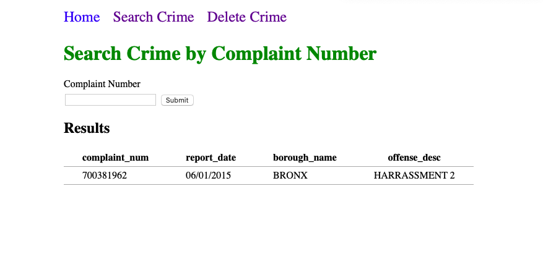

* + 1. Attach screenshots of relevant part of your front-end code showing calls to the database. This can be embedded SQL statements or calls to procedures etc.

* + 1. Have you implemented any DML components (INSERT, UPDATE, DELETE) yet in your project (Note that you must have DML components in the final version of your project).
  1. What is the status of front-end application? In terms of percentage how much do you think, you have completed on front-end side of the project? Describe what is completed and what is left. 2-3 sentences.

## Report and demo video

* Have you started working on your report? If yes, how much is completed (percentage)
* Which tool you are planning to use to create a demo video of your application?

## Final Submission

* The final submission of Project will be due on 4/26/2020 at 12 noon.

# Submission:

Complete this document and save it as pdf. You must submit a PDF file named **p2-part3-lastname1-lastname2.pdf** (For example if I submit this document with John Smith, I would name it p2-part3-singh-smith.pdf). Submit your files on Brightspace.

You must include your name and your partner name in the Brightspace submission text box.

Each member of the team must make the submission of same file.

# Grading:

This Assignment will be graded on the following criteria:

1. Completeness of document.
2. Completeness of required components at this stage of project.
3. Clear evidence of work completed.

*NO grading will be done on file/s sent through email or not uploaded to Brightspace.*