Air Flow and Cooling in an Air-Cooled Volkswagen

Introduction

This is an exploration of air flow and heat transfer in the context of an air-cooled VW engine. I decided to compare the effect of changing various cooling options on an air-cooled (AC) VW microbus to see what the effects are on the pressurization of the engine compartment and the actual cooling of the engine. I also wanted to correlate temperature changes with changes in airflow. We know that the rate of heat transfer is proportional to the difference in temperature times the area, but with a complicated 3 dimensional system with unknown combinations of turbulent and laminar flow, how is the rate of heat transfer related to airflow? This boiled down to the question: How does adding scoops over the engine ventilation louvers affect the temperature of the engine?

Procedure

An air flow meter was used to measure airflow at the heater defogger outlet of the test vehicle, a 1961 deluxe microbus, to measure airflow through the cooling system. Airflow data were also taken at the inside of the engine vents. Note that the latter is not airflow through the motor cooling system. The airflow meter measured both airflow and air temperature. The model was a TA- 5 Thermal Anemometer 9020758/B/194.
There was a stainless temperature probe attached in the engine compartment and another attached to the roof rack. A pressure sensor was in the engine compartment. One of the thermocouple leads was attached under the #2 spark plug; the other was outside the engine compartment, giving the difference of temperature (ΔT) between the cylinder head and ambient. These four sensors were hooked into a Lab Pro that was attached to a laptop computer with Logger Pro.
Readings were taken at 5mph intervals in 3rd gear (from 25 to 55 mph) and 4th gear (40 to 70 mph). When the readings were taken, all windows were closed, except the back right window where the sensors wires go into the vehicle, and the driver’s side vent wing was open 4cm. Readings were done both with and without scoops installed.

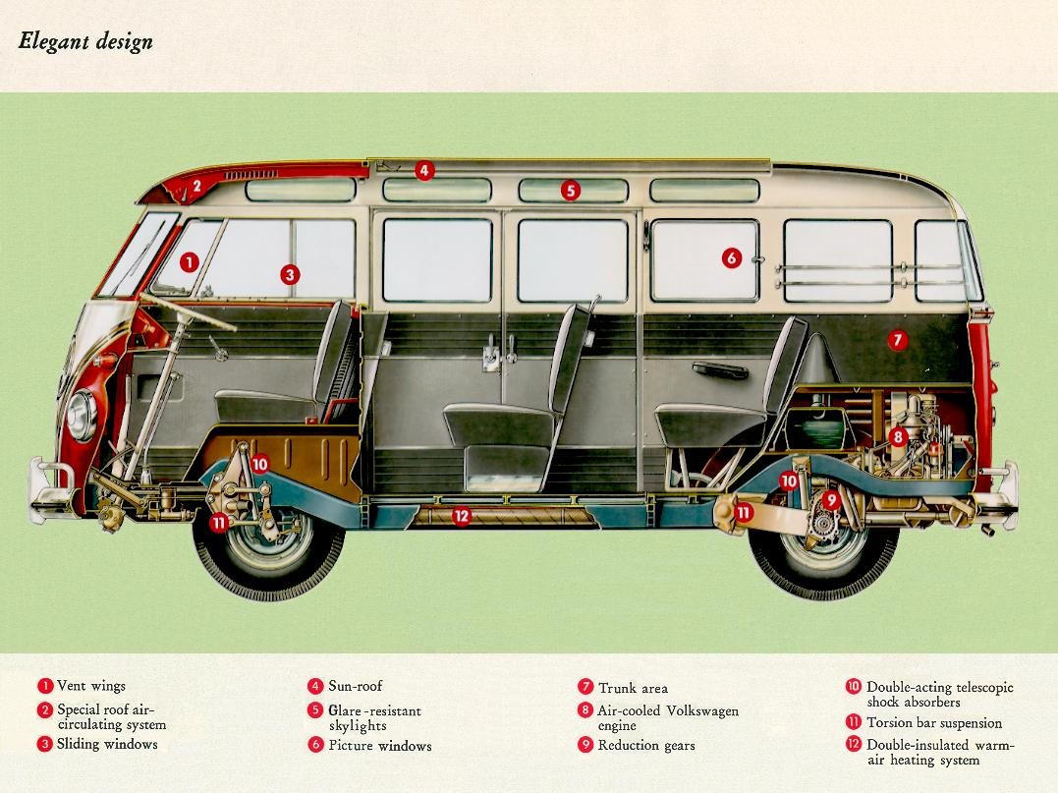 | 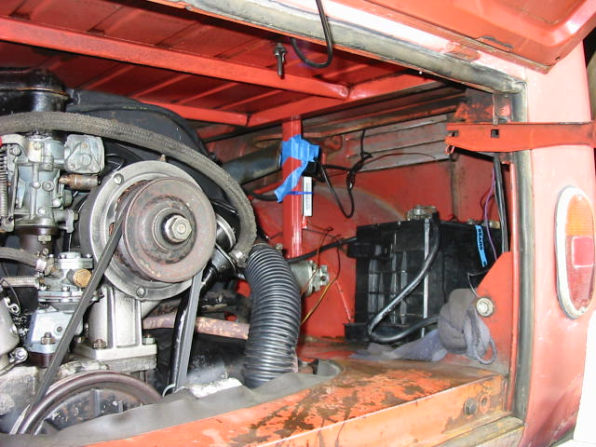

Results and Discussion
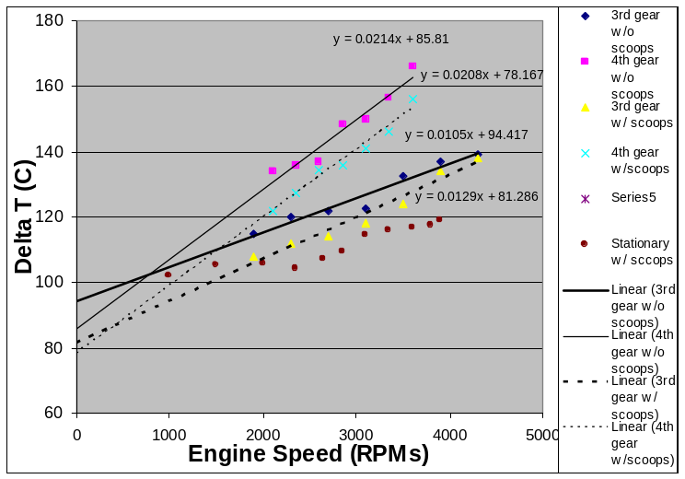
Figure 1. ΔT between Cylinder Head and Ambient vs. Engine Speed:
with and without scoops
The relation ship between engine speed and ΔT (between the cylinder head and ambient temperature) is shown in Figure 1. The ΔT is lower with scoops installed than without scoops. This suggests that there is greater air flow with scoops, as the heads are air cooled. The ΔT is lowest for the stationary readings, which makes sense as the engine is not working to maintain speed.
In third gear the difference between the scoops and no scoops values narrows noticeably with increased rpms. The 4th gear lines are nearly parallel, with head ΔT about 10° lower with scoops.
The trend clearly is that the ΔT is higher the faster the engine goes, although there seems to be a dip around or just below 3000 rpms. This is understandable as the data measured is the combination of (at least) two functions, one being the heat generated by the head, and the other the heat removed by cooling air blown by the fan.

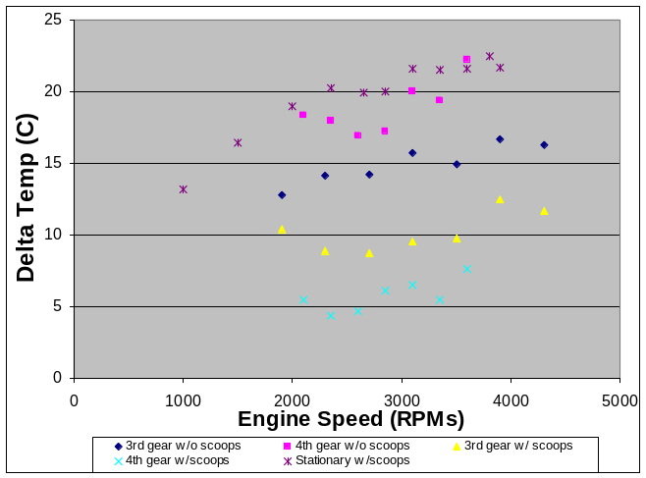  Figure 2. ΔT between Engine Compartment and Ambient vs. Engine Speed | 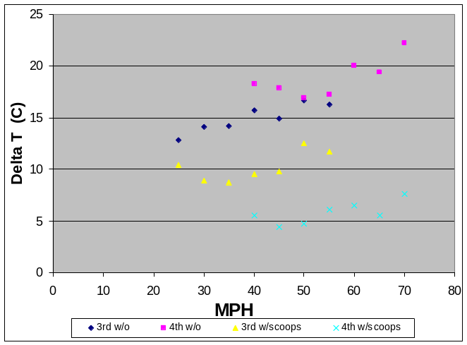  Figure 3. ΔT between Engine Compartment and Ambient vs. Road Speed

Differences between engine compartment and outside temperature are shown in Figures 3 & 4, vs. engine speed and road speed respectively. I thought this would be relevant as it is actually the air in the engine compartment that is blown over the engine to cool it, rather than the outside air.
In both gears, the engine compartment was cooler with scoops installed. With scoops, ΔT was lower in 4th gear than in 3rd gear. Without scoops, ΔT was lower in 3rd gear than in 4th. This suggests that the scoops will catch more air with increased road speed. The stationary reading had the highest ΔT.
The difference between with and without scoops in 4th gear ΔT was 10° across the board. This tidily corresponds with the10° drop at the cylinder head ΔT in 4th gear with scoops. It ties in that the rate of heat transfer is proportional to ΔT.
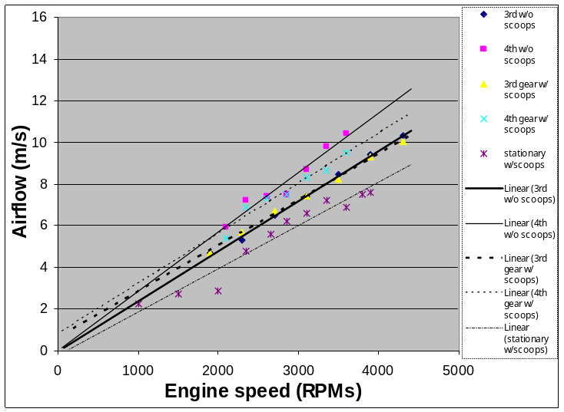
Figure 4. Air Flow vs. Engine Speed
Air flow under a variety of conditions is shown in Figure 4. In all cases, the air flow condition had fairly constant slope and originated close to (0, 0). Driving gave a higher airflow than stationary and 4th gear (higher road speed) gave more airflow than 3rd gear (lower road speeds).
The scoops seem to slightly decrease air flow in 4th gear. In third gear there seems to be no significant difference in airflow between scoops and no scoops. I would like to point out this is inconsistent with the head ΔT and engine compartment ΔT data.
The airflow meter has to be calibrated to the operating temperature, and as it got farther from the calibrated temperature, readings fluctuated more. Also, air flow readings fluctuated with breezes and traffic. The fluctuation was greater with scoops installed than no scoops. It is also possible that increased airflow through the cooling system is not evenly distributed between the heater channels and over the engine fins, but went more towards cooling than heating.

The relationship of airflow taken inside the louvers vs. road speed is shown in Fig 5. This correlates with the engine compartment ΔT data being closer for the 3rd gear lines, and farther apart for the 4th gear lines. Here the 3rd gear lines are nearly parallel, while the readings for 4th gear with scoops have a steeper slope than the 4th gear without.
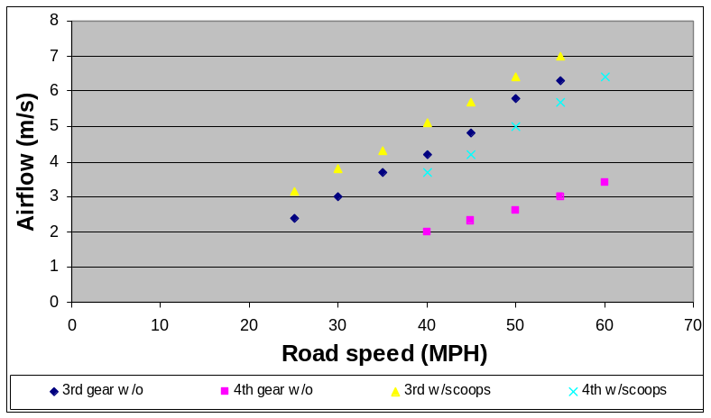
Figure 5. Airflow inside ventilation louvers vs. Road Speed
This also correlates with the thermocouple readings being parallel for 4th and narrowing for 3rd. The engine has to work harder proportional to the square of the speed, which increases the heat more than the cooling, which is proportional to the speed of the motor blowing the fan and some function of the speed of the air going into the engine compartment.

There were only very slight (< 1 mmHg) significant air pressure changes in the engine compartment. This implies that what goes into the engine compartment does go out. Hopefully it goes out through the cooling system, though it is possible that air may be escaping around the engine seals. (Which are actually in good shape). I had hoped to do additional test by removing seals or tin to see how that affected the air and cooling dynamics, but due to time constraints that did not happen.

Conclusion

Alas, the data suggests that the ugly scoops do increase cooling. This is possibly due to a temperature drop in the engine compartment. There are also interesting relationships between air flow, engine speed, road speed and cooling.

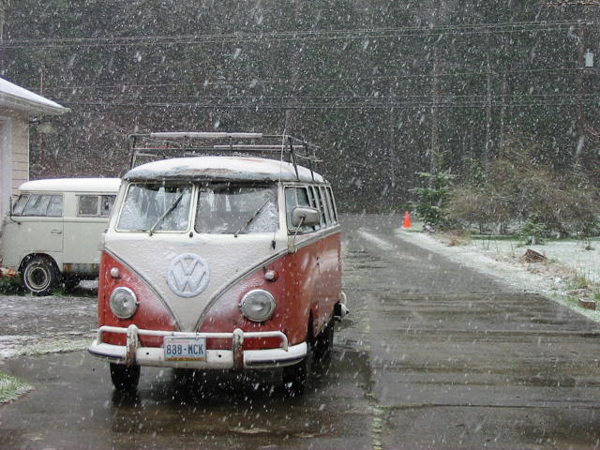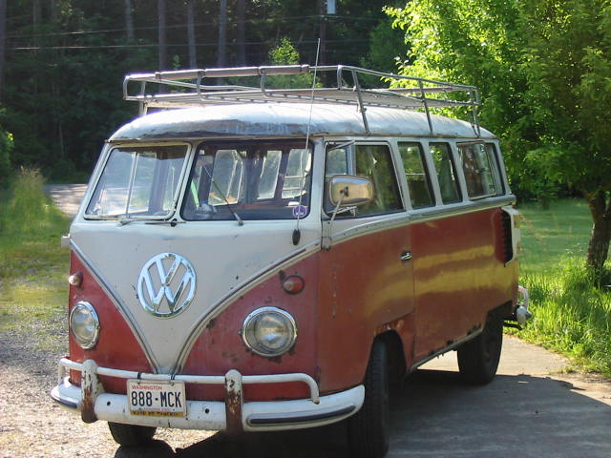
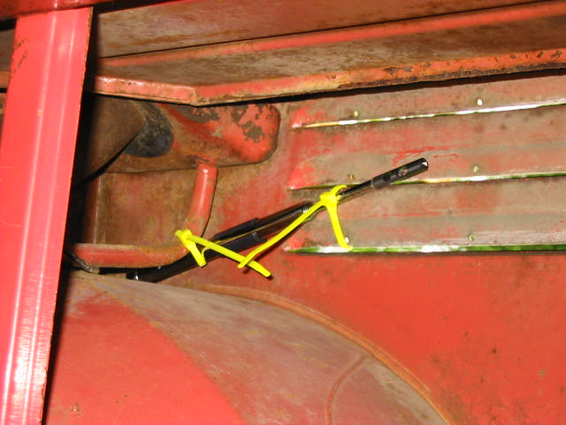

Sources

Kaufmann, Walther Fluid Mechanics Translated by Ernest G. Chilton pub McGraw-Hill 1963

Knudsen, James George Fluid Dynamics and Heat Transfer pub McGraw-Hill 1979

Lighthill, M. J. Sir An Informal Introduction to Theoretical Fluid Dynamics pub Clarendon Press 1986

Muir, John How to Keep Your Volkswagen Alive, A Manual of Step by Step Procedures for the Compleat Idiot (1981 edition) pub John Muir Publications 1981

Vogel, Steven Life in Moving Fluids pub Princeton University Press 1994.

Volkswagen Transporter Workshop Manual 1963 pub Volkswagenwerk Aktiengesellshaft, Wolfsburg 1963

http://www.ghia.com/faq/flaps.html

http://www.offroadvw.net/tech/wes/fan.html

http://www.vintagebus.com

