**Director’s Management Team Meeting**

**Three Scenarios of Future Housing Supply in London (2024-2029)**

# Executive Summary

* 1. Lorem ipsum

# Recommendations

We recommend:

* 1. that DMT **comment** on the scenarios outlined and the assessment mad
  2. that DMT **consider** the implications for the directorate's work
  3. that we **monitor and report back** to DMT - perhaps in six months

# Introduction and background

* 1. We are in an important moment for understanding possible future scenarios of London housing supply for several reasons. **First**, the new Government has announced a range of reforms affecting the housing delivery pipeline. Chiefly, local authorities will have to conform to mandatory housing targets calculated with a new methodology. Under the new target, London will have to deliver over 80,000 new homes a year. **Second,** housing delivery has faced several setbacks in recent years, falling to historic lows in both the public and private sectors. This is amidst a growing housing affordability and homelessness crisis in London.[3]
  2. As our main approach to understand the future of housing supply, we developed three scenarios, which cover the plausible best-case, worst-case and business-as-usual pathways of housing delivery. The three scenarios are described in both qualitative and quantitative terms, focusing on **advance indicators** – factors that would reveal which scenario we find ourselves in before completions on ground.
  3. **Qualitatively,** we looked at the key contingencies in the present situation. What are the factors that contribute to the current state of delivery, and how might they change in the different scenarios? We identified economic and policy factors.
  4. **Quantitatively,** we built a simple transmission model with real-world data on th e state of the housing pipeline. This allowed us to make some uncertain but quantifiable predictions about future states of the pipeline given certain outcomes. E.g., for a given number of completions at a given future time, our model estimates when these would need to show up as planning applications, approvals and starts. (See [Appendix – Detailed methodology])
  5. For the general approach and methodology we relied on a range of similar work, including the [Macroeconomic scenarios research], [Savill’s research] and [the JRF stagnation research – tidy up references later]. The Macroeconomic scenarios research is similar in outlining three plausible scenarios for London’s future economic trajectory at a crucial moment. We take from it the general design and presentation of the research. Savill’s research directly addresses the potential future of supply, but doesn’t really offer a range of scenarios. The JRF research specifically addresses the question of stagnation, and lays emphasis on the ways policy can be the key contingent factor in the future. (More on this later.)
  6. The system of housing supply is highly complex, so we had to make a range of assumptions to specify the scope of this research. We proceeded first from the present, by identifying the key factors that affect housing supply in the present. We divided these into **economic, policy** and **long-standing** factors. Based on an understanding of their effects, we could describe the three scenarios as outcomes of various arrangements of these factors.
  7. To provide a quantitative description of what the scenarios might look like, we constructed a simple **transmission model.** This type of model is used to track changes in a system where quantities move from one state to another. We modelled the housing pipeline as homes moving from planning to approved to under construction to completed. The *flows* from one category to another then represent *planning applications, approvals, starts* and *completions.* The rate at which homes move between these categories represent *time to get planning permission, time from permission to start* and *time from start to completion.*We allow these variables to change over time, representing the effect of a change in market conditions and policy reforms.
  8. The model is initialised with values derived from the current state of the housing pipeline in Q2 2024. The model values are recorded for each quarter in the next five years (that is, 20 quarters until Q1 2029).

# Key factors of supply

## Economic factors

* 1. **Housing effective demand.** Most homebuyers rely on mortgages to afford a house. The amount they can borrow therefore has a direct effect on house prices and effective demand, and thereby supply by private sector developers. Borrowing power in turn is determined by the general level of interest rates, largely dependent on the Bank of England rate. Long-term expectations about housing demand influence the build-out rates of developers.
  2. ***Inflation.*** Interest rates were raised since the Coronavirus pandemic to curb inflation. According to the Bank of England, inflation was caused by economic conditions after the pandemic (large levels of spending from pandemic savings and a strong labour market) and the impacts of the war in Ukraine (especially on energy prices, but this has a knock-on effect on the rest of the economy.) As of August 2024 year-on-year inflation is down to the 2% target. But the Bank of England warns that “ there is a risk that inflationary pressures from second-round effects will prove more enduring in the medium term. A stronger-than-expected path for demand, and structural factors such as a higher equilibrium rate of unemployment, could affect domestic wage and price-setting more persistently.”
  3. ***Interest rates.*** With falling inflation, the Bank of England cut interest rates for the first time since 2020 [double check]. The BoE is reluctant to influence future expectations, but both markets and analysts expect interest rates to be lowered from their recent highs. The IMF suggests rates should be cut to 3.5%. However, this might not happen if the BoE judges that inflationary pressures are still present.
  4. **On the supply side, developers have faced challenges with the cost of building.**
  5. *Construction costs.* The cost of construction materials rose both during the pandemic and after the invasion of Ukraine in 2022. The worst affected were products containing steel, of which Russia and Ukraine were direct exporters, and which take a large amount of energy to manufacture (which was worst affected by the war-induced energy price shock.) The latest data shows that the cost of construction materials now largely stabilised, but at much higher levels than in pre-pandemic years. This will put a constant upward pressure on input costs.
  6. *Labour costs and supply.* Various construction industry bodies have repeatedly raised concerns about the lack of skilled construction labour nationally, and especially in the wake of the post-pandemic low rates of labour market participation. The issue is exacerbated in the wake of Brexit by low levels of immigration from the EU. However, from the developers perspective, labour shortages do not seem to be amongst the most pressing concerns at the moment, even though the expansion of London construction mandated by the new housing targets requires an estimated 20,000 further labourers.[1]

## Policy factors

* 1. **Planning system performance** is cited as one of the biggest factors in blocking or enabling development. The poor performance of the planning system, beset by understaffing and backlogs, and often becoming a site of political contestation is often cited as the primary reason for the UK’s low levels of building compared to similar countries. The new Government has set out to both fund the existing system and make wide-ranging reforms including making housing targets mandatory for local authorities. The effectiveness of such interventions will be a key factor of determining which scenario we find ourselves in by the end of this Parliament.
  2. **Regulatory uncertainty.** At the moment there is slowdown in many projects because of uncertainty surrounding regulation about second staircases for buildings over 18 m tall. In a future where London builds more, such regulatory uncertainties are likely avoided or administered better.
  3. **Affordable housing.** There is in the present uncertainty about the future of the GLA’s Affordable Housing Programme and whether it will get grant funding beyond 2026. Councils and Registered Providers also struggle with funding temporary accommodation alongside new construction while navigating a set of fiscal inflexibilities. Supporting affordable housing, especially social housing, is beneficial not just for housing affordability, but the general health of the housing sector. Social housing can provide countercyclical demand in the construction sector. This allows firms to stay afloat when private sector demand is low (see paragraph 4.11), which has a range of positive externalities. Supply chains can remain resilient and transaction costs associated with rebuilding them after a recession are eliminated. Skills can also be better conserved as labourers do not have to leave the sector during economic downturns.

## Structural challenges

* 1. Two factors that do not fit neatly into either policy or economic factors are discussed here. First, **the persistent high price of land** is connected to the long-term evolution of land use in the UK, but is a factor that constantly puts upward pressure on house prices and therefore affordability.
  2. Second, **the lack of diversity in the development sector** has long been an issue. We have evidence that having small and medium enterprises develop a larger number of small sites can deliver more homes in a given time than a few large developers focusing on very large sites. And yet it is the latter that we are moving towards. There are three immediate reasons for this arrangement: first, smaller developers are less resilient in times of crisis. Second, they are less well equipped to deal with planning risk (the risk of not getting a permission) and with the uncertainties of waiting times in the planning system. Third, the incentive structure of the planning system points towards the development of large contiguous sites rather than smaller infill sites where SMEs can be more competitive.

# Three scenarios

* 1. In each scenario, we start from the present situation and model reaching a certain different state by a certain point in time. This is to represent a transitional period while policies and market developments slowly roll out.

## Starting conditions

* 1. We worked with the following starting parameters for Q2 2024:
     1. Number of planning applications: 10,146 (MHCLG)
     2. Number of pending planning decisions: based on a combination of Molior and our Planning Pipeline Dashboard, we estimate this at 50,000
     3. Number of approvals: 1472 (Molior)
     4. Number of approved homes not yet started: 115,000 (Molior, Planning pipeline dashboard)
     5. Number of starts: 1879 (Molior)
     6. Number of homes on sites that started but not yet completed: 188,000 (Molior, Planning pipeline dashboard)
     7. Number of completions: 4561 (Molior)
  2. For the purposes of the model, we calculated the momentary rates of change based on these values. These values should be read on a hypothetical basis and do not represent long-term averages. For example, the “average time from start to completion” value should be understood as “if buildout continued at the rate of Q2 2024 it would take this amount of time to build out all the homes that have started”.
     1. Time in planning: 33.96 quarters (8.49 years)[2]
     2. Time between planning and start: 61.20 quarters (15.3 years)
     3. Time between start and completion: 41.22 quarters (10.3 years)

## Scenario 1 – Successful government policy and favourable market conditions

* 1. In the first scenario, macroeconomic background conditions turn out largely as analysts and markets expect them. Interest rates fall to a stable level between 3 and 4 percent. Inflation stabilises around or under the 2% goal. The UK’s economy as a whole grows at a low but steady level of 0.5-1.5% a year. London within this is doing somewhat better. Effective demand for housing recovers and large developers increase the build-out of their sites. Successful government policies to fund the planning system and encourage supply-friendly local plans, combined with measures to make the building sector more diverse and competitive create the conditions of shorter delivery pipelines. These changes gradually take effect and by early 2027, or around the time the new London Plan is published, we see a major uptick in planning approvals and construction starts as planning departments developers work through their backlogs. Completions reach 20,000 a quarter (seasonally adjusted) by mid 2027, leading the way to the 80,000 a year London housing target.

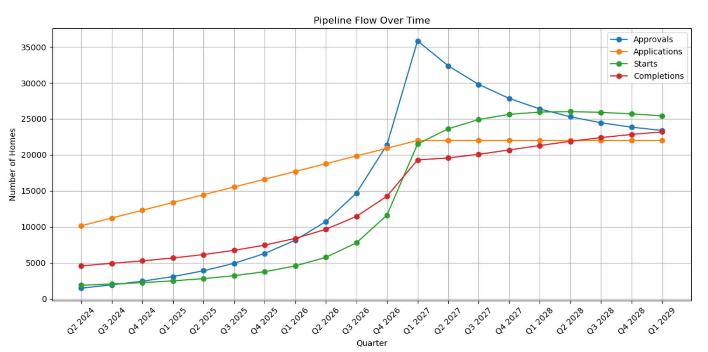

* 1. Our data suggests that there is a large “backlog” of planning applications and stalled sites. This means that if these could be “unlocked”, we could see a temporary surge in supply while the pipeline catches up. Because of the very low levels we see now,

## Scenario 2 – Business as usual (reversal to the means of the 5 pre-pandemic years)

* 1. There are acute macroeconomic shocks to the construction industry at the start of the model period, which the industry takes some time to recover from. However, the effect of government policies is not as pronounced as hoped and even though construction activity ticks up as planning is now better funded, local authorities allocate more land for housing and interest rates drop, they only reach the levels of the pre-pandemic 2010s, barely exceeding half of the London goals. Planning approvals remain lower than starts and completions as developers take a long time working through their existing backlogs of sites. London builds around 50-56,000 homes a year, which is higher than at present but does not meaningfully increase affordability, with London remaining one of the least affordable cities in Europe.

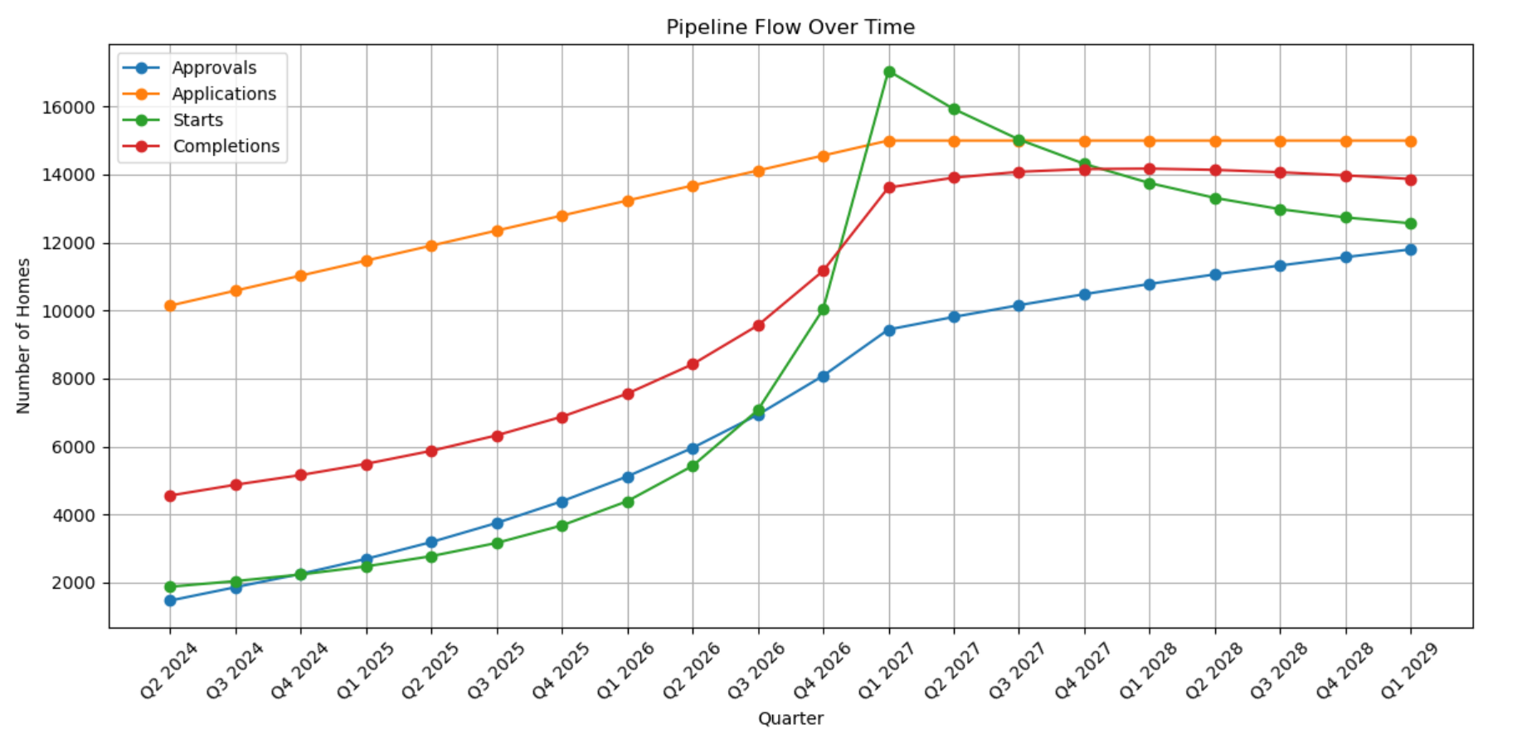

## Scenario 3 – Unsuccessful policy and recession

* 1. In this scenario, the recent slump persists either because of worsening economic conditions (e.g., a recession in the US). Initially ambitious policies to reform planning and help delivery at most mitigate the worst of the worst. House prices remain extremely unaffordable even as more and more low-to-middle-income people leave London as they cannot afford to live here anymore. Planning applications slowly decrease as developers no longer see London as a profitable place to construct. This hits affordable housing targets as well. Completions remain around the current level, decreasing slightly until the end of the decade, with a meagre 10,000 in the year leading up to Q1 2029.

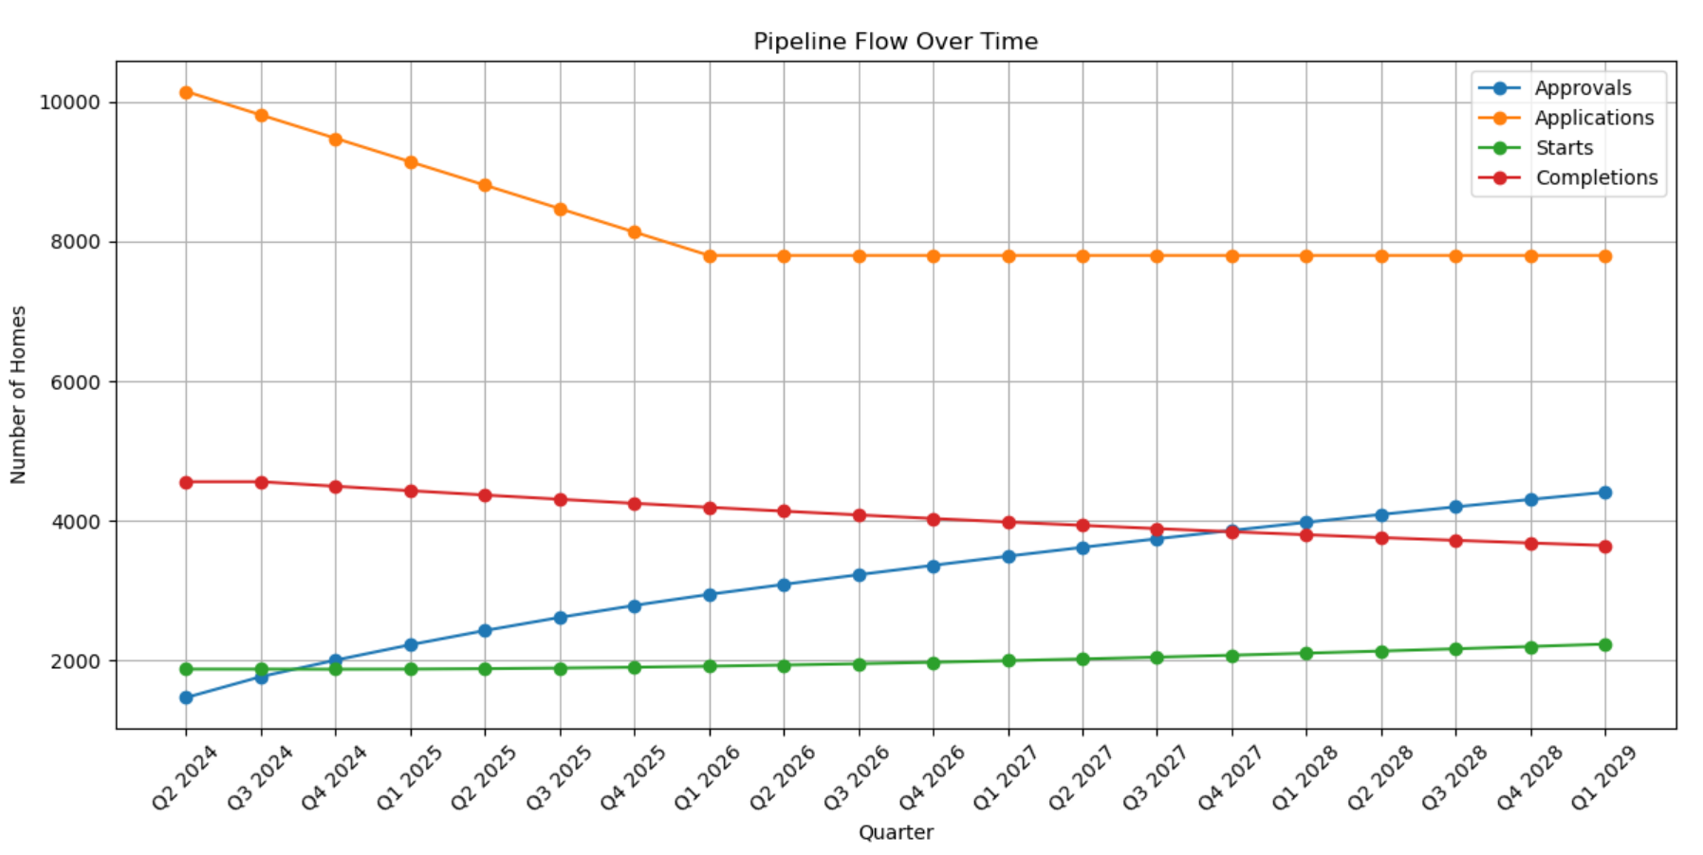

# Limitations

* 1. The scenario design, the qualitative indicators and the modelling of the quantitative indicators all have their limitations. However, as we emphasise in our Recommendations, this paper is intended as a starting point for further thought on plausible scenarios for London housing supply. The GLA should think carefully of its own role about bringing the favourable scenario about.
  2. The transmission model provides a highly abstracted view of the housing pipeline and how it might change in the future. They are most useful in providing a general sense of the magnitude of applications, approvals, starts and completions we should see given certain outcomes. They are also useful for testing the effect of lowering obstructions in various places of the process, and to prompt further thinking about what reductions would be realistic and what implications that could have.
  3. The key limitation is that it abstracts away all qualitative differences between sites, different types of housing, and different providers to provide a generalised picture of the process. It can only represent qualitative shifts within the sector as quantitative changes in aggregate variables. For example, if more small developers enter the market and therefore there are more sites delivering, we can only show this as a change in the abstract variable controlling the flow from the “started” to “completed” category.
  4. While we tried to account for as many qualitative factors as possible, and control for plausibility based on a range of evidence, it is possible that other factors (including difficult-to-predict ones) might end up having outsized influence on the housing supply pipeline in London.

# ****Appendix 1 – Description of the flow model****

1. [London’s affordable housing funding requirement | London City Hall](https://www.london.gov.uk/programmes-strategies/housing-and-land/increasing-housing-supply/londons-affordable-housing-funding-requirement#:~:text=London%20needs%20%C2%A34.9bn,produced%20by%20Savills%20Affordable%20Housing.)
2. Again, this is based only on the current quarter’s data and changes throughout the model timeline.