SRS-SPPO USER MANUAL
Schedule and Record System of Saint Patrick's Parish Office
Version 1.8 | User guide and scheduled backup operations
This guide describes the current public forms and secretary interface and includes safe operating guidance for the Secretary role. Database restoration and hosting operations require an authorized recovery process; never experiment on a live parish database.
CONTENTS
1. System overview and access
2. Parishioner: choose a service and submit
3. Documents, privacy, and updates
4. Secretary: start of day and request queues
5. Match applicants to master person profiles
6. Process sacrament applications
7. Process certificate requests
8. Maintain sacramental records
9. Calendar, announcements, and reports
10. Accounts, audit, backup, and privacy
11. Troubleshooting and quick reference
12. Screenshot reference
Appendix A. Database Systems Technology (DST)
1. SYSTEM OVERVIEW AND ACCESS
SRS-SPPO supports Baptism, First Communion, Confirmation, and Marriage. The public portal accepts future-sacrament applications and requests for copies of existing parish certificates. The secretary interface reviews submissions, matches people to the master person index, maintains register indexes, schedules events, and records certificate processing.
A public submission is intake only. It is not approval, a confirmed schedule, or an official sacramental register entry. Public users do not need an account. Do not enter real parishioner data into a demonstration installation.
Public entry: http://localhost/srs-sppo/public/index.php
Staff entry: http://localhost/srs-sppo/admin/login.php
For a hosted installation, use the URL supplied by the parish. Database setup and upgrades must be handled by the system maintainer, not from staff request screens.
2. PARISHIONER: CHOOSE A SERVICE AND SUBMIT
From the public site, open Office Services. Choose a sacrament application when preparing for a future Baptism, First Communion, Confirmation, or Church Wedding. Choose a certificate request when the sacrament has already taken place and you need a certified copy of an existing parish register entry. The requirements guide and How It Works page explain preparation and next steps.
Submit a sacrament application
1. Open the appropriate application form and complete the requested contact and sacrament details.
2. For a Marriage application, enter details for both parties. Select St. Patrick's Parish Church or Other for the venue. If Other is selected, enter the venue name. A preferred wedding date is a request, not a confirmed booking.
3. Review the information, provide the requested consent, and submit once. Save the reference number shown after submission and check the email address provided for a reply.
4. The parish office reviews the application and contacts you about documents, preparation, payment if applicable, and scheduling. Do not send identity or sacramental documents through the form.
Submit a certificate request
1. Open Request a Certificate and choose Baptism, First Communion, Confirmation, or Marriage.
2. Enter the subject's name and identifying sacrament details accurately. Marriage requests need both spouses' names and the marriage date. Give the requester relationship and a working email address.
3. Submit the request and keep its reference number. Certificates are collected at the Parish Office; they are not downloaded or issued on the website.
3. DOCUMENTS, PRIVACY, AND UPDATES
The public forms do not accept document uploads. The Parish Office confirms which documents apply to each person's circumstances. The online requirements and preparation guide is general guidance; a secretary's confirmation is the final checklist for the case.
Depending on the request, the office may ask for a valid ID matching the person named on a certificate, a signed authorization letter for an authorized representative, original or certified external-parish records, an origin-parish permission or transfer letter, PSA civil-status documents such as a CENOMAR for a marriage application, or other parish-specific requirements. Bring only documents the office has asked you to provide.
For certificate pickup by the person named on the certificate, bring a valid matching ID. A representative must bring the signed authorization letter. A claim stub can help locate the request but is not required if the reference number and certificate details are available. The Acknowledgment Receipt is placed with the completed certificate in its folder.
Payment is handled outside the public website and recorded by staff. The fee amount is not stored. Follow the Parish Office's instructions. Do not include sensitive identity documents in email unless the office has explicitly provided an approved process.
Use the submission reference number when contacting the Parish Office. Email delivery depends on the installation's mail configuration; if no email arrives, contact the office with the reference number and the email address used.
4. SECRETARY: START OF DAY AND REQUEST QUEUES
Sign in at the staff URL with your individual secretary account. The sidebar provides Requests (Certificate Requests and Sacrament Applications), Records, Schedule (Calendar and Announcements), and System (Accounts, Audit Log, and Backup). Reports is in the top navigation. Sign out when finished, especially on a shared computer.
Open the dashboard to see current work and notifications. Then open the relevant request queue. Use search and filters to locate an item by reference, name, sacrament, channel, date, or status. Open the Review control to inspect the full request; select Close review to collapse it. Verify the reference number and applicant before making changes.
Record factual processing notes only. Explain missing documents or a declined request clearly and respectfully. Save checklist and status updates through their own controls; a status change is not a substitute for matching the correct person or checking the register.
5. MATCH APPLICANTS TO MASTER PERSON PROFILES
The master Persons index is the reusable identity for parishioners across sacramental events. Search before creating a profile. Compare more than a name: check date of birth, parents' names, and other available details. A similar name alone is not enough to merge identities.
In an application review, use the person matcher to find and select the correct existing profile. For a Marriage application, match the groom and bride separately; they must be different person profiles. If no accurate match exists, use the explicit create-and-link option and verify the submitted biographical details before saving.
After linking, confirm that the profile belongs to the applicant and that the required prerequisite record is present. For First Communion and Confirmation, check the Baptism record in this parish or review the origin-parish documentation. Warnings are prompts for secretary review, not proof that a document was received.
6. PROCESS SACRAMENT APPLICATIONS
Open Requests > Sacrament Applications. Review the submitted details, match the applicant or both marriage applicants, and update the requirement checklist as documents or preparation are verified. Checklist states are Not received, Received, Verified, or Not applicable; use a note when staff need context.
Normal application status labels: New application > Being checked > Waiting for documents (if needed) > Approved, date not yet set > Date set > Done and recorded. A request can be declined where appropriate. The system only offers permitted next statuses; it does not allow arbitrary jumps.
Approval is not a confirmed event date. Use the calendar to confirm and manage the actual schedule. The official record is created separately from the intake application; when an approved application is ready, use Prefill Register Form, verify every value against the source, then save the official record. The application is marked completed when the register record is saved through that linked workflow.
Marriage preparation includes interview, banns, and other parish steps as applicable. Pre-Cana Seminar is tracked in the Marriage application's requirements checklist; update it only after confirming the seminar requirement with the couple.
7. PROCESS CERTIFICATE REQUESTS
Open Requests > Certificate Requests and select the request. Search the master Persons index, then select the matching record of the same sacrament type. Check the physical parish register against the digital index, including entry, book, page, and line references. A record from another parish may be linked for context, but this parish must not print a certificate for an external-parish record.
Certificate stages: New request > Record found > Waiting for priest's signature > Ready for pickup > Given to the requester. A request may instead be declined with a recorded reason. If the record is not immediately found, search carefully and ask the requester or consult the physical register before rejecting.
After matching and verifying the parish record, record payment when received. The fee amount is not stored. Print the certificate using the appropriate certificate action and enter the certificate number. Mark it as waiting for signature only after printing. Mark it Ready for Pickup only after confirming the priest has signed it.
At release, verify the requester or representative and the required ID/authorization letter, record the claimant, then use Confirm Payment and Release. The system records pickup information and release time. Keep the Acknowledgment Receipt with the certificate folder.
8. MAINTAIN SACRAMENTAL RECORDS
Open Records to search across the digital register index. Filter by sacrament, name, year, and register references. Use the type-specific editor to add or edit Baptism, First Communion, Confirmation, and Marriage entries. Profiles are shared, but event-specific details and participants are recorded with their sacrament.
For each entry, select or create the correct master person profile, transcribe from the authorized source, and compare the entry with the physical parish register. Record book/page/line details carefully. Use the editor's book-verification action only after checking the actual logbook. Keep internal remarks factual and appropriate. Never treat a public application as an official record until the required staff review and record-entry steps are complete.
A person profile links that person's events and contact information. Open the profile from a dashboard person-search result or a linked register entry to review sacramental history. Correct identity duplicates carefully; do not create a second profile just because a record uses a different name format.
9. CALENDAR, ANNOUNCEMENTS, AND REPORTS
Open Schedule > Calendar to add, edit, or remove parish events. Enter event type, title, date, times, and public details. Keep private operational notes in the internal Notes field, not Public Details. A time-overlap warning flags a possible conflict for staff to resolve; it does not itself block saving or confirm a booking.
Use Announcements for notices intended for the public site. Confirm the wording and publication state before saving. Reports in the top navigation provide the available monthly and yearly summaries. Review filters and date ranges before interpreting or printing a report.
10. ACCOUNTS, AUDIT, BACKUP, AND PRIVACY
Only the secretary role is described by the current system. Accounts is for authorized staff to create or deactivate accounts. Give every staff member an individual account; never share passwords. Use a strong password that meets the account form's current minimum. Deactivate accounts that are no longer authorized.
The Audit Log records staff actions and is useful for tracing changes; do not alter audit history. The Secretary is the only in-app staff role and can administer the available System pages. This does not automatically grant hosting or database-server access.
Automatic monthly backup (if enabled): the system creates one compressed, encrypted full database export per Philippine calendar month, uploads it to the configured parish Google Drive folder, and keeps the six newest monthly backups. It does not include application files or server configuration. Ask the designated technical administrator whether the host scheduler and Drive integration are configured; this page alone cannot show whether automation is active. Continue making manual backups when instructed.
1. Create a routine encrypted backup: open System > Backup and review the displayed table counts. If expected tables or counts appear missing, contact the system maintainer before relying on the export.
2. In Administrator password, enter your current staff-account password to re-authenticate. This is not the backup encryption passphrase.
3. Enter a new, unique backup passphrase of at least 12 characters. Do not reuse your staff password. Save the passphrase in the parish-approved password manager or other approved secret store, separate from the backup file. The system does not save or recover it; if it is lost, that encrypted backup cannot be decrypted.
4. Select Download Encrypted Backup (.sql.enc). Save the file in parish-approved, access-controlled storage, preferably with an offline or separate protected copy. Never email it, leave it in a public web folder, or store it beside the passphrase.
5. Record the backup filename, date, responsible staff member, and application/schema version in the approved backup log. Confirm that the downloaded file exists and has a non-zero size; this check alone does not prove that it can be restored.
6. Arrange a periodic recovery drill with the authorized technical administrator. The drill must decrypt and restore a copy into an isolated test database and verify the application and records; never test by importing over the live database.
Recovery is not a button on the Backup page. If a live system needs restoration, notify the designated technical administrator, preserve the current database, and stop changes until a recovery plan is approved. Restore to a separate compatible database first and validate it before any production action. Do not use phpMyAdmin to import the backup into a populated/live database.
Keep screens and exports away from public view. Use only information needed for parish duties. Do not use real personal data in demonstrations, screenshots, or test submissions. Report suspected misdirected email, unauthorized access, or lost backup media to the system maintainer promptly.
11. TROUBLESHOOTING AND QUICK REFERENCE
No person match: search spelling variants and date of birth, compare parent names, and check the official index. Create a new profile only after a careful search.
Application cannot move forward: read its current status, use only the displayed next status, link the correct applicant profiles, and verify required documents or prerequisite sacrament records.
Certificate cannot be printed: confirm that the request is matched to the correct in-parish record, the register entry has been verified, and payment has been recorded where required. Complete printing and priest signature steps in order.
No email received: confirm the address with the applicant, inspect notification information available to staff, and contact the system maintainer if delivery remains unavailable. Tell the applicant to retain the reference number.
Calendar conflict: compare start/end times with existing events and confirm the venue and availability directly. A saved event is not by itself confirmation to the applicant.
Need help: record the page, reference number, what action was attempted, and the exact message. Do not send passwords, backup passphrases, or identity documents in a support request.
Reference: current public guide at /public/requirements.php and /public/how-it-works.php. Secretary menu: Requests, Records, Schedule, Reports, and System.
12. SCREENSHOT REFERENCE
The following laptop-width screenshots illustrate the public portal and secretary interface. The dashboard image uses demo data and shows aggregate counts only.
Figure 1. Public landing page at laptop width.
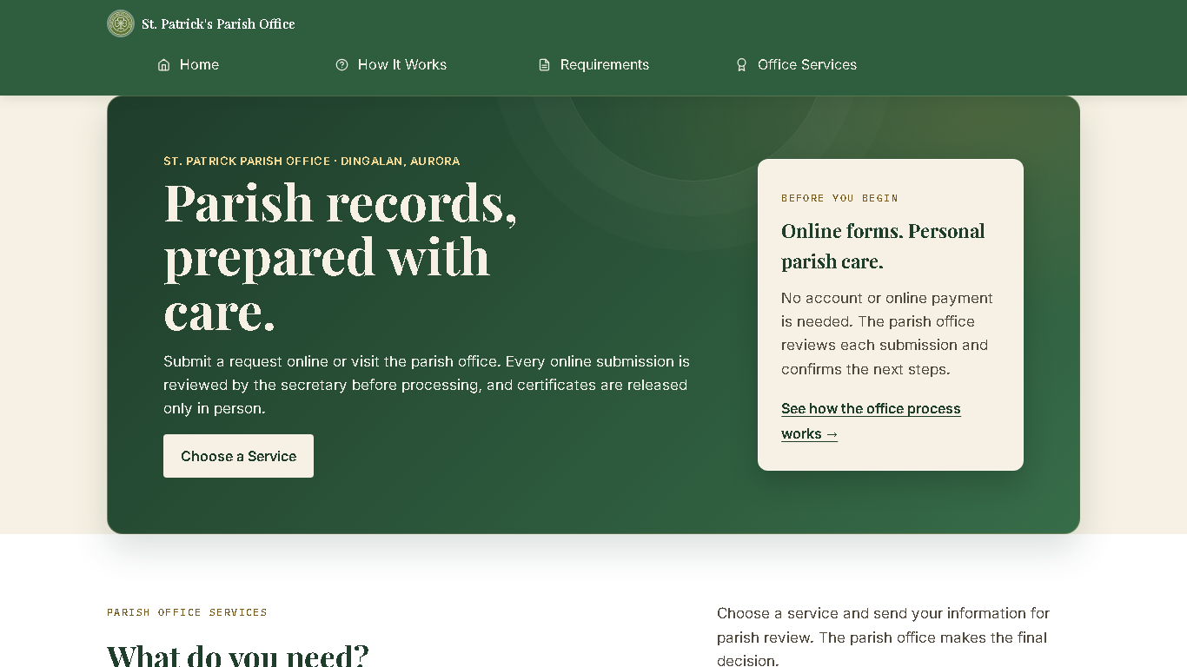
Figure 2. Office Services separates applications from certificate requests.
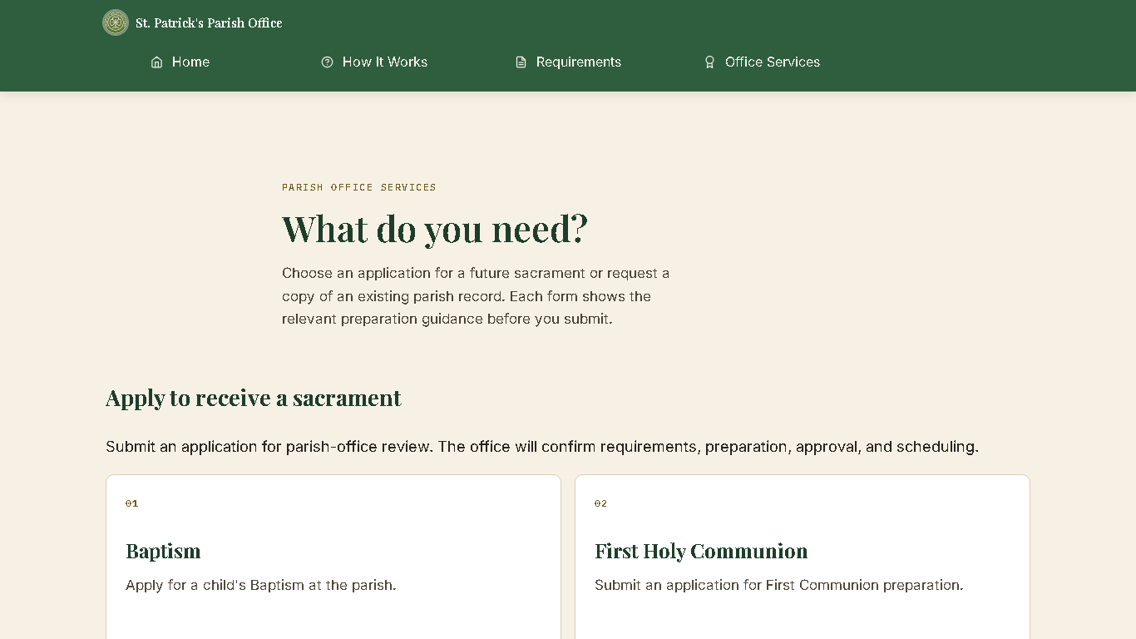
Figure 3. How It Works explains online intake and parish follow-up.
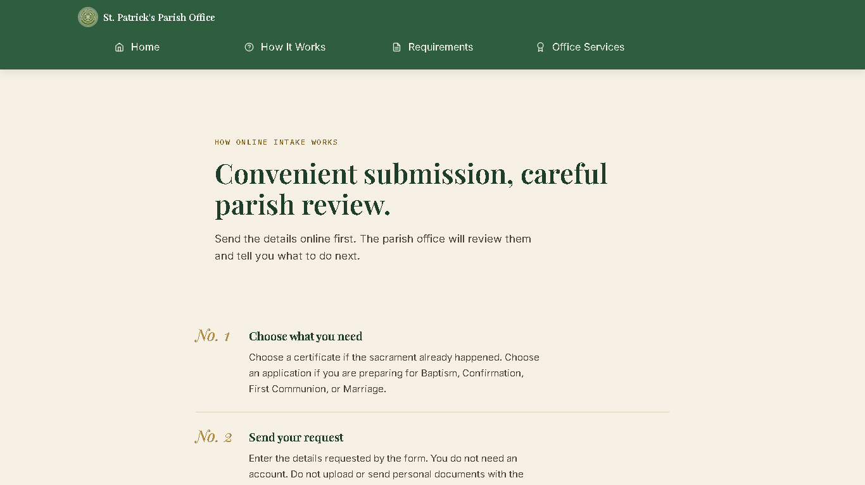
Figure 4. Requirements and preparation guide.
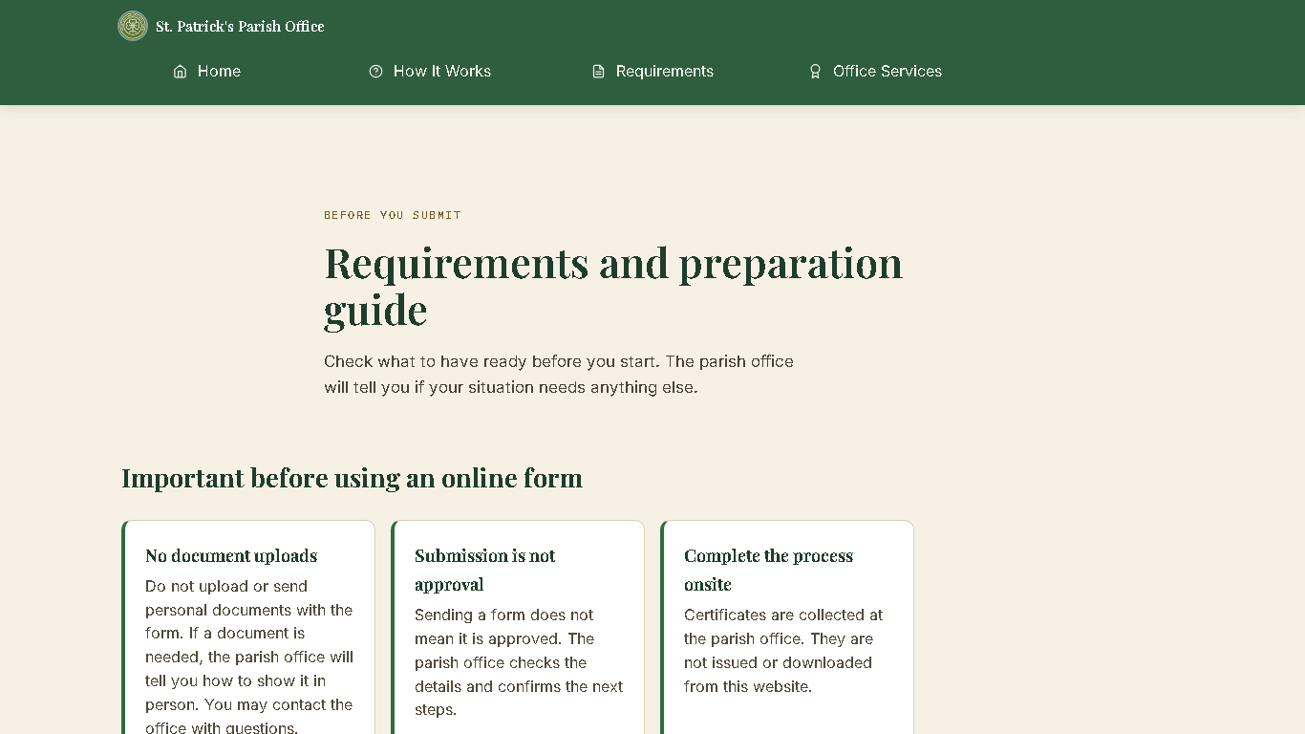
Figure 5. Baptism application form.
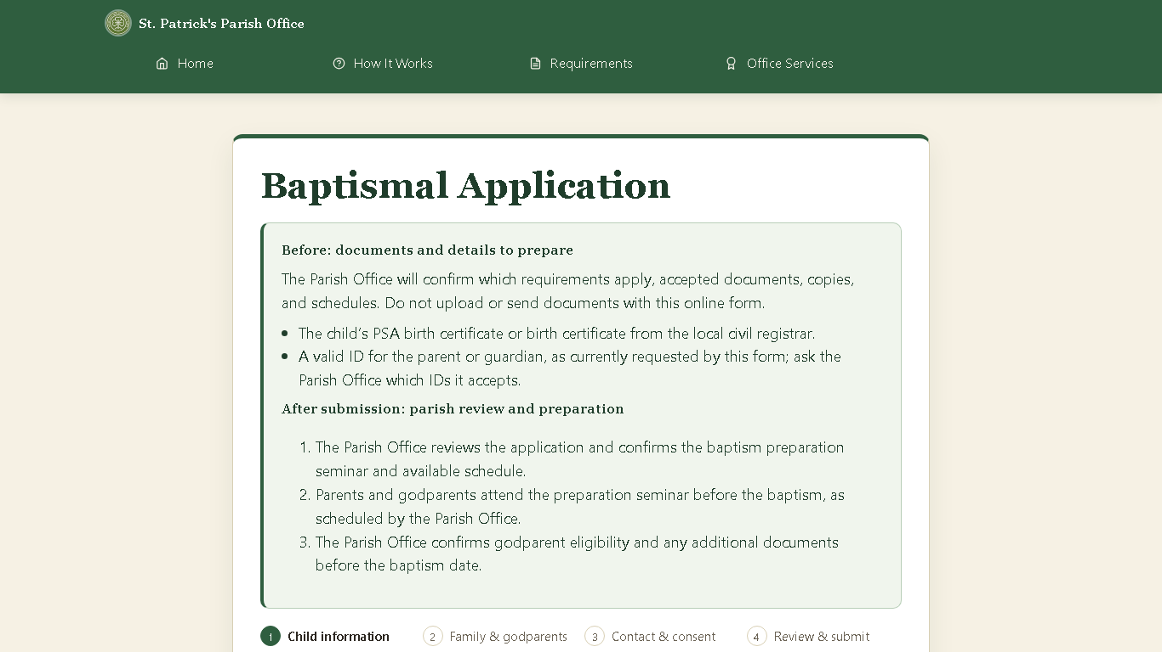
Figure 6. First Communion application form.
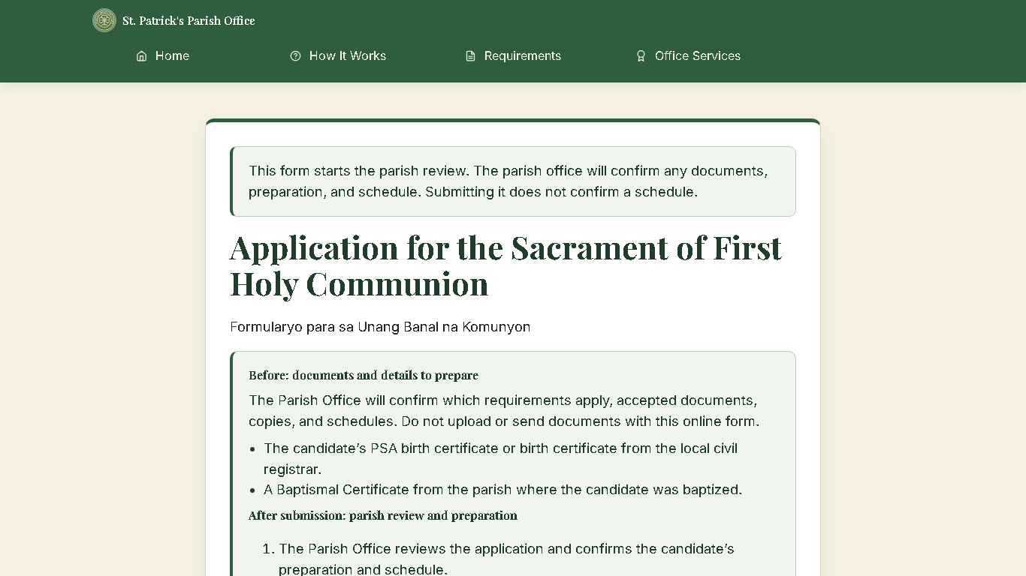
Figure 7. Confirmation application form.
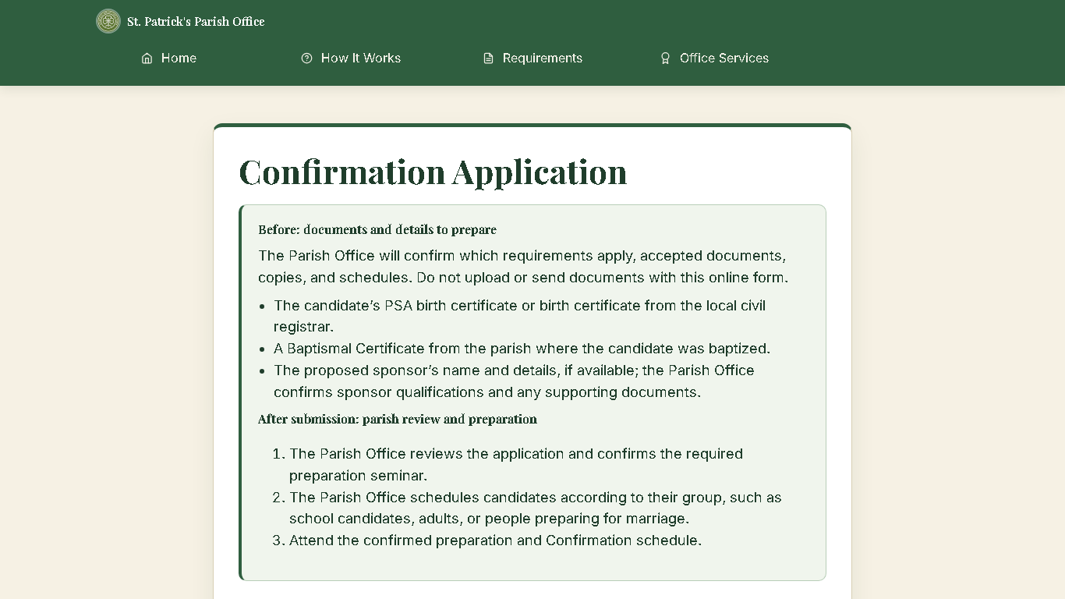
Figure 8. Marriage application form.
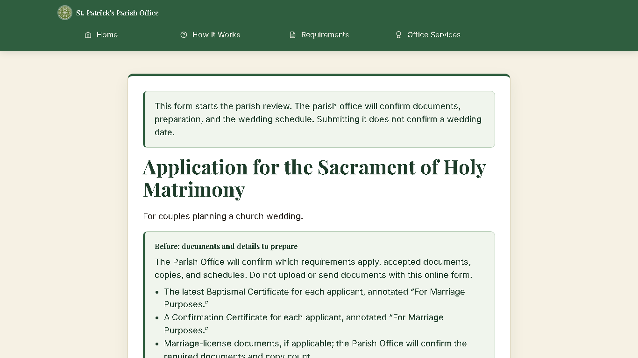
Figure 9. Certificate request form.
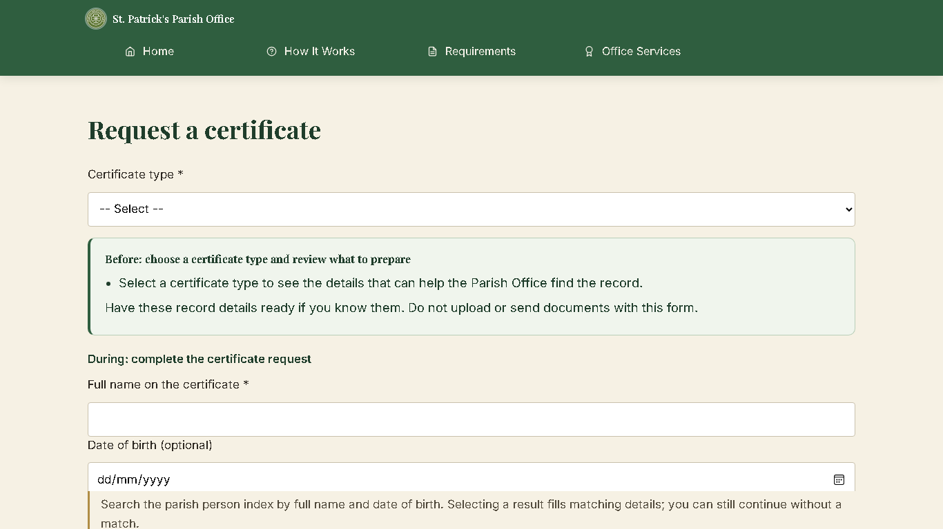
Figure 10. Secretary dashboard showing sample workload and register totals.
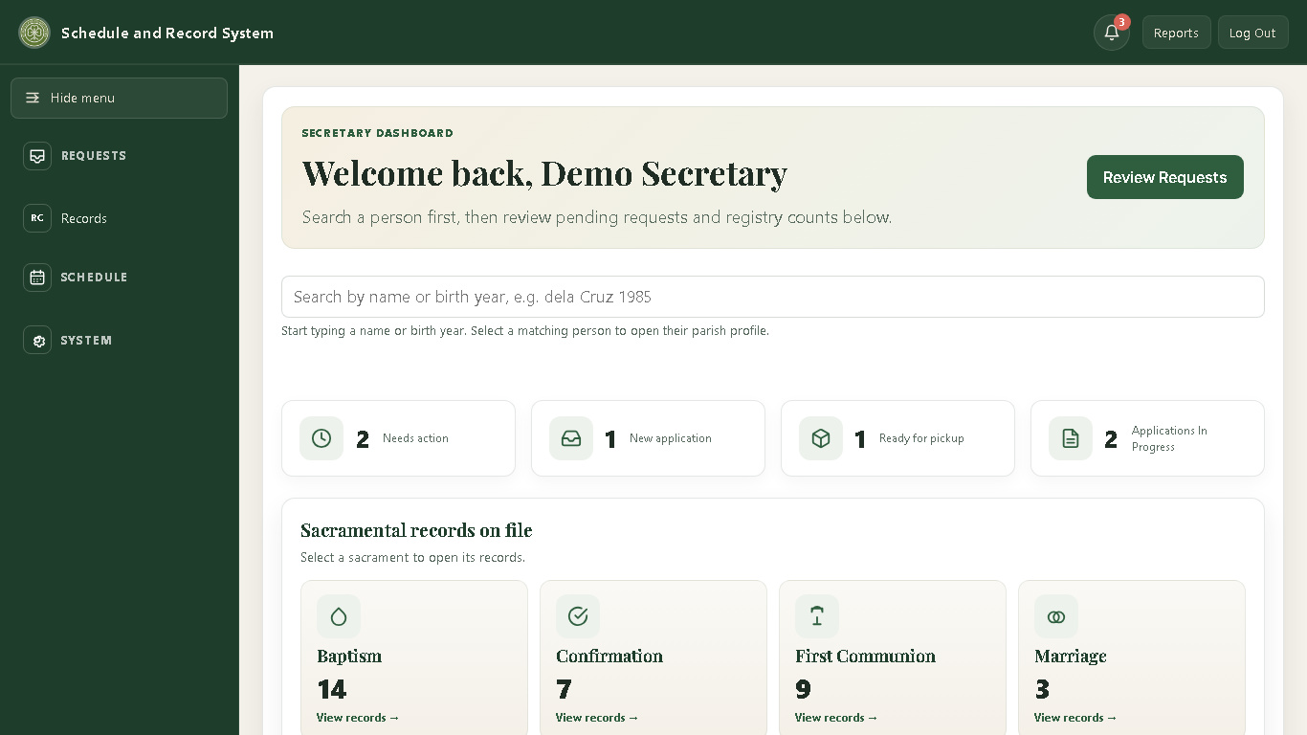

APPENDIX A. DATABASE SYSTEMS TECHNOLOGY (DST)
This appendix summarizes the database design and operational safeguards for technical readers. It supplements the user instructions and data dictionary; it is not a deployment runbook.
Architecture and entities
SRS-SPPO is a PHP web application backed by one MySQL/MariaDB database. A central persons table stores shared identity profiles. Sacrament records link to those profiles, while sacrament participants store roles such as sponsors, godparents, and witnesses. Sacrament applications and certificate requests are separate workflow records: an online submission is not, by itself, an official register entry.
Data integrity and source records
Foreign-key relationships connect records to people and related workflow data. Staff must verify a person match using reliable identifying details; a name alone is not proof of identity. Digital records are an index and office workflow, not a replacement for the parish physical logbooks, which remain the authoritative source.
Schema and data dictionary
The current canonical schema for a fresh installation is database/v2/schema.sql. Field descriptions and relationships are documented in database/v2/DATA_DICTIONARY.md. The data dictionary describes the schema; the SQL schema is authoritative if they differ. Confirm which schema version is deployed before using either document to assess an existing database.
Configuration and change control
The application connects through PDO. Database host, name, username, and password are configured through the SRS_DB_* environment variables or a server-only config/local.php file. Keep credentials out of source control and public web folders. For a new empty database, use the canonical schema. For an existing database, make and verify a backup first; use System > Database Setup only for updates it explicitly supports. Do not import a fresh-install schema over populated data or run all historical migration files as a batch.
Backup, recovery, and privacy
The export contains parish data and omits password hashes and selected operational tables; it is not a complete system image. Plan to recreate or reset staff accounts and review omitted operational data as part of recovery. The Secretary can create and safeguard one-time exports through System > Backup. If configured by the technical administrator, a daily host task uploads one compressed, encrypted full database snapshot per Philippine calendar month to a dedicated Google Drive folder and retains the latest six monthly copies. Hosting and database-server permissions may be separate from the in-app Secretary role.
For a recovery drill, the authorized technical administrator should confirm the backup file, its passphrase, and the matching application/schema version; keep the current database untouched.
Decrypt and restore only in a restricted, trusted environment into a new isolated test database. The decrypted SQL is sensitive plaintext: do not email it, put it in a public web folder, or leave it on a shared workstation. For scheduled v2 backups, the decrypt utility reads SRS_BACKUP_PASSPHRASE from the environment; avoid placing the secret directly in shell history or a command argument.
Verify the restored schema and representative records, confirm the application can connect to the test copy, and document the result. A failed or incomplete check means the backup is not ready for recovery.
Only the designated technical administrator should plan a production restoration. Before any approved production change, verify a separate current backup, schedule downtime, confirm compatibility, obtain parish authorization, and keep a rollback plan. The Secretary assists with record validation and staff communication; do not improvise SQL or perform an unreviewed live import.

