USER MANUAL
About this manual
This manual explains how to use the Schedule and Record System of St. Patrick's Parish Office (SRS-SPPO). It is organized around the work of parishioners, the parish secretary, and the person responsible for system maintenance.
The instructions describe the application as reviewed for this draft. Screen labels and available options may change when the hosted system is updated. Follow current parish-office instructions whenever they differ from this guide.

Important: Online forms start a request or application; they do not grant approval, collect payment, or issue a certificate. Final verification and certificate pickup take place through the Parish Office.

Who should use each part?
• Public users: Chapters 2-5 cover certificates, sacrament applications, status tracking, and correction requests.
• Parish Secretary: Chapters 6-10 cover staff access, request processing, records, certificates, scheduling, and reports.
• System Administrator: Chapter 11 covers system-maintenance tasks. There is only one staff role, Secretary; in-app tasks use the same Secretary accounts, while hosting, recovery, and database restoration are handled by the designated technical administrator.

Contents
• 1. Getting started and user roles
• 2. Public home page and office services
• 3. Requesting a sacramental certificate
• 4. Applying to receive a sacrament
• 5. Tracking a submission and requesting a correction
• 6. Secretary sign-in and dashboard
• 7. Reviewing certificate requests
• Processing correction requests (Chapter 7)
• 8. Reviewing applications and managing sacramental records

• Worked example: Baptismal record and walk-in request (Chapter 8)
• 9. Generating certificates and recording pickup
• 10. Calendar, announcements, and reports
• 11. System administration and backups
• 12. Troubleshooting and quick reference

1. Getting started and user roles

What the system does
SRS-SPPO supports parish service intake, sacramental-record keeping, certificate processing, scheduling, and office reporting. Public visitors can submit information without creating an account. Authorized staff sign in to review and process work.

Access points
• Public website: use the official parish link provided by the Parish Office. The home page includes service links, requirements, a calendar, and request tracking.
• Staff area: open the staff login link supplied by the Parish Office. Staff pages require an active account.
• A local development URL such as http://localhost/srs-sppo is for the local test installation only; it is not the public hosted address.

Roles and responsibilities
• Public visitor: supplies accurate information, keeps the tracking number, and follows office directions.
• Parish Secretary: reviews submissions, verifies information, updates workflow status, maintains records, schedules events, and prepares reports.
• System maintainer: uses the same Secretary staff account for in-app maintenance, protects staff access, applies approved database updates, and creates protected backups. The designated technical administrator handles hosting, recovery, and database restoration.

Never share a staff password. Use only real personal information on the authorized hosted site; use test data for demonstrations and screenshots.

2. Public home page and office services
The public home page is the starting point. Use the navigation menu or the large service buttons to find the correct task.
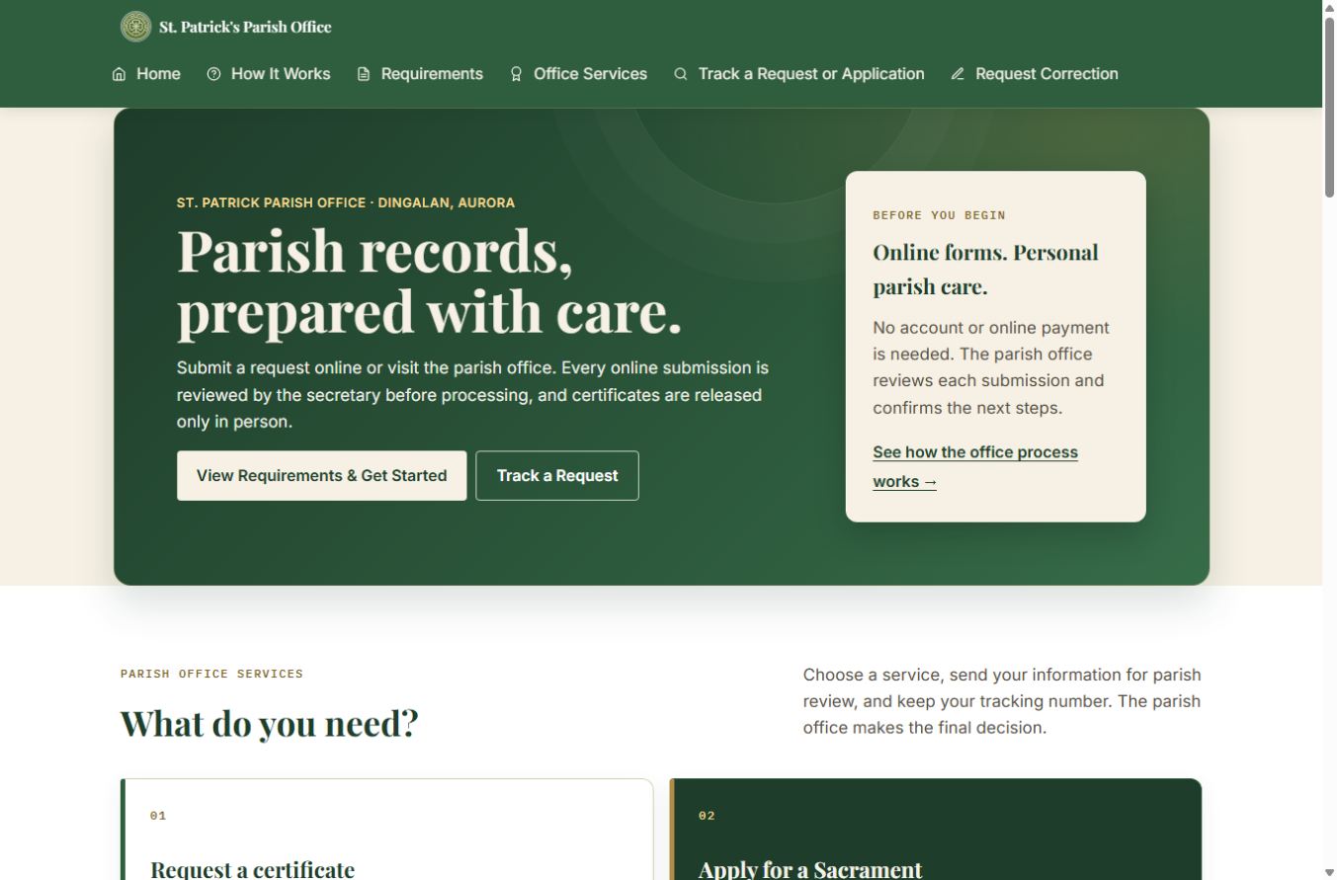
Figure 1. Public home page (local test installation; example screen only).

Choose the correct path
• Request a certificate when the sacrament has already taken place and you need a copy of the parish register entry.
• Apply for a sacrament when preparing for a future Baptism, Confirmation, First Communion, or Church Wedding.
• Track a request or application after submission using its tracking number and the same email address entered on the form.
• Request a correction if a certificate has already been issued and you need to report an error.
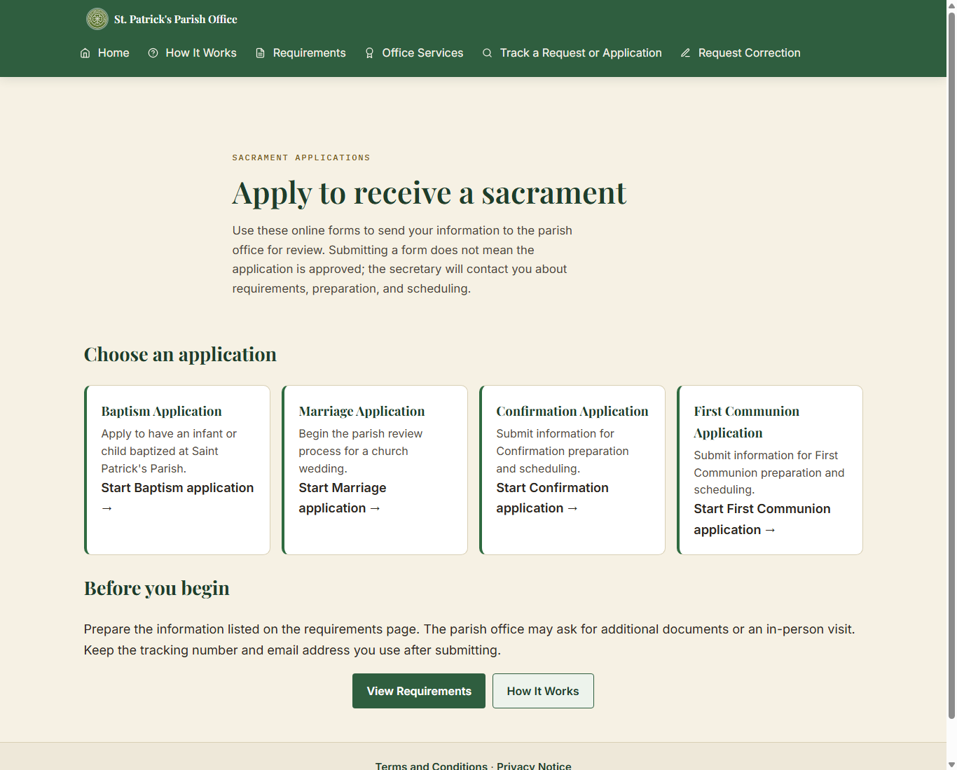
Figure 2. Sacrament application choices on the public website.

Before using an online form
• Review Requirements and How It Works before starting.
• Do not upload or send identity documents through the form, email, or Messenger. The office will explain how documents should be shown in person.
• A submission is not approval. The secretary verifies the information and confirms next steps.
• Certificates are collected from the Parish Office; they are not downloaded from the website.

3. Requesting a sacramental certificate
Use a certificate request only for a sacrament that has already been recorded. The public site provides Baptismal, Confirmation, First Communion, and Marriage certificate request forms.

Typical steps
1. From Office Services, select Request a Certificate and choose the sacrament.
2. Choose whether you are requesting for yourself or for someone else, if that choice is shown.
3. Enter the subject's name and the identifying dates requested by the form. Use First, Middle, Last, and Suffix fields where provided. Middle name and suffix can be left blank when not applicable.
4. For Baptism, Confirmation, and First Communion searches, enter one or both parent names when known. For marriage, provide both spouses' identifying details as requested.
5. Review any possible record match carefully. A search result is only a possible match; the Parish Secretary verifies the source register.
6. If no record is found, follow the option to ask the secretary to search the register manually. Not finding an online result does not prove that the sacrament did not occur.
7. Enter contact details, review the information, accept the required terms, and submit.
8. Save the tracking number and use it with the same email address to check progress.
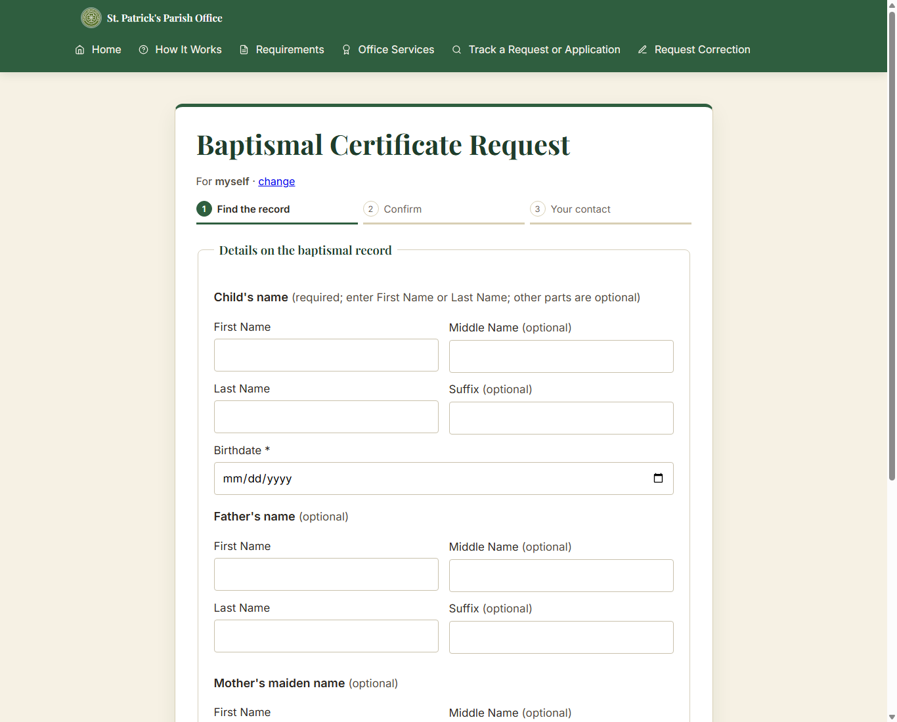
Figure 3. Baptismal certificate form: register search step (blank local test screen).

Do not submit the same request repeatedly just because a search result is not found. Contact the Parish Office or use the manual-search option.

4. Applying to receive a sacrament
Applications are for a future sacrament. Select Baptism, Confirmation, First Communion, or Marriage from Sacrament Applications. Forms are divided into guided phases; use Next and Back to review sections before submission.
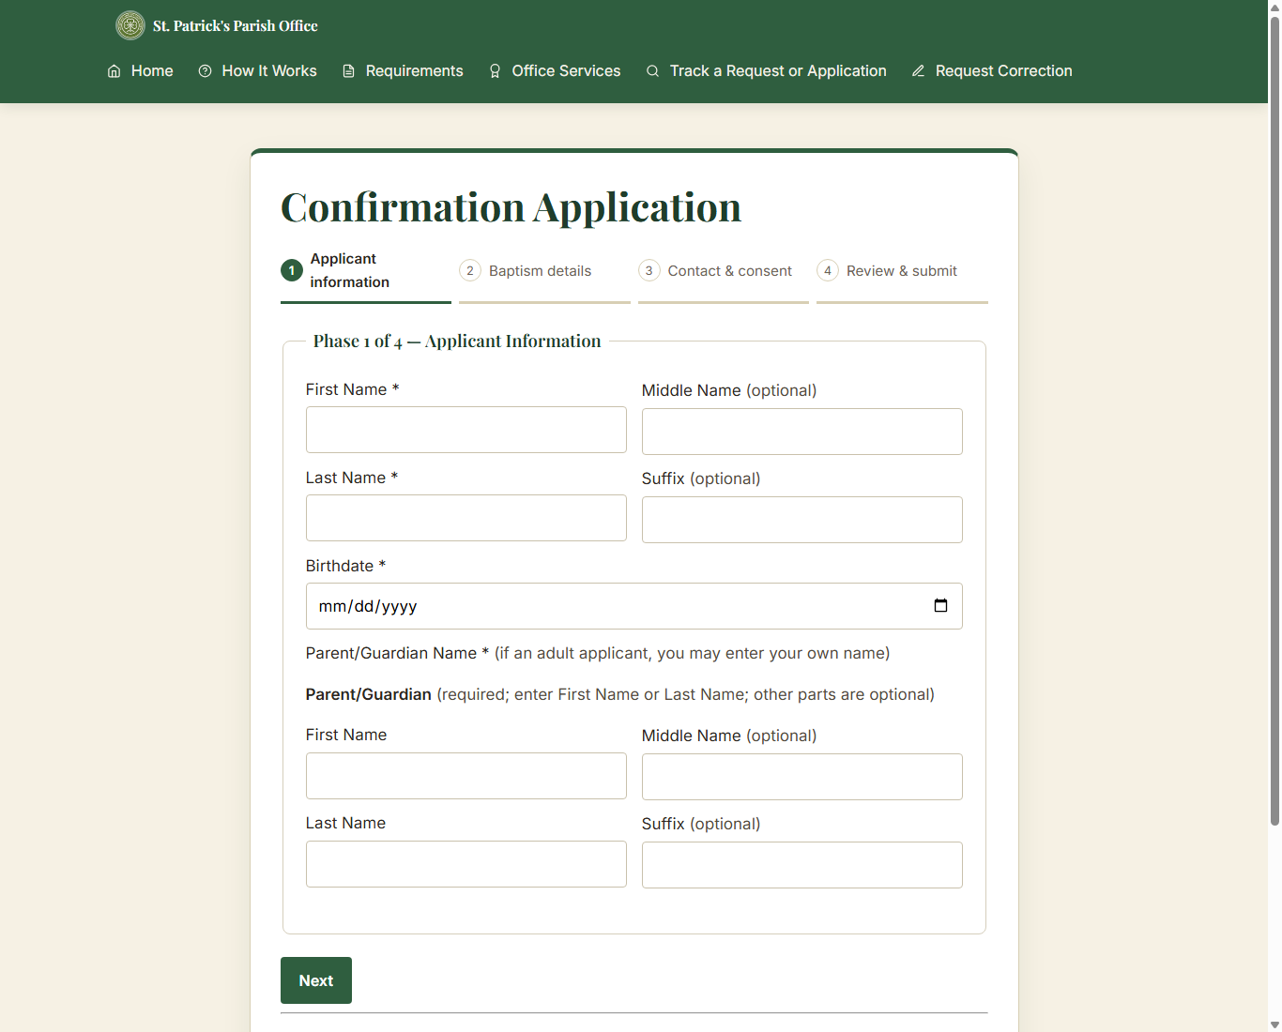
Figure 4. Confirmation application: phased information form (blank local test screen).

Prepare the information
• Baptism: child's name and birth details, parent or guardian contact, known parent details, sponsors if known, and a preferred date if available.
• Confirmation and First Communion: applicant's name and birthdate, parent/guardian contact, and known baptism information. Use "Not sure" when the form offers it and you cannot confirm the detail.
• Marriage: both parties' names, birth and contact details, current marital status, sacramental history, and preferred date/time/venue. The preferred date is a request, not a confirmed booking.

Submit carefully
1. Read the on-screen guidance and complete the required fields in each phase.
2. Use optional name fields only when the information is known; do not invent a middle name or suffix.
3. Review the summary on the final phase and correct errors before submitting.
4. Submit once, then record the tracking number and the email address used.
5. Wait for the secretary to review and contact you about preparation, documents, payment if applicable, or scheduling.
The website does not collect payment. If payment applies, follow the Parish Office instructions; payment is recorded by staff and is never entered as an amount in the system.

5. Tracking a submission and requesting a correction

Track a request or application
Open Track a Request or Application. Enter the tracking number exactly as shown in the confirmation and the same email address provided with that submission. One email can be used for more than one submission; each tracking number is checked separately.
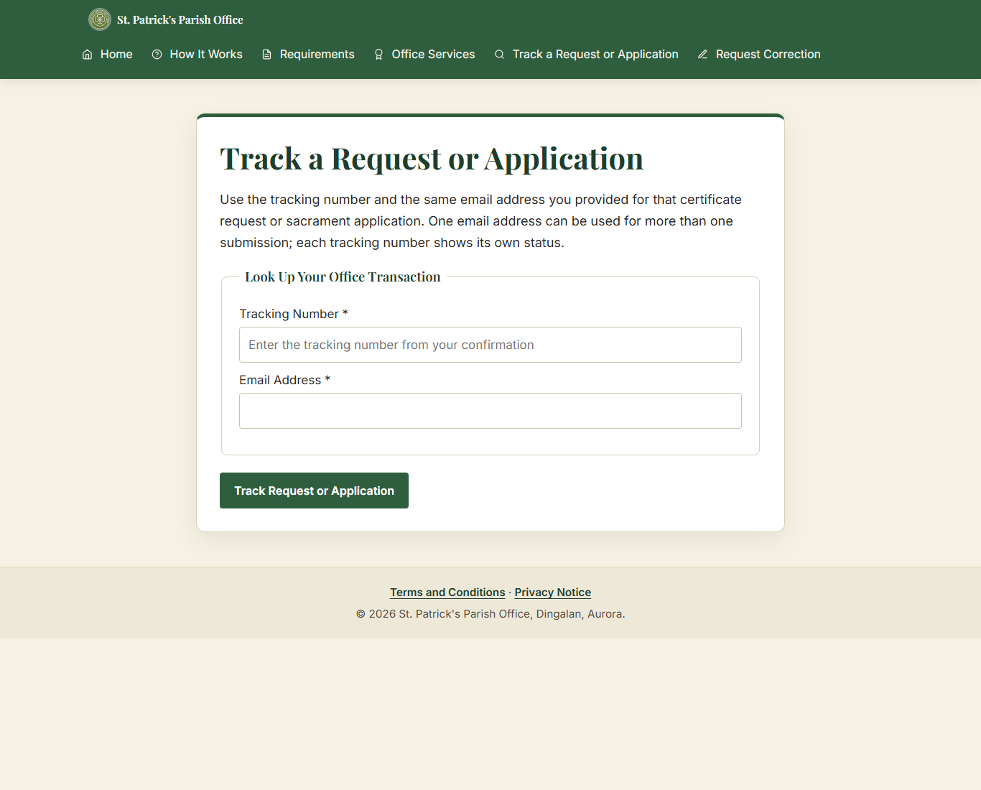
Figure 5. Public status lookup (blank local test screen).
• If no result appears, check for typing errors and confirm that you used the correct email address.
• The displayed status is informational. Contact the Parish Office if you need help interpreting it.

Request a correction
Use Request Correction only for an error on a certificate that has already been issued. Enter the requested tracking/certificate details, describe the error and requested correction, provide contact information, and submit for staff review. The office will verify the original record before making a correction.

A correction request does not automatically change the original parish register or issue a replacement certificate. Wait for the Parish Office to review it.

6. Secretary sign-in and dashboard

Sign in
1. Open the staff login page supplied by the Parish Office.
2. Enter the assigned username and password, then select Log In.
3. If you forget your password, select "Forgot your password?" on the login page, enter the address in the "Staff email" field, select "Send reset link," and use the emailed link. The link works once and expires after 30 minutes. The reset form requires at least 12 characters; it does not currently enforce uppercase, lowercase, and number requirements.
4. If sign-in is blocked, 8 failed attempts for one username within 15 minutes or 20 failed attempts from one IP address within 15 minutes blocks further attempts for 15 minutes. Wait 15 minutes, then use "Forgot your password?" first. If that does not resolve access, ask the designated technical administrator or another active staff member.

Staff sessions end after 30 minutes of inactivity. Sign in again to continue.
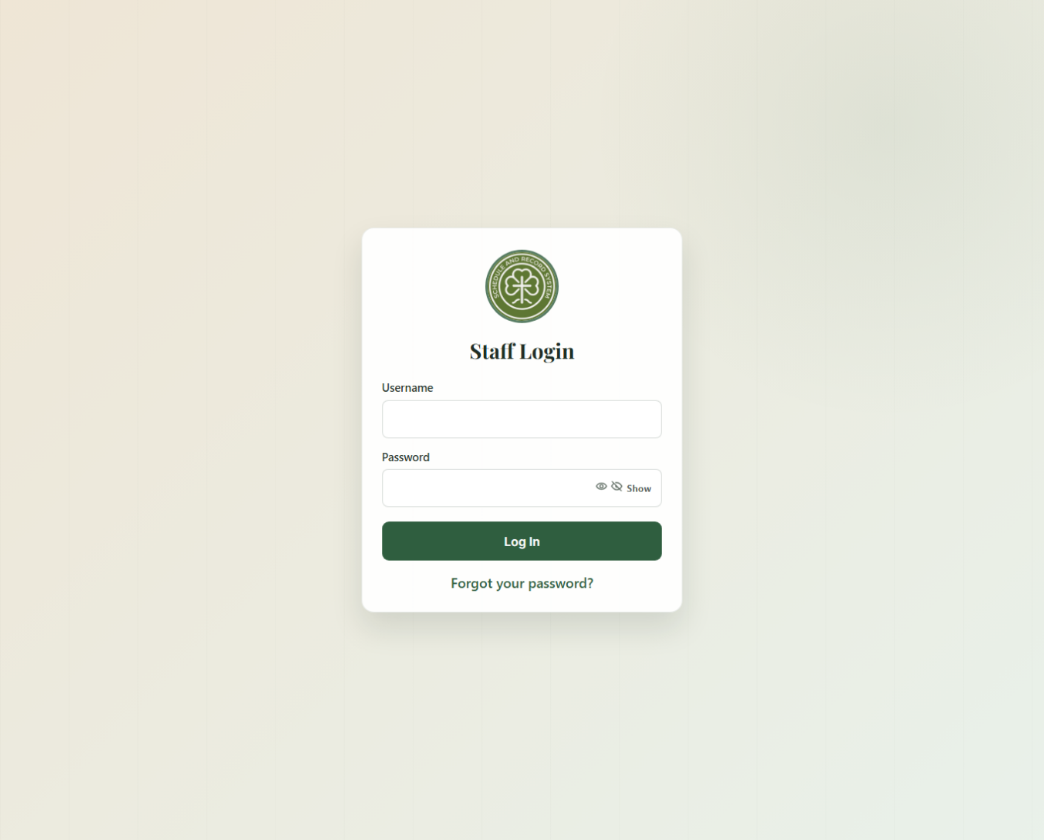
Figure 6. Staff login screen (blank local test installation).

Use the dashboard
The dashboard summarizes pending certificate requests, new applications, ready-for-pickup items, in-progress applications, and sacramental archive totals. Select a card or use the sidebar to open the relevant work area.
• Requests: Online Submissions, Certificate Requests, Sacrament Applications, and walk-in encoding.
• Records: All Records, Baptismal, Confirmation, First Communion, Marriage, Person Linking, Persons.
• Certificates: Generate / Preview, Print / Pickup History, Correction Requests.
• Schedule: Calendar, Booking Conflicts, Announcements.
• Reports: top-bar link (not a sidebar item) for monthly/yearly activity.
• Notifications: top-bar bell with "View All" and "Mark all read."
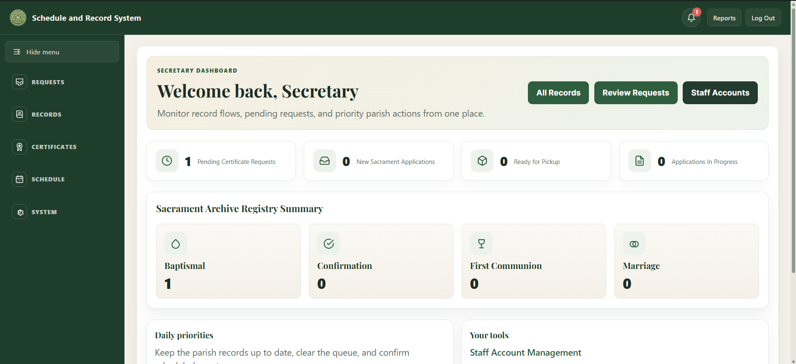
[Insert screenshot: Chapter 6 dashboard, top bar and navigation groups]
• System: Accounts, Backup, Archive / Restore, Email Log, Audit Log, Database Setup, Clean Up Old Data.

The current system uses the Secretary role for staff accounts. Menu availability can depend on that role and on the hosted build.

7. Reviewing certificate requests
Certificate Requests is the staff queue for certificate copies. Online Submissions provides a broader view of incoming public submissions. Select a row to open its detail page.
1. Search or filter the queue by tracking number, requester, email, status, channel, sacrament, or date as available.
2. Open the request and compare the requester's details with the relevant sacramental record.
3. If a digital record match is available, select the correct record. If it is not encoded, search the physical register and follow the manual process.
4. Verify the digital entry against the physical parish register before certificate generation when the page asks for book verification.
5. Update the request through the available workflow controls. Record a rejection reason when required.
6. If payment is required, follow the Parish Office process outside the system and mark it received only after confirmation. The system records who/when, not a payment amount.
7. Generate/preview the certificate only when the request and matching record satisfy the on-screen checks.
8. When ready, notify the requester according to office practice. Verify identity and record pickup/release through the certificate history workflow.

Processing correction requests
Open Certificates > Correction Requests and open the request. Compare the requested change with the physical register before taking action.
1. Select "Mark as Processing" while reviewing, or "Reject Request" when the request should not proceed. An internal Admin Review Note can be saved with the action.
2. If the correction is approved, correct the record through the parish's record-correction process first. Only after the record has actually been corrected, select "Mark as Completed."

A correction request does not change the parish register by itself. The staff action updates the request status and note; it does not perform the record correction.
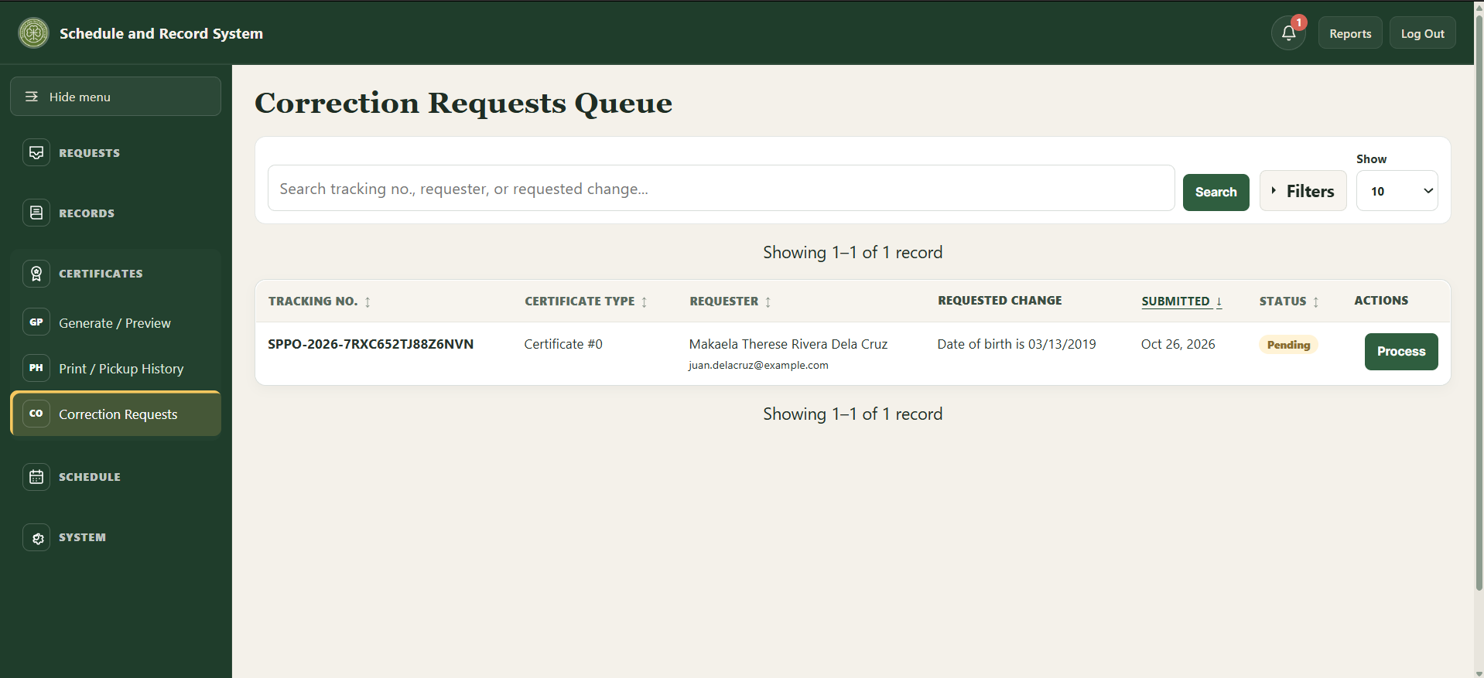
[Insert screenshot: Certificates > Correction Requests, request review and action buttons]

Do not treat a public search match as verification. Check names, dates, sacrament type, and source register. Stop and ask for a second review if any detail is uncertain.

8. Reviewing applications and managing sacramental records

Application queue
Open Sacrament Applications to review applications and manage their current stage. Use filters to narrow by sacrament, status, or submission channel, then open the application details.
• Baptism, Confirmation, and First Communion typically move through review, requirements/documents, preparation, approval, scheduling, and completion.
• Marriage applications include additional steps such as interview, banns, and seminar where applicable.
• Use only the statuses offered for the selected sacrament. The system may block an invalid transition or approval when required checklist items are incomplete.
• For online submissions awaiting payment, record receipt through the payment control before advancing when the workflow requires it.

Walk-in requests and applications
Use Walk-in Request or Walk-in Application when the parishioner is present and staff are encoding an onsite transaction. Confirm the correct submission channel and enter details from the source materials provided by the parishioner. Review the summary before saving.

Sacramental records
Use the relevant register page to search, filter, add, or edit an entry. The register stores the parish record; it is distinct from an online application or a certificate request.
• Enter names in First, Middle, Last, and Suffix fields as provided by the source register. Leave genuinely absent name parts blank.
• Check sacrament date and book/page/line references against the physical register.
• Use All Records for a combined search across sacrament registers. Use record detail pages to review links and history.
• Use Archive/Restore rather than attempting to permanently remove a historical entry. Confirm the record identity before archiving or restoring.

Worked example: Baptismal register entry and walk-in certificate request
The following example shows how a Baptismal register entry can be used when encoding an in-person certificate request. Keep given names, middle name, surname, and suffix in their corresponding fields. Here, “Mikaela Therese” are the given names, “Rivera” is the middle name, and “Dela Cruz” is the surname.

Encoding the register entry
1. Open Records > Baptismal and select “Add New Entry.” Enter the book, page, and line reference from the register. In this example the reference is Book I, page 1, line 1.
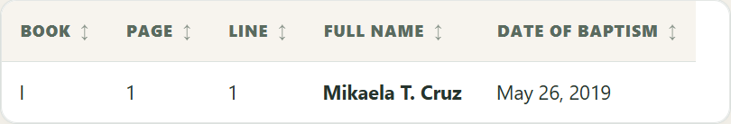
Figure 7. Baptismal Records list showing the encoded entry and baptism date.
2. In the Child fields, enter First Name: Mikaela Therese; Middle Name: Rivera; Surname: Dela Cruz. Enter Birth Date: March 14, 2019; Birthplace: Taguig City; Baptism Date: May 26, 2019; and Place of Baptism: St. Patrick’s Parish Church, Taguig City.
3. Enter the parents in their separate fields: Father Juan Miguel Lopez Dela Cruz (First Name: Juan Miguel; Middle Name: Lopez; Last Name: Dela Cruz) and Mother Ana Patricia Garcia Rivera (First Name: Ana Patricia; Middle Name: Garcia; Last Name: Rivera). The mother’s maiden surname, Rivera, is her last name in the parent section and is the child’s middle name in this example.
4. Enter the other register details as applicable: father’s birthplace Taguig City; mother’s birthplace Makati City; parents’ hometown and residence Taguig City; union type Legitimate (Church Marriage); Godfather Carlos Miguel Santos Reyes; Godmother Elena Grace Mendoza Navarro; and officiating minister Jose Ramon Bautista Santos.
5. Review the final check carefully and save the entry. The saved register entry remains a digital index; verify its details against the physical register before using it to issue a certificate.

Encoding the matching walk-in request
1. Open Requests > Walk-in Request and select Baptismal. Search using the child’s First Name Mikaela Therese, Middle Name Rivera, Last Name Dela Cruz, and Birthdate March 14, 2019. Add parent names to help find the entry, then select the exact register match.
2. Enter the requester as Juan Miguel Lopez Dela Cruz and select Parent as the relationship. For this example, enter juan.delacruz@example.com as the requester email address, then add any other details supplied at the counter.
3. Add a note describing the request as needed. Leave “Payment received at the counter” unchecked unless payment was actually received. Review the summary, then select “Encode Request.”
4. Give the requester the tracking number shown after saving. The request in this example has tracking number SPPO-2026-7RXC652TJ88Z6NVN; each new request receives its own tracking number. The request appears in Certificate Requests with Pending status and creates a staff notification and audit-history entry.
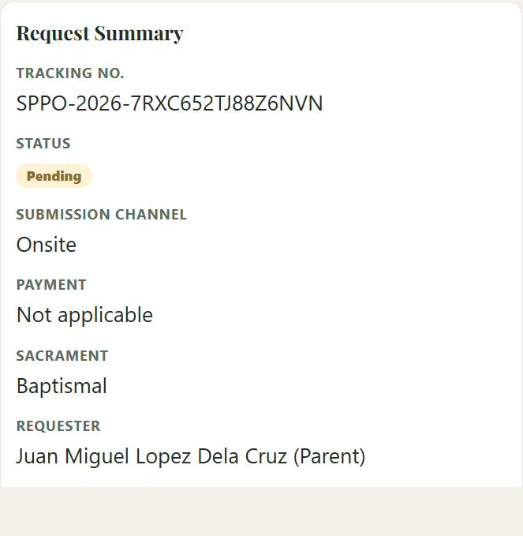
Figure 8. Certificate request summary showing the tracking number, status, and requester.
5. Use the Requirements Checklist to record what was actually received or verified. A matching digital entry alone does not confirm the physical register: the register-location checklist item must still be verified through the certificate preview workflow before certificate generation. Do not mark payment or documents received unless they were actually received.

This example demonstrates encoding and request tracking only. Follow the parish’s normal source-register, identity, payment, checklist, approval, and certificate-release procedures.

9. Generating certificates and recording pickup
1. Open Certificates > Generate / Preview and select the approved request. If it is not already matched, match it to the correct digital record.
2. Compare the digital entry with the physical register book. If the matched record has not been verified, select "Confirm Verification." "Mark as Generated" remains disabled until verification is confirmed.
3. Review the preview. For a Baptismal certificate, select "Print on Blank Stock" for pre-printed stock or "Print Full Certificate" for plain paper; use plain paper for the first alignment test. For other certificates, use "Print Certificate" in the print view.
4. Select "Mark as Generated."
5. Open Certificates > Print / Pickup History. After the physical copy is printed, select "Mark as Printed."
6. After the certificate is signed and sealed, select "Finalize Signed and Sealed."
7. At pickup, verify the claimant's valid ID in person. Enter the claimant name and relationship to the subject, check "I verified valid ID at the counter," add optional notes if needed, then select "Confirm Release."

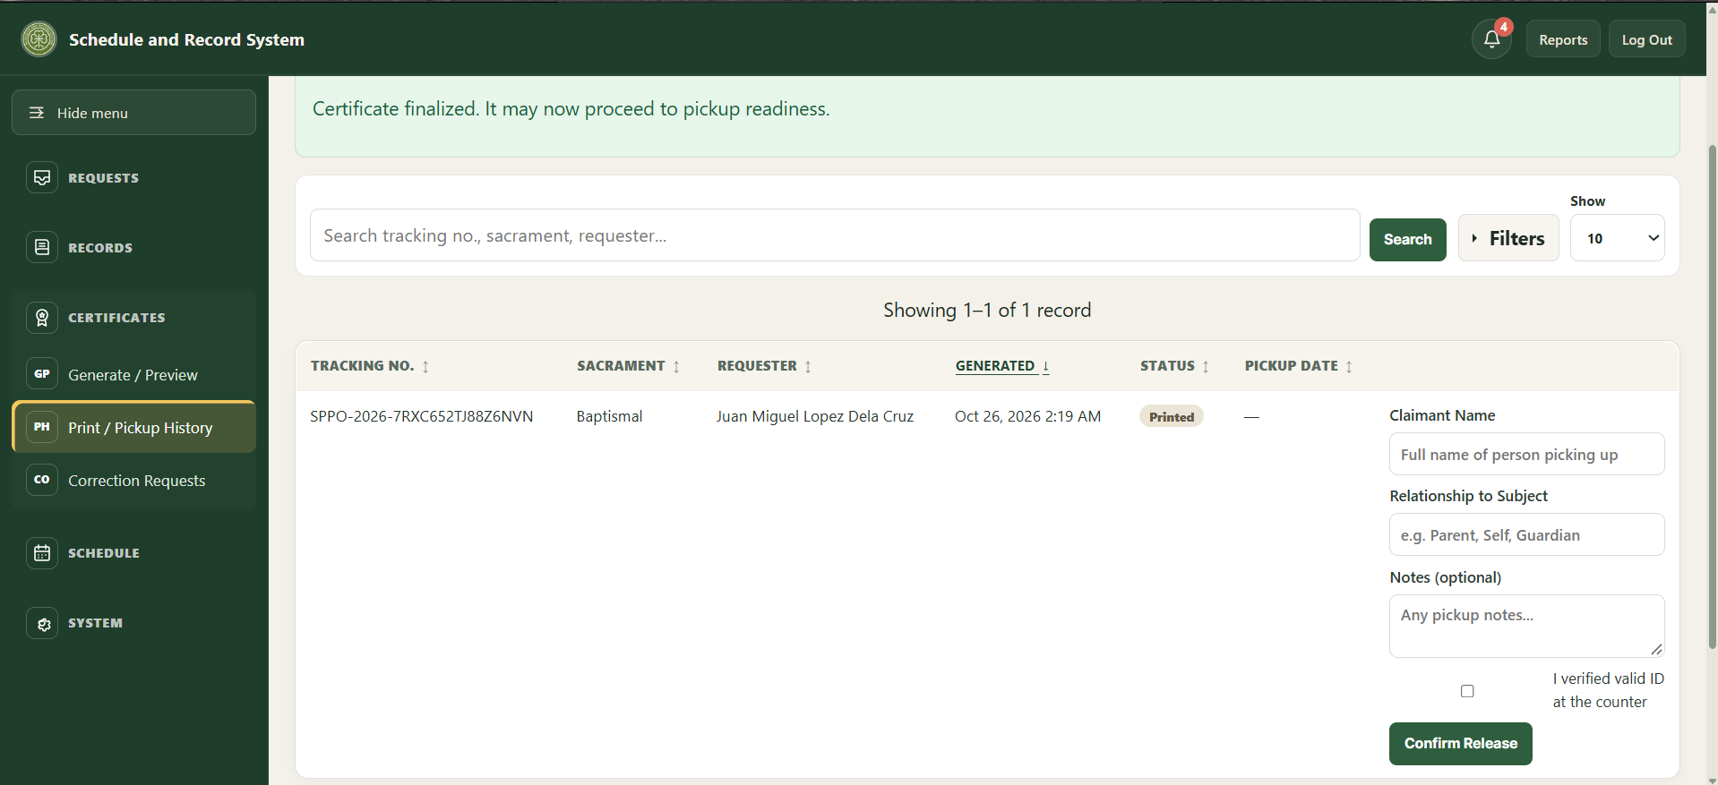
[Insert screenshot: Certificates > Print / Pickup History, release form]

A digital preview is not an issued certificate. Certificate release is an in-person office process.

If the preview is wrong
• Return to the request and check the matched record.
• Do not change a historical record to make it fit a request without checking the physical register and following correction procedure.
• Ask a supervisor or technical administrator for help if generation is blocked or the print alignment is incorrect.
• If the certificate must be generated again, select "Regenerate" and confirm with "Confirm Regeneration." The current generation log is updated rather than silently creating another active log.

10. Calendar, announcements, and reports

Calendar
• Open Schedule > Calendar. Use Month or List to browse events; use Previous, Next, and Today to move through dates.
• Select Add event to enter the event type, title, date, and optional times. Review conflict warnings; the secretary resolves scheduling conflicts manually.
• Public details are optional text intended for parishioners and appear in the public calendar's event details. Keep names and personal information out unless disclosure is appropriate and permission has been obtained.
• Staff notes are internal to staff and are not shown in the public event dialog. Keep confidential or operational details there.
• The Search, edit, or remove events section below the calendar is collapsible. Open it when you need the full searchable table or event actions.

Announcements
Use Schedule > Announcements to create or update public notices. Check the title, text, publication setting, and any date before publishing. Remove or unpublish outdated notices according to parish practice.

Reports
• Open Reports and choose Monthly or Yearly, then select the reporting period.
• Records Encoded counts records by the date they were entered into the system, not the historical date of the sacrament. A record added today for an older baptism belongs to today's encoding period.
• Certificate Requests Submitted and Sacrament Applications Submitted measure intake in the selected period. Export CSV downloads the displayed period's report data.

11. System administration and backups
These tasks do not use a separate administrator role. In-app maintenance is done through the same Secretary staff accounts; the designated technical administrator handles hosting, recovery, and database restoration.

Staff accounts
Open System > Accounts to manage authorized staff accounts. Passwords set or changed here must be at least 12 characters and include an uppercase letter, a lowercase letter, and a number. An account cannot deactivate or delete itself, and the last active account cannot be deactivated or deleted. If system history references an account, deletion is blocked; deactivate that account instead.
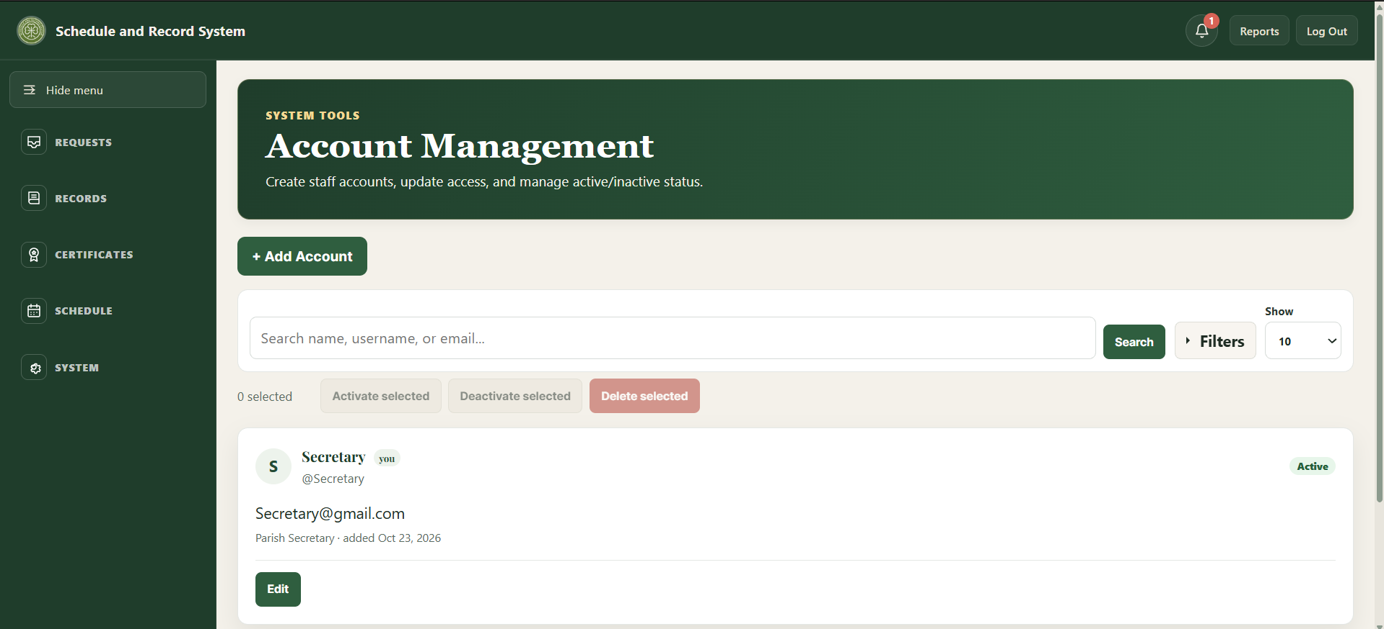
[Insert screenshot: System > Accounts, staff account controls and password rule]

Database updates
Database Setup lists supported compatibility updates and checks whether their database objects exist. Updates do not run automatically during normal page loads.
1. Create and verify a fresh backup before applying a database update.
2. Open System > Database Setup and read the update description and status.
3. Check the status: "Ready to update," "Already up to date," or "Needs administrator review." Use "Apply update" only when an update is ready, or "Mark as already updated" when that option is offered for an update already present. Stop and ask the technical administrator if review is needed.
4. Wait for completion confirmation, then reload the relevant page and verify expected behavior.

The Public calendar event details update adds the schedule_events.public_details column required by the public-facing details feature. Apply it before editing event public details on installations that do not yet have the column.
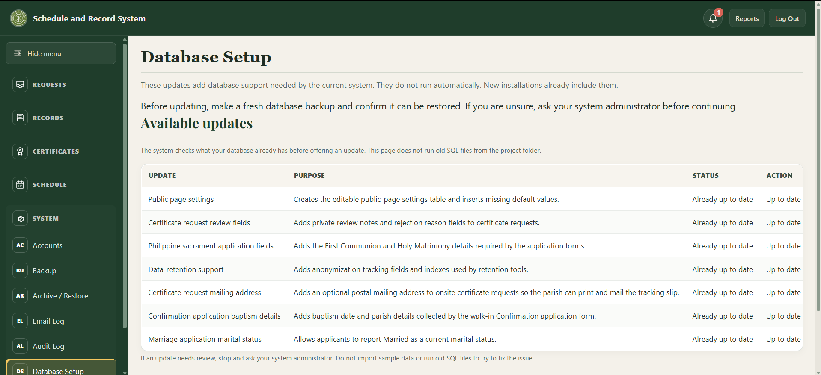
[Insert screenshot: System > Database Setup, update statuses and actions]

Encrypted backup/export
Open System > Backup. The password field is labeled "Administrator password"; enter the signed-in staff account password there. Provide a backup passphrase of at least 12 characters, then download the encrypted export and store its passphrase separately. The export excludes password hashes, password-reset tokens, submission rate-limit data, and email delivery logs.
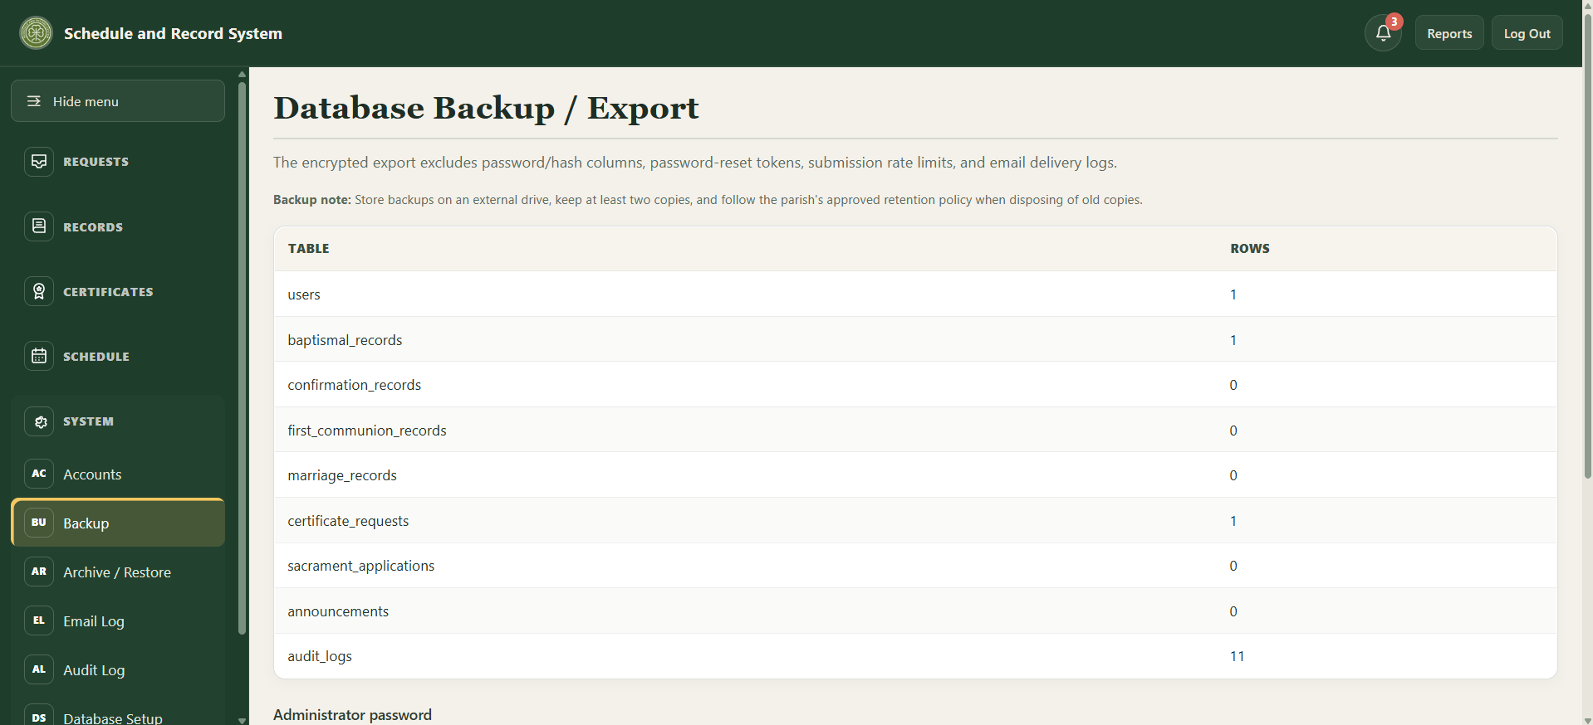
[Insert screenshot: System > Backup, encrypted export form]
• Keep at least two protected copies in approved storage. Do not email an unencrypted export or store the passphrase alongside the file.
• Database restoration is handled by the designated technical administrator. The command-line script scripts/decrypt-backup.php decrypts an encrypted export to a .sql file; it does not import or restore that file into the database.

Email Delivery Log
Open System > Email Log to review sent, failed, and other recorded email-delivery attempts. A "sent" status means the configured local mail relay accepted the message; it does not guarantee delivery to the recipient's inbox.
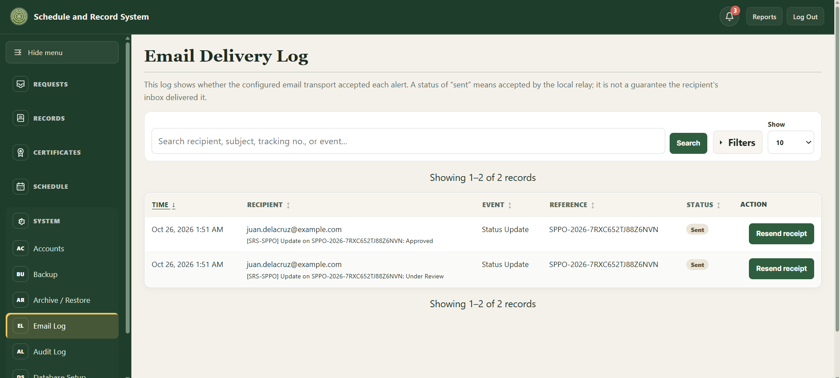
[Insert screenshot: System > Email Log, delivery status list]

Clean Up Old Data
This cleanup anonymizes older finished certificate requests (released, rejected, or cancelled), sacrament applications (completed, rejected, or cancelled), and correction requests (completed or rejected), using the retention periods configured for this installation. It scrubs old audit-log details and removes older email-delivery logs, notifications, rate-limit entries, and expired or used password-reset tokens. Open submissions and permanent church-register and person records are not changed.
Back up the database before continuing. The page first previews counts without changing data; "Run cleanup now" is an irreversible action. If the readiness check fails or you are unsure, stop and ask the designated technical administrator.
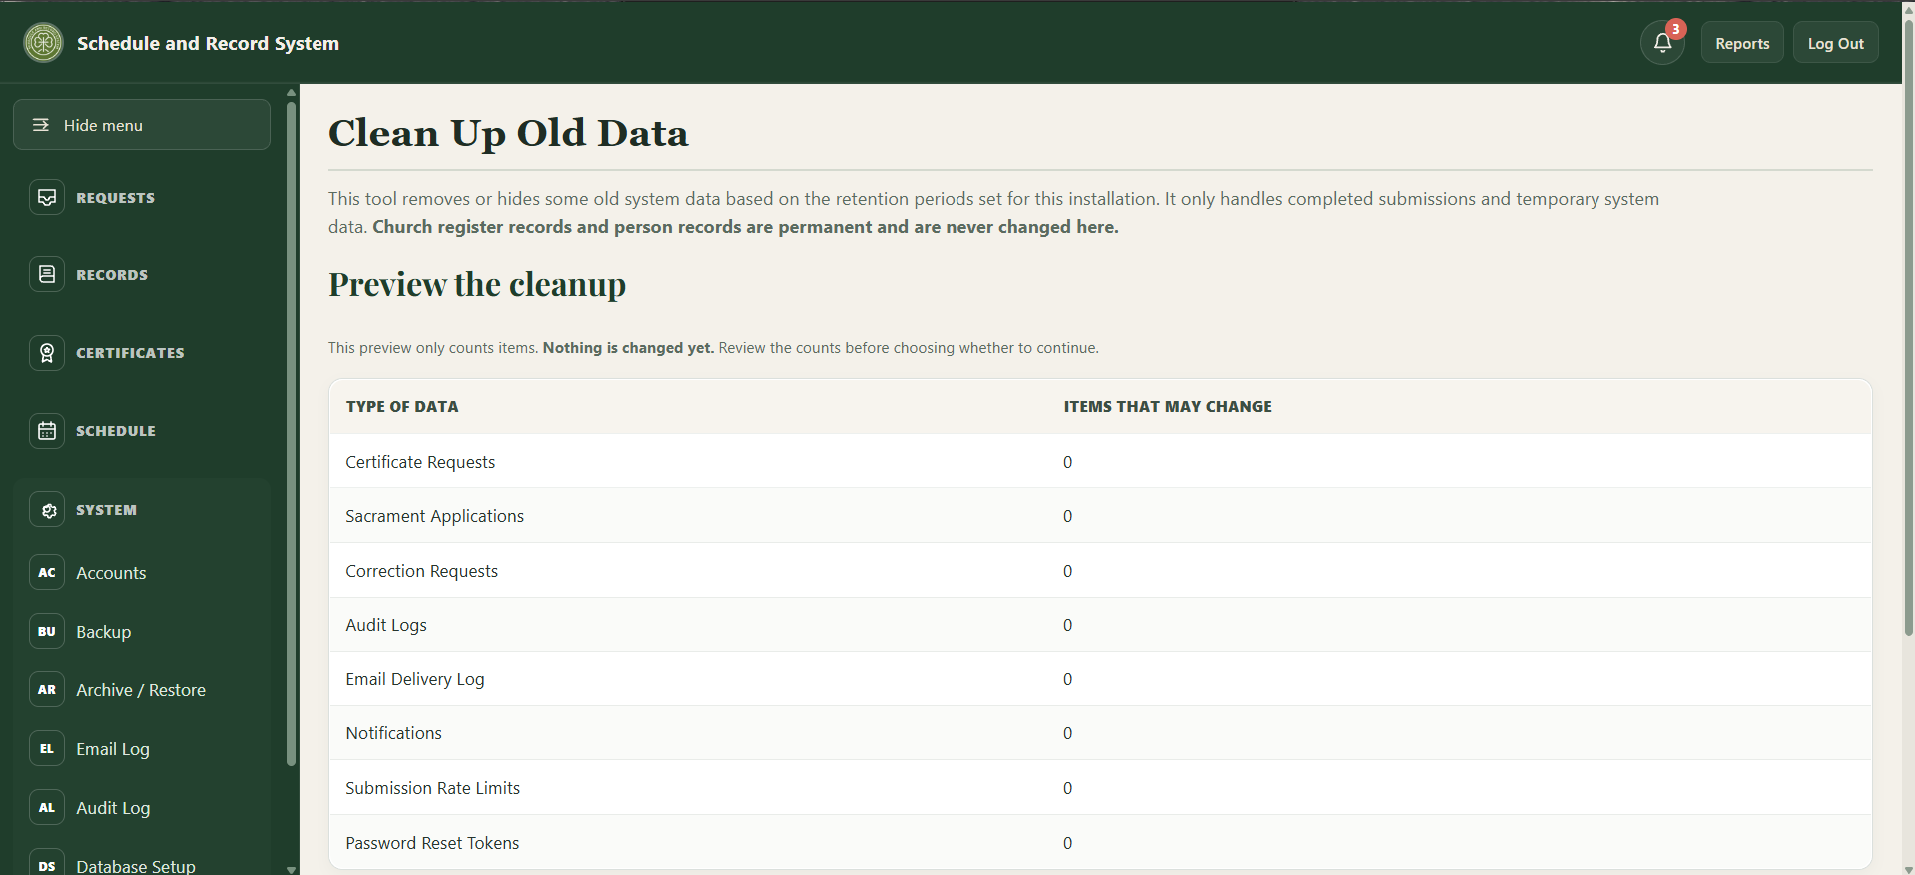
[Insert screenshot: System > Clean Up Old Data, preview counts and confirmation]

Audit and other system tools
Use the Audit Log to review recorded staff actions. Person Linking and Persons are under Records, not System; use these tools only after confirming the person and register entries. Database maintenance, hosting configuration, and recovery should be performed by the designated technical administrator.

12. Troubleshooting and quick reference

Public user quick checks
• Record not found: check spelling and dates, provide one or both parent names if known, or ask the secretary to search the physical register.
• Tracking lookup fails: use the exact tracking number and the same email used on that submission.
• Form will not advance: review highlighted errors and complete required fields; optional middle names and suffixes may remain blank.
• Calendar event has no details: only events with public details entered by staff open a details view.
• Need additional requirements: contact the Parish Office; online form lists are guidance, and the secretary confirms final requirements.

Staff quick checks
• Page reports an unknown database column: do not repeatedly submit the form. Back up the database, open Database Setup, and apply the matching supported update or ask the technical administrator.
• No certificate preview: verify approval, correct record match, physical-book verification, and required checklist items.
• Unexpected report totals: confirm selected month/year and remember encoded-record totals use date entered, while service dates may be historical.
• Calendar conflict: compare date and time with other scheduled events and resolve with the parties involved; the system flags but does not automatically decide the booking.
• Logged out unexpectedly: staff sessions end after 30 minutes of inactivity; sign in again.
• Too many failed attempts: wait 15 minutes, then use "Forgot your password?".
• Password reset email did not arrive: check System > Email Log, check the spam folder, and confirm the staff email address on the account in System > Accounts.
• Login or permission problem: after trying password reset, ask the designated technical administrator or another active staff member. Do not share passwords through chat or email.

Terms
• Certificate request: request for a copy of an existing parish register record.
• Sacrament application: request to begin preparation for a future sacrament.
• Tracking number: reference used with the submission email to check status.
• Public details: optional event description visible to website visitors.
• Staff notes: internal event notes intended for authorized staff.

Manual maintenance
Draft for review. Before capstone submission, replace the cover placeholders, confirm the official hosted URL, and have the Parish Office verify workflow names, contact details, and screenshots against the final deployed build.
Screenshots in this draft were captured from the local test installation with blank forms. They illustrate interface locations only; sample events, page text, and hosted appearance may differ.

