ST. PATRICK'S PARISH OFFICE

SCHEDULE AND RECORD SYSTEM
USER MANUAL
Public users | Parish Secretary | System Administrator

Prepared for the Capstone Project
Prepared by: ______________________________________________
Program / Section: _________________________________________
Institution: _______________________________________________
Adviser: ___________________________________________________
Draft for review | Version 1.0

About this manual
This manual explains how to use the Schedule and Record System of St. Patrick's Parish Office (SRS-SPPO). It is organized around the work of parishioners, the parish secretary, and the person responsible for system maintenance.
The instructions describe the application as reviewed for this draft. Screen labels and available options may change when the hosted system is updated. Follow current parish-office instructions whenever they differ from this guide.
Important: Online forms start a request or application; they do not grant approval, collect payment, or issue a certificate. Final verification and certificate pickup take place through the Parish Office.

Who should use each part?
• Public users: Chapters 2-5 cover certificates, sacrament applications, status tracking, and correction requests.
• Parish Secretary: Chapters 6-10 cover staff access, request processing, records, certificates, scheduling, and reports.
• System Administrator: Chapter 11 covers accounts, backups, database updates, and routine system safeguards. In the current system, staff accounts use the Secretary role; a separate administrator role is not provided.

Contents
• 1. Getting started and user roles
• 2. Public home page and office services
• 3. Requesting a sacramental certificate
• 4. Applying to receive a sacrament
• 5. Tracking a submission and requesting a correction
• 6. Secretary sign-in and dashboard
• 7. Reviewing certificate requests
• 8. Reviewing applications and managing sacramental records
• 9. Generating certificates and recording pickup
• 10. Calendar, announcements, and reports
• 11. System administration and backups
• 12. Troubleshooting and quick reference

1. Getting started and user roles

What the system does
SRS-SPPO supports parish service intake, sacramental-record keeping, certificate processing, scheduling, and office reporting. Public visitors can submit information without creating an account. Authorized staff sign in to review and process work.

Access points
• Public website: use the official parish link provided by the Parish Office. The home page includes service links, requirements, a calendar, and request tracking.
• Staff area: open the staff login link supplied by the Parish Office. Staff pages require an active account.
• A local development URL such as http://localhost/srs-sppo is for the local test installation only; it is not the public hosted address.

Roles and responsibilities
• Public visitor: supplies accurate information, keeps the tracking number, and follows office directions.
• Parish Secretary: reviews submissions, verifies information, updates workflow status, maintains records, schedules events, and prepares reports.
• System maintainer: protects staff access, applies approved database updates, and creates protected backups. Ask the designated technical administrator for hosting or recovery actions.
Never share a staff password. Use only real personal information on the authorized hosted site; use test data for demonstrations and screenshots.

2. Public home page and office services
The public home page is the starting point. Use the navigation menu or the large service buttons to find the correct task.
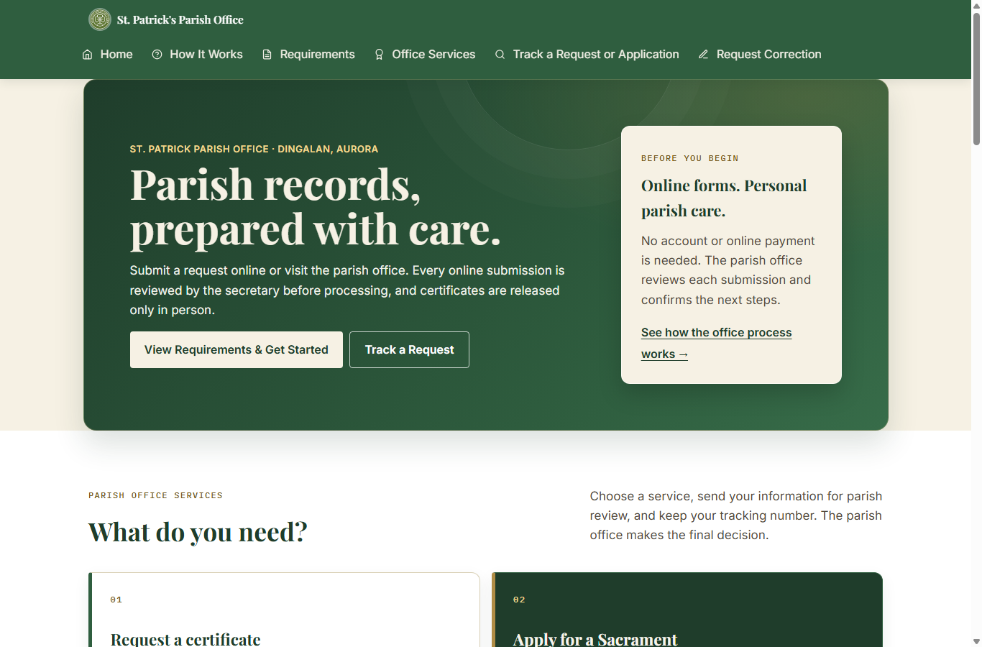
Figure 1. Public home page (local test installation; example screen only).

Choose the correct path
• Request a certificate when the sacrament has already taken place and you need a copy of the parish register entry.
• Apply for a sacrament when preparing for a future Baptism, Confirmation, First Communion, or Church Wedding.
• Track a request or application after submission using its tracking number and the same email address entered on the form.
• Request a correction if a certificate has already been issued and you need to report an error.
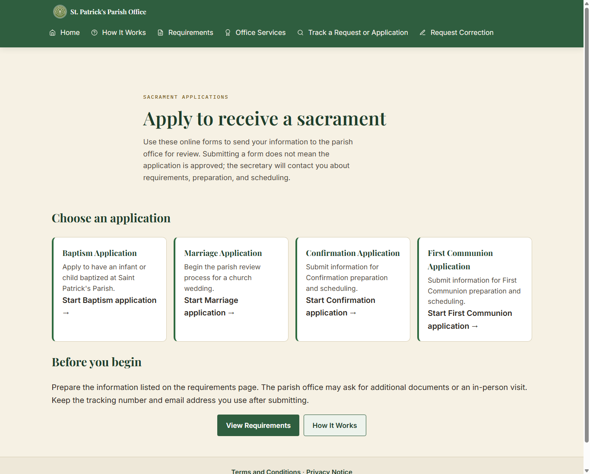
Figure 2. Sacrament application choices on the public website.

Before using an online form
• Review Requirements and How It Works before starting.
• Do not upload or send identity documents through the form, email, or Messenger. The office will explain how documents should be shown in person.
• A submission is not approval. The secretary verifies the information and confirms next steps.
• Certificates are collected from the Parish Office; they are not downloaded from the website.

3. Requesting a sacramental certificate
Use a certificate request only for a sacrament that has already been recorded. The public site provides Baptismal, Confirmation, First Communion, and Marriage certificate request forms.

Typical steps
1. From Office Services, select Request a Certificate and choose the sacrament.
2. Choose whether you are requesting for yourself or for someone else, if that choice is shown.
3. Enter the subject's name and the identifying dates requested by the form. Use First, Middle, Last, and Suffix fields where provided. Middle name and suffix can be left blank when not applicable.
4. For Baptism, Confirmation, and First Communion searches, enter one or both parent names when known. For marriage, provide both spouses' identifying details as requested.
5. Review any possible record match carefully. A search result is only a possible match; the Parish Secretary verifies the source register.
6. If no record is found, follow the option to ask the secretary to search the register manually. Not finding an online result does not prove that the sacrament did not occur.
7. Enter contact details, review the information, accept the required terms, and submit.
8. Save the tracking number and use it with the same email address to check progress.
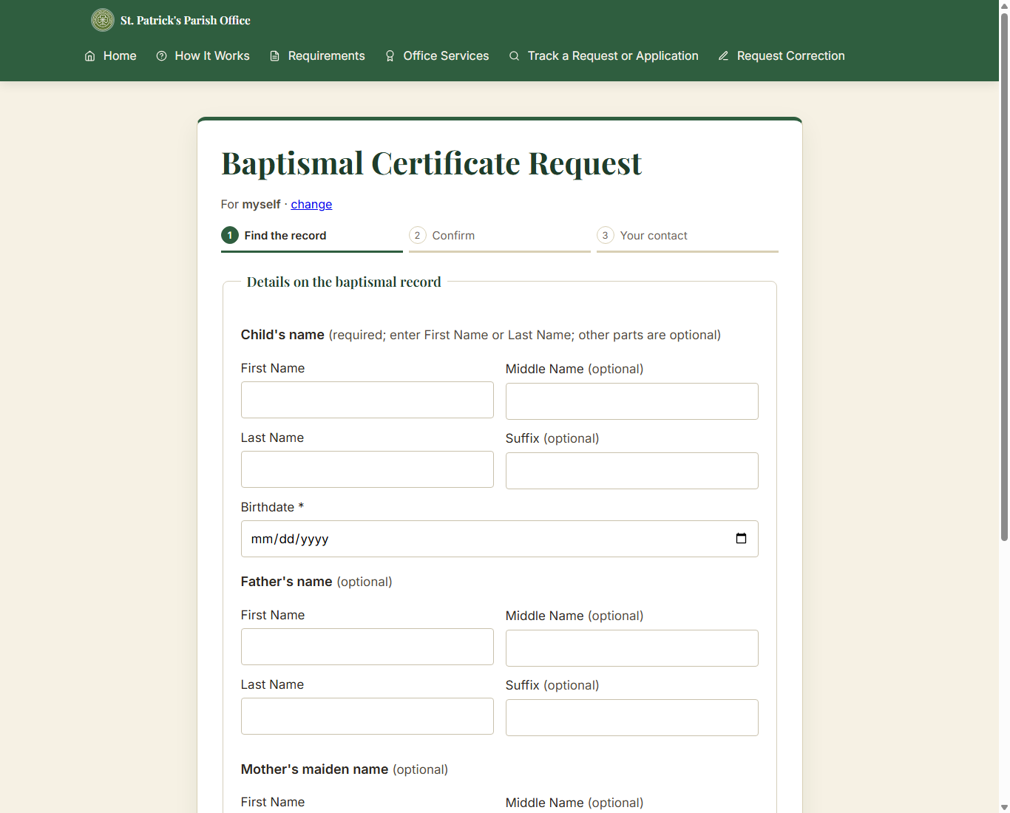
Figure 3. Baptismal certificate form: register search step (blank local test screen).
Do not submit the same request repeatedly just because a search result is not found. Contact the Parish Office or use the manual-search option.

4. Applying to receive a sacrament
Applications are for a future sacrament. Select Baptism, Confirmation, First Communion, or Marriage from Sacrament Applications. Forms are divided into guided phases; use Next and Back to review sections before submission.
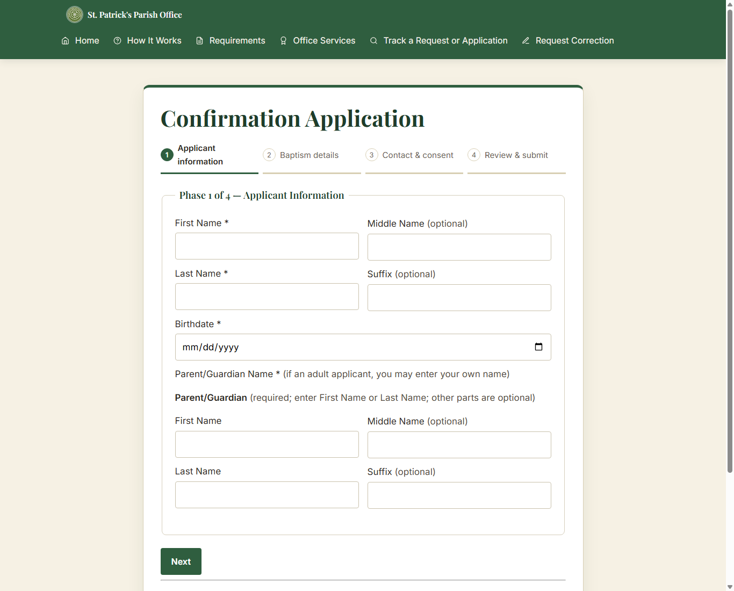
Figure 4. Confirmation application: phased information form (blank local test screen).

Prepare the information
• Baptism: child's name and birth details, parent or guardian contact, known parent details, sponsors if known, and a preferred date if available.
• Confirmation and First Communion: applicant's name and birthdate, parent/guardian contact, and known baptism information. Use "Not sure" when the form offers it and you cannot confirm the detail.
• Marriage: both parties' names, birth and contact details, current marital status, sacramental history, and preferred date/time/venue. The preferred date is a request, not a confirmed booking.

Submit carefully
1. Read the on-screen guidance and complete the required fields in each phase.
2. Use optional name fields only when the information is known; do not invent a middle name or suffix.
3. Review the summary on the final phase and correct errors before submitting.
4. Submit once, then record the tracking number and the email address used.
5. Wait for the secretary to review and contact you about preparation, documents, payment if applicable, or scheduling.
The website does not collect payment. If payment applies, follow the Parish Office instructions; payment is recorded by staff and is never entered as an amount in the system.

5. Tracking a submission and requesting a correction

Track a request or application
Open Track a Request or Application. Enter the tracking number exactly as shown in the confirmation and the same email address provided with that submission. One email can be used for more than one submission; each tracking number is checked separately.
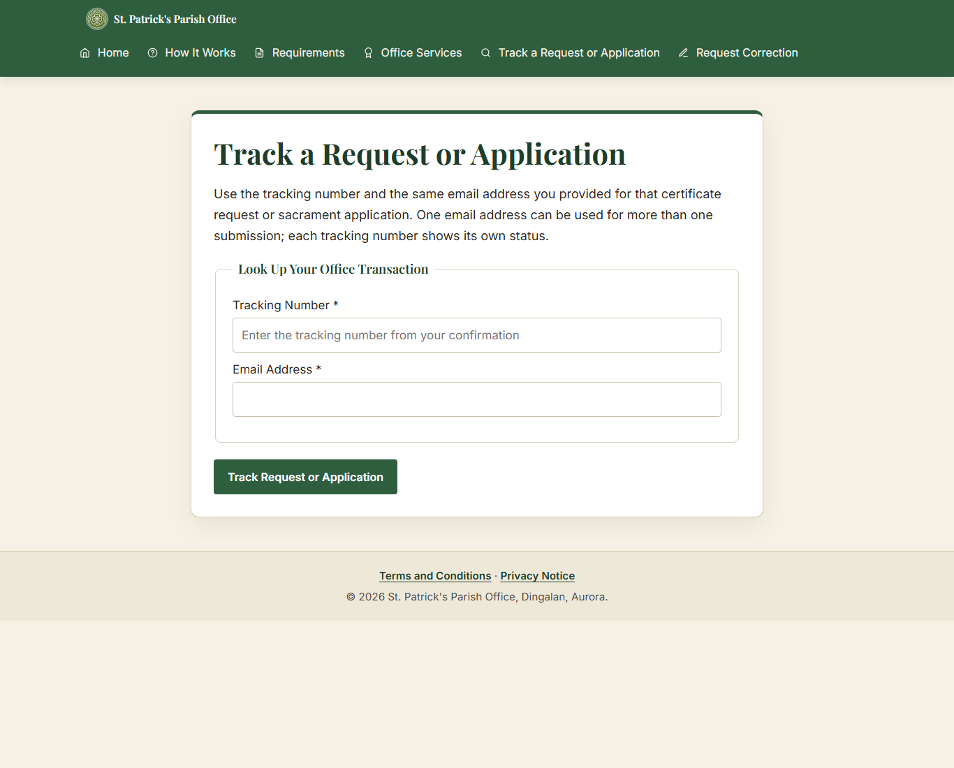
Figure 5. Public status lookup (blank local test screen).
• If no result appears, check for typing errors and confirm that you used the correct email address.
• The displayed status is informational. Contact the Parish Office if you need help interpreting it.

Request a correction
Use Request Correction only for an error on a certificate that has already been issued. Enter the requested tracking/certificate details, describe the error and requested correction, provide contact information, and submit for staff review. The office will verify the original record before making a correction.
A correction request does not automatically change the original parish register or issue a replacement certificate. Wait for the Parish Office to review it.

6. Secretary sign-in and dashboard

Sign in
1. Open the staff login page supplied by the Parish Office.
2. Enter the assigned username and password, then select Log In.
3. If sign-in fails, recheck the username and password. Repeated failures may temporarily limit attempts; contact the account administrator if access remains unavailable.
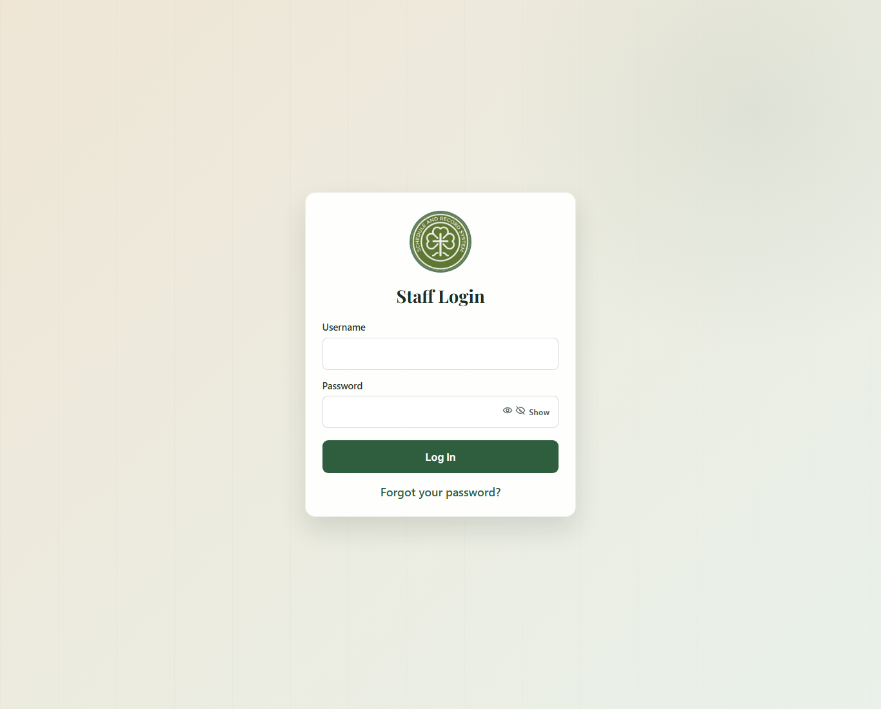
Figure 6. Staff login screen (blank local test installation).

Use the dashboard
The dashboard summarizes pending certificate requests, new applications, ready-for-pickup items, in-progress applications, and sacramental archive totals. Select a card or use the sidebar to open the relevant work area.
• Requests: Online Submissions, Certificate Requests, Sacrament Applications, and walk-in encoding.
• Records: all records and the Baptismal, Confirmation, First Communion, and Marriage registers.
• Certificates: generate/preview and print/pickup history.
• Schedule: calendar, booking conflicts, and announcements.
• Reports: monthly/yearly activity.
• System: accounts, backups, archive/restore, audit log, person tools, and database setup.
The current system uses the Secretary role for staff accounts. Menu availability can depend on that role and on the hosted build.

7. Reviewing certificate requests
Certificate Requests is the staff queue for certificate copies. Online Submissions provides a broader view of incoming public submissions. Select a row to open its detail page.
1. Search or filter the queue by tracking number, requester, email, status, channel, sacrament, or date as available.
2. Open the request and compare the requester's details with the relevant sacramental record.
3. If a digital record match is available, select the correct record. If it is not encoded, search the physical register and follow the manual process.
4. Verify the digital entry against the physical parish register before certificate generation when the page asks for book verification.
5. Update the request through the available workflow controls. Record a rejection reason when required.
6. If payment is required, follow the Parish Office process outside the system and mark it received only after confirmation. The system records who/when, not a payment amount.
7. Generate/preview the certificate only when the request and matching record satisfy the on-screen checks.
8. When ready, notify the requester according to office practice. Verify identity and record pickup/release through the certificate history workflow.
Do not treat a public search match as verification. Check names, dates, sacrament type, and source register. Stop and ask for a second review if any detail is uncertain.

8. Reviewing applications and managing sacramental records

Application queue
Open Sacrament Applications to review applications and manage their current stage. Use filters to narrow by sacrament, status, or submission channel, then open the application details.
• Baptism, Confirmation, and First Communion typically move through review, requirements/documents, preparation, approval, scheduling, and completion.
• Marriage applications include additional steps such as interview, banns, and seminar where applicable.
• Use only the statuses offered for the selected sacrament. The system may block an invalid transition or approval when required checklist items are incomplete.
• For online submissions awaiting payment, record receipt through the payment control before advancing when the workflow requires it.

Walk-in requests and applications
Use Walk-in Request or Walk-in Application when the parishioner is present and staff are encoding an onsite transaction. Confirm the correct submission channel and enter details from the source materials provided by the parishioner. Review the summary before saving.

Sacramental records
Use the relevant register page to search, filter, add, or edit an entry. The register stores the parish record; it is distinct from an online application or a certificate request.
• Enter names in First, Middle, Last, and Suffix fields as provided by the source register. Leave genuinely absent name parts blank.
• Check sacrament date and book/page/line references against the physical register.
• Use All Records for a combined search across sacrament registers. Use record detail pages to review links and history.
• Use Archive/Restore rather than attempting to permanently remove a historical entry. Confirm the record identity before archiving or restoring.

9. Generating certificates and recording pickup
1. Open Certificates > Generate / Preview and select the approved request.
2. Confirm the request is linked to the correct sacramental record and that the source entry has been verified as required.
3. Review every name, date, register reference, and printed field in the preview. Do not print if the record or certificate layout is uncertain.
4. Select the print mode approved for the parish printer and certificate stock. Use the test/preview print first when aligning a new printer or stock.
5. Print the certificate and complete the parish's required signature/seal process.
6. When the certificate is handed to the verified recipient, record the pickup/release in Print / Pickup History.
A digital preview is not an issued certificate. Certificate release is an in-person office process.

If the preview is wrong
• Return to the request and check the matched record.
• Do not change a historical record to make it fit a request without checking the physical register and following correction procedure.
• Ask a supervisor or technical administrator for help if generation is blocked or the print alignment is incorrect.

10. Calendar, announcements, and reports

Calendar
• Open Schedule > Calendar. Use Month or List to browse events; use Previous, Next, and Today to move through dates.
• Select Add event to enter the event type, title, date, and optional times. Review conflict warnings; the secretary resolves scheduling conflicts manually.
• Public details are optional text intended for parishioners and appear in the public calendar's event details. Keep names and personal information out unless disclosure is appropriate and permission has been obtained.
• Staff notes are internal to staff and are not shown in the public event dialog. Keep confidential or operational details there.
• The Search, edit, or remove events section below the calendar is collapsible. Open it when you need the full searchable table or event actions.

Announcements
Use Schedule > Announcements to create or update public notices. Check the title, text, publication setting, and any date before publishing. Remove or unpublish outdated notices according to parish practice.

Reports
• Open Reports and choose Monthly or Yearly, then select the reporting period.
• Records Encoded counts records by the date they were entered into the system, not the historical date of the sacrament. A record added today for an older baptism belongs to today's encoding period.
• Certificate Requests Submitted and Sacrament Applications Submitted measure intake in the selected period. Export CSV downloads the displayed period's report data.

11. System administration and backups

Staff accounts
Open System > Accounts to manage authorized staff accounts. Create or update accounts only with approval from the Parish Office. Assign a unique password and keep access limited to staff who need it. Deactivate access promptly when a staff member no longer needs it.

Database updates
Database Setup lists supported compatibility updates and checks whether their database objects exist. Updates do not run automatically during normal page loads.
1. Create and verify a fresh backup before applying a database update.
2. Open System > Database Setup and read the update description and status.
3. Apply only an update marked Ready to update. If the system reports blockers or an unexpected state, stop and ask the technical administrator.
4. Wait for completion confirmation, then reload the relevant page and verify expected behavior.
The Public calendar event details update adds the schedule_events.public_details column required by the public-facing details feature. Apply it before editing event public details on installations that do not yet have the column.

Encrypted backup/export
Open System > Backup. Review the listed data counts, re-enter the staff password, and provide a backup passphrase of at least 12 characters. Download the encrypted backup and store the passphrase separately from the backup.
• Keep at least two protected copies in approved storage. Do not email an unencrypted export or store the passphrase alongside the file.
• Test restore procedures only in an authorized test environment with the technical administrator.

Audit and other system tools
Use the Audit Log to review recorded staff actions. Person Linking/Persons support record identity management; use these tools only after confirming the person and register entries. Database maintenance, hosting configuration, and recovery should be performed by the designated technical administrator.

12. Troubleshooting and quick reference

Public user quick checks
• Record not found: check spelling and dates, provide one or both parent names if known, or ask the secretary to search the physical register.
• Tracking lookup fails: use the exact tracking number and the same email used on that submission.
• Form will not advance: review highlighted errors and complete required fields; optional middle names and suffixes may remain blank.
• Calendar event has no details: only events with public details entered by staff open a details view.
• Need additional requirements: contact the Parish Office; online form lists are guidance, and the secretary confirms final requirements.

Staff quick checks
• Page reports an unknown database column: do not repeatedly submit the form. Back up the database, open Database Setup, and apply the matching supported update or ask the technical administrator.
• No certificate preview: verify approval, correct record match, physical-book verification, and required checklist items.
• Unexpected report totals: confirm selected month/year and remember encoded-record totals use date entered, while service dates may be historical.
• Calendar conflict: compare date and time with other scheduled events and resolve with the parties involved; the system flags but does not automatically decide the booking.
• Login or permission problem: stop after a few careful attempts and contact the account administrator. Do not share passwords through chat or email.

Terms
• Certificate request: request for a copy of an existing parish register record.
• Sacrament application: request to begin preparation for a future sacrament.
• Tracking number: reference used with the submission email to check status.
• Public details: optional event description visible to website visitors.
• Staff notes: internal event notes intended for authorized staff.

Manual maintenance
Draft for review. Before capstone submission, replace the cover placeholders, confirm the official hosted URL, and have the Parish Office verify workflow names, contact details, and screenshots against the final deployed build.
Screenshots in this draft were captured from the local test installation with blank forms. They illustrate interface locations only; sample events, page text, and hosted appearance may differ.

