DESIGN AND DEVELOPMENT OF SCHEDULE AND
RECORD SYSTEM OF SAINT PATRICK
PARISH OFFICE




A CAPSTONE AND RESEARCH PROJECT

By:
AMISTOSO, FATIMA SURDILLA
CORDOVA, JULYAN ORLASAN
EBOL, ROCHELLE EVIA
POSAS, VINCE JAYROWN

NOVEMBER 2026

Design And Development Of Schedule And
Record System Of Saint Patrick
Parish Office

A Capstone Project Presented
to the Faculty of the
College of Information and
Communications Technology
Nueva Ecija University of Science
and Technology, Gabaldon Campus

In Partial Fulfillment of the
Requirements for the Degree of
Bachelor of Science in Information Technology with Specialization in Web Systems Technology

By:
Amistoso, Fatima Surdilla
Cordova, Julyan Orlasan
Ebol, Rochelle Evia
Posas, Vince Jayrown

November 2026

APPROVAL SHEET
This capstone and research project entitled Design and Development of Schedule and Record System of Saint Patrick Parish Office, prepared and submitted by Fatima S. Amistoso, Julyan O. Cordova, Rochelle E. Ebol, and Vince Jayrown Posas in partial fulfillment of the requirements for the degree of Bachelor of Science in Information Technology with Specialization in Web Systems Technology, is hereby recommended for approval and acceptance.
RENZ JANSEN L. CRISOSTOMO  Technical Adviser  Date:_____________ | RONALDO C. ARIMBUYUTAN, MIT  Adviser  Date:_____________
Approved in partial fulfillment of the requirements for the degree, Bachelor of Science in Information Technology with Specialization in Web Systems Technology, by the Examining Committee.

ARJAY D. VICENCIO
Chairman

ALDRIN DAVE S. QUILINGIN, MIT  Member | MELVIN C. TADILI, MSIT  Member
Accepted in partial fulfillment of the requirements for the degree, Bachelor of Science in Information Technology with Specialization in Web Systems Technology, by the Examining Committee.
RONALDO C. ARIMBUYUTAN, MIT  Department Head  Date:_____________ | RONALD S. SANTOS, DIT, REE  Dean, CICT  Date:_____________

Republic of the Philippines
______________________SS.
Province of Nueva Ecija
JOINT UNDERTAKING
We, Fatima S. Amistoso, Julyan O. Cordova, Rochelle E. Ebol, and Vince Jayrown Posas, all members, all of legal age, Filipino, and students of Nueva Ecija University of Science and Technology (NEUST), after having been duly sworn in accordance with law, do hereby state and depose:
1. That the undersigned are the authors/researchers of an academic project entitled Design and Development of Schedule and Recordt System of Saint Patrick Parish Office, in partial fulfillment of the requirements for the degree of Bachelor of Science in Information Technology at Nueva Ecija University of Science and Technology (NEUST). This project was completed with the guidance and contribution of our adviser, Prof. Ronaldo C. Arimbuyutan, and our course teacher, Prof. Renz Jansen L. Crisostomo , who are hereby recognized as co-authors of this work in acknowledgment of their valuable intellectual and professional support throughout the development of the project.
2. That the manuscript, attachments, models, system software/enterprise resource plan, source code, algorithms, or any part of the above-mentioned project have not been copyrighted, published, or under consideration for publication before or upon submission thereof.
3. That the manuscript, attachments, models, system software/enterprise resource plan, source code, algorithms, or any part of the above-mentioned project have not been plagiarized, copyrighted, submitted, or published elsewhere by the authors.
4. That the College of Information and Communications Technology and the Nueva Ecija University shall not be held liable for any consequences, damages, loss of life and/or property, or financial gain resulting from the authors' misrepresentation, plagiarism, or inclusion of plagiarized work. Furthermore, this manuscript should be thoroughly reviewed and edited by a competent editor, ensuring clarity, coherence, and adherence to academic writing standards.
5. The authors hereby retain full ownership of the above-mentioned project, including all moral and economic rights under Philippine law. However, the authors grant the Nueva Ecija University of Science and Technology an exclusive, irrevocable right to utilize, modify, reverse engineer, and disseminate the project for academic, institutional, community extension, and production purposes, subject to the condition that the authors’ moral rights, including the right to be credited as the creators and the right to object to any derogatory treatment of the work, shall be upheld. This exclusive right does not transfer ownership of the copyright to the university but allows it to utilize the work for its institutional needs.
6. The project thus submitted, and upon acceptance by the College of Information and Communications Technology, shall grant the Nueva Ecija University of Science and Technology exclusive rights to use, reproduce, and distribute the work for academic, institutional, and extension purposes, to the exclusion of all others.
7. The authors shall not commercially use or distribute the project without the written consent of the President of Nueva Ecija University of Science and Technology. Still, they retain the right to use the project for personal, academic, or non-commercial purposes, provided that the university’s exclusive rights are respected.
8. Additionally, the authors grant permission to their adviser, Prof. Ronaldo C. Arimbuyutan , and course teacher, Prof. Renz Jansen L. Crisostomo , as co-authors, to present the project in various research conferences, seminars, and fora. However, it is recognized that the student-researchers are the senior authors of this project, and their contribution shall be duly acknowledged in any presentation or publication related to this work.

Name | ID No. | Address
Fatima S. Amistoso | 202300196 | Tanawan, Dingalan, Aurora
Julyan O. Cordova | 202100322 | Paltic, Dingalan, Aurora
Rochelle E. Ebol | 202300433 | Umiray, Dingalan, Aurora
Vince Jayrown Posas | 202300406 | Malinao ,Gabaldon, Nueva Ecija
IN WITNESS WHERE OF, we have hereunto set on our hands this ____day of _______, 20________ in the City of Cabanatuan, Philippines.

SUBSCRIBED AND SWORN to before us this ______________ day of __________, 20 ____ in the City of Cabanatuan, Philippines
Doc No. ___
Page No. ___

Research Critic Certification
This is to certify that the thesis entitled “DESIGN AND DEVELOPMENT OF SCHEDULE AND RECORD SYSTEM OF SAINT PATRICK PARISH OFFICE” has been reviewed and evaluated grammatically. The manuscript has been run through Turnitin and has a Similarity Matrices of Index (SMI) of 16%, and the Artificial Intelligence Percentage result is 17%, which means “there is a possibility of false positives result. Although some text in the submission is likely AI-generated, scores below the 20% threshold have not surfaced because they have a higher likelihood of false positives” (Based on Turnitin Software).
This certification is issued to Fatima S. Amistoso, Julyan O. Cordova, Rochelle E. Ebol, and Vince Jayrown Posas in partial fulfillment of the requirements for the degree, Bachelor of
Science in Information Technology with specialization in Web Systems Technology.
Given this 24th day of October 2026.
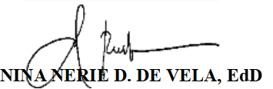
Research Editor/English Critic

Acknowledgement
First and foremost, the researchers thank Almighty God for the wisdom, strength, and perseverance that carried them through this capstone project.
The researchers sincerely thank their capstone teacher, Mr. Renz Jansen L. Crisostomo, and their capstone adviser, Ronaldo C. Arimbuyutan, MIT, for their guidance, patience, and valuable insights throughout the study. They also thank the members of the examining committee for their comments and suggestions that helped improve this work.
Sincere thanks are also given to the Parish Secretary and the parish priest of Saint Patrick Parish Office in Dingalan, Aurora, for opening the office to the researchers and for sharing how the parish records and requests are handled.
The researchers are grateful to the IT experts and the parishioners who gave their time to evaluate the system and to share their honest feedback.
Finally, the researchers thank their families for their love, support, and sacrifices, which made it possible to finish this study.

Dedication
This capstone project is dedicated to our families, whose support and sacrifices kept us going from the first day of this journey until its completion.
To our teachers and our adviser, thank you for your patience, guidance, and the knowledge you shared with us.
To the Saint Patrick Parish community in Dingalan, Aurora, we hope this work makes the parish office’s daily tasks lighter.
Above all, we dedicate this work to Almighty God, the source of our wisdom and strength.

Table of Contents
Title Page i
Approval Sheet ii
Joint Undertaking iii
Research Critic Certification iv
Acknowledgement v
Dedication vi
Table of Contents vii
List of Tables x
List of Figures xv
Abstract xv
Chapter I: THE PROBLEM AND ITS BACKGROUND
Introduction 1
Review of Related Literature 3
Synthesis 15
Research Paradigm 17
Statement of the Problem 18
Scope and Delimitation 21
Significance of the Study 22
Definition of Terms 23
Chapter II: RESEARCH METHODOLOGY
Research Design 26
Research Locale 27
Research Respondents 29
Sampling Technique 31
Research Instruments 31
Data Gathering Procedures 33
Data Analysis 35
Ethical Considerations 51
Chapter III: RESULTS AND DISCUSSION
1. Description of the Current Manual Record Management System 53
1.1 Organization and Record Retrieval of Documents 53
1.2 Tracking of Certificate Requests 54
1.3 Risk of Record Loss, Damage, or Duplication 55
2. Design and Development of the Schedule and Record System 55
2.1 Planning 56
2.2 Requirements Analysis 57
2.3 System Design 62
2.4 System Development 135
2.5 System Testing 136
2.6 Evaluation 137
3. Assessment on the Technical Features of the System Using the ISO/IEC 25010 Software Product Quality Standards 139
3.1 Functional Suitability 140
3.2 Performance Efficiency 141
3.3 Compatibility 142
3.4 Usability 144
3.5 Reliability 145
3.6 Security 147
3.7 Maintainability 148
3.8 Portability 150
3.9 Summary of the IT Experts’ Assessment 151
4. The Assessment on the Quality of Using the System Using the Selected ISO 25010 SQuaRE Standards 153
4.1 Functional Suitability 153
4.2 Usability 155
4.3 Security 159
4.4 Discussion 162
Chapter IV: SUMMARY, CONCLUSIONS, AND RECOMMENDATIONS
Summary 164
Conclusions 167
Recommendations 168
References 169
Appendices 175
A. Request Letter to Saint Patrick’s Parish Office 176
B. Request Letter to Capstone Project Adviser 177
C. IT Expert Evaluation Form 178
D. End-User Evaluation Form 187
E. User Manual 191
F. Curriculum Vitae 222

List of Tables
Table 1. Distribution of Respondents 30
Table 2. Scoring Rubrics for Functional Suitability 36
Table 3. Scoring Rubrics for Performance Efficiency 38
Table 4. Scoring Rubrics for Compatibility 39
Table 5. Scoring Rubrics for Usability 41
Table 6. Scoring Rubrics for Reliability 43
Table 7. Scoring Rubrics for Security 45
Table 8. Scoring Rubrics for Maintainability 47
Table 9. Scoring Rubrics for Portability 49
Table 10. Functional Requirements of the System 58
Table 11. Data Dictionary for users 69
Table 12. Data Dictionary for persons 71
Table 13. Data Dictionary for certificate_requests 72
Table 14. Data Dictionary for certificate_generation_log 75
Table 15. Data Dictionary for schedule_events 76
Table 16. Data Dictionary for announcements 77
Table 17. Data Dictionary for audit_logs 78
Table 18. Data Dictionary for baptismal_records 79
Table 19. Data Dictionary for baptismal_sponsors 83
Table 20. Data Dictionary for confirmation_records 83
Table 21. Data Dictionary for first_communion_records 87
Table 22. Data Dictionary for marriage_records 90
Table 23. Data Dictionary for marriage_witnesses 94
Table 24. Data Dictionary for baptismal_certificate_requests 94
Table 25. Data Dictionary for confirmation_certificate_requests 96
Table 26. Data Dictionary for first_communion_certificate_requests 98
Table 27. Data Dictionary for marriage_certificate_requests 99
Table 28. Data Dictionary for sacrament_applications 102
Table 29. Data Dictionary for baptismal_applications 103
Table 30. Data Dictionary for baptismal_application_godparents 106
Table 31. Data Dictionary for confirmation_applications 107
Table 32. Data Dictionary for first_communion_applications 110
Table 33. Data Dictionary for marriage_applications 112
Table 34. Data Dictionary for marriage_principal_sponsors 120
Table 35. Data Dictionary for sacrament_eligibility_settings 121
Table 36. Data Dictionary for correction_requests 122
Table 37. Data Dictionary for submission_rate_limits 123
Table 38. Data Dictionary for site_settings 124
Table 39. Data Dictionary for notifications 125
Table 40. Data Dictionary for email_delivery_log 126
Table 41. Data Dictionary for workflow_requirements 127
Table 42. Data Dictionary for password_reset_tokens 129
Table 43. Data Dictionary for srs_schema_migrations 130
Table 44. Summary of Automated Integration Tests 101
Table 45. Scale for the End-Users’ Assessment 138
Table 46. Result of the Assessment Made by IT Experts on the Functional Suitability of the System 140
Table 47. Result of the Assessment Made by IT Experts on the Performance Efficiency of the System 142
Table 48. Result of the Assessment Made by IT Experts on the Compatibility of the System 143
Table 49. Result of the Assessment Made by IT Experts on the Usability of the System 144
Table 50. Result of the Assessment Made by IT Experts on the Reliability of the System 146
Table 51. Result of the Assessment Made by IT Experts on the Security of the System 147
Table 52. Result of the Assessment Made by IT Experts on the Maintainability of the System 149
Table 53. Result of the Assessment Made by IT Experts on the Portability of the System 150
Table 54. Summary of the IT Experts’ Assessment by ISO/IEC 25010 Characteristic 151
Table 55. Result of the Assessment by End-Users on the Functionality of the System 154
Table 56. Result of the Assessment by End-Users on the Usability of the System 156
Table 57. Result of the Assessment by End-Users on the Security of the System 159
List of Figures
Figure 1. Research Paradigm of the Study 18
Figure 2. Agile Methodology 27
Figure 3. Satellite View of Saint Patrick’s Parish 28
Figure 4. Actual Photo of Saint Patrick’s Parish Office 29
Figure 5. Gantt Chart of the Study 57
Figure 6. Use Case Diagram of the System 62
Figure 7. Unnormalized Form of the Database 65
Figure 8. First Normal Form of the Database 66
Figure 9. Second Normal Form of the Database 67
Figure 10. Third Normal Form of the Database 68
Figure 11. Entity-Relationship Diagram of the System 69
Figure 12. Context Diagram (Level 0 Data Flow Diagram) 131
Figure 13. Level 1 Data Flow Diagram 132

Abstract
Saint Patrick Parish Office in Dingalan, Aurora recorded sacramental information in handwritten logbooks and processed certificate requests with pre-printed forms handled by a single parish secretary. Record retrieval was slow, certificate requests could not be tracked, and the only copies of the records were exposed to loss, damage, and duplication.
This study aimed to design and develop the Schedule and Record System of Saint Patrick’s Parish Office, a web-based system that improves how the parish manages its records, requests, and schedules. The researchers used a developmental research design and the Agile methodology, covering planning, requirements analysis, system design, system development, system testing, and evaluation.
Data were gathered through interviews and direct observation of the parish office. The system has a public interface for announcements, the parish calendar, certificate requests, sacrament applications, and request tracking, and an administrative module where the Parish Secretary processes requests, maintains a digital index of the sacramental registers, generates certificates, manages schedules and announcements, and views reports. It also has role-based access, an audit log, and database backup, while the physical logbooks remain the official record.
The system was evaluated by twenty (20) IT experts, the Parish Secretary, and fifty (50) parishioners using the ISO/IEC 25010 software quality model. The end-users rated the system Highly Functional (3.39), Highly Usable (3.39), and Highly Secured (3.34). The IT experts rated the system Acceptable, with an overall mean of 3.16, and found it suitable for use in the parish office.
The study concludes that the system offers the parish office a computerized alternative to its manual process of record keeping, request handling, and scheduling.
Keywords: parish management system, record management, schedule management, Agile methodology, ISO/IEC 25010.
Chapter I
THE PROBLEM AND ITS BACKGROUND
This chapter presents the background of the study, review of related literature and studies, research paradigm, statement of the problem, scope and delimitation, significance of the study, and definition of terms.

Introduction
The management of parish activities and records plays a vital role in maintaining organized and efficient operations within religious institutions. As parishes grow in membership and activities, the demand for accurate scheduling and reliable record-keeping systems becomes increasingly important. Across both religious and non-religious institutions, the shift from manual to digital systems has become a practical necessity as administrative workloads grow and expectations for faster, more reliable service delivery continue to rise. Parish offices in particular carry a wide range of administrative responsibilities including the maintenance of sacramental records, the scheduling of priests and pastoral events, and the processing of certificate requests that community members rely on for civil, educational, and legal purposes. As these responsibilities accumulate, manual record-keeping methods become increasingly difficult to sustain accurately and efficiently as parish communities continue to grow. Diabordo, Felicia, and Igloso (2026) similarly noted that manual reservation and record-keeping processes in parishes lead to scheduling conflicts, delays, and data loss, which a parish management system can reduce.
Saint Patrick Parish Office in Dingalan, Aurora currently manages all administrative responsibilities through handwritten logbooks and printed certificate templates handled by a single parish secretary. Sacramental information is recorded manually, certificate requests are processed using pre-printed forms, priest assignments are coordinated informally, and schedules with announcements are posted without a platform accessible to parishioners outside office hours. Parishioners requesting certificates must visit the office without prior knowledge of the secretary's availability, frequently resulting in wasted trips and processing delays.
To address these operational gaps, this study focuses on the design and development of a web-based Schedule and Record System for Saint Patrick Parish Office (SRS-SPPO). The system provides a public interface through which parishioners can view announcements, check Mass and priest schedules, and submit sacrament applications and certificate requests, each with a generated tracking number. On the administrative side, the Parish Secretary can manage priest schedules, process sacrament applications and certificate requests, and maintain a digital index of sacramental records for rapid retrieval, while the original handwritten logbooks remain the canonical record. Developed following the Agile methodology, the system is built through an iterative process to ensure it meets the specific functional and operational needs of Saint Patrick's Parish community.

Review of Related Literature and Studies
This section presents related literature and studies organized thematically to provide a strong theoretical and empirical foundation for the design and development of the web-based Schedule and Record System for Saint Patrick's Parish Office. The review draws from local Philippine studies on church digitization while incorporating relevant international practices and verified commercial systems.

Traditional Challenges in Parish Record Management
Manual record-keeping continues to be the dominant practice in many small parishes across the Philippines. These traditional methods are prone to numerous problems, including slow retrieval of sacramental records, difficulty in tracking certificate requests, high risk of physical document loss or damage due to poor storage conditions, informal priest scheduling practices, and overall inefficient service delivery. Libadia, Botangen, Lucero, and Tecson (2025) established that organizations relying on manual record-keeping frequently encounter challenges in information retrieval, accuracy, and service delivery, reinforcing the need for digital solutions. As parish membership grows, the single parish secretary often becomes overwhelmed, leading to data inconsistencies, duplication of entries, and diminished quality of service to parishioners. These persistent issues highlight the urgent need for digital solutions tailored to the realities of small parish offices.
Castro, Domingo, Giron, and Ignacio (2025) likewise examined how perceived organizational culture attributes relate to the efficiency of an electronic records management system in the public sector. Their work points to organizational factors, and not only the software itself, as part of what makes a records system effective, which is why the proposed system was shaped around the actual practices of the parish office.

Digitalization of Church and Sacramental Records
The transition from manual to digital systems has shown promising results in improving parish operations. Olipas, Sawit, and Esperon (2021) developed and assessed a Web-Based Church Records and Information Management System (CRIMS) for a Philippine parish. Their study found that digitizing baptismal, confirmation, first communion, and marriage records significantly improved efficiency, data organization, retrieval speed, and user satisfaction, earning a very satisfactory rating across multiple criteria. This research provides strong local evidence that digital solutions can effectively alleviate the burdens of manual record-keeping in parish settings and serves as a direct reference for the hybrid approach — digital index plus physical logbooks — adopted in the proposed system.

Parish Information Management Systems in the Philippines
Several dioceses have undertaken major digital transformation initiatives. Pulumbarit (2025) documented the Digitalization of Church Records Management System (DCRMS) of the Diocese of Malolos, which oversees 120 parishes across Bulacan Province and Valenzuela City. The project aimed to integrate sacramental records across all parishes, improve accessibility for parish secretaries and parishioners, and ensure compliance with data privacy regulations. The study highlights both the technical and organizational challenges of implementing church record systems at scale, and provides practical insights applicable to the proposed system at the parish level.
In a similar diocese-wide initiative, Barlis, Tan, Tanquerio, Llesol, and Intal (2020) developed a centralized Parish Record and Information Management System (PRIMS) to support the Strategic Information System Plan (SISP) of the Diocese of Cubao. Through interviews and observations, the researchers validated recurring issues in the diocese’s traditional record-keeping practices, including excessive time spent searching for information, difficulty generating reports, and the loss of valuable records. Applying an iterative development approach, they produced and simulated a working PRIMS prototype, demonstrating that a centralized, diocese-level information system can directly support long-term strategic planning while resolving the day-to-day inefficiencies parish offices commonly face. This study reinforces the relevance of centralized, diocese-scale digitalization efforts and further validates the iterative, feedback-driven development approach adopted for the proposed system.

Web-Based Church Management Systems
Numerous studies have developed web-based systems specifically addressing the administrative needs of churches and congregations. Tamu Ina, Rada, and Sitaniapessy (2024) developed a web-based congregation data management information system for the Sumba Christian Church using the Waterfall Development method, which addressed problems of manual data collection and physical ledger inefficiencies.
Arundaa, Mokalu, and Sintaro (2025) developed a church management information system for Syaloom Imandi Bolaang Mongondow using the Spiral Model, providing the church secretary with tools to manage worship schedules, congregation data, inventory, and announcements through a single web-based platform.
Simanjuntak, Maulana, and Widodo (2024) similarly implemented a web-based congregation data processing information system for HKBP Cikarang Kota using the Waterfall method, demonstrating that such systems can reduce data management time by up to 60% while significantly improving data accuracy.
Bernardino, Basilio, and Calaguas (2024) further developed E-Church, a web and mobile-based church management system for Holy Rosary Parish, which streamlined administrative tasks, event management, and parishioner engagement. At the international level, Siregar, Mayatopani, Olivia, and Kurniawan (2025) built a church information management system using the Scrum methodology at HKBP Sola Gratia Kayu Mas Jakarta, confirming that iterative development approaches produce systems well-aligned with church operational requirements.
Most recently, Diabordo, Felicia, and Igloso (2026) developed and evaluated a Church Management System for Saint Isidore Parish in Biabas, Ubay, Bohol, directly addressing the scheduling conflicts, delays, and data loss caused by manual reservation and record-keeping processes. Their system integrated online sacrament reservations, Basic Ecclesial Community (BEC) monitoring, and centralized record management within a single platform. Applying a user-centered design approach grounded in Integrated Marketing Communications, User-Centered Design, and Diffusion of Innovation theories, the researchers evaluated the system for usability, accessibility, and efficiency, finding significant improvements in record accuracy, reduced administrative workload, and enhanced parishioner satisfaction. This recent study offers a directly comparable model for combining online reservation and centralized record-keeping functions within a single parish platform, reinforcing the design direction of the proposed system.

Online Certificate Request and Document Tracking Systems
Online request systems have proven highly effective in both civil and ecclesiastical contexts. The Philippine Statistics Authority's Serbilis and PSAHelpline.ph platforms (2023) established a national benchmark by enabling citizens to request civil documents online with reference and tracking numbers. In the church domain, the Diocesan Catholic Records Management System allows online submission and tracking of baptismal, confirmation, marriage, and other sacramental certificates (Diocesan Catholic Records Management System, n.d.).
Taruc, Martin, Olipas, and Alegado (2023) further developed Docu-Go, a web-based barangay document requesting system evaluated using ISO 25010, which demonstrated that digital document request systems significantly improve accessibility and transparency for community members. These systems serve as strong models for the certificate request and tracking features of the proposed system.

Web-Based Scheduling and Calendar Systems for Parish Use
Effective scheduling is one of the most critical yet challenging aspects of parish administration. Diabordo, Felicia, and Igloso (2026) directly addressed the scheduling conflicts, delays, and data loss caused by manual reservation and record-keeping processes by integrating online sacrament reservations within a single centralized platform, while Arundaa, Mokalu, and Sintaro (2025) equipped the church secretary with tools to manage worship schedules, congregation data, and announcements through a single web-based platform. These studies demonstrate the value of accessible, centralized scheduling tools that reduce conflicts and provide real-time information to both staff and parishioners. The integration of such scheduling tools with public viewing access addresses parishioners' most common complaint about the lack of up-to-date schedule information. Because of this, the proposed system will include a public-facing calendar page where parishioners can view Mass schedules, sacrament reservations, and parish events online in real time, without needing to call or visit the parish office for updates.

Hybrid Record Management Approaches
A recurring best practice observed in successful church digitization projects is the adoption of a hybrid model. This approach maintains physical handwritten logbooks as the canonical and official records while developing a digital index for rapid search, retrieval, backup, and reporting purposes. Olipas, Sawit, and Esperon (2021) demonstrated the value of this hybrid approach in their Church Records and Information Management System, where digitizing baptismal, confirmation, first communion, and marriage records alongside the retained physical logbooks significantly improved efficiency, data organization, and retrieval speed while preserving institutional and canonical compliance. The proposed Schedule and Record System adopts this same balanced approach to ensure both canonical compliance and improved operational efficiency.

Usability and Accessibility for Non-Technical Users
Parish secretaries and parishioners often possess varying levels of digital literacy. Diabordo, Felicia, and Igloso (2026) applied a user-centered design approach in developing and evaluating their Church Management System, finding that designing interfaces and workflows around the actual needs of parish staff and parishioners led to significant improvements in usability, accessibility, and overall system efficiency. ISO/IEC 25010:2011 further specifies usability as a primary quality characteristic, encompassing learnability, operability, and user error protection. Local church system evaluations, including CRIMS (Olipas et al., 2021) and E-Church (Bernardino et al., 2024), reinforce that systems prioritizing ease of use achieve significantly higher adoption rates and user satisfaction.

System Development Using Agile Methodology
Siregar, Mayatopani, Olivia, and Kurniawan (2025) applied Scrum, an Agile development framework, in building a church information management system at HKBP Sola Gratia Kayu Mas Jakarta, confirming that iterative sprints and continuous review cycles make Agile particularly suitable for developing systems in dynamic environments such as small parishes, where requirements may evolve as users interact with early prototypes.
The Agile methodology has also been applied beyond church settings. Djutalov, Irham, Putra, Elistiawan, and Syah (2024) used it to build a web and mobile-based tracer study and career center application, and Houeninvo (2023) developed and evaluated the OSCA information management system for senior citizens using the Agile methodology. Serrador and Pinto (2015) analyzed the success of Agile projects quantitatively, and de Vicente Mohino, Bermejo Higuera, Bermejo Higuera, and Sicilia Montalvo (2019) proposed a secure software development life cycle that combines security activities with Agile methodologies. Together, these studies support the choice of Agile for the proposed system, whose requirements were refined with the Parish Secretary across iterations.
Software Quality Evaluation Using ISO/IEC 25010
The ISO/IEC 25010 standard (ISO/IEC 25010:2011, 2011) defines the product quality characteristics used in this study to evaluate the system. Taruc, Martin, Olipas, and Alegado (2023) evaluated Docu-Go with ISO 25010, Canlas, Piad, and Lagman (2022) used the standard to assess the software quality of a faculty research productivity monitoring and prediction system, and Houeninvo (2023) evaluated the OSCA information management system for ISO/IEC 25010 compliance. These studies show that the standard is an accepted basis for evaluating locally developed information systems, which supports its use in the IT experts' assessment of the proposed system.

Security and Data Privacy in Church Information Systems
Given the highly sensitive nature of sacramental and personal data, security and privacy are of utmost importance. Libadia, Botangen, Lucero, and Tecson (2025) emphasize that records management systems handling sensitive personal information must incorporate controlled access, accurate retrieval processes, and safeguards against loss or duplication to maintain the integrity and confidentiality of records. Compliance with the Data Privacy Act of 2012 (RA 10173), which is mandatory for any system handling parishioner information, is further reinforced by Pulumbarit (2025), whose diocese-wide digitalization initiative was specifically designed to ensure such compliance across all parishes it served. These security principles are fully integrated into the proposed system, which incorporates user authentication, activity logging, and access control to protect data integrity and maintain the trust of the parish community.

Synthesis
The reviewed studies and literature consistently point to the same conclusion: manual, paper-based processes in parish administration are no longer sufficient to meet the demands of modern religious institutions. Empirical studies conducted in local and international church settings demonstrate measurable gains in record accuracy, retrieval speed, and administrative efficiency once these processes are digitized, while diocese-wide initiatives show that this shift toward digital systems is being pursued not only by individual parishes but also by entire dioceses seeking centralized, standardized recordkeeping.
Meanwhile, the reviewed literature provides theoretical grounding for these findings, emphasizing that digital transformation works best when it does not fully abandon existing recordkeeping traditions but instead adopts a hybrid approach that preserves physical logbooks while introducing digital tools for speed and convenience. The literature further stresses that usability, iterative development, and compliance with data privacy standards are not optional additions but core requirements for any system expected to be adopted by non-technical parish staff and trusted by parishioners with sensitive personal information.
Together, these studies and literature converge on a central insight: web-based scheduling and record management systems are not simply a technological convenience but a necessary evolution for parish offices seeking to reduce administrative burden, protect sensitive sacramental data, and better serve their communities. They address the recurring challenges of manual, error-prone recordkeeping, draw on proven local and international development practices across varying methodologies, and align with the broader movement toward accountable, transparent, and accessible service delivery within religious institutions.

Research Paradigm
This section presents the research paradigm that guides the development of the proposed system. A research paradigm is a diagram that shows how the inputs, processes, and outputs of a study relate to one another, and it directs the research process and the formulation of the research questions. In this study, the paradigm illustrates the logical flow of the research by organizing the essential inputs required for system development, the processes undertaken to produce the system, and the expected outputs that address the operational challenges of Saint Patrick's Parish Office. The relationship between these components is further reinforced by a feedback loop that ensures continuous evaluation and refinement of the system. This study adopts the Input-Process-Output (IPO) Model as its research paradigm, as shown in Figure 1.

Figure 1
Research Paradigm of the Study

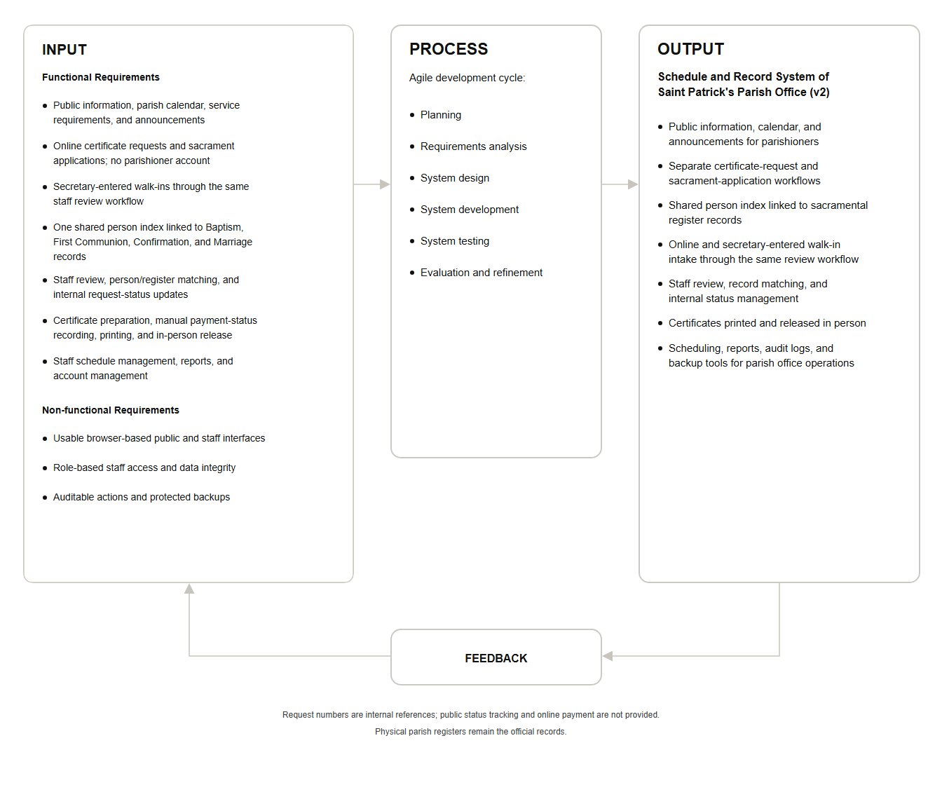

Statement of the Problem
The rapid growth of parishioners and the increasing demand for efficient parish services have highlighted the limitations of traditional manual record-keeping and scheduling practices at Saint Patrick Parish Office. These challenges necessitate the development of a digital solution to improve administrative efficiency, record accuracy, and service delivery to the community.

The general problem of this study is:
How may a web-based Schedule and Record System be designed and developed to address the manual record management and scheduling challenges at Saint Patrick Parish Office in Dingalan, Aurora?

Specifically, this study aims to answer the following questions:

1. How may the current manual record management system of Saint Patrick Parish Office be described in terms of:
1.1 organization and record retrieval of documents;
1.2 tracking of certificate requests; and
1.3 risk of record loss, damage, or duplication?

2. How may the proposed Schedule and Record System be developed based on the stages of the Agile Model which are:
2.1 Planning;
2.2 Requirements Analysis;
2.3 System Design;
2.4 System Development;
2.5 System Testing; and
2.6 Evaluation?

3. How may the IT experts evaluate the developed system following the ISO/IEC 25010 Software Quality Standards in terms of:
3.1 Functional Suitability;
3.2 Performance Efficiency;
3.3 Compatibility;
3.4 Usability;
3.5 Reliability;
3.6 Security;
3.7 Maintainability; and
3.8 Portability?

4. How may the end-users (Parish Secretary and Parishioners) assess the developed system in terms of:
4.1 Functionality;
4.2 Usability; and
4.3 Security?

Scope and Delimitation
This study focuses on the design and development of a web-based Schedule and Record System for Saint Patrick Parish Office in Dingalan, Aurora. The system aims to digitize and streamline the parish's manual record management and scheduling processes while preserving the integrity of traditional parish operations.

The scope of this study includes the development of a web-based system with two main interfaces: a public landing page accessible to parishioners and a secure administrative module for the Parish Secretary. The public interface allows parishioners to view announcements, Mass schedules, and office hours, submit sacrament applications, submit certificate requests, track the status of their requests, request corrections to issued certificates, and verify printed certificates. The administrative module enables the Parish Secretary to manage submitted sacrament applications, process certificate requests, generate sacramental certificates, print them for signing, maintain a digital index of sacramental records, and manage the priest's schedule through a calendar feature. The system also includes user authentication, role-based access, activity logging, reports, database backup, and certificate request tracking through tracking numbers. The system was developed using the Agile methodology and was evaluated using ISO/IEC 25010 standards.

This study is delimited to Saint Patrick Parish Office in Dingalan, Aurora only. The original handwritten logbooks shall remain the canonical and official records. Although the system can generate and print certificates, these printed documents must still be manually signed and sealed by the Parish Secretary. The study does not include financial management modules, online payment processing, SMS notifications, or a dedicated native mobile application. It is limited to browser-based access and does not cover implementation in other parishes.

Significance of the Study
This section presents the importance and potential benefits of the developed web-based Schedule and Record System to various stakeholders. This study is expected to contribute meaningfully to the improvement of parish administration, particularly in addressing the challenges posed by manual processes at Saint Patrick Parish Office.

Parish Secretary. The system will significantly reduce the workload of the Parish Secretary by providing an organized digital index of sacramental records, certificate generation and printing capabilities, and a calendar feature for managing the priest's schedule, and enhance administrative oversight and accountability through activity logging and better record organization.
Parishioners. The system will provide greater convenience by allowing them to view schedules and submit requests online, reducing unnecessary visits to the parish office.
Future Researchers. This study will serve as a reference for similar Agile-developed parish information systems.
Community. The local community will benefit from faster and more reliable access to essential sacramental documents.

Definition of Terms
The terms defined below are fundamental to understanding the concepts, technologies, and processes involved in the Design and Development of Schedule and Record System of Saint Patrick Parish Office.

Activity Logs. Records generated by the system that track user actions for audit trail and accountability purposes.
Agile Methodology. An iterative software development approach used in this study.
Calendar Feature. A tool in the administrative module that allows the Parish Secretary to manage the priest's Mass and activity schedules.
Certificate Request. A formal request submitted by a parishioner through the public interface.
Index. A searchable electronic database of sacramental records maintained by the Parish Secretary.
ISO/IEC 25010. An international standard that defines the product quality model used to evaluate software, composed of eight quality characteristics: functional suitability, performance efficiency, compatibility, usability, reliability, security, maintainability, and portability.
Landing Page. The public-facing page that displays announcements, schedules, and office hours accessible to parishioners.
Parish Secretary. The day-to-day operator and primary administrative user of the web-based Schedule and Record System.
Sacramental Records. The official entries of Baptism, Confirmation, First Communion, and Marriage kept in the parish’s physical logbooks and indexed in the system by book, page, and line number.
Tracking Number. A unique number issued to a parishioner upon submitting a certificate request or sacrament application, used together with the e-mail address recorded on the request to check its status.

Chapter II
RESEARCH METHODOLOGY
This chapter presents the research design, research locale, research respondents, sampling technique, research instruments, data gathering procedures, data analysis, and ethical considerations employed in the development and evaluation of the web-based Schedule and Record System for Saint Patrick Parish Office.

Research Design
This study employs a developmental research design aimed at designing, developing, testing, and evaluating a functional web-based information system to address the manual record management and scheduling challenges at Saint Patrick Parish Office. Developmental research is appropriate because the main goal is to create a working software solution that directly solves real operational problems identified in the parish.
The system was developed using the Agile Software Development Methodology. This approach supports iterative development, continuous feedback from the Parish Secretary, and incremental delivery of features. The system was built using PHP as the server-side scripting language, MySQL for the database, HTML, CSS, and JavaScript for the front-end, and Visual Studio Code as the primary development environment. This technology stack was chosen for its robustness, scalability, and suitability for web-based applications in a small parish setting.

Figure 2
Agile Methodology
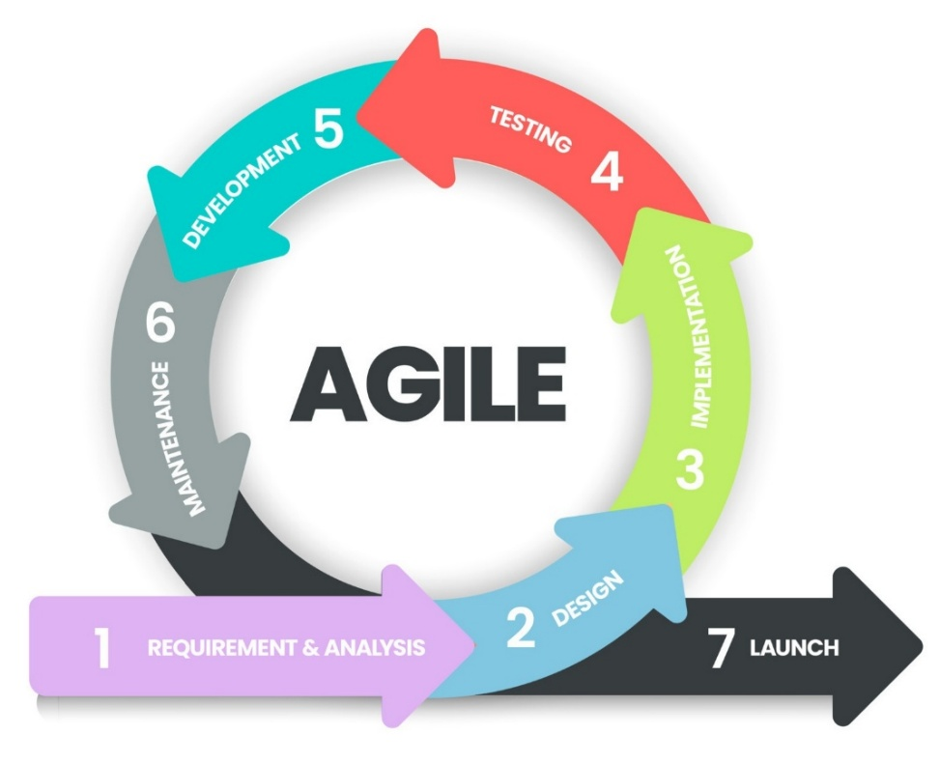

Research Locale
This study is conducted at Saint Patrick Parish Office located in the Municipality of Dingalan, Aurora. The parish serves the Catholic community in the municipality and currently relies on fully manual processes for sacramental record-keeping, certificate requests, and scheduling. Saint Patrick Parish is selected as the research locale because it represents a typical small parish office facing common administrative inefficiencies that can be effectively addressed through a web-based system.

Figure 3
Satellite View of Saint Patrick Parish
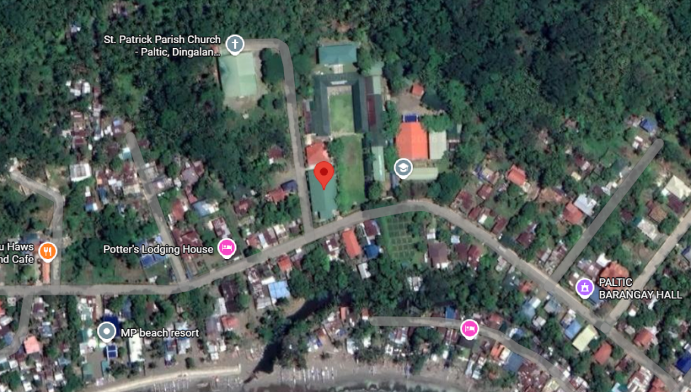

Figure 4
Actual Photo of Saint Patrick Parish Office
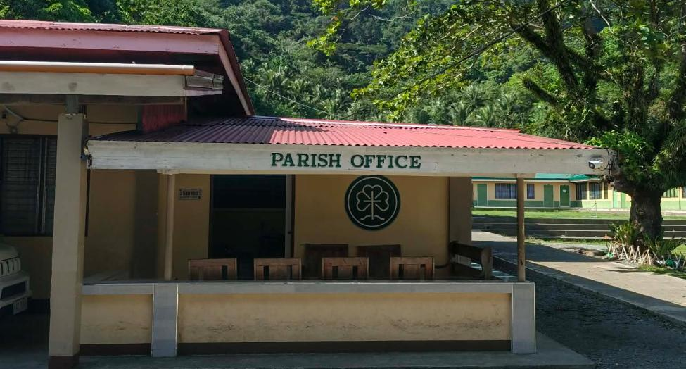

Research Respondents
The respondents of this study consisted of IT professionals who evaluated the technical aspects of the system and actual end-users who assessed its functionality, usability, and security. A total of seventy-one (71) respondents participated in the evaluation.
The first group consists of twenty (20) IT Experts who hold a degree in Information Technology or a related field. They evaluated the system based on the eight criteria of the ISO/IEC 25010 Software Quality Standards, namely functional suitability, performance efficiency, compatibility, usability, reliability, security, maintainability, and portability.

The second group is the Parish Secretary of Saint Patrick Parish, who serves as the primary administrator and end-user of the system. As the day-to-day operator of the system, the Parish Secretary evaluated the system in terms of functionality, usability, and security based on direct interaction with the developed system.

The third group consists of fifty (50) Parishioners of Saint Patrick's Parish who represent the public users of the system. They evaluated the system in terms of functionality, usability, and security, focusing on its public-facing features, including the sacrament application form, certificate request tracking, and schedule and announcement viewing.

Table 1
Distribution of Respondents

Respondents | Frequency | Percentage
IT Experts | 20 | 28.17%
End-Users | 51 | 71.83%
Parish Secretary | 1 | 1.41%
Parishioners | 50 | 70.42%
Total | 71 | 100%

As shown in Table 1, the total number of respondents is seventy-one (71), composed of twenty (20) IT Experts, one (1) Parish Secretary, and fifty (50) Parishioners. This composition ensures a comprehensive evaluation of the system from both technical and operational perspectives.

Sampling Technique
This study used total population sampling for the Parish Secretary, as there is only one secretary serving Saint Patrick Parish. For the IT Experts, random sampling was used to select twenty (20) individuals who hold a degree in Information Technology or a related field. For the Parishioners, random sampling was also applied to select fifty (50) individuals from the parish community who represent the public users of the system. This sampling approach ensures that the evaluation reflects a broad and unbiased assessment of the system's quality and usability.

Research Instruments
The primary instrument used in this study was a structured interview guide designed to collect, measure, and assess data relevant to the objectives of the research. The interview guide consists of a prepared set of questions administered to the respondents, accompanied by a rating form through which respondents provide numerical evaluations of the system based on specific criteria. In addition, semi-structured interviews and direct observation were used during the requirements analysis phase to document the existing manual processes of the parish office.
Two sets of instruments were used. The first is the interview guide and rating form for IT Experts, which is divided into eight (8) components based on the ISO/IEC 25010 Software Quality Standards: functional suitability, performance efficiency, compatibility, usability, reliability, security, maintainability, and portability. The second is the interview guide and rating form for end-users, composed of the Parish Secretary and Parishioners, which covers three (3) components: functionality, usability, and security.
All rating items used a four-point scale (4 – Strongly Agree, 3 – Agree, 2 – Disagree, and 1 – Strongly Disagree) to determine the level of agreement of the respondents. The instruments were validated prior to administration to ensure clarity, relevance, and reliability.

Data Gathering Procedures
The following phases formed the basis of the data gathering procedures of this study.

Phase I: Planning
The researchers coordinated with the Parish Secretary of Saint Patrick Parish to identify the project scope, objectives, and deliverables. The existing manual processes of the parish office were reviewed to establish the foundation for system development. Timelines and resource requirements were also defined during this phase.

Phase II: Requirements Analysis
The researchers conducted semi-structured interviews and direct observation of the existing manual record-keeping and scheduling processes at the parish office. The information gathered served as the basis for identifying the functional and non-functional requirements of the web-based Schedule and Record System.

Phase III: System Design
Based on the requirements gathered in Phase II, the researchers designed the system architecture, database structure, and user interface layout. The design accounted for both the administrative interface of the Parish Secretary and the public-facing interface accessible to parishioners.

Phase IV: System Development
The system was developed in iterative sprints following the Agile methodology. Core functionalities including sacrament application submission, sacramental record management, certificate request tracking, priest schedule management, Mass and event scheduling, and announcement posting were implemented and reviewed incrementally across development sprints.

Phase V: System Testing
The researchers conducted unit testing and integration testing to identify and correct system errors before the formal evaluation. All modules were tested to ensure that features operate correctly and that data is handled accurately. Feedback from this phase was used to refine the system prior to evaluation.

Phase VI: Evaluation
After system testing, the researchers sought authorization from the respondents before administering the interview guides and rating forms. The twenty (20) IT Experts evaluated the system using the ISO/IEC 25010-based instrument, while the Parish Secretary and fifty (50) Parishioners evaluated the system using the end-user instrument. All collected data were recorded and prepared for statistical analysis.

Data Analysis
Descriptive statistics were used to analyze the quantitative data gathered from the rating forms. The weighted mean was computed for each criterion to determine the overall evaluation rating of the developed system. For the IT Experts' evaluation, the eight (8) ISO/IEC 25010:2011 software quality characteristics were analyzed. The weighted mean was computed using the formula x̄ = Σ(fx) / N, where f is the frequency of each rating, x is the rating value, and N is the total number of respondents. The ratings of the Parish Secretary and the Parishioners were interpreted using the agreement scale presented as Table 45 in Chapter III.

The interpretation of results was guided by the following scale:

Table 2
Scoring Rubrics for Functional Suitability

Range | Qualitative Remarks | Verbal Description
3.26 – 4.00 | Highly Suitable | The system fully meets all functional requirements of the parish office. It accurately processes certificate requests, manages sacramental records, and performs all intended tasks with high completeness and correctness.
2.51 – 3.25 | Moderately Suitable | The system meets most functional requirements with satisfactory accuracy and completeness. Minor gaps or limitations may exist but do not significantly affect overall performance.
1.76 – 2.50 | Unsuitable | The system meets some functional requirements but with low accuracy and completeness. Notable deficiencies are present that affect its usefulness in the parish office context.
1.00 – 1.75 | Highly Unsuitable | The system fails to meet most or all functional requirements. Critical functions such as certificate processing or record management are deficient or non-operational.

As presented in Table 2 above, the scoring Rubrics is used to measure the functional suitability of the system in accurately fulfilling the sacramental record-keeping and certificate request requirements of the parish office.

Table 3
Scoring Rubrics for Performance Efficiency

Range | Qualitative Remarks | Verbal Description
3.26 – 4.00 | Excellent | The system performs exceptionally, meeting or exceeding all efficiency requirements. Users experience no delays or errors, and the system performs consistently well under all operating conditions within the parish environment.
2.51 – 3.25 | Good | The system performs adequately under most conditions. Occasional minor delays may occur but do not significantly impede the processing of certificate requests or retrieval of records.
1.76 – 2.50 | Fair | The system exhibits noticeable performance issues. Delays in processing or retrieving data are frequent enough to affect the efficiency of the parish secretary's workflow.
1.00 – 1.75 | Poor | The system consistently underperforms. Significant delays and resource inefficiencies render it inadequate for the operational demands of the parish office.

As presented in Table 3 above, the scoring Rubrics is used to measure the speed, resource utilization, and capacity of the system under normal parish office operating conditions.

Table 4
Scoring Rubrics for Compatibility

Range | Qualitative Remarks | Verbal Description
3.26 – 4.00 | Highly Compatible | The system operates seamlessly across different browsers, devices, and environments without conflict. It exchanges information and shares resources effectively with other systems used in the parish office.
2.51 – 3.25 | Moderately Compatible | The system works across most environments with minor compatibility issues. It can share information and coexist with other systems, though occasional adjustments may be needed.
1.76 – 2.50 | Slightly Compatible | The system experiences noticeable compatibility issues across certain browsers or devices. Information exchange with other systems may be inconsistent or require manual intervention.
1.00 – 1.75 | Not Compatible | The system fails to operate correctly in most environments. It cannot reliably share information or coexist with other systems, severely limiting its usability in the parish context.

As presented in Table 4 above, the scoring Rubrics is used to assess the degree to which the system can function alongside other software and across various devices and browsers used in the parish office.

Table 5
Scoring Rubrics for Usability

Range | Qualitative Remarks | Verbal Description
3.26 – 4.00 | Highly Usable | The system is intuitive and easy to navigate for all users, including the Parish Secretary and Parishioners. Users can efficiently accomplish tasks such as submitting certificate requests and accessing records with minimal effort or guidance.
2.51 – 3.25 | Moderately Usable | The system is generally easy to use, though some users may require occasional assistance. Most tasks can be completed without significant difficulty, and the interface is reasonably clear.
1.76 – 2.50 | Slightly Usable | The system presents usability challenges that require users to seek help frequently. The interface may be confusing or inconsistent, resulting in errors or inefficiencies during use.
1.00 – 1.75 | Not Usable | The system is difficult to use and causes significant user frustration. Users are unable to accomplish basic tasks without extensive assistance, rendering it impractical for parish operations.

As presented in Table 5 above, the scoring Rubrics is used to evaluate the ease with which the Parish Secretary and Parishioners can interact with the system to accomplish their intended tasks.

Table 6
Scoring Rubrics for Reliability

Range | Qualitative Remarks | Verbal Description
3.26 – 4.00 | Highly Reliable | The system consistently delivers accurate results with a low probability of failure. It operates without interruptions and can be depended upon to correctly process certificate requests and maintain sacramental records over time.
2.51 – 3.25 | Moderately Reliable | The system usually works correctly but occasional errors or interruptions may occur. Its overall reliability is acceptable and does not significantly hinder parish operations.
1.76 – 2.50 | Slightly Reliable | The system is prone to errors and occasional failures. Its reliability is questionable, and users may experience disruptions when performing critical functions.
1.00 – 1.75 | Not Reliable | The system consistently delivers inaccurate results and has a high probability of failure. It is unreliable, inconsistent, and cannot be trusted for managing sensitive sacramental records.

As presented in Table 6 above, the scoring Rubrics is used to determine the ability of the system to carry out its tasks without interruptions or failures over a defined period of operation.

Table 7
Scoring Rubrics for Security

Range | Qualitative Remarks | Verbal Description
3.26 – 4.00 | Strong Security | The system has multiple robust security measures providing comprehensive protection against unauthorized access, data breaches, and other threats. Sensitive sacramental records and user data are fully safeguarded.
2.51 – 3.25 | Moderate Security | The system has adequate security controls that protect most data and functions. Minor vulnerabilities may exist but do not pose significant risks to the integrity of sacramental records or user information.
1.76 – 2.50 | Weak Security | The system has limited security features that leave data and records at risk. Gaps in access control or data protection may expose the system to unauthorized access or data loss.
1.00 – 1.75 | No Security | The system lacks sufficient security measures. It is highly vulnerable to unauthorized access and data breaches, making it unsafe for storing confidential sacramental records and personal information.

As presented in Table 7 above, the scoring Rubrics is used to assess the capacity of the system to protect sacramental data and user information against unauthorized access and security threats.

Table 8
Scoring Rubrics for Maintainability

Range | Qualitative Remarks | Verbal Description
3.26 – 4.00 | Highly Maintainable | The system is well-structured and easy to modify, update, and extend. Errors can be identified and corrected quickly, and enhancements can be implemented without disrupting existing parish office operations.
2.51 – 3.25 | Moderately Maintainable | The system can be maintained with reasonable effort. Most modifications and corrections can be made without significant complications, though some areas may require extra attention.
1.76 – 2.50 | Slightly Maintainable | The system is difficult to maintain in certain areas. Modifications and error corrections require considerable effort, and changes may introduce new issues or affect system stability.
1.00 – 1.75 | Not Maintainable | The system is poorly structured and extremely difficult to maintain. Any modification risks system failure, and it cannot be efficiently updated to meet the evolving needs of the parish office.

As presented in Table 8 above, the scoring Rubrics is used to assess the ease with which the system can be modified, corrected, and updated by designated maintainers over its operational life.

Table 9
Scoring Rubrics for Portability

Range | Qualitative Remarks | Verbal Description
3.26 – 4.00 | Highly Portable | The system can be easily transferred and deployed across different environments, operating systems, and hardware configurations. It adapts well to changes without requiring significant rework.
2.51 – 3.25 | Moderately Portable | The system can be transferred to different environments with minor adjustments. It functions adequately across most configurations commonly used in parish office settings.
1.76 – 2.50 | Slightly Portable | The system requires significant effort to migrate to different environments. Compatibility issues arise frequently, limiting its flexibility for deployment in varying technical setups.
1.00 – 1.75 | Not Portable | The system cannot be transferred or deployed to different environments without major rework. It is tightly bound to its original configuration and cannot adapt to change.

As presented in Table 9 above, the scoring Rubrics is used to evaluate the ability of the system to be effectively installed and operated across different hardware and software environments.

Ethical Considerations
This study adhered to the provisions of the Data Privacy Act of 2012 (Republic Act No. 10173). Informed consent was secured from all participants prior to the conduct of interviews and administration of survey rating forms. Respondents were fully informed about the purpose of the study, the procedures involved, and their right to withdraw at any time without any penalty. They were assured of the confidentiality and anonymity of their responses. All personal data collected were used solely for academic purposes and were securely stored with restricted access.

Furthermore, the researchers maintained academic integrity throughout the study by properly acknowledging all referenced works, avoiding plagiarism, and reporting all findings accurately and objectively. The development and evaluation of the system were conducted with due respect to the privacy of the Parish Secretary and the parishioners whose data may be involved in the system.
Chapter III
RESULTS AND DISCUSSION
This chapter presents the results drawn from the gathered data. The findings are organized according to the statement of the problem: the description of the current manual system, the design and development of the Schedule and Record System of Saint Patrick Parish Office (SRS-SPPO), the assessment of IT experts based on ISO/IEC 25010, and the assessment of the end-users.
- Description of the Current Manual Record Management System
The first problem of the study sought to describe how records and requests were handled at Saint Patrick Parish Office in Dingalan, Aurora before the system was developed. The description is based on the interviews and direct observation conducted with the Parish Secretary during the requirements analysis phase, and it focuses on three areas: organization and retrieval of documents, tracking of certificate requests, and the risk of record loss, damage, or duplication.
  - Organization and Record Retrieval of Documents
All sacramental information at the parish office was recorded by hand in physical logbooks (registers) for Baptism, Confirmation, First Communion, and Marriage. A single parish secretary was responsible for entering, safekeeping, and searching these entries. Because the logbooks are organized by book, page, and line number and not by name or date of request, locating one entry required leafing through the pages of one or more volumes. Retrieval time therefore grew as the number of entries grew, and it depended on how well the secretary remembered the approximate year of the sacrament. According to the Parish Secretary, retrieving a single record could take up to one week during peak periods.

1.2 Tracking of Certificate Requests
Certificate requests were handled using pre-printed forms filled out at the office. Parishioners had no way to learn whether the secretary was available, so they had to visit the office without prior notice, which often resulted in wasted trips. Once a form was submitted, no reference number was issued and no channel existed for the parishioner to check the status of the request. Schedules, announcements, and priest assignments were coordinated informally and were posted without any platform that parishioners could view outside office hours. Staff had no consolidated list of pending, processed, and released certificates other than the stack of submitted forms.

1.3 Risk of Record Loss, Damage, or Duplication
Because the handwritten logbooks and printed templates were the only copies, they were exposed to loss, wear, moisture, and other storage hazards, and they had no backup. Manual re-copying of entries onto certificates created room for transcription errors, and the same person could be recorded more than once under slightly different spellings across the four sacramental registers. No activity trail showed who entered or changed a record. These conditions are consistent with the problems reported in the reviewed literature on manual parish record-keeping (Libadia et al., 2025; Barlis et al., 2020) and confirm the need for a digital index that keeps the logbooks as the official record.

2. Design and Development of the Schedule and Record System
The system was designed and developed following the stages of the Agile model: planning, requirements analysis, system design, system development, system testing, and evaluation. Development proceeded in iterations, with the Parish Secretary reviewing working features and the researchers refining them in the next cycle. This is reflected in the database, which evolved through more than thirty incremental migration scripts as requirements were clarified.
These stages correspond to the phases of the Agile development life cycle as follows: planning corresponds to conception; requirements analysis and system design correspond to inception; system development, carried out in iterations, corresponds to iteration; and system testing corresponds to testing. The evaluation by the respondents then served as the acceptance check on the working system.

2.1 Planning
During planning, the researchers met with the Parish Secretary to define the project scope, objectives, and deliverables, and reviewed the existing manual processes. A Gantt chart (Figure 5) was used to schedule the work. As shown, planning was carried out in January, system design from February to April, development from March to October, and testing from October to November. The deployment and review activities were left unscheduled in the chart pending the results of testing and evaluation.

Figure 5
Gantt Chart of the Study
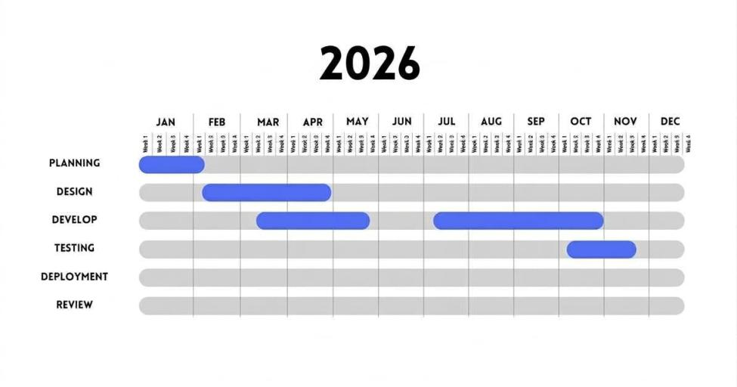

2.2 Requirements Analysis
Requirements were gathered through semi-structured interviews and direct observation of the parish office workflow. One staff role and one public role were identified. The Parish Secretary is the day-to-day operator. Parishioners are public users who do not log in; they identify themselves by a tracking number and the e-mail address recorded on their request.
The functional requirements derived from these interviews are summarized in Table 10.

Table 10
Functional Requirements of the System

No. | Requirement | Description
FR-1 | Public information | Parishioners can view announcements, the parish calendar of Masses and events, office hours, and documentary requirements without logging in.
FR-2 | Online certificate request | Parishioners can submit baptismal, confirmation, first communion, and marriage certificate requests and receive a tracking number.
FR-3 | Online sacrament application | Parishioners can submit pre-applications for Baptism, Confirmation, First Communion, and Marriage; submissions are not official records until verified in person.
FR-4 | Request tracking | Parishioners can check the status of a request using the tracking number and e-mail address.
FR-5 | Request processing | The secretary reviews queues, records requirement checks and payment status by hand (no amounts stored), and encodes walk-in requests and applications.
FR-6 | Sacramental record index | The secretary maintains a searchable digital index of the four sacramental registers, keeping the book, page, and line numbers of the physical logbooks.
FR-7 | Certificate generation | The system generates a print-ready certificate from the matched record, logs printing and release, and supports a verification code or QR on the printed copy.
FR-8 | Schedule and announcements | The secretary manages Mass and event schedules, detects booking conflicts, and publishes announcements.
FR-9 | Correction requests | Parishioners can report an error on an issued certificate, and the secretary processes the correction.
FR-10 | Security and accountability | Staff authentication, role-based access, activity (audit) logging, password recovery, and database backup.
FR-11 | Reports | The secretary can view monthly and yearly summaries of requests and records.

The non-functional requirements include browser-based access without installation, protection of personal data in line with the Data Privacy Act of 2012 (RA 10173), ease of use for staff with limited digital literacy, and the ability to run on a low-cost local server using XAMPP.
The use case diagram in Figure 6 shows how the two user groups interact with the public interface and the administrative module.

Figure 6
Use Case Diagram of the System
Schedule and Record System of
Saint Patrick's Parish Office
Log In
Manage User Account
Encode Sacramental Records
Process Certificate Request
Verify Records
Process Sacrament Application
Process Correction Request
Manage Schedule and Calendar
Post Public Announcements
View Audit Logs
Generate Reports
Submit Certificate Request
Submit Sacrament Application
Request Correction
Track Request Status
View Announcements and Schedule
Parishioner
(no account)
Parish
Secretary
(also System
Administrator)

2.3 System Design
The system follows a three-tier web architecture. Users access the system through a web browser. The presentation and application logic are written in PHP, HTML, CSS, and JavaScript and are served by Apache, and all data are stored in a MySQL/MariaDB database. The public interface and the administrative module share the same database but are separated by folders and by an authentication guard that protects every administrative page.

Database Normalization
The database was normalized up to the Third Normal Form (3NF) to reduce redundancy and protect data integrity. In the First Normal Form, repeating groups were removed by moving them into their own tables; for example, godparents and sponsors are stored in baptismal_sponsors and baptismal_application_godparents, and wedding witnesses and principal sponsors are stored in marriage_witnesses and marriage_principal_sponsors, instead of being squeezed into repeated columns of one record. In the Second Normal Form, partial dependencies were removed so that every non-key attribute depends on the whole primary key: shared request details (tracking number, channel, status, payment mark, processing staff) are kept in certificate_requests and sacrament_applications, while sacrament-specific details are placed in one extension table for each sacrament. In the Third Normal Form, transitive dependencies were removed by storing identity details of people once in the persons table and referencing them by person_id from the register tables, and by storing staff details once in users and referencing them by foreign key in fields such as processed_by, encoded_by, generated_by, and posted_by.
Figures 7 to 10 show the normalization of the core entities of the system in simplified form. The table names in these figures are conceptual; the implemented tables are described in the data dictionary (Tables 11 to 43).
Figure 7
Unnormalized Form of the Database
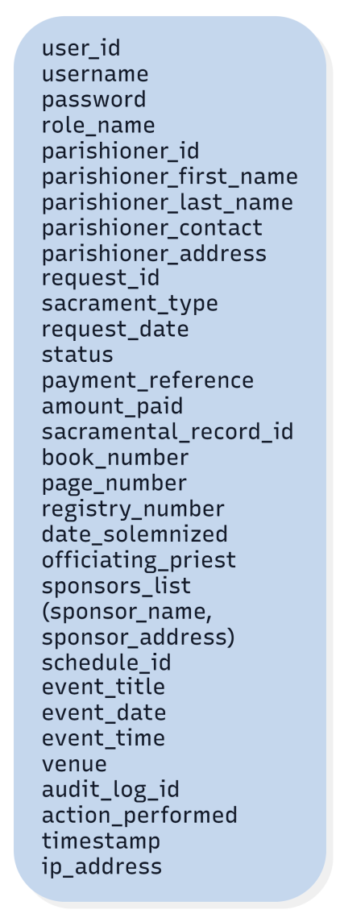
Figure 7 shows the unnormalized form, in which the staff account, parishioner, request, sacramental record, sponsor, schedule, and audit log attributes are held in one flat structure. Sponsors appear as a repeating list inside the record, and parishioner details would be repeated in every request, which causes redundancy and update anomalies.
Figure 8
First Normal Form of the Database
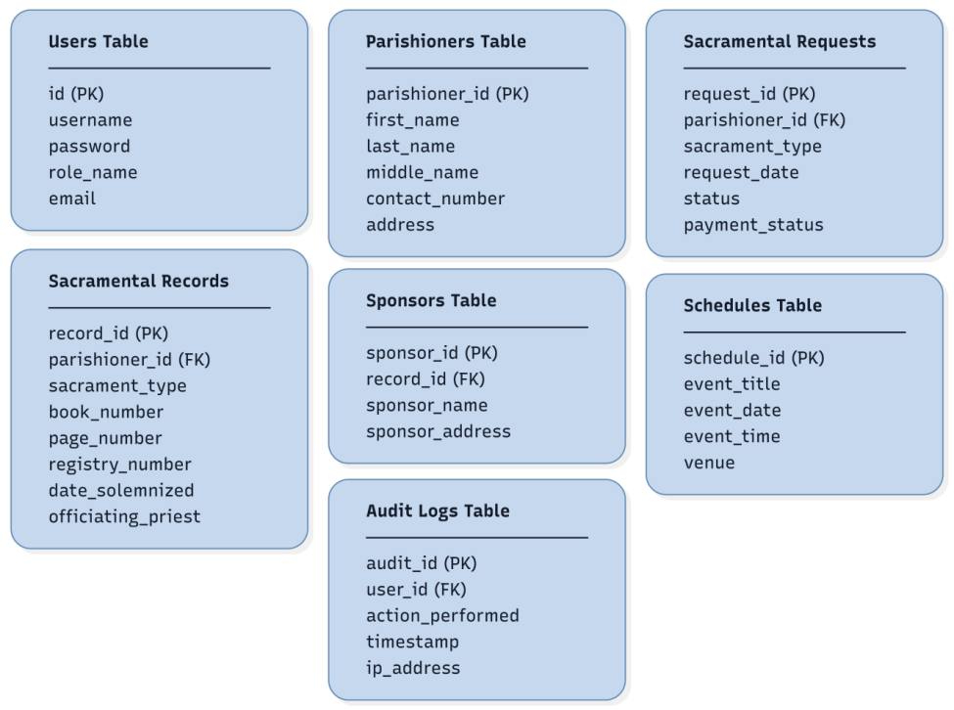
Figure 8 shows the first normal form. The repeating group of sponsors was moved to its own table, and the flat structure was divided into seven tables (Users, Parishioners, Sacramental Requests, Sacramental Records, Sponsors, Schedules, and Audit Logs), each with a primary key and atomic values.
Figure 9
Second Normal Form of the Database
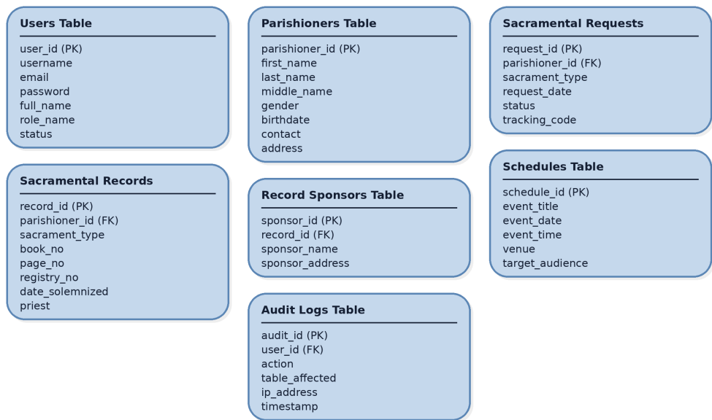
Figure 9 shows the second normal form. Every table uses a single-column primary key, so no attribute depends on only part of a key, and each non-key attribute depends on the whole key of its table. Keys were also standardized and descriptive attributes such as tracking_code were completed.
Figure 10
Third Normal Form of the Database
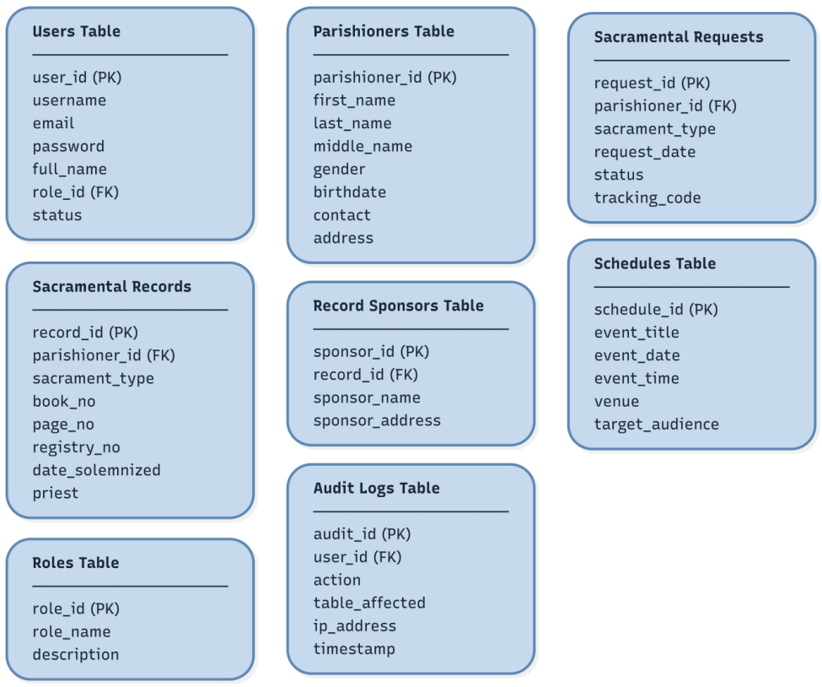
Figure 10 shows the third normal form. The transitive dependency of the role on the user account was removed by moving roles into a separate Roles table referenced by role_id, so that no non-key attribute depends on another non-key attribute.

Entity-Relationship Diagram
Figure 11 shows the main entities of the system and their relationships. For readability, the four register tables, the certificate request extension tables, and the application extension tables are each grouped into one box, and supporting tables such as notifications, e-mail delivery log, and workflow requirements are omitted.

Figure 11
Entity-Relationship Diagram of the System
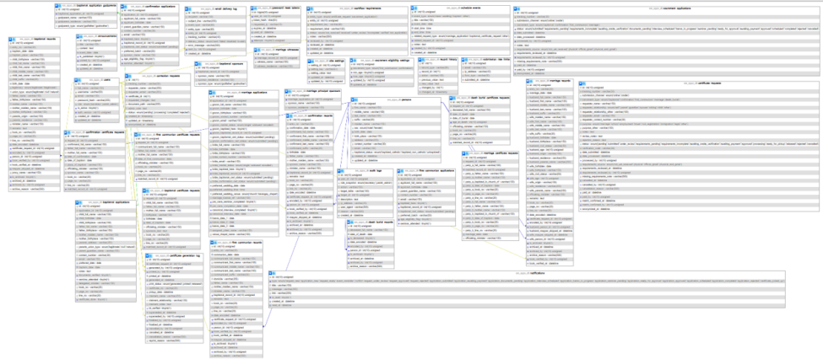

Data Dictionary
The data dictionary below describes all the tables of the database. Table 11 to Table 43 list the field name, data type, and description of the fields.

Table 11
Data Dictionary for users

Field Name | Data Type | Description
id | INT, Primary Key | Unique identifier of the staff account.
full_name | VARCHAR(150) | Full name of the staff member.
username | VARCHAR(50), Unique | Username used to log in.
email | VARCHAR(150), Unique | E-mail address used for password recovery.
password_hash | VARCHAR(255) | Hashed password; the plain password is never stored.
role | ENUM | Account role: secretary.
is_active | TINYINT(1) | Whether the account can log in.
auth_version | INT | Counter that invalidates other sessions after a password reset.
created_at / updated_at | DATETIME | Date and time the account was created and last changed.

Table 12
Data Dictionary for persons

Field Name | Data Type | Description
id | INT, Primary Key | Unique identifier of the person.
first_name, middle_name, last_name, suffix | VARCHAR | Structured name of the person.
maiden_name | VARCHAR(150) | Maiden name, where applicable.
sex | ENUM | Male or female.
birth_date, birth_place | DATE, VARCHAR(150) | Date and place of birth.
address, contact_number, email | VARCHAR | Contact details of the person.
baptismal_status | ENUM | Baptized Catholic, baptized non-Catholic, or unbaptized.

Table 13
Data Dictionary for certificate_requests

Field Name | Data Type | Description
id | INT, Primary Key | Unique identifier of the request.
tracking_number | VARCHAR(30), Unique | Number given to the requester for status tracking.
submission_channel | ENUM | online (public form) or onsite (walk-in encoded by staff).
sacrament_type | ENUM | Baptismal, confirmation, first communion, or marriage.
requester_name, requester_relationship | VARCHAR, ENUM | Who is requesting and their relationship to the person on the record.
requester_email, requester_contact_number | VARCHAR | Contact details used for tracking and notifications.
purpose | VARCHAR(40) | Reason for requesting the certificate.
status | ENUM | Current stage of the request in the office workflow.
date_submitted, date_processed | DATETIME | When the request was submitted and processed.
verification_code | VARCHAR(64), Unique | Code used to verify a printed certificate.
processed_by | INT, Foreign Key | Staff member who processed the request (users.id).
paid_at, paid_by | DATETIME, INT | Manual record that payment was received outside the system; no amount is stored.

Table 14
Data Dictionary for certificate_generation_log

Field Name | Data Type | Description
id | INT, Primary Key | Unique identifier of the log entry.
certificate_request_id | INT, Foreign Key | Request the certificate was generated for.
generated_by, printed_by | INT, Foreign Key | Staff who generated and who confirmed printing.
generated_at, printed_at | DATETIME | When the certificate was generated and printed.
print_status | ENUM | generated, printed, or released.
pickup_date | DATETIME | Date the certificate was picked up.
claimant_name, claimant_relationship | VARCHAR | Person who claimed the certificate and their relationship.
id_verified | TINYINT(1) | Whether a valid ID was checked in person at release.
superseded_at, superseded_by | DATETIME, INT | Set when a newer regeneration replaces this entry.

Table 15
Data Dictionary for schedule_events

Field Name | Data Type | Description
id | INT, Primary Key | Unique identifier of the event.
event_type | ENUM | Mass, wedding, baptism, or other.
title | VARCHAR(150) | Title of the event.
event_date | DATE | Date of the event.
start_time, end_time | TIME | Start and end time, used to detect booking conflicts.
notes | TEXT | Additional details.
created_by | INT, Foreign Key | Staff member who created the event.

Table 16
Data Dictionary for announcements

Field Name | Data Type | Description
id | INT, Primary Key | Unique identifier of the announcement.
title, content | VARCHAR(150), TEXT | Heading and body of the announcement.
event_date | DATE | Related event date, if any.
is_published | TINYINT(1) | Whether the announcement is visible on the public page.
posted_by | INT, Foreign Key | Staff member who posted it.
created_at, updated_at | DATETIME | When it was created and last edited.

Table 17
Data Dictionary for audit_logs

Field Name | Data Type | Description
id | INT, Primary Key | Unique identifier of the log entry.
user_id | INT, Foreign Key | Staff member who performed the action.
role_snapshot | ENUM | Role of the user at the time of the action.
action | VARCHAR(150) | Action performed.
target_table, target_id | VARCHAR, INT | Table and row affected.
description, reason | TEXT, VARCHAR | Details and stated reason for the action.
ip_address, user_agent | VARCHAR | Origin of the request.
created_at | DATETIME | Date and time of the action.
Table 18
Data Dictionary for baptismal_records

Field Name | Data Type | Description
id | INT, Primary Key | Unique identifier of the record.
entry_no | VARCHAR(20) | Entry number in the physical register.
baptism_date | DATE | Baptism date.
baptism_place | VARCHAR(150) | Baptism place.
child_birthplace | VARCHAR(150) | Child's birthplace.
child_full_name | VARCHAR(150) | Full name of the child.
child_first_name | VARCHAR(100) | Child's first name.
child_middle_name | VARCHAR(100) | Child's middle name.
child_last_name | VARCHAR(100) | Child's last name.
child_suffix | VARCHAR(20) | Child's suffix.
birth_date | DATE | Date of birth.
legitimacy | ENUM | Legitimacy status stated in the register (legitimate, illegitimate).
union_type | ENUM | Type of union of the parents (legitimate, civil, natural).
father_name | VARCHAR(150) | Father's name.
father_birthplace | VARCHAR(150) | Father's birthplace.
mother_name | VARCHAR(150) | Mother's name.
mother_maiden_name | VARCHAR(150) | Mother's maiden name.
mother_birthplace | VARCHAR(150) | Mother's birthplace.
parents_origin | VARCHAR(150) | Place of origin of the parents.
parents_residence | VARCHAR(150) | Residence of the parents.
minister_name | VARCHAR(150) | Name of the officiating minister.
proxy_name | VARCHAR(150) | Name of the proxy, if any.
remarks | TEXT | Remarks written in the register.
book_no | VARCHAR(20) | Book number of the physical register.
page_no | VARCHAR(20) | Page number in the physical register.
line_no | VARCHAR(20) | Line number on the register page.
date_encoded | DATETIME | Date and time the entry was encoded.
encoded_by | INT, Foreign Key | Staff member who encoded the entry.
certificate_request_id | INT | Certificate request that led to this entry, if any.
person_id | INT | Person in the shared identity index linked to this entry.
mapper_skipped_at | DATETIME | Date and time the Person Mapper step was skipped.
book_verified_by | INT, Foreign Key | Staff member who verified the entry against the logbook.
book_verified_at | DATETIME | Date and time of the logbook verification.

Table 19
Data Dictionary for baptismal_sponsors

Field Name | Data Type | Description
id | INT, Primary Key | Unique identifier of the record.
baptismal_record_id | INT, Foreign Key | Baptismal register entry of the sponsor.
sponsor_name | VARCHAR(150) | Name of the sponsor.
sponsor_residence | VARCHAR(150) | Residence of the sponsor.
sponsor_type | ENUM | Role of the sponsor (godfather, godmother).

Table 20
Data Dictionary for confirmation_records

Field Name | Data Type | Description
id | INT, Primary Key | Unique identifier of the record.
entry_no | VARCHAR(20) | Entry number in the physical register.
confirmation_date | DATE | Confirmation date.
confirmand_full_name | VARCHAR(150) | Confirmand's full name.
confirmand_first_name | VARCHAR(100) | Confirmand's first name.
confirmand_middle_name | VARCHAR(100) | Confirmand's middle name.
confirmand_last_name | VARCHAR(100) | Confirmand's last name.
confirmand_suffix | VARCHAR(20) | Confirmand's suffix.
birthdate | DATE | Date of birth.
birthdate_not_recorded | TINYINT(1) | Whether the birth date is not recorded in the register.
father_name | VARCHAR(150) | Father's name.
father_name_not_recorded | TINYINT(1) | Whether the father's name is not recorded.
mother_maiden_name | VARCHAR(150) | Mother's maiden name.
mother_maiden_name_not_recorded | TINYINT(1) | Whether the mother's maiden name is not recorded.
sponsor_name | VARCHAR(150) | Name of the confirmation sponsor.
minister_name | VARCHAR(150) | Name of the officiating minister.
baptismal_record_id | INT, Foreign Key | Linked baptismal register entry.
remarks | TEXT | Remarks written in the register.
book_no | VARCHAR(20) | Book number of the physical register.
page_no | VARCHAR(20) | Page number in the physical register.
line_no | VARCHAR(20) | Line number on the register page.
date_encoded | DATETIME | Date and time the entry was encoded.
encoded_by | INT, Foreign Key | Staff member who encoded the entry.
certificate_request_id | INT | Certificate request that led to this entry, if any.
person_id | INT | Person in the shared identity index linked to this entry.
mapper_skipped_at | DATETIME | Date and time the Person Mapper step was skipped.
book_verified_by | INT, Foreign Key | Staff member who verified the entry against the logbook.
book_verified_at | DATETIME | Date and time of the logbook verification.

Table 21
Data Dictionary for first_communion_records

Field Name | Data Type | Description
id | INT, Primary Key | Unique identifier of the record.
entry_no | VARCHAR(20) | Entry number in the physical register.
communion_date | DATE | Communion date.
communicant_full_name | VARCHAR(150) | Communicant's full name.
communicant_first_name | VARCHAR(100) | Communicant's first name.
communicant_middle_name | VARCHAR(100) | Communicant's middle name.
communicant_last_name | VARCHAR(100) | Communicant's last name.
communicant_suffix | VARCHAR(20) | Communicant's suffix.
domicile | VARCHAR(255) | Residence of the communicant.
father_name | VARCHAR(150) | Father's name.
mother_maiden_name | VARCHAR(150) | Mother's maiden name.
minister_name | VARCHAR(150) | Name of the officiating minister.
baptismal_record_id | INT, Foreign Key | Linked baptismal register entry.
remarks | TEXT | Remarks written in the register.
book_no | VARCHAR(20) | Book number of the physical register.
page_no | VARCHAR(20) | Page number in the physical register.
line_no | VARCHAR(20) | Line number on the register page.
date_encoded | DATETIME | Date and time the entry was encoded.
encoded_by | INT, Foreign Key | Staff member who encoded the entry.
certificate_request_id | INT | Certificate request that led to this entry, if any.
person_id | INT | Person in the shared identity index linked to this entry.
mapper_skipped_at | DATETIME | Date and time the Person Mapper step was skipped.
book_verified_by | INT, Foreign Key | Staff member who verified the entry against the logbook.
book_verified_at | DATETIME | Date and time of the logbook verification.

Table 22
Data Dictionary for marriage_records

Field Name | Data Type | Description
id | INT, Primary Key | Unique identifier of the record.
entry_no | VARCHAR(20) | Entry number in the physical register.
marriage_date | DATE | Marriage date.
husband_full_name | VARCHAR(150) | Husband's full name.
husband_first_name | VARCHAR(100) | Husband's first name.
husband_middle_name | VARCHAR(100) | Husband's middle name.
husband_last_name | VARCHAR(100) | Husband's last name.
husband_suffix | VARCHAR(20) | Husband's suffix.
wife_maiden_name | VARCHAR(150) | Wife's maiden name.
wife_first_name | VARCHAR(100) | Wife's first name.
wife_middle_name | VARCHAR(100) | Wife's middle name.
wife_last_name | VARCHAR(100) | Wife's last name.
wife_suffix | VARCHAR(20) | Wife's suffix.
husband_birthdate | DATE | Husband's birthdate.
husband_birthplace | VARCHAR(150) | Husband's birthplace.
husband_civil_status | VARCHAR(50) | Husband's civil status.
husband_age | INT | Husband's age.
husband_origin | VARCHAR(150) | Husband's origin.
husband_residence | VARCHAR(255) | Husband's residence.
husband_parents_name | VARCHAR(255) | Husband's parents name.
wife_birthdate | DATE | Wife's birthdate.
wife_birthplace | VARCHAR(150) | Wife's birthplace.
wife_civil_status | VARCHAR(50) | Wife's civil status.
wife_age | INT | Wife's age.
wife_origin | VARCHAR(150) | Wife's origin.
wife_residence | VARCHAR(255) | Wife's residence.
wife_parents_name | VARCHAR(255) | Wife's parents name.
officiating_minister | VARCHAR(150) | Name of the officiating minister.
remarks | TEXT | Remarks written in the register.
book_no | VARCHAR(20) | Book number of the physical register.
page_no | VARCHAR(20) | Page number in the physical register.
line_no | VARCHAR(20) | Line number on the register page.
date_encoded | DATETIME | Date and time the entry was encoded.
encoded_by | INT, Foreign Key | Staff member who encoded the entry.
certificate_request_id | INT | Certificate request that led to this entry, if any.
husband_person_id | INT | Person index entry of the husband.
wife_person_id | INT | Person index entry of the wife.
husband_mapper_skipped_at | DATETIME | Date and time the husband mapping was skipped.
wife_mapper_skipped_at | DATETIME | Date and time the wife mapping was skipped.
book_verified_by | INT, Foreign Key | Staff member who verified the entry against the logbook.
book_verified_at | DATETIME | Date and time of the logbook verification.

Table 23
Data Dictionary for marriage_witnesses

Field Name | Data Type | Description
id | INT, Primary Key | Unique identifier of the record.
marriage_record_id | INT, Foreign Key | Marriage register entry of the witness.
witness_name | VARCHAR(150) | Name of the witness.
witness_residence | VARCHAR(150) | Residence of the witness.

Table 24
Data Dictionary for baptismal_certificate_requests

Field Name | Data Type | Description
id | INT, Primary Key | Unique identifier of the record.
request_id | INT, Unique, Foreign Key | Parent certificate request.
child_full_name | VARCHAR(150) | Full name of the child.
father_full_name | VARCHAR(150) | Father's full name.
mother_full_name | VARCHAR(150) | Mother's full name.
birthplace | VARCHAR(150) | Birthplace.
birthdate | DATE | Date of birth.
date_of_baptism | DATE | Date of baptism.
officiating_minister | VARCHAR(150) | Name of the officiating minister.
sponsors_text | TEXT | Sponsors as written on the request.
book_no | VARCHAR(20) | Book number of the physical register.
page_no | VARCHAR(20) | Page number in the physical register.
line_no | VARCHAR(20) | Line number on the register page.
matched_record_id | INT, Foreign Key | Register entry matched to the request.

Table 25
Data Dictionary for confirmation_certificate_requests

Field Name | Data Type | Description
id | INT, Primary Key | Unique identifier of the record.
request_id | INT, Unique, Foreign Key | Parent certificate request.
confirmand_full_name | VARCHAR(150) | Confirmand's full name.
father_full_name | VARCHAR(150) | Father's full name.
mother_full_name | VARCHAR(150) | Mother's full name.
date_of_confirmation | DATE | Date of confirmation.
date_of_baptism | DATE | Date of baptism.
place_of_baptism | VARCHAR(150) | Place of baptism.
officiating_minister | VARCHAR(150) | Name of the officiating minister.
sponsor_name | VARCHAR(150) | Name of the sponsor.
book_no | VARCHAR(20) | Book number of the physical register.
page_no | VARCHAR(20) | Page number in the physical register.
line_no | VARCHAR(20) | Line number on the register page.
matched_record_id | INT, Foreign Key | Register entry matched to the request.

Table 26
Data Dictionary for first_communion_certificate_requests

Field Name | Data Type | Description
id | INT, Primary Key | Unique identifier of the record.
request_id | INT, Unique, Foreign Key | Parent certificate request.
communicant_full_name | VARCHAR(150) | Communicant's full name.
father_full_name | VARCHAR(150) | Father's full name.
mother_full_name | VARCHAR(150) | Mother's full name.
date_of_first_communion | DATE | Date of first communion.
officiating_minister | VARCHAR(150) | Name of the officiating minister.
book_no | VARCHAR(20) | Book number of the physical register.
page_no | VARCHAR(20) | Page number in the physical register.
line_no | VARCHAR(20) | Line number on the register page.
matched_record_id | INT, Foreign Key | Register entry matched to the request.

Table 27
Data Dictionary for marriage_certificate_requests

Field Name | Data Type | Description
id | INT, Primary Key | Unique identifier of the record.
request_id | INT, Unique, Foreign Key | Parent certificate request.
party_a_full_name | VARCHAR(150) | Full name of the first party.
party_a_father_name | VARCHAR(150) | Father of the first party.
party_a_mother_name | VARCHAR(150) | Mother of the first party.
party_a_baptized_in_church_of | VARCHAR(150) | Church where the first party was baptized.
party_a_date_of_baptism | DATE | Baptism date of the first party.
party_a_book_no | VARCHAR(20) | Baptismal book number of the first party.
party_a_page_no | VARCHAR(20) | Baptismal page number of the first party.
party_a_line_no | VARCHAR(20) | Baptismal line number of the first party.
party_b_full_name | VARCHAR(150) | Full name of the second party.
party_b_father_name | VARCHAR(150) | Father of the second party.
party_b_mother_name | VARCHAR(150) | Mother of the second party.
party_b_baptized_in_church_of | VARCHAR(150) | Church where the second party was baptized.
party_b_date_of_baptism | DATE | Baptism date of the second party.
party_b_book_no | VARCHAR(20) | Baptismal book number of the second party.
party_b_page_no | VARCHAR(20) | Baptismal page number of the second party.
party_b_line_no | VARCHAR(20) | Baptismal line number of the second party.
marriage_date | DATE | Marriage date.
officiating_minister | VARCHAR(150) | Name of the officiating minister.
matched_record_id | INT, Foreign Key | Register entry matched to the request.

Table 28
Data Dictionary for sacrament_applications

Field Name | Data Type | Description
id | INT, Primary Key | Unique identifier of the record.
tracking_number | VARCHAR(30), Unique | Tracking number given to the submitter.
submission_channel | ENUM | How the item was submitted (online or onsite) (online, onsite).
sacrament_type | ENUM | Type of sacrament.
status | ENUM | Current processing status.
date_submitted | DATETIME | Date and time of submission.
date_processed | DATETIME | Date and time the item was processed.
anonymized_at | DATETIME | Date and time personal data was anonymized.
processed_by | INT, Foreign Key | Staff member who processed the item.
paid_at | DATETIME | Date and time payment was marked as received.
paid_by | INT | Staff member who marked the item as paid.
notes | TEXT | Notes of the secretary.

Table 29
Data Dictionary for baptismal_applications

Field Name | Data Type | Description
id | INT, Primary Key | Unique identifier of the record.
application_id | INT, Unique, Foreign Key | Parent sacrament application.
child_full_name | VARCHAR(150) | Full name of the child.
child_birthdate | DATE | Child's birthdate.
child_birthplace | VARCHAR(150) | Child's birthplace.
father_full_name | VARCHAR(150) | Father's full name.
father_birthplace | VARCHAR(150) | Father's birthplace.
mother_maiden_name | VARCHAR(150) | Mother's maiden name.
mother_birthplace | VARCHAR(150) | Mother's birthplace.
parents_address | VARCHAR(255) | Parents' address.
parents_union_type | ENUM | Parents' union type (legitimate, civil, natural).
parent_guardian_name | VARCHAR(150) | Parent guardian name.
contact_number | VARCHAR(30) | Contact number.
email | VARCHAR(150) | E-mail address of the contact person.
preferred_date | DATE | Preferred date.
delegated_minister | VARCHAR(150) | Name of the delegated minister.
book_no | VARCHAR(20) | Book number of the physical register.
page_no | VARCHAR(20) | Page number in the physical register.
line_no | VARCHAR(20) | Line number on the register page.
certificate_done | TINYINT(1) | Whether the certificate has been completed.
baptism_date | DATE | Scheduled date of the baptism.
notes | TEXT | Additional notes on the application.
documents_verified | TINYINT(1) | Whether the documents were verified.
seminar_attended | TINYINT(1) | Whether the required seminar was attended.

Table 30
Data Dictionary for baptismal_application_godparents

Field Name | Data Type | Description
id | INT, Primary Key | Unique identifier of the record.
baptismal_application_id | INT, Foreign Key | Baptismal application of the godparent.
godparent_name | VARCHAR(150) | Name of the godparent.
godparent_residence | VARCHAR(150) | Residence of the godparent.
godparent_type | ENUM | Role of the godparent (godfather, godmother).

Table 31
Data Dictionary for confirmation_applications

Field Name | Data Type | Description
id | INT, Primary Key | Unique identifier of the record.
application_id | INT, Unique, Foreign Key | Parent sacrament application.
applicant_full_name | VARCHAR(150) | Applicant's full name.
applicant_birthdate | DATE | Applicant's birthdate.
applicant_gender | VARCHAR(20) | Applicant's gender.
applicant_birthplace | VARCHAR(150) | Applicant's birthplace.
current_address | VARCHAR(255) | Current address.
school_name | VARCHAR(150) | School name.
grade_level_section | VARCHAR(100) | Grade level and section.
adviser_name | VARCHAR(150) | Name of the class adviser.
parent_guardian_name | VARCHAR(150) | Parent guardian name.
father_full_name | VARCHAR(150) | Father's full name.
mother_maiden_name | VARCHAR(150) | Mother's maiden name.
contact_number | VARCHAR(30) | Contact number.
email | VARCHAR(150) | E-mail address of the contact person.
parents_catholic_married | VARCHAR(30) | Whether the parents are Catholic and married in church.
baptized_here | TINYINT(1) | Whether baptism was received in this parish.
baptism_date | DATE | Baptism date.
baptism_parish_name | VARCHAR(150) | Parish where baptism was received.
baptism_parish_address | VARCHAR(255) | Address of the baptism parish.
baptismal_record_id | INT, Foreign Key | Linked baptismal register entry.
baptismal_cert_status | ENUM | Status of the baptismal certificate requirement (submitted, pending).
psa_birth_certificate_status | VARCHAR(20) | Status of the PSA birth certificate requirement.
catechetical_formation_status | VARCHAR(20) | Status of the catechetical formation requirement.
confession_completed | TINYINT(1) | Whether the confession requirement is completed.
parental_consent | TINYINT(1) | Whether parental consent was given.
preferred_batch | VARCHAR(50) | Preferred batch or schedule.
sponsor_name | VARCHAR(150) | Name of the proposed sponsor.
age_eligibility_flag | TINYINT(1) | Flag raised when the age is outside the allowed range.
seminar_attended | TINYINT(1) | Whether the required seminar was attended.

Table 32
Data Dictionary for first_communion_applications

Field Name | Data Type | Description
id | INT, Primary Key | Unique identifier of the record.
application_id | INT, Unique, Foreign Key | Parent sacrament application.
applicant_full_name | VARCHAR(150) | Applicant's full name.
applicant_birthdate | DATE | Applicant's birthdate.
parent_guardian_name | VARCHAR(150) | Parent guardian name.
contact_number | VARCHAR(30) | Contact number.
email | VARCHAR(150) | E-mail address of the contact person.
baptized_here | TINYINT(1) | Whether baptism was received in this parish.
baptismal_record_id | INT, Foreign Key | Linked baptismal register entry.
baptismal_cert_status | ENUM | Status of the baptismal certificate requirement (submitted, pending).
preferred_batch | VARCHAR(50) | Preferred batch or schedule.
age_eligibility_flag | TINYINT(1) | Flag raised when the age is outside the allowed range.
seminar_attended | TINYINT(1) | Whether the required seminar was attended.

Table 33
Data Dictionary for marriage_applications

Field Name | Data Type | Description
id | INT, Primary Key | Unique identifier of the record.
application_id | INT, Unique, Foreign Key | Parent sacrament application.
groom_full_name | VARCHAR(150) | Groom's full name.
groom_birthdate | DATE | Groom's birthdate.
groom_birthplace | VARCHAR(150) | Groom's birthplace.
groom_current_address | VARCHAR(255) | Groom's current address.
groom_address_length | VARCHAR(80) | Length of residence at the groom's current address.
groom_contact_number | VARCHAR(30) | Groom's contact number.
groom_email | VARCHAR(150) | Groom's email.
groom_religion | VARCHAR(100) | Groom's religion.
groom_occupation | VARCHAR(150) | Groom's occupation.
groom_father_name | VARCHAR(150) | Groom's father name.
groom_mother_maiden_name | VARCHAR(150) | Groom's mother maiden name.
groom_marital_status | ENUM | Groom's marital status (single, widowed, annulled, married).
groom_baptized_here | TINYINT(1) | Yes/no indicator: groom's baptized here.
groom_confirmed | TINYINT(1) | Whether the groom is confirmed.
groom_previous_marriage | VARCHAR(30) | Groom's previous marriage.
groom_baptismal_record_id | INT, Foreign Key | Groom's baptismal record ID.
groom_baptismal_cert_status | ENUM | Groom's baptismal certificate status (submitted, pending).
groom_confirmation_cert_status | ENUM | Groom's confirmation certificate status (submitted, pending).
bride_full_name | VARCHAR(150) | Bride's full name.
bride_birthdate | DATE | Bride's birthdate.
bride_birthplace | VARCHAR(150) | Bride's birthplace.
bride_current_address | VARCHAR(255) | Bride's current address.
bride_address_length | VARCHAR(80) | Length of residence at the bride's current address.
bride_contact_number | VARCHAR(30) | Bride's contact number.
bride_email | VARCHAR(150) | Bride's email.
bride_religion | VARCHAR(100) | Bride's religion.
bride_occupation | VARCHAR(150) | Bride's occupation.
bride_father_name | VARCHAR(150) | Bride's father name.
bride_mother_maiden_name | VARCHAR(150) | Bride's mother maiden name.
bride_marital_status | ENUM | Bride's marital status (single, widowed, annulled, married).
bride_baptized_here | TINYINT(1) | Yes/no indicator: bride's baptized here.
bride_confirmed | TINYINT(1) | Whether the bride is confirmed.
bride_previous_marriage | VARCHAR(30) | Bride's previous marriage.
bride_baptismal_record_id | INT, Foreign Key | Bride's baptismal record ID.
bride_baptismal_cert_status | ENUM | Bride's baptismal certificate status (submitted, pending).
bride_confirmation_cert_status | ENUM | Bride's confirmation certificate status (submitted, pending).
preferred_wedding_date | DATE | Preferred wedding date.
preferred_wedding_time | TIME | Preferred wedding time.
preferred_wedding_venue | ENUM | Preferred wedding venue (church, barangay_chapel).
assigned_priest_name | VARCHAR(150) | Assigned priest name.
civilly_married_to_each_other | TINYINT(1) | Whether the couple is already civilly married.
civil_marriage_date | DATE | Civil marriage date.
civil_marriage_place | VARCHAR(150) | Civil marriage place.
venue_chapel_name | VARCHAR(150) | Venue chapel name.
marriage_license_ref | VARCHAR(100) | Marriage license reference number.
groom_cenomar_status | VARCHAR(20) | Groom's CENOMAR status.
bride_cenomar_status | VARCHAR(20) | Bride's CENOMAR status.
marriage_license_status | VARCHAR(20) | Marriage license status.
psa_marriage_contract_status | VARCHAR(20) | PSA marriage contract status.
groom_baptismal_annotated | TINYINT(1) | Yes/no indicator: groom's baptismal annotated.
bride_baptismal_annotated | TINYINT(1) | Yes/no indicator: bride's baptismal annotated.
groom_confirmation_annotated | TINYINT(1) | Yes/no indicator: groom's confirmation annotated.
bride_confirmation_annotated | TINYINT(1) | Yes/no indicator: bride's confirmation annotated.
pre_cana_seminar_completed | TINYINT(1) | Whether the Pre-Cana seminar is completed.
pre_cana_completion_date | DATE | Date the Pre-Cana seminar was completed.
canonical_interview_completed | TINYINT(1) | Whether the canonical interview is completed.
canonical_interview_date | DATE | Date of the canonical interview.
banns_date_1 | DATE | Date of the first publication of banns.
banns_date_2 | DATE | Date of the second publication of banns.
banns_date_3 | DATE | Date of the third publication of banns.
groom_banns_status | VARCHAR(30) | Banns status of the groom.
bride_banns_status | VARCHAR(30) | Banns status of the bride.

Table 34
Data Dictionary for marriage_principal_sponsors

Field Name | Data Type | Description
id | INT, Primary Key | Unique identifier of the record.
marriage_application_id | INT, Foreign Key | Marriage application of the sponsor.
sponsor_name | VARCHAR(150) | Name of the sponsor.
sponsor_residence | VARCHAR(150) | Residence of the sponsor.

Table 35
Data Dictionary for sacrament_eligibility_settings

Field Name | Data Type | Description
id | INT, Primary Key | Unique identifier of the setting.
sacrament_type | ENUM, Unique | Sacrament the age limits apply to.
min_age | TINYINT | Minimum eligible age.
max_age | TINYINT | Maximum eligible age.
updated_by | INT, Foreign Key | Staff member who last changed the row.
updated_at | DATETIME | Date and time the row was last changed.

Table 36
Data Dictionary for correction_requests

Field Name | Data Type | Description
id | INT, Primary Key | Unique identifier of the record.
tracking_number | VARCHAR(50) | Tracking number given to the submitter.
requester_name | VARCHAR(255) | Name of the requester.
requester_email | VARCHAR(255) | E-mail address of the requester.
certificate_id | INT | Certificate request being corrected.
requested_changes | TEXT | Corrections requested by the submitter.
document_path | VARCHAR(255) | Path of the uploaded supporting document.
admin_note | TEXT | Note of the secretary on the request.
status | ENUM | Status of the correction request.
created_at | DATETIME | Date and time the row was created.
updated_at | DATETIME | Date and time the row was last changed.
anonymized_at | DATETIME | Date and time personal data was anonymized.

Table 37
Data Dictionary for submission_rate_limits

Field Name | Data Type | Description
id | INT, Primary Key | Unique identifier of the record.
email | VARCHAR(150) | E-mail address used in the submission.
ip_address | VARCHAR(45) | IP address of the sender.
form_type | VARCHAR(50) | Type of public form submitted.
submitted_at | DATETIME | Date and time of the submission.

Table 38
Data Dictionary for site_settings

Field Name | Data Type | Description
setting_id | INT, Primary Key | Unique identifier of the setting.
setting_key | VARCHAR(64), Unique | Name of the setting.
setting_value | TEXT | Value of the setting.
updated_at | DATETIME | Date and time the row was last changed.
updated_by | INT | Staff member who last changed the row.

Table 39
Data Dictionary for notifications

Field Name | Data Type | Description
id | INT, Primary Key | Unique identifier of the notification.
type | ENUM | Type of notification.
title | VARCHAR(150) | Title of the notification.
message | VARCHAR(255) | Message shown to the secretary.
link | VARCHAR(200) | Page the notification links to.
is_read | TINYINT(1) | Whether the notification was read.
created_at | DATETIME | Date and time the row was created.
read_at | DATETIME | Date and time it was read.

Table 40
Data Dictionary for email_delivery_log

Field Name | Data Type | Description
id | INT, Primary Key | Unique identifier of the log entry.
recipient | VARCHAR(150) | E-mail address of the recipient.
subject_line | VARCHAR(255) | Subject of the e-mail.
event_type | VARCHAR(80) | Event that triggered the e-mail.
entity_type | VARCHAR(80) | Kind of record the item belongs to.
entity_id | INT | Identifier of the related record.
tracking_number | VARCHAR(40) | Tracking number the e-mail refers to.
delivery_status | ENUM | Whether the e-mail was sent or failed (sent, failed, disabled, invalid).
error_message | VARCHAR(500) | Error returned when sending failed.
sent_by | INT, Foreign Key | Staff member who triggered the e-mail.
created_at | DATETIME | Date and time the row was created.

Table 41
Data Dictionary for workflow_requirements

Field Name | Data Type | Description
id | INT, Primary Key | Unique identifier of the record.
entity_type | ENUM | Kind of record the item belongs to (certificate_request, sacrament_application).
entity_id | INT | Identifier of the related record.
requirement_key | VARCHAR(80) | Internal code of the requirement.
requirement_label | VARCHAR(180) | Name of the requirement.
status | ENUM | Verification status of the requirement.
notes | VARCHAR(500) | Notes about the requirement.
reviewed_by | INT, Foreign Key | Staff member who reviewed the requirement.
reviewed_at | DATETIME | Date and time of the review.
created_at | DATETIME | Date and time the row was created.
updated_at | DATETIME | Date and time the row was last changed.

Table 42
Data Dictionary for password_reset_tokens

Field Name | Data Type | Description
id | BIGINT, Primary Key | Unique identifier of the record.
user_id | INT, Foreign Key | Staff account that requested the reset.
token_hash | CHAR(64), Unique | Hashed reset token.
requested_ip | VARCHAR(45) | IP address that requested the reset.
expires_at | DATETIME | Date and time the token expires.
used_at | DATETIME | Date and time the token was used.
created_at | DATETIME | Date and time the row was created.
attempts | TINYINT | Number of attempts made with the token.

Table 43
Data Dictionary for srs_schema_migrations

Field Name | Data Type | Description
migration_key | VARCHAR(80), Primary Key | Name of the applied migration script.
applied_at | DATETIME | Date and time it was applied.
applied_by | INT | Account that applied it.

Data Flow Diagrams
The context diagram (Level 0) in Figure 12 shows the system as a single process and its three external entities: the Parishioner, the Parish Secretary, and the e-mail gateway used for status notifications. Parishioners send certificate requests, sacrament applications, correction requests, and personal details, and receive tracking numbers, request status, and certificates. Staff send new or updated records, requirement verifications and workflow status, and schedules, events, and site content, and receive application queues, pending verification lists, print-ready certificates, and audit logs. The e-mail gateway receives automated notifications and delivery logs from the system.
Figure 12
Context Diagram (Level 0 Data Flow Diagram)
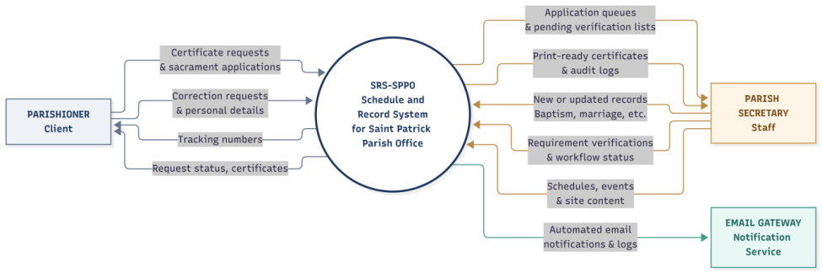
The Level 1 diagram in Figure 13 breaks the system into five main processes: 1.0 Manage User Access, 2.0 Process Requests and Applications, 3.0 Manage Parish Records, 4.0 Manage Schedules and Announcements, and 5.0 Generate Certificates and Reports. These processes read from and write to five data stores: D1 Users, D2 Requests and Applications, D3 Sacramental Records, D4 Schedules and Settings, and D5 Audit and Delivery Logs.
Figure 13
Level 1 Data Flow Diagram
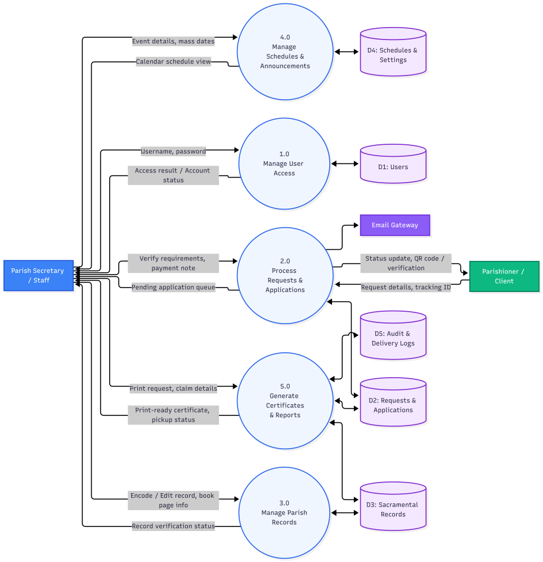

Interface Design
The public interface contains the landing page with a calendar and announcements, the how-it-works and requirements pages, the certificate request and sacrament application forms, the tracking page, the correction request page, and the certificate verification page. The administrative module contains the login page, dashboard, request and application queues, walk-in encoding, sacramental records, person mapper, certificate generation and history, schedule and announcements, reports, and the system tools for accounts, audit log, and backup.
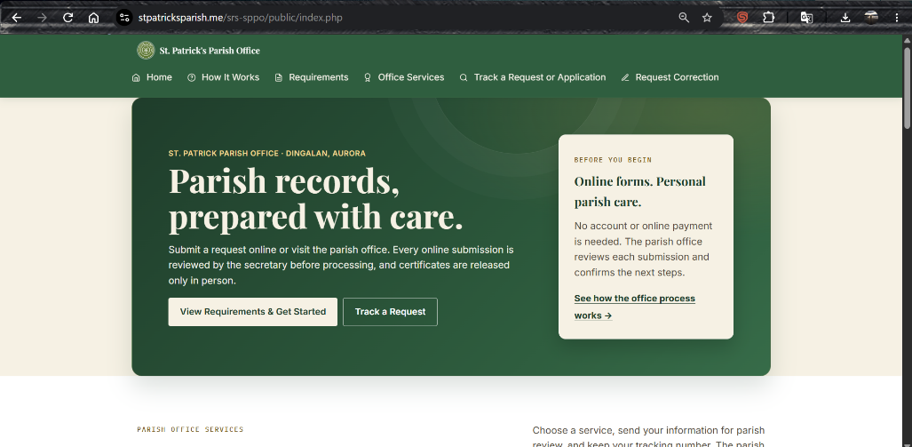

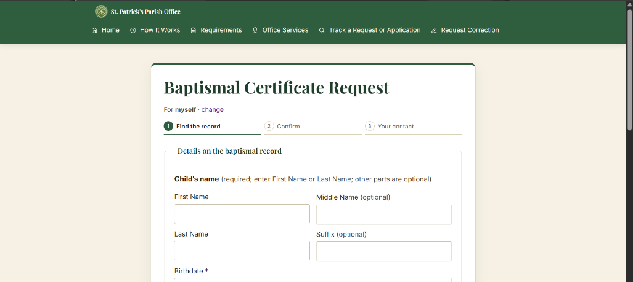
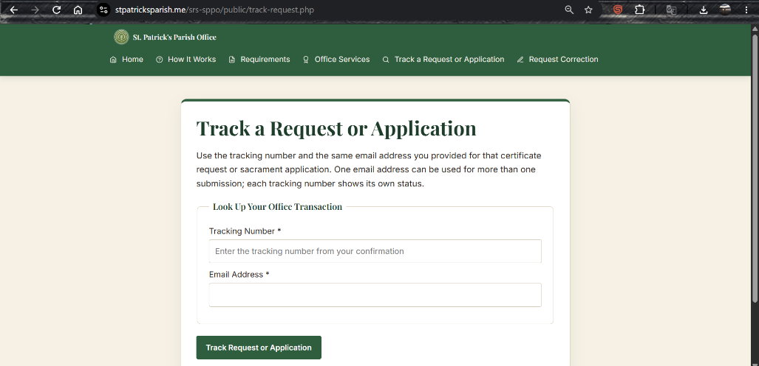
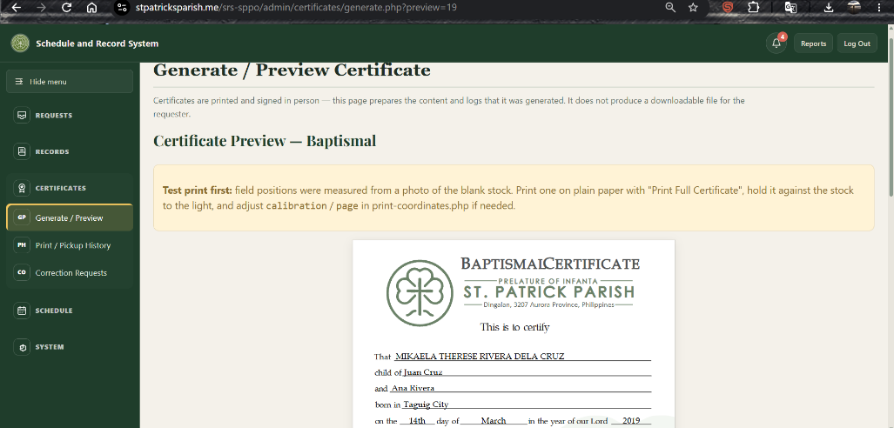
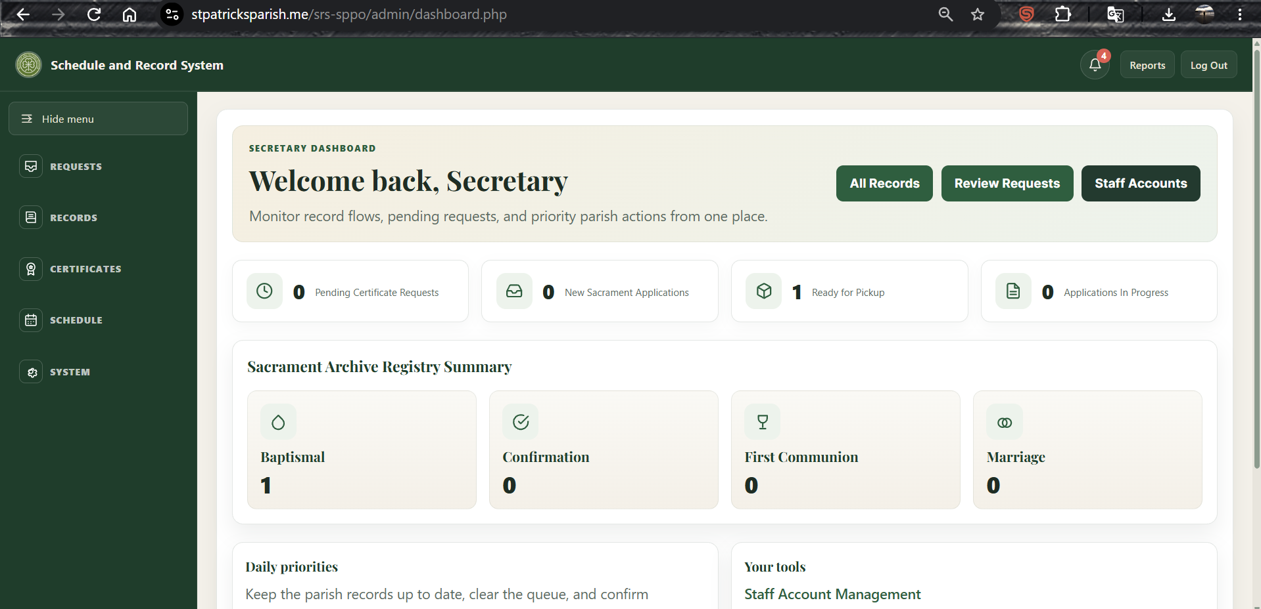

2.4 System Development
The system was developed as a plain PHP web application with no framework, using MySQL/MariaDB as the database. XAMPP provided the local Apache and MySQL environment, Visual Studio Code was the code editor, FullCalendar.js was used for the public calendar, and Git was used for version control. PHPUnit and PHPStan were added through Composer for automated testing and static analysis.
The development followed the Agile approach in iterations. The public intake forms, tracking, and secretary queues were built first, followed by the register modules, person mapping, certificate generation and printing, the schedule and announcements module, correction requests, reports, and the system tools. The following design decisions were adopted during development, based on the reviews with the Parish Secretary and on the delimitations of the study:
- Physical logbooks remain the official record, so every digital register entry keeps its book, page, and line number.
- An online submission is only a pre-application. The secretary verifies requirements and identity in person before processing or releasing anything.
- The system stores no payment amounts. Payment is made outside the system and is recorded only as a manual paid status.
- Eligibility and prerequisite checks (such as age or prior baptism) only flag the record for the secretary and never silently reject a submission.
- Parishioners have no accounts; they track requests with a tracking number and the recorded e-mail address.
Security measures implemented in the code include hashed passwords with a minimum strength rule of 12 characters, CSRF protection on forms, role-based access checks on every administrative page, a 30-minute idle session timeout, rate limiting on logins and public submissions, single-use password-reset tokens that expire in 30 minutes, an audit log of staff actions, optional enforcement of HTTPS, and a backup export feature.

2.5 System Testing
Testing covered the unit, integration, system, and acceptance levels. First, automated tests written with PHPUnit run against an isolated test database. The suite currently contains sixteen test methods: eleven integration tests (DatabaseIntegrationTest) and five function tests (FunctionsTest), which serve as the unit tests of the helper functions. Second, PHPStan static analysis was configured to detect type and code errors early. Third, a GitHub Actions workflow runs the test suite on every push and pull request using PHP 8.2 and MariaDB 10.4. System testing of the complete workflow, from public submission through certificate release, was also performed manually by the researchers to verify that the modules work together as a whole. Acceptance testing was carried out through the formal evaluation in Section 2.6, in which the IT experts, the Parish Secretary, and the parishioners assessed the working system. Table 44 summarizes the automated integration tests.

2.6 Evaluation
After testing, the researchers obtained the consent of the respondents and administered the rating forms. Twenty (20) IT experts evaluated the system using the ISO/IEC 25010-based instrument, while the Parish Secretary and fifty (50) parishioners evaluated it using the end-user instrument. Responses were rated on a four-point scale. The weighted mean of each item was computed as the sum of each rating multiplied by its frequency divided by the number of respondents, and the overall mean of each characteristic was the average of its item means. The results were interpreted using the scoring Rubricss in Tables 2 to 9 for the IT experts and the agreement scale in Table 45 for the end-users.
Table 45
Scale for the End-Users’ Assessment

Range | Verbal Description | Meaning
3.26 – 4.00 | Strongly Agree | The respondent strongly agrees that the system meets the criterion. Rated Highly Functional, Highly Usable, or Highly Secured.
2.51 – 3.25 | Agree | The respondent agrees that the system meets the criterion. This is the second highest rating.
1.76 – 2.50 | Disagree | The respondent disagrees that the system meets the criterion. This is rated Needs Improvement.
1.00 – 1.75 | Strongly Disagree | The respondent strongly disagrees that the system meets the criterion. This is rated Poor.

3. Assessment on the Technical Features of the System Using the ISO/IEC 25010 Software Product Quality Standards
The following tables present the results of the evaluation of the twenty (20) IT experts on the Design and Development of Scheduling and Record System of Saint Patrick Parish. Three (3) of the experts answered the survey through Google Forms and the other seventeen (17) answered the printed questionnaire. The experts rated each item using a four-point scale, where 4 is Highly (Functional, Efficient, Compatible, Usable, Reliable, Secured, Maintainable, or Portable), 3 is the characteristic itself, 2 is Needs Improvement, and 1 is Poor. The weighted means were interpreted as follows: 3.26 to 4.00 as Highly; 2.51 to 3.25 as the characteristic itself; 1.76 to 2.50 as Needs Improvement; and 1.00 to 1.75 as Poor. In each table, the columns headed 4, 3, 2, and 1 show the number of experts who gave that rating.

3.1 Functional Suitability
Table 46 presents the IT experts’ evaluation of the functional suitability of the system. It shows whether the Scheduling and Record System of Saint Patrick Parish provides functions that meet the stated and implied needs of the parish office under specified conditions.

Table 46
Results of the IT Experts’ Assessment on the Functional Suitability of the System

Item | Mean | Verbal Description
1. Functional completeness | 3.30 | Highly Functional
2. Functional correctness | 3.05 | Functional
3. Functional appropriateness | 3.35 | Highly Functional
Grand Mean | 3.23 | Functional

The IT experts rated the functional suitability of the system as Functional, with a grand mean of 3.23. Functional appropriateness (3.35) and functional completeness (3.30) obtained the highest means and were both rated Highly Functional, which indicates that the system covers the specified tasks of the parish office and that its functions help users accomplish them. Functional correctness obtained the lowest mean of 3.05 (Functional). Five of the twenty experts rated it 2 (Needs Improvement), which suggests that the accuracy and precision of the results the system produces, such as the schedule and record outputs, should be double-checked and improved.

3.2 Performance Efficiency
Table 47 shows the IT experts’ assessment of the performance efficiency of the system, which refers to how well the system performs relative to the amount of resources it uses under stated conditions.

Table 47
Results of the IT Experts’ Assessment on the Performance Efficiency of the System

Item | Mean | Verbal Description
1. Time behavior | 3.30 | Highly Efficient
2. Resource utilization | 2.90 | Efficient
3. Capacity | 3.20 | Efficient
Grand Mean | 3.13 | Efficient

The IT experts rated the performance efficiency of the system as Efficient, with a grand mean of 3.13. Time behavior obtained the highest mean of 3.30 (Highly Efficient), showing that the response and processing times of the system meet the requirements of the parish office. Capacity obtained a mean of 3.20 (Efficient). Resource utilization obtained the lowest mean of 2.90 (Efficient), with eight of the twenty experts giving it a rating of 2. This indicates that the amount and type of resources the system consumes can still be optimized, for example by streamlining its database queries and the size of the files it loads.

3.3 Compatibility
Table 48 presents the IT experts’ assessment of the compatibility of the system, which is its ability to perform its required functions and to exchange information with other products, systems, or components while sharing the same hardware or software environment.
Table 48
Results of the IT Experts’ Assessment on the Compatibility of the System

Item | Mean | Verbal Description
1. Co-existence | 3.20 | Compatible
2. Inter-operability | 3.05 | Compatible
Grand Mean | 3.13 | Compatible

The IT experts rated the compatibility of the system as Compatible, with a grand mean of 3.13. Co-existence obtained a mean of 3.20 and inter-operability obtained a mean of 3.05, both rated Compatible. Four experts rated co-existence 2, and five rated inter-operability 2, which means that 20 to 25 percent of the experts saw moderate weaknesses in how the system works alongside other software and in how it exchanges information with other components. Testing the system on more browsers, devices, and operating environments would help address these concerns.

3.4 Usability
Table 49 shows the IT experts’ usability assessment of the system. It reflects how well the system can be used by its specified users to achieve specified goals with effectiveness, efficiency, and satisfaction in the context of the parish office.

Table 49
Results of the IT Experts’ Assessment on the Usability of the System

Item | Mean | Verbal Description
1. Appropriateness recognizability | 3.30 | Highly Usable
2. Learnability | 2.90 | Usable
3. Operability | 3.20 | Usable
4. User error protection | 2.85 | Usable
5. User interface aesthetics | 3.30 | Highly Usable
6. Accessibility | 3.10 | Usable
Grand Mean | 3.11 | Usable

The IT experts rated the usability of the system as Usable, with a grand mean of 3.11. Appropriateness recognizability and user interface aesthetics obtained the highest means of 3.30 (Highly Usable), and half of the experts gave the interface a rating of 4, which shows that the system looks pleasing and that users can tell it fits their needs. Operability (3.20) and accessibility (3.10) were rated Usable. Learnability (2.90) and user error protection (2.85) obtained the lowest means, and user error protection had the fewest 4 ratings (3 of 20) and six ratings of 2. These results suggest that new users may need more guidance to learn the system and that it should do more to prevent and correct mistakes, such as clearer input validation, confirmation messages before deleting or changing records, and a short user guide.

3.5 Reliability
Table 50 presents the IT experts’ assessment of the reliability of the system, which is the degree to which the system performs its specified functions under specified conditions for a specified period of time.

Table 50
Results of the IT Experts’ Assessment on the Reliability of the System

Item | Mean | Verbal Description
1. Maturity | 3.25 | Reliable
2. Availability | 3.15 | Reliable
3. Fault tolerance | 3.00 | Reliable
4. Recoverability | 3.40 | Highly Reliable
Grand Mean | 3.20 | Reliable

The IT experts rated the reliability of the system as Reliable, with a grand mean of 3.20. Recoverability received the highest mean of 3.40 (Highly Reliable), and no expert rated it below 3, indicating that the system can restore its data and return to its normal state after an interruption or failure. Maturity (3.25) and availability (3.15) were rated Reliable. Fault tolerance obtained the lowest mean of 3.00, with five experts rating it 2, indicating that the system could be made more resilient in continuing to operate when hardware or software faults occur.

3.6 Security
Table 51 presents the IT experts’ assessment of the system's security. Security is the degree to which the system protects information and data so that people or other systems have the appropriate level of data access for their roles and authorization, which is important for a system that keeps parish records.

Table 51
Results of the IT Experts’ Assessment on the Security of the System

Item | Mean | Verbal Description
1. Confidentiality | 3.30 | Highly Secured
2. Integrity | 2.80 | Secured
3. Non-repudiation | 3.15 | Secured
4. Accountability | 3.35 | Highly Secured
5. Authenticity | 3.25 | Secured
Grand Mean | 3.17 | Secured

The IT experts rated the security of the system as Secured, with a grand mean of 3.17. Accountability (3.35) and confidentiality (3.30) obtained the highest means and were rated Highly Secured, and no expert rated accountability below 3, which means that user actions are properly traced and that records are shielded from unauthorized viewing. Authenticity (3.25) and non-repudiation (3.15) were rated Secured. Integrity obtained the lowest mean of 2.80, the lowest of all items in the evaluation, and ten of the twenty experts gave it a rating of 2. This shows that protecting data and programs from unauthorized access and modification is the main security concern, and measures such as stricter role-based permissions, audit logs for record changes, and input sanitization should be prioritized.

3.7 Maintainability
Table 52 shows the IT experts’ assessment of the system's maintainability. It reflects the effectiveness and efficiency with which the system can be modified to improve it, correct it, or adapt it to changes in the environment and in requirements.
Table 52
Results of the IT Experts’ Assessment on the Maintainability of the System

Item | Mean | Verbal Description
1. Modularity | 3.40 | Highly Maintainable
2. Reusability | 3.10 | Maintainable
3. Analysability | 3.10 | Maintainable
4. Modifiability | 3.00 | Maintainable
5. Testability | 2.95 | Maintainable
Grand Mean | 3.11 | Maintainable

The IT experts rated the system's maintainability as Maintainable, with a grand mean of 3.11. Modularity received the highest mean of 3.40 (Highly Maintainable), with half of the experts rating it 4, indicating that the system is built from components that can be changed without greatly affecting the others. Reusability and analysability (both 3.10) and modifiability (3.00) were rated Maintainable. Testability obtained the lowest mean of 2.95; only one expert rated it 4, while seventeen rated it 3. This suggests establishing documented test cases and procedures so changes to the system can be verified more easily.

3.8 Portability
Table 53 presents the IT experts’ assessment of the system's portability, the effectiveness and efficiency with which it can be transferred from one hardware, software, or other operational or usage environment to another.

Table 53
Results of the IT Experts’ Assessment on the Portability of the System

Item | Mean | Verbal Description
1. Adaptability | 3.15 | Portable
2. Installability | 3.15 | Portable
3. Replaceability | 3.35 | Highly Portable
Grand Mean | 3.22 | Portable

IT experts rated the system's portability as Portable, with a grand mean of 3.22. Replaceability had the highest mean of 3.35 (Highly Portable), indicating that the system can replace the parish office’s existing way of handling schedules and records. Adaptability and installability both obtained a mean of 3.15 (Portable), meaning that the system can be adapted to and installed in other environments with minimal weakness. Four of the twenty experts rated installability 2, so a simpler installation and migration procedure would strengthen this characteristic.

3.9 Summary of the IT Experts’ Assessment
Table 54 summarizes the grand weighted means for the eight ISO/IEC 25010 quality characteristics evaluated by the IT experts.
Table 54
Summary of the IT Experts’ Assessment on the Quality of the System

Quality Characteristic | Grand Mean | Verbal Description
Functional Suitability | 3.23 | Functional
Performance Efficiency | 3.13 | Efficient
Compatibility | 3.13 | Compatible
Usability | 3.11 | Usable
Reliability | 3.20 | Reliable
Security | 3.17 | Secured
Maintainability | 3.11 | Maintainable
Portability | 3.22 | Portable
Overall Mean | 3.16 | Acceptable

Overall, the IT experts evaluated the system with a mean of 3.16, indicating that the system meets the ISO/IEC 25010 software product quality standards. All eight characteristics had grand means between 3.11 and 3.23, and no expert gave a rating of 1 on any item. Functional Suitability (3.23), Portability (3.22), and Reliability (3.20) obtained the highest grand means, while Usability and Maintainability (both 3.11) obtained the lowest. At the item level, ten of the 31 items reached the Highly range (3.26 and above), and five items fell below 3.00: integrity (2.80), user error protection (2.85), resource utilization (2.90), learnability (2.90), and testability (2.95). These items point to areas that should be improved first: protecting data against unauthorized changes, preventing user errors, using resources efficiently, making the system easy to learn, and improving testing procedures. Overall, the results show that the system is suitable for use in the Saint Patrick’s Parish Office, with minimal to moderate weaknesses in these specific areas.

4. The Assessment on the Quality of Using the System Using the Selected ISO 25010 SQuaRE Standards
The next tables present the end-users’ evaluation of the quality of the Scheduling and Record System of Saint Patrick’s Parish Office. As shown in Table 1 of Chapter II, the end-users include fifty-one (51) respondents: one (1) Parish Secretary, the system's primary administrator, and fifty (50) Parishioners, who represent its public users. They rated the system on functional suitability, usability, and security using a four-point scale: 3.26–4.00 is the highest rating, 2.51–3.25 is the second highest, 1.76–2.50 is Needs Improvement, and 1.00–1.75 is Poor. Their responses reflect how well the system worked for them.

4.1 Functional Suitability
As shown in Table 55, end-users’ evaluation of the system’s functional suitability indicates how well the system provides functions that meet their stated and implied needs.
Table 55
Results of the Assessment Made by End-Users on the Functional Suitability of the System

Item Statement | Weighted Mean | Verbal Description
The set of functions covers all the specified tasks and user objectives. (Functional Completeness) | 3.33 | Highly Functional
The system provides the correct results with the needed degree of precision. (Functional Correctness) | 3.31 | Highly Functional
The functions facilitate the accomplishment of specified tasks and objectives. (Functional Appropriateness) | 3.51 | Highly Functional
Grand Mean | 3.39 | Highly Functional

End-users rated the system Highly Functional in all functional suitability items, with a grand mean of 3.39. Functional appropriateness had the highest mean (3.51), with 29 of the 51 end-users rating it 4, indicating that the functions help them accomplish their tasks and objectives. Functional completeness followed with a mean of 3.33, indicating that the set of functions covers the scheduling and record-keeping tasks of the parish office, although eight end-users rated it 2. Functional correctness had a mean of 3.31, the lowest of the three, and remains Highly Functional, with 25 end-users rating it 4 and 17 rating it 3. However, nine end-users gave it a rating of 2, suggesting that some users noticed room for improvement in the precision of the results the system produces. Overall, the results show that the system provides functions that meet the needs of its end-users

4.2 Usability
Table 56 presents the end-users’ assessment of the system’s usability, which shows how easily the system can be understood, learned, operated, and used by its intended users.
Table 56
Results of the Assessment Made by End-Users on the Usability of the System
Item Statement | Weighted Mean | Verbal Description
Users can recognize whether the system is appropriate for their needs. (Appropriateness Recognizability) | 3.49 | Highly Usable
Specified users can use the system to achieve the specified goals of learning. (Learnability) | 3.37 | Highly Usable
The system has attributes that make it easy to operate and control. (Operability) | 3.39 | Highly Usable
The system protects users against making errors. (User Error Protection) | 3.27 | Highly Usable
The user interface of the system enables pleasing and satisfying interaction for the user. (User Interface Aesthetics) | 3.35 | Highly Usable
The system can be used by people with the widest range of characteristics and capabilities. (Accessibility) | 3.43 | Highly Usable
Grand Mean | 3.39 | Highly Usable

End users rated the system's usability as Highly Usable, with a grand mean of 3.39. Appropriateness recognizability earned the highest mean of 3.49, with 29 end-users rating it 4, indicating that users can easily recognize that the system suits their needs. Accessibility (3.43), operability (3.39), learnability (3.37), and user interface aesthetics (3.35) were likewise rated Highly Usable. User error protection obtained the lowest mean of 3.27, which is still within the Highly Usable range but close to its lower limit, with eleven end-users giving it a rating of 2. This suggests that some users may still make mistakes or find it unclear how the system prevents them, so clearer error messages and confirmation prompts, together with a short user manual or brief orientation, may help improve the usability of the system

4.3 Security
Table 57 shows end-users’ evaluation of the system’s security, covering how well the system protects information and data from unauthorized access and modification.

Table 57
Results of the Assessment Made by End-Users on the Security of the System
Item Statement | Weighted Mean | Verbal Description
The system ensures that data are accessible only to those authorized to have access. (Confidentiality) | 3.31 | Highly Secured
The system prevents unauthorized access to, or modification of, computer programs or data. (Integrity) | 3.33 | Highly Secured
The system’s actions or events can be proven to have taken place and cannot be repudiated later. (Non-repudiation) | 3.27 | Highly Secured
Actions of the entity can be traced uniquely to the entity. (Accountability) | 3.41 | Highly Secured
The system can prove that the identity of a subject or resource is the one claimed. (Authenticity) | 3.35 | Highly Secured
Grand Mean | 3.34 | Highly Secured

End users rated the system Highly Secure, with a grand mean of 3.34. Accountability had the highest mean (3.41), indicating that users’ actions in the system can be traced to them. Authenticity (3.35), integrity (3.33), and confidentiality (3.31) followed, and all were rated Highly Secured. Non-repudiation had the lowest mean of 3.27, still Highly Secured but close to its lower limit, with nine end-users giving it a rating of 2, suggesting some users are less certain that the system records every action in a way that cannot be denied later. In every item, at least 23 of the 51 end-users gave a rating of 4, and no item received a rating of 1. These results show that the end-users are generally confident that the system keeps the parish’s schedules and records protected and accessible only to authorized persons
Overall, of the 714 ratings given by the fifty-one end-users across the three characteristics, 364 were 4, 249 were 3, and 101 were 2, with none rated 1. This confirms that the Scheduling and Record System of Saint Patrick’s Parish Office is highly functional, highly usable, and highly secure from the end-users’ perspective

4.4 Discussion
Taken together, the results show that the system meets the objectives set in Chapter I. The three problems identified in the manual process were slow record retrieval, no request tracking, and the risk of lost, damaged, or duplicated records. The digital index and search address the first; the tracking number with email lookup addresses the second; and the database backup, audit log, and person mapper address the third. At the same time, the physical logbooks remain the official record. From the end-users’ side, the highest-rated items were functional appropriateness (3.51), appropriateness recognizability (3.49), and accountability (3.41), while the lowest-rated were user error protection (3.27) and non-repudiation (3.27), both still within the highest rating range. These results are consistent with the very satisfactory rating that Olipas et al. (2021) reported for their church records system, and with Taruc et al. (2023), who found that an ISO 25010-evaluated document request system improved accessibility and transparency, as reflected in the system’s accessibility (3.43) and accountability (3.41) ratings. The lower user error protection rating suggests that clearer error messages, confirmation prompts, and a short user orientation would further help users. From the IT experts’ side, Functional Suitability (3.23) was the highest-rated characteristic, while Usability and Maintainability (both 3.11) were the lowest-rated, although all eight characteristics remained within the acceptable range.
Chapter IV
SUMMARY, CONCLUSIONS, AND RECOMMENDATIONS
This chapter presents a summary of the findings, the conclusions drawn from the preceding chapter, and recommendations for the future development of the system and for subsequent studies.

Summary
This study focused on designing, developing, and evaluating the Schedule and Record System of Saint Patrick Parish Office (SRS-SPPO), a web-based system built to address the parish office's manual record management and scheduling challenges in Dingalan, Aurora. The study sought to answer four questions: (1) how the current manual record management system may be described, (2) how the proposed system may be developed following the stages of the Agile model, (3) how IT experts evaluate the system based on ISO/IEC 25010, and (4) how the end-users assess the system in terms of functionality, usability, and security.
The researchers used a developmental research design and the Agile methodology, covering planning, requirements analysis, system design, system development, system testing, and evaluation. The system was built with PHP, MySQL/MariaDB, HTML, CSS, and JavaScript on XAMPP, using Visual Studio Code. Key features include a public interface for announcements, the calendar, certificate requests, sacrament applications, and request tracking; and a secure administrative module for the Parish Secretary to process requests, maintain a digital index of the Baptism, Confirmation, First Communion, and Marriage registers, generate and print certificates, manage schedules and announcements, and view reports, with an audit log and backup tools. The physical logbooks remain the official record. The evaluation involved twenty (20) IT experts, the Parish Secretary, and fifty (50) parishioners, using a four-point rating scale and weighted means.
The findings of the study are summarized as follows:
1. The manual system relied on handwritten logbooks and pre-printed forms handled by a single secretary. Record retrieval was slow because entries could be found only by book, page, and line; certificate requests had no tracking number or status channel, resulting in wasted trips; and the only copies of the records were exposed to loss, damage, and duplication. According to the Parish Secretary, retrieving a single record could take up to one week during peak periods.
2. The system was developed following the Agile stages. It supports certificate requests and sacrament applications for four sacraments; tracking by tracking number and email; a digital register index with book, page, and line references; certificate generation with print and release logging; a schedule with conflict detection; announcements; correction requests; reports; role-based access; and audit logging. Automated tests with PHPUnit and static analysis with PHPStan were used during testing. All sixteen automated test methods (eleven integration tests and five function tests) passed, PHPStan reported no errors at the configured analysis level, and the continuous integration workflow ran successfully on PHP 8.2 and MariaDB 10.4.
3. The IT experts rated the system Acceptable with a grand mean of 3.16. The highest-rated characteristic was Functional Suitability (3.23), and the lowest-rated was Usability (3.11). Maintainability obtained the same mean of 3.11.
4. The end-users strongly agreed on the functionality (3.39), usability (3.39), and security (3.34) of the system, with an overall mean of 3.37.

Conclusions
Based on the findings of the study, the researchers arrived at the following conclusions:
1. The manual record management system at Saint Patrick Parish Office was inefficient in record retrieval, offered no way to track certificate requests, and exposed the only copies of sacramental records to loss, damage, and duplication, which confirms the need for a digital solution.
2. The Schedule and Record System of Saint Patrick Parish Office was successfully designed and developed following the Agile model. It gives parishioners online access to schedules, announcements, requests, and tracking. It gives the Parish Secretary a digital index and office workflow, while keeping the physical logbooks as the official record.
3. The IT experts found the system acceptable across the eight ISO/IEC 25010 quality characteristics, which indicates that the system is technically sound for use in the parish office. Usability and Maintainability had the lowest grand means (3.11), and integrity, user error protection, resource utilization, learnability, and testability still need improvement.
4. The Parish Secretary and the parishioners found the system highly functional, highly usable, and highly secure, which indicates that the system is acceptable to its intended users.

Recommendations
In light of the findings and conclusions, the researchers offer the following recommendations:
For Saint Patrick’s Parish Office:
- Deploy the system on a hosted server with HTTPS enabled and set the public application URL so that the QR code on printed certificates can be scanned from any device.
- Align the printed certificate template with the parish’s official certificate stock before using it for released certificates.
- Have the parish priest confirm the age ranges used for the Confirmation and First Communion eligibility flags, which are currently placeholders.
- Configure the e-mail relay so that parishioners receive status notifications, and keep the tracking page as the fallback.
- Store database backups encrypted and offline, and test restoring them regularly.
- Train the Parish Secretary and any additional staff, and gradually encode older logbook entries and map them to persons using the person mapper.
For future researchers:
- Add SMS notifications and a mobile-friendly or installable (PWA) version, which were outside the scope of this study.
- Add offline support so that essential schedules and requirements remain viewable when the connection is poor.
- Add an analytics dashboard for the Parish Administrator showing trends in requests and sacraments.
- Consider a priest role for clearances and an optional online payment integration, if the parish decides to change its current rules.
- Extend the system to other parishes and conduct a longer-term evaluation after actual deployment, including accessibility testing with older users.

References
Arundaa, R., Mokalu, Y. B., & Sintaro, S. (2025). Church management information system of Syaloom Imandi Bolaang Mongondow. Nuansa Informatika, 19(1), 23–30. https://doi.org/10.25134/ilkom.v19i1.332
Barlis, M. M., Tan, J. S., Tanquerio, E., Llesol, M., & Intal, G. L. (2020). Development of centralized Parish Record and Information Management System (PRIMS) to support Strategic Information System Plan (SISP) of Diocese of Cubao. 2020 IEEE 7th International Conference on Industrial Engineering and Applications (ICIEA), 509–513. https://doi.org/10.1109/ICIEA49774.2020.9101967
Bernardino, C. S., Basilio, J. D., & Calaguas, B. (2024). E-Church: A web and mobile-based church management system for Holy Rosary Parish. IEOM Society International.
Canlas, R. B., Piad, K. C., & Lagman, A. C. (2022). An ISO/IEC 25010 based software quality assessment of a faculty research productivity monitoring and prediction system. Proceedings of the 2021 9th International Conference on Information Technology: IoT and Smart City, 238–242. https://doi.org/10.1145/3512576.3512619
Castro, A. T. M., Domingo, J. G. C., Giron, M. A. B., & Ignacio, E. M. D. G. (2025). Perceived organizational culture attributes and electronic records management system efficiency in the public sector. EPRA International Journal of Research and Development (IJRD), 10(8), 144–156. https://doi.org/10.36713/epra2016
de Vicente Mohino, J., Bermejo Higuera, J., Bermejo Higuera, J. R., & Sicilia Montalvo, J. A. (2019). The application of a new secure software development life cycle (S-SDLC) with agile methodologies. Electronics, 8(11), Article 1218. https://doi.org/10.3390/electronics8111218
Diabordo, R. V., Felicia, J. C., & Igloso, J. C. (2026). Enhancing reservation and record efficiency thru parish management system. GAS Journal of Engineering and Technology (GASJET), 3(5), 48–63. https://gaspublishers.com/wp-content/uploads/2026/05/Enhancing-Reservation-and-Record-Efficiency-thru-Parish-Management-System.pdf
Diocesan Catholic Records Management System. (n.d.). Diocesan Catholic Records Management System. https://www.catholicrecords.ph/
Djutalov, R., Irham, M., Putra, A. D., Elistiawan, A., & Syah, R. F. (2024). Agile methodology in web and mobile based app of tracer study and career center. Brilliance: Research of Artificial Intelligence, 4(1), 453–465. https://doi.org/10.47709/brilliance.v4i1.4372
Houeninvo, H. G. (2023). Enhancing support for senior citizens: Development and evaluation of the OSCA information management system with Agile methodology and ISO/IEC 25010 compliance. Journal of Applied Engineering and Technological Science (JAETS), 5(1), 581–594. https://doi.org/10.37385/jaets.v5i1.3062
ISO/IEC 25010:2011. (2011). Systems and software engineering—Systems and software Quality Requirements and Evaluation (SQuaRE)—System and software quality models. International Organization for Standardization.
Libadia, M., Botangen, K. A., Lucero, P. J., & Tecson, J. (2025). Development of a web-based records management system: An ERMS initiative for the Office of Senior Citizen Affairs in the Philippines. Records Management Journal, 35(2), 160–179. https://doi.org/10.1108/RMJ-06-2023-0031
Olipas, C. N. P., Sawit, R. C. M., & Esperon, R. M. (2021). The design and assessment of a Church Records and Information Management System. International Journal of Research and Innovation in Applied Science (IJRIAS), 6(1), 48–52. https://zenodo.org/records/8024706
Philippine Statistics Authority. (2023). PSA Serbilis and PSAHelpline.ph e-Certificate Services. https://psa.gov.ph/
Pulumbarit, J. P. (2025). Digitalization of church records (Phase I): A project management approach. ResearchGate. https://www.researchgate.net/publication/389878126_Digitalization_of_Church_Records_Phase_I_A_Project_Management_Approach
Serrador, P., & Pinto, J. K. (2015). Does Agile work? A quantitative analysis of agile project success. International Journal of Project Management, 33(5), 1040–1051. https://doi.org/10.1016/j.ijproman.2015.01.006
Simanjuntak, A., Maulana, D., & Widodo, E. (2024). Web-based congregation data processing information system of HKBP Cikarang Kota church. IDEALIS: InDonEsiA Journal Information System, 7(2), 248–257. https://doi.org/10.36080/idealis.v7i2.3237
Siregar, M. E., Mayatopani, H., Olivia, D., & Kurniawan, R. D. (2025). Development of a church information management system using Scrum at HKBP Sola Gratia Kayu Mas Jakarta. Jurnal Teknik Informatika (JUTIF), 6(5), 2929–2939.
Tamu Ina, N., Rada, Y., & Sitaniapessy, D. A. (2024). Web-based congregation data management information system at Sumba Christian Church Kanjonga Bakul. Journal of Artificial Intelligence and Engineering Applications (JAIEA), 4(1), 87–92. https://doi.org/10.59934/jaiea.v4i1.564
Taruc, F. S., Martin, T. A. S., Olipas, C. N. P., & Alegado, R. T. (2023). Docu-Go: The development and assessment of a web-based barangay document requesting system. International Journal of Information Technology & Computer Engineering, 3(04), 40–49. https://doi.org/10.55529/ijitc.34.40.49
Appendices
Appendix A
Request Letter to Saint Patrick Parish Office

Appendix B
Request Letter to Capstone Project Adviser

Appendix C
IT Expert Evaluation Form
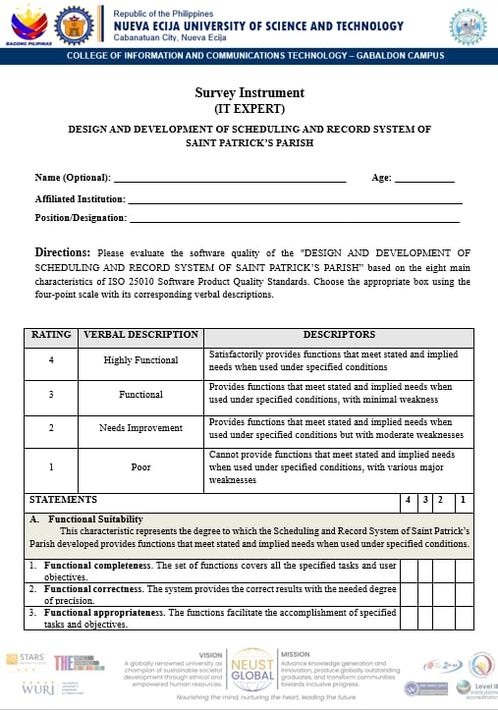
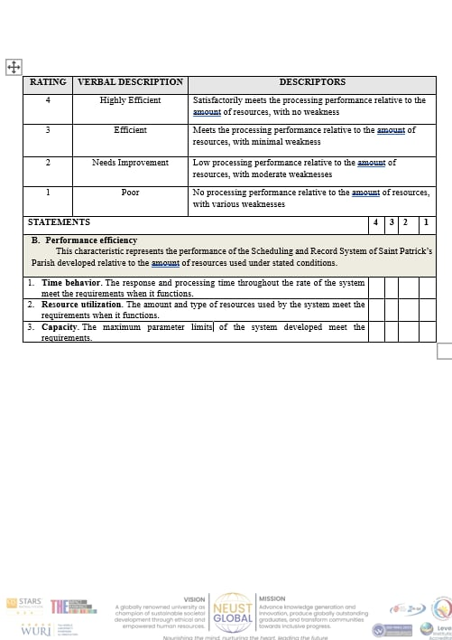

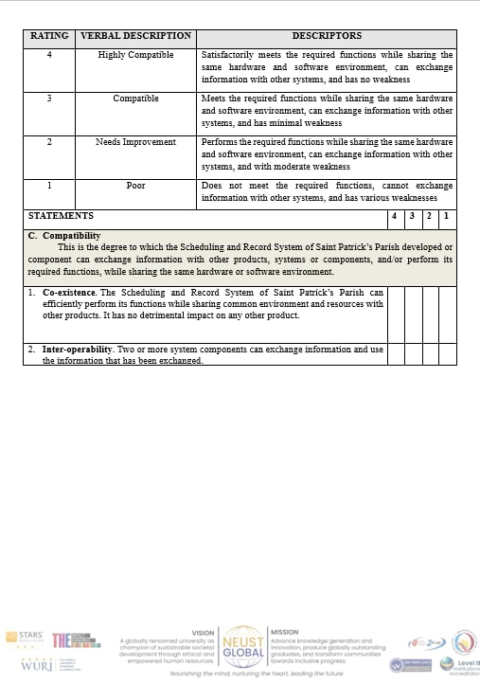
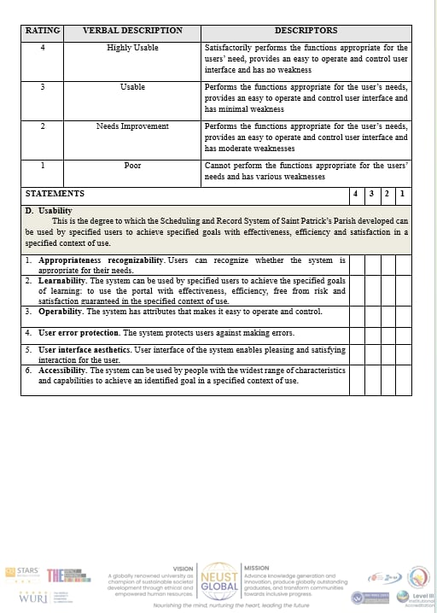
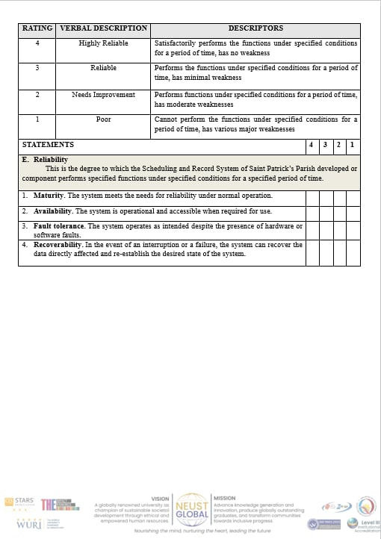
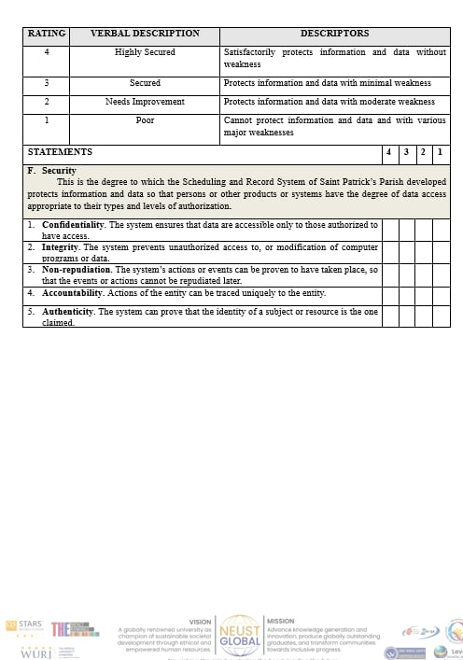
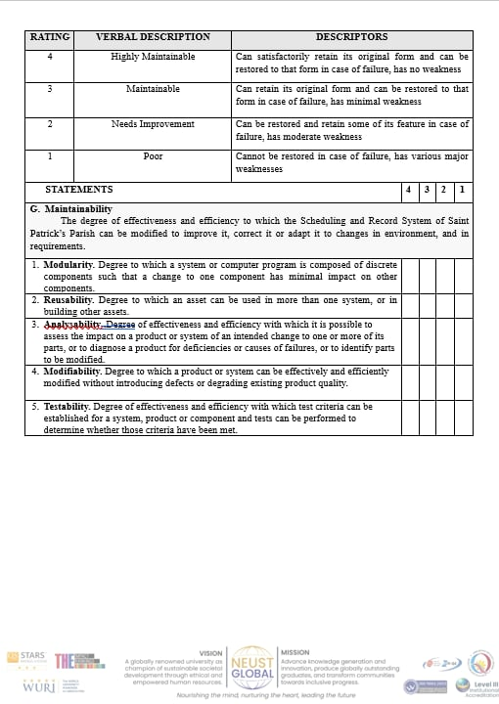
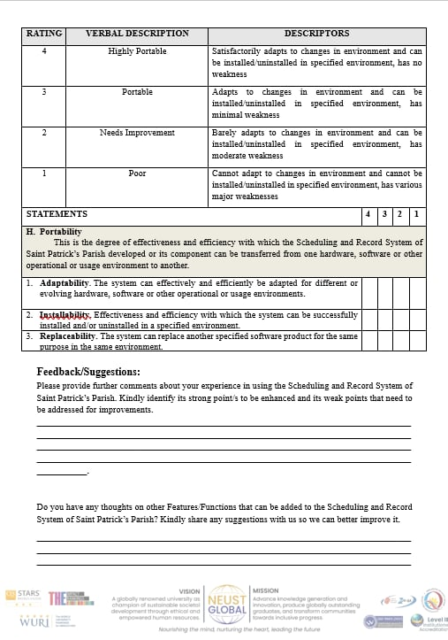


Appendix D
End-User Evaluation Form
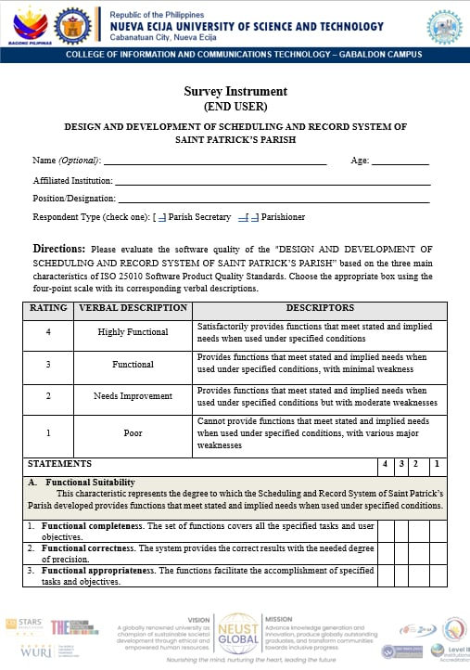
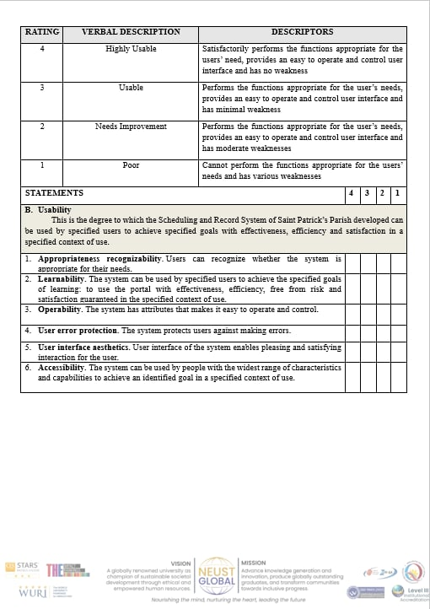
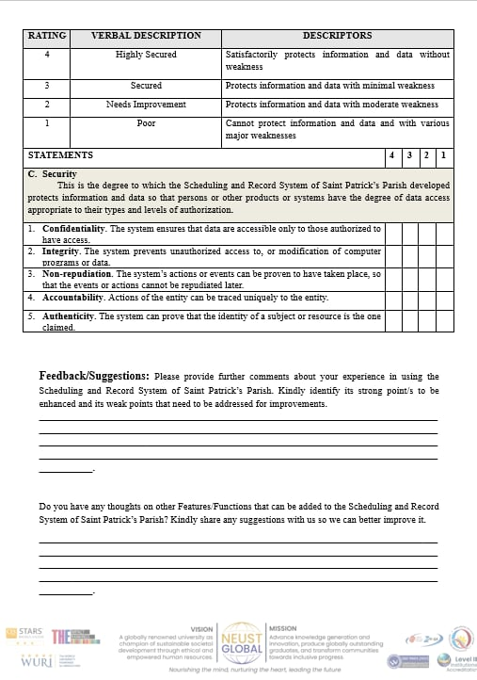

Appendix E
USER MANUAL
About this manual
This manual explains how to use the Schedule and Record System of St. Patrick's Parish Office (SRS-SPPO). It is organized around the work of parishioners, the parish secretary, and the person responsible for system maintenance.
The instructions describe the application at the time of writing. Screen labels and available options may change when the hosted system is updated. Follow current parish-office instructions whenever they differ from this guide.

Important: Online forms start a request or application; they do not grant approval, collect payment, or issue a certificate. Final verification and certificate pickup take place through the Parish Office.

Who should use each part?
• Public users: Chapters 2-5 cover certificates, sacrament applications, status tracking, and correction requests.
• Parish Secretary: Chapters 6-10 cover staff access, request processing, records, certificates, scheduling, and reports.
• System Administrator: Chapter 11 covers system-maintenance tasks. There is only one staff role, Secretary; in-app tasks use the same Secretary accounts, while hosting, recovery, and database restoration are handled by the designated technical administrator.

1. Getting started and user roles

What the system does
SRS-SPPO supports parish service intake, sacramental-record keeping, certificate processing, scheduling, and office reporting. Public visitors can submit information without creating an account. Authorized staff sign in to review and process work.

Access points
• Public website: use the official parish link provided by the Parish Office. The home page includes service links, requirements, a calendar, and request tracking.
• Staff area: open the staff login link supplied by the Parish Office. Staff pages require an active account.

Roles and responsibilities
• Public visitor: supplies accurate information, keeps the tracking number, and follows office directions.
• Parish Secretary: reviews submissions, verifies information, updates workflow status, maintains records, schedules events, and prepares reports.
• System maintainer: uses the same Secretary staff account for in-app maintenance, protects staff access, applies approved database updates, and creates protected backups. The designated technical administrator handles hosting, recovery, and database restoration.

Never share a staff password. Use only real personal information on the authorized hosted site; use test data for demonstrations and screenshots.

2. Public home page and office services
The public home page is the starting point. Use the navigation menu or the large service buttons to find the correct task.
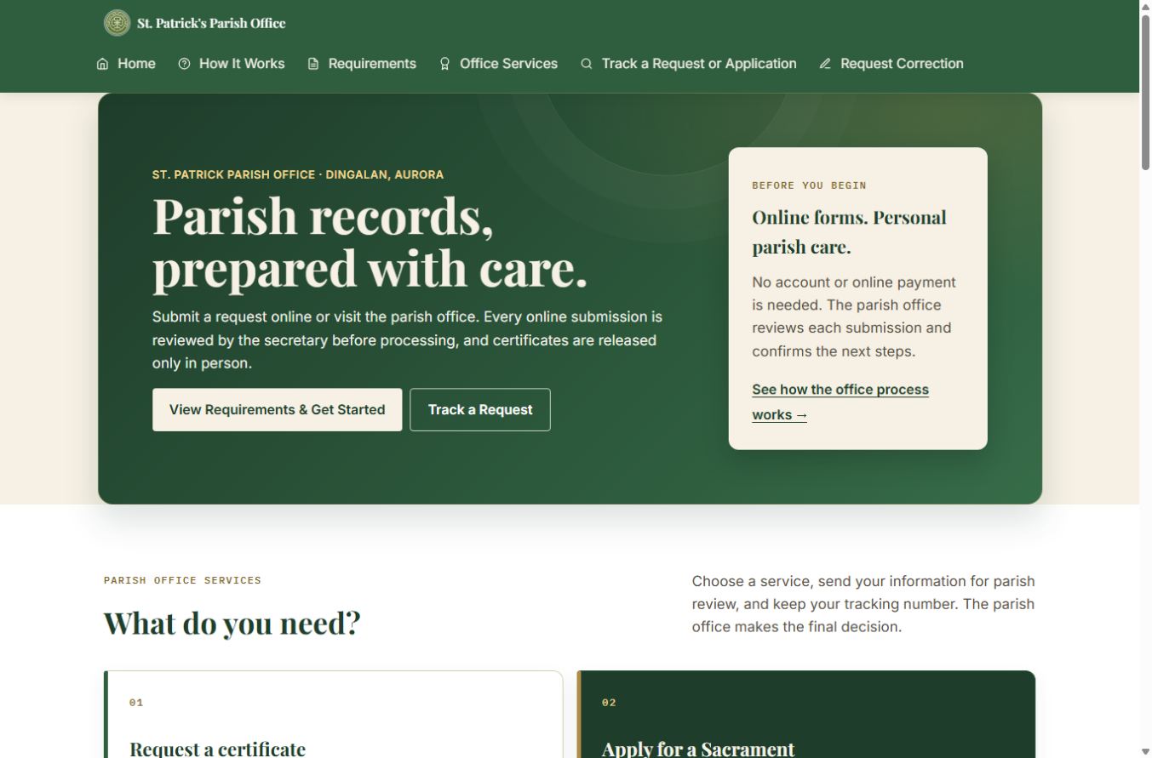
Figure 1. Public home page (local test installation; example screen only).

Choose the correct path
• Request a certificate when the sacrament has already taken place and you need a copy of the parish register entry.
• Apply for a sacrament when preparing for a future Baptism, Confirmation, First Communion, or Church Wedding.
• Track a request or application after submission using its tracking number and the same email address entered on the form.
• Request a correction if a certificate has already been issued and you need to report an error.
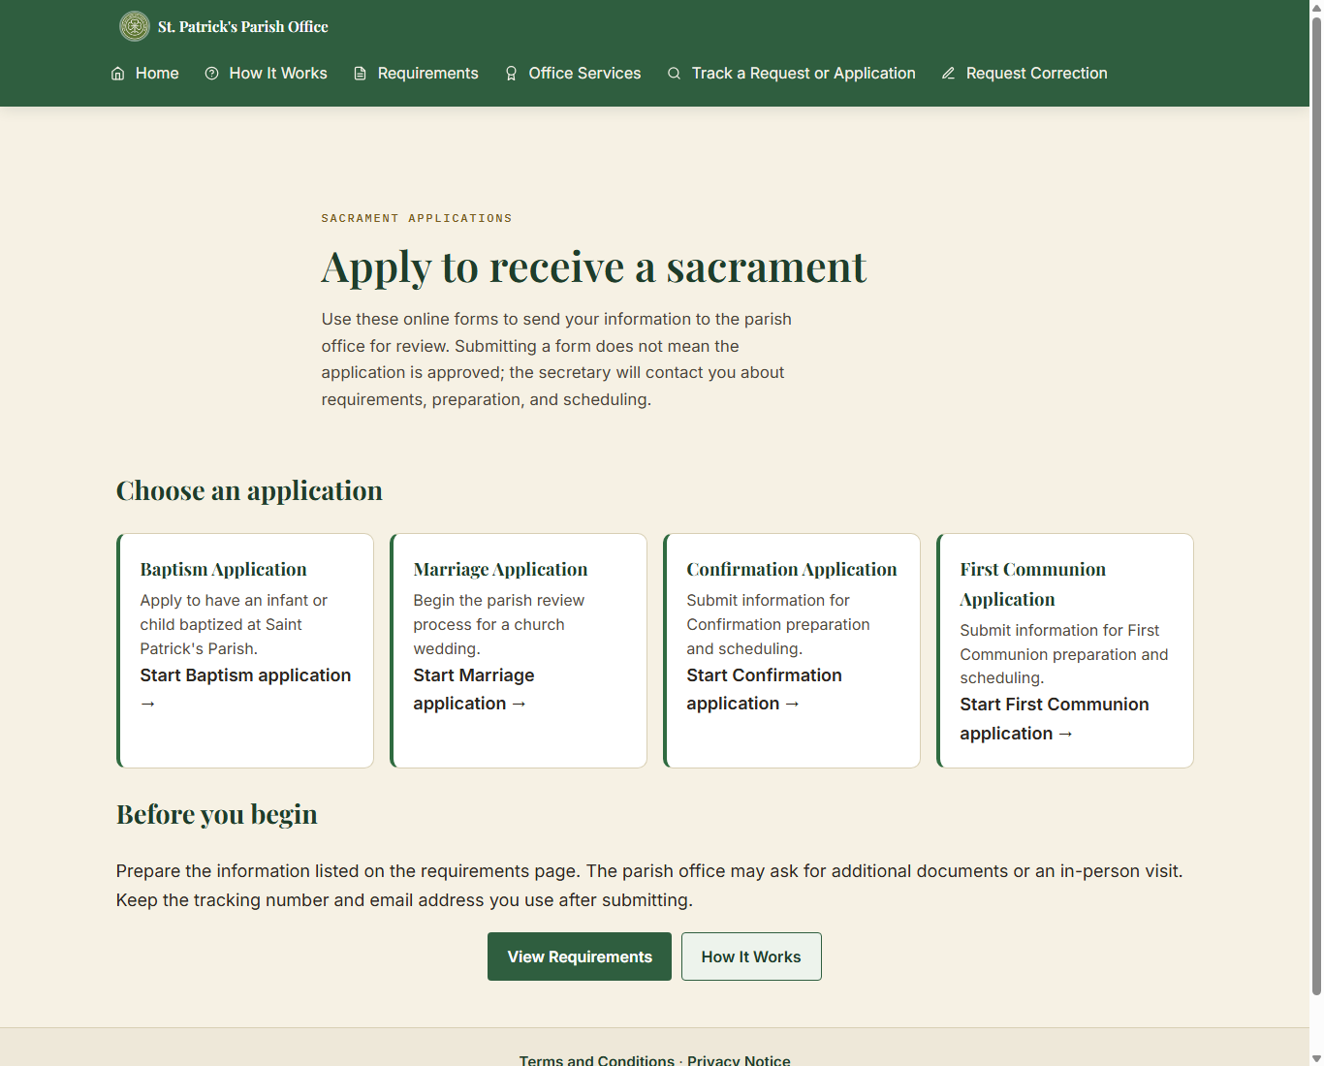
Figure 2. Sacrament application choices on the public website.

Before using an online form
• Review Requirements and How It Works before starting.
• Do not upload or send identity documents through the form, email, or Messenger. The office will explain how documents should be shown in person.
• A submission is not approval. The secretary verifies the information and confirms next steps.
• Certificates are collected from the Parish Office; they are not downloaded from the website.

3. Requesting a sacramental certificate
Use a certificate request only for a sacrament that has already been recorded. The public site provides Baptismal, Confirmation, First Communion, and Marriage certificate request forms.

Typical steps
1. From Office Services, select Request a Certificate and choose the sacrament.
2. Choose whether you are requesting for yourself or for someone else, if that choice is shown.
3. Enter the subject's name and the identifying dates requested by the form. Use First, Middle, Last, and Suffix fields where provided. Middle name and suffix can be left blank when not applicable.
4. For Baptism, Confirmation, and First Communion searches, enter one or both parent names when known. For marriage, provide both spouses' identifying details as requested.
5. Review any possible record match carefully. A search result is only a possible match; the Parish Secretary verifies the source register.
6. If no record is found, follow the option to ask the secretary to search the register manually. Not finding an online result does not prove that the sacrament did not occur.
7. Enter contact details, review the information, accept the required terms, and submit.
8. Save the tracking number and use it with the same email address to check progress.
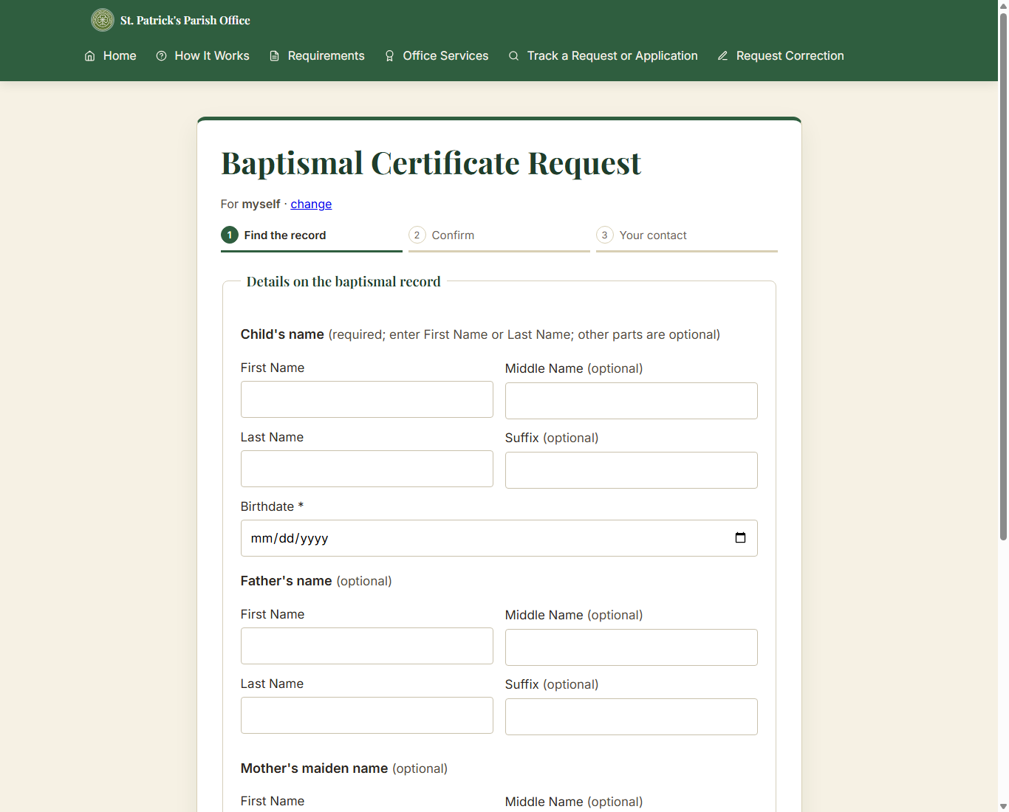
Figure 3. Baptismal certificate form: register search step (blank local test screen).

Do not submit the same request repeatedly just because a search result is not found. Contact the Parish Office or use the manual-search option.

4. Applying to receive a sacrament
Applications are for a future sacrament. Select Baptism, Confirmation, First Communion, or Marriage from Sacrament Applications. Forms are divided into guided phases; use Next and Back to review sections before submission.
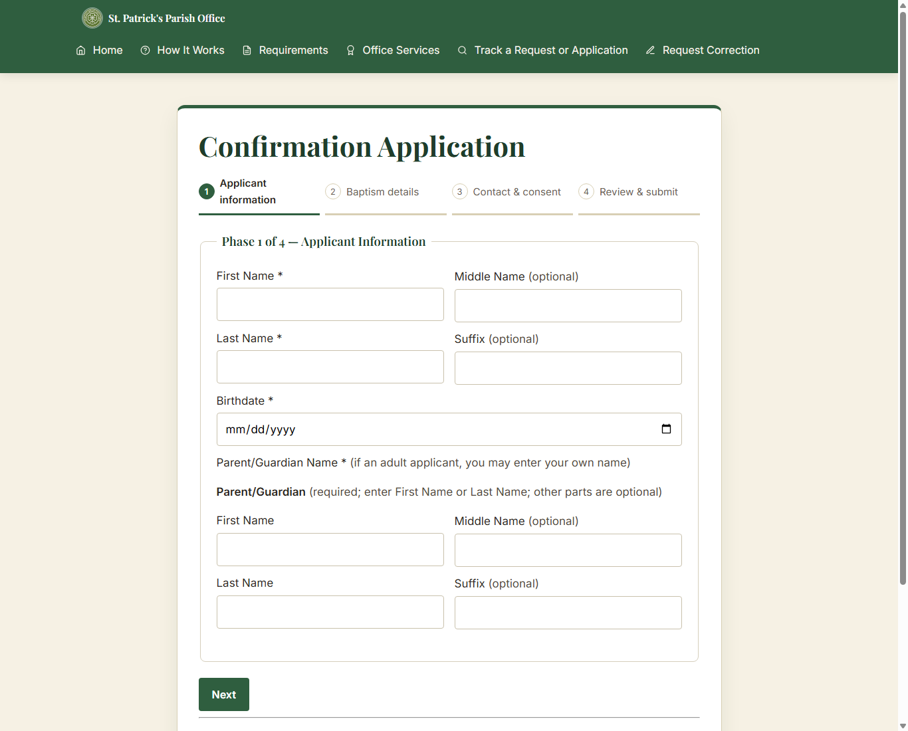
Figure 4. Confirmation application: phased information form (blank local test screen).

Prepare the information
• Baptism: child's name and birth details, parent or guardian contact, known parent details, sponsors if known, and a preferred date if available.
• Confirmation and First Communion: applicant's name and birthdate, parent/guardian contact, and known baptism information. Use "Not sure" when the form offers it and you cannot confirm the detail.
• Marriage: both parties' names, birth and contact details, current marital status, sacramental history, and preferred date/time/venue. The preferred date is a request, not a confirmed booking.

Submit carefully
1. Read the on-screen guidance and complete the required fields in each phase.
2. Use optional name fields only when the information is known; do not invent a middle name or suffix.
3. Review the summary on the final phase and correct errors before submitting.
4. Submit once, then record the tracking number and the email address used.
5. Wait for the secretary to review and contact you about preparation, documents, payment if applicable, or scheduling.
The website does not collect payment. If payment applies, follow the Parish Office instructions; payment is recorded by staff and is never entered as an amount in the system.

5. Tracking a submission and requesting a correction

Track a request or application
Open Track a Request or Application. Enter the tracking number exactly as shown in the confirmation and the same email address provided with that submission. One email can be used for more than one submission; each tracking number is checked separately.
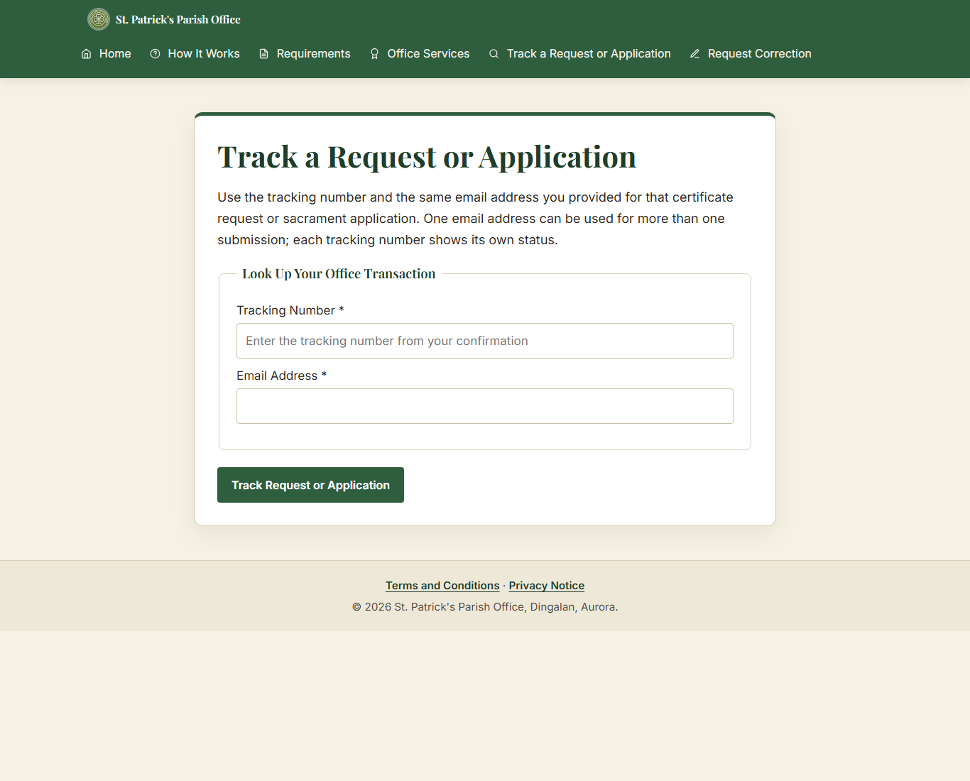
Figure 5. Public status lookup (blank local test screen).
• If no result appears, check for typing errors and confirm that you used the correct email address.
• The displayed status is informational. Contact the Parish Office if you need help interpreting it.

Request a correction
Use Request Correction only for an error on a certificate that has already been issued. Enter the requested tracking/certificate details, describe the error and requested correction, provide contact information, and submit for staff review. The office will verify the original record before making a correction.

A correction request does not automatically change the original parish register or issue a replacement certificate. Wait for the Parish Office to review it.

6. Secretary sign-in and dashboard

Sign in
1. Open the staff login page supplied by the Parish Office.
2. Enter the assigned username and password, then select Log In.
3. If you forget your password, select "Forgot your password?" on the login page, enter the address in the "Staff email" field, select "Send reset link," and use the emailed link. The link works once and expires after 30 minutes. The reset form requires at least 12 characters; it does not currently enforce uppercase, lowercase, and number requirements.
4. If sign-in is blocked, 8 failed attempts for one username within 15 minutes or 20 failed attempts from one IP address within 15 minutes blocks further attempts for 15 minutes. Wait 15 minutes, then use "Forgot your password?" first. If that does not resolve access, ask the designated technical administrator or another active staff member.

Staff sessions end after 30 minutes of inactivity. Sign in again to continue.
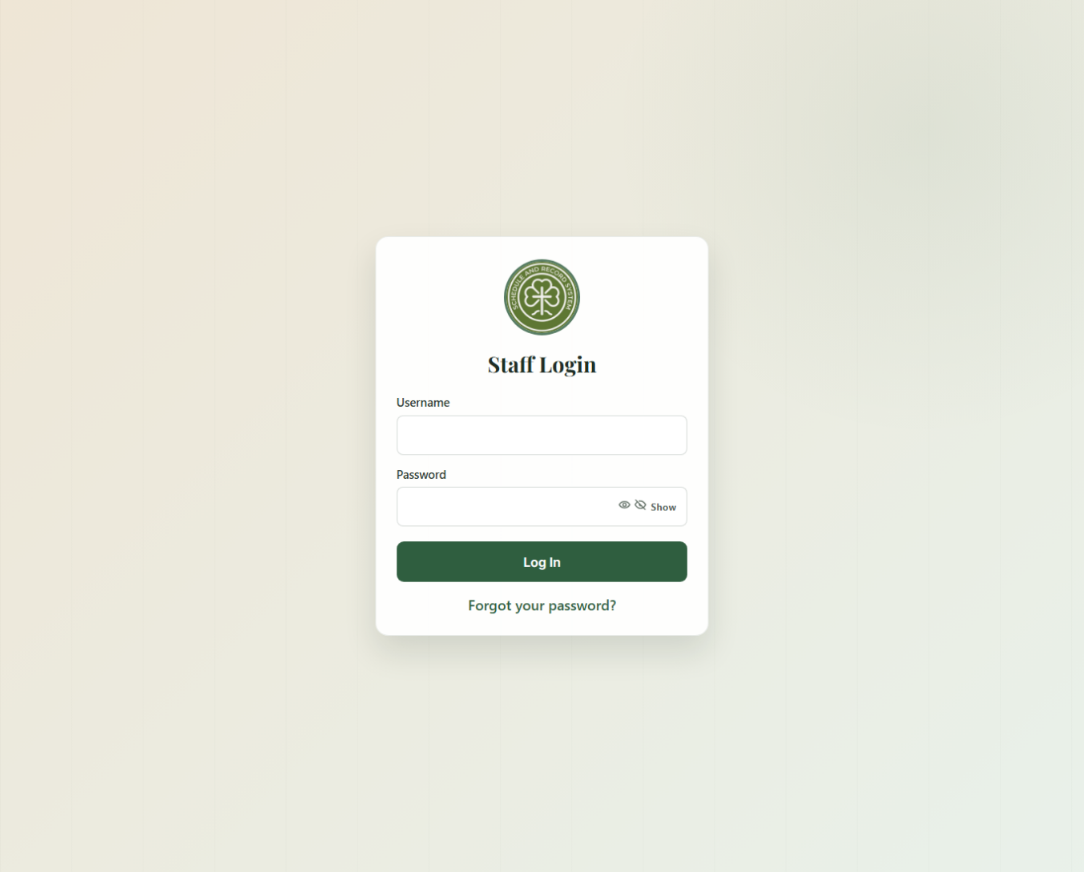
Figure 6. Staff login screen (blank local test installation).

Use the dashboard
The dashboard summarizes pending certificate requests, new applications, ready-for-pickup items, in-progress applications, and sacramental archive totals. Select a card or use the sidebar to open the relevant work area.
• Requests: Online Submissions, Certificate Requests, Sacrament Applications, and walk-in encoding.
• Records: All Records, Baptismal, Confirmation, First Communion, Marriage, Person Linking, Persons.
• Certificates: Generate / Preview, Print / Pickup History, Correction Requests.
• Schedule: Calendar, Booking Conflicts, Announcements.
• Reports: top-bar link (not a sidebar item) for monthly/yearly activity.
• Notifications: top-bar bell with "View All" and "Mark all read."
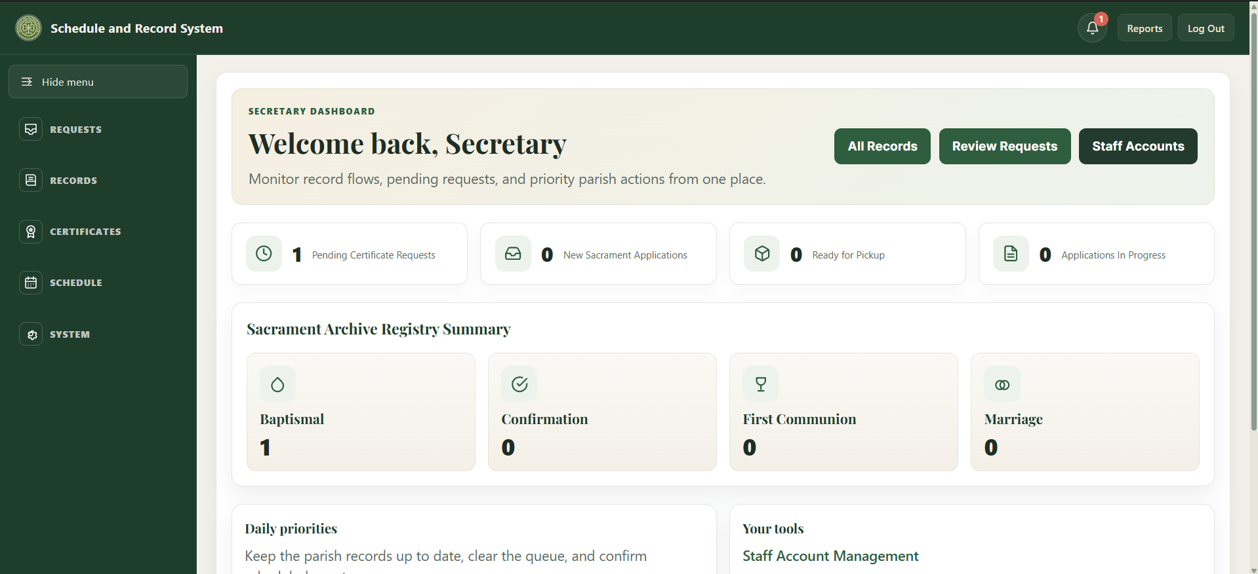
• System: Accounts, Backup, Archive / Restore, Email Log, Audit Log, Database Setup, Clean Up Old Data.

The current system uses the Secretary role for staff accounts. Menu availability can depend on that role and on the hosted build.

7. Reviewing certificate requests
Certificate Requests is the staff queue for certificate copies. Online Submissions provides a broader view of incoming public submissions. Select a row to open its detail page.
1. Search or filter the queue by tracking number, requester, email, status, channel, sacrament, or date as available.
2. Open the request and compare the requester's details with the relevant sacramental record.
3. If a digital record match is available, select the correct record. If it is not encoded, search the physical register and follow the manual process.
4. Verify the digital entry against the physical parish register before certificate generation when the page asks for book verification.
5. Update the request through the available workflow controls. Record a rejection reason when required.
6. If payment is required, follow the Parish Office process outside the system and mark it received only after confirmation. The system records who/when, not a payment amount.
7. Generate/preview the certificate only when the request and matching record satisfy the on-screen checks.
8. When ready, notify the requester according to office practice. Verify identity and record pickup/release through the certificate history workflow.

Processing correction requests
Open Certificates > Correction Requests and open the request. Compare the requested change with the physical register before taking action.
1. Select "Mark as Processing" while reviewing, or "Reject Request" when the request should not proceed. An internal Admin Review Note can be saved with the action.
2. If the correction is approved, correct the record through the parish's record-correction process first. Only after the record has actually been corrected, select "Mark as Completed."

A correction request does not change the parish register by itself. The staff action updates the request status and note; it does not perform the record correction.
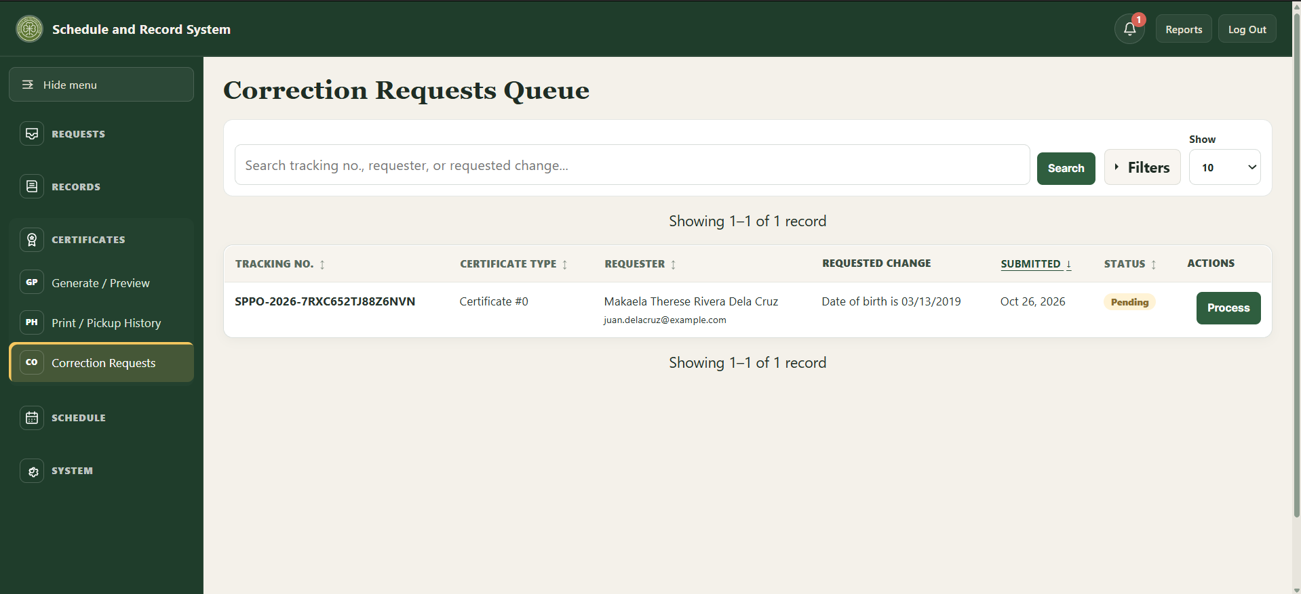

Do not treat a public search match as verification. Check names, dates, sacrament type, and source register. Stop and ask for a second review if any detail is uncertain.

8. Reviewing applications and managing sacramental records

Application queue
Open Sacrament Applications to review applications and manage their current stage. Use filters to narrow by sacrament, status, or submission channel, then open the application details.
• Baptism, Confirmation, and First Communion typically move through review, requirements/documents, preparation, approval, scheduling, and completion.
• Marriage applications include additional steps such as interview, banns, and seminar where applicable.
• Use only the statuses offered for the selected sacrament. The system may block an invalid transition or approval when required checklist items are incomplete.
• For online submissions awaiting payment, record receipt through the payment control before advancing when the workflow requires it.

Walk-in requests and applications
Use Walk-in Request or Walk-in Application when the parishioner is present and staff are encoding an onsite transaction. Confirm the correct submission channel and enter details from the source materials provided by the parishioner. Review the summary before saving.

Sacramental records
Use the relevant register page to search, filter, add, or edit an entry. The register stores the parish record; it is distinct from an online application or a certificate request.
• Enter names in First, Middle, Last, and Suffix fields as provided by the source register. Leave genuinely absent name parts blank.
• Check sacrament date and book/page/line references against the physical register.
• Use All Records for a combined search across sacrament registers. Use record detail pages to review links and history.
• Use Archive/Restore rather than attempting to permanently remove a historical entry. Confirm the record identity before archiving or restoring.

Worked example: Baptismal register entry and walk-in certificate request
The following example shows how a Baptismal register entry can be used when encoding an in-person certificate request. Keep given names, middle name, surname, and suffix in their corresponding fields. Here, “Mikaela Therese” are the given names, “Rivera” is the middle name, and “Dela Cruz” is the surname.

Encoding the register entry
1. Open Records > Baptismal and select “Add New Entry.” Enter the book, page, and line reference from the register. In this example the reference is Book I, page 1, line 1.
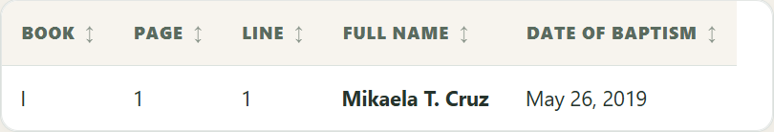
Figure 7. Baptismal Records list showing the encoded entry and baptism date.
2. In the Child fields, enter First Name: Mikaela Therese; Middle Name: Rivera; Surname: Dela Cruz. Enter Birth Date: March 14, 2019; Birthplace: Taguig City; Baptism Date: May 26, 2019; and Place of Baptism: St. Patrick’s Parish Church, Taguig City.
3. Enter the parents in their separate fields: Father Juan Miguel Lopez Dela Cruz (First Name: Juan Miguel; Middle Name: Lopez; Last Name: Dela Cruz) and Mother Ana Patricia Garcia Rivera (First Name: Ana Patricia; Middle Name: Garcia; Last Name: Rivera). The mother’s maiden surname, Rivera, is her last name in the parent section and is the child’s middle name in this example.
4. Enter the other register details as applicable: father’s birthplace Taguig City; mother’s birthplace Makati City; parents’ hometown and residence Taguig City; union type Legitimate (Church Marriage); Godfather Carlos Miguel Santos Reyes; Godmother Elena Grace Mendoza Navarro; and officiating minister Jose Ramon Bautista Santos.
5. Review the final check carefully and save the entry. The saved register entry remains a digital index; verify its details against the physical register before using it to issue a certificate.

Encoding the matching walk-in request
1. Open Requests > Walk-in Request and select Baptismal. Search using the child’s First Name Mikaela Therese, Middle Name Rivera, Last Name Dela Cruz, and Birthdate March 14, 2019. Add parent names to help find the entry, then select the exact register match.
2. Enter the requester as Juan Miguel Lopez Dela Cruz and select Parent as the relationship. For this example, enter juan.delacruz@example.com as the requester email address, then add any other details supplied at the counter.
3. Add a note describing the request as needed. Leave “Payment received at the counter” unchecked unless payment was actually received. Review the summary, then select “Encode Request.”
4. Give the requester the tracking number shown after saving. The request in this example has tracking number SPPO-2026-7RXC652TJ88Z6NVN; each new request receives its own tracking number. The request appears in Certificate Requests with Pending status and creates a staff notification and audit-history entry.
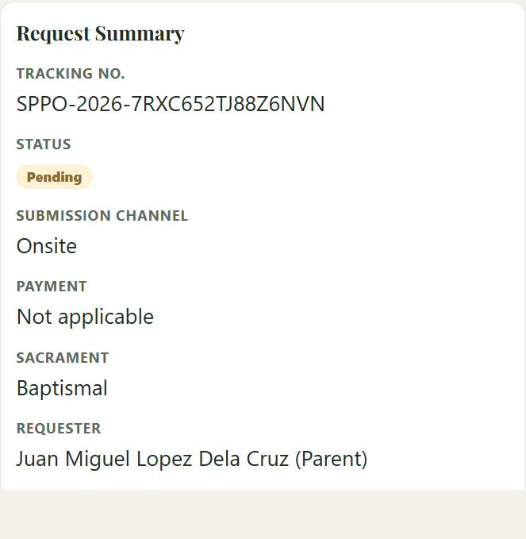
Figure 8. Certificate request summary showing the tracking number, status, and requester.
5. Use the Requirements Checklist to record what was actually received or verified. A matching digital entry alone does not confirm the physical register: the register-location checklist item must still be verified through the certificate preview workflow before certificate generation. Do not mark payment or documents received unless they were actually received.

This example demonstrates encoding and request tracking only. Follow the parish’s normal source-register, identity, payment, checklist, approval, and certificate-release procedures.

9. Generating certificates and recording pickup
1. Open Certificates > Generate / Preview and select the approved request. If it is not already matched, match it to the correct digital record.
2. Compare the digital entry with the physical register book. If the matched record has not been verified, select "Confirm Verification." "Mark as Generated" remains disabled until verification is confirmed.
3. Review the preview. For a Baptismal certificate, select "Print on Blank Stock" for pre-printed stock or "Print Full Certificate" for plain paper; use plain paper for the first alignment test. For other certificates, use "Print Certificate" in the print view.
4. Select "Mark as Generated."
5. Open Certificates > Print / Pickup History. After the physical copy is printed, select "Mark as Printed."
6. After the certificate is signed and sealed, select "Finalize Signed and Sealed."
7. At pickup, verify the claimant's valid ID in person. Enter the claimant name and relationship to the subject, check "I verified valid ID at the counter," add optional notes if needed, then select "Confirm Release."

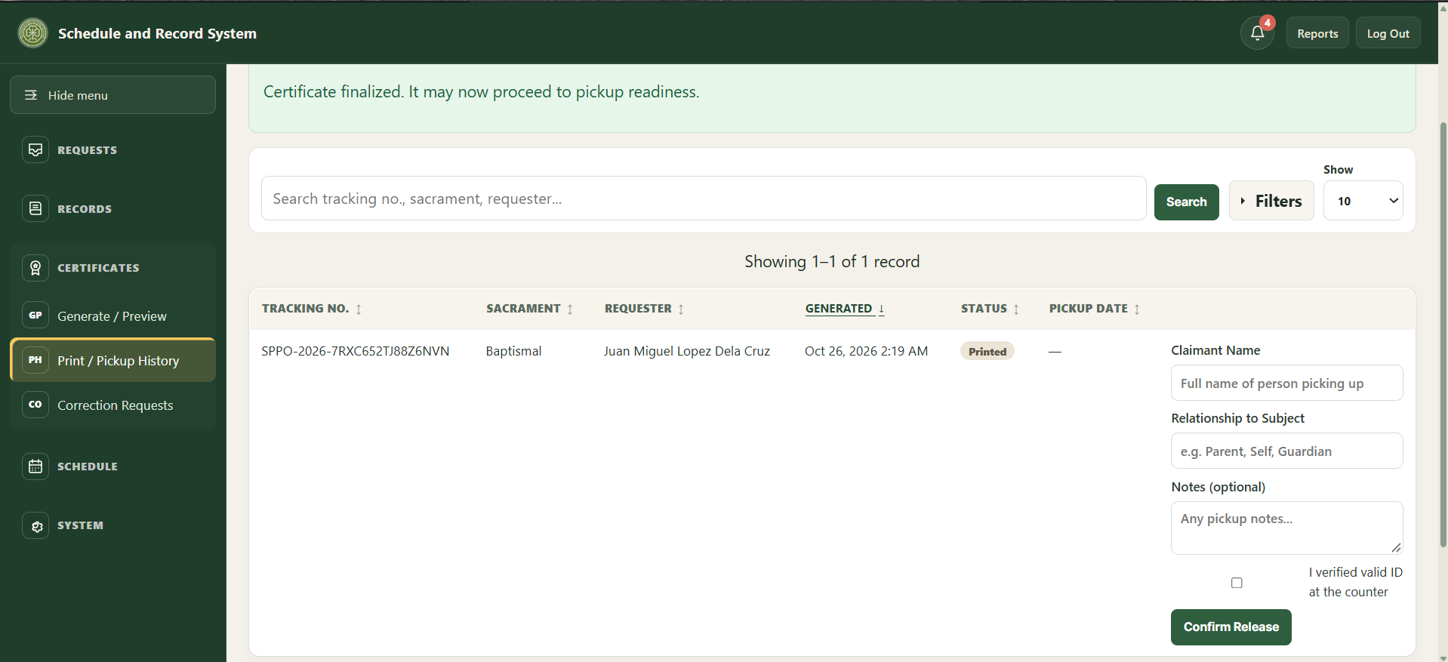

A digital preview is not an issued certificate. Certificate release is an in-person office process.

If the preview is wrong
• Return to the request and check the matched record.
• Do not change a historical record to make it fit a request without checking the physical register and following correction procedure.
• Ask a supervisor or technical administrator for help if generation is blocked or the print alignment is incorrect.
• If the certificate must be generated again, select "Regenerate" and confirm with "Confirm Regeneration." The current generation log is updated rather than silently creating another active log.

10. Calendar, announcements, and reports

Calendar
• Open Schedule > Calendar. Use Month or List to browse events; use Previous, Next, and Today to move through dates.
• Select Add event to enter the event type, title, date, and optional times. Review conflict warnings; the secretary resolves scheduling conflicts manually.
• Public details are optional text intended for parishioners and appear in the public calendar's event details. Keep names and personal information out unless disclosure is appropriate and permission has been obtained.
• Staff notes are internal to staff and are not shown in the public event dialog. Keep confidential or operational details there.
• The Search, edit, or remove events section below the calendar is collapsible. Open it when you need the full searchable table or event actions.

Announcements
Use Schedule > Announcements to create or update public notices. Check the title, text, publication setting, and any date before publishing. Remove or unpublish outdated notices according to parish practice.

Reports
• Open Reports and choose Monthly or Yearly, then select the reporting period.
• Records Encoded counts records by the date they were entered into the system, not the historical date of the sacrament. A record added today for an older baptism belongs to today's encoding period.
• Certificate Requests Submitted and Sacrament Applications Submitted measure intake in the selected period. Export CSV downloads the displayed period's report data.

11. System administration and backups
These tasks do not use a separate administrator role. In-app maintenance is done through the same Secretary staff accounts; the designated technical administrator handles hosting, recovery, and database restoration.

Staff accounts
Open System > Accounts to manage authorized staff accounts. Passwords set or changed here must be at least 12 characters and include an uppercase letter, a lowercase letter, and a number. An account cannot deactivate or delete itself, and the last active account cannot be deactivated or deleted. If system history references an account, deletion is blocked; deactivate that account instead.
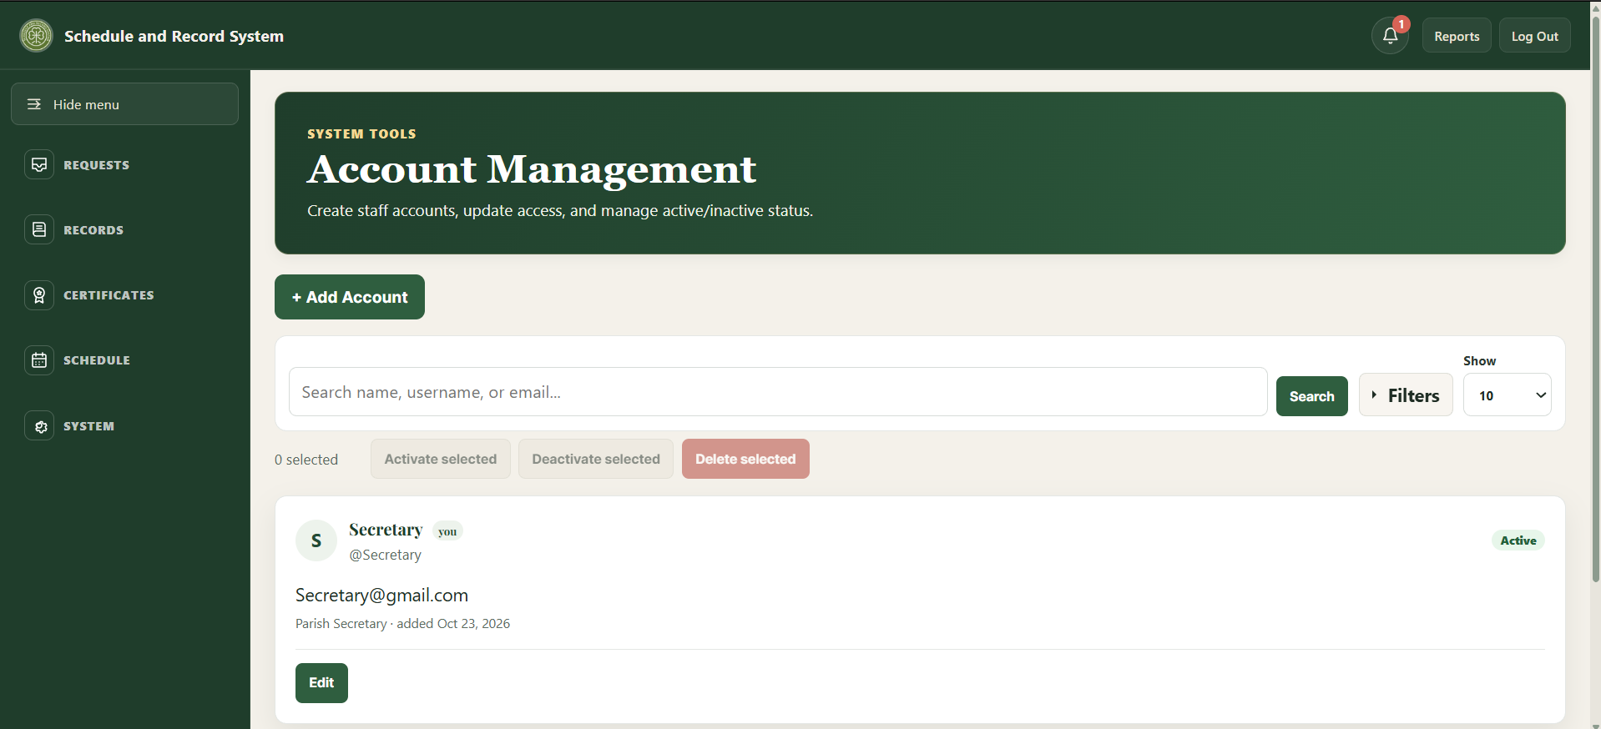

Database updates
Database Setup lists supported compatibility updates and checks whether their database objects exist. Updates do not run automatically during normal page loads.
1. Create and verify a fresh backup before applying a database update.
2. Open System > Database Setup and read the update description and status.
3. Check the status: "Ready to update," "Already up to date," or "Needs administrator review." Use "Apply update" only when an update is ready, or "Mark as already updated" when that option is offered for an update already present. Stop and ask the technical administrator if review is needed.
4. Wait for completion confirmation, then reload the relevant page and verify expected behavior.

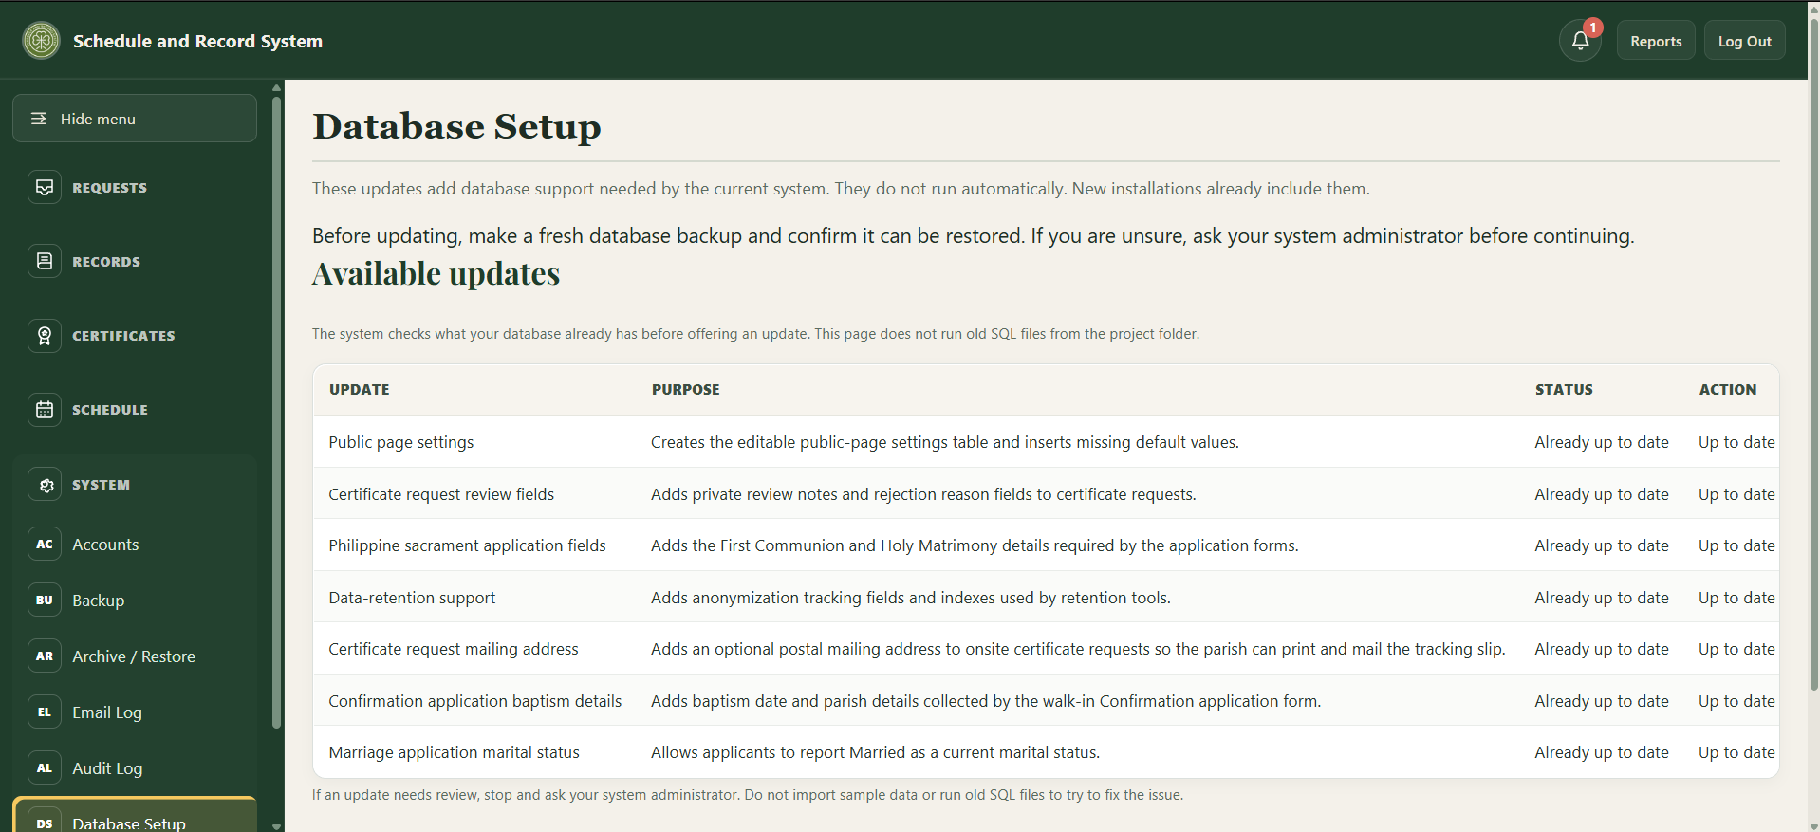

Encrypted backup/export
Open System > Backup. The password field is labeled "Administrator password"; enter the signed-in staff account password there. Provide a backup passphrase of at least 12 characters, then download the encrypted export and store its passphrase separately. The export excludes password hashes, password-reset tokens, submission rate-limit data, and email delivery logs.
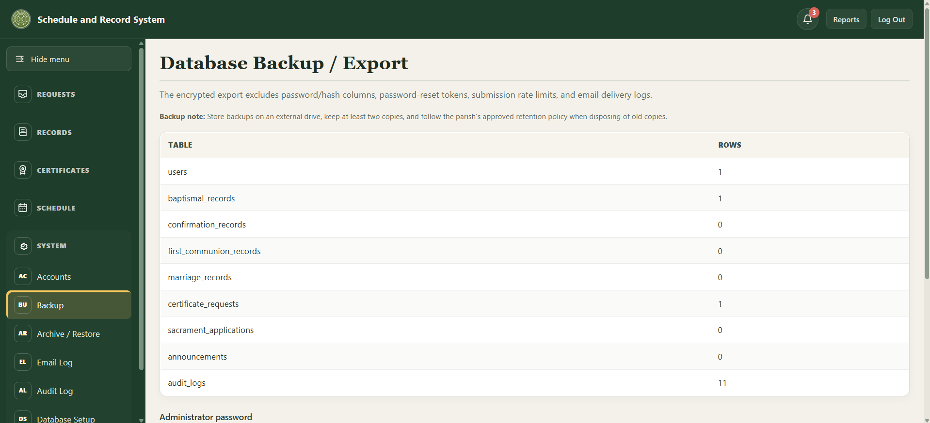
• Keep at least two protected copies in approved storage. Do not email an unencrypted export or store the passphrase alongside the file.
• Database restoration is handled by the designated technical administrator.

Email Delivery Log
Open System > Email Log to review sent, failed, and other recorded email-delivery attempts. A "sent" status means the configured local mail relay accepted the message; it does not guarantee delivery to the recipient's inbox.
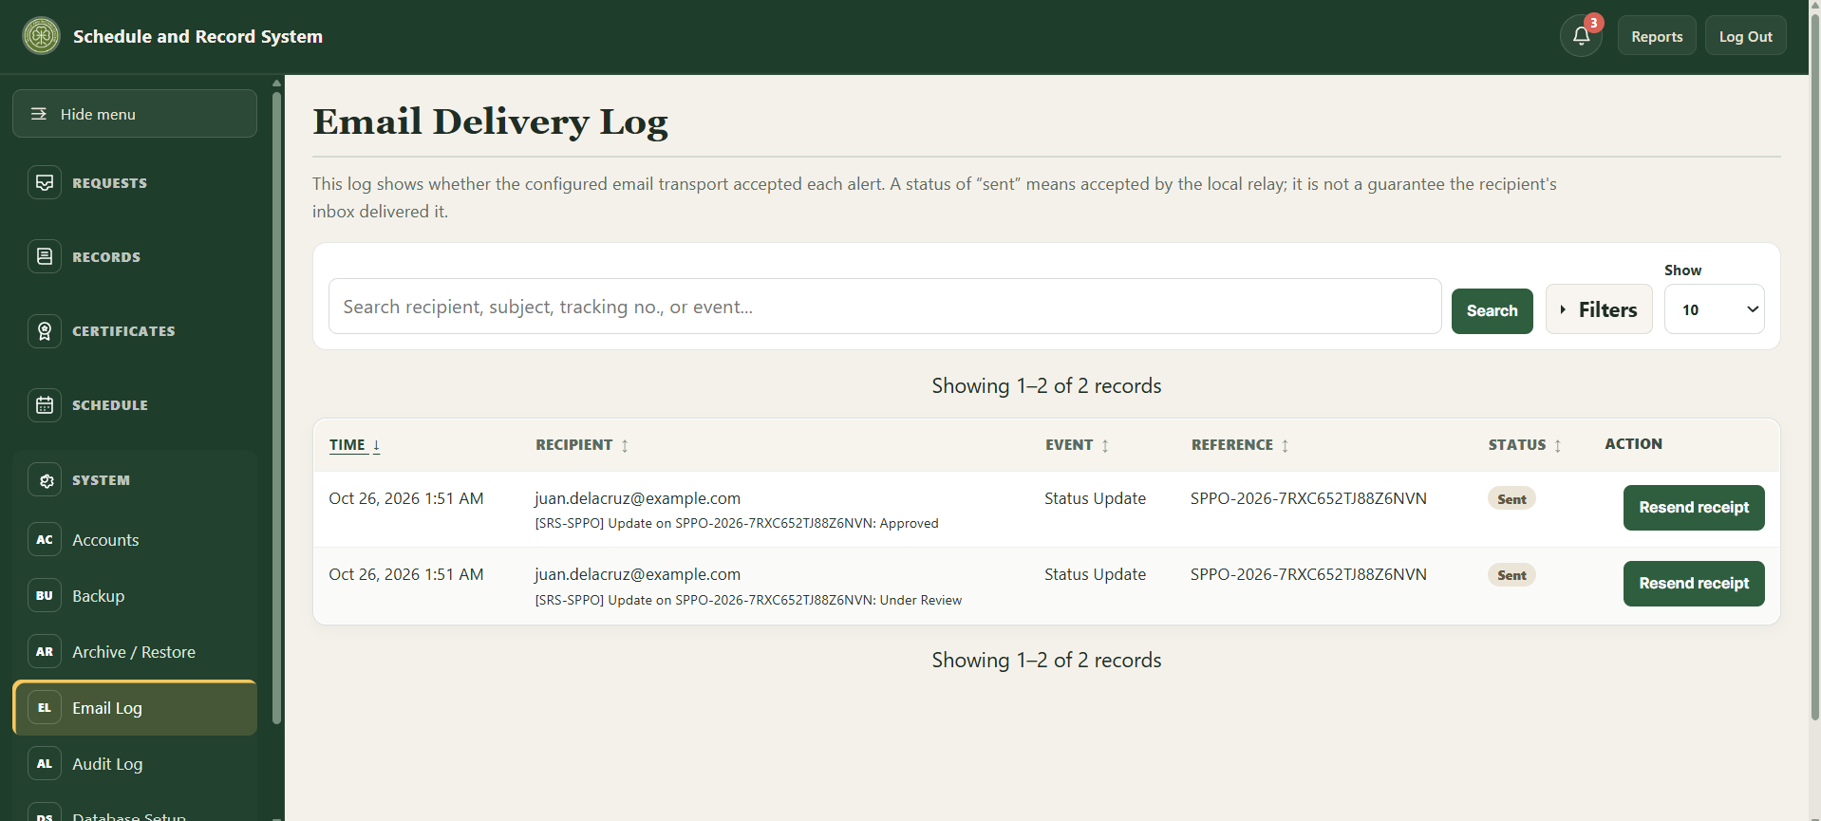

Clean Up Old Data
This cleanup anonymizes older finished certificate requests (released, rejected, or cancelled), sacrament applications (completed, rejected, or cancelled), and correction requests (completed or rejected), using the retention periods configured for this installation. It scrubs old audit-log details and removes older email-delivery logs, notifications, rate-limit entries, and expired or used password-reset tokens. Open submissions and permanent church-register and person records are not changed.
Back up the database before continuing. The page first previews counts without changing data; "Run cleanup now" is an irreversible action. If the readiness check fails or you are unsure, stop and ask the designated technical administrator.
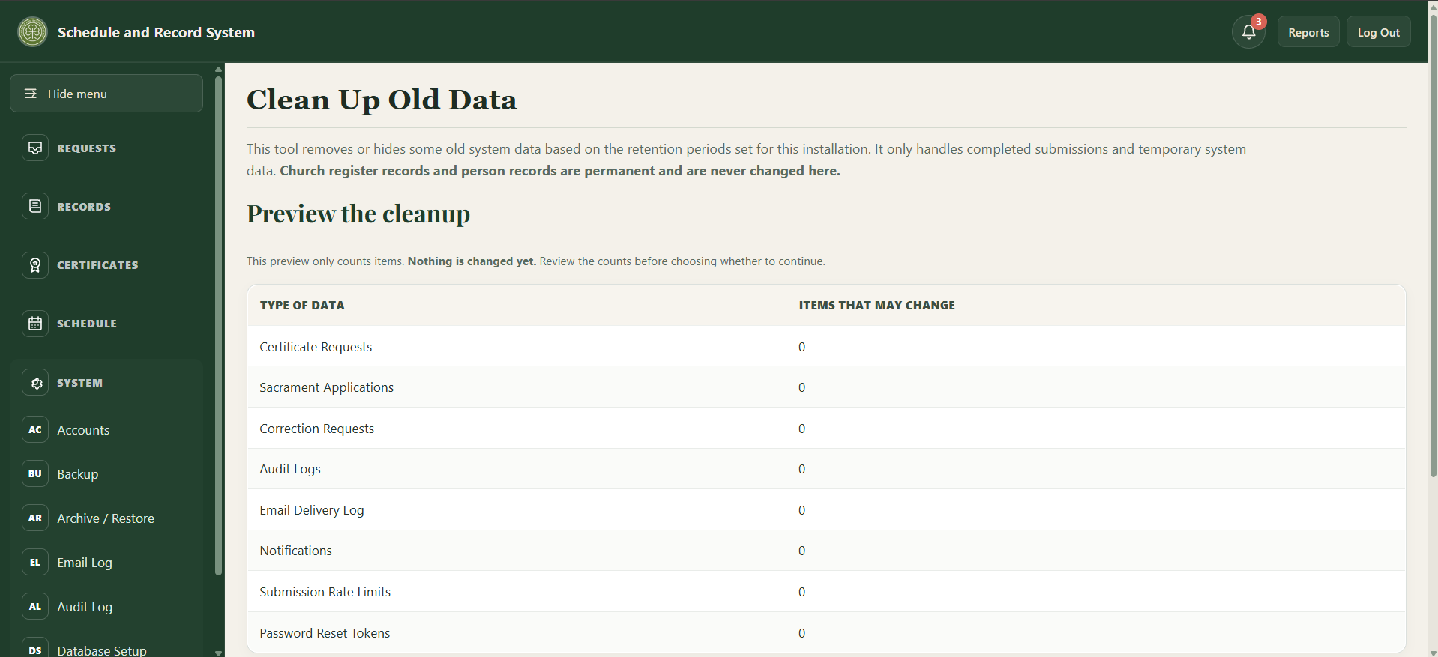

Audit and other system tools
Use the Audit Log to review recorded staff actions. Person Linking and Persons are under Records, not System; use these tools only after confirming the person and register entries. Database maintenance, hosting configuration, and recovery should be performed by the designated technical administrator.

12. Troubleshooting and quick reference

Public user quick checks
• Record not found: check spelling and dates, provide one or both parent names if known, or ask the secretary to search the physical register.
• Tracking lookup fails: use the exact tracking number and the same email used on that submission.
• Form will not advance: review highlighted errors and complete required fields; optional middle names and suffixes may remain blank.
• Calendar event has no details: only events with public details entered by staff open a details view.
• Need additional requirements: contact the Parish Office; online form lists are guidance, and the secretary confirms final requirements.

Staff quick checks
• Page reports an unknown database column: do not repeatedly submit the form. Back up the database, open Database Setup, and apply the matching supported update or ask the technical administrator.
• No certificate preview: verify approval, correct record match, physical-book verification, and required checklist items.
• Unexpected report totals: confirm selected month/year and remember encoded-record totals use date entered, while service dates may be historical.
• Calendar conflict: compare date and time with other scheduled events and resolve with the parties involved; the system flags but does not automatically decide the booking.
• Logged out unexpectedly: staff sessions end after 30 minutes of inactivity; sign in again.
• Too many failed attempts: wait 15 minutes, then use "Forgot your password?".
• Password reset email did not arrive: check System > Email Log, check the spam folder, and confirm the staff email address on the account in System > Accounts.
• Login or permission problem: after trying password reset, ask the designated technical administrator or another active staff member. Do not share passwords through chat or email.

Terms
• Certificate request: request for a copy of an existing parish register record.
• Sacrament application: request to begin preparation for a future sacrament.
• Tracking number: reference used with the submission email to check status.
• Public details: optional event description visible to website visitors.
• Staff notes: internal event notes intended for authorized staff.
Appendix F
Curriculum Vitae
  CONTACT  09152181642  fatimaamistoso24@gmail.com  TANAWAN, DINGALAN, AURORA | AMISTOSO  FATIMA S.  EDUCATION  ELEMENTARY – SY 2010-2016  Silanganan Elementary School  JUNIOR HIGHSCHOOL – SY 2016-2020  Dingalan National High School  SENIOR HIGHSCHOOL – SY 2020-2022  Dingalan National High School  COLLEGE  Nueva Ecija University of Science and Technology, Gabaldon Campus (BS Information Technology)

  CONTACT  09670478073  Julyanightire@gmail.com  PALTIC, DINGLAN, AURORA | CORDOVA  JULYAN O.  EDUCATION  ELEMENTARY – SY 2009-2015  Paltic Elementary School  JUNIOR HIGHSCHOOL – SY 2015-2019  Saint Patrick's Academy  SENIOR HIGHSCHOOL – SY 2019-2021  Saint Patrick's Academy  COLLEGE  Nueva Ecija University of Science and Technology, Gabaldon Campus (BS Information Technology)

  CONTACT  09301618241  bhitinarochelle25@gmail.com  UMIRAY, DINGLAN, AURORA | EBOL  ROCHELLE E.  EDUCATION  ELEMENTARY – SY 2008-2014  Umiray Elementary School  JUNIOR HIGHSCHOOL – SY 2014-2018  Umiray National High School  SENIOR HIGHSCHOOL – SY 2018-2020  Ibona High School  COLLEGE  Nueva Ecija University of Science and Technology, Gabaldon Campus (BS Information Technology)

  CONTACT  09509698815  vincejayrown123@gmail.com  Malinao, Gabaldon, Nueva Ecija | POSAS  VINCE JAYROWN  EDUCATION  ELEMENTARY – SY 2009-2015  Apolonia F. Rafael Elementary School  JUNIOR HIGHSCHOOL – SY 2015-2019  Mapulang Lupa National High School  SENIOR HIGHSCHOOL – SY 2019-2021  Our Lady of Lourdes College  COLLEGE  Nueva Ecija University of Science and Technology, Gabaldon Campus (BS Information Technology)

