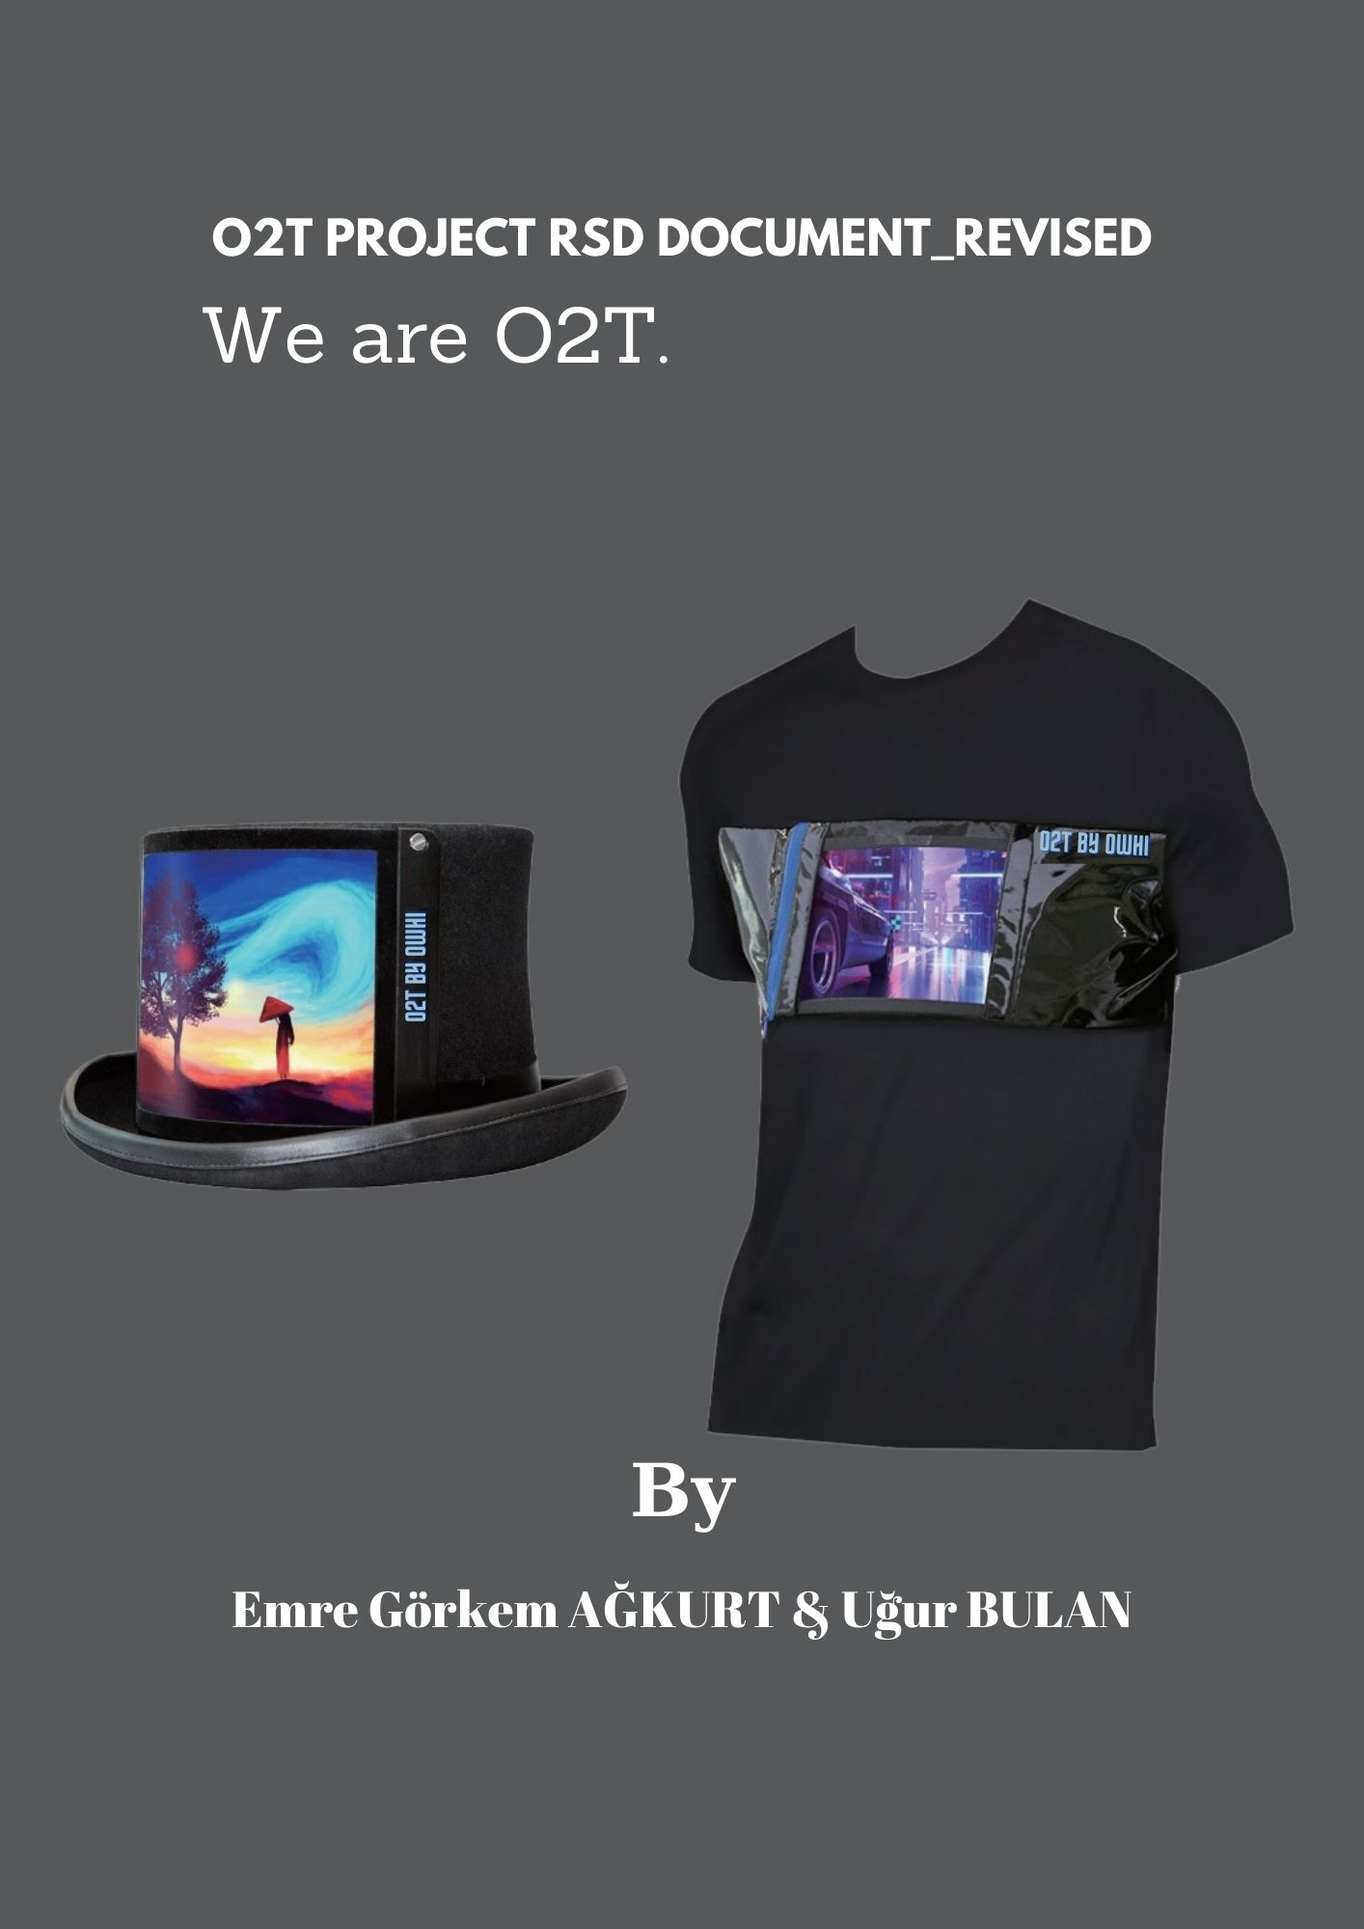
Revision History

Date | Revision | Description | Author
17.11.22 | 1.0 | RSD document of O2T Project | Ağkurt & Bulan
05/07/23 | 2.0 | RSD document of O2T Project_revised | Ağkurt & Bulan

Table of Contents
1. Introduction 1
1.1. Purpose 1
1.2. Scope 1
1.3. Acronyms and Definitions 1
1.3.1. Acronyms 1
1.4. Total Way of Product 1
2. Overall Specifications 2
2.1. Functional Requirements Specifications 2
2.2. Non-Functional Requirements Specifications 2
2.3. Design Constraints Specifications 2
2.4. Disaster Recovery Specifications 2
2.5. Documentation Specifications 2
2.6. Workload Specifications 2
2.7. Graphical User Interface (GUI) Specifications 2
2.8. Quality Attributes Specifications 2
2.9. Reliability Specifications 2
3. Interfaces 3
3.1. Communications Interfaces 3
3.2. Hardware Interfaces 3
3.3. Software Interfaces 3
3.4. User Interfaces 3
4. References 4

Introduction
The O2T project is an innovative system designed to bring animations and games to life on a LED matrix screens through a user-friendly mobile application. By integrating a Raspberry Pi, an Arduino, an LED matrix, and an Android device, the project enables users to control captivating visuals and interactive experiences with ease. Through the seamless communication between the Raspberry Pi and Arduino, powered by a shared ground connection, the system harnesses the potential of a custom shell script and Python code running on the Raspberry Pi. This allows the mobile application, operating on the Android device, to send commands and instructions to the Arduino, which then translates them into captivating displays on the LED matrix. With its ability to support various functionalities, such as text writing, animations, and even games like the popular snake game, the O2T project opens up a world of creativity and entertainment for users to explore.

Purpose
- Sustainability and Low Carbon Emissions
According to “T-shirts typically have a shelf life of six months to a year,” says Men's Health magazine executive fashion director Brian Boyé;
“You'll want to replace them as soon as you start to notice discoloration.”
With the O2T project, we prevent these discolorations and the wear of the design of the worn product. The life of a t-shirt, which you can control with the mobile application and make your designs, will be directly proportional to its textile quality. However, it can significantly reduce the weight of waste textile products and our carbon footprint, which is thrown out millions of tons every day because its design is ageing.
2. Smart Advertising
Athletes place the emblems of these companies on the clothes they wear to advertise their sponsors. As a result of this process made by printing on classical wearable textile products, these emblems cannot be replaced, so they can find very few sponsors. O2T technology aims not only to reduce environmental pollution but also to global marketing strategies. Thanks to O2T, numerous sponsors' emblems can be displayed on the digital screen, which can be adjusted from the mobile application.



For example, some watch brands advertise on the gloves of f1 pilots. However, that watch advertisement consists of a picture affixed to the glove by means of printing. Athletes cannot receive more than one sponsor as there is no more room left in the glove. Thanks to the flexible screen that we can place on the glove, the athlete will be able to get sponsors from more than one watch brand.

Scope
- Main components
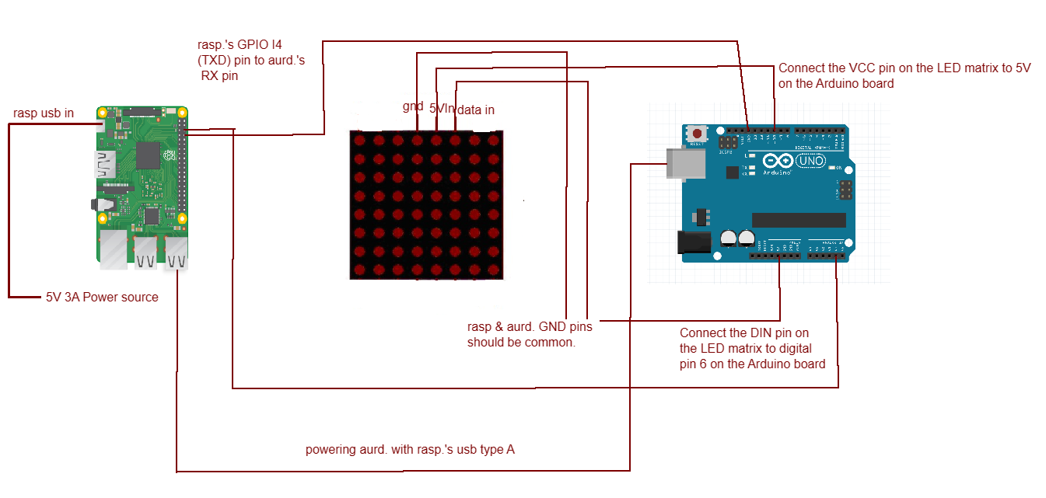
- Raspberry Pi: This small single-board computer serves as the central control unit of the system, responsible for processing commands from the mobile application and sending instructions to the Arduino.
- Arduino: Acting as an interface between the Raspberry Pi and the LED matrix, the Arduino board receives commands from the Raspberry Pi and translates them into signals that can be understood by the LED matrix.
- LED Matrix: An 8x8 matrix of LEDs that serves as the display for animations and games. It receives instructions from the Arduino and illuminates the LEDs accordingly to create visually appealing patterns and effects.
- Android Device: The project is accessed and controlled through a mobile application running on an Android device. The app allows users to send commands and interact with the LED matrix, choosing animations, games, or even inputting custom text.
- Shell Script: A custom shell script running on the Raspberry Pi initiates the communication between the Raspberry Pi and Arduino, facilitating the exchange of commands and data.
- Python: The Raspberry Pi runs a Python code that checks the network connectivity between the Raspberry Pi and the Android device. It ensures that both devices are on the same network before initiating the transmission of commands to the Arduino.
- Power Supply: The Raspberry Pi is powered by batteries, while the Arduino is powered by the USB output of the Raspberry Pi. This arrangement ensures a consistent power supply to the system.
- 1x Sweatshirt
- 3x Jumper Cables

By combining these components and leveraging their functionalities, the O2T project enables users to control and manipulate captivating animations and games on the LED matrix using a mobile application.

- Mobile Application
The mobile application in the O2T project serves as the primary interface for controlling and interacting with the LED matrix. Here is a brief summary of its main features:
User Interface: The mobile application provides a user-friendly interface that allows users to easily navigate and access various functionalities of the O2T system.
Animation Selection: Users can choose from a selection of pre-defined animations to be displayed on the LED matrix. These animations can include moving patterns, visual effects, or scrolling text.
Game Interaction: The mobile application offers interactive games that can be played on the LED matrix. Users can control the gameplay through the app, directing characters or objects on the matrix to achieve certain objectives.
Customization Options: Users have the ability to customize the LED matrix display by inputting their own text or creating personalized animations. This feature allows for a unique and personalized user experience.
Connectivity: The mobile application establishes a connection with the Raspberry Pi, enabling seamless communication between the app and the O2T system. This ensures that commands and instructions from the app are accurately transmitted to the LED matrix.
Real-time Updates: The mobile application provides real-time updates and feedback on the status of the LED matrix, allowing users to monitor the currently displayed animation or game progress.

Overall, the mobile application enhances the user experience by providing intuitive controls and a range of interactive features, enabling users to engage with captivating animations and games on the LED matrix.

Acronyms and Definitions

Acronyms

Term | Definition
O2T | Stands for "Owhi To Tech." It refers to the overall project aimed at creating a system that enables animations and games on an 8x8 LED matrix through a mobile application.
LED | Short for Light Emitting Diode. It is a semiconductor device that emits light when an electric current passes through it. The LED matrix consists of an array of these light-emitting diodes.
Raspberry Pi | A small single-board computer that serves as the main controller in the O2T system. It provides the necessary computing power and interfaces to communicate with the LED matrix and the mobile application.
Arduino | An open-source electronics platform used for building interactive projects. In the O2T project, the Arduino board is employed to facilitate communication between the Raspberry Pi and the LED matrix.
Mobile Application | Refers to the software application designed to run on a mobile device, such as a smartphone or tablet. It allows users to control and interact with the O2T system, selecting animations, playing games, and customizing the LED matrix display.
SDK | Stands for Software Development Kit. It is a collection of tools, libraries, and documentation that developers use to create software applications for a specific platform or framework. In the context of the O2T project, there may be an Android SDK involved for developing the mobile application.
API | Short for Application Programming Interface. It defines a set of rules and protocols that allows different software applications to communicate and interact with each other. The O2T project may utilize APIs to establish communication between the mobile application, Raspberry Pi, and Arduino.
Python | A widely used high-level programming language known for its simplicity and readability. In the O2T project, Python may be used for coding various functionalities, such as controlling the Raspberry Pi, interacting with the LED matrix, and handling communication with the mobile application.
Unix Shell Script | A script written in a shell scripting language that runs in a Unix-based operating system. It is used for automating tasks, executing commands, and managing system resources. In the O2T project, a Unix shell script may be employed to initiate specific actions or sequences of commands on the Raspberry Pi.
Java | A modern programming language used for developing Android applications. It offers enhanced functionality and interoperability. In the O2T project, Java may be utilized for coding specific components or functionalities of the mobile application.
Jumper Cable | A jumper cable, also known as a jumper wire or simply a jumper, is an electrical cable with connectors on each end used to establish a temporary electrical connection between two points or components. It is typically made of insulated wires with alligator clips, male/female headers, or other types of connectors attached to the ends.
XML | Extensible Markup Language - A markup language used for structuring and organizing data in a human-readable format. In the O2T project, XML files may be employed for defining the layout and configuration of the Android application's user interface.

These acronyms and definitions provide a basis for understanding the key terms and concepts associated with the O2T project and its various components.

Total way of product

1. Crafting Budget

Market research was conducted for the required components and these components were ordered.
According to each external component:
- 1x Raspberry Pi (we have already) = 0TL.
- 40x Jumper Cable male to male = 18,24TL
- 40x Jumper Cable female to male = 18,24TL
- 40x Jumper Cable female to female = 18,24TL
- 1x Arduino UNO = 126,56TL
- 1x 16x16 Led Matrix (FAILED) = 240,66TL
- 1x 16x32 Concept Led Matrix for Research = 432,59TL
- 1x 8X8 Led Matrix = 256,50TL
- 1x Sweatshirt = 0TL

2. Accounting Operations and Management
2.1. Budgeting and Cost Estimation:
a. Identify the hardware components required for the O2T Project, such as Raspberry Pi, Arduino Uno, LED matrix, jumper cables, and power supply.
b. Estimate the costs associated with purchasing these hardware components, considering factors like quantity, quality, and any additional accessories or peripherals required.
c. Allocate a budget for software development, including licenses, development tools, and any third-party libraries or frameworks needed.

2.2 Expense Tracking and Control:
a. Maintain a record of all project-related expenses, including hardware and software purchases, development costs, testing expenses, and any other financial transactions.
b. Implement an expense tracking system to monitor and control project expenditures, ensuring they align with the allocated budget.
c. Regularly review and analyze project expenses to identify areas where cost optimization or adjustments can be made.

3. Marketing Plans and Brand Recognition

Since we will be investing in the project after the academic situation, questions such as how we open this project to the public and how this project is promoted? began to be considered and noted. In this process, it was decided to get support from a marketer later on.
However, these are the steps that we are thinking to follow later on:
- Market Research:
a. Conduct comprehensive market research to identify the target audience, their preferences, and needs related to the O2T Project.
b. Analyze the competition, market trends, and potential opportunities to position the project effectively.
- Brand Identity and Messaging:
a. Develop a strong brand identity for the O2T Project, including a logo, tagline, and visual elements that represent its values and unique selling propositions.
b. Craft clear and compelling messaging that communicates the project's features, benefits, and value proposition to the target audience.
- Online Presence:
a. Create a professional website dedicated to the O2T Project, providing information about its functionalities, hardware requirements, and software capabilities.
b. Utilize search engine optimization (SEO) techniques to improve the project's visibility in online searches and drive organic traffic to the website.
c. Establish social media profiles on platforms relevant to the target audience, regularly sharing updates, project milestones, and engaging content to build a community around the project.
- Content Marketing:
a. Develop informative and engaging content, such as blog posts, articles, and video tutorials, highlighting the features and applications of the O2T Project.
b. Share this content through various channels, including the project website, social media platforms, relevant online forums, and industry publications.
c. Collaborate with influencers, bloggers, or technology enthusiasts who can review and endorse the project to expand its reach and credibility.
- Strategic Partnerships:
a. Identify potential strategic partners, such as technology companies, educational institutions, or hardware manufacturers, who can support or promote the O2T Project.
b. Collaborate with these partners to co-market or integrate the project with their offerings, leveraging their existing customer base and brand recognition.
- Events and Demonstrations:
a. Participate in relevant industry events, conferences, or trade shows to showcase the O2T Project and engage with potential users, investors, or collaborators.
b. Conduct live demonstrations of the project's capabilities, allowing attendees to experience its functionalities firsthand and understand its value.
- User Feedback and Testimonials:
a. Encourage users of the O2T Project to provide feedback, testimonials, or case studies highlighting their positive experiences and successful implementations.
b. Share these testimonials on the project website, social media platforms, and marketing materials to build trust and credibility among the target audience.

Overall Specifications

Functional Requirements Specifications
2.1.1. Mobile Application
- The mobile application should have a user-friendly interface for controlling the LED matrix.
- Users should be able to select and play pre-defined animations and games.
- The application should provide options for customizing and creating new animations.
- Users should be able to send commands to the Arduino for displaying text, running animations, or playing games on the LED matrix.
2.1.2. Raspberry Pi
- The Raspberry Pi should establish communication with the Arduino via serial connection.
- It should run a shell script that triggers the Arduino based on user commands from the mobile application.
- The Raspberry Pi should check if the Android device and Raspberry Pi are on the same network for communication.
2.1.3. Arduino
- The Arduino should receive commands from the Raspberry Pi and interpret them to control the LED matrix.
- It should use the Adafruit library to interface with the LED matrix and display animations and games.

Non-Functional Requirements Specifications
2.2.1. Performance
- The system should have a responsive user interface, ensuring that interactions with the mobile application are smooth and without noticeable delays.
- The animations and games displayed on the LED matrix should run smoothly and without any visible lag.
- The system should be able to handle multiple user connections simultaneously without compromising performance.
2.2.2. Reliability
- The system should be highly reliable, minimizing the occurrence of errors or failures during operation.
- It should be capable of recovering from unexpected errors or disruptions, such as network connectivity issues or power outages.
- The LED matrix should display animations and games accurately, without any artifacts or distortions.
2.2.3. Scalability
- The system should be scalable, allowing for the addition of more LED matrices or expansion of functionality in the future.
- It should support a growing number of users without significant performance degradation.
- The software architecture should be designed in a modular and extensible manner to facilitate future enhancements or modifications.
2.2.4. Security
- The system should ensure the security of user data and prevent unauthorized access or tampering.
- User authentication mechanisms should be implemented to restrict access to sensitive features or data.
- Communication between the mobile application, Raspberry Pi, and Arduino should be encrypted to protect against potential vulnerabilities.
2.2.5. Usability
- The mobile application should have an intuitive and user-friendly interface, making it easy for users to navigate and control the LED matrix.
- Clear instructions and tooltips should be provided within the application to guide users on its usage and features.
- The system should support multiple languages, allowing users from different regions to use the application effectively.
2.2.6. Maintainability
- The software codebase should be well-structured, following best practices and coding standards.
- Documentation should be provided, including system architecture, APIs, and user guides, to facilitate future maintenance and updates.
- The system should be designed with modularity and reusability in mind, enabling efficient troubleshooting and code modifications.
2.2.7. Compatibility
- The mobile application should be compatible with a wide range of Android devices, supporting various screen sizes and resolutions.
- The system should work seamlessly with different versions of the Raspberry Pi and Arduino, ensuring compatibility across hardware revisions.
These non-functional requirements specify the desired qualities and characteristics of the O2T Project beyond its functional capabilities. They address aspects such as performance, reliability, scalability, security, usability, maintainability, and compatibility, ensuring that the system meets the expectations and needs of its users while providing a robust and enjoyable experience.

Design Constraints Specifications
2.3.1. Technical Expertise
- The design and implementation of the screen and its associated module require expertise in Python programming language.
- Basic knowledge of physics is necessary to determine the center of gravity of the t-shirt and ensure proper voltage distribution.
- An electronic electrical specialist is required to ensure the overall stability and functionality of the product from an electronic standpoint.
2.3.2. Hardware Compatibility
- The screen and module should be designed to be compatible with standard t-shirt sizes and shapes.
- Considerations should be given to the weight and dimensions of the components to maintain the comfort and wearability of the t-shirt.
2.3.3. Power Requirements
- The screen and module should be designed to operate within specified power requirements, considering the limitations of the power source and battery life.
- Efforts should be made to optimize power consumption and ensure efficient use of resources.
2.3.4. Safety Regulations
- The design and construction of the screen and module should comply with relevant safety regulations and standards to ensure user safety.
- Proper insulation and grounding techniques should be employed to minimize the risk of electrical hazards.
2.3.5. Cost Constraints
- The design should consider cost constraints in terms of material selection, production processes, and overall manufacturing expenses.
- Cost-effective components and manufacturing methods should be explored without compromising product quality and functionality.
2.3.6. Production and Assembly Constraints
- The design should consider ease of production and assembly, taking into account the available production facilities and resources.
- Compatibility with standard manufacturing processes and techniques should be ensured to streamline production and reduce costs.
These design constraints specify the limitations and considerations that need to be taken into account during the development and implementation of the O2T Project. They encompass technical expertise requirements, hardware compatibility, power requirements, safety regulations, cost constraints, and production and assembly considerations. Adhering to these constraints will contribute to the successful realization of the project while ensuring its safety, functionality, and cost-effectiveness.

Disaster Recovery Specifications
The information documents used in the project, the protection of the product if it has entered the market since the release date, the warranty conditions to be given to the consumer, the documents containing the production, repair and distribution costs have been backed up to the cloud drive in case the devices we work with are damaged.
2.4.1. Disaster Response Plan
- A comprehensive disaster response plan should be developed and documented, outlining the steps to be taken in the event of a disaster or system failure.
- The plan should include procedures for notifying relevant personnel, activating backup systems, and restoring the system to its normal operation.
- Regular drills and tests of the disaster response plan should be conducted to validate its effectiveness and identify areas for improvement.
2.4.2. Security Measures
- Disaster recovery plans should incorporate appropriate security measures to protect the O2T system and its data during and after a disaster.
- Access controls, encryption, and other security mechanisms should be implemented to safeguard sensitive information from unauthorized access or tampering.
- Regular security audits and updates should be conducted to identify and address potential vulnerabilities in the system.
2.4.3. Business Continuity
- The disaster recovery specifications should aim to minimize the impact of a disaster on the overall business operations and ensure continuity of critical functions.
- Alternative communication channels, temporary workspaces, and contingency plans should be established to enable key personnel to continue their work even during a disaster.
- Business impact assessments should be conducted to identify and prioritize critical processes and resources, guiding the disaster recovery efforts.

Documentation Specifications
In the documentation of this product, the features of each of the design, development and technology components are specified. In the DSD report, on the other hand, it is explained how the components used in depth are brought together in which task.
However, All Documentation steps given below:
2.5.1. Product Manual
- A comprehensive user manual should be developed to provide detailed instructions on how to use the O2T system effectively.
- The manual should include step-by-step guides, screenshots, and explanations of the system's features and functionalities.
- It should cover both the mobile application and the hardware components, providing clear instructions for setup, configuration, and troubleshooting.
2.5.2. Technical Documentation (RSD – DSD)
- Detailed technical documentation should be created to document the design, architecture, and implementation of the O2T system.
- This documentation should include system diagrams, hardware specifications, software architecture, and any other relevant technical details.
- It should serve as a reference for developers, system administrators, and other technical personnel involved in the maintenance and support of the system.

2.5.3. Final Report
- A final report should be prepared to provide a comprehensive overview of the O2T project, including its objectives, scope, methodology, findings, and conclusions.
- The report should document the development process, challenges faced, and the achieved outcomes.
- It should also include an evaluation of the project's success criteria and recommendations for future improvements or enhancements.
2.5.4. Source Codes
- The source codes of the O2T system should be properly documented and organized.
- Clear comments and documentation within the source codes should explain the purpose and functionality of each module and component.
- The source codes should be easily accessible and provided in a version-controlled repository for future reference, modifications, and collaboration.
2.5.5. System Maintenance Documentation
- Documentation should be created to outline the necessary maintenance tasks and procedures for the O2T system.
- This documentation should include instructions for routine maintenance, such as software updates, hardware maintenance, and system backups.
- It should also provide guidelines for system monitoring, performance optimization, and security practices.
By adhering to these documentation specifications, the O2T project will ensure that users, developers, and administrators have access to accurate and comprehensive information about the system. The user manual will guide users in utilizing the system effectively, while technical documentation, the final report, source codes, and system maintenance documentation will facilitate proper understanding, future reference, and maintenance of the O2T system.

Workload Specifications
Emre Görkem Ağkurt:
- Conduct research on suitable hardware components and technologies for the O2T project (5 days)
- Collaborate with Uğur Bulan to define the system requirements and specifications (3 days)
- Making power supply and satisfied hardware research technically. (10 days)
- Design the circuit layout and electrical connections for the hardware module (12 days)
- General Documantation processes (RSD – DSD- FINAL) (15 days)
- Conduct thorough testing and debugging of the hardware and software components (10 days)
- Assist in documenting the technical details and preparing the final report (5 days)

Uğur Bulan:
- Collaborate with Emre Görkem Ağkurt to define the system requirements and specifications (3 days)
- Develop the demo hardware implementation and test processes (10 days)
- Design the software ( mobile application) for the hardware module (8 days)
- Making the developer tests to software components and ensure proper functionality (12 days)
- implement wireless communication between the mobile app and the hardware module (12 days)
- Conduct thorough testing and debugging of the hardware and software components (10 days)
Timeline:
Day 1-5: Conduct research on hardware components and technologies
Day 6-8: Define system requirements and specifications Day 9-18: Develop the mobile application interface
Day 19-30: Implement wireless communication functionality
Day 31-45: Design and assemble the hardware components
Day 46-55: Testing and debugging of hardware and software
Day 56-60: Documentation and preparation of final report

Graphical User Interface (GUI) Specifications
FOR MOBILE APP ONLY!
MOBİL APLİKASYON SAYFALARI VE AÇIKLAMALARININ SS LERİ!

Quality Attributes Specifications

- Prompt Response: We will strive to provide timely and efficient customer support to address any issues or queries related to the O2T product. Our customer support team will be available during business hours to assist customers via email, phone, or an online support ticketing system.
- Troubleshooting Guidelines (Source Codes): As part of our support, we will provide detailed source codes and documentation to assist customers in troubleshooting any software-related issues. The source codes will be well-commented and organized, enabling users to understand and modify the code if necessary.
- Knowledge Base: We will maintain an online knowledge base with frequently asked questions (FAQs), troubleshooting guides, and instructional articles to help users navigate common challenges. This knowledge base will serve as a self-help resource for customers, providing step-by-step instructions and solutions.
- Warranty Coverage: The O2T project will come with a limited warranty that covers manufacturing defects and malfunctions. The duration of the warranty will be clearly stated in the product documentation. Customers will be eligible for repairs, replacements, or refunds in accordance with the terms and conditions outlined in the warranty policy.
- Return and Exchange Policy: In the event that customers receive a defective or damaged product, we will have a streamlined return and exchange process. Customers will be able to initiate a return or exchange request through our website or by contacting our customer support team. We will aim to process returns and exchanges promptly, ensuring customer satisfaction.
- Continuous Improvement: We are committed to continuously improving the quality and functionality of the O2T product. We will actively seek customer feedback and suggestions to identify areas for enhancement. Updates and patches will be released periodically to address any known issues and introduce new features based on customer requirements.
Used Component Reliability:
Raspberry Pi:
- Reliability: The Raspberry Pi board used in the O2T project will undergo rigorous testing to ensure its reliability in performing the desired functions. It should be able to handle continuous operation without encountering frequent hardware failures.
- Compatibility: The Raspberry Pi board should be compatible with the required software components and libraries, allowing seamless integration and efficient communication between different hardware modules.
- Power Efficiency: The Raspberry Pi board should be designed to consume power efficiently, maximizing the battery life and optimizing the overall energy usage of the O2T system.
Arduino:
- Robustness: The Arduino microcontroller used in the O2T project should be capable of withstanding various environmental conditions and physical impacts. It should be built with high-quality components to ensure its durability and reliability.
- Real-time Response: The Arduino should be able to process incoming data and execute commands in real-time, providing quick and accurate responses to user inputs or external events.
- Expandability: The Arduino platform should support expandability, allowing additional modules or sensors to be easily integrated into the O2T system. This flexibility will enable future enhancements and customization options.
Battery:
- Longevity: The battery selected for the O2T project should have a sufficient capacity to power the system for a reasonable duration, considering the expected usage patterns. It should be capable of providing a reliable power supply without requiring frequent recharging or replacement.
- Safety: The battery should adhere to safety standards and regulations, minimizing the risk of overheating, leakage, or other hazards. Proper safety mechanisms, such as overcharge and over-discharge protection, should be incorporated to ensure safe operation.
- Compatibility: The battery should be compatible with the power requirements of both the Raspberry Pi and Arduino. It should provide the necessary voltage and current levels to support their optimal performance.

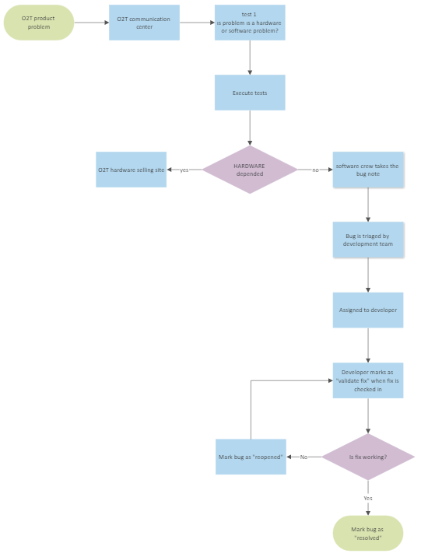
When our product is launched, we will provide support to our customers for this product. Within the scope of this support, we have prepared a flowchart on how we will approach the problems faced by the users and the warranty regardless of the quality tests of the product.

Reliability Specifications
The durability data of the components we will buy are given in the links below. For OWHI brand t-shirt:
1. The screen needs to be detached from the t-shirt Velcro before washing
2. You should turn your OWHI T-shirt inside out and wash it at 30 degrees.

To ensure the reliability of the O2T project, we have considered industry best practices and relied on reputable sources. The following citations and resources provide valuable insights and guidelines for achieving reliability in similar projects:
- Avizienis, A., Laprie, J. C., Randell, B., & Landwehr, C. (2004). Basic concepts and taxonomy of dependable and secure computing. IEEE Transactions on Dependable and Secure Computing, 1(1), 11-33. doi: 10.1109/TDSC.2004.2
- Laprie, J. C. (1992). Dependable computing and fault tolerance: Concepts and terminology. In Proceedings of the 22nd International Symposium on Fault-Tolerant Computing (FTCS-22) (pp. 2-11). doi: 10.1109/FTCS.1992.226689
- IEEE Computer Society. (2012). IEEE Standard Glossary of Software Engineering Terminology. doi: 10.1109/IEEESTD.2012.6217265
- Wittenburg, J., Cotteleer, M., & Howell, K. (2016). Beyond uptime: IT's quest for industrial systems reliability. Deloitte University Press. Retrieved from https://www2.deloitte.com/content/dam/Deloitte/us/Documents/strategy/us-cons-beyond-uptime.pdf
- VanderMeer, D., & Bell, C. (2019). Improving reliability and safety in software systems through a comprehensive program. NIST Special Publication 800-160 Volume 2. Retrieved from https://doi.org/10.6028/NIST.SP.800-160v2
These resources provide insights into the concepts, terminology, and strategies related to reliability in computing systems. They cover various aspects, including fault tolerance, dependable computing, software engineering, and industrial systems reliability. By incorporating the principles outlined in these publications, we aim to enhance the reliability of the O2T project and ensure its robust operation.

Interfaces

Communications Interfaces
Serial Communication Interface:

Purpose: Facilitates communication between the Raspberry Pi and Arduino.
Protocol: UART (Universal Asynchronous Receiver-Transmitter) serial communication.
Interface Pins: TX (Transmit), RX (Receive), GND (Ground).
USB Interface:

Purpose: Powers the Arduino and establishes communication with the Raspberry Pi.
Protocol: USB (Universal Serial Bus).
Interface: USB Type-A connector for connection with the Raspberry Pi's USB port.
Wireless Communication Interface:

Purpose: Enables wireless communication between the mobile application and the Raspberry Pi.
Protocol: Wi-Fi or Bluetooth.
Interface: Wireless network connection established through the Raspberry Pi's Wi-Fi module or Bluetooth module.
LED Matrix Interface:

Purpose: Allows the Raspberry Pi and Arduino to interface with the LED matrix display.
Protocol: GPIO (General Purpose Input Output) communication.
Interface Pins: Data pin, Ground pin, and other necessary control pins.

Hardware Interfaces
Raspberry Pi GPIO (General Purpose Input Output) Interface:

Purpose: Facilitates communication between the Raspberry Pi and other hardware components.
Interface Pins: GPIO pins used for sending and receiving digital signals.
Arduino I/O (Input/Output) Interface:

Purpose: Enables communication between the Arduino and other hardware modules.
Interface Pins: Digital I/O pins used for sending and receiving signals.
LED Matrix Data In Interface:

Purpose: Connects the LED matrix display to the Arduino for controlling the LEDs.
Interface: Data pin, Ground pin, and other necessary control pins.
Power Supply Interface:

Purpose: Provides power to the various hardware components of the O2T system.
Interface: Power connectors, such as USB ports, barrel jacks, or battery terminals, to supply the required voltage and current.
Android Device For Mobile Application Interface:

Purpose: Allows communication between the mobile application and the Raspberry Pi.
Interface: Wireless communication protocols such as Wi-Fi or Bluetooth.

Software Interfaces
Mobile Application Interface:

Purpose: This interface serves as the primary medium through which users interact with the O2T system, enabling them to control and configure the system's functionalities.
Technical Details: The mobile application interface encompasses user interface elements such as buttons, menus, screens, and input controls that facilitate intuitive and user-friendly interaction.
Raspberry Pi - Arduino Interface:

Purpose: The Raspberry Pi - Arduino interface enables the exchange of data and commands between the Raspberry Pi and Arduino, facilitating communication and coordination between the two components.
Technical Details: The interface leverages a suitable communication protocol, such as UART (Universal Asynchronous Receiver-Transmitter), SPI (Serial Peripheral Interface), or I2C (Inter-Integrated Circuit), to establish a reliable and efficient connection between the Raspberry Pi and Arduino.
Python - Arduino Interface:

Purpose: This interface facilitates seamless communication between the Python code running on the Raspberry Pi and the Arduino, allowing for the transmission of data and instructions.
Technical Details: The interface leverages serial communication, typically using a USB connection, to establish a reliable and bidirectional data transfer channel between the Python code running on the Raspberry Pi and the Arduino.
LED Matrix Library Interface:

Purpose: The LED Matrix library interface provides a set of programming abstractions and functions for controlling the LED matrix display.
Technical Details: The interface exposes a well-defined set of functions and methods that enable developers to manipulate and control the LED matrix, including rendering graphics, animations, and text.
Network Interface:

Purpose: The network interface allows the Raspberry Pi to establish connectivity with a network, enabling communication and data exchange with external devices or services.
Technical Details: The network interface relies on standard network protocols such as TCP/IP, Wi-Fi, or Ethernet to establish reliable and secure connections, facilitating the exchange of data between the O2T system and other network-enabled devices.

References
- Ortega, Maria. (2021). Analysis of Pre-Consumer Textile Waste Across Different Countries.
- Haque, Md.Mahbubul & Rahman, Mominur. (2016). INVESTIGATION OF FABRIC WASTAGES IN KNIT T-SHIRT MANUFACTURING INDUSTRY IN BANGLADESH.
- Avizienis, A., Laprie, J. C., Randell, B., & Landwehr, C. (2004). Basic concepts and taxonomy of dependable and secure computing. IEEE Transactions on Dependable and Secure Computing, 1(1), 11-33. doi: 10.1109/TDSC.2004.2
- Laprie, J. C. (1992). Dependable computing and fault tolerance: Concepts and terminology. In Proceedings of the 22nd International Symposium on Fault-Tolerant Computing (FTCS-22) (pp. 2-11). doi: 10.1109/FTCS.1992.226689
- IEEE Computer Society. (2012). IEEE Standard Glossary of Software Engineering Terminology. doi: 10.1109/IEEESTD.2012.6217265
- Wittenburg, J., Cotteleer, M., & Howell, K. (2016). Beyond uptime: IT's quest for industrial systems reliability. Deloitte University Press. Retrieved from https://www2.deloitte.com/content/dam/Deloitte/us/Documents/strategy/us-cons-beyond-uptime.pdf
- VanderMeer, D., & Bell, C. (2019). Improving reliability and safety in software systems through a comprehensive program. NIST Special Publication 800-160 Volume 2. Retrieved from https://doi.org/10.6028/NIST.SP.800-160v2

- CP210x USB to UART Bridge VCP Drivers - Silicon Labs (silabs.com)

- Niu, Lirui & Ding, Jun & Liu, Wei. (2022). Analysis on the Mechanical Behavior of Flexible Screens. Materials. 15. 2829. 10.3390/ma15082829.

- Leontiev, Dmitriy & Kleshchenko, I. & Schlein, G. & Semenenko, A. & Levitina, E. & Dolzhikova, L.. (2019). Technology of creating a mobile viscoelastic waterproof screen in the well that uncovers an oilwater reservoir. Oil and Gas Studies. 72-78. 10.31660/0445-0108-2019-5-72-78.

By
Emre Görkem AĞKURT
&
Uğur BULAN

