CHAPTER 1
INTRODUCTION
1.1 Background to the Study
The rapid advancement of information and communication technology has significantly transformed the way organizations manage information and conduct their daily operations. In modern society, digital systems have replaced traditional manual methods in many sectors, leading to improved efficiency, accuracy, and accessibility of information. Law enforcement agencies, particularly the police, are not exempt from this transformation, as they rely heavily on accurate and timely information to carry out investigations and maintain public safety. According to Laudon and Laudon (2018), information systems play a critical role in enhancing organizational performance by improving data management, decision-making, and operational control.
Traditionally, many police departments have relied on manual record-keeping systems for managing criminal cases and investigation records. These systems often involve the use of paper files, registers, and physical documentation, which are prone to errors, misplacement, and damage. Manual processes can lead to delays in retrieving information, difficulties in tracking case progress, and inefficiencies in communication among officers. Chan (2001) noted that early policing systems faced significant challenges due to reliance on manual processes, which limited the speed and accuracy of information handling within law enforcement agencies.
The need for a computerized system in police operations has become increasingly important due to the growing volume and complexity of criminal cases. Digital systems provide a more structured and reliable approach to storing and managing records, allowing for quick retrieval and better organization of case information. According to United Nations Office on Drugs and Crime (2019), the adoption of digital technologies in criminal justice systems improves transparency, accountability, and efficiency in handling investigations and legal processes. This highlights the importance of transitioning from manual to computerized systems in law enforcement.
Furthermore, web-based applications have made it possible to access information from different locations, enabling better coordination among officers and departments. A centralized digital system allows authorized personnel to update and monitor case records in real time, thereby improving collaboration and reducing duplication of effort. INTERPOL (2020) emphasized that effective information sharing and secure data management are essential components of modern policing, as they enhance cooperation and support efficient investigation processes.
In light of these developments, there is a need to design and implement a web-based Police Case Record Management System that addresses the limitations of manual record-keeping. Such a system will provide a secure and efficient platform for managing case records, tracking investigations, and generating reports. This project aims to contribute to the ongoing digital transformation in law enforcement by developing a system that improves the overall management of police investigation records.
1.2 Statement of the Problem
Despite advancements in digital technology, many police stations still rely heavily on manual methods for recording and managing criminal cases. These methods involve documenting case details in physical files and registers, which are stored in cabinets or record rooms. Over time, the accumulation of files makes it increasingly difficult to manage, organize, and retrieve information efficiently. This often leads to delays in accessing critical case data, especially when older records are required for reference.

Manual systems are also prone to errors such as incomplete documentation, duplication of records, and accidental loss of files. In some cases, important information may be misplaced or damaged, making it difficult to continue investigations effectively. The lack of automated tracking mechanisms makes it challenging to monitor case progress, assign responsibilities clearly, and ensure accountability among officers handling investigations.

Furthermore, traditional record-keeping systems provide limited security and access control. Unauthorized individuals may gain access to sensitive files if proper supervision is not maintained. In addition, the absence of centralized digital storage prevents efficient data backup and recovery in the event of disasters. These challenges highlight the need for a reliable, secure, and efficient computerized system that can manage police case records effectively. This project seeks to address these problems by developing a web-based police case management system that digitizes record storage and improves case tracking processes.
1.3 Aim and objectives of the study
The main aim of this project is to design and implement a web-based police case record management system that improves the documentation, tracking, and security of criminal investigation records.

Objectives of the Study
The specific objectives of this study are to:
- Design a user interface for managing police case records
- Develop a secure authentication system for authorized personnel access
- Develop a database to implement the system using a programming language
- Provide a case tracking mechanism to monitor investigation progress
1.4 Significance of the Study
This study is significant to law enforcement agencies, researchers, and the field of computer science. The modernization of police record management is essential for improving operational efficiency and maintaining accurate documentation of criminal investigations. By replacing manual processes with a digital system, this project demonstrates how technology can enhance public service delivery within law enforcement institutions.
To police personnel, the proposed system provides a structured and secure platform for managing case information. It simplifies the process of registering new cases, updating investigation details, and retrieving stored records. By reducing paperwork and minimizing record loss, the system enhances productivity and accountability among officers.
For administrators and decision-makers, the system enables better organization and centralized storage of case data. The availability of digital reports and searchable records improves decision-making processes and facilitates quick access to historical data when required. This contributes to improved case handling and overall institutional efficiency.
In the field of computer science, this study contributes to knowledge in database management, web application development, and secure information systems. It also serves as a reference material for students and researchers interested in developing management information systems for public institutions. Overall, the project highlights the practical application of computing technologies in solving administrative and operational challenges within law enforcement agencies.
1.5 Scope of Study
The scope of this project is limited to the design and implementation of a web-based police case record management system for digitizing investigation records. The system focuses on replacing manual documentation processes with a structured digital database for storing and managing case information.
The system includes features such as user authentication, case registration, suspect, witness, and complainant information management, evidence recording, and report generation. It is designed to allow authorized personnel to create, update, search, and retrieve case records within the application environment.
This project does not cover advanced forensic analysis tools, biometric identification systems, or national-level crime databases. It is implemented primarily for academic demonstration purposes and focuses on core record management functions rather than full-scale deployment across multiple law enforcement agencies. Despite these limitations, the system effectively demonstrates how digital solutions can improve police case documentation and management.
1.6 Definitions of Terms
For clarity and better understanding of this study, the following terms are defined as used in this project:
- Police Case Management System:
A web-based software application designed to manage, track, and store criminal investigation records digitally.
- Case Registration:
The process of recording the details of a reported crime into the system for documentation and investigation purposes.
- Investigation Record:
Documented information related to a criminal case, including suspect details, witness statements, complainant information, and evidence collected.
- Database:
An organized collection of structured data stored electronically for easy access and management.
- User Authentication:
A security process that verifies the identity of a user before granting access to the system.
- Role-Based Access Control:
A system feature that restricts access to certain functions based on a user’s role or authorization level.
- Evidence Record:
Documented details of materials or information collected during a criminal investigation.
- Report Generation:
The process of producing structured summaries or printable documents containing case information.
- Web-Based Application
A software system that operates through a web browser and is accessible over a network.
- Digital Record:
Information stored electronically rather than in physical paper form.
- Manual Record-Keeping:
The traditional method of documenting information using paper files and physical storage systems.
- System Administrator:
An authorized user responsible for managing system operations and user accounts.
- Data Security:
Measures implemented to protect digital information from unauthorized access or modification.
1.7 Project Layout
This project is organized into five chapters.
Chapter One presents the introduction to the study, including the background of the study, statement of the problem, aim and objectives, significance of the study, scope of the project, and definition of terms.

Chapter Two reviews relevant literature related to police information systems, digital record management, and computerized case tracking solutions. It provides a conceptual review and examines related works by other researchers, highlighting their contributions and limitations.

Chapter Three focuses on the system analysis and design of the proposed police case management system. It discusses the existing system, the proposed system, system requirements, and the design methodology, including system architecture and diagrams.

Chapter Four describes the implementation of the system. It covers the tools and technologies used, system modules, database structure, and testing procedures, along with system evaluation results.

Chapter Five presents the summary, conclusion, and recommendations for future work. It evaluates the performance of the system and suggests possible improvements and extensions.

CHAPTER 2
LITERATURE REVIEW

2.1 Conceptual Review
The conceptual review discusses the key concepts related to this study in order to provide a clear understanding of the ideas and technologies involved in the design and implementation of a web-based police case record management system. These concepts form the theoretical foundation upon which the proposed system is developed.

2.1.1 Police Information Systems

Police Information Systems refer to computerized systems designed to support law enforcement agencies in managing operational data, criminal records, and administrative information. These systems are used to store, retrieve, and process information related to crime reports, suspect details, investigation updates, and case outcomes. The primary objective of police information systems is to enhance efficiency, improve data accuracy, and support informed decision-making within law enforcement institutions.

Modern police information systems are typically implemented using database technologies and secure web platforms. They allow authorized personnel to access relevant information quickly and update case records in real time. By digitizing criminal records, these systems reduce reliance on paper documentation and minimize the risks associated with manual record-keeping, such as file loss, duplication, and delayed retrieval.

The implementation of police information systems contributes significantly to improved case management and institutional accountability. Through structured storage and centralized access, law enforcement agencies can maintain organized records and ensure that sensitive information is protected through authentication and role-based access controls.

2.1.2 Digital Record Management Systems

Digital Record Management Systems are software-based solutions designed to manage electronic records efficiently and securely. These systems provide mechanisms for storing, organizing, retrieving, and archiving information in digital form. In the context of law enforcement, digital record management systems play a vital role in maintaining accurate and accessible case documentation.

Unlike traditional paper-based systems, digital record management systems enable quick search and retrieval of information using structured queries. They reduce physical storage requirements and provide backup and recovery mechanisms to protect data against loss or damage. This is particularly important in environments where records must be preserved for long periods for legal or investigative purposes.

By implementing digital record management systems, organizations improve operational efficiency and ensure better data integrity. In police operations, such systems facilitate systematic case tracking, secure documentation of evidence, and organized storage of investigative records. These advantages highlight the importance of transitioning from manual record-keeping to digital solutions.

2.1.3 Case Management Systems
Case Management Systems are applications designed to manage the lifecycle of cases from registration to resolution. In law enforcement contexts, these systems support the recording of crime reports, assignment of officers, documentation of evidence, and monitoring of investigation progress. They provide structured workflows that ensure cases are handled systematically and efficiently.
A key feature of case management systems is the ability to track case status and maintain historical records of actions taken during investigations. This tracking capability enhances transparency and accountability, as each update is recorded within the system. Automated tracking reduces reliance on memory or manual logs, which are often prone to errors and omissions.
In addition, case management systems often include reporting functionalities that allow administrators to generate summaries and statistical reports. These reports assist in analyzing crime trends, evaluating performance, and supporting strategic planning. By integrating case registration, tracking, and reporting, such systems significantly improve overall operational management.

2.1.4 Role-Based Access Control
Role-Based Access Control (RBAC) is a security mechanism used to restrict system access based on predefined user roles. In sensitive environments such as police departments, access control is essential to ensure that confidential information is only available to authorized personnel. RBAC assigns permissions according to roles such as administrator, investigating officer, or records officer.

Through RBAC, users can only perform actions relevant to their responsibilities. For example, an administrator may have full system access, while an officer may only view and update cases assigned to them. This structured access control reduces the risk of unauthorized modification or exposure of sensitive data.

Implementing role-based access control enhances system security and accountability. It ensures that all user activities are traceable and that data integrity is maintained. In web-based police systems, RBAC is a critical component for protecting investigation records and maintaining confidentiality.

2.1.5 Web-Based Database Systems
Web-based database systems are applications that operate through web browsers and use centralized databases for data storage. These systems combine front-end interfaces with back-end database management technologies to provide accessible and secure platforms for managing information.

In law enforcement record management, web-based database systems offer significant advantages over standalone desktop applications. They allow authorized users to access case records from designated network environments while maintaining centralized control of data storage. Updates made by one user are immediately reflected in the system, ensuring consistency and accuracy.

Furthermore, web-based systems provide scalability and easier maintenance compared to traditional systems. They support secure authentication mechanisms, encrypted communication, and structured data management. By leveraging web technologies and relational databases, police departments can achieve efficient digital record management and improved operational coordination.

2.2 Review of Related Works
This section reviews previous research and existing systems developed for record management and case tracking in law enforcement and related fields. The focus is on computerized systems designed to replace manual record-keeping and improve efficiency, accuracy, and data security.
Chan (2001) examined the evolution of police information systems and their impact on law enforcement operations over time. The study analyzed how early computerized systems were gradually introduced to replace traditional manual record-keeping processes in police departments. During the early stages of digital transformation, many law enforcement agencies relied heavily on paper files, handwritten reports, and physical archives, which made information retrieval slow and inefficient. Chan’s research explored how the introduction of digital databases and electronic reporting tools marked a significant shift toward modernization in policing practices.
The study highlighted measurable improvements in information retrieval speed, record accuracy, and overall administrative efficiency following the implementation of computerized systems. Officers were able to access criminal histories, case files, and investigation updates more quickly than under manual systems. The research also emphasized that digitized systems reduced paperwork, minimized duplication of records, and improved documentation consistency across departments.
However, Chan noted several challenges associated with technological adoption, including resistance to change among personnel, limited technical expertise, and the need for structured training programs. The research primarily focused on institutional transformation and organizational behavior rather than detailed system architecture or implementation frameworks. While it provided valuable insight into the benefits of police information systems, it did not propose a specific web-based case management model.

This project builds upon these findings by recognizing the importance of digital transformation in policing and proposing a practical web-based implementation specifically tailored to police case record management.
Koper et al. (2014) investigated the role of technology in improving police performance, operational coordination, and data management processes. Their study examined how the integration of digital tools, databases, and reporting systems enhanced the effectiveness of law enforcement agencies. The researchers emphasized that computerized systems significantly improve data accuracy by reducing human error associated with manual documentation.

The study further explained that structured databases allow officers to store information in organized formats, making it easier to generate reports, track trends, and evaluate operational outcomes. Digital reporting tools were found to enhance communication among officers and departments, ensuring that information is shared more efficiently. Additionally, the researchers highlighted the importance of secure access mechanisms to prevent unauthorized use of sensitive law enforcement data.

Although the study demonstrated clear advantages of adopting digital systems, it primarily evaluated performance outcomes rather than proposing a detailed case management system design. It emphasized institutional benefits but did not provide a specific framework for implementing a web-based record management application.

In contrast, the current project focuses directly on designing and implementing a structured web-based system dedicated to managing police investigation records. By translating theoretical advantages into a functional software solution, this project contributes a practical application aligned with the technological integration principles discussed by Koper et al.
Gottschalk (2006) explored the concept of knowledge management within police organizations and examined how digital systems support information sharing and organizational learning. The study emphasized that law enforcement agencies generate large volumes of knowledge through investigations, case reports, intelligence gathering, and operational experiences. Proper management of this knowledge is essential for improving efficiency and preventing duplication of effort.
The research highlighted that digital information systems play a crucial role in collecting, storing, and disseminating investigative knowledge. By centralizing records within electronic databases, officers can access historical case data, review prior investigative strategies, and make informed decisions. The study also pointed out that structured digital systems enhance collaboration by enabling different units to share relevant information securely.

However, the research primarily focused on the organizational and managerial aspects of knowledge flow rather than providing technical details on how to digitize manual case records. It did not outline a specific web-based implementation model for police record management.
The proposed project complements this work by implementing a database-driven case management system that structures and centralizes investigation records in a secure digital environment, thereby translating knowledge management concepts into a functional application.
Xu and Chen (2005) examined computerized crime data management systems designed to organize, store, and analyze criminal records within law enforcement agencies. Their study emphasized the importance of structured relational databases in supporting crime analysis and investigative decision-making. The researchers explained that digital crime data systems improve retrieval speed, reduce redundancy, and enhance consistency in documentation.
The study further discussed how organized data storage enables advanced analytical techniques such as pattern recognition and crime trend analysis. By digitizing records, law enforcement agencies can move beyond simple documentation toward data-driven strategies for crime prevention and resource allocation. The research highlighted that digital systems improve both administrative efficiency and strategic planning capabilities.
Despite demonstrating the effectiveness of computerized crime data systems, the study placed greater emphasis on analytical data mining techniques rather than foundational record digitization processes. It focused more on crime intelligence analysis than on the core system responsible for registering and storing case records.
This project differs by concentrating primarily on the foundational digitization of case records, ensuring secure storage, structured organization, and reliable retrieval mechanisms before advanced analytical tools are introduced.
Laudon and Laudon (2018) discussed the broader concept of Management Information Systems (MIS) and their role in improving organizational performance across various sectors. According to the authors, MIS integrates people, processes, and technology to collect, process, store, and distribute information for decision-making purposes. The study emphasized that effective information systems enhance operational control, strategic planning, and institutional accountability.
The authors explained that centralized databases, user authentication mechanisms, and structured reporting tools are key components of effective information systems. These components ensure data accuracy, consistency, and security within organizations. Although the discussion was not specifically related to policing, the theoretical principles outlined in the study are directly applicable to law enforcement record management.

By applying MIS principles to police operations, organizations can improve documentation processes and reduce inefficiencies associated with manual record-keeping.
The current project applies these MIS concepts to the development of a web-based police case record management system, demonstrating how general information system principles can be adapted to a law enforcement environment for improved efficiency and security.
The United Nations Office on Drugs and Crime (UNODC) emphasized the importance of digital transformation within criminal justice institutions. The report highlighted that digitized case management systems enhance transparency, accountability, and efficiency in law enforcement and judicial processes. By transitioning from paper-based systems to digital platforms, institutions can reduce delays, improve documentation accuracy, and strengthen institutional trust.
The report also discussed how digital systems facilitate secure record storage and efficient retrieval of case information. It stressed that effective digitalization requires secure authentication measures and proper data protection policies to safeguard sensitive information. However, the report primarily provided policy-level guidance and strategic recommendations rather than technical system designs.
While the UNODC emphasized the need for modernization, it did not present a specific software implementation model suitable for academic development.
This project responds to such recommendations by presenting a structured web-based system for digitizing police case records within an academic framework, demonstrating how digital transformation principles can be practically implemented.
INTERPOL (2020) discussed the growing importance of digital information systems in supporting cooperation and secure data exchange among law enforcement agencies worldwide. The report emphasized that centralized databases and secure communication channels are essential for maintaining accurate and reliable records. Proper information management enables agencies to respond more effectively to criminal activities and share relevant data when necessary.
The report also highlighted the importance of controlled access mechanisms to protect sensitive investigation records. Unauthorized access to criminal databases can compromise investigations and threaten public safety. Therefore, digital systems must incorporate authentication protocols and access control measures to maintain confidentiality and integrity.
Although the primary focus of the report was international collaboration, the principles of secure digital record management are equally relevant to local police operations. Even within a single department, structured and secure data management is critical for maintaining operational efficiency.
The proposed system integrates secure authentication and structured digital storage, aligning with the principles of controlled information access emphasized in the INTERPOL report.
The European Commission (2021) highlighted the adoption of digital record systems within justice and law enforcement sectors as part of broader e-Justice initiatives. The report emphasized that web-based platforms significantly reduce administrative paperwork, enhance documentation accuracy, and improve case tracking processes. By digitizing records, institutions can streamline operations and ensure faster information retrieval.
The report further noted that digital systems promote better coordination between departments and reduce delays associated with manual documentation processes. Structured databases and web-based interfaces were identified as essential components for achieving efficient case management within public institutions.
Although the initiative addressed broader judicial systems rather than local police departments specifically, the principles of digital documentation and structured record management are directly relevant to this project.
This study contributes by implementing a simplified but functional web-based police case management system tailored for academic demonstration and institutional improvement, reflecting the core objectives of digital transformation highlighted in the European Commission’s report.
The World Bank (2020) examined the role of digital governance systems in improving efficiency, transparency, and accountability within public sector institutions. The report emphasized that government agencies, including law enforcement bodies, increasingly rely on digital information systems to manage records, streamline administrative processes, and enhance service delivery. According to the study, transitioning from paper-based systems to centralized digital platforms significantly reduces delays, minimizes data duplication, and improves record accuracy.
The report further highlighted the importance of secure databases, structured workflows, and role-based access control mechanisms in public institutions handling sensitive information. It emphasized that digital systems must incorporate authentication, authorization, and audit-tracking features to ensure accountability and prevent unauthorized access. Additionally, the study noted that successful implementation requires proper planning, system design, and staff training to ensure sustainability.
However, the World Bank report primarily addressed digital transformation at a broad governance level and did not provide a specific implementation model tailored to police investigation case management.
This project aligns with the digital governance principles discussed in the report by designing a structured, role-based web application that centralizes police case records, improves workflow management, and enhances administrative efficiency within law enforcement operations.
The Federal Bureau of Investigation (FBI) has long emphasized the importance of computerized Criminal Justice Information Systems (CJIS) in supporting effective law enforcement operations. These systems are designed to manage criminal records, fingerprint databases, and investigative information in a secure and structured manner. The FBI’s approach highlights the necessity of maintaining data integrity, confidentiality, and controlled access when handling sensitive case information.
CJIS frameworks demonstrate how centralized digital systems enhance coordination between officers and departments by enabling quick retrieval of criminal histories, case updates, and investigative documentation. The system architecture typically incorporates strong security measures, including authentication protocols, encryption standards, and role-based permissions to ensure that only authorized personnel can access specific data.
Although the FBI’s systems operate on a large national scale and involve complex infrastructure, the underlying principles of secure data management, structured databases, and controlled information access are directly relevant to institutional-level case management systems.
The proposed Police Case Record Management System reflects these principles by implementing secure login functionality, structured case registration processes, officer assignment modules, and investigation tracking features within a web-based platform. While simplified for academic purposes, the system demonstrates how core criminal justice information system concepts can be applied to improve local police case management efficiency.

CHAPTER 3
3.1 Methodology of the Existing System
The existing system for managing police case records is largely based on manual, paper-based methods, where information is recorded in physical files and stored in filing systems within police stations. This traditional approach requires officers to document case details such as incidents, suspects, witnesses, and evidence manually, making the process time-consuming and prone to human error (O’Brien & Marakas, 2011). Despite being widely used, this method lacks the efficiency and reliability required to handle the growing volume of case records in modern law enforcement environments.
The manual system operates through physical documentation and file storage, where case records are organized in folders and cabinets for future reference. Retrieval of information depends on manually searching through these files, which can be slow and inefficient, especially when dealing with a large number of cases (Laudon & Laudon, 2018). Additionally, information sharing between departments often requires the physical movement of files, making collaboration difficult and delaying investigative processes.
Despite its simplicity, the analysis of the existing system reveals several limitations that affect its effectiveness and reliability. One of the most significant limitations is the risk of data loss or damage. Physical records are vulnerable to misplacement, theft, fire, or deterioration over time, which can result in the permanent loss of important case information (Stair & Reynolds, 2016). This poses a serious challenge to maintaining accurate and complete records.
Another major limitation of the existing system is the inefficiency in data retrieval. Locating specific case information requires manually searching through files, which is time-consuming and can delay investigations. This issue becomes more critical when quick access to information is required for decision-making or reporting purposes (Laudon & Laudon, 2018).
The manual system also increases the likelihood of errors and duplication of records. Since data entry is done manually, there is a higher chance of incomplete, inconsistent, or duplicated information, which can affect the accuracy and reliability of case records. Additionally, there is limited accountability, as it is difficult to track who created or modified a record at any given time.
Furthermore, the existing system lacks adequate security and access control. Physical files can be accessed by unauthorized individuals if not properly secured, leading to potential breaches of sensitive information (O’Brien & Marakas, 2011). There are no structured mechanisms to restrict access based on user roles, making it difficult to ensure confidentiality and data protection.
In summary, while the existing manual system provides a basic method for recording police case information, it is limited by issues such as inefficiency, lack of security, risk of data loss, and poor accessibility. These limitations highlight the need for a more efficient and secure solution, which forms the basis for the development of the proposed web-based police case record management system.
3.2 Limitations of the Existing System
- Reliance on Manual Record-Keeping Processes
The existing system depends heavily on paper files, registers, and handwritten forms for recording crime reports, investigation notes, and case updates. This manual method makes documentation slow, stressful, and difficult to manage as records increase. Officers spend valuable time writing, sorting, and storing files instead of focusing on investigations. It also reduces overall efficiency in police operations.
- Poor Data Storage, Retrieval, and Case Tracking
Physical records are often stored in cabinets or record rooms, making it difficult to quickly locate case files when needed. Searching through multiple files consumes time and may delay investigations. In addition, the system lacks an automated way to monitor case progress, assign responsibilities, or track updates in real time. This makes supervision and decision-making more difficult.
- High Risk of Errors, Data Loss, and Duplication
Since information is entered manually, mistakes such as incomplete records, wrong entries, duplicated files, and inconsistent details are common. Physical documents are also vulnerable to theft, fire, flooding, wear and tear, or misplacement. When important records are damaged or missing, investigations may be affected and organizational reliability is reduced.
- Weak Security, Limited Collaboration, and Poor Accountability
Manual files can be accessed by unauthorized persons if not properly secured, exposing sensitive case information. There are no proper access control measures to restrict records based on user roles. Case files may also be scattered across departments, slowing communication and cooperation. Furthermore, it is difficult to know who created, edited, or handled a record, reducing accountability and transparency.
3.3 Analysis of the Proposed System
The proposed system is a web-based Police Case Record Management System developed to replace the existing manual paper-based method of handling police records. It is built using Next.js for the frontend, Node.js and Express.js for backend processing, and MySQL for database management. The system is designed to improve efficiency, security, and organization by providing a centralized platform where criminal case records can be created, updated, and managed digitally. Unlike the manual system, it removes delays caused by physical file handling and improves access to information.
The system operates through digital forms where officers can enter case details such as date, location, suspects, witnesses, complainant information, and evidence. Once submitted, the information is stored instantly in the database and becomes accessible to authorized users. It also includes real-time case tracking, allowing officers and supervisors to monitor investigation progress, case status, and updates. This improves accountability, transparency, and overall case management.
To ensure data protection, the system uses secure login authentication and role-based access control. Different users such as administrators and investigating officers are given specific permissions based on their responsibilities. This prevents unauthorized access to sensitive records and improves confidentiality compared to the existing manual system.
The system also provides search and reporting tools that allow users to quickly retrieve records using filters such as case ID, suspect name, or date. Reports can be generated automatically without manual compilation. Overall, the proposed system offers a secure, user-friendly, and efficient solution that improves data management, speeds up information retrieval, enhances collaboration, and increases accountability in police operations.
The main objective of the proposed system is to develop a secure and efficient web-based platform for recording, managing, and tracking police case records digitally. It is intended to reduce dependence on manual paper files while ensuring proper organization, fast access, and data security. Specific objectives include developing a centralized application for case management, creating a structured database for storing case information, implementing secure login and access control features, and providing a simple interface that allows users to register cases, update records, search information, and generate reports easily.
3.5 System Requirements
The system requirements are divided into functional and non-functional categories and prioritized based on importance.
Functional Requirements:
The functional requirements define the key operations the system must perform. The system shall provide a user login feature, allowing officers and administrators to access the system securely using a username and password.
The system shall support role management, where the administrator can create, edit, and assign roles to users to control access levels. It shall also allow case registration, enabling officers to enter new case details into the system.
Furthermore, the system shall provide a case update function, allowing authorized users to modify case information and add notes. A case search feature shall also be available to help users quickly find records using parameters such as case ID, date, or suspect name.
The system shall allow users to view detailed case records, including information about suspects, witnesses, and evidence. It shall also support evidence entry, where users can record and manage evidence related to cases.
In addition, the system shall include report generation, enabling users to produce reports in PDF format. An audit log shall be maintained to track user activities for accountability.
Finally, the system shall provide a logout function to ensure secure session termination after use.
Non-Functional Requirements:
The non-functional requirements describe the overall quality and performance of the system.
The system must ensure a high level of security by authenticating all users and enforcing role-based access control. Sensitive data such as passwords must be properly protected, and measures like input validation must be implemented to prevent attacks such as SQL injection and cross-site scripting.
The system must also be reliable, ensuring minimal downtime and providing backup and recovery mechanisms to prevent data loss.
In terms of performance, the system should allow fast data processing, with search and retrieval operations returning results within a short time.
The system should be user-friendly, with a simple and intuitive interface that makes it easy for users to navigate and perform tasks.
Additionally, the system should be maintainable, with a well-structured design that allows for easy updates and modifications. It should also be scalable, allowing for future expansion as the number of users or data increases.
Overall, security and reliability are given the highest priority due to the sensitive nature of the data being managed.
3.6 Architecture of the Proposed System
System architecture refers to the overall structure of a system, showing its major components and how they interact to perform required functions. It explains how data flows between different parts of the system and how processes are organized to ensure efficiency, reliability, and proper communication.
The proposed Police Case Record Management System uses a modular three-layer architecture consisting of the User Interface Layer, Application Logic Layer, and Data Storage Layer. This design improves scalability, maintainability, and clear separation of responsibilities within the system.
The User Interface Layer is developed with Next.js and serves as the point where users interact with the system. Through this interface, authorized users such as administrators and investigating officers can register cases, update records, search information, and generate reports. It is designed to be simple and user-friendly for efficient operation.
The Application Logic Layer is built with Node.js and acts as the processing center of the system. It handles requests from users, applies business rules, manages authentication, enforces role-based access control, validates records, and supports real-time case tracking. It also connects the frontend interface with the database.
The Data Storage Layer uses MySQL to store and manage all records such as users, cases, suspects, witnesses, and evidence. It provides centralized and consistent data storage, reduces duplication, and allows fast retrieval of information for searches and reporting.
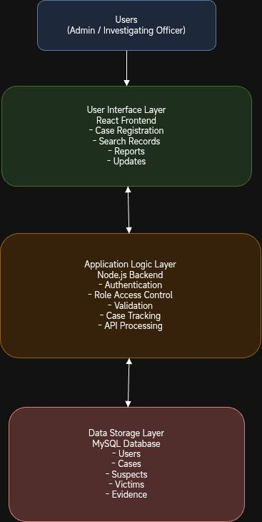
3.6.2 System Interaction Flow
The interaction within the system follows a structured and logical process that ensures smooth operation and efficient data handling. Initially, users interact with the system through the interface by entering data or making requests, such as registering a new case or searching for existing records. These inputs are transmitted to the application logic layer, where they are validated and processed according to predefined system rules.
Once validated, the data is stored in the database, where it becomes part of the centralized record system. When users request information, the application logic layer retrieves the relevant data from the database and sends it back to the interface for display. In cases where updates are made, the system records the changes along with timestamps and user details, ensuring that all activities are traceable. This continuous interaction between layers enables real-time updates, efficient data retrieval, and consistent system performance.
3.6.3 Architectural Advantages
The proposed architecture offers several significant advantages over traditional manual systems. By adopting a modular layered design, the system ensures that each component operates independently, making it easier to maintain, update, and extend. This modularity allows developers to modify one part of the system without affecting others, thereby improving long-term sustainability.
The architecture also enhances system efficiency by enabling fast data processing and retrieval through centralized storage and optimized database queries. Unlike manual systems, which require time-consuming physical searches, the digital system provides instant access to information, significantly improving operational speed. In addition, the implementation of authentication and role-based access control strengthens data security, ensuring that sensitive information is protected from unauthorized access.
Another important advantage is improved collaboration and accessibility. Since the system is web-based, authorized users can access and update records from different locations, enabling better coordination among personnel. This is a major improvement over the existing system, where information sharing is limited by physical file movement.
Furthermore, the architecture supports scalability and future expansion. New features and modules can be integrated into the system without requiring a complete redesign, making it adaptable to evolving requirements. A well-structured system architecture is essential for ensuring performance, reliability, and maintainability in software systems (Clements et al., 2010).
By clearly separating the user interface, application logic, and data storage components, the proposed system achieves a robust and organized structure that supports efficient operation and future growth.

3.7 System Design
System design is the process of defining the architecture, components, data structures, and interactions of a system based on the identified requirements. It provides a detailed framework that guides the development and implementation of the proposed system.
The proposed Police Case Record Management System adopts a client–server web architecture using a three-tier structure, consisting of the presentation layer, application layer, and data layer. This architectural approach ensures proper separation of concerns, improves system scalability, and enhances maintainability.
The presentation layer represents the user interface, which is accessed through a web browser. It is developed using modern web technologies and is responsible for displaying forms, dashboards, tables, and interactive elements that allow users to interact with the system.
The application layer handles the core logic of the system. It processes user requests, enforces system rules, manages authentication, and ensures proper communication between the interface and the database. This layer guarantees that all operations such as case registration, updates, and searches are executed correctly and securely.
The data layer is responsible for storing and managing all system information in a structured database. It maintains records related to users, cases, suspects, witnesses, and evidence. This layered design ensures that data management, system logic, and user interaction remain independent, making the system easier to develop, maintain, and extend.
The system is implemented using a modern technology stack that supports scalability and secure data handling. The frontend is developed using Next.js, the backend is implemented with Node.js and Express.js, and MySQL is used as the relational database management system. Together, these technologies provide a robust and efficient platform for managing police case records.
3.7.1 System Modeling
System modeling represents the structure and behavior of the system in a simplified form. It helps in understanding how users interact with the system and how data flows between different components.
The user interface of the system is first designed using Figma to create wireframes and prototypes that define the layout and user experience. These designs are then implemented using Next.js, which enables the development of reusable components and dynamic user interactions. This approach ensures that the interface is responsive, visually consistent, and easy to use.
The backend of the system is implemented using Node.js, which handles server-side logic and manages communication between the frontend and the database. It processes API requests, validates user input, and ensures that all system operations are carried out according to defined rules. In addition, the backend implements authentication and role-based access control to ensure that only authorized users can access sensitive case information.
The system uses MySQL as its database management system, where all records are stored in structured tables. The database is designed to ensure data integrity, consistency, and efficient retrieval of information.
Use Case Representation
The system involves three main actors: the Administrator, the Investigating Officer, and the Records Officer. The Administrator manages users, oversees all cases, and generates reports. The Investigating Officer logs investigation updates, manages evidence, suspects, and witnesses on assigned cases. The Records Officer registers new cases, views all cases, and manages the case archive.
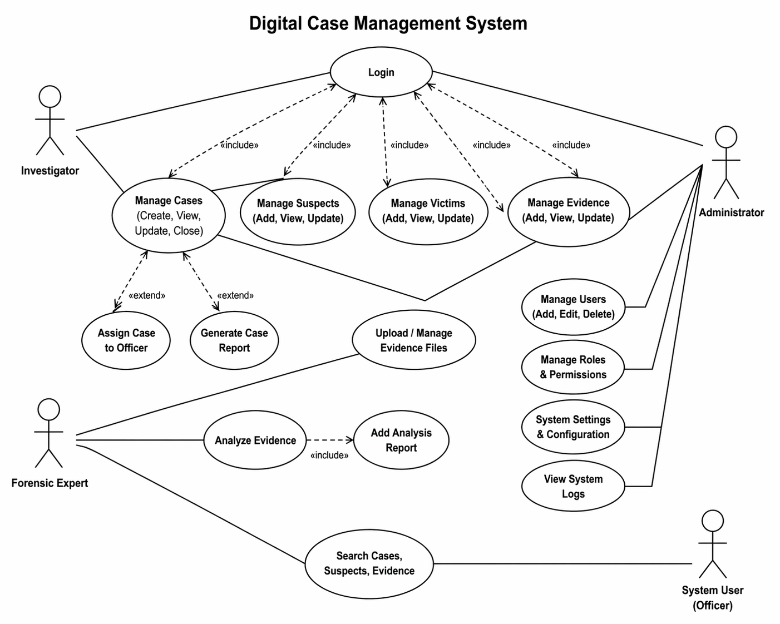
3.7.2 Database Design
The database is designed to store all information required for the operation of the system in a structured and organized manner. It consists of multiple related tables that manage users, cases, investigation updates, suspects, witnesses, evidence, notifications, and activity logs.
The users table stores information about system users, including login credentials and assigned roles such as administrator or officer. The cases table contains core case details such as case ID, date, location, description, and status.
Additional tables such as suspects, witnesses, and evidence store related information linked to each case. These tables are connected using unique identifiers (foreign keys), ensuring that all records are properly associated and can be retrieved efficiently.
This relational structure reduces data redundancy and improves consistency across the system. It also enables fast querying and efficient data management, which is essential for real-time case tracking and reporting.
Entity Relalatest
The Entity Relationship Structure defines how the main entities in the system are related to each other and how data integrity is maintained across the database. It provides a conceptual view of the relationships between cases, suspects, witnesses, and evidence, ensuring proper linkage and consistency of data within the system.
In addition to the conceptual structure, the database design can also be represented in a relational format, where each entity is structured as a table with defined attributes, primary keys, and foreign keys. This relational representation clearly shows how the different tables are connected and how data flows between them in a structured manner.
Together, both the entity relationship structure and the relational table representation provide a complete understanding of the database design, showing both the logical relationships and the physical implementation of the system.
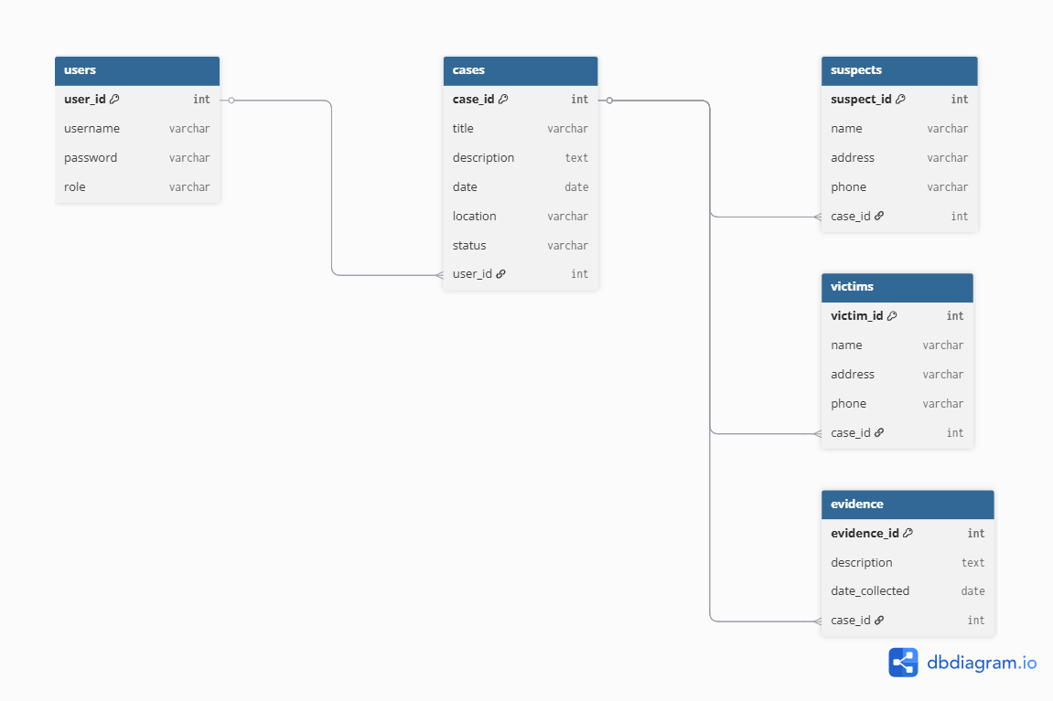
3.7.3 Interface Design
The system interface is designed to be simple, clear, and user-friendly to ensure ease of use by police personnel. The goal is to allow users to perform tasks efficiently without requiring advanced technical knowledge.
The system begins with a secure login page where users enter their credentials to access the application. After successful authentication, users are directed to a dashboard that provides navigation to different system modules.
The case registration interface allows officers to input detailed case information, including description, date, location, suspects, witnesses, and evidence. The form is structured with clear labels and organized fields to ensure accurate data entry.
The case search interface enables users to retrieve records using filters such as case ID, date, or case status. Results are displayed in a structured format, allowing users to quickly locate relevant information.
The case detail interface provides a comprehensive view of a selected case and allows authorized users to update records or add new information. Evidence management is also handled within this section.
The report generation interface allows administrators to generate reports based on specific criteria such as date range or case type. These reports support decision-making and documentation processes.
In addition, the user management interface allows administrators to create, modify, and manage user accounts and roles within the system.
Overall, the interface design prioritizes clarity, simplicity, and efficiency to ensure smooth interaction between users and the system.
3.7.4 System Flow
The system flow describes how data moves through the system and how different processes are executed. It provides a step-by-step representation of how user inputs are transformed into outputs.
The process begins when a user logs into the system and is authenticated. Once access is granted, the user can perform operations such as registering a new case, updating existing records, or searching for information. The system processes these requests through the application layer, validates the data, and stores it in the database.
When a user requests information, the system retrieves the relevant data from the database and displays it through the interface. Access control mechanisms ensure that only authorized users can perform specific actions.
This continuous interaction between the user interface, application logic, and database ensures efficient and secure system operation.
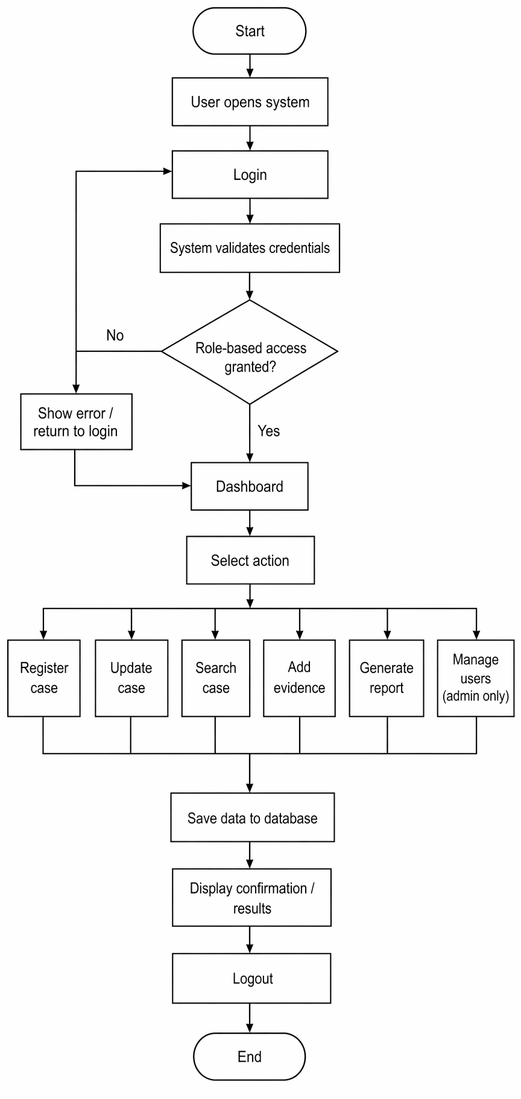

References
Chan, J. (2001). Police and new information technologies. Journal of Criminal Justice.
European Commission. (2021). Digital record systems and e-Justice initiatives in the European Union.
Gottschalk, P. (2006). Knowledge management systems in law enforcement organizations. Information Systems Frontiers.
International Journal of Research Publication and Reviews. (2025). Role based crime data management platform for law enforcement agencies, 6(5), 5996–6002.
INTERPOL. (2020). I-CORE programme: Driving a digital transformation in policing.
Koper, C. S., Lum, C., & Willis, J. J. (2014). Optimizing the use of technology in policing. Criminology & Public Policy.
Laudon, K. C., & Laudon, J. P. (2018). Management information systems: Managing the digital firm.
United Nations Office on Drugs and Crime. (2019). Digital technologies in criminal justice systems.
World Bank. (2020). Digital governance in public sector institutions.
Xu, J. J., & Chen, H. (2005). Crime data mining and analysis systems. Communications of the ACM.
O’Brien, J. A., & Marakas, G. M. (2011). Management information systems. McGraw-Hill.
Stair, R., & Reynolds, G. (2016). Fundamentals of information systems. Cengage Learning.
Bass, L., Clements, P., & Kazman, R. (2012). Software architecture in practice (3rd ed.). Addison-Wesley.
IEEE. (2000). IEEE recommended practice for architectural description of software-intensive systems (IEEE Std 1471-2000).
Clements, P., Bachmann, F., Bass, L., Garlan, D., Ivers, J., Little, R., Nord, R., & Stafford, J. (2010). Documenting software architectures: Views and beyond (2nd ed.). Addison-Wesley.

