**Experiment 1.1**

**Student Name: Umang Kaushik UID: 23BCS10712**

**Branch: BE CSE Section/Group: 702/A**

**Semester: 4th Date of Performance: 6th Jan**

**Subject Name: DBMS Subject Code: 23CSH-205**

1. **Aim:** To implement different types of DDL, DML, DCL queries.
2. **Objective:** To understand and demonstrate the usage of commands.
3. **DBMS script and output:**

Create Command and Describe Command-

**Syntax:** Create table <tablename>(col1,datatype, col2,datatype…… coln,datatype);

**Syntax:** Describe <tablename>;

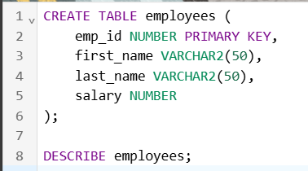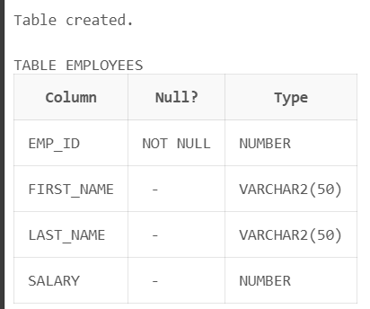

Insert Command and Select Command-

**Syntax:** Insert into<tablename>(col1,col2…coln)values(List of values)

**Syntax:** Select * from <tablename>;

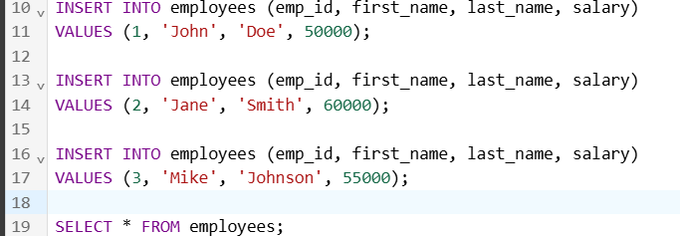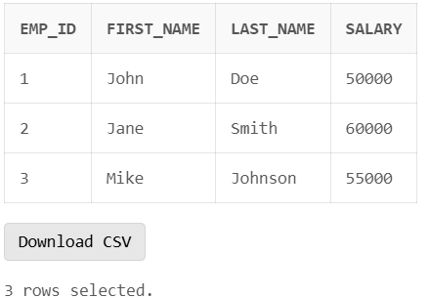

Delete Command-

**Syntax:** Delete from<table name> where condition;

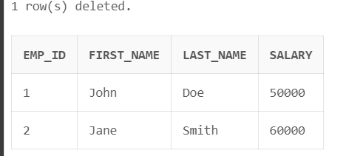

Alter Command-

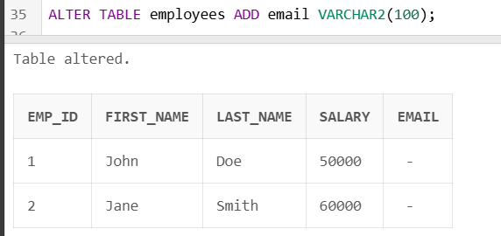

Rename Command-

**Syntax**: Rename old name to new name;



Truncate Command-

**Syntax**: Truncate table <tablename>;

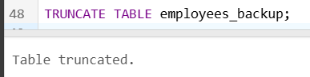

Drop Command-

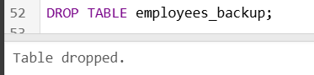

Union Command-

**Syntax**: Select <column name> from<tablename1> union all Select <column name> from<tablename2>

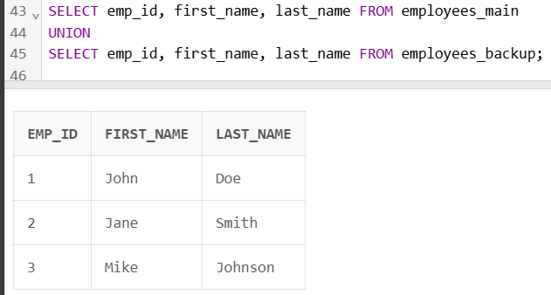

Merge Command-

**Syntax**: Insert into <tablename1>(col1,col2) select col1,col2 from <tablename2>where condition;

