Experiment 3
Student Name: Umang Kaushik UID: 23BCS10712
Branch: BE CSE Section/Group: KRG-1-B
Semester: 6th Date of Performance:26th Jan
Subject Name: SD Subject Code: 23CSH-314

- Aim: To design a social-media application

- Objectives:

  - Facilitate Connectivity: Allow users to find and follow others.
  - Content Management: Provide tools to create, share, and interact with multimedia content.
  - Real-time Interaction: Enable instant notifications and messaging.
  - Data Security: Ensure the protection of user privacy and personal information.

- Procedure:
  - Requirement Analysis: Define target audience and core features.
  - UI/UX Design: Create wireframes and high-fidelity prototypes focusing on intuitive navigation
  - Architecture Design: Plan the database schema (SQL/NoSQL) and system backend.
  - Development: Build the frontend (React/Flutter) and backend (Node.js/Python) APIs.
  - Testing: Conduct unit, integration, and user acceptance testing (UAT).
  - Deployment: Host the application on cloud services (AWS/Azure) with CI/CD pipelines.

- Functional Requirements:
  - User Authentication: Secure sign-up, login, and profile management.
  - News Feed: An algorithm-based or chronological feed of posts from followed accounts.
  - Interactions: Capabilities to like, comment on, and share posts.
  - Direct Messaging: Private one-on-one or group chat functionality.
  - Search: Ability to find users, hashtags, or specific topics.

- Non-Functional Requirements:
- Scalability: The system must handle a growing number of users and concurrent requests.
- Latency: Post updates and messages should reflect in under 2 seconds.
- Availability: Target 99.9% uptime to ensure the service is always accessible.
- Security: Use of End-to-End Encryption (E2EE) for messages and OAuth for authentication.

- Outcome:

The result is a fully functional social media prototype capable of supporting high-traffic interactions, providing a seamless user experience, and maintaining a secure environment for digital socialization.

- Required System Design:
HLD:

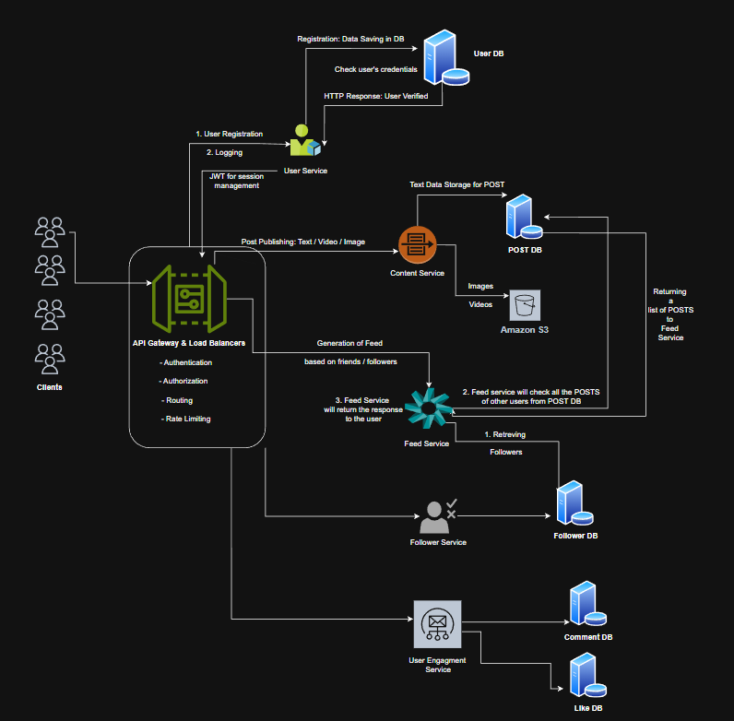

LLD

