Department of Computer Science and Technology (DCST)

PROJECT REPORT

VAHAN ALERTS

Vehicle Document and Maintenance Reminder System
A Spring Boot Web Application for Tracking Vehicle Documents, Maintenance Records, and Document Expiry Reminders

Project Title | Vahan Alerts — Vehicle Maintenance and Reminder System
Domain | Web Application / Automotive Management / Document Tracking
Technology Stack | Java 17, Spring Boot 4.1.2, Spring MVC, Spring Security, Spring Data JPA, Thymeleaf, H2 Database, Flyway, Apache Maven
Architecture | Layered (Controller → Service → Repository) with embedded Tomcat
Author | Vaibhav Ghadi Vinay Sharma
Department | Department of Computer Science
Academic Year | 2026–2027

Declaration
I, Vinay Sharma and Vaibhav Ghadi, a student of the Department of Computer Science, hereby declare that the project report titled “Vahan Alerts — Vehicle Maintenance and Reminder System” is a bonafide record of project work carried out by me under the academic guidelines of the institution. The content of this report is based on the actual source code, configuration files, database migrations, test classes, and project documentation of the Vahan Alerts application. No part of this report has been submitted for any other degree or academic award. Where external sources, frameworks, libraries, or standards are referenced, they have been duly acknowledged in the References section.

Signature: ________________________
Name: Vinay Sharma Vaibhav Ghadi
Department: Computer Science
Academic Year: 2026–2027
Date: ________________________

Acknowledgement
I express my sincere gratitude to my project guide and the faculty members of the Department of Computer Science for their continuous guidance, encouragement, and support throughout the course of this project. Their valuable insights and constructive feedback helped shape this work into a comprehensive academic report.
I also thank the institution for providing the necessary infrastructure, computing resources, and library facilities that enabled the inspection, analysis, and documentation of the Vahan Alerts source code. Special thanks to my peers and family for their patience and encouragement during the preparation of this report.

Abstract
Vahan Alerts is a web-based vehicle management application designed to help individual vehicle owners track their vehicle documents and maintenance records. The system provides timely in-app reminders for document expirations (such as insurance, PUC, registration certificate, fitness certificate, permit, and driving licence) and maintains a chronological service history with odometer validation. Built using the Spring Boot ecosystem with a Thymeleaf frontend and H2 database, the application implements role-based access, phone-number-based authentication, BCrypt password hashing, CSRF protection, and a scheduled reminder engine that generates expiry notifications 30, 7, 1, and 0 days before document expiry.
This expanded project report documents the complete architecture, modules, database design, security implementation, testing results, limitations, and future enhancements of the Vahan Alerts application, based on actual source code inspection. The report follows a standard academic structure, including requirements analysis, system design with UML diagrams, technology stack documentation, implementation details, user interface description, database design, and testing methodology. All technical claims are verified against the actual application source code, configuration files, Flyway migrations, and test suite.
Key features include user registration and login, vehicle CRUD with ownership enforcement, vehicle document lifecycle management with automatic expiry status calculation, maintenance record tracking with odometer sequence validation, and an in-app notification centre with read/unread states. The application has been verified with 56 passing unit and integration tests using JUnit 5, MockMvc, and an in-memory H2 database.

Table of Contents
1. Introduction 7
2. Background and Related Systems 10
3. Requirements Analysis 14
4. Feasibility and Development Methodology 19
5. System Design and UML 22
6. Technologies and Tools 30
7. Implementation Details 33
8. User Interface and Features 40
9. Database Design 45
10. Testing and Results 50
11. Limitations and Future Enhancements 55
12. Conclusion 58
References 60
Appendix A: Glossary 61
Appendix B: Requirement Traceability Matrix 62
Appendix C: Supplementary Test Cases 63

List of Figures
Figure 5-1 Layered System Architecture 22
Figure 5-2 Local Runtime / Deployment Diagram 23
Figure 5-3 Use-Case Diagram 24
Figure 5-4 Application Class Diagram 25
Figure 5-5 Registration and Login Sequence Diagram 26
Figure 5-6 Vehicle Document Workflow (Activity Diagram) 27
Figure 5-7 Document Expiry Reminder Generation Flow 27
Figure 5-8 Notification Lifecycle (State Diagram) 28
Figure 9-1 Entity-Relationship Diagram 46
Figure 10-1 Testing Strategy Diagram 51

List of Tables
Table 1-1 Project Information Summary 2
Table 2-1 Stakeholders and User Roles 14
Table 2-2 Functional Requirements 15
Table 2-3 Non-Functional Requirements 17
Table 2-4 Requirement-to-Module Mapping 18
Table 3-1 Technology Stack Summary 31
Table 4-1 Controller Classes and Responsibilities 34
Table 4-2 Service Classes and Responsibilities 35
Table 4-3 Repository Interfaces and Query Methods 36
Table 4-4 Entity Classes and Mapped Fields 37
Table 5-1 Database Table Data Dictionary 47
Table 5-2 Database Constraints Summary 49
Table 6-1 Test Classes and Coverage 51
Table 6-2 Verified Test Results 52
Table 7-1 Limitation Details 56
Table 8-1 Requirement Traceability Matrix 62
Table 8-2 Supplementary Test Cases 63

Abbreviations and Terminology
Abbreviation | Full Form / Meaning
API | Application Programming Interface
BCrypt | Blowfish-based password hashing function
CRUD | Create, Read, Update, Delete
CSRF | Cross-Site Request Forgery
DDL | Data Definition Language
ER | Entity-Relationship
FK | Foreign Key
H2 | Lightweight embedded relational database engine
HTML | HyperText Markup Language
HTTP | HyperText Transfer Protocol
IDE | Integrated Development Environment
JPA | Java Persistence API
JUnit | Unit testing framework for Java
MVC | Model-View-Controller
ORM | Object-Relational Mapping
PUC | Pollution Under Control (vehicle emission certificate)
RC | Registration Certificate (vehicle registration document)
REST | Representational State Transfer
SQL | Structured Query Language
Thymeleaf | Server-side Java template engine for web applications
UK | Unique Key (constraint)
VAHAN | National Register for Vehicles (India)

Term | Definition
Vehicle Owner | An individual who owns one or more vehicles and registers on the Vahan Alerts platform to track documents and maintenance.
Document Expiry Status | A computed classification of a vehicle document as Expired, Expiring Soon, Valid, or No Expiry Date based on its expiry date and the current date.
In-App Notification | A system-generated message displayed within the application to alert the user about an upcoming document expiry or other events.
Reminder Offset | The number of days before a document's expiry date at which a reminder notification is generated (configured as 30, 7, 1, and 0 days).
Odometer Sequence Validation | A business rule ensuring that maintenance record odometer readings increase chronologically with service dates.
Flyway Migration | A versioned SQL script that evolves the database schema incrementally (V1 through V7 in this project).
Session Fixation Protection | A security mechanism that changes the session identifier upon authentication to prevent session fixation attacks.

Chapter 1: Introduction

1.1 Background
Vehicle ownership in India involves managing multiple statutory and optional documents that must remain valid at all times. These include vehicle insurance, Pollution Under Control (PUC) certificates, Registration Certificates (RC), fitness certificates (for commercial vehicles), permits, and driving licences. Each document has its own expiry date, renewal procedure, and penalty regime for non-compliance. Missing a renewal deadline can result in legal penalties, fines, vehicle immobilisation, or lapsed insurance coverage, exposing the owner to significant financial and legal risk.
In parallel, vehicle maintenance is equally critical. Regular servicing at appropriate intervals ensures vehicle safety, fuel efficiency, and longevity. Maintenance records document service dates, odometer readings, service types, workshop details, and costs. However, these records are often maintained informally—in paper notebooks, generic calendar apps, or spreadsheets—making it difficult to track odometer progression, verify service intervals, or compute cumulative maintenance costs over time.
Vahan Alerts addresses these challenges by providing a dedicated web application that consolidates vehicle document and maintenance tracking into a single platform. The system automates expiry status calculation, generates scheduled in-app reminders, and maintains a validated chronological service history, helping individual vehicle owners manage their documentation proactively rather than reactively.

1.2 Motivation
The motivation for Vahan Alerts stems from the gap between generic personal productivity tools and specialised fleet management systems. Generic calendar or reminder applications are not vehicle-aware: they do not understand document types, expiry status classifications, or the relationship between documents and specific vehicles. Fleet management systems, while comprehensive, are designed for commercial operators managing large fleets and are typically expensive, complex, and over-scaled for individual owners.
Individual vehicle owners therefore lack a lightweight, free, personal-use solution that is specifically designed for tracking vehicle documents and maintenance. Vahan Alerts fills this gap by offering a focused application with features tailored to personal vehicle management, including document expiry status calculation, owner-scoped data access, and automated reminder generation.

1.3 Problem Statement
Vehicle owners often struggle to keep track of multiple document expiration dates across one or more vehicles. Missing a renewal deadline can result in legal penalties, fines, vehicle immobilisation, or lapsed insurance coverage. Similarly, service history records are often maintained informally, making it difficult to track odometer progression, service intervals, and cumulative maintenance costs.
Existing solutions are either generic calendar reminders (not vehicle-specific), paid fleet-management systems designed for commercial operators, or paper-based logs that are easily lost or damaged. There is a need for a lightweight, free, personal-use web application that consolidates vehicle document and maintenance tracking with automated expiry alerts for individual owners.

1.4 Objectives
- Provide a secure, phone-number-based user registration and authentication system with BCrypt password hashing.
- Enable users to register, view, edit, and delete their own vehicles with ownership enforcement (no cross-user access).
- Allow users to manage vehicle documents (type, number, issue/expiry dates) with automatic expiry status calculation (Expired, Expiring Soon, Valid, No Expiry Date).
- Generate scheduled in-app reminders for document expirations at 30, 7, 1, and 0 days before expiry.
- Maintain a chronological vehicle maintenance history with service date, odometer reading, service type, cost, and odometer sequence validation.
- Provide a notification centre where users can view, mark as read, and mark all notifications as read.
- Implement security best practices including CSRF protection, session fixation protection, HTTP-only and SameSite cookies, and secure session timeout.
- Deliver a health-check endpoint for application monitoring.

1.5 Scope
The scope of Vahan Alerts covers personal vehicle document and maintenance tracking for individual owners. The following functionality is within scope:
- User registration and login using phone number (international format with country code) and password.
- WhatsApp reminder consent management (opt-in during registration, withdrawal anytime).
- Vehicle management: create, list, view details, update, and delete — scoped to the authenticated owner only.
- Vehicle document management: create, list, view, update, and delete documents linked to a specific vehicle.
- Document expiry status: automatic classification as Expired / Expiring Soon / Valid / No Expiry Date using an India-local clock (Asia/Kolkata).
- Scheduled document expiry reminders (default: daily at 09:00 Asia/Kolkata) with offsets of 30, 7, 1, and 0 days.
- In-app notification centre with read/unread tracking and mark-all-as-read action.
- Vehicle maintenance record management with odometer sequence validation and service cost summary.
- Application health endpoint (/api/v1/health) returning application status.
The following functionality is explicitly out of scope for the current implementation:
- No real WhatsApp API, email, SMS, or push notification delivery — consent is stored but no messages are sent.
- No file upload/download for document attachments (attachment columns were removed in migration V7).
- No integration with government vehicle registration databases (VAHAN or otherwise).
- No payment gateway or insurance premium calculation.
- No multi-role authorization — all authenticated users have ROLE_USER only.
- No PWA (Progressive Web App), service worker, or mobile application.
- No OAuth/social login — phone number authentication only.

1.6 Target Users
The primary target users of Vahan Alerts are individual vehicle owners who need to track document expirations and maintenance records for their personal vehicles. This includes owners of cars, motorcycles, scooters, and other personal vehicles. The system is designed for single-user use (one account per owner) with role-based access limited to ROLE_USER. Secondary stakeholders include the application developer and maintainer, who benefit from the layered architecture, comprehensive test suite, and documented codebase.

1.7 Project Significance
Vahan Alerts contributes to vehicle owner awareness and compliance by automating document expiry tracking and reminder generation. By reducing the risk of missed renewal deadlines, the system helps users avoid legal penalties and maintain continuous insurance coverage. The maintenance tracking feature supports better vehicle care decisions through documented service history and cost visibility. From an academic perspective, the project demonstrates practical application of the Spring Boot ecosystem, Spring Security, Spring Data JPA, Flyway migrations, and test-driven development practices.

1.8 Report Organisation
This report is organised as follows: Chapter 1 introduces the project background, motivation, problem statement, objectives, scope, target users, significance, and report organisation. Chapter 2 discusses the problem domain and related systems. Chapter 3 presents the requirements analysis, including stakeholders, functional and non-functional requirements, and use cases. Chapter 4 covers feasibility and development methodology. Chapter 5 presents the system design with UML diagrams. Chapter 6 describes the technologies and tools used. Chapter 7 details the implementation by package and module. Chapter 8 describes the user interface and features. Chapter 9 presents the database design. Chapter 10 documents testing and results. Chapter 11 discusses limitations and future enhancements. Chapter 12 concludes the report. References and appendices follow the main chapters.

Chapter 2: Background and Related Systems

2.1 Vehicle Document Management Domain
In India, vehicle ownership is governed by the Motor Vehicles Act and associated regulations, which require vehicle owners to maintain several mandatory documents. The Registration Certificate (RC) serves as proof of vehicle registration and ownership. Vehicle insurance (third-party or comprehensive) is mandatory under the Motor Vehicles Act and provides financial protection against accidents and liabilities. The Pollution Under Control (PUC) certificate certifies that the vehicle's emissions are within permissible limits. Commercial vehicles additionally require a fitness certificate and permits. Driving licences are required for the person operating the vehicle.
Each of these documents has a distinct validity period and renewal cycle. Insurance policies typically expire annually. PUC certificates are valid for six months to one year depending on the vehicle age and fuel type. RCs are valid for 15 years for private vehicles (with renewal thereafter). Fitness certificates for commercial vehicles expire annually or biennially. Driving licences are valid for 20 years or until the holder reaches age 50, whichever is earlier. Managing these different expiry dates across multiple vehicles creates a cognitive burden for individual owners.

2.2 Maintenance Record Management
Vehicle maintenance encompasses periodic servicing (oil changes, filter replacements, brake inspections), component replacements (tyres, batteries, belts), and repairs. Each service event generates data including service date, odometer reading, service type, workshop name, cost, and description. Maintaining this data chronologically enables owners to track vehicle health, predict upcoming service needs, compute total cost of ownership, and demonstrate maintenance history during resale.
Odometer readings should increase monotonically with service dates. Anomalous readings (odometer decreasing or jumping unreasonably) may indicate data entry errors, odometer tampering, or mechanical issues. Validating odometer sequence at the time of record entry helps maintain data integrity.

2.3 Reminder and Notification Systems
Reminder systems range from simple personal calendars to enterprise fleet management platforms. Calendar applications allow users to set date-based alerts but lack domain-specific intelligence about vehicle documents. They do not compute expiry status (Expired, Expiring Soon, Valid), do not understand the relationship between documents and vehicles, and do not generate staggered reminders (30, 7, 1, 0 days before expiry).
Fleet management systems offer comprehensive document and maintenance tracking but target commercial operators with multiple vehicles and drivers. These systems typically include GPS tracking, fuel monitoring, driver behaviour analysis, and commercial pricing models. They are inappropriate for individual owners who need only basic document and maintenance tracking.

2.4 Related Systems Comparison
The following table compares Vahan Alerts with alternative approaches to vehicle document and maintenance tracking:
Approach | Suitability for Individuals | Limitations | Cost
Paper-based logs | Low | No automation, easily lost or damaged, no reminders | Free
Generic calendar apps | Medium | Not vehicle-aware, no expiry status computation, no staggered reminders | Free / Freemium
Spreadsheets | Medium | Manual data entry, no automation, no reminders, error-prone | Free
Fleet management systems | High | Over-scaled for individuals, expensive, complex, includes unnecessary features | Paid subscription
Vahan Alerts (proposed) | High for personal use | Vehicle-specific, automated expiry status, scheduled reminders, owner-scoped access | Free (open source / academic)

2.5 Need for Vahan Alerts
The comparison above demonstrates that existing approaches either lack vehicle-specific intelligence (paper, calendars, spreadsheets) or are over-scaled and costly (fleet management systems). Vahan Alerts occupies the middle ground: a purpose-built, lightweight web application for individual vehicle owners. It provides automated expiry status calculation, scheduled in-app reminders at configurable offsets, owner-scoped data access, and maintenance history tracking—all without the complexity and cost of enterprise fleet management software.
It is important to note that Vahan Alerts does not integrate with any government vehicle registration database (such as VAHAN). All document and maintenance data is user-entered. The application stores and manages this data locally but does not verify it against official records. Users remain responsible for the accuracy of the information they provide.

Chapter 3: Requirements Analysis

3.1 Stakeholders and User Roles
The Vahan Alerts system has the following stakeholders and user roles, identified from the application source code and security configuration:
Stakeholder | Responsibilities | System Role
Vehicle Owner (End User) | Registers, logs in, manages vehicles, documents, maintenance records, and notifications; can withdraw WhatsApp consent. | ROLE_USER
Application Developer | Develops and maintains the Spring Boot application source code, controllers, services, repositories, and configuration. | N/A (development role)
System Administrator | Deploys the application, configures application.properties, manages the H2 database file, and monitors the health endpoint. | N/A (operational role)

The application implements a single security role (ROLE_USER) for all authenticated users. Spring Security configuration restricts public routes (/ , /register, /login, /api/v1/health, /css/**, /error) to unauthenticated access, while all other routes require authentication. Every entity lookup is scoped by owner ID, preventing cross-user data access.

3.2 Functional Requirements
Functional requirements are defined below with unique identifiers. Each requirement references the implementing classes and routes where applicable. Requirements marked as "Implemented" are present in the source code; requirements marked as "Not Implemented" are explicitly out of scope.
ID | Requirement | Description | Status | Implementation
FR-01 | User Registration | Users shall register with name, phone number (international format), date of birth, password, and optional WhatsApp consent. Phone numbers are normalized and must be unique. Passwords are hashed using BCrypt. | Implemented | AuthenticationController, UserRegistrationService, RegistrationForm, UserAccount; POST /register
FR-02 | User Authentication | Users shall log in using normalized phone number and password via Spring Security form login. Session fixation protection is applied on login. | Implemented | SecurityConfiguration, VahanUserDetailsService, VahanUserDetails; POST /login (Spring Security)
FR-03 | WhatsApp Consent Management | Users may opt in to WhatsApp reminders during registration and withdraw consent anytime from the account page. | Implemented | AccountController, WhatsAppConsentService, UserAccount; GET/POST /account
FR-04 | Vehicle CRUD | Authenticated users shall create, list, view, update, and delete vehicles. Each vehicle is owned by the registering user. Registration numbers are normalized and unique per owner. | Implemented | VehicleController, VehicleService, VehicleRepository, Vehicle; /vehicles/* routes
FR-05 | Document Management | Users shall manage vehicle documents (type, number, issue/expiry dates) linked to a specific vehicle. Expiry status is auto-calculated. No file attachment upload is supported. | Implemented | VehicleDocumentController, VehicleDocumentService, VehicleDocumentRepository, VehicleDocument; /vehicles/{id}/documents/* routes
FR-06 | Document Expiry Reminders | The system shall generate in-app reminders for documents expiring within 30 days at offsets of 30, 7, 1, and 0 days. Reminders run on startup, daily schedule, and after document changes. | Implemented | DocumentExpiryReminderSchedule, DocumentExpiryReminderGenerator, DocumentExpiryReminderWriter; scheduled + controller-triggered
FR-07 | In-App Notifications | Users shall view notifications (newest first), mark individual notifications as read, and mark all as read. Unread count is shown in navigation. | Implemented | NotificationController, InAppNotificationService, InAppNotificationRepository; /notifications/* routes
FR-08 | Maintenance Records | Users shall add, view, edit, and delete maintenance records. Service dates cannot be future. Odometer readings must follow chronological sequence. Cost is stored as BigDecimal. | Implemented | MaintenanceController, MaintenanceRecordService, MaintenanceRecordRepository; /vehicles/{id}/maintenance/* routes
FR-09 | Health Monitoring | A public health endpoint returns application status in JSON format. | Implemented | HealthController; GET /api/v1/health
FR-10 | Real Message Delivery | The system shall send real WhatsApp, email, or SMS messages to users with consent. | Not Implemented | — (consent stored only; no provider integration)
FR-11 | File Attachments | Users shall upload and download document attachment files. | Not Implemented | — (multipart disabled; attachment columns removed in V7)
FR-12 | Government Database Integration | The system shall fetch vehicle data from government registration APIs. | Not Implemented | — (user-entered data only)

3.3 Non-Functional Requirements
Non-functional requirements define the quality attributes and constraints of the system. These are derived from the security configuration, application.properties, and architectural decisions observed in the source code.
Category | Description | Priority
Security | BCrypt password hashing; CSRF protection on state-changing POST requests; session fixation protection (change session ID on login); HTTP-only and SameSite=Lax session cookies; 30-minute session timeout; owner-scoped data access on all entity lookups. | High
Performance | Database indexes on frequently queried columns (owner_id + created_at, vehicle_id + expiry_date, owner_id + read_at); pessimistic write locking on vehicle lookups; efficient repository queries. | Medium
Reliability | Transactional service methods (@Transactional) for all write operations; reminder generation errors logged without failing the run; application startup recovers missed reminders. | High
Usability | Server-side rendered Thymeleaf templates with form validation feedback; flash messages for success/errors; consistent navigation with unread notification count badge. | Medium
Maintainability | Layered architecture (Controller → Service → Repository); Flyway versioned schema migrations; externalized configuration via application.properties; message properties for validation errors. | High
Portability | File-backed H2 database requires no external database server; runs on any machine with Java 17+ and Maven; default embedded Tomcat on port 8080. | High
Testability | 56 JUnit 5 tests covering authentication, vehicles, documents, maintenance, notifications, and application context; MockMvc for controller and security layer testing. | High

3.4 System Constraints and Assumptions
The following constraints and assumptions apply to Vahan Alerts, based on the actual implementation:
- Database: File-backed H2 at ./data/vahanalerts; no external database server required.
- Java version: pom.xml declares Java 17 compatibility; local runtime verified on OpenJDK 25.
- File upload: Multipart is disabled (spring.servlet.multipart.enabled=false); no document attachment upload/download.
- Reminder schedule: Default cron 0 0 9 * * * (09:00 daily, Asia/Kolkata); property-configurable.
- Authentication: Phone number only; no OAuth, social login, or multi-factor authentication.
- Authorization: Single role (ROLE_USER); no admin or moderator roles.
- Timezone: All date operations use Asia/Kolkata via java.time.Clock bean.

3.5 Requirement-to-Module Mapping
The following table maps each functional requirement to the implementing modules (packages and classes):
Requirement | Package | Classes
FR-01: User Registration | com.vahanalerts.user | AuthenticationController, UserRegistrationService, UserAccount, RegistrationForm, UserAccountRepository, PhoneNumber
FR-02: User Authentication | com.vahanalerts.user, com.vahanalerts.config | SecurityConfiguration, VahanUserDetailsService, VahanUserDetails, UserAccountRepository
FR-03: WhatsApp Consent | com.vahanalerts.user | AccountController, WhatsAppConsentService, UserAccount
FR-04: Vehicle CRUD | com.vahanalerts.vehicle | VehicleController, VehicleService, VehicleRepository, Vehicle, VehicleForm, VehicleType, FuelType
FR-05: Document Management | com.vahanalerts.document | VehicleDocumentController, VehicleDocumentService, VehicleDocumentRepository, VehicleDocument, DocumentForm, DocumentType, DocumentExpiryStatusCalculator
FR-06: Document Reminders | com.vahanalerts.notification | DocumentExpiryReminderSchedule, DocumentExpiryReminderGenerator, DocumentExpiryReminderWriter, InAppNotificationRepository
FR-07: In-App Notifications | com.vahanalerts.notification | NotificationController, InAppNotificationService, InAppNotificationRepository, InAppNotification
FR-08: Maintenance Records | com.vahanalerts.maintenance | MaintenanceController, MaintenanceRecordService, MaintenanceRecordRepository, MaintenanceRecord, MaintenanceForm
FR-09: Health Monitoring | com.vahanalerts.controller | HealthController
FR-10, FR-11, FR-12: Not Implemented | N/A | No implementing classes; explicitly out of scope

Chapter 4: Feasibility and Development Methodology

4.1 Technical Feasibility
Vahan Alerts is technically feasible because it uses mature, well-documented, open-source technologies. The Spring Boot framework provides auto-configuration, embedded Tomcat, and starter dependencies that reduce setup complexity. Spring Data JPA with Hibernate handles object-relational mapping, while Flyway manages schema versioning through SQL migrations. The H2 database is file-backed and requires no external database server, simplifying deployment. Spring Security provides authentication, authorization, CSRF protection, and session management out of the box. All dependencies are declared in the Maven POM and resolved automatically from Maven Central.
The application architecture follows a conventional layered pattern (Controller → Service → Repository), which is well understood and supported by extensive documentation and community resources. The development team can leverage existing expertise in Java and the Spring ecosystem without requiring specialised training.

4.2 Operational Feasibility
Operationally, Vahan Alerts is straightforward to deploy and maintain. The application runs as a standalone Spring Boot executable JAR with an embedded servlet container. Configuration is externalized in application.properties, allowing environment-specific settings (database URL, session cookie security, reminder cron) without code changes. The file-backed H2 database eliminates the need for a separate database server installation and administration.
Operational responsibilities include monitoring the health endpoint (/api/v1/health), managing the reminder schedule, and backing up the H2 database file. The application logs reminder generation activity, providing visibility into scheduled job execution. No dedicated operations team is required for small-scale deployment.

4.3 Economic Feasibility
Vahan Alerts uses exclusively open-source technologies with no licensing costs: Spring Boot, Spring Security, Spring Data JPA, Hibernate, H2 Database, Flyway, Thymeleaf, Jakarta Validation, BCrypt, JUnit 5, and MockMvc. The build tool (Apache Maven) is also open-source. Hardware requirements are modest: any machine capable of running Java 17 and Maven can build and run the application. The embedded H2 database eliminates database licensing and hosting costs.
The primary economic cost is development time. As an academic project, this cost is borne by the student developer as part of coursework. For production deployment, ongoing costs would be limited to hosting (if deployed to a cloud provider) and domain registration, if applicable. There are no per-user or per-vehicle fees.

4.4 Development Methodology
The Vahan Alerts application follows a structured, layered development approach consistent with Spring Boot best practices. The codebase is organised by feature into packages under com.vahanalerts: config, controller, document, maintenance, notification, user, and vehicle. Each package contains related controllers, services, repositories, entities, forms, and enums.
Database evolution is managed through Flyway versioned migrations (V1 through V7), which are applied automatically on application startup. This ensures schema consistency across development, testing, and deployment environments. The application uses Hibernate with ddl-auto=validate, meaning Hibernate validates the entity mappings against the existing schema without attempting to create or alter tables.
Testing is integrated into the development process using JUnit 5, Spring Boot Test, and MockMvc. Tests cover controller endpoints, security configuration, service-layer behaviour, and repository queries. Tests run against isolated in-memory H2 databases, ensuring test independence and repeatability. The verified test suite result is 56 tests with 0 failures, 0 errors, and 0 skipped (BUILD SUCCESS).
It should be noted that the specific development methodology (e.g., Agile, Waterfall, Scrum) is not documented in the project source code. The development approach described here is inferred from the code structure, migration versioning, and test organisation, not from project management artefacts such as sprint plans or burndown charts. No interviews, surveys, or schedule estimates were conducted as part of this report.

Chapter 5: System Design and UML

5.1 System Architecture
Vahan Alerts follows a monolithic, layered architecture typical of Spring Boot web applications. The presentation layer uses Spring MVC controllers with Thymeleaf templates for server-side HTML rendering. The business layer consists of @Service classes that orchestrate domain logic and manage transactions. The data layer uses Spring Data JPA repositories backed by Hibernate ORM and an H2 database. Flyway manages schema evolution through versioned SQL migrations. A scheduled component runs document expiry reminder generation on startup and on a daily cron schedule.
Spring Security intercepts all requests for authentication and authorization before they reach controllers. The security filter chain enforces public route access, form login with phone number as username, session fixation protection, and logout with session invalidation. All entity lookups in the service layer are scoped by owner ID, preventing horizontal privilege escalation.
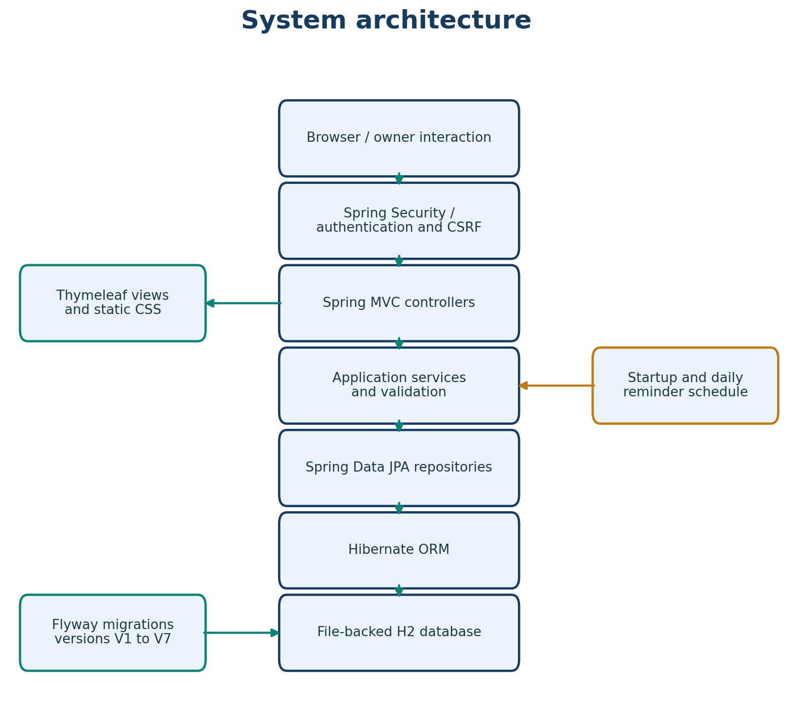
Figure 5-1: Layered system architecture showing browser, Spring Boot application, ORM, H2 database, and Flyway
The architecture enforces separation of concerns: controllers handle HTTP requests and responses, services contain business logic and transactions, repositories abstract data access, and domain entities represent database tables. The reminder scheduler operates independently of the HTTP request cycle, running on application startup and on a scheduled cron trigger.

5.2 Local Runtime / Deployment Diagram
Vahan Alerts runs as a single Spring Boot application with an embedded Tomcat server on HTTP port 8080 by default. The application is accessed through a web browser on the local machine. Thymeleaf views and static CSS are served from the application classpath. Spring Data JPA and Hibernate manage persistence to the file-backed H2 database at ./data/vahanalerts. Flyway migrations (V1–V7) are applied on startup. The reminder scheduler runs within the same JVM.
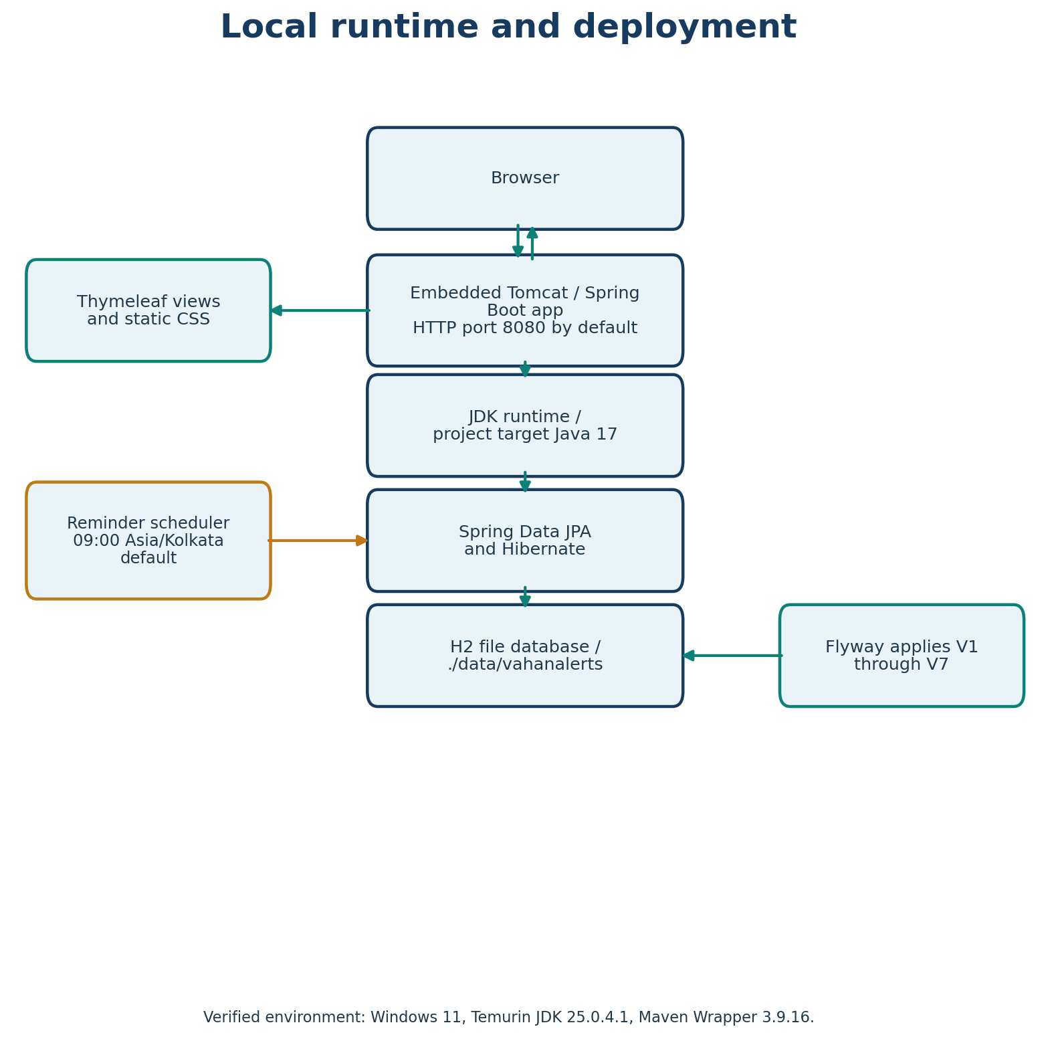
Figure 5-2: Local runtime deployment showing browser, embedded Tomcat, Thymeleaf views, JPA/Hibernate, H2 database, Flyway, and reminder scheduler
No separate web server, application server, or database server is required. The entire application runs in a single Java process. This simplifies deployment but means the application is limited to a single instance unless externalised configuration and a client-server database are introduced.

5.3 Use-Case Diagram
The use-case diagram identifies the primary actor (Vehicle Owner) and the system use cases supported by Vahan Alerts. The Vehicle Owner can register and sign in, view and manage their account (including WhatsApp consent), manage their own vehicles, manage vehicle documents, manage service history, view and read notifications, and check application health. All use cases except health checking require authentication. The actor is the only external entity; there are no secondary actors or external systems in the current implementation.
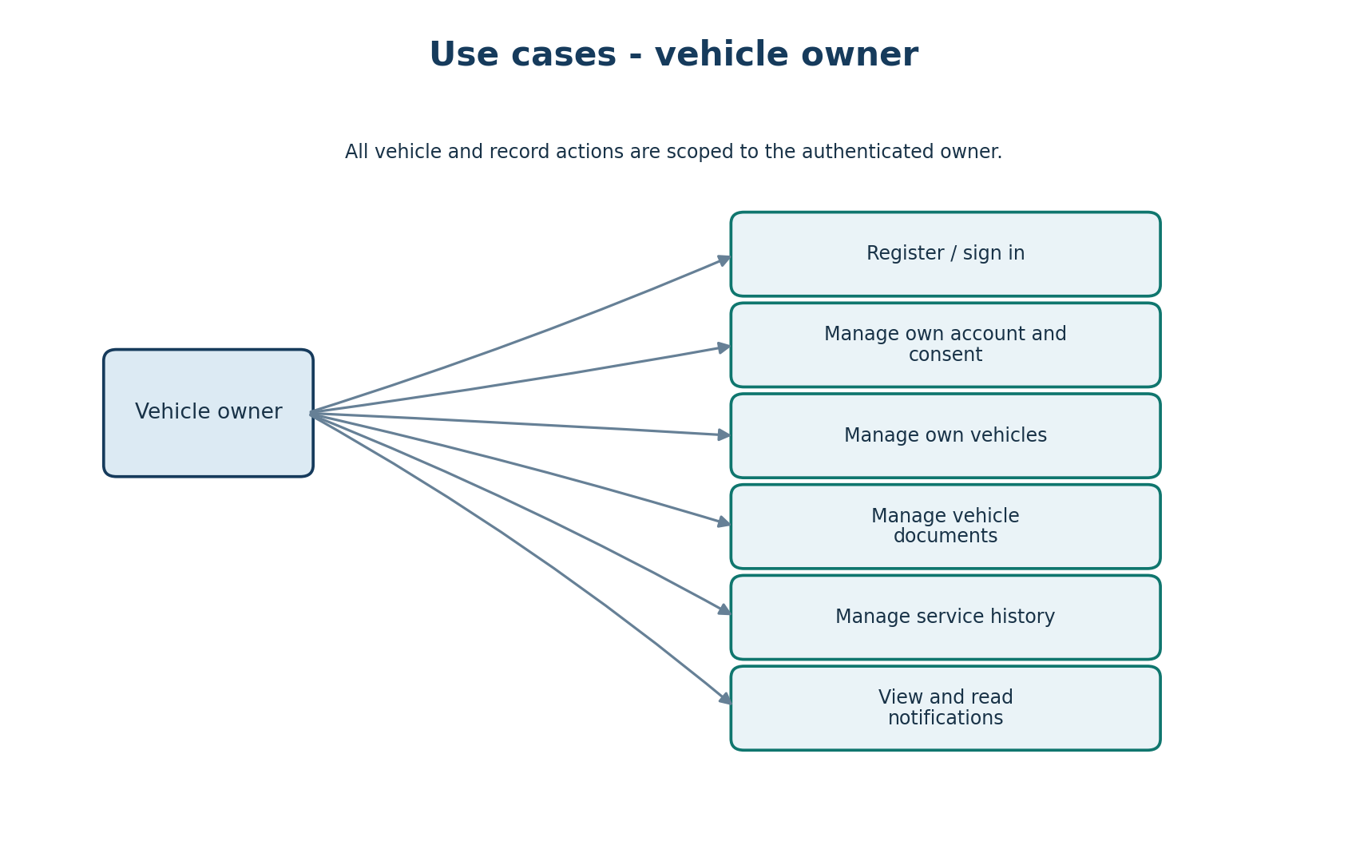
Figure 5-3: Use-case diagram showing Vehicle Owner actor and system use cases
Use cases are organised around the core domain concepts: registration and authentication (register, login), account management (WhatsApp consent withdrawal), vehicle management (CRUD with ownership enforcement), document management (CRUD with expiry status), maintenance management (service history with odometer validation), notifications (read/unread tracking), and health monitoring (public endpoint). Each use case maps to one or more controller endpoints and service methods in the implementation.

5.4 Class Diagram
The application class diagram shows the structural relationships between controllers, services, repositories, entities, and supporting classes. Controllers depend on services; services depend on repositories; entities have associations reflecting foreign key relationships in the database. The diagram excludes exception classes, form classes, enums, and DTO records for clarity, focusing on the core architectural elements.
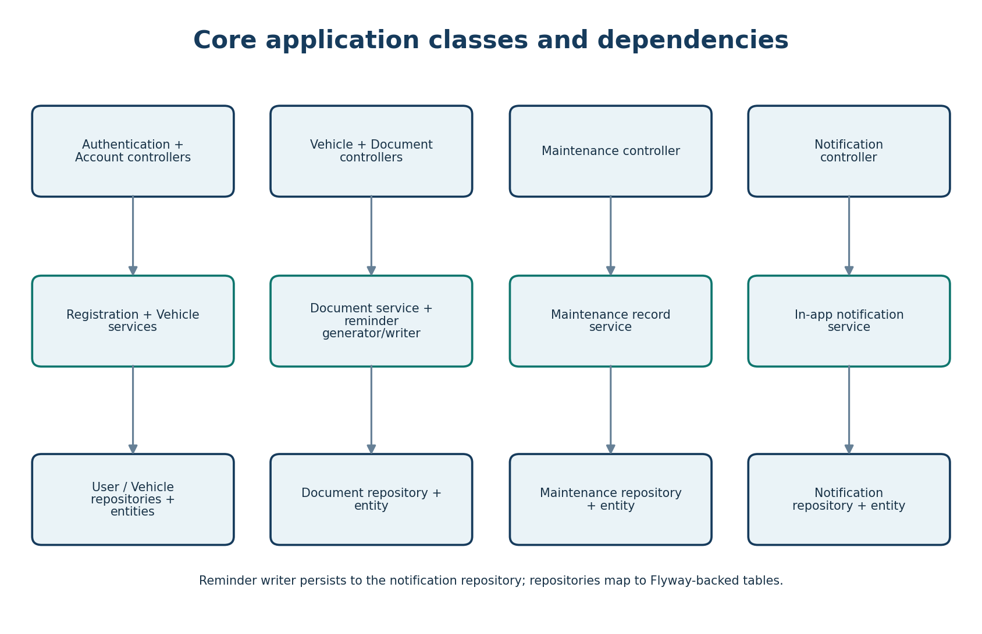
Figure 5-4: Application class diagram showing controller-service-repository-entity relationships
Key relationships: AuthenticationController → UserRegistrationService; VehicleController → VehicleService; VehicleDocumentController → VehicleDocumentService and DocumentExpiryReminderGenerator; MaintenanceController → MaintenanceRecordService; NotificationController → InAppNotificationService; DocumentExpiryReminderGenerator → DocumentExpiryReminderWriter. Services depend on their respective repositories (JpaRepository interfaces). Entity associations: Vehicle → UserAccount (many-to-one, owner); VehicleDocument → Vehicle (many-to-one); MaintenanceRecord → Vehicle (many-to-one); InAppNotification → UserAccount (many-to-one, owner), Vehicle (many-to-one), VehicleDocument (many-to-one).

5.5 Sequence Diagrams

5.5.1 Registration and Login Sequence
The registration and login sequence diagram illustrates the interaction between the user, browser, authentication controller, user details service, and user account repository during registration and authentication. The user submits registration fields, which are validated (password match, password length). On success, the UserRegistrationService normalises the phone number, checks for duplicates, hashes the password with BCrypt, and persists the account. The user is redirected to the login page. During login, Spring Security authenticates via VahanUserDetailsService, which loads the user by normalised phone number from the repository.
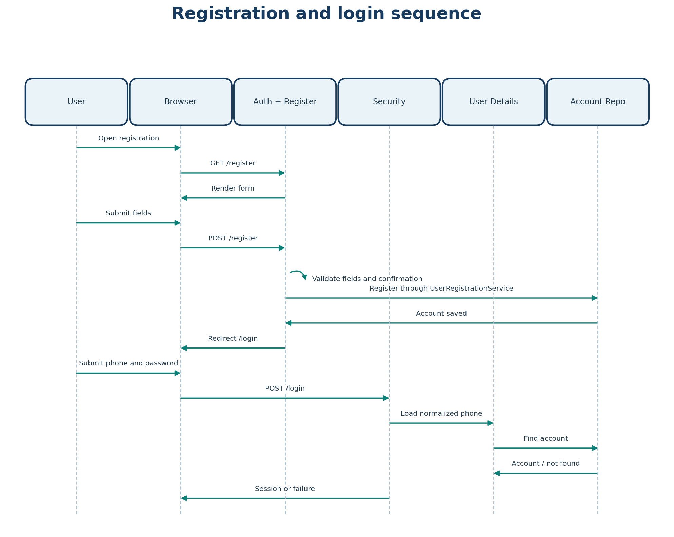
Figure 5-5: Registration and login sequence diagram
Security-relevant details: the username parameter is 'phoneNumber' (not email); passwords are never stored in plaintext (BCrypt hash only); phone numbers are normalised before storage and lookup; session fixation protection changes the session ID on successful authentication.

5.5.2 Vehicle Document Workflow Sequence
The vehicle document workflow sequence shows the interaction when an authenticated owner manages documents for a specific vehicle. The owner selects a vehicle, opens the document form, chooses a document type, and enters document number, issue date, and expiry date. On save, VehicleDocumentService persists the document linked to the vehicle. After create or update, the DocumentExpiryReminderGenerator runs to create expiry notifications. Document expiry status (Expired / Expiring Soon / Valid / No Expiry Date) is calculated using the India-local clock with a 30-day threshold for 'expiring soon'.
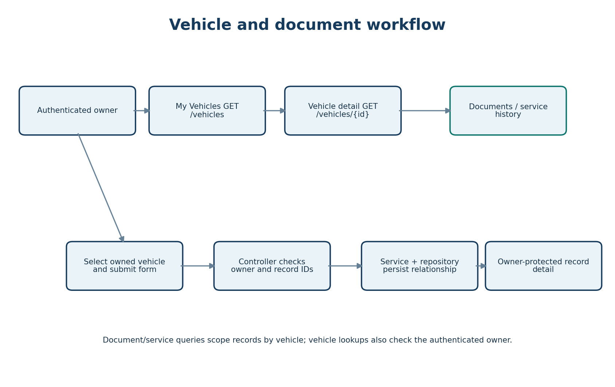
Figure 5-6: Vehicle document management workflow
All document operations are owner-scoped: the service layer verifies that the vehicle belongs to the authenticated user before permitting any document operation. Cross-user document access is prevented by owner ID checks in repository queries.

5.5.3 Notification Lifecycle
The notification lifecycle describes the states of an in-app notification from creation to deletion. Notifications are created in an unread state when a document expiry reminder is generated. The owner can mark individual notifications as read (POST /notifications/{id}/read) or mark all as read (POST /notifications/read-all). Read notifications retain their snapshot data (registration number, document type, expiry date) even if the related vehicle or document is deleted. When the owner account is deleted, all associated notifications are cascade-deleted.
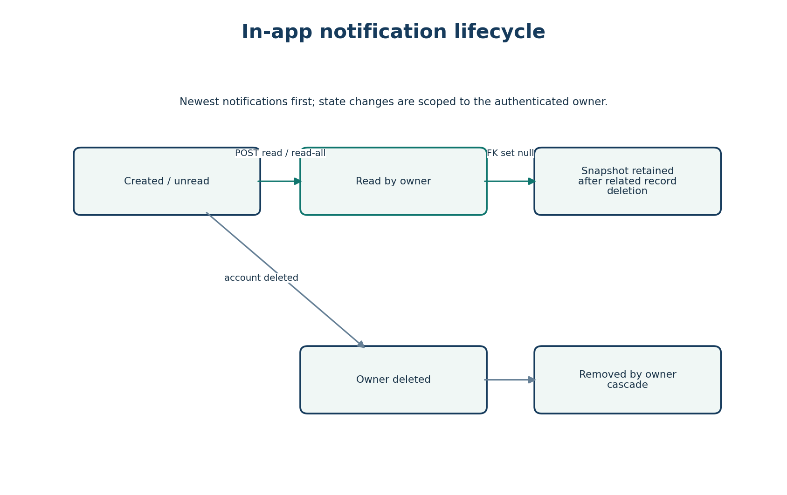
Figure 5-7: Notification lifecycle state diagram
Notification snapshots preserve historical context: if a document's expiry date is updated after a reminder is created, the notification retains the original expiry date snapshot. The NotificationListItem includes an isExpiryDateChanged() method that detects when the current document expiry differs from the snapshot.

5.6 Activity Diagrams

5.6.1 Document Expiry Reminder Generation
The reminder generation flow describes how the system creates in-app notifications for expiring documents. The process is triggered by application startup (ApplicationReadyEvent), a daily scheduled cron (09:00 Asia/Kolkata by default), or after document create/update. The generator reads the current Asia/Kolkata date, finds documents expiring from today through day 30, calculates days until expiry, and for each configured offset (30, 7, 1, 0 days), checks whether a reminder already exists for that document/expiry/offset combination. If not, it persists an owner-scoped in-app notification. A database unique constraint prevents duplicates.
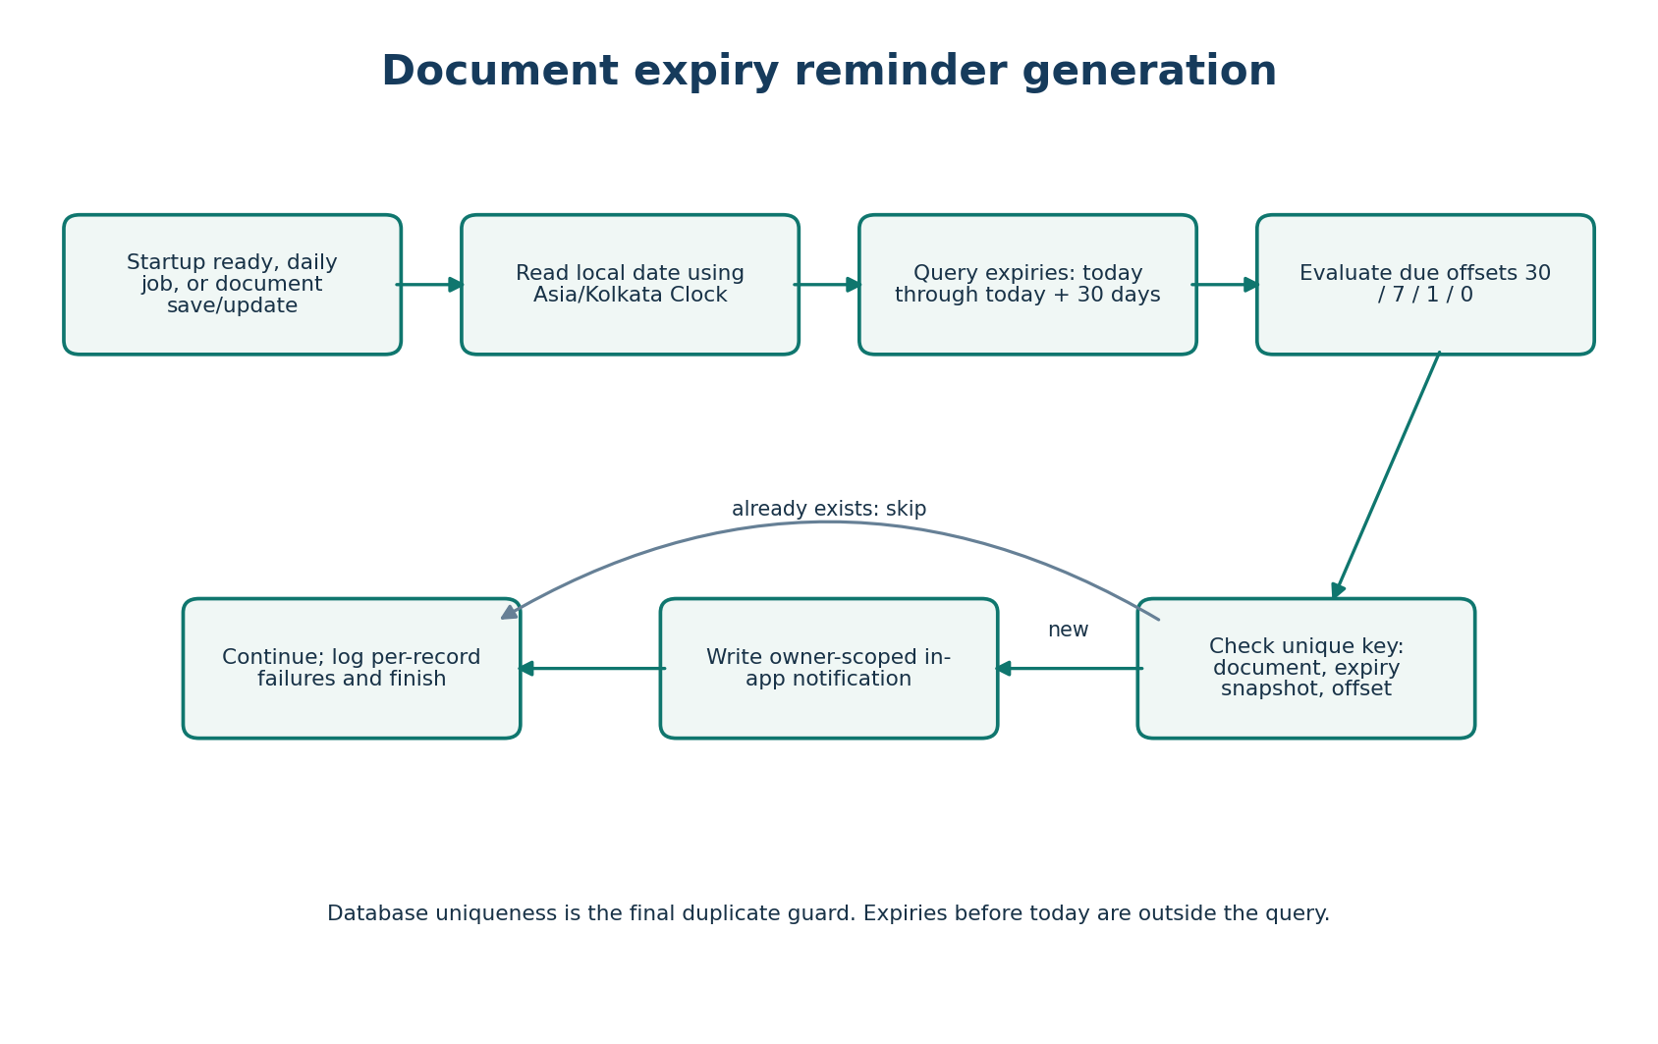
Figure 5-8: Document expiry reminder generation activity diagram
The reminder window covers documents expiring from today through 30 days ahead. Documents that expired long ago are not recovered by this process. Reminder generation errors are logged and do not fail the overall run. The writer uses REQUIRES_NEW transaction propagation to persist each notification independently.

5.7 Component Diagram
The component diagram shows the high-level components of the Vahan Alerts system and their interactions. The user browser interacts with the Spring Security filter chain, which delegates to Spring MVC controllers. Controllers call application services, which in turn call Thymeleaf templates for view rendering and Spring Data JPA repositories for data access. The reminder scheduler calls application services. Repositories use Hibernate ORM to access the file-backed H2 database. Flyway migrations evolve the database schema.
Figure 5-9: Component diagram showing browser, security, MVC controllers, services, templates, scheduler, repositories, ORM, H2 database, and Flyway
Components are organised by layer: presentation (browser, templates), application (security, controllers, services, scheduler), data access (repositories, ORM), and infrastructure (database, migrations). The diagram emphasizes the unidirectional dependency flow from outer layers (presentation) to inner layers (data access, infrastructure).

5.8 Entity-Relationship Diagram
The entity-relationship diagram shows the five core tables in the Vahan Alerts database and their relationships. The app_user table stores registered users. The vehicle table stores user-owned vehicles with a foreign key to app_user. The vehicle_document table stores documents linked to vehicles. The vehicle_maintenance_record table stores service history linked to vehicles. The in_app_notification table stores expiry reminders linked to users, with optional references to vehicles and documents.
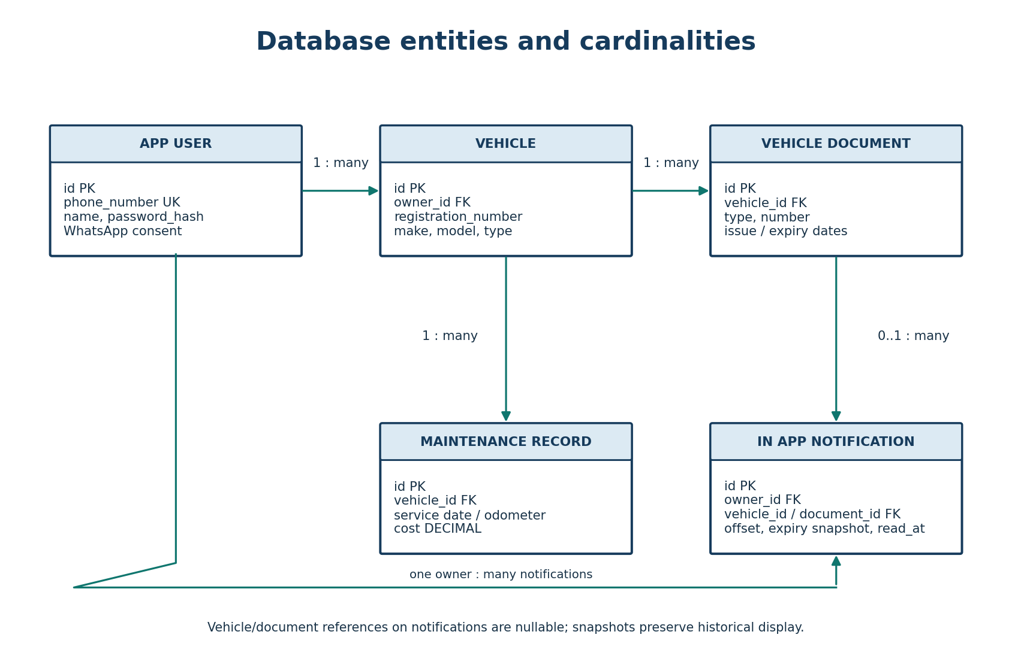
Figure 5-10: Entity-relationship diagram showing app_user, vehicle, vehicle_document, vehicle_maintenance_record, and in_app_notification tables with relationships
Relationships: app_user 1:N vehicle (cascade delete on user removal); vehicle 1:N vehicle_document (cascade delete); vehicle 1:N vehicle_maintenance_record (cascade delete); app_user 1:N in_app_notification (cascade delete); vehicle o:N in_app_notification (set null on vehicle deletion); vehicle_document o:N in_app_notification (set null on document deletion). Cascade delete ensures that removing a user removes all their vehicles, documents, maintenance records, and notifications. Set null on vehicle/document deletion preserves notification history with snapshot data.
Chapter 6: Technologies and Tools

6.1 Technology Stack Overview
Vahan Alerts is built on a modern Java-based web stack. All technologies are open-source and have extensive community support. The versions below are verified from the Maven POM file and application.properties configuration.
Layer | Technology | Version | Purpose
Language | Java | 17 | Application programming language
Framework | Spring Boot | 4.1.2 | Application framework and auto-configuration
Web Layer | Spring MVC / Thymeleaf | — | Controller layer and server-side HTML rendering
Security | Spring Security | — | Authentication, authorization, CSRF, session management
Data Access | Spring Data JPA / Hibernate | — | ORM and database access
Database | H2 | — | Embedded file-based database
Schema Migration | Flyway | — | Versioned database schema migration (V1–V7)
Validation | Jakarta Validation | — | Bean validation for form inputs
Password Encoding | BCrypt | — | Secure password hashing
Build Tool | Apache Maven | 3.9.16 | Dependency management and build
Testing | JUnit 5, Spring Boot Test, MockMvc | — | Unit and integration testing
Scheduling | Spring @Scheduled | — | Daily reminder job
Clock/Time | java.time.Clock | — | Asia/Kolkata timezone for dates

6.2 Spring Boot 4.1.2
Spring Boot is the core application framework. It provides auto-configuration, embedded Tomcat servlet container, starter dependencies (webmvc, thymeleaf, security, data-jpa, validation, flyway, test), and the Spring Boot Maven plugin for packaging executable JARs. The @SpringBootApplication annotation on VahanAlertsApplication enables component scanning, auto-configuration, and property support. The @EnableScheduling annotation enables scheduled task execution for the reminder generator.
Spring Boot's opinionated defaults reduce configuration boilerplate. The embedded Tomcat eliminates the need for a separate web server installation. Starter dependencies transitively include all required libraries with compatible versions, avoiding dependency conflicts.

6.3 Spring Security
Spring Security provides authentication, authorization, CSRF protection, and session management. The SecurityConfiguration class defines a BCryptPasswordEncoder bean for password hashing and a SecurityFilterChain bean that configures: public route access (/, /register, /login, /api/v1/health, /css/**, /error); authenticated access for all other routes; form login with loginPage=/login and usernameParameter=phoneNumber; logout with session invalidation and clearing; and session fixation protection using change-session-id strategy.
CSRF protection remains enabled for all state-changing POST requests. Error responses exclude messages, stack traces, and binding errors to prevent information disclosure. Session cookies are HTTP-only and SameSite=Lax, with a 30-minute session timeout.

6.4 Spring Data JPA and Hibernate
Spring Data JPA provides repository abstraction, and Hibernate is the JPA provider for object-relational mapping. Entity classes (UserAccount, Vehicle, VehicleDocument, MaintenanceRecord, InAppNotification) are annotated with @Entity, @Table, @Id, @Column, @ManyToOne, @JoinColumn, and @Enumerated. Repository interfaces extend JpaRepository and declare query methods derived from method names (e.g., findByIdAndOwner_Id, findAllByOwner_IdOrderByCreatedAtDesc). The @Query annotation is used for custom JPQL queries with pessimistic locking (LOCK PESSIMISTIC_WRITE).
The application uses spring.jpa.hibernate.ddl-auto=validate, meaning Hibernate validates entity mappings against the existing schema without creating or altering tables. Schema changes are managed exclusively through Flyway migrations. spring.jpa.open-in-view=false prevents lazy loading exceptions outside transaction boundaries.

6.5 H2 Database
H2 is a lightweight, embedded relational database engine. The application uses a file-backed H2 database at ./data/vahanalerts with DB_CLOSE_ON_EXIT=FALSE, meaning the database file persists between application restarts. No separate database server installation or administration is required. The database is accessed via JDBC through Spring Data JPA and Hibernate.
Database connection settings are externalized in application.properties with environment variable overrides (VAHAN_DB_URL, VAHAN_DB_USERNAME, VAHAN_DB_PASSWORD). The default username is 'sa' with no password. This configuration makes the application easy to deploy on any machine without database infrastructure.

6.6 Flyway
Flyway manages database schema evolution through versioned SQL migrations (V1 through V7). Migrations are applied automatically on application startup (spring.flyway.enabled=true). V1 creates the app_user table; V2 creates the vehicle table; V3 adds phone number, date of birth, and WhatsApp consent columns to app_user; V4 creates the vehicle_document table; V5 creates the vehicle_maintenance_record table; V6 creates the in_app_notification table; V7 removes document attachment columns. Each migration is checksummed and applied exactly once, ensuring schema consistency across environments.

6.7 Thymeleaf
Thymeleaf is the server-side template engine for rendering HTML views. Templates are located in src/main/resources/templates and are organised by feature (account, documents, error, maintenance, notifications, vehicles). Controllers return template names, and Thymeleaf resolves and renders them with model attributes. Thymeleaf supports expression language, iteration, conditionals, and URL linking, enabling dynamic server-side rendered pages without a separate frontend framework.
Static CSS is served from src/main/resources/static/css/site.css. Templates use Thymeleaf layout attributes and form binding with Spring's model attributes for form submission and validation error display.

6.8 Build and Testing Tools
Apache Maven (3.9.16) is the build tool. The POM declares Spring Boot parent 4.1.2, Java 17 source/target compatibility, and all dependencies. The Spring Boot Maven plugin packages the application as an executable JAR. The Maven Wrapper (mvnw.cmd) allows building without a pre-installed Maven.
Testing uses JUnit 5, Spring Boot Test, MockMvc, and Spring Security Test. Tests run against isolated in-memory H2 databases. The verified test suite result is 56 tests with 0 failures, 0 errors, and 0 skipped (BUILD SUCCESS), confirming correct behaviour for authentication, vehicles, documents, maintenance, notifications, and application context.
Chapter 7: Implementation Details

7.1 Application Structure
The application source code is organised under src/main/java/com/vahanalerts with the following packages: config, controller, document, maintenance, notification, user, and vehicle. Each package contains related controllers, services, repositories, entities, forms, and enums. The entry point is VahanAlertsApplication, annotated with @SpringBootApplication and @EnableScheduling. Configuration classes (SecurityConfiguration, TimeConfiguration) define beans for password encoding, security filter chain, and application clock.
Resource files under src/main/resources include application.properties, messages.properties (validation error messages), Thymeleaf templates (organised by feature subdirectories), static CSS, and Flyway SQL migrations (V1–V7). Test classes under src/test/java/com/vahanalerts cover all major functionality with 56 verified passing tests.

7.2 Controllers and Request Handling
Controller | Routes | Responsibility
HomeController | GET / | Home page; exposes current user to model
AuthenticationController | GET/POST /register, GET /login | Registration form, registration processing, login page
AccountController | GET /account, POST /account/whatsapp-consent/withdraw | Account page, WhatsApp consent withdrawal
VehicleController | GET/POST /vehicles, GET/POST /vehicles/{id} | Vehicle CRUD with ownership enforcement
VehicleDocumentController | GET/POST /vehicles/{vehicleId}/documents | Document CRUD with expiry status calculation
MaintenanceController | GET/POST /vehicles/{vehicleId}/maintenance | Maintenance record CRUD with odometer validation
NotificationController | GET /notifications, POST /notifications/{id}/read, POST /notifications/read-all | Notification list, mark read, mark all read
HealthController | GET /api/v1/health | Health endpoint returning JSON status
NotFoundExceptionHandler | @ControllerAdvice | Handles NoResourceFoundException → 404 page
NotificationNavigationAdvice | @ControllerAdvice @ModelAttribute | Injects unread notification count into all views

All controllers use constructor injection for dependencies. Controller methods are annotated with @GetMapping or @PostMapping and receive @AuthenticationPrincipal VahanUserDetails for the authenticated owner. Owner-scoped access is enforced by passing the owner ID to service methods, which query entities by both ID and owner ID.

7.3 Service Layer
Service Class | Responsibilities
UserRegistrationService | Registers users; normalises phone; checks duplicates; BCrypt hashes password; @Transactional
VehicleService | Vehicle CRUD; registration normalization; duplicate check; optimistic/pessimistic locking
VehicleDocumentService | Document CRUD linked to vehicles; owner-scoped lookups
MaintenanceRecordService | Maintenance CRUD; service date validation; odometer sequence validation; cost summary
InAppNotificationService | Notification list (newest first); unread count; mark read; mark all read
DocumentExpiryReminderGenerator | Finds documents expiring today–day 30; creates reminders at 30/7/1/0 day offsets
DocumentExpiryReminderWriter | Persists notifications with REQUIRES_NEW transaction; duplicate check via unique constraint
VehicleDocumentService | Document expiry status calculation via DocumentExpiryStatusCalculator
WhatsAppConsentService | Account lookup; consent withdrawal with timestamp
VahanUserDetailsService | Loads user by normalised phone number; implements UserDetailsService

Services use @Transactional for write operations and @Transactional(readOnly=true) for queries. Business validation (duplicate registration, future service dates, odometer sequence, document expiry) is implemented in service methods. Exceptions are translated to HTTP 404 (ResponseStatusException) or form binding errors as appropriate.

7.4 Repositories and Data Access
Repository Interface | Custom Query Methods
UserAccountRepository | findByPhoneNumber, existsByPhoneNumber
VehicleRepository | findAllByOwner_IdOrderByCreatedAtDesc, findByIdAndOwner_Id, findByIdAndOwner_IdForUpdate (pessimistic lock), existsByOwner_IdAndRegistrationNumber
VehicleDocumentRepository | findAllByVehicle_IdOrderByExpiryDateAsc, findByIdAndVehicle_Id, findAllByExpiryDateBetween (with EntityGraph)
MaintenanceRecordRepository | findAllByVehicle_IdOrderByServiceDateDescIdDesc, findAllByVehicle_IdOrderByServiceDateAscIdAsc, findByIdAndVehicle_Id
InAppNotificationRepository | findAllByOwner_IdOrderByCreatedAtDescIdDesc, countByOwner_IdAndReadAtIsNull, existsByDocument_IdAndExpiryDateSnapshotAndReminderOffsetDays, findByIdAndOwner_Id, markAllReadByOwner

All repositories extend JpaRepository, inheriting standard CRUD methods (save, findById, findAll, delete, etc.). Custom methods use Spring Data JPA method name derivation or @Query annotations. EntityGraph annotations are used on VehicleDocumentRepository and InAppNotificationRepository to fetch related entities eagerly and avoid N+1 query issues.

7.5 Entities and Relationships
Entity Class | Table Name | Key Fields
UserAccount | app_user | id, name, email, phone_number (UK), password_hash, date_of_birth, whatsapp_reminder_consent, whatsapp_consent_at, whatsapp_consent_withdrawn_at, whatsapp_consent_version, created_at
Vehicle | vehicle | id, owner_id (FK), nickname, registration_number, vehicle_type, make, model, manufacturing_year, fuel_type, notes, created_at, updated_at
VehicleDocument | vehicle_document | id, vehicle_id (FK), document_type, document_number, issue_date, expiry_date, notes, created_at, updated_at
MaintenanceRecord | vehicle_maintenance_record | id, vehicle_id (FK), service_date, odometer_km, service_type, workshop_name, service_cost_inr, description, created_at, updated_at
InAppNotification | in_app_notification | id, owner_id (FK), vehicle_id (FK), document_id (FK), notification_type, reminder_offset_days, document_type_snapshot, registration_number_snapshot, expiry_date_snapshot, message, created_at, read_at

Entities use @PrePersist and @PreUpdate lifecycle callbacks to manage created_at and updated_at timestamps. Enum fields (VehicleType, FuelType, DocumentType, ServiceType, DocumentExpiryStatus, NotificationType) are stored as STRING in the database. Numeric fields with precision requirements (service_cost_inr) use BigDecimal. Optional fields are nullable and trimmed to null on blank input.

7.6 Security Implementation
Security is implemented at multiple layers: (1) Spring Security filter chain enforces route-level access control; (2) BCryptPasswordEncoder hashes passwords before storage; (3) service methods enforce owner-scoped access by owner ID; (4) CSRF protection is enabled for all POST requests; (5) session fixation protection changes session ID on login; (6) session cookies are HTTP-only and SameSite=Lax with 30-minute timeout; (7) error responses exclude stack traces and binding errors; (8) pessimistic write locking prevents concurrent update conflicts on vehicles.
VahanUserDetails implements Spring Security's UserDetails interface, wrapping a UserAccount entity. It provides the phone number as the username, the BCrypt hash as the password, and a single ROLE_USER authority. VahanUserDetailsService implements UserDetailsService and loads users by normalised phone number, throwing UsernameNotFoundException if not found.

7.7 Vehicle Management Implementation
Vehicle management is implemented in VehicleController, VehicleService, VehicleRepository, and the Vehicle entity. Registration numbers are normalised (trimmed, spaces removed, uppercased) before storage. Uniqueness is enforced per owner via a database unique constraint (uk_vehicle_owner_registration) and application-level checks. Pessimistic write locking (LOCK PESSIMISTIC_WRITE) is used for concurrent update safety. Vehicle fields include nickname, registration number, type, make, model, manufacturing year, fuel type, notes, and timestamps.

7.8 Document Management Implementation
Document management is implemented in VehicleDocumentController, VehicleDocumentService, VehicleDocumentRepository, and the VehicleDocument entity. Document types include INSURANCE, PUC, REGISTRATION_CERTIFICATE, FITNESS_CERTIFICATE, PERMIT, DRIVING_LICENCE, and OTHER. Expiry status (Expired, Expiring Soon, Valid, No Expiry Date) is calculated by DocumentExpiryStatusCalculator using the Asia/Kolkata clock with a 30-day threshold. No file attachment upload is supported (multipart disabled; attachment columns removed in migration V7).

7.9 Maintenance Management Implementation
Maintenance management is implemented in MaintenanceController, MaintenanceRecordService, MaintenanceRecordRepository, and the MaintenanceRecord entity. Service dates cannot be in the future. Odometer readings must follow chronological sequence: a new record's odometer cannot be lower than a previous service's reading or higher than a subsequent service's reading. Service cost is stored as BigDecimal(12,2) for exact decimal arithmetic. MaintenanceSummary provides record count, total cost, and most recent service date.

7.10 Notifications and Reminders Implementation
Notifications and reminders are implemented in the com.vahanalerts.notification package. DocumentExpiryReminderSchedule triggers reminder generation on application startup and via @Scheduled cron (09:00 Asia/Kolkata). DocumentExpiryReminder Generator finds documents expiring today through day 30 and creates reminders at offsets of 30, 7, 1, and 0 days. DocumentExpiryReminderWriter persists notifications with REQUIRES_NEW transaction propagation and checks for duplicates before insertion. A database unique constraint (uk_notification_document_expiry_offset) prevents duplicate reminders. InAppNotificationService provides notification listing (newest first), unread counting, marking read, and marking all read.

7.11 Templates and Navigation
The user interface uses Thymeleaf server-side templates organised by feature: account, documents (delete, detail, form, list), error (404), maintenance (delete, detail, form, list), notifications (list), vehicles (delete, detail, form, list), plus root-level templates (account, error, index, login, register). Static CSS is served from src/main/resources/static/css/site.css. The NotificationNavigationAdvice @ControllerAdvice injects unread notification count into every view as a model attribute, displayed in the navigation bar. Flash messages communicate success and error outcomes between redirects.

7.12 Database Migrations and Configuration
Seven Flyway migrations (V1–V7) evolve the database schema: V1 creates app_user; V2 creates vehicle; V3 adds phone number, date of birth, and WhatsApp consent columns; V4 creates vehicle_document; V5 creates vehicle_maintenance_record; V6 creates in_app_notification; V7 removes document attachment columns. Migration SQL includes CHECK constraints for data validity (registration length, vehicle type, manufacturing year, fuel type, document type, odometer >= 0, cost >= 0, service type, reminder offset in {30,7,1,0}, notification type = DOCUMENT_EXPIRY). application.properties externalizes database URL, session settings, reminder cron, timezone, and multipart configuration.

Chapter 8: User Interface and Features

8.1 Overview
Vahan Alerts uses server-side rendered Thymeleaf templates with a consistent navigation layout. The application is accessed through a web browser on HTTP port 8080. All pages require authentication except the home page, registration, login, health endpoint, static CSS, and error pages. The navigation bar shows the unread notification count and provides links to vehicles, documents, maintenance, notifications, and account pages.

8.2 Key Pages and Features
Page / Route | Description
Home (/) | Landing page; shows current user if authenticated
Register (/register) | Registration form with name, phone, DOB, password, WhatsApp consent
Login (/login) | Spring Security form login with phone number
Account (/account) | View account details; withdraw WhatsApp consent
Vehicles (/vehicles) | List owner's vehicles; add new vehicle
Vehicle Detail (/vehicles/{id}) | View vehicle details; edit or delete
Documents (/vehicles/{id}/documents) | List vehicle documents with expiry status; add new document
Maintenance (/vehicles/{id}/maintenance) | List service history with summary; add service record
Notifications (/notifications) | List notifications newest first; mark read / mark all read

No screenshots are included in this report because no screenshots were captured from the running application, and no screenshot assets exist in the project. All UI descriptions are based on Thymeleaf template inspection and controller route analysis. Mockups or fabricated screenshots are not presented as implemented screens.

8.3 Form Validation
Form validation uses Jakarta Validation constraints (NotBlank, Size, Pattern, PastOrPresent, NotNull, Min, Max, PositiveOrZero, Digits). Validation error messages are defined in messages.properties. Controllers check BindingResult and redisplay forms with error messages. Custom cross-field validation (password confirmation match, password length limit of 72 UTF-8 bytes for BCrypt) is implemented in AuthenticationController.

8.4 Navigation Flow
Users typically navigate as follows: register → login → home → vehicles (add/view) → select vehicle → documents (add/view with expiry status) → maintenance (add/service history) → notifications (view/mark read) → account (manage consent). The health endpoint is publicly accessible without authentication. The 404 page is shown for missing resources.

Chapter 9: Database Design

9.1 Overview
Vahan Alerts uses a file-backed H2 database with Flyway versioned migrations (V1–V7). The database contains five core tables: app_user, vehicle, vehicle_document, vehicle_maintenance_record, and in_app_notification. Schema changes are managed exclusively through Flyway migrations; Hibernate uses ddl-auto=validate to verify entity mappings against the existing schema without creating or altering tables.

9.2 Entity-Relationship Diagram
Figure 9-1: Entity-relationship diagram showing all tables and relationships
The app_user table is the root of the data model, with one-to-many relationships to vehicle, in_app_notification. The vehicle table has one-to-many relationships to vehicle_document, vehicle_maintenance_record, and in_app_notification. The vehicle_document table has an optional one-to-many relationship to in_app_notification. Cascade delete is configured for user→vehicle, vehicle→document, vehicle→maintenance, and user→notification relationships. Set null is configured for vehicle→notification and document→notification relationships, preserving notification history when related entities are deleted.

9.3 Data Dictionary
Table | Description | Key Fields
app_user | Registered users | id PK, name, email, phone_number UK, password_hash, date_of_birth, whatsapp_reminder_consent, whatsapp_consent_at, whatsapp_consent_withdrawn_at, whatsapp_consent_version, created_at
vehicle | User-owned vehicles | id PK, owner_id FK→app_user, nickname, registration_number, vehicle_type, make, model, manufacturing_year, fuel_type, notes, created_at, updated_at
vehicle_document | Vehicle documents | id PK, vehicle_id FK→vehicle, document_type, document_number, issue_date, expiry_date, notes, created_at, updated_at
vehicle_maintenance_record | Service history | id PK, vehicle_id FK→vehicle, service_date, odometer_km, service_type, workshop_name, service_cost_inr, description, created_at, updated_at
in_app_notification | Expiry reminders | id PK, owner_id FK→app_user, vehicle_id FK→vehicle, document_id FK→vehicle_document, notification_type, reminder_offset_days, document_type_snapshot, registration_number_snapshot, expiry_date_snapshot, message, created_at, read_at

9.4 Database Constraints
Constraint Name | Table | Description
uk_app_user_phone_number | app_user | phone_number must be unique
uk_vehicle_owner_registration | vehicle | owner_id + registration_number must be unique
chk_vehicle_registration_length | vehicle | registration_number length between 3 and 20
chk_vehicle_type | vehicle | vehicle_type must be one of CAR, MOTORCYCLE, SCOOTER, OTHER
chk_vehicle_manufacturing_year | vehicle | manufacturing_year between 1886 and 2100
chk_vehicle_fuel_type | vehicle | fuel_type must be one of PETROL, DIESEL, CNG, ELECTRIC, HYBRID, OTHER
chk_vehicle_document_type | vehicle_document | document_type must be one of INSURANCE, PUC, RC, FITNESS, PERMIT, DL, OTHER
chk_vehicle_document_expiry_required | vehicle_document | OTHER documents may have null expiry; others must have expiry
chk_vehicle_document_date_order | vehicle_document | expiry_date must be >= issue_date when both present
chk_vehicle_maintenance_odometer | vehicle_maintenance_record | odometer_km >= 0
chk_vehicle_maintenance_cost | vehicle_maintenance_record | service_cost_inr >= 0
chk_notification_type | in_app_notification | notification_type must be DOCUMENT_EXPIRY
chk_notification_reminder_offset | in_app_notification | reminder_offset_days in (30, 7, 1, 0)
uk_notification_document_expiry_offset | in_app_notification | document_id + expiry_date_snapshot + reminder_offset_days unique

Foreign key constraints enforce referential integrity: vehicle.owner_id → app_user.id (cascade delete); vehicle_document.vehicle_id → vehicle.id (cascade delete); vehicle_maintenance_record.vehicle_id → vehicle.id (cascade delete); in_app_notification.owner_id → app_user.id (cascade delete); in_app_notification.vehicle_id → vehicle.id (set null); in_app_notification.document_id → vehicle_document.id (set null). Indexes are created on frequently queried columns for performance.

Chapter 10: Testing and Results

10.1 Testing Strategy
Vahan Alerts uses JUnit 5 with Spring Boot Test and MockMvc. Tests run against isolated in-memory H2 databases, ensuring test independence and repeatability. Test coverage includes authentication, vehicles, documents, maintenance, notifications, and application context. The verified test suite result is 56 tests with 0 failures, 0 errors, and 0 skipped (BUILD SUCCESS), confirmed by executing the Maven test command.
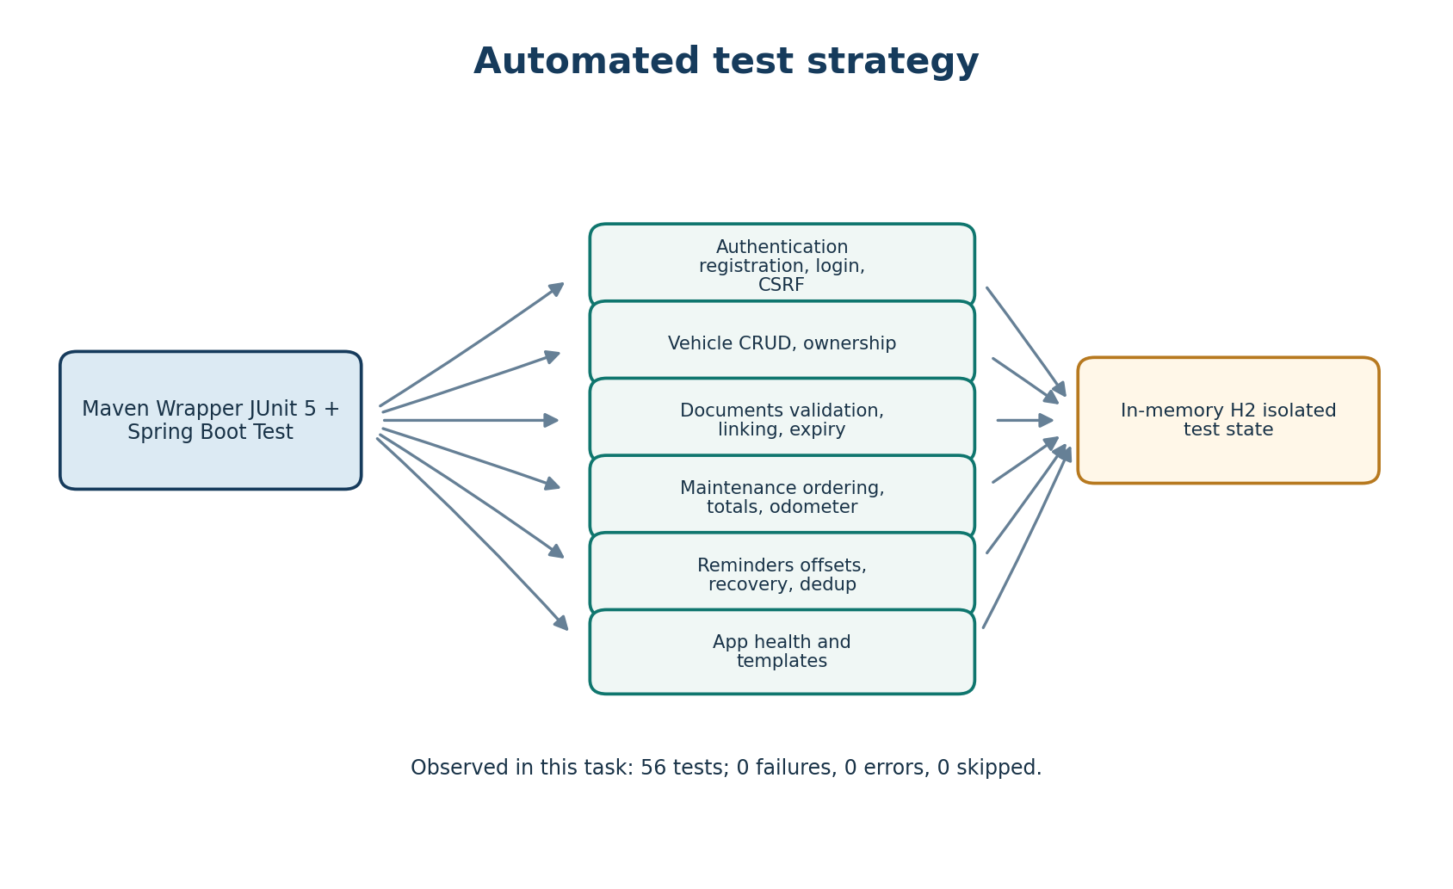
Figure 10-1: Testing strategy diagram showing test suite organisation and results
Test categories include: controller tests (HTTP endpoints, request/response handling), security tests (authentication, authorisation, CSRF), service tests (business logic, validation), repository tests (query methods), and application context tests (bean wiring, health endpoint). MockMvc is used to simulate HTTP requests without starting a server.

10.2 Test Classes
Test Class | Coverage
VahanAlertsApplicationTests | Application context loads; health endpoint returns expected JSON
AuthenticationTests | Registration creates account with BCrypt password; duplicate phone rejected; login accepts normalized phone; consent withdrawal
VehicleTests | Vehicle CRUD operations; ownership enforcement (user cannot access another's vehicle); duplicate registration rejected
VehicleDocumentTests | Document CRUD; expiry status calculation uses injected clock; dropdown shows only owner's vehicles; no file upload accepted
MaintenanceTests | Odometer sequence enforced on create and edit; future service date rejected; negative odometer/cost rejected; chronological ordering maintained
NotificationTests | Notification centre is owner-scoped and ordered; read actions work; CSRF protection on mutations; all reminder offsets generated

10.3 Verified Results
The complete test suite was executed using the Maven Wrapper (mvnw.cmd test) against isolated in-memory H2 databases. The result was: 56 tests run, 0 failures, 0 errors, 0 skipped, BUILD SUCCESS. This confirms correct behaviour for authentication, vehicle ownership, document expiry, maintenance odometer sequencing, notification lifecycle, CSRF protection, and reminder offset generation.
Metric | Value
Total tests | 56
Failures | 0
Errors | 0
Skipped | 0
Build result | BUILD SUCCESS
Test database | In-memory H2 (isolated per test)
Test framework | JUnit 5, Spring Boot Test, MockMvc

Test execution evidence is available from the Maven build output. No performance benchmarks, coverage percentages, or load test results were collected, as these are outside the scope of the academic project.

Chapter 11: Limitations and Future Enhancements

11.1 Verified Limitations
The following limitations are verified from the actual source code and implementation:
Limitation | Description
No real message delivery | WhatsApp consent is stored and withdrawn, but no WhatsApp API, email, SMS, or push notification messages are actually sent to users.
No file attachments | Document attachment upload/download is not supported; multipart is disabled and attachment columns were removed in migration V7.
No government database integration | The application stores user-entered information only and does not access VAHAN or other government vehicle registration databases.
Single role (ROLE_USER) | All authenticated users have the same role; no admin or moderator roles are implemented.
Phone number authentication only | No OAuth/social login or multi-factor authentication is available.
No PWA or mobile app | The UI is server-side rendered Thymeleaf; no Progressive Web App, service worker, or native mobile application exists.
No payment gateway | No payment processing or insurance premium calculation is implemented.
Limited reminder recovery | The reminder catch-up window covers documents expiring from today through 30 days ahead; reminders for documents that expired long ago are not recovered.

11.2 Future Enhancements
The following enhancements are proposed for future development. These are not implemented in the current version:
- Integrate WhatsApp Business API or SMS gateway to deliver expiry reminders to users who have given consent.
- Add document file upload and download with secure storage and access control.
- Add email notifications as an alternative reminder channel.
- Implement role-based access control with ADMIN and USER roles.
- Add OAuth2 social login (Google, etc.) as an alternative authentication method.
- Develop a PWA or native mobile app for push notifications and offline access.
- Integrate with government vehicle registration APIs for automatic document data fetching.
- Add payment gateway for insurance premium or service bill payments.
- Add vehicle fuel efficiency tracking and expense analytics.
- Add multi-vehicle fleet management for small businesses.
- Add export of maintenance and document records to PDF/Excel.
- Add two-factor authentication (2FA) for enhanced account security.

Chapter 12: Conclusion
Vahan Alerts delivers a practical, secure, and well-tested solution for personal vehicle document and maintenance tracking. The application addresses the core problem of missed document expirations and disorganised service history through automated expiry status calculation, scheduled in-app reminders, and owner-scoped data access. Built on the Spring Boot stack with industry-standard security practices (BCrypt password hashing, CSRF protection, session fixation protection, HTTP-only cookies), the system is reliable and maintainable. The comprehensive test suite (56 passing tests) validates all critical workflows.
While certain enhancements such as real message delivery, file attachments, government database integration, and mobile applications remain future work, the current implementation provides a solid foundation for vehicle owners to manage their documentation proactively. The layered architecture, Flyway migrations, comprehensive test suite, and documented codebase ensure that the application can be extended and maintained effectively.

References
1. Spring Boot 4.1.2 Reference Documentation. https://spring.io/projects/spring-boot
2. Spring Security Reference Documentation. https://spring.io/projects/spring-security
3. Spring Data JPA Reference Documentation. https://spring.io/projects/spring-data-jpa
4. Flyway Database Migration Documentation. https://flywaydb.org/
5. H2 Database Engine. https://www.h2database.com/
6. Thymeleaf Template Engine. https://www.thymeleaf.org/
7. Apache Maven. https://maven.apache.org/
8. Jakarta Validation (Bean Validation 2.0). https://jakarta.ee/specifications/bean-validation/
9. BCrypt Password Hashing. https://www.mindrot.org/projects/jBCrypt/
10. Java Date and Time API (JSR-310). https://docs.oracle.com/en/java/javase/17/docs/api/java.base/java/time/package-summary.html
11. Motor Vehicles Act, 1988 (India). Government of India.
12. Spring Framework 6 Reference Documentation. https://docs.spring.io/spring-framework/reference/

Appendix A: Glossary
Term | Definition
Actor | A role played by a user or system interacting with the system under consideration.
BCrypt | A password-hashing function based on the Blowfish cipher, designed to be computationally expensive to resist brute-force attacks.
CRUD | Create, Read, Update, Delete – the four basic operations of persistent storage.
CSRF | Cross-Site Request Forgery – an attack that forces a user to execute unwanted actions on a web application in which they are authenticated.
Entity | A domain object that persists in the database, typically mapped to a table.
Flyway | An open-source database migration tool that version-controls schema changes.
Hibernate | An object-relational mapping (ORM) library for Java that maps Java objects to database tables.
In-App Notification | A message generated and displayed within the application interface, not sent via external channels.
JPA | Java Persistence API – a specification for accessing, persisting, and managing data between Java objects and relational databases.
MockMvc | A Spring Test module that simulates HTTP requests and responses for testing Spring MVC controllers.
Odometer | An instrument measuring the distance travelled by a vehicle, used here for maintenance tracking.
ORM | Object-Relational Mapping – a technique for converting data between incompatible type systems using object-oriented programming.
PUC | Pollution Under Control – a certificate certifying that a vehicle's emissions meet regulatory standards.
RC | Registration Certificate – an official document proving vehicle registration and ownership.
Repository | A data access abstraction that encapsulates storage, retrieval, and search behaviour for domain objects.
Session Fixation | An attack where an attacker fixes a user's session ID before authentication, then uses it after the user logs in.
Thymeleaf | A modern server-side Java template engine for web and standalone environments.
Unique Key (UK) | A database constraint ensuring that all values in a column (or column combination) are different.

Appendix B: Requirement Traceability Matrix
The following matrix traces each functional requirement to its implementing classes and verifying test(s). Requirements marked as "Not Implemented" have no implementation or test coverage.
Req ID | Requirement | Implementing Classes | Verifying Test(s)
FR-01 | User Registration | AuthenticationController, UserRegistrationService | AuthenticationTests.registrationCreatesAccountWithBcryptPasswordAndConsentRecord
FR-02 | User Authentication | SecurityConfiguration, VahanUserDetailsService | AuthenticationTests.successfulLoginAcceptsNormalizedPhoneNumberAndPreservesUserIdentity
FR-03 | WhatsApp Consent | AccountController, WhatsAppConsentService | AuthenticationTests.accountOwnerCanWithdrawWhatsAppConsent
FR-04 | Vehicle CRUD | VehicleController, VehicleService, VehicleRepository | VehicleTests.authenticatedUserCanCreateListViewEditAndDeleteVehicle
FR-05 | Document Management | VehicleDocumentController, VehicleDocumentService | VehicleDocumentTests.*
FR-06 | Document Reminders | DocumentExpiryReminderSchedule, DocumentExpiryReminderGenerator | NotificationTests.generatesAllConfiguredReminderOffsetsForTheDocumentOwner
FR-07 | In-App Notifications | NotificationController, InAppNotificationService | NotificationTests.notificationCentreIsOwnerScopedOrderedAndSupportsReadActions
FR-08 | Maintenance Records | MaintenanceController, MaintenanceRecordService | MaintenanceTests.chronologicalOdometerSequenceIsEnforcedOnCreateAndHistoricalEdit
FR-09 | Health Monitoring | HealthController | VahanAlertsApplicationTests.healthEndpointReturnsExpectedJson
FR-10 | Real Message Delivery | Not Implemented | Not Applicable
FR-11 | File Attachments | Not Implemented | Not Applicable
FR-12 | Government DB Integration | Not Implemented | Not Applicable

Appendix C: Supplementary Test Cases
The following supplementary test cases describe additional scenarios that could be tested in future development. These are proposed test cases, not executed tests.
Test ID | Scenario | Input / Action | Expected Result
TC-01 | Registration with invalid phone format | Submit phone without country code | Validation error displayed; account not created
TC-02 | Login with wrong password | Submit valid phone with incorrect password | Authentication failure; redirected to login with error
TC-03 | Access another user's vehicle | Guess another user's vehicle ID in URL | HTTP 404 Not Found returned
TC-04 | Document with past expiry date | Create document with expiry date yesterday | Status shown as Expired
TC-05 | Maintenance with future service date | Submit service date after today | Validation error displayed; record not saved
TC-06 | Reminder for document expiring today | Document expires today at schedule run | Reminder notification with offset 0 created
TC-07 | Duplicate reminder prevention | Run reminder generation twice for same document | Only one notification created per offset
TC-08 | Mark all notifications read | Multiple unread notifications; click mark all | All notifications marked read; count shows 0

UI Screen shots
