HAFZA NAWAZ

FA21-BCS-018

CC-LAB-MID

Question 2

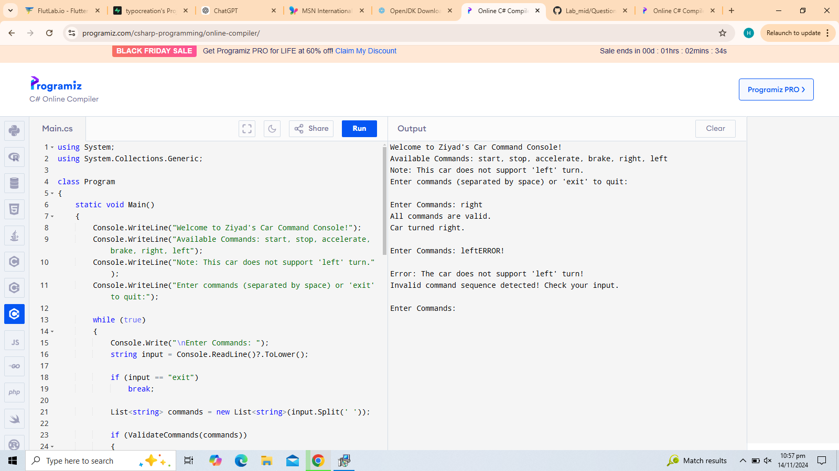

Question 3

