School Days Automation
Two automations live here:
- yearbook-choice — Yearbook photo choice entry
- package-choice — Package choice entry
Each folder has its own run script. Use the one you need.

Yearbook choice
- Put one Excel file in the yearbook-choice folder (same folder as the run script).
- Double-click Run_Yearbook_Choice.bat (Windows) inside yearbook-choice.
- Do Step 1 (validation), then Step 2 (click where the program asks), then Step 3 (automation runs).
- To stop: move the mouse to a corner of the screen.

Package choice
- Put one Excel file in the package-choice folder (same folder as the run script).
- Double-click Run_Package_Choice.bat (Windows) or Run_Package_Choice.command (Mac) inside package-choice.
- Do Step 1 (validation), then Step 2 (click where the program asks), then Step 3 (automation runs).
- To stop: move the mouse to a corner of the screen.

Output files
All of these are created in a reports folder inside the automation folder you ran (e.g. yearbook-choice/reports or package-choice/reports).
File | Meaning
yearbook-choice-errors-….xlsx | List of errors (validation or during run). Check this if something went wrong.
yearbook-choice-completed-….xlsx | List of students that were finished successfully.
package-choice-errors-….xlsx | List of errors (data problems or during run). Check this if something went wrong.
package-choice-completed-….xlsx | List of students that were finished successfully.
package-choice-run-summary-….xlsx | Summary of what the automation is entering (packages, choices, etc.) for the run.
All report files are Excel (.xlsx).

When the code is updated
If the code is updated, get the latest version like this:
- Go to Schooldays folder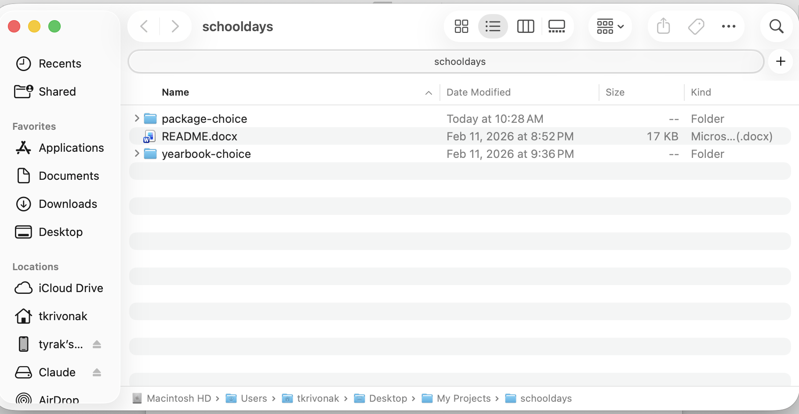
- Right click inside of the folder
- Open Git Bash
- Tyoe: git pull
- Ensure files have been updated
That’s it. You’ll then have the latest instructions and fixes.

