📊 Marketing Campaign Performance Analysis
1. Business Problem
The marketing department has invested in multiple campaigns across various channels, locations, and customer segments but lacks clarity on which strategies are driving meaningful financial returns.
The objective of this analysis is to:
- Identify high-performing channels and campaign types
- Detect underperforming regions
- Evaluate cost efficiency
- Provide data-driven recommendations for future budget allocation

2. Dataset Overview
Source: Kaggle – Marketing Campaign Performance Dataset
200,000 campaign records spanning two years.
The dataset includes:
- Campaign characteristics (Type, Duration, Channel, Location, Language)
- Performance metrics (Conversion Rate, ROI, Acquisition Cost)
- Engagement metrics (Clicks, Impressions, Engagement Score)
- Targeting attributes (Customer Segment, Target Audience)

3. Data Cleaning & Preparation
The dataset was initially explored in Excel; however, due to its size, processing was moved to MySQL.
Key preparation steps:
- Created a clean table with corrected data types.
- Converted Duration from text format to numeric using CAST() and REPLACE() to ensure accurate aggregation.
- Used NULLIF() in calculated fields to prevent division-by-zero errors.
- Standardized date formatting for monthly trend analysis.
These steps ensured reliable metric calculations for analysis.

4. Key Insights
🔹 Campaign Duration
Search campaigns have the longest average duration.
However, duration alone does not determine profitability and was further evaluated alongside ROI and cost metrics.

🔹 Channel Performance (ROI & Conversion Rate)
- Conversion rates are consistent across all channels, indicating similar funnel effectiveness.
- YouTube generates the highest average ROI despite similar conversion rates.
Implication: ROI differences are likely driven by cost efficiency rather than conversion effectiveness.

🔹 Channels Outperforming Portfolio Average
Facebook, Website, and Google Ads exceed the overall average ROI.
Implication: These channels represent scalable opportunities for increased investment.

🔹 Regional Performance
Chicago and New York generate high impressions but below-average ROI.
Implication: Campaign targeting, messaging, or channel allocation in these regions should be reviewed to improve financial return.

🔹 Customer Segment Performance
ROI differences across customer segments are minimal.
At higher precision, the Foodies segment shows marginally higher returns.
Implication: Customer segment may not be a primary driver of ROI variation within this dataset.

🔹 Cost Efficiency
- Google Ads has the highest acquisition cost and highest cost-per-click.
- Search campaigns demonstrate strong engagement yield while maintaining relatively lower acquisition costs.
Implication: Search campaigns appear to offer strong engagement efficiency relative to cost.

🔹 Monthly Performance Trends
Using a window function to identify top-performing campaign–channel combinations per month:
- Email campaigns led ROI performance in April, driven primarily by the Website channel.
- Influencer campaigns consistently ranked among top monthly performers.
Implication: Influencer campaigns show sustained ROI strength across time periods.

5. Strategic Recommendations
Based on the analysis:
- Increase budget allocation toward YouTube and other above-average ROI channels.
- Optimize or reassess Google Ads cost structure due to high acquisition cost and CPC.
- Reevaluate strategy in Chicago and New York to improve return on high-visibility campaigns.
- Consider scaling Search campaigns due to strong engagement efficiency.
- Monitor influencer campaigns as a consistently strong ROI contributor.

POWERBI-DASHBOARD
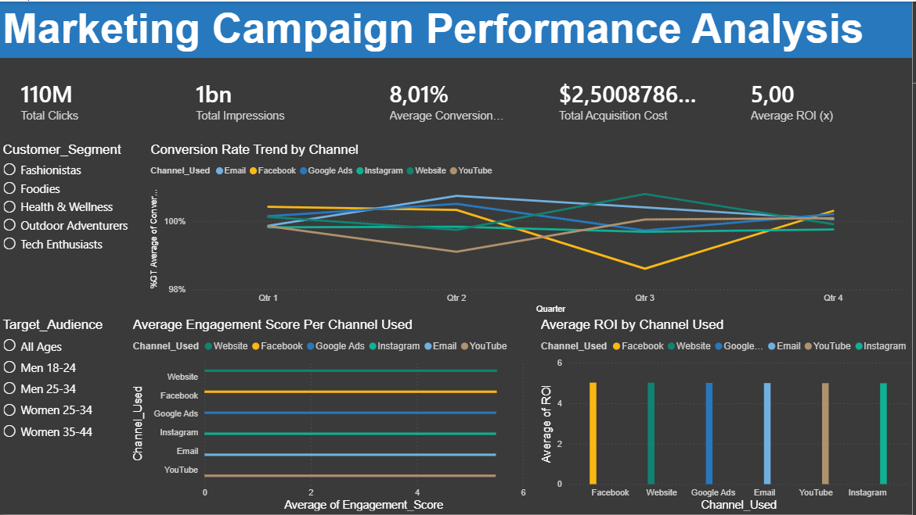

Insight Summary
1. Channel Conversion Trends
Across all four quarters, Google Ads and Website consistently maintain higher conversion rates compared to social channels.
Facebook shows a noticeable dip in Q3, which may indicate seasonal audience disengagement or less effective campaign content during that period.
Overall, the trend suggests that paid search and website traffic attract users with stronger purchase intent.
2. Engagement Performance by Channel
Engagement scores reveal that Website and Facebook generate the highest levels of user interaction, while YouTube and Email show lower engagement.
This suggests that Website visitors are more actively exploring content, and Facebook campaigns may be effective at capturing attention even when conversion rates fluctuate.
3. ROI Distribution Across Channels
ROI is strongest for Google Ads and Website, indicating that these channels deliver the best financial return relative to spend.
Facebook and Instagram show lower ROI, suggesting that while they may drive awareness or engagement, they are less efficient at converting that engagement into revenue.
4. Customer Segment & Audience Insights
Filters reveal that performance varies across customer segments and target audiences.
For example, certain demographics (such as Women 25–34) may respond more strongly to specific channels, allowing for more targeted budget allocation.
5. Recommended Budget Strategy
Based on the combined performance across conversion rate, engagement, and ROI:
- Increase budget for Google Ads and Website, as they consistently outperform other channels across all key metrics.
- Optimize or reduce spend on Facebook and Instagram, focusing on improving content relevance or retargeting strategies.
- Maintain Email and YouTube as supporting channels for awareness and nurturing.

