<Budget>

**<DESIGN Manual>**

Purpose of the document

The purpose of this document is to describe the

Design of Budget to the user

**Table of Contents**

**PURPOSE OF THE DOCUMENT................................................................................................................1**

1. **GENERAL DESCRIPTION...................................................................................................................3**
   1. Brief description..................................................................................................................................3
   2. Project Players.....................................................................................................................................3
   3. Support................................................................................................................................................3
   4. Address...............................................................................................................................................3
   5. Authentication.....................................................................................................................................3
   6. System Requirement...........................................................................................................................3
2. **DESIGN ELEMENTS.............................................................................................................................4**
   1. General Layout....................................................................................................................................4
   2. ICONS................................................................................................................................................4
      1. Sizing ...................................................................................................................................4
   3. Colors..................................................................................................................................................4
   4. TYPOGRAPHY..................................................................................................................................5
      1. FONTS .................................................................................................................................5
      2. Shadows ...............................................................................................................................6
3. **PROBLEM ENCOUNTERED................................................................................................................7**
4. **REFERENCES.........................................................................................................................................8**

# General Description

## Brief description

Created to manage finance or budgeting that allows users to access and have a simple design that has new innovations such as having some features of expense / income, calendar and graph.

## Project players

Budget is developed by Informatics student at Universitas Pelita Harapan for Human Computer Interaction project.

-Williem Citralin, 00000014292 as a [Database Management](https://docs.google.com/presentation/d/1mrLRyO5NjbvO2sn-O3GPvVcxg_0zNZVoFd7lKOvpqbQ/edit#slide=id.g28a1fc02b0_2_86), Documentation, [Schedule and Resource](https://docs.google.com/presentation/d/1mrLRyO5NjbvO2sn-O3GPvVcxg_0zNZVoFd7lKOvpqbQ/edit#slide=id.g28a1fc02b0_2_92), Main Feature, Design, Slide.

-Leonardo Bunjamin, 00000014225 [Main Feature](https://docs.google.com/presentation/d/1mrLRyO5NjbvO2sn-O3GPvVcxg_0zNZVoFd7lKOvpqbQ/edit#slide=id.g28a1fc02b0_2_104), Slide, Documentation, User Manual, Program Manual, Limitation&Prototype Consideration, Coordinator

-Rickhen Hermawan 00000012311 as a Slide, Documentation, Design, Main Feature, Questionnaire & Evaluation,T-test, Anova

-Octa Wijaya-0000001939 as a [Main Feature](https://docs.google.com/presentation/d/1mrLRyO5NjbvO2sn-O3GPvVcxg_0zNZVoFd7lKOvpqbQ/edit#slide=id.g28a1fc02b0_2_104), Documentation, Slide, User Manual, Program Manual

## Support

You can contact us through [budgetuph@gmail.com](mailto:budgetuph@gmail.com) for support.

## Address

Budget does not require internet connection to be accessed.

## Authentication

Budget does not require authentication in order to be used.

## System Requirement

Minimum System Requirement for Budget to run:

1. Android OS: API 15: Android 4.0.3 (IceCreamSandwich)

# Design Elements

## General Layout

Budgeting uses custom listview to show its data. In the main menu which is today’s transaction.

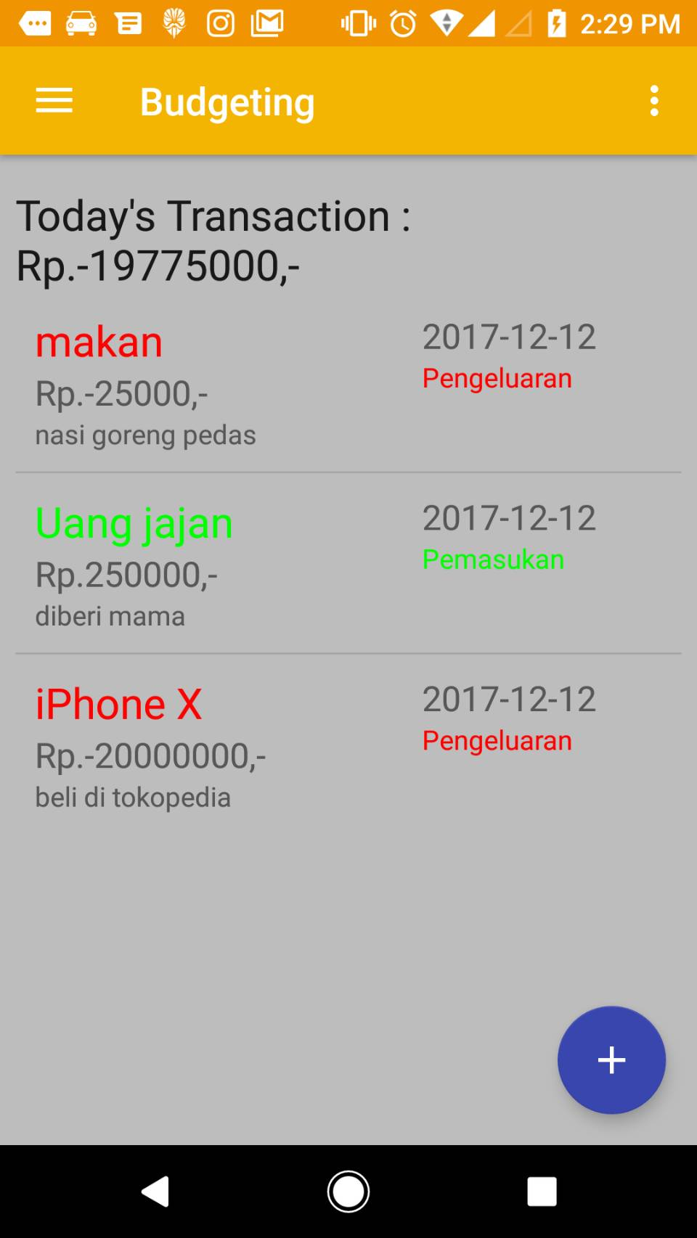

There’s navigation bar if u swipe from the left edge of the screen, there’s also the floating action button to add new data.

If the 3-dots option is clicked it will show the help button which navigate to help page.

## ICONS

Budgeting uses the material icons from Google, except for the application icon. Material icons are beautifully crafted, delightful, and easy to use in your web, Android, and iOS projects. These icons is consistent to the application which use the material design principle from Google.

## Colors

Budgeting application color’s uses material design principles from Google.

We choose the orange color because it’s eye catching which attracts more user.

Primary : It’s primary color called Material amber 600.

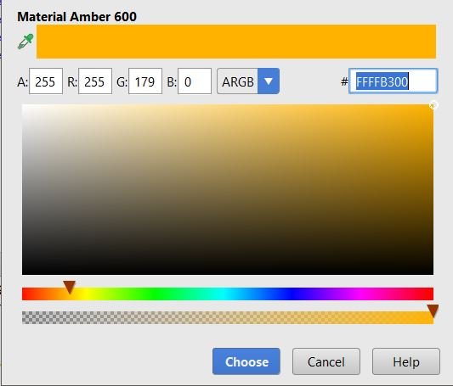

Primary Dark : It’s primary color called Material Orange 600.

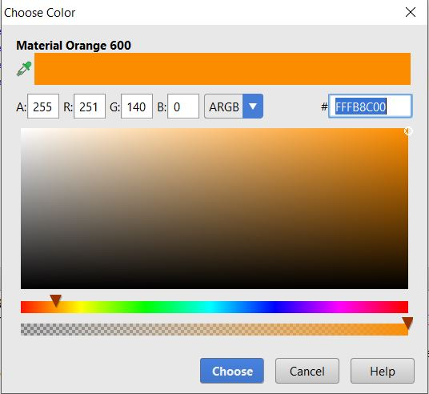

Color Accent : To make it contrast with the primary color we choose Material Indigo 600

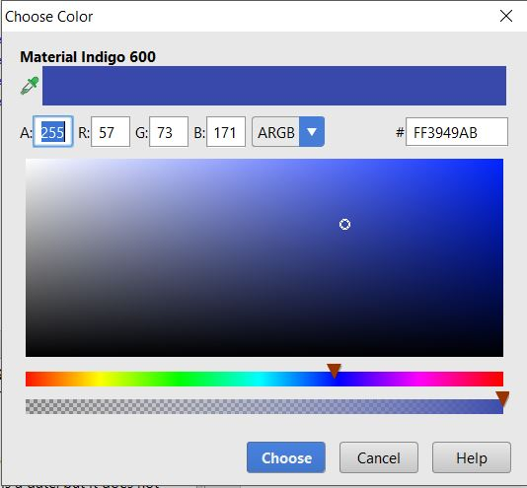

Background Color : To make it not too plain, we choose Material Grey 400 as background color in the mainActivity.

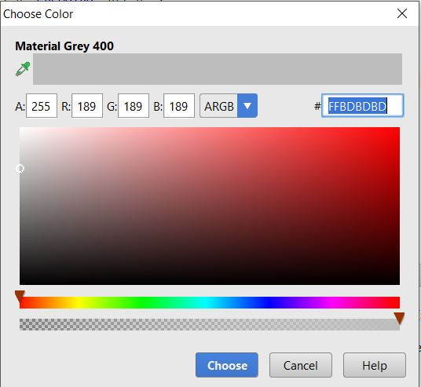

Expense color : We use red bright color to show that this transaction is expense.

Income color : We use green bright color to show that this transaction is income.

## 2.4 TYPOGRAPHY

2.4.1 FONTS

Budgeting uses Roboto font because it look simple and elegant as well.

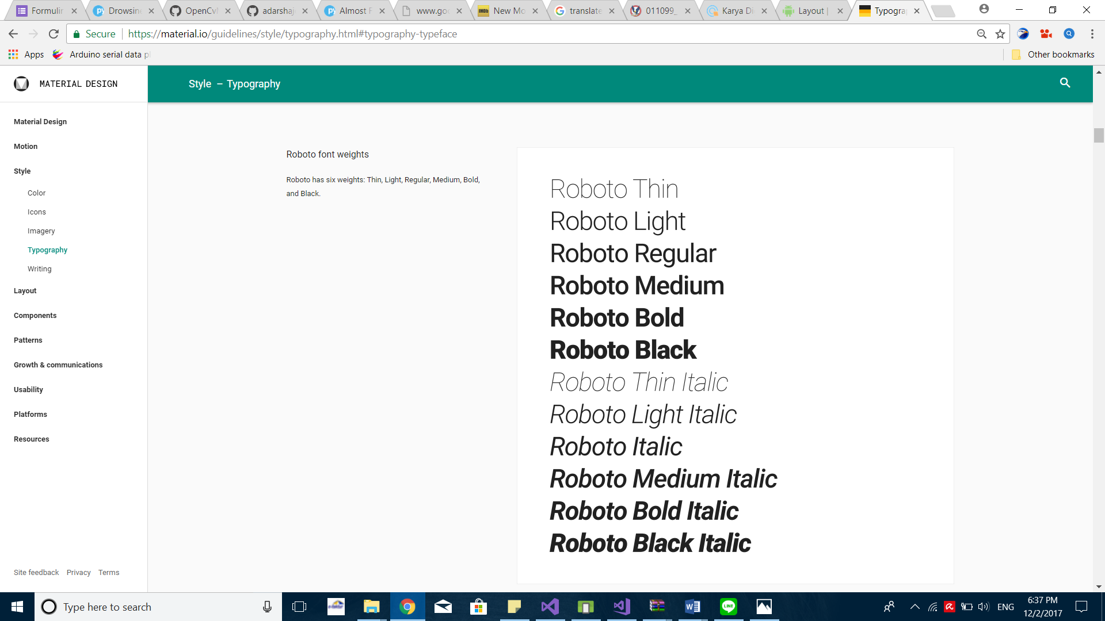

# REFERENCES

<https://developer.android.com/guide/topics/ui/declaring-layout.html?hl=id>

<https://developer.android.com/guide/topics/ui/layout/linear.html?hl=id>

<https://material.io/guidelines/style/color.html>

<https://material.io/icons/>