<Budget>

**<USER Manual>**

Purpose of the document

The purpose of this document is to describe the

Application Budget to the user

**Table of Contents**

**PURPOSE OF THE DOCUMENT...............................................................................................1**

1. **GENERAL DESCRIPTION...................................................................................................................3**
   1. Brief description..................................................................................................................................3
   2. Project Players.....................................................................................................................................3
   3. Support................................................................................................................................................3
   4. Address...............................................................................................................................................3
   5. Authentication.....................................................................................................................................3
   6. System Requirement...........................................................................................................................3
2. **STRUCTURE OF THE APPLICATION...............................................................................................4**
   1. Layout.................................................................................................................................................4
   2. Menus.................................................................................................................................................4
   3. Icons....................................................................................................................................................4
   4. Functionalities.....................................................................................................................................5
      1. Functionalities Presented .....................................................................................................5
      2. Functionalities not Presented ...............................................................................................6
3. **Functionalities 1:Budgeting.....................................................................................................................7**
4. **Functionalities 2:......................................................................................................................................7**
5. **REFERENCES.........................................................................................................................................8**

# General Description

## Brief description

In a Brief, Budgeting Created to manage finance or budgeting that allows users to access and have a simple design that has new innovations such as having some features of expense / income, calendar and graph.

## Project players

Budget is developed by Informatics student at Universitas Pelita Harapan for Human Computer Interaction project.

-Williem Citralin, 00000014292 as a Database Management, Design.

-Leonardo Bunjamin, 00000014225 Main Feature, Documentation.

-Rickhen Hermawan 00000012311 as a Database Management(PIC), input Bill with Camera.

-Octa Wijaya-0000001939 as a Main Feature, Documentation

## Support

You can contact us through [budgetuph@gmail.com](mailto:budgetuph@gmail.com) for support.

## Address

Budget does not require internet connection to be accessed

## Authentication

Budget does not require authentication in order to be used.

## System Requirement

Minimum System Requirement for Budget to run:

1. Android OS: LOLLIPOP(API 21)

# Structure of the Application

## Layout

In general, the layout for main activity Budgeting is given below:

-Navigation drawer: when clicked,

-Top Bar: shows the title of apps, contains navigation drawer and options menu.

-Options menu: when clicked, options will pop out help file,settings.

-Main Content: all the content for apps will be shown here.

## Menus

Navigation Drawer:

-

Options Menu:

1. Help: show help for user in using the app

2. Settings :

## Icons

* Isinya gambar icon dan penjelasan

|  |  |
| --- | --- |
| Icon | Function |
|  | App icon |
|  | Checklist icon, when finished filling |
|  | Add new icon, make new expense/income |
|  | Other icon, help file and settings |
|  |  |
|  |  |

## Functionalities

2.4.1. Functionalities Presented

The functionalities that will be described in this manual are:

1. Add New
2. HCIs

2.4.2. Functionalities not Presented

All the main functionalities of the app will be describe in this manual

# Functionalities 1 : Add new

This function enable user to make new expense or income, will contain :

1. Amount
2. Date, DD/MM/YY
3. Type
4. Some Notes

## SCREENSHOOT

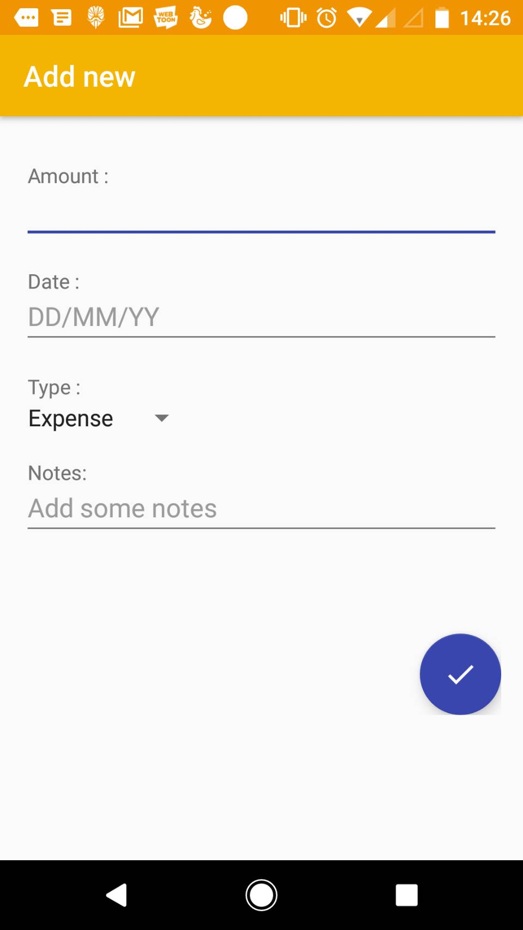

## DESCRIPTIONS OF FIELDS, CONTENT

Screenshot 3.1 shows all the functionalities of Add New. The description for each component are:

1. Amount : fill in some income
2. Date, DD/MM/YY : the time required for income or expenditure
3. Type : type of expenses incurred
4. Some Notes : additional note of interest

## DESCRIPTION OF ACTIONS

Actions possible in this screen are user able to fill new expense/income with some supporting components that need to be filled.

## SEQUENCE OF SCREENS

Add new will be shown when user selected expense/income menu.

# Functionalities 2 : HCIs

This function enables user to add new expenditure and view expenditure total

## SCREENSHOOT

5.2 DESCRIPTION OF FIELDS, CONTENT

User can click on the some money and user can add new expense/income. And then user can show total of expenditure of money.

5.3 DESCRIPTIONS OF ACTIONS

When HCIs are select, the interface will be shown and in the top side can show total of expenditure.

5.4 SEQUENCE OF SCREENS

User view total expenditure, then user have done filling expense/income.

# References