**C# Homework 01**

**Question 1**

What is a console app?

**Answer**

Console application is an application that runs in a command prompt window instead of providing a graphical user interface (GUI).

**Question 2**

List the two differences between .NET *Framework* and .NET *Core.* Note that in this class, we will be writing C# applications in .NET Framework and ASP.NET applications in NET Core.

**Answer**

You use the .NET Core template for building portable applications that can also run on other operating systems, such as Linux. However, >NET Core applications do not provide the range of features available to the complete .NET Framework. .NET Framework is a software development framework for building and running applications on Windows. It is a part of the .NET platform, a collection of technologies for bu8ilding apps for Linux, macOS, Windows, iOS, Android, and more.

**Question 3**

What does Main() (the main method) do in a console application?

**Answer**

It is a program entry point.

**Question 4**

Describe these three files: TextHello.sln, TextHello.csproj, and AssemblyInfo.cs.

**Answer**

Solution File names have the .sln suffix. A solution can contain one or more projects. Visual C# project files have the .cspoj suffix. If you open a project rather than a solution, Visual Studio 2017 automatically creates a new solution file for it. .cs is a special file that you can use to add attributes to a program, such as the name of the author, the date the program was written and so on. You can specify additional attributes to modify the way in which the program runs.

**Question 5**

What is the purposed of a namespace?

**Answer**

It helps keep things organized. A namespace is designed for providing a way to keep one set of names separate from another. The class names declared in one namespace does not conflict with the same class declared in another. Sort of like a last name of a family you could have multiple people name Joe, but one is Joe Smit and the other is Joe Dirt. The last name distinguishes which Joe you are talking about. A namespace distinguishes between different objects of the same name.

**Question 6**

Describe specifically what *using*  statements do.

**Answer**

They enable you to ring a class into scope and omit the class name when accessing member. Using statements import a namespace so when you use a name the computer knows where to go to find that object.

**Question 7**

What is the entry point for a console app? What is the entry point for a UWP app?

**Answer**

The entry point for a console app is the main method. The entry point for the UWP app is app.xaml.cs.

**Question 8**

What is an assembly?

**Answer**

It is essentially a program, it’s everything that goes into a program. It is a file that is automatically generated by the compiler upon successful compilation of every .NET application. It can either be a Dynamic Link Library or an executable file.

**Question 9**

How many different versions of the WriteLine() method does the Console class contain?

**Answer**

It has 19 versions.

**Question 10**

What is the relationship between assembly and a namespace?

**Answer**

There is no relationship between the two. Namespace is a collection of objects; assembly is an executable program

**Question 11**

What is a graphical app?

**Answer**

It is an app designed to be used in the GUI.

**Question 12**

What does Build do?

**Answer**

It compiles code files that have changed, and takes the source code you have written turns it into English.

**Question 13**

(Not in book) What is bytecode? What is Microsoft CIL? Do you think that CIL is bytecode? Why or why not?

**Answer**

Bytecodes are compact numeric codes, constants, and references (numerally numeric addresses) that encode the result of compiler parsing and performing semantic analysis of things like type, scope, and nesting depths of program objects. Microsoft CIL (common intermediate language) is the intermediate language binary instruction set defined within the CIL specification; CIL is object-oriented stack-based bytecode.

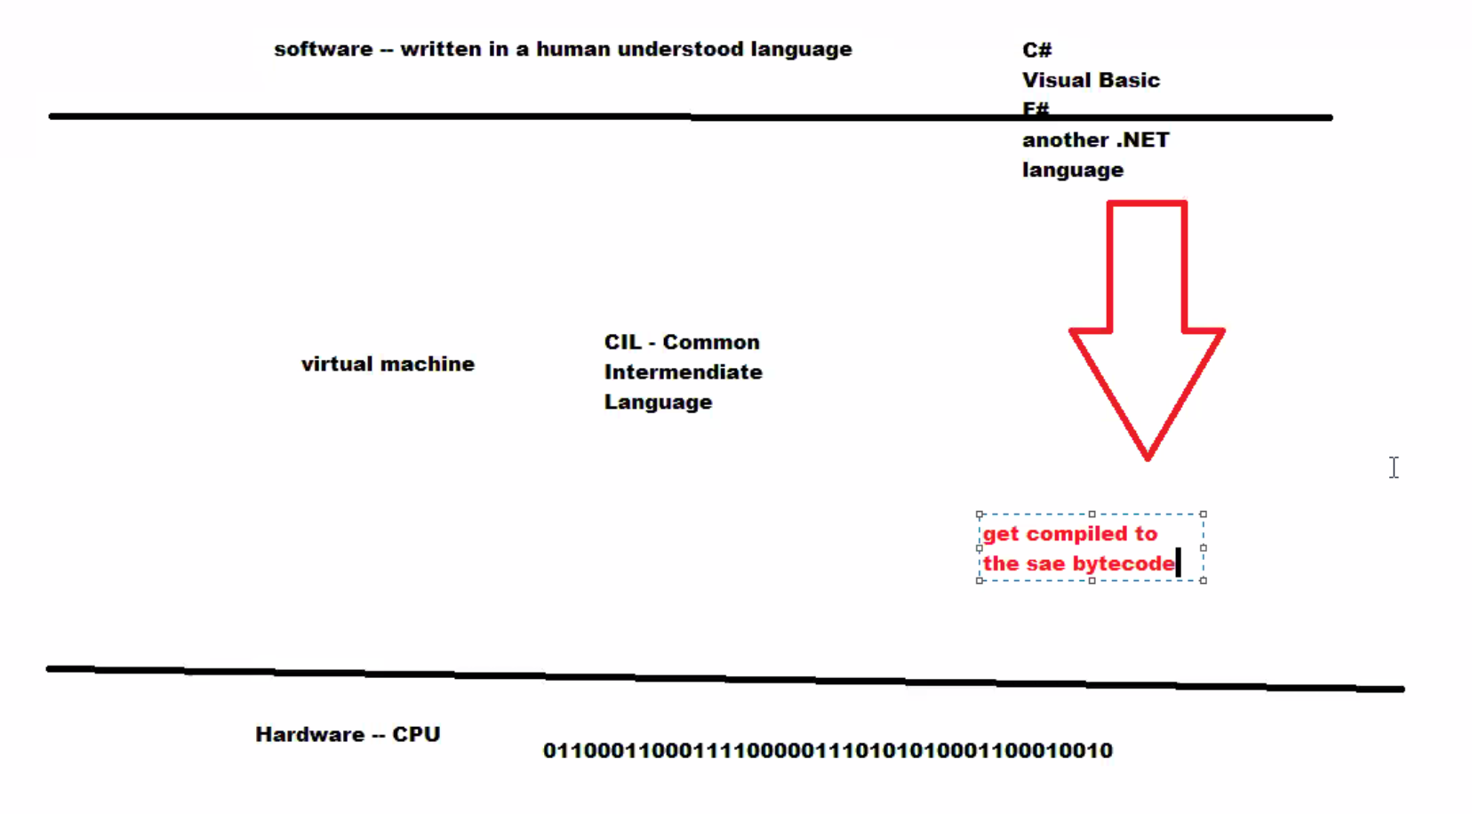

**Question 14**

What does Debug do?

**Answer**

When you debug your app, it usually means that you are running your application with debugger attached. When you do this, the debugger provides many way to see what your code is doing while it runs.