**C# Homework 04**

**Question 1**

What are all possible values of Booelan expression?

**Answer**

There are only two possible Boolean values: false and true. Boolean values result when a Boolean expression is evaluated by C#.

**Question 2**

List the equality operators. List the relational operators. List the logical operators. How are they the same? How are they different?

**Answer**

X == y, x != y are the equality operators. X < y, x > y, x <= y, x >= y, is, as are the relational operators. && Called logical AND operator. If both the operands are non zero then condition becomes true. || called logical OR operator. If any of the two operands is non zero then condition becomes true. ! Called logical NOT operator. Use to reverses the logical state of its operand. If a condition is true then logical NOT operator will make false. The two equality operators each have the same level of precedence, the relational operators each have the same level of precedence, and the equality operators have lower precedence than the relational operators.

**Question 3**

What is the general concept of short circuiting? This question has a short and simple answer and you do need to have a detailed response.

**Answer**

If one or both operands return true, then it evaluates true. If both operands are false, it will return false.

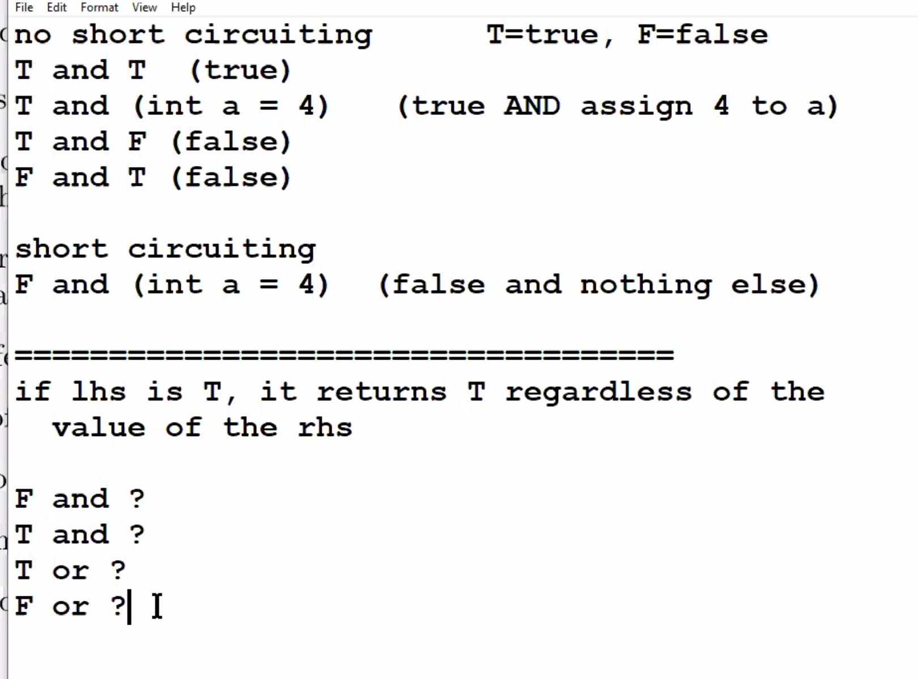

**Question 4**

What is the difference in how short-circuiting works for && and ||?

**Answer**

The conditional logical AND operator &&, also known as the “short-circuiting” logical AND operator, computes the logical AND of its operands. The result of x && y is true if both x and y evaluate to true. Otherwise, the result is false. If x evaluates to false, y is not evaluated. The conditional logical OR operator ||, also known as the “short-circuiting” logical OR operator, computes the logical OR of its operands. The result of x || y is true if either x or y evaluates to true. Otherwise, the result is false. If x evaluates to true, y is not evaluated.

**Question 5**

Look at the list of operators. What operator has the highest precedence? Which has the lowest?

**Answer**

The parentheses operator has highest precedence. The assignment operator has the lowest.

**Question 6**

In an if or else construction using multiple lines of code, what effect does the use of curly braces have?

**Answer**

You have to use braces using an if or else statement.

**Question 7**

In a switch statement, what happens if you omit break?

**Answer**

Without break, the program continues to the next labeled statement, executing the statements until a break or the end of the statement is reached. This continuation may be desirable in some situations. The default statement is executed if no case constant-expression value is equal to the value of expression.

**Question 8**

The four keywords in a switch statement are switch, case, break, and default. Explain what each keyword does.

**Answer**

Switch statement allows a variable to be tested for equality against a list of values. Each value is called a case, and the variable being switched on is checked for each switch case. It specifies a pattern to match. The case statement defines a pattern to match the match expression. There are two types of patterns, constant pattern, and non-constant (type) pattern. The constant pattern tests whether the match expression equals a specified constant. In case of a constant pattern, the case statement is followed by a constant value. When the break statement is encountered inside a loop, the loop is immediately terminated, and program control resumes at the next statement following the loop. It can be used to terminate a case in the switch statement. Default keyword helps you initialize the instance of an object like class, list, and more types. It is used because of its generic property where it helps you to assign the type default value when you do not know its value as advance way to avoid mistakes in your further(future) code.

**Question 9**

Look at the source listing below. It contains two methods: recurr1() and recrr2(). There is a significant difference between the two methods. What is it?

**Answer**

K

**Question 10**

What is a recursive method? Using a language, you know (such as English), write a recursive method that adds up the integers in a list of integers. The input to the method is a list of integers and the output is a scalar value representing a sum.

**Answer**

A recursive function is a function that calls itself. A function that calls another function is normal but when a function calls itself then that is a recursive function.

**Question 11**

Read a short summary of De Morgan’s laws.

1. Explain how this statement, “It’s not snowing or raining,” is the same as this statement, “It’s not snowing and it’s not raining.”
2. Explain how this statement, “I’m not running and walking,” is the same as this statement, “I’m not running or I’m not walking.”

**Answer**