**資料分析方法-HW6**

**經研一 江彥亨 R11323040**

1. **a**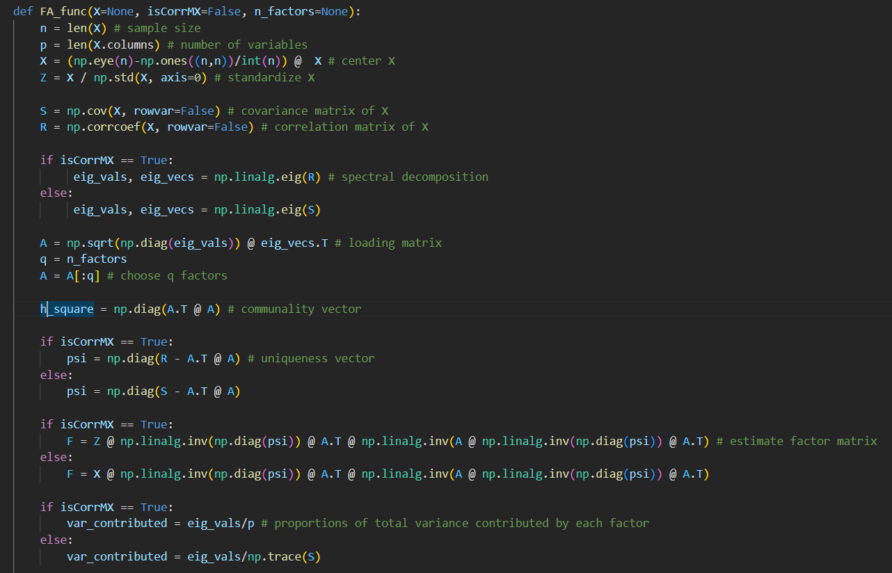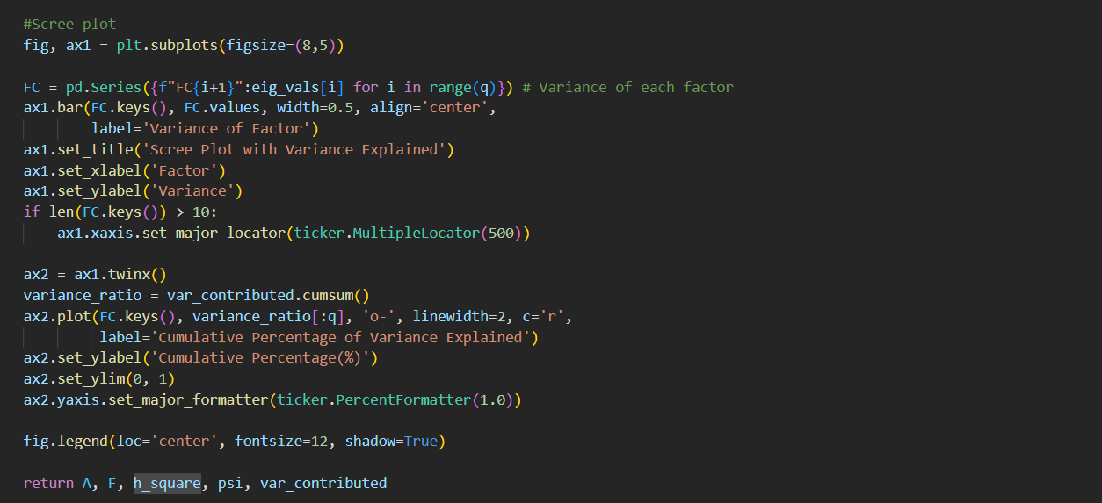
2. **b**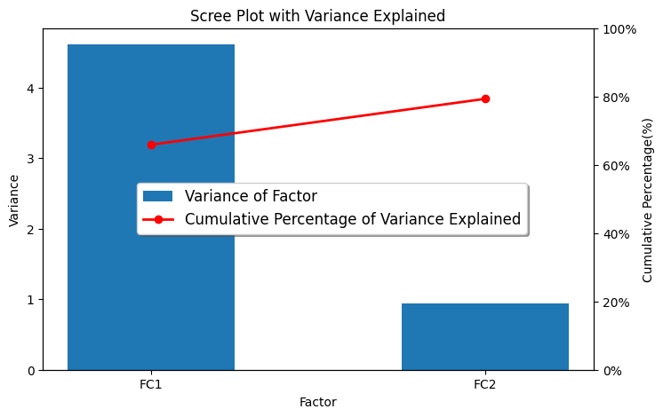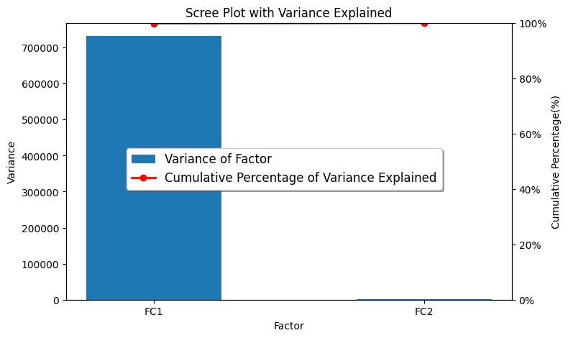As shown in two graphs above, using the covariance matrix produces different results from using the correlation matrix. Similar to PCA, the loading matrix in FA is derived by spectral decomposition, so the results of FA can also be affected by scale transformation. Therefore, FA is scale variant.

2.a

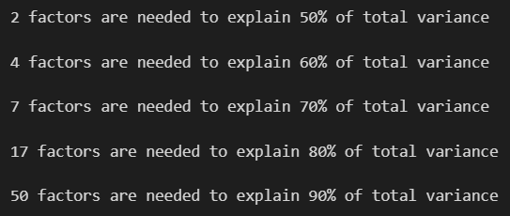

2.b

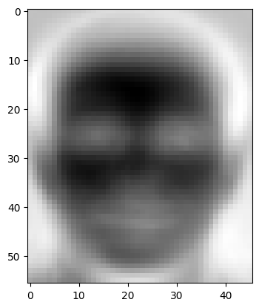

3.a

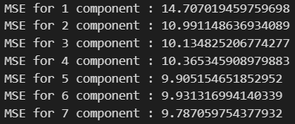

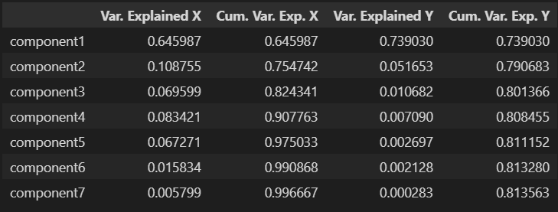

Based on the testing results, the mean square error decreases as the more components(iterations) are included in the model. In addition, four components can explain 90% of the covariance of in the training data of X. However, even if we include all components, only 81% of the covariance in the training data of y can be explained.

3.b

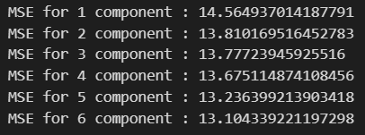

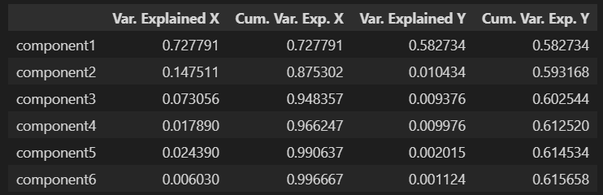

Based on the testing results, including more components in the model also leads to a decrease in mean squared error, but the rate of decrease is smaller than in 3.a. Additionally, just three components can explain 95% of the covariance of in the training data of X. However, when all components are included, only 61% of the covariance in the training data of y can be explained. The reason behind this is that we have reduced the number of explanatory variables while increasing the number of explained variables in model, which implies that we are using less information to predict more complex targets. Therefore, it is expected to have more prediction errors in the target variables.