**資料分析方法-HW7**

**經研一 江彥亨 R11323040**

**Q1:**

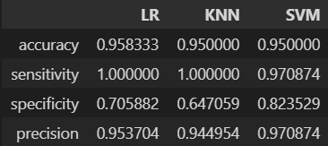

Based on the results, the accuracy of all three algorithms is roughly the same. LR and KNN have predicted men's outcomes with 100% accuracy. However, SVM has a higher accuracy for predicting women's outcomes compared to the other two algorithms, and its precision is also superior to the other two. In conclusion, I consider that SVM is a better algorithm for estimating the data set “ORL Faces”.

**Q2:**

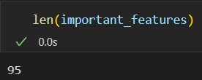

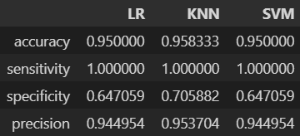

I used LASSO regression with a tuning parameter of 0.01 to select significant pixels, and the results are displayed above. 95 features were selected, and the accuracy is comparable to the results in EX1. However, it's worth noting that the specificity and precision of SVM decrease after feature selection.

**Q3:**

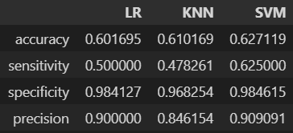

Based on the results, the accuracy of all three algorithms is similar. Additionally, all three algorithms demonstrate good specificity, but poor sensitivity. However, when considering all indicators, SVM exhibits better performance compared to the other two algorithms.