**資料分析方法-HW4**

**經研一 江彥亨 R11323040**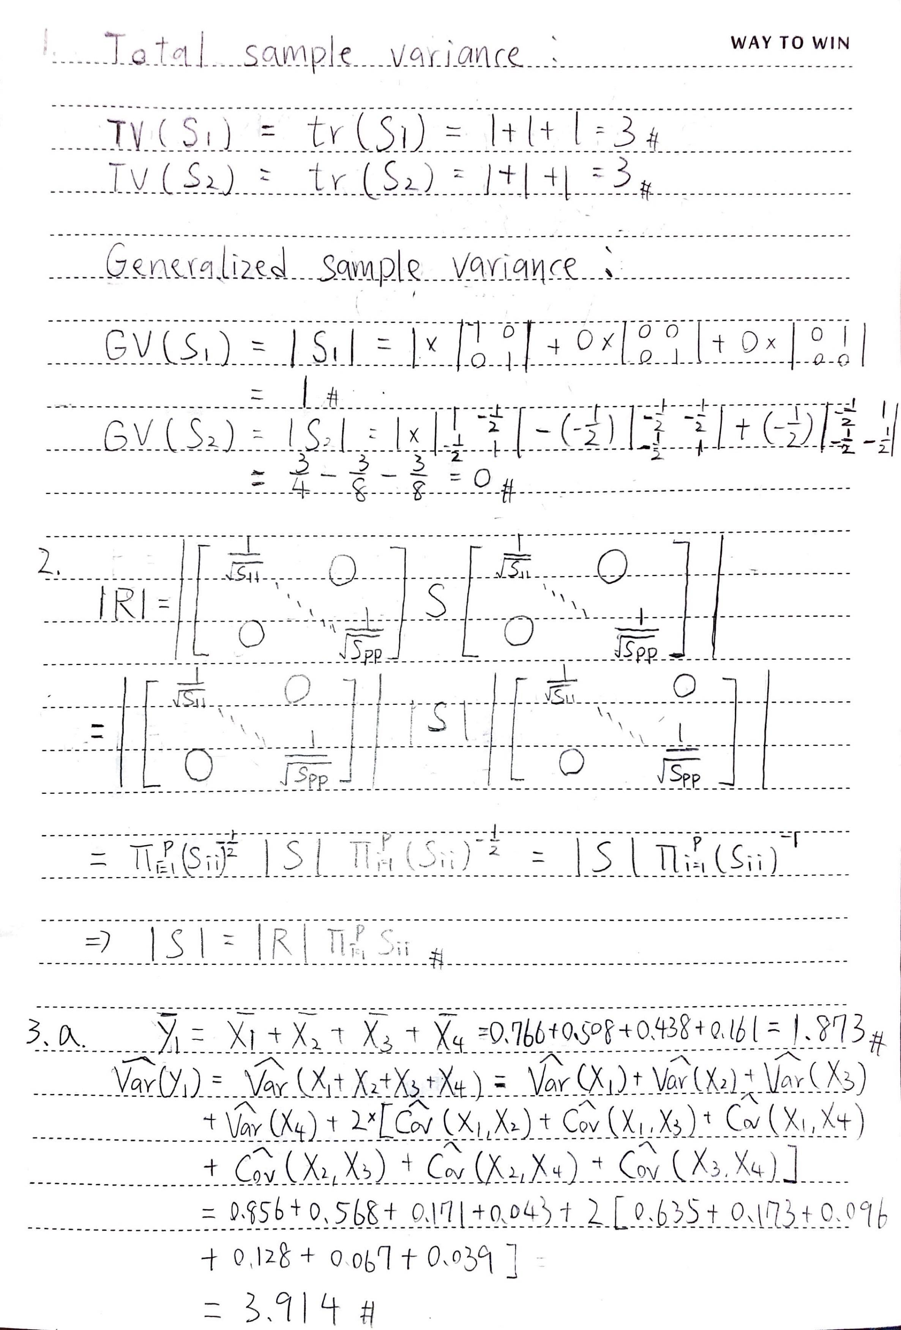

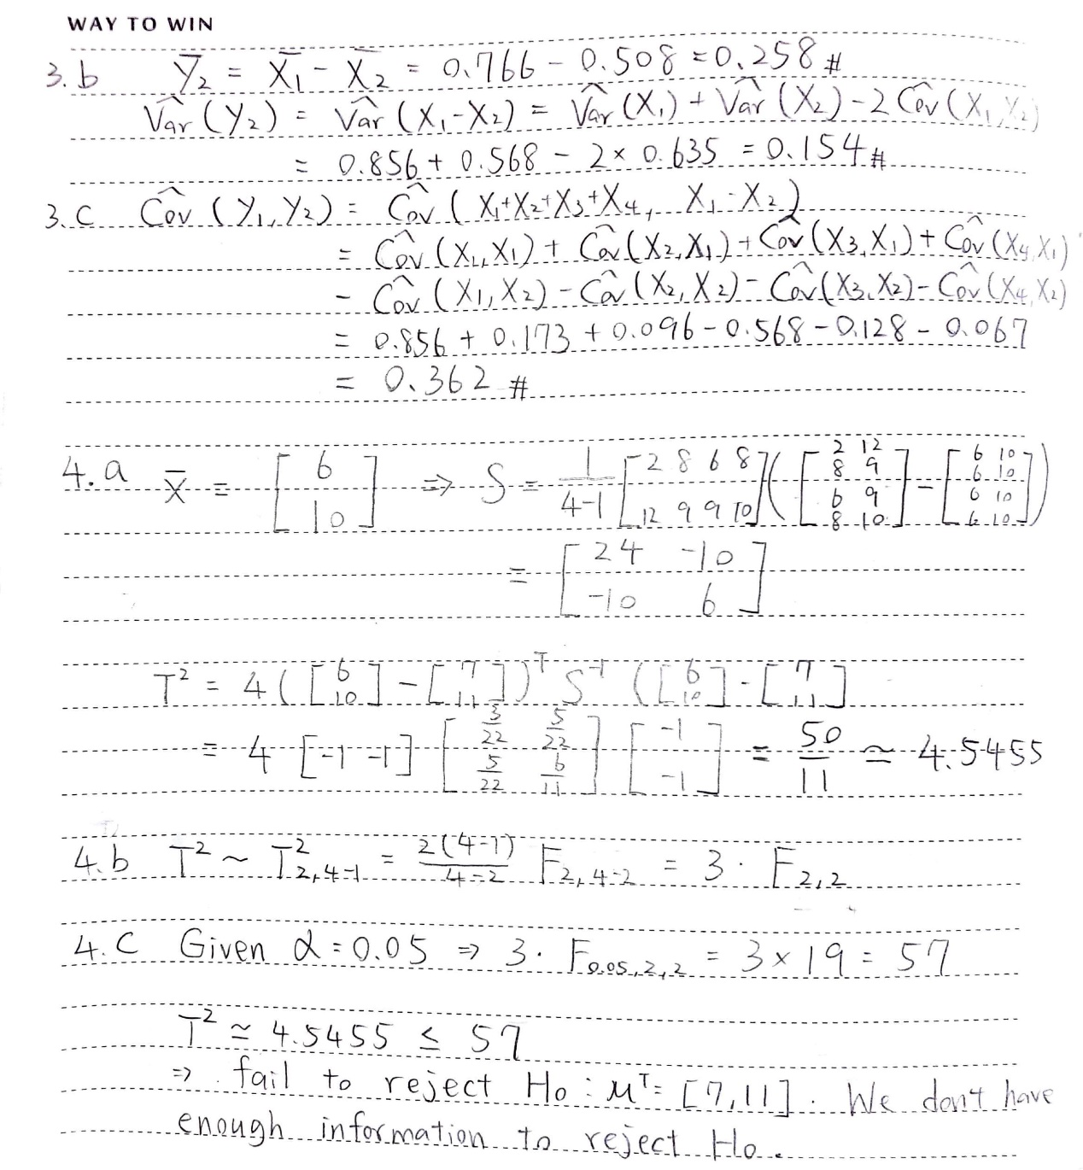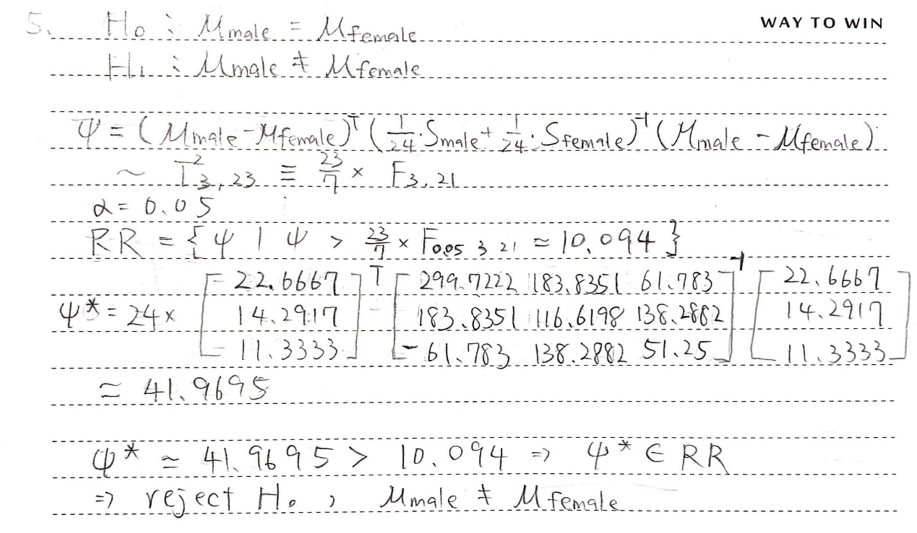

**6.a**

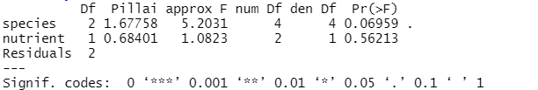

Based on the results, given a significance level of 0.05, species effect and nutrient effect are both insignificant. Therefore, we can conclude that neither species nor nutrient have significant effect on 560 cell means and 720 cell means.

**6.b**

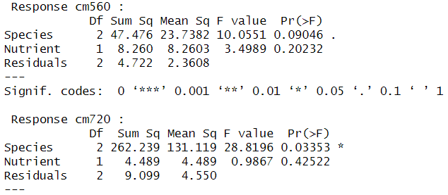

Based on the results, given a significance level of 0.05, in 560 cells mean, both species effect and nutrient effect are both insignificant. However, in 720 cells mean, species effect is significant but nutrient effect is not significant. The reason why species effect is significant in 720 mean cells under the two-way ANOVA probably may be that two-way ANOVA does not take into account the covariance between 560 cells mean and 720 cells mean.