**資料分析方法-HW5**

**經研一 江彥亨 R11323040**

**1.a**

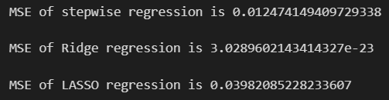

Based on results, Ridge regression has the best prediction.

**1.b**

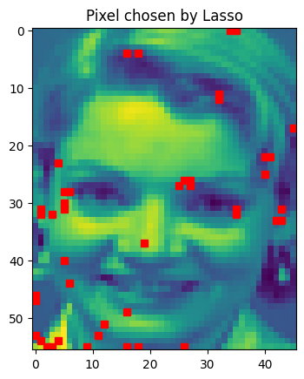

**2.a**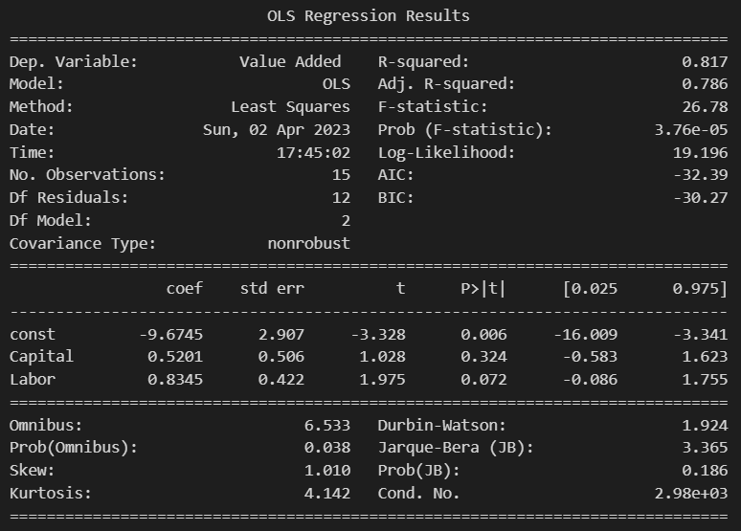

Based on results with a significance level of 0.05, both two coefficients are insignificant.

**2.b**

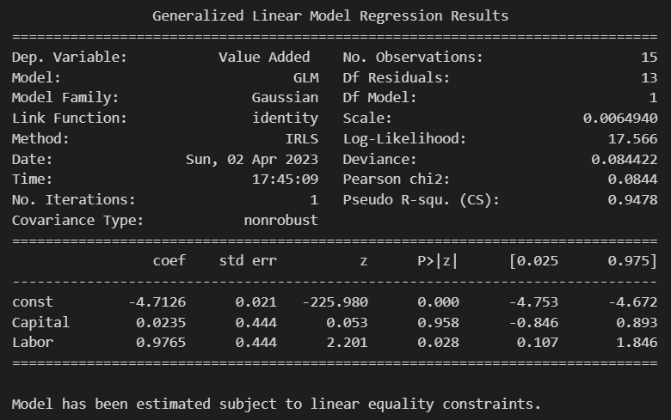

Based on the results with a significance level of 0.05 and the CRTS constraint, it can be concluded that the coefficient of capital share is insignificant and small, whereas the coefficient of labor share is significant and large. These findings suggest that the value added of the U.S. between the years 72 to 86 was largely driven by labor share.

**3.a**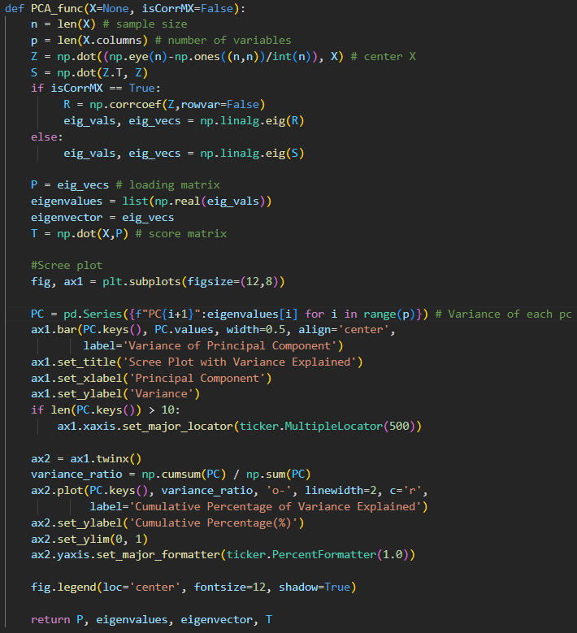

**3.b**

**Correlation matrix:**

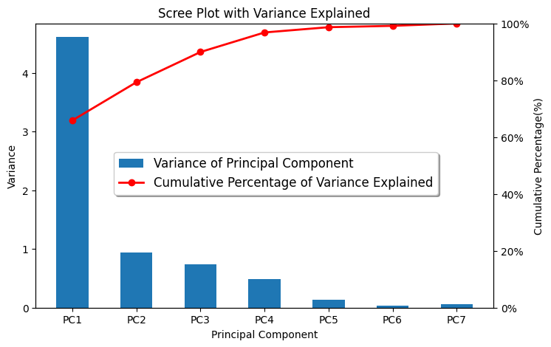

**Covariance matrix:**

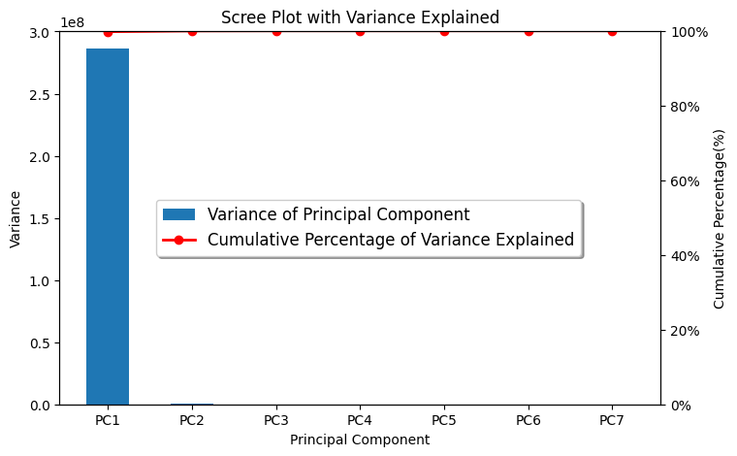

As shown in the two images above, using the covariance matrix produces different results from using the correlation matrix. Scale transformation can have an impact on the outcome of spectral decomposition, leading to differences in eigenvalues and eigenvectors. This means that the results of PCA can vary depending on the scaling method used, and therefore, PCA is scale-variant.

**4.a**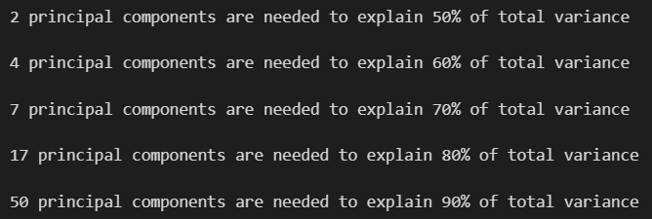

**4.b**

