**資料分析方法-HW8**

**經研一 江彥亨 R11323040**

**Q1.**

**Hierarchical clustering :**

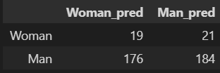

**Kmeans :**

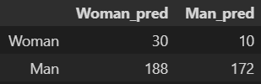

Based on the results, neither Hierarchical clustering nor Kmeans perfectly match the two genders and their respective accuracy are almost the same. In addition, Kmeans has better prediction for men, but worse prediction for women.

**Q2.**

**Hierarchical clustering :**

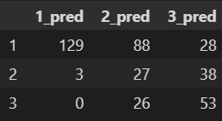

**Kmeans :**

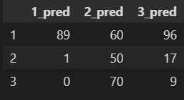

**DBSCAN :**

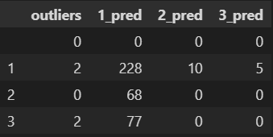

Based on the results, all three algorithms don’t perfectly match the origin. Although DBSCAN has the highest accuracy, it can only classify samples with 'origin=1' and fails to classify the other two classes. On the other hand, Kmeans performs well in predicting samples with 'origin=2', but its performance is poor for the other two classes. However, the performance of Hierarchical clustering is relatively good compared to the other two methods. Therefore, Hierarchical clustering is a relatively good method for this dataset and produces similar results to the supervised learning methods.