CME 433
Lab 5 Report
Tyrel Kostyk, tck290, 11216033

Lab 5 – Caching Part 3: Direct-Mapped and Set-Associative Cache

Part 1 – Multi-line Direct Mapped Cache

1. Please refer to the diagram of a direct-mapped cache provided in class as a reference:

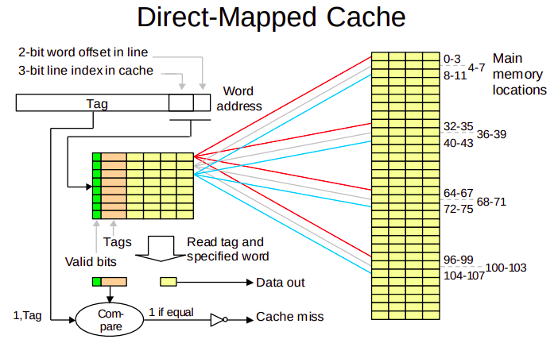

There are some key differences between the Direct-Mapped cache above and the one we implemented in Part 1 of this lab. First, we only had 4 lines in our cache instead of 8 shown above, and therefor also only needed 2 bits to represent the line number, not 3. Further, our word offset required 3 bits instead of 2, as our cache’s lines had 8 words each, not 4.

So overall: compared to the diagram above, our cache had half the amount of lines to store, but also had twice as many words per line, so it ended up being the same amount of words in the cache.

2. Initially, (let’s assume) the cache will be empty, so the first cache request is definitely a miss. Lets say it was address 6. The direct-mapped cache loads in the respective line into the cache (which in this case would hold words 0-7), filling the first line of the cache with the 8 words of data. Next, address 4 is requested – it’s a hit! Memory is provided to the instruction decoder much faster than usual. Next, address 11 is requested – it’s a miss! So now the second line of the cache fills up with words 8-15. Finally, let’s say a request to memory address 40 is requested, and the tag for memory address 32 over laps with memory address 0 – that’s a cache conflict! The cache will load in words 32-39, overwriting words 0-7 in the process. And the process continues!

3. See the following two photos showing the resource utilization of the single_cache vs the multi_cache. As you can see, the multi_cache uses significantly less combinational functions and logic elements. Additionally, the multi_cache is slightly faster than the singe_cache implementation.

< insert image of resource utilization of single line cache>
< double check facts above; faster n shit??>

Resource Utilization of the Single Line Cache Resource Utilization of the Multi-Line Cache

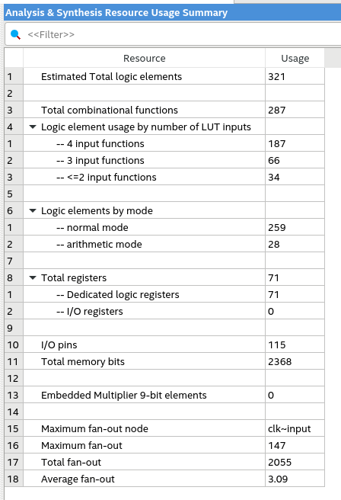

4. See waveforms before

Part 2 – Set-Associative Cache

1. Please refer to the diagram of a direct-mapped cache provided in class as a reference:

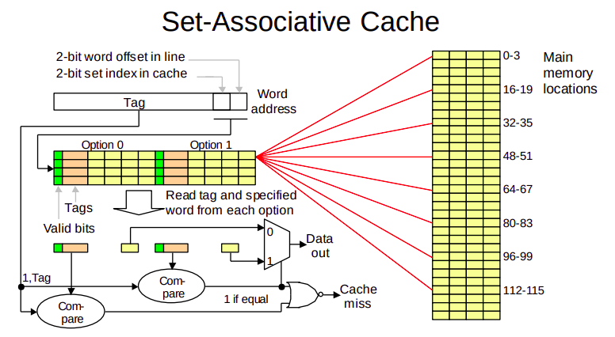

Just like in part 1, there are some slight differences in the diagram compared to our lab implementation: instead of 4 lines with 4 words each (per group), our design had 2 lines with 8 words (per group). So again same amount of words.

2. We implemented our set-associative cache using the Least-Recently Used (LRU) replacement scheme. First, with an empty cache – a miss occurs, and then the cache pulls in that line from main memory and then places it into either of the sets. Another miss occurs, but this time the cache places it in the empty set, but the same line as the last line that was fetched (let’s assume the memory addresses lined up like that). A cache hit will occur when the tag bits of the request match any of the tags of the cache lines in a set. A cache miss occurs when the tag bits don’t match any of the tags of the cache lines in the set. At this point, the LRU scheme fetches and places the new line in what it deems to be the “oldest” line.

3. See the following image of the Resource Utilization of the set_assoc_cache implementation.

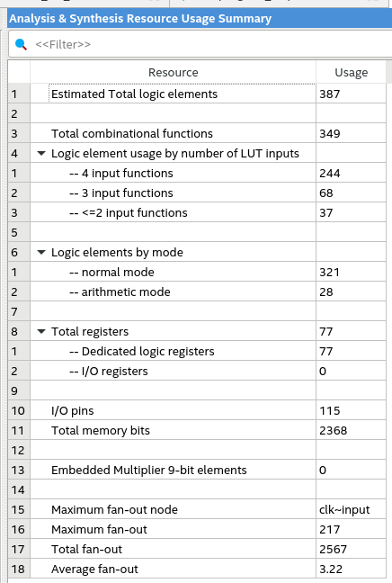
As you can see, set_assoc_cache uses more combinational functions and logic elements than multi_cache, but uses less than single_cache. set_assoc_cache uses the same number of memory bits as multi cache, which is less than the amount used by single cache. set_assoc_cache is also the slowest of the 3 implementations.

4. See waveforms before

5.
- tagID represents the the requested memory address; it’s what gets evaluated to check for a hit, miss, or conflict. The line offset is used to select which line (and therefor, which tag) to compare it to. It is updated every time start_hold is asserted.

- valid is used to determine whether a line has been written with data or not, and is an array (with 4 values), each holding a single bit. Gets updated whenever end_hold is asserted.

- currdentry is used to find the current entry for the cache.

- lastused represents the last used value in the cache.

