CME 433 – Lab 3
Tyrel Kostyk, tck290, 11216033

Suspend Micro
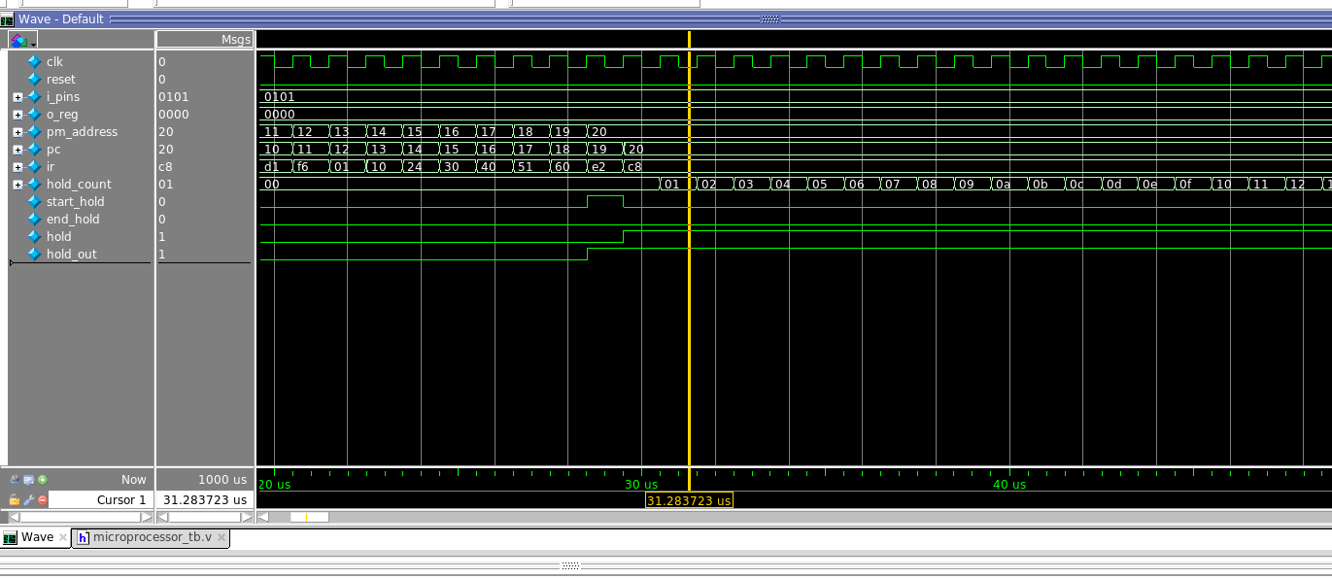
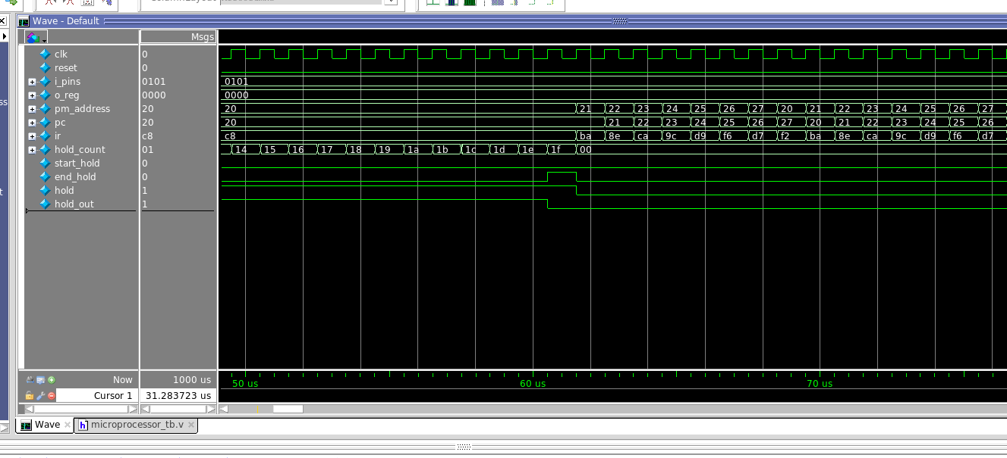
Start of waveform (first hold)

End of waveform (first hold)

